# Design and Development of Sign Language to Speech Conversion

# Prof. P.D.Pange1, Mr. P. A. Jadhav2, Mr. R. N. Jadhav3, Mr. A. B. Latwadekar4, Mr. P. S. Jagtap5, Mr. N. I. Jamadar6

1Project Guide, Department Of Electrical Engineering,

2,3,4,5,6Sanjeevan Engineering And Technology Institute

Sanjeevan Knowledge City, Somwar Peth, Panhala, Kolhapur - 416201, Maharashtra, India.

DOI: https://[www.doi.org/10.58257/IJPREMS33357](http://www.doi.org/10.58257/IJPREMS33357)

# ABSTRACT

**This project focuses on the design and development of an innovative Sign Language to Speech Conversion System (SLSCS) aiming to facilitate communication between individuals proficient in sign language and those who use spoken language. Leveraging advanced computer vision techniques, the system interprets and recognizes diverse sign language gestures. Natural Language Processing (NLP) algorithms are employed to convert these gestures into intelligible spoken language. The abstract emphasizes the project's commitment to inclusivity, user-friendliness, and continuous improvement through iterative refinement, ensuring a seamless and effective communication experience for users across different sign languages.**

**Keywords: Firing angle delay, Motor current control, Opto-couplers, Opto-isolators, SCR triggering, Zero voltage**



# INTRODUCTION

This report is about a glove that can help people who have trouble speaking. These people often communicate through hand gestures, but it can be hard for others to understand them. The glove has sensors that can read the hand gestures and convert them into speech and text. It is affordable and easy to use. We use a computer program called Python to make it work. The glove has been tested and calibrated using American Sign Language. The glove has the potential to make communication easier for people who are speech-impaired. In the future, we hope to improve the glove even more.

Communicating through hand gestures is one of the most common forms of non- verbal and visual communication adopted by speech-impaired populations all around the world. The problem existing now is that most people are not able to comprehend hand gestures or convert them to k enough for the listener to understand. A large fraction of India’s population is speech impaired. In addition to this communication to sign language is not a very easy task. This problem demands a better solution that can assist the speech-impaired population in conversation without any difficulties. As a result, reducing the communication gap for the speech impaired.

This paper proposes an idea that will assist in removing or at least reducing this gap between the chaired people research going on in this area mostly focusing on image-processing approaches. However, a cheaper and user-friendly approach has been used in this paper. The idea is to make a glove that can be worn by speech-impaired people which will further be used to convert sign language into speech and text. Our prototype involves Arduino Uno as a microcontroller which is interfaced with flex sensors an accelerometer, gyroscopic sensor for reading hand gestures. Furthermore, to perform better execution, we have incorporated an algorithm for better data interpretation and to produce more accurate results. Thereafter, we use Python to interface Arduino Uno with a microprocessor and finally converting into speech. The prototype has been calibrated by ASL.



1. **LITERATURE REVIEW**

This report proposes an idea which will assist in removing or at least reducing this gap between the chaired research going on in this area mostly focusing on image- processing approaches. However, a

cheaper and user-friendly approach has been used in this paper. The idea is to make a glove that can be worn by speech-impaired people which will further be used to convert sign language into speech and text.

**Review of Literature**

**Deena Nath, Jitendra Kurami and Deveki Nandan Shukla**

Is studies have suggested that mindfulness meditation can have a positive impact on mental health, including reducing symptoms of anxiety and depression. One study found that individuals who practiced mindfulness meditation had reduced symptoms of anxiety and improved overall well-being. Overall, the literature suggests that mindfulness meditation can be an effective tool for promoting mental health and well-being. While further research is needed to fully understand the mechanisms by which mindfulness meditation exerts its positive effects, the existing evidence is promising.

**Sanish Manandhar et al**

Is studies have suggested that excessive social media use can have negative impacts on mental health, including increased feelings of social isolation, anxiety, depression, and low self- esteem. However, some studies have also found positive effects on social connectedness and support. Further research is needed to fully understand the relationship between social media use and mental health.

**Giancarlo Orengo, Antonino Lagati and Giovanni Saggio**

Is shown that regular physical exercise has a positive impact on both physical and mental health. It can improve cardiovascular health, reduce the risk of chronic diseases such as diabetes and cancer, and promote healthy ageing. Exercise has also been found to reduce symptoms of anxiety and depression, improve mood and cognitive function, and enhance overall well-being. However, further research is needed to fully understand the mechanisms underlying these effects and to identify the most effective types and doses of exercise for different populations.

**Srinivas Gutta, Jeffrey Huang, Ibrahim F. Imam, and Harry Wechsler**

Is gesture recognition algorithm was made from Euler angles acquired using multiple orientation sensors. A real-time arm gesture recognition system using the IS-300 Pro Precision Motion Tracker by InterSense was used for the recognition. This is a very good approach and also a very accurate one. The angles achieved by the sensor are precise and the algorithm can properly identify and predict many gestures

**Sushmita Mitra and Tinku Acharya Automatic Gesture Recognition for Intelligent Human**-

The robot Interaction method develops a system to automatically recognize a face or gesture. A large database was constructed that stored all the possible gestures. For efficient and natural operation, they used several approaches at each step of gesture recognition; learning and extraction of articulated joint information, representing gesture as a sequence of clusters, spotting and recognizing a gesture with HMM



**Kazunori Umeda et al. propose a method of recognising hand gestures using range images in their paper**. Five hand gestures: "come on", "go away", "turn right", "turn left" and "stop" are dealt with. A sequence of velocity vectors and normal vectors of a moving hand are extracted from range

images, and gestures are recognized using the features. A recognition system is constructed which utilizes the recognition methods. This system is not that reliable as the images if blur wouldn’t be

able to detectthe distance properly. Also the estimation of the gesture from the distance and velocity may not be feasible for a large number of gestures

**Kunal Kadam, Rucha Ganu, Ankita Bhosekar and Prof. S. D. Joshi** discusses the historical use of sign language by the deaf community, including one of the earliest written records from Plato's Cratylus in fifth century BC, and the publication of thefirst modern treatise of sign language Phonetics by Juan Pablo Bonet in 1620. The review also highlights the need to overcome communication barriers between individuals who are vocally disabled and those who are not, and references the Sign Language Interpreter recognition system as a potential solution.

**Srinivas Gutta, Jeffrey Huang, Ibrahim F. Imam, and Harry Wechsler** ]

This review discusses a hybrid classification architecture for face and hand gesture recognition using an ensemble of radial basis functions and decision trees. The study shows promising experimental results with high accuracy rates for content-based imageretrieval and forensic verification tasks, as well as low false negative and false positive rates for hand gesture recognition.

**Laura Dipietro And Angelo M Seior**

His member Glove system is composed of an array of sensors, electronics for data acquisition or processing, power supply & support for sensors that can worn on user's hand. LED glove, data glove, Sayre gloves, and cyber gloves are the different types of gloves used here. Glove-based system helps to user for selecting a particular glove for a particular application.

1. **METHODOLOGY**

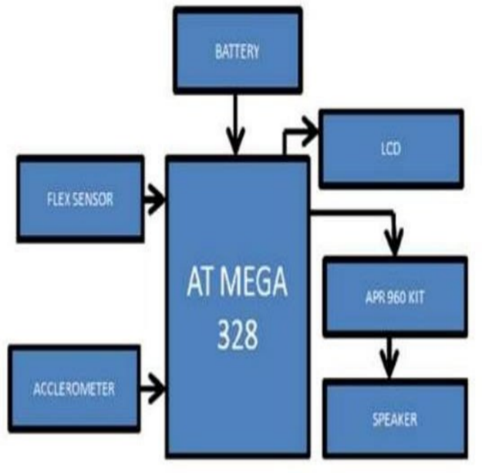

Fig. 3.1 Block diagram



1. **Working Principle:**

The development of a Sign Language to Speech Conversion System involves various stages. Initially, diverse sign language gestures are collected to train the system. Computer vision algorithms process video input, recognizing gestures through techniques like image segmentation and deep learning. Machine learning models, such as convolutional or recurrent neural networks, interpret and classify these gestures. Natural Language Processing (NLP) algorithms then convert recognized gestures into spoken language, considering syntactic and semantic analysis.

The user interface is designed to be intuitive and user-friendly, with real-time feedback for an enhanced experience. The system is made adaptable to different sign languages, addressing variations in signs and expressions across cultures. Accessibility features are implemented for users with varying motor skills and communication needs, possibly integrating with other assistive technologies.

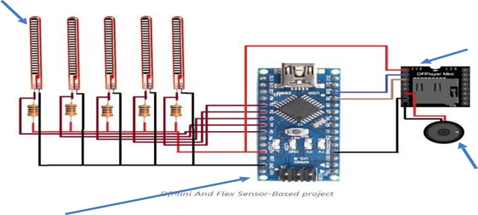

Continuous learning mechanisms and user feedback drive regular updates, improving accuracy, expanding sign language support, and addressing emerging challenges. Collaboration with linguists, sign language experts, and the Deaf community ensures cultural sensitivity and accuracy. Thorough testing evaluates the system's accuracy, speed, and usability in real-world scenarios, leading to iterative design improvements.

By using LM339 firstly a zero voltage reference is generated as follows. The inverting terminal ofthe comparator is connected to pulsating DC “P” and the non-inverting terminal is connected to the pure DC of amplitude lesser than the pulsating DC. Hence we get a zero voltage signal “Z” atthe output of comparator and it is inverted by an n-p-n transistor and fed to the inverting terminalof another comparator whose non-inverting terminal is being fed from level generator circuit. At the output of n-p-n transistor an electrolyte capacitor is connected which charges gradually and discharges rapidly, hence a saw tooth or ramp” R” is achieved



1. **Components**

Arduino Nano microcontroller

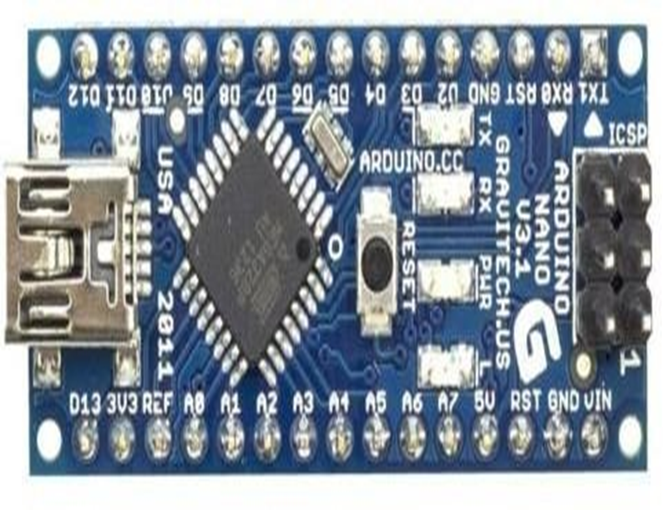

Arduino Nano microcontroller

Arduino Nano is a microcontroller board based on the ATMEGA328P. It has 14 digital input/output pins(of which 6 can be used as PWM output), 6 analog input, a 16 MHZ quarts crystal, a USB connection, a power jack, an ICSP header and a reset button. It contains everything needed to support the microcontroller, simply connect it to a computer with a USB cable or power it with a AC to DC adapter or battery to get started. Arduino Uno can be powered via USB connection or with an external power supply. Arduino IDE supports Windows, Mac OS X or Linux

Flex sensors

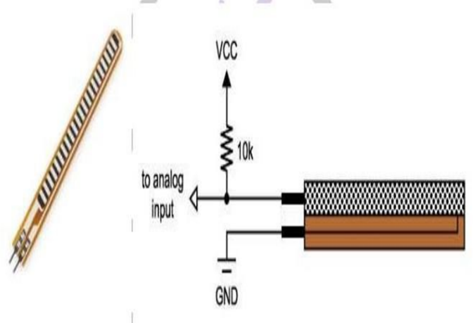

Fig No.4.2 Flex sensors



A Flex and Force sensor. This is a flexible sensor which changes its output when it is bent or when force is applied on it. This sensor has two output wires. The resistance between these two wires varies when the sensor is bent or when subjected to a force. Hence, this sensor can be used as a flex or force sensor. When the sensor is kept straight with no force acting on it, it has a resistance of around 10 K Ohms. When the sensor is bent in either way, or when force is applied on the sensor, the resistance between these two wires increases proportionally to the amount of bending. They convert the change in bend to electrical resistance - the more the bend, the more the resistance value. They are usually in the form of a thin strip from 1"-5" long that vary in resistance from approximately 10 to 50 K ohms

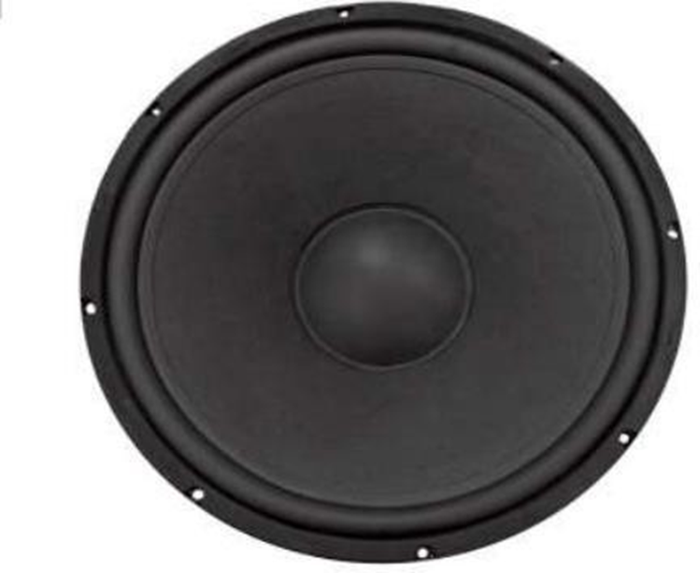

A loudspeaker (or loud-speaker or speaker) is a device which converts electrical signal into audio signal containing alternating current electrical audio signal is applied to its voice coil, a coil of wire suspended in a circular gap between the poles of a permanent magnet, the coil is forced to move rapidly back and forth due to Faraday's law of induction, which causes (usually conically shaped) attached to the coil to move back and forth, pushing on the air to create sound waves. Besides this most common method, there are several alternative technologies that can be used to convert an electrical signal into sound. The sound source (e.g., a sound recording or a microphone) must be amplified with an amplifier before the signal is sent to the speaker. Speaker or driver type (individual units only) – Full-range, woofer, tweeter, or mid-ran



4.3 Df Mini Player

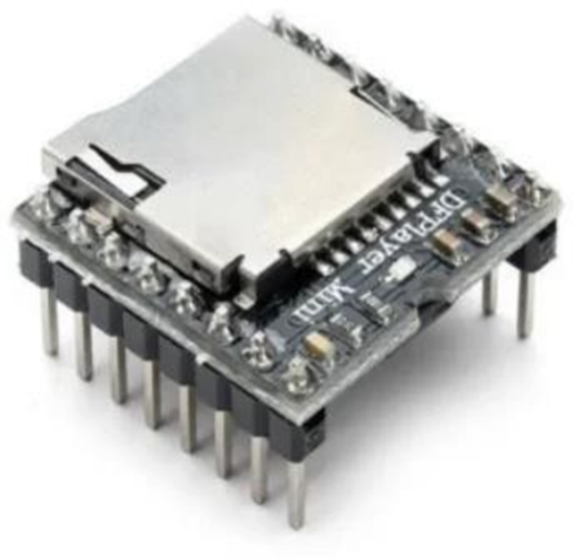

Fig. No. 4.4 Df Mini Player

(1) Df mini is Small Playback Music System, is Providing Alerts or Sounds When the MicroController gives the Command.

(2) You Just Save the MP3 File On SD Card And just put the DF Mini But which name or number do you put on the sd card same name or number Given To The Code

Working Image's

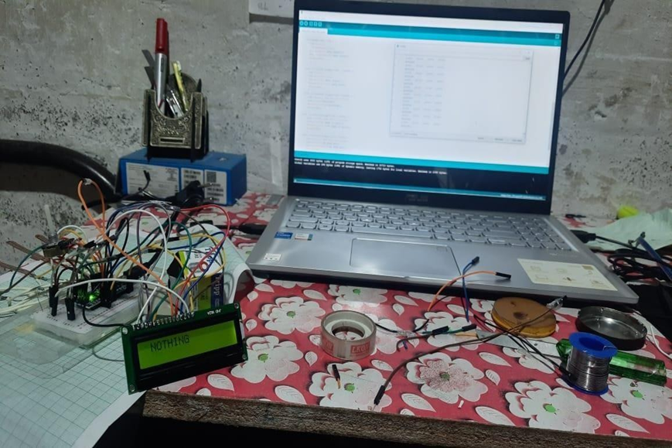

Fig. No. 4.5 Testing of display

• Fig shows the testing of LED screen by giving several signals



1. **Gesture**

Gesture 1:

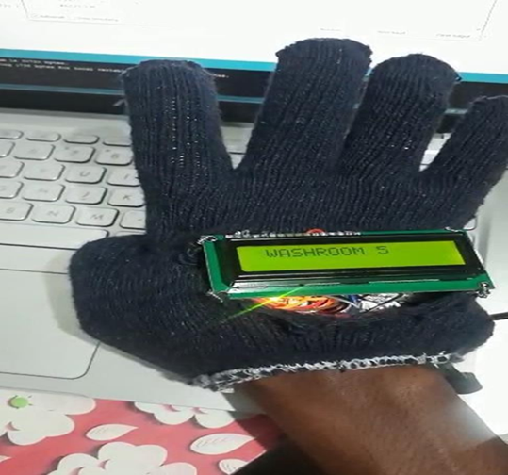

• Gesture 1 shows the sign of washroom

Gesture 2

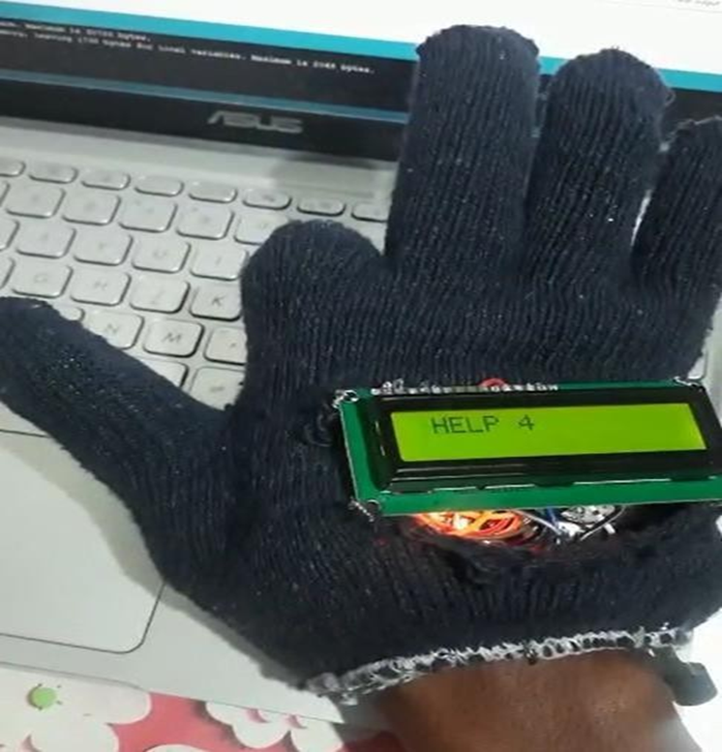

• Gesture 2 shows the sign of help





4.8 Gesture 3:

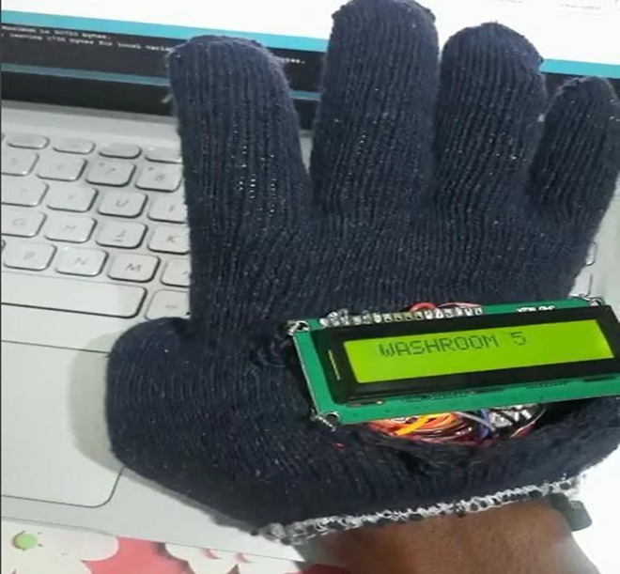

Fig. No. 4.8 Gesture 3 Gesture 3 shows the sign of washroom 2

4.9 Gesture 4:

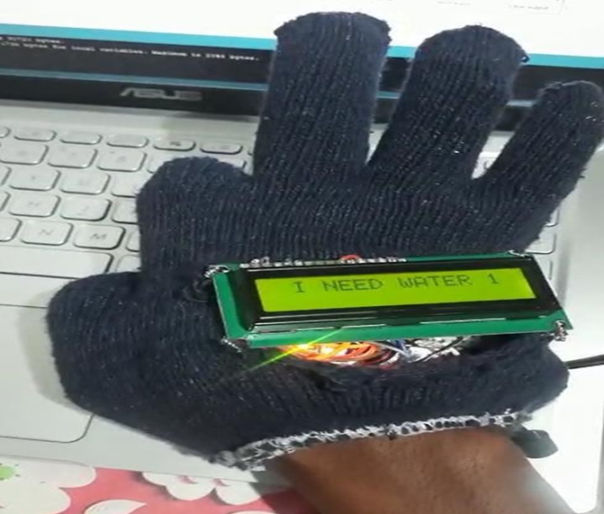

Fig. No. 4.9 Gesture 4

Gesture 4 shows the sign of need of water



**7.SUMMARY**

This will be the final chapter of the report. A brief report of the work carried out shall form the first part of the Chapter. Conclusions derived from the logical analysis presented in the Results and Discussions Chapter shall be presented and clearly enumerated, each point stated separately. Scope for future work should be stated lucidly in the last part of the chapter

**8.CONCLUSION**

The speech-to-text glove is a device that helps speech-impaired individuals communicate more easily by converting their hand gestures into speech or text output. It uses an Arduino Uno microcontroller, flex sensors, an accelerometer, and a gyroscopic sensor for interpretation, and is a more cost-effective and user- friendly approach than existing image-processing methods. Calibration using ASL ensures accuracy, and the device has the potential to significantly improve the quality of life for speech-impaired individuals. Further research and development in this area can lead to more inclusive and accessible communication for all

**9.REFERENCES**

[1] Srinivas Gutta, Jeffrey Huang, Ibrahim F. Imam,and Harry Wechsler, “Face and Hand Gesture Recognition Using Hybrid Classifiers”,ISBN:0-8186-7713-9/96, pp.164-169.

[2] Ata-Ur-Rehman, Salman Afghani, Muhammed Akmal and Raheel Yousaf, “Microcontroller And Sensors Based Gesture Vocalizer,” 7th WSEASInternational Conference on SIGNAL PROCESSING, ROBOTICS and AUTOMATION (ISPRA '08),University of Cambridge, UK, February 20-22, 2008

[3] Kunal Kadam, Rucha Ganu, Ankita Bhosekar, Prof. S. D. Joshi, “American Sign - Language Interpreter”, Proceedings of the 2012 IEEE Fourth InternationalConference on Technology for Education.

[4] R.L.R. Lokesh Babu , S. Gagana Priyanka , P.Pooja Pravallika , Ch. Prathyusha – “Gesture Vocalizer