**Design and Fabrication of Mars Rovers**

Rohan Chide, Prajakta Darekar, Prof Manas M Ramteke

Department of Electronics and Telecommunication Engineering,

Shri Sai College of Engineering and Technology Bhadrawati , Maharashtra, India

# 

# Abstract

Robots are currently playing a big role in our lives. There is different type of robots: wheeled robots, flying robots, factory building robots. The current way to control these robots are by using a keyboard, joystick, or pre-programmed commands.

The robotics and automation industry which is ruled the sectors from manufacturing to household entertainments. It is widely used because of its simplicity and ability to modify to meet changes of needs. The project is designed to develop a robotic vehicle using android application for remote operation attached with Bluetooth module. The Bluetooth technology is relatively new as compared to other technologies and there is huge potential of its growth and practical application. The application can be loaded on any device, can connect with security system and easy to use GUI. A robot can be controlled by a human operator, sometimes from a great distance. In such type of applications wireless communication is more important. This paper also shows general idea and design of the robot.

***Keywords****: Arduino UNO, Arduino IDE, Bluetooth Module, Li ion Battery, BMS*

# Introduction

We've projected this research work to provide simpler hardware architecture, but with powerful and concise computational platforms required to build the Robot. Our purpose on educational robotics is simple architecture so as to serve the students an elegant idea so that they can build their own robots at low cost and use them as a decent platform for experiments in several courses, also aid the robot’s designer to focus on their research instead of Bluetooth connection infrastructure. The following list shows the typical robot control architecture.

In today's fast pacing world more and more people are moving into smart phone technology. This is due to the various applications in the smart phones that allow users to control and automate stuff around them at the press of a button, reducing the time they spend on work they consider unproductive. The time catered for the entertainment of a child is also diminishing in this regard.

## Bluetooth Technology

Bluetooth wireless technology is a short-range radio technology, which is developed for Personal Area Network (PAN). Bluetooth is a standard developed by a group of electronics manufacturers that allows any sort of electronic equipment, from computers and cell phones to keyboards and headphones, to make its own connections, without wires, cables, or any direct action from a user. It is an ad hoc type of network operable over a small area such as a room. Bluetooth wireless technology makes it possible to transmit signals over short distances between telephones, computers and other devices and thereby simplify communication and synchronization between devices. It is a global standard that eliminates wires and cables between both stationary and mobile devices and facilitates both data and voice communication. Bluetooth offers the possibility of ad hoc networks and delivers the ultimate synchronicity between all your personal devices. Bluetooth is a dynamic standard where devices can automatically find each other, establish connections, and discover what they can do for each other on an ad hoc basis.

Bluetooth is intended to be a standard that works at two levels:

Bluetooth is a radio-frequency:

1. It provides agreement at the physical level standard.
2. It also provides agreement at the next level up, where products have to agree on when bits are sent, how many will be sent at a time and how the parties in a conversation can be sure that the message received is the same as the message sent.

It is conceived initially by Ericsson, before being adopted by a myriad of other companies,

Bluetooth is a standard for a small, cheap radio chip to be plugged into computers, printers, mobile phones, etc. A Bluetooth chip is designed to replace cables by taking the information normally carried by the cable and transmitting it at a special frequency to a receiver.

Bluetooth chip, which will then give the information received to the computer, phone Etc.

### Bluetooth topologies:

Bluetooth networks (commonly referred to as Piconets) use a master/slave model to control when and where devices can send data. In this model, a single master device can be connected to up to seven different slave devices as shown in Fig. 1. Any shave device in the Piconets can only be connected to a single master.

The master coordinates communication throughout the Piconets. It can send data to any of its slaves and request data from them as well. Slaves are only allowed to transmit to and receive from their master. They can't talk to other slaves in the Piconets.

**Flow Diagram**

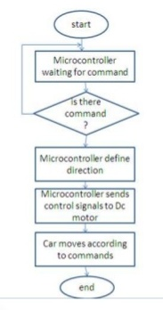

### 

### Major Components

### Arduino IDE

The Arduino Integrated Development Environment (IDE) is the main text editing program used for Arduino programming. It is where you’ll be typing up your code before uploading it to the board you want to program. Arduino code is referred to as sketches.



### Arduino UNO

The Arduino Uno is a microcontroller board based on the ATmega328.It has 14 digital input/output pins (of which 6 can be used as PWM outputs), 6 analog inputs, a 16 MHz ceramic resonator, a USB connection, a power jack, an ICSP header, and a reset button. Arduino board designs use a variety of microprocessors and controllers.

### HC 05 Bluetooth Module

HC-05 module (Fig4) is an easy-to-use Bluetooth SPP (Serial Port Protocol) module, designed for transparent wireless serial connection setup. The HC-05 Bluetooth Module can be used in a Master or Slave configuration, nuking it a great solution for wireless This serial port Bluetooth module is fully qualified Bluetooth V2.O+EDR (Enhanced Data Rate) 3Mbps Modulation with convoluted 2.4GHz radii) transceiver and baseband. It uses CSR Blue core 04-External single chip Bluetooth system with CMOS technology and with AFH (Adaptive Frequency Hopping Feature).

### 18650 Li-ion Batteries

An 18650 battery is a lithium-ion battery. The name derives from the battery’s specific measurements: 18mm x 65mm. For scale, that’s larger than an AA battery. The 18650 battery has a voltage of 3.6v and has between 2600mAh and 3500mAh (mili-amp-hours).

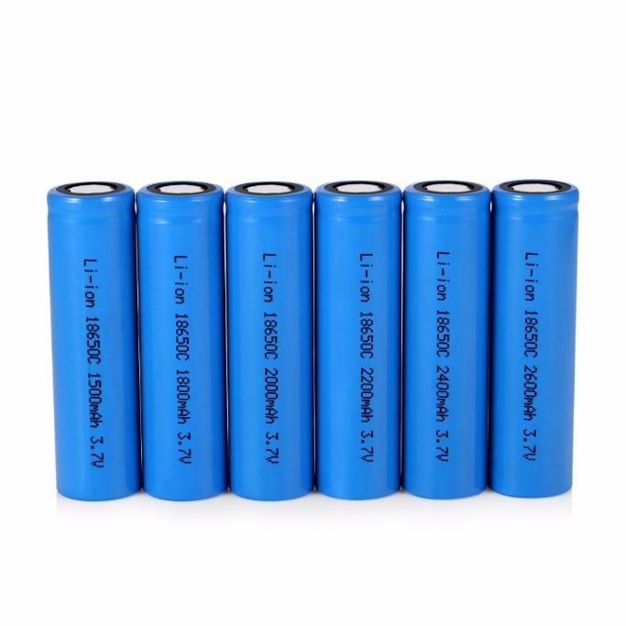

### 3S Li-ion Battery Charger

A LiPo cell has a nominal voltage of 3.7V. For the 7.4V battery above, that means that there are two cells in series (which means the voltage gets added together). This is sometimes why you will hear people talk about a "3S" battery pack - it means that there are 3 cells in Series. So, a two-cell (2S) pack is 7.4V, a three-cell (3S) pack is 11.1V, and so on.

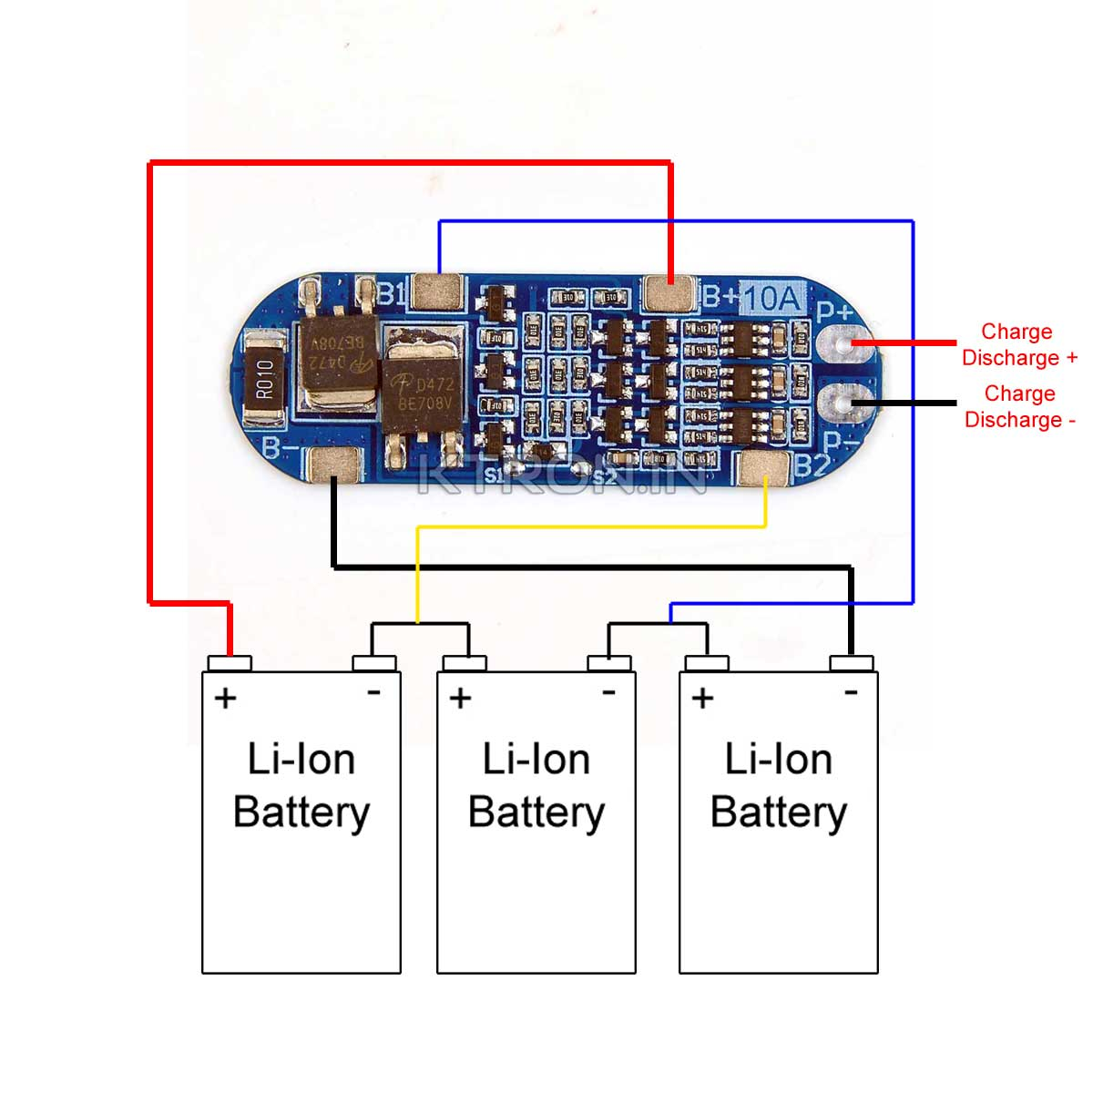

### Mobile app

We have used Arduino Bluetooth controller application .It provides a Nintendo joystick style interface which is highly convenient for controlling robot cars.

Similar projects that utilize Bluetooth as their communication Technology. The buttons can be assigned ASCII Characters that can be sent with the button pressed.

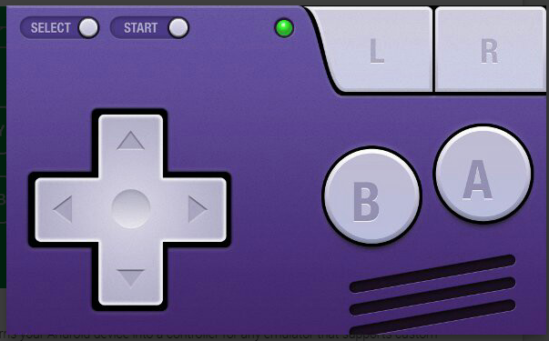

# Conclusion:

In conclusion, this project successfully achieved the design and development of a Bluetooth-controlled off-roading robot for applications in rough terrains such as mines and space exploration. The integration of an Arduino Uno microcontroller, HC-05 Bluetooth module, and a rover-type structure with six wheels enabled the robot to navigate challenging environments with enhanced stability and traction.

Through this project, we demonstrated the feasibility of remote-control using Bluetooth technology, allowing users to wirelessly operate the robot from a Bluetooth-enabled device. The robot showcased its capability to traverse rough terrains and adapt to various challenging surfaces, showcasing its potential for off-roading applications.

## Future Scope

This robot could include the integration of obstacle detection sensors, such as ultrasonic or infrared sensors, to enable autonomous navigation and obstacle avoidance. Additionally, modifications to withstand extreme environmental conditions, such as temperature and low visibility, could be explored to further enhance its utility in specific application.

# References

[1]. Jignesh Patolia, Haard Mehta, Hitesh Patel, Patel.V.T. “Arduino Controlled War Field Spy Robot Using Nightvision Camera And

[2] Android Application”. Department of Electronics And Communication of Engineering, Charotar University of Science And Technology, Changa, Anand, Gujarat - 388421,India.(2015)

[3]. Mohammad Shoeb Shah, Borole. P.B. “Surveillance And Rescue Robot Using Android Smart Phone And Internet”. International Conference on Communication And Signal Processing, India. (2016)

[4]. Manish Yadhav, Vibha Singh, Vinay Uniyal, Manish Singh. “Smart Aero Amphibian Surveillance System” Department of Electronics Engineering, Thakur College Of Engineering And Technology, Mumbai, India.(2016)

[5]. Chinmay Kulkarni, Suhas Grama, Pramod Gubbi Suresh, Chaitanya Krishna, Joseph Antony. “Surveillance Robot Using Arduino Microcontroller, Android Apis and Internet”. Department of Electronics And Communication Engineering, National Institute of Technology, Karnataka, Surathkal, Mangalore, India.(2014)

[6]. Dr. Shaik Mahaboob Basha, Abdul Khayyum. S.K, Amarendra.B, Sajid.S.K. “Design Of Security Robot in Night Vision Using Wireless Video Camera And Ultrasonic Sensor” Geethanjali Institute of Science And Technology, Nellore, Andhra Pradesh, India.(2017)

[7]. Shaik Shoeb Maroof Nasima, Ansari Asgar Ali Shamshul Haque Shakina. “Surveillance Robot Controlled Using An Android Application”. Department of Computer Engineering, School Of Engineering and Technology, Anjumaan-I- Islam’s Kalsekar Technical Campus, Mumbai, India. (2015)

[8]. m Merlin Ruby.K.M, Anne Jenefer.F, Vidhya.D. “Study of Arduino Controlled Robotic System” Department of Electronics and Communication Engineering, Panimalar Engineering College, Chennai, India. (2016)