**Does variability in Climate Elements affect Maize yield in Southwest Nigeria?**

**Ajiboye Abiodun ,**

**Department of Agricultural Economics and Extension Services Ekiti State University**

**PMB 5363, Ado Ekiti. Ekiti State, Nigeria**

**Corresponding Author:** [**abiodun.aj****iboye@eksu.edu.ng**](mailto:abiodun.ajiboye@eksu.edu.ng)

**Telephone: +2348030452320**

**Abstract**

If African climate change stake-holders, at any time succumb to a dearth of climate change adaptation and mitigation policies, the continent will finally bow low under the heavy weight of climate change hazards affecting the region. Comprehensive policies paramount to building adaptation and mitigation mechanisms must not quash. The aim of this paper is therefore, to investigate the effect of climate change elements on maize production in southwestern Nigerian from 1991 to 2022. We did an estimation of, a panel regression through the production function, using the FGLS ,fixed, and random effects models. Tests such as , the Chow, Hausman, Breusch-Pagan, and Wooldridge tests were performed in order to verify the statistical significance of the panel data model. The results from the three panel models showed that the coefficient of the Log of rainfall in the fixed and random effect models were not significant but very significant in the FGLS model at 5% level. The log of temperature was highly significant in all the three models, underscoring that crops could sometimes be less dependent on rainfall than on temperature at their stages of development

Key word: FGLS, Fixed Effects , Random Effects, southwest

**1.0 Introduction**

Agriculture remains an indispensable sector in most developing countries, where it is a major factor in the provision of food and a means of livelihood for the people. In Nigeria, agriculture has a share of more than 60 percent in the Nigeria’s labor force, It contributed 21.91%, 26.08% and 25.75% to the Gross Domestic Product (GDP) of Nigeria in 2019, 2020 and 2021 respectively (Doris 2022, Ajiboye *et al.,* 2021,). Ever since independence, the nation has been embattled with diverse economic hardships coupled with myriads of bottlenecks, nevertheless, agriculture has maintained its stand as the shock absorber of economic instabilities and sustainer of the people at various times (World Bank, 2024). The survival of some people

Is solely dependent on agriculture and its allies alone (Mojeed and Mukta 2021). Going by projection therefore, the world’s population is expected to grow to nearly 10 billion by 2050 and according to the UN Food and Agriculture Organization (FAO) 70 percent more food will be needed in 2050 than was produced in 2009, the year FAO made its calculation. Experts have identified four main developments that are putting pressure on agriculture to meet the demands of the future: demographics, scarcity of natural resources, climate change and food waste.  To this end, a very big responsibility lies ahead for all the stakeholders in the sector if success will be achieved. There is no gainsaying that agriculture remains an effective poverty reduction strategy especially in the rural sector (World Bank, 2024). Production from agriculture must intensify greatly if the projected bridging of the supply-demad gap will be attained at the set time (Daniel *et al.,* 2019).

One of the challenges undermining food production all over the worl is climate change and variabilities. Researches from many places in the world have demonstrates how climate variations can negatively impact crop productivity and food access (Daloz et al., 2021). Such alterations also provide a mechanism to assess the flexibility of means of support relied on for generations ( Gukurume, 2013). As populations expand, challenges from climate change in agriculture take on more determination (Serraj & Pingali, 2018). Developing nations disproportionately bear the brunt due to limited adaptive capabilities, hindering effective responses to climate risks and disasters ( Mekonnen et al., 2021). It is also not a new conclusion in research that farmers with small farm holdings are exposed to the greatest vulnerabilities and challenges arising from climate change and thus culminating in food insecurity. Therefore, Investment in climate change polices that is driven towards the inclusiveness of such disadvantaged farmers can result in robust agricultural adaptations and community resilience-building initiatives . This could help to safeguard livelihoods from disruptions, though successful implementation requires sustained international cooperation and financial support (Dumenu & Obeng, 2016).

One of the most important staple food globally and especially Africa is maize . Recent production figures have claimed that Nigeria is the second highest maize producing nation in Africa after South Africa (Mojeed and Muktar 2021). The production of maize is dominated by Ogun, Oyo and Ondo states in south western Nigeria (Makama et. al, 2022). In 2023, maize production in Nigeria is projected to reach 10,837,665 metric tons, indicating a 1% increase over 2022 production levels. The most significant production levels are expected in the Eastern and Central part of the country (Ndoye et al , 2023). This means that the southwest which receives more rains than the north needs to also brace up their productivity level. However, with the current over-bloating population of the country, production must move upward the frontiers against the backdrop of limitations faced by farmers.

Climate change can be made reference to as those changes relating to climate measures or variables over a prolonged period of time (Audu*et al.,* 2020). It is evident that Nigeria being an agrarian nation has started facing these ordeal of climate instabilities and varied ecological mayhem attributed to them (Ajiboye *et al.,* 2021). Diverse climate parameters have been studied including rainfall and temperature both on a long-term and short-term trends

In the face of the obvious rage of climate instabilities against food production studies, need to be intensified as one of the strategy to combat it. This paper depends on a panel data to amylase the effects of climate change on maize production in south west Nigeria. Globally, three main methods have been widely employed to analyze the impacts of climate change on agriculture, one of which is panel data analysis [Blanc and Reilly, 2017]. In panel data analysis, regional dummies are included in the model in order to overcome omitted.This approach has been widely applied in many researches, including those of Arnell et al. , Welch et al. 2010 , Sarker et al. 2014, and Mahrous 2019. The panel model most commonly applies two types of effect models, namely ﬁxed- and random-effects models. Most of the above-mentioned studies used the fixed-effects model because state or regional-speciﬁc characteristics can be included in this model. Similarly, the random-effects model does not require a correlation between unobserved time-invariant characteristics and the independent variables, while the ﬁxed-effects model eases this assumption [. Kabir, 2015].

Particularly, in Nigeria, few studies have employed panel data analysis to assess the impact of climate change on the platform of a geopolitical zoning viz a viz the southwest Nigeria, especially for maize crop. Therefore, this study speciﬁcally aimed at analysing the impact of climate characteristics on maize yield in south west Nigeria using the panel data model approach.

**2.0 Materials and Methods**

# 2.1. The Study Area

This research was be carried out in Southwest, Nigeria. The southwest Nigeria is made up of six states which are: Oyo, Osun, Ogun, Ondo, Ekiti and Lagos, collectively referred to as south-western geographical zone of Nigeria. The zone having its location between latitude 6° and 8° north of the Equation and 2° and 6° East of the Greenwich Meridian covers about 114, 271 square kilometer land area accounting for around 12% of the country’s total land area, respectively shares boundaries in the north with kwara and Kogi States, in the South with Gulf of guinea, in the west with Republic of Benin and in the East with Edo and Delta states.

The climate in Southwest Nigeria is tropical, characterized by two distinct seasons: the rainy season (March - October) and the dry season (November - February). The dry season is marked by the harmattan dust, where cold dry winds from the northern deserts blow into the southern region. Temperature fluctuations range between 21°C and 34°C, while annual rainfall varies from 1500mm to 3000mm (Falade, 2016). During the dry season, there is high temperature, while the rainy season (November to March) experiences heavy rainfall. The wet season is influenced by the Southwest monsoon wind from the Atlantic Ocean, whereas the dry season is associated with the Northeast trade wind originating from the Sahara desert (Otitoju and Enete, 2014).

The region features fertile soils conducive to agricultural production. Common livelihoods among the people of Southwest Nigeria include farming, hunting, and fishing, produce buying, sports, butchering and meat selling, crafts, and trading. Agriculture is a major source of income and employment for approximately 75% of the population, encompassing both food and cash crop cultivation. Food crops cultivated in the area include rice, yam, cassava, maize, cocoyam, and cowpea, while cash crops comprise cocoa, oil palm, kolanut, plantain, banana, cashew, citrus fruits, and timber (Sakiru, 2013).

The crops grown are: tree crops like cocoa, kola coffee, oil palm, rubber, root crops like cassava, yam, potato; cereal crops like maize, rice, sorghum; legumes like melon, cowpea, soybean; fruit and leafy vegetables. The major food crops grown in the study area are maize, yam, cassava, cocoyam, melon. Common livestock are sheep and goats, cattle, pigs, rabbits, poultry. Aquatic species reared are fishes among others. In terms of transportation, the states are connected by roads, rail and air.

**2.2 Data**

This study used panel data sets in the analysis, in order to estimate the effect of climate parameters on maize yields. Panel data, sometimes referred to as longitudinal data, is data that contains observations about different cross sections across time. Like time series data, panel data contains observations collected at a regular frequency, chronologically. Like cross-sectional data, panel data contains observations across a collection of individuals .panel data generally use regression techniques by way of a production function approach . Data from different states (i.e., output and cultivated area) were sourced from National Bureau of Statistics (NBS) while climate data were provided by the Nigerian Meteorological Station (NIMET). State-based data on output and land area and the weather variables were all seasonal .The empirical analysis was based on panel data involving all the six states in the zone from 1991 to 2022. To avoid the possiblility of conducting spurious correlation between variables, unit root tests (i.e., Fisher-ADF) was conducted on the variables

**2.3. Model Specification**

We applied The least-squares dummy variable (LSDV) model in this study. The LSDV model allows for heterogeneity among the cross-section by allowing each entity to have an intercept value. The model is defined as:

where N is the number of cross-sections, T is the period, K is the number of independent variables, and yit and xk,it are the dependent and independent observations, respectively, for the ith individual and tth period. Moreover, _i and _k are parameters of interest that measure the impact of the dependent variable, while Di is the dummy variable (value equals 1 when the observation relates to state i, and 0 otherwise) and "it the error term.



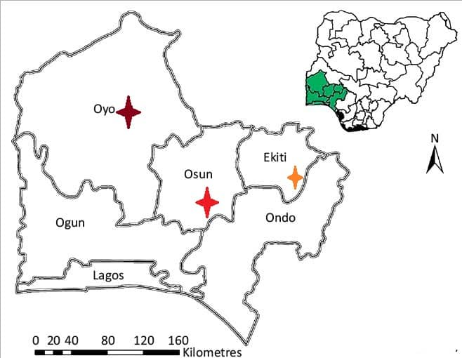

**Figure 1: Map of Southwest, Nigeria showing the study area**

**Source:** [**https://t2.gstatic.com/images**](https://t2.gstatic.com/images)

**3.0 Results and Discussion**

**3.1 Descriptive Statistics**

Table1 presents the descriptive statistics of the six states. The state with highest mean yield is Ondo while the lowest was Osun with 4.0 ton/ha and 2.0 ton/ha respectively. Minimum and maximum temperatures were respectively 23°C and 31°C for all the states except a slight difference of -1°C minimum temperature recorded for Osun State, the maximum average precipitation is 1576mm which was recorded in Lagos State while the minimum was in Ekiti State and the value was 900 mm the same values of 17°C and 27°C for Growing degree day and Average temperature were recorded for all the states except for Ekiti with 18°C and 28°C for Growing degree day and Average temperature respectively. Figures 1-3 also presented a graphical illustration of the maize yield , average daily temperature and rainfall from 1991-2022. The implication of the above is that the weather pattern was the same on the average across the years but the different values of the yield speaks volume about the productive capacities of the respective states.

|  |  |  |  |  |  |  |  |
| --- | --- | --- | --- | --- | --- | --- | --- |
| Variable | | Mean | Std. Dev. | Min | Pctl. 25 | Pctl. 75 | Max |
| Ekiti State | | | | | | | |
| Yield | | 2.8 | 0.94 | 1.8 | 2 | 3.6 | 4.5 |
| Minimum temperature | | 23 | 0.95 | 20 | 23 | 23 | 24 |
| Maximum temperature | | 33 | 1.8 | 31 | 32 | 34 | 38 |
| Precipitation | | 900 | 362 | 397 | 630 | 1135 | 2077 |
| Growing degree day | | 18 | 0.81 | 17 | 17 | 18 | 20 |
| Average temperature | | 28 | 0.81 | 27 | 27 | 28 | 30 |
|  |  |  |  |  |  |  |  |
| Lagos State | | | | | | | |
| Yield | | 2.5 | 0.42 | 1.5 | 2.2 | 2.7 | 3.4 |
| Minimum temperature | | 23 | 0.84 | 22 | 23 | 24 | 25 |
| Maximum temperature | | 31 | 1.7 | 28 | 31 | 33 | 34 |
| Precipitation | | 1576 | 305 | 913 | 1446 | 1742 | 2267 |
| Growing degree day | | 17 | 0.66 | 16 | 17 | 18 | 19 |
| Average temperature | | 27 | 0.66 | 26 | 27 | 28 | 29 |
| Ogun State | | | | | | | |
| Yield | | 3.5 | 2.2 | 1.4 | 1.4 | 4.9 | 8.1 |
| Minimum temperature | | 23 | 1 | 22 | 22 | 23 | 25 |
| Maximum temperature | | 31 | 1.2 | 28 | 30 | 32 | 34 |
| Precipitation | | 1002 | 610 | 261 | 479 | 1292 | 2934 |
| Growing degree day | | 17 | 0.5 | 16 | 17 | 17 | 18 |
| Average temperature | | 27 | 0.5 | 26 | 27 | 27 | 28 |
|  |  |  |  |  |  |  |  |
| Ondo State | | | | | | | |
| Yield | | 4.2 | 2.5 | 1.7 | 1.9 | 6.2 | 9.3 |
| Minimum temperature | | 23 | 0.68 | 21 | 22 | 23 | 24 |
| Maximum temperature | | 31 | 1.7 | 27 | 31 | 32 | 34 |
| Precipitation | | 1110 | 624 | 266 | 611 | 1666 | 2342 |
| Growing degree day | | 17 | 1.1 | 14 | 17 | 17 | 19 |
| Average temperature | | 27 | 1.1 | 24 | 27 | 27 | 29 |
|  |  |  |  |  |  |  |  |
| Osun State | | | | | | | |
| Yield | | 2 | 0.54 | 1.4 | 1.6 | 2.3 | 3.8 |
| Minimum temperature | | 22 | 0.9 | 20 | 22 | 23 | 24 |
| Maximum temperature | | 31 | 1.4 | 28 | 30 | 32 | 33 |
| Precipitation | | 1258 | 397 | 670 | 1056 | 1639 | 2090 |
| Growing degree day | | 17 | 1.1 | 14 | 16 | 17 | 18 |
| Average temperature | | 27 | 1.1 | 24 | 26 | 27 | 28 |
|  |  |  |  |  |  |  |  |
| Oyo State | | | | | | | |
| Yield | | 3.4 | 2.1 | 1.3 | 1.5 | 5.1 | 7.2 |
| Minimum temperature | | 23 | 0.5 | 21 | 22 | 23 | 24 |
| Maximum temperature | | 31 | 1.3 | 27 | 30 | 31 | 32 |
| Precipitation | | 1145 | 228 | 514 | 1030 | 1189 | 1668 |
| Growing degree day | | 17 | 0.78 | 15 | 16 | 17 | 18 |
| Average temperature | | 27 | 0.78 | 25 | 26 | 27 | 28 |

**Table 1: Descriptive Statistics of variables for the six States.**

**Source : Author’s computation**

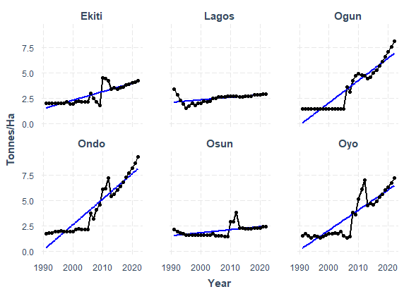

**Figure 1: Maize Yield in Southwestern Nigeria: 1991-2022**

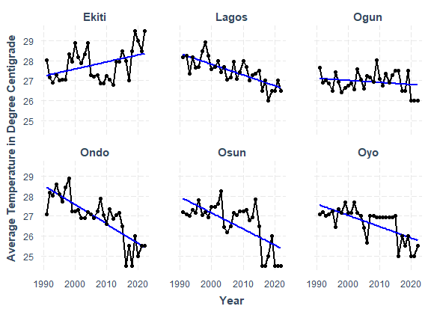

**Figure 2: Average Daily Temperature in Southwestern Nigeria: 1991-2022**

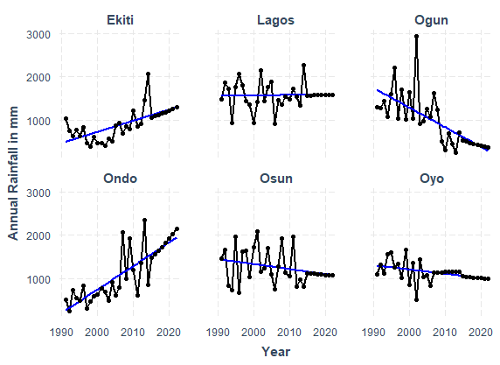

**Figure 3: Annual Rainfall in Southwestern Nigeria in Milimeter**

**3.2 Diagnostic tests**

The Breusch-Pagan test was used to assess the presence of heteroscedasticity. As shown in Table 2, the result of the panel test had a p-value of 0.000, which was highly statistically significant and indicated that the null hypothesis of homoscedasticity should be rejected and that heteroscedasticity was not discovered in the panel data model. Also the Wooldridge test was applied to identify the presence of a first-order autocorrelation. In Table 2, the result shows that data set is devoid of autocorrelation by a significance pvalue of 0.000. Consequently, the null hypothesis of no presence of autocorrelation was rejected. Of the three models, the FGLS exhibited highest statistical dependence due to the significance of the both climate variables, the R square value and that of the F statistics

|  |  |  |
| --- | --- | --- |
| Type of Test | Statistics | P-value |
| Chow | 15.368 | 0.000 |
| Hausman | 2.208 | 0.332 |
| Breuch-Pagan | 6.626 | 0.000 |
| Wald and Wooldridge | 155.220 | 0.000 |
|  |  |  |

**Table 2: Econometric Test for the Choice of Panel Data Model**

**The regression results**

Table 3 shows the result of the effect of climate variables on maize yield from the three models

The coefficient of the Log of rainfall in the fixed and random effect models were not significant but very significant in the FGLS model at 5% level. The log of temperature was highly significant in all the three models. The results implied that both whether variables are very important in determining rise yield but it also underscored the prevalence of one over the other at the seasonal level of planting up to the harvest period. Temperature had a more pronounced negative impact on maize yield based on the models result. In the FGLS regression result, a negative correlation is observed when calculating yield in relation to temperature and rainfall. By increasing the rainfall by 1%, the impact on maize production will be − 0.07 %. Likewise, by increasing temperature by 1%, the increase in maize production will be -3.72 %. The negative signs of both temperature and rainfall meant that a higher temperature and rainfall respectively resulted in a lower maize production performance. Although water is very important at every level of crop development, but most of the times the residual soil moisture can serve as a proxy for rain in periods of intermittent droughts hence making crop to be less dependent on rainfall than on temperature. Though both variables work hand in hand and as expected, should have cumulative effects on maize yield, higher temperatures at even very short periods can cause a permanent crop wilting, sterility and hence yield loss.

|  |  |  |  |
| --- | --- | --- | --- |
|  | | |  |
|  | *Dependent variable:* | |  |
|  |  | |  |
|  | log(Yield) | |  |
|  | (Fixed Effect) | (Random Effect) | (FGLS) |
|  | | |  |
| Log(Rainfall) | -0.066 | -0.078 | -0.0680** |
|  | (0.081) | (0.079) | (0.0283) |
|  |  |  |  |
| Log(Temperature) | -5.742*** | -5.533*** | -3.724*** |
|  | (1.069) | (1.052) | (0.746) |
|  |  |  |  |
| Constant |  | 19.761*** |  |
|  |  | (3.596) |  |
| State FE | YES | NO | YES |
|  | | |  |
| Observations | 192 | 192 | 192 |
| R2 | 0.135 | 0.128 | 0.230 |
| Adjusted R2 | 0.103 | 0.119 | 0.223 |
| F Statistic | 14.416*** (df = 2; 184) | 27.710*** | 33.551*** |
|  | | |  |
| *Note:* | *p**p***p<0.01 | |  |

**Table 3: Results from the three models showing the effect of climate variables on maize yield**

**4.0 Conclusion**

This study examined the impact of climate change on maize yield using a panel approach based on the LSDV model with FGLS, fixed and random effects and using data from 1991 to 2022 on the six states of south west Nigeria . Variabilities in climatic patterns would rigorously impact the southwestern Nigerian maize production. Thus, investigations relating to the impact of climate change on maize yield are important because maize is a very essential staple food for Nigerians and even a major ingredient of animal feeds. The basic findings show that climate variables significantly affect maize yield. Remarkably, while rainfall shows a negative impact on maize yield in all the three models, it was only significant in the FGLS. The impact of temperature was also negative but significant in all the three models. The inverse effect of precipitation on maize yield also, is quite noteworthy since maize cultivation is mainly rain-fed in the rain forest zones of Nigeria in which south west belong, increased precipitation would lead to flooding, which usually occurs during this season and would result in lots of crop losses. The impact of temperature is more pronounced than that of rainfall on maize yield. Since, naturally there is a proxy for rain but none for temperature the latter seemed to rank higher in preference than the former in maize production in the study area.

References

Ajiboye A., Aturamu O. A., Amao S.A. and Farayola C. O (2021): Yield response of Nigerian rice agriculture (1970-2017): Journal of Science and Agricultural Practice. 6 (3):98-104 (Nigeria

Arnell, N.W.; Lowe, J.A.; Challinor, A.J.; Osborn, T.J. Global and regional impacts of climate change at different levels of global temperature increase. Clim. Chang. 2019, 155, 377–391.

Blanc, E.; Reilly, J. Approaches to Assessing Climate Change Impacts on Agriculture: An Overview of the Debate. Rev. Environ. Econ. Policy 2017, 11, 247–257.

Daloz et al., (2021) Direct and indirect impacts of climate change on wheat yield in the Indo-Gangetic plain in IndiaFebruary 2021 [Journal of Agriculture and Food Research](https://www.researchgate.net/journal/Journal-of-Agriculture-and-Food-Research-2666-1543?_tp=eyJjb250ZXh0Ijp7ImZpcnN0UGFnZSI6InB1YmxpY2F0aW9uIiwicGFnZSI6InB1YmxpY2F0aW9uIn19) 4(9):100132 DOI:[10.1016/j.jafr.2021.100132](http://dx.doi.org/10.1016/j.jafr.2021.100132)

Dumenu, W.K. and Obeng, E.A. (2016): Climate Change and Rural Communities in Ghana: Social Vulnerability, Impacts, Adaptations and Policy Implications. Environmental Science and Policy, 55, 208-217. <https://doi.org/10.1016/j.envsci.2015.10.010>

Gukurume, S. (2013) Climate Change, Variability and Sustainable Agriculture in Zimbabwe’s Rural Communities. Russian Journal of Agricultural and Socio-Economic Sciences, 2, 89-100.

Guntukula, R. (2019). Assessing the impact of climate change on Indian agriculture: Evidence from major crop yields. *Journal of Public Affairs*, *20*(1). <https://doi.org/10.1002/pa.2040>

Kabir, M.H. Impacts of Climate Change on Rice Yield and Variability: An Analysis of Disaggregate Level in the Southwestern part of Bangladesh especially Jessore and Sathkhira Districts. J. Geogr. Nat. Disast. 2015, 5, 148.

Mahrous, W. Climate Change and Food Security in E.A.C. Region: A Panel Data Analysis. Rev. Econ. Pol. Sci. 2019, 4, 270–284.

Makama S.A ,. Umar S.M , Isah M.A. , Sadiq M.S. and Magaji B.D. (2022) : Socioeconomic Factors Influencing Maize Production In Giwa Local Government Area Of Kaduna State, Nigeria. Journal of Agriculture and Environment Vol. 18 No. 2, 2022: 135-139 ISSN: 1595-465X (Print) 2695-236X (Online)

Mojeed A. and F. Muktar, "Special Report: How Nigeria’s Maize Production has grown since 1960," 2021. [Online]. Available: <https://www.premiumtimesng.com/news/headlines/435678-special-rrport-how-nigerias-maize-production-has-grown-since-1960.html>.

Ndoye, A., M. Dia, and K. Dia. 2023. AAgWa Crop Production Forecasts Brief Series: Nigeria – Maize. AAgWa Crop Production Forecasts Brief Series, No. 31. Kigali, Rwanda: AKADEMIYA2063. <https://doi.org/10.54067/acpf.31>

Sarker, M.A.R.; Alam, K.; Gow, J. Assessing the Effects of Climate Change on Rice Yields: An Econometric Investigation Using Bangladeshi Panel Data. Econ. Anal. Policy 2014, 44, 405–416.

[The Opec Fund For International Development](https://opecfund.org/) (2024): How to Feed 10 Billion People Only a revolution can save us. <https://opecfund.org/news/how-to-feed-10-billion-people>

Welch, J.R.; Vincent, J.R.; Auffhammer, M.; Moya, P.F.; Dobermann, A.; Dawe, D. Rice Yields in Tropical/Subtropical Asia Exhibit Large but Opposing Sensitivities to Minimum and Maximum Temperatures. Proc. Natl. Acad. Sci. USA 2010, 107, 14562–14567.

World Bank (2024): Agriculture and Food

<https://www.worldbank.org/en/topic/agriculture/overview>