**AN ANALYTICAL STUDY ON CONCRETE DEMOLITION WASTES WITH AN EXPERIMENTAL INVESTIGATION ON THEIR POSSIBLE APPLICATIONS IN STRUCTURES**

**ARSALAN KHAN1, MR. BHUPENDER MALIK2**

**1** M.Tech Scholar,Ganga Institute Of Technology & Management Kablana Jhajjar,India

2 Assistant Professor, Ganga Institute Of Technology & Management Kablana Jhajjar,India

## **ABSTRACT**

Concrete demolition trash poses a substantial environmental problem because of the large amount of development and demolition operations taking place globally. This study aims to analyse the properties, management, and possibility for reusing concrete demolition wastes (CDW) in new structural components. The research includes both an extensive literature review and an experimental investigation.

The study initially investigates the characteristics of CDW, such as its composition, particle size distribution, and degrees of contamination. The article examines different approaches to handle and reuse construction and demolition waste (CDW), with a particular focus on cutting-edge techniques such as crushing, screening, and treatment procedures that improve the overall quality of recycled concrete aggregates (RCA).

The experimental step entails integrating RCA into novel concrete mixtures to assess their efficacy in structural applications. Essential properties including compressive strength, tensile strength, and durability are examined and contrasted with standard concrete. The study also investigates the influence of varying quantities of recycled concrete aggregate (RCA) on the workability and mechanical qualities of the concrete. Furthermore, an evaluation is conducted to determine the practicality of utilising RCA in non-structural uses, such as road base material and environmentally sustainable construction goods.

The results indicate that by employing suitable processing techniques, CDW can be efficiently utilised in structural applications, hence promoting resource conservation and waste reduction. The research findings indicate that RCA can meet acceptable performance criteria, making it a feasible substitute for natural aggregates in some construction situations. The study's findings seek to advance sustainable construction practices and provide policymakers and industry stakeholders with information regarding the advantages and constraints of utilisingrecycled concrete demolitionwastes in construction.

This study adds to the expanding pool of information on sustainable construction materials and provides practical suggestions for the efficient repurposing of construction and demolition waste (CDW) in the field of structural engineering.

**Key Words:** Demolition waste, Concrete Recycling, Sustainability, Waste management, Construction materials

# INTRODUCTION

In countries with rapid economic growth, the building sector is viewed as essential for nation’s development. This sector of economy is deemed to be most stable due to constant influx of investment. To meet this enormous requisite for aggregates, substantial illicit quarrying is done, which depletes the aggregate’s natural reserve and is also damaging to the environment. The excessive production of Construction and Demolition Waste (C&D) waste from building deconstruction is an additional effect of the construction industry that exacerbates the worldwide waste problem. Frequent components of C&D trash include sand and gravel, dirt, metal, concrete, bricks and masonry. Recycling C&D trash is essential for lowering carbon footprint and waste output, as it contributes more to the overall waste dilemma than municipal waste. However, due to a lack of reliable data, The global production of C&D trash is significantly underestimated. Reused Concrete Aggregates (RCA) and Reused Aggregate Concrete (RAC) manufactured from C&D waste are required sources of additional construction materials for the manufacturing of "green concrete". The majority of variances in RCA's mechanical and physical qualities are governed by the amount and quality of "adhered mortar".

In contrast to control mix (CM) (concrete with standard components), the workability of RAC reduces when coarse natural aggregate (CNA) and Fine Natural Aggregates (FNA) are substituted by Fine Reused Concrete Aggregates (FRCA) and Coarse Reused Concrete Aggregates (CRCA) respectively. Because attached mortar makes RCA more porous, less dense, and more water-absorbent, this is the case. However, using high-range water reducer or other method can effectively limit the effectiveness of RAC, and RCA can be pre-soaked in water (prior to combining) to help initiate the internal curative process.

The quantity of mortar that adheres is inversely related to the RCA's size, so the larger the RCA, the less mortar will attach. This explains why the relative quality decline of FRCA is greater than that of CRCA. Studies showed that there was a drop of 5.4% in strength when CNA is replaced by CRCA, a drop of ten percent, as FNA is replaced with FRCA, whereas when both FNA and CNA are replaced by RCA, a drop of 15% was reported. These values further reduced to 3.4%, 8.1% and 13.5% respectively, as the curative period was extended to 56 days. RCA indicated presence of unhydrated cement particles which were responsible for strength at older ages. Moreover, due to its multiphase nature, it is challenging to produce RCA in the correct form and dimension.

Previously, several attempts were made to cure RCA, thus reducing the detrimental effects caused by layer of adhered mortar. In these some successful methods were “mechanical and chemical treatment treating of RCA with chemicals” prior to its usage, use of cementitious materials’ slurry” for strengthening of adherent mortar, increasing cement content, etc.

Hanaa Khaleel et al. compared many CRCA enhancing approaches through study. Researchers discovered that treating CRCA with moderate – acid was advantageous. In addition, moderate acid mitigates the results of acid assaults on the surface of the CRCA more effectively than strong acids . Further it was found out that combination of thermal heating (3500C) along with short mechanical treatment performed best and helped in lowering the water absorption by 27.4%.

According to Wang et al. treatment of CRCA by soaking in mild acid prior to mechanical abrasion gives optimum strength of RCA. In a second study, CRCA was submerged in sodium silicate solution (10%) followed by coating it with micro-silica, resulting in an improved transition zone of RAC which ultimaltely elevations its early strength .

# OBJECTIVES

The primary aspirations of the project are:

* + - To compare the characteristics of CNA, FNA, CRCA, FRCA.
    - To analyse the change in attributes of CRCA upon treatment with mild acid.
    - To do a Mix design conforming to M25 grade as control mix.
    - Partially replacing both CRCA and FRCA in CM such that the total aggregates replaced remains constant and equal to 20%.
    - Testing RAC for Fresh (workability, unit weight), Mechanical (Compressive, Flexural) and Durability (Water penetration test, water permeability test) characteristics.
    - Provide a simple economic study on different samples obtained.

# LITERATURE REVIEW

The present chapter involves the detailed literature study done to understand in depth about the incorporation of CRCA and FRCA in concrete. Researchers found out that CRCA can be incorporated in concrete production when subjected to mild acid treatment along with brief mechanical treatments. Other studies showed that the use of RCA in RAC production has been found to be successful to a large extent showing minor loss of strength (compared to CM), which can further be improved upon increasing w/c ratio and improved curative ages. A detailed literature review of several researches has been summarized below :

P. Pereira (2012) showed that when CNA is replaced by CRCA, compressive strength dropped by 5.4%, by 10% when NFA is replaced with FDCA, and by 15% when both NFA and NCA are replaced by RCA. These values further reduced to 3.4%, 8.1% and 13.5% respectively, when the curative period was extended to 56 days. The results obtained are clear indicator that the unreacted cement molecules in RCA bestowed to its strength at older ages.

Berredjem et al (2020) found that the mechanism of both stiffened concretes are essentially similar, despite the fact that replacing hundred percent of the naturally occurring aggregate with RCA reduces the strength of RAC. Previously, several attempts were made to cure RCA, thus reducing the detrimental effects caused by layer of adhered mortar. In these some successful methods were mechanical and chemical treatment treating of RCA with chemicals” prior to its usage, use of cementitious materials slurry for strengthening of adherent mortar, increasing cement content, etc.

Hanaa Khaleel et al. (2016) compared many CRCA enhancing approaches through study. According to research, treatment of CRCA with moderate – acid was advantageous. In addition, moderate acid mitigates the results of acid assaults on the surface of the CRCA more effectively than strong acids.

Thermal heating (3500 C) in amalgamation with brief mechanical treatment performed best and helped in lowering the water absorption by 27.4%.

Wang et al. (2017) showed that prior to mechanical abrasion, immersion of CRCA in acetic acid, produces RAC that is more durable than CM.

Bui et al. (2018) submerged CRCA in a ten percent sodium silicate suspension and then covered it with micro-silica. The integrated action of both microscopic- silica & sodium silicate showed an improved transition zone of CRCA integrated concrete which ultimately elevations its early age strength [12].

H. Donza et al. (2002) in an independent research found out that FRCA addition in CM, reduced concretes’ compressive strength predominantly as greater amount of water was required to achieve same degree of wrokability, similar to CM. The elevation of strength in compression is attributable to the Infill effect, asymmetrical exterior appearance, internal curative outcome, and angular form of FRCA.

How-JiChen et al. (2003) found out that as the w/c ratio enhanced, the strength of RAC became similar to that of CM. The utilisation of unclean reused material in concrete will diminish its strength. Reused concrete's modulus of elasticity was approximately 70 percent of that of conventional concrete.

Susan L.Tigheet al. (2016) studied several techniques for improving the salient features of CRCA were investigated. The study concluded that mild acid is extra effective and safer than aggressive acid and is hence preferred (better than Heat Treatment method).

SallehanIsmail et al. (2013) did a Comparative study on Concrete made with Untreated & Treated Reused Aggregate. Experiments demonstrated that the application of acid with a low concentration was effective in removing loosely adherent mortar from RCA surfaces. The acid's molarity has a important consequence on the quantity of mortar loss. Using treated RCA generated concrete with greater compressive strength than untreated RCA.

Limbachiya et al. (2003) studied high strength concrete made with RCAIt was found that there was no effect on concrete strength in replacement up to 30%, however the strength started to reduce on account of further addition of RCA.

Miren Etxeberria et al (2016) in their research Considered four unique reused aggregate concretes consisting of zero percent, twenty five percent, fifty percent and hundred percent RAC, respectively. The compressive strength of concrete including reused coarse particles at 100 percent is 20 to 25 percent lower than that of CM. Due t non-uniformity of quality control in RCA, the RAC showed a standard deviation of 50% in compressive strengths of RAC compared to CM.

B.M.Vinay Kumar et al. (2018) worked on Concrete mix prepared for strength of grade sixty. Study showed that as FRCA content elevationd, higher superplasticizer amount was required to achieve same workability. Strength of 20% Fine-RCA mix was found to be 1.18 times the control concrete

whereas the strength of 20% Coarse-RCA mix was 0.98 times the control concrete. The Demolished waste incorporated concrete provided satisfactory performance against sulphate attack but a significant loss in strength was reported on exposure to H2SO4.

Rahul Singh et al. (2022) found out that M30 concrete can be made by 100% RCA and 30% RFA or combination of both. Concrete characteristics are influenced more by age of curing than density of RCA. RCA influences permeability of concrete mostly.

# METHODOLOGY

* 1. **Material Characteristics**

This experimental study required various raw materials, natural or artificial in order to suffice for the experimental work, which is casting of specimens for further testing.

* + 1. **Cement**

Conforming to standard IS 8112 OPC Grade 43 was utilized. The chemical and physical attributes of cement are illustrated in table 4.1, whereas crystallographic state is shown by X-ray diffractogram in fig. 4.1 respectively.

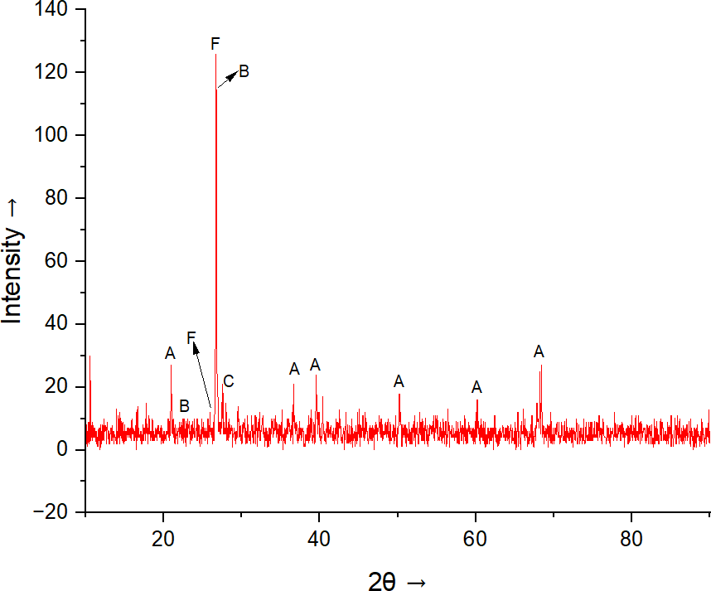

Fig 4.1. X-ray diffractogram of OPC (C-Celite, B-Belite, A-Alite, F- Ferrite)

* + 1. **Natural Aggregates**

CNA were manufactured from 10 mm and 20 mm pulverized dolomite, while FNA were acquired from a local business in the vicinity of DTU campus. FNA and CNA both satisfy the requirements of standard IS 383.

**Table 4.1 Characteristics of Cement**

|  |  |  |  |
| --- | --- | --- | --- |
| Chemical Attributes | | Physical Attributes | |
| Compound | %  Quantity | Characteristics | Recorded Value (as per IS- 8112:1989) |
| (Lime) CaO | 64.32 | Fineness | 7.6 % (<10) |
| (Silica) SiO2 | 21.54 | Consistency | 34 % (25-35) |
| (Alumina) Al2O3 | 4.78 | Initial setting time | 130min (>30Min) |
| (Iron Oxide) Fe2O3 | 4.52 | Final setting time | 450min (<600Min) |
| (Sulfur) SO3 | 1.73 | Compressive Strength | 49MPa |
| (Magnesium) MgO | 0.45 |  | |
| (Chloride) Cl | 0.12 |
| (Potassium) K2O | 0.52 |

* + 1. **Reused Concrete Aggregates**

East Delhi MCD C&D plant provided us with the RCA required for this study. The location of the aforementioned facility is depicted in Figure 4.2. The RCA waste consisted of Demolished Building Rubble that was pulverized and separated into 10mm Fine Aggregate (FRCA) and 20mm Coarse Aggregate (CRCA), respectively.

|  |  |
| --- | --- |
| A person standing in front of a store front  Description automatically generated with medium confidence  (a) | A picture containing sky, outdoor, ground, hill  Description automatically generated  (b) |
| Text, letter  Description automatically generated  (c) | A pile of coffee beans  Description automatically generated with medium confidence  (d) |
| A pile of small rocks  Description automatically generated with low confidence  (e) | A close-up of a rock  Description automatically generated with medium confidence  (f) |

Fig. 4.2. (a) C&D demolition waste facility; (b) Crushing & Segregation unit; (c) C&D unit details; (d) 20mm CRCA sample; (e) 10mm CRCA sample; (f) FRCA

% Finer

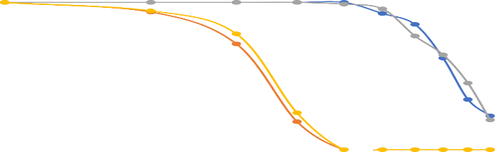

FNA

CNA

FRCA

CRCA

120

100

80

60

40

20

0

1

10

Sieve Size (Log scale) (mm)

Fig. 4.3 Gradation curve of various aggregates

* 1. **Experimental Setup**

For the experimental setup, cubes of 150mm dimensions were casted for compression testing and for measurement of unit weight, whereas for flexural testing beam of 100x100x500 mm are casted considering that maximum nominal size of aggregate is less than 38mm. Slump test was used for determining workability of samples.

* + 1. **Design of Control Mix**

CRCA and FRCA are included in this study as partial replacements. The notation for concrete containing a percent CRCA and b percent FRCA replacement is a RACb, thus a sample containing 15 percent CRCA and 5 percent FRCA replacement is 15RCA5.. Six concrete types were incorporated in the present study: CM, 20RAC0, 15RAC5, 10RAC10, and 5RAC15. Control Mix was designed for a grade of M25 as per the instructions laid down in IS 456 2000 having a w/c proportion of 0.45. To compensate for FRCA's elevationd liquid absorption, the 'Water compensation technique' was utilized to treat it. The aggregate content of each concrete mixture is listed in Table 4.2; nonetheless, each combination comprised of 339 kilograms of cement per m3 of concrete. Compressive test samples are shown in Figure 4.4

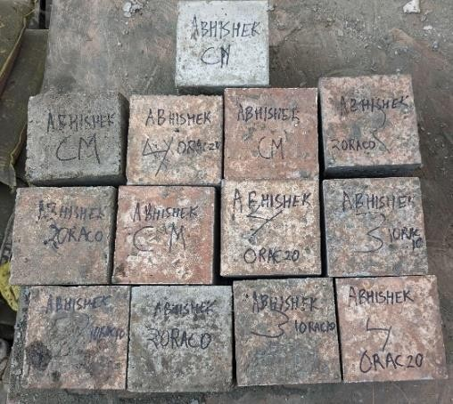

a

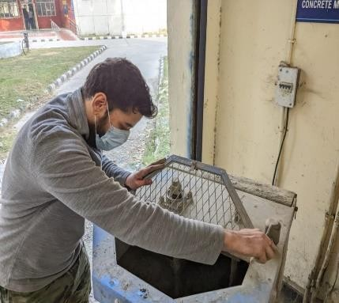

(b)

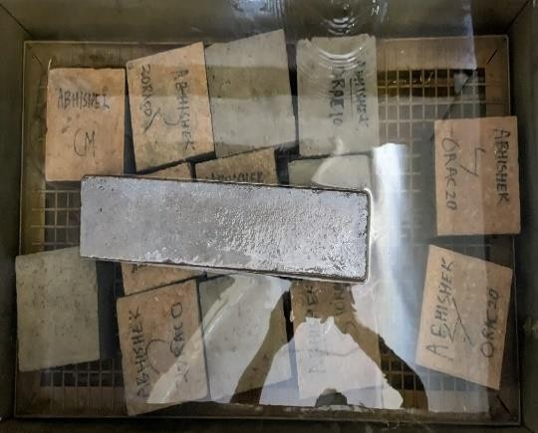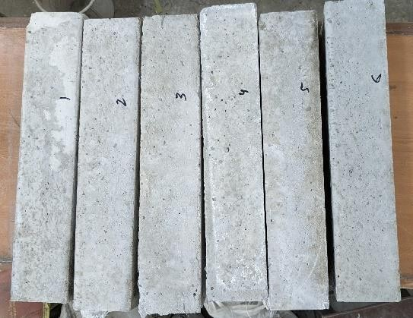

(c) (d)

Fig. 4.4 (a) Mixing of concrete in mixer; (b) A batch of samples made for compression testing; (c) Curing of samples; (d) Samples made for Flexure testing.

To achieve the desirable slump of 100mm, Fosroc® Auramix 200, a high- performance super plasticizing additive with a specific gravity of 1.07 and a modified polycarboxylate base, was utilised. The dosage was set at 1% (by cement weight). The 'Water Compensation Method' was used to treat FRCA to mitigate for their greater water absorption.

**Table 4.2 Aggregates per cubic meter of concrete**

|  |  |  |  |  |
| --- | --- | --- | --- | --- |
|  | Natural Aggregates | | Reused Aggregates | |
| Sample Designation | Coarse Aggregate [CNA]  (Kg) | Fine Aggregate [FNA]  (Kg) | Reused Coarse Aggregates [CRCA]  (Kg) | Reused Fine Aggregate [FRCA]  (Kg) |
| CM | 1227.52 | 667.8 | 0 | 0 |
| 20RAC0 | 982.02 | 667.8 | 245.50 | 0 |
| 15RAC5 | 1043.39 | 634.41 | 184.13 | 33.39 |
| 10RAC10 | 1104.77 | 601.02 | 122.752 | 66.78 |
| 5RAC15 | 1166.14 | 567.63 | 61.38 | 100.17 |
| 0RAC20 | 1227.52 | 534.24 | 0 | 133.56 |

* + 1. **Concrete Property assessment**

Conforming to IS 1199 (II), workability was measured using slump test by slump cone [22]. To ascertain the density of the material, fresh concrete was poured into an airtight, sturdy container, compacted using a vibrating table, and then weighed in accordance with IS 1199 (III).

1. **RESULT**
   1. **GENERAL**

Testing was done on natural aggregates and on reused concrete aggregates as well as on treated CRCA. Furthermore, compressive strength test, bending strength test, workability test and water penetration cum permeability tests were also performed on the samples. Finally, an economic study was performed on samples obtained and results of all the tests are discussed in the concluding units.

* + 1. **Comparative Examination of Different Aggregates**

Table 5.1 investigates the characteristics of several aggregates. Figure 3.4 illustrates the grading of CNA (50 percent - 20mm - 50 percent - 10mm), whereas the grading of FNA exceeds the standards for Grading Zone II of IS 383 [19]. Table 4.1 depicts the many aspects of the aggregate quality. After mild acid exposure for a duration of 24 hours, CRCA had a water absorption value of 6.1%, whereas TRCA had a water absorption value of 4.2%, suggesting a reduce of 30.43 % in water absorption value.

The Gs of natural aggregate and RCA displayed small variations from one another (Table 5.1). CRCA and TCRCA had specific gravities that were 17 percent and 16 percent less than CNA, respectively. In the instance of the FRCA, this percentage was 11.78%. It is suggested that the overall water absorption should not exceed 2 percent. As demonstrated in Table 5.1, CNA and FNA are the only aggregates which abided by the given recommendation of 2% water absorption. Due to cleaning of FRCA with water & its drying prior to water absorption test, the water absorption is likely exaggerated. FRCA if left untreated would have resulted in more value of water absorption due to the abundance of more foreign particles.

Various tests, including abrasion, fall, compression, specific gravity etc., were performed in accordance with IS 383 to investigate the mechanical characteristics of aggregates. These tests included abrasion, impact, and compression. Figure 5.1 illustrates the CRCA therapy with a moderate acid (one molecule of acetic acid).

**Table 5.1 Characteristics of various aggregates**

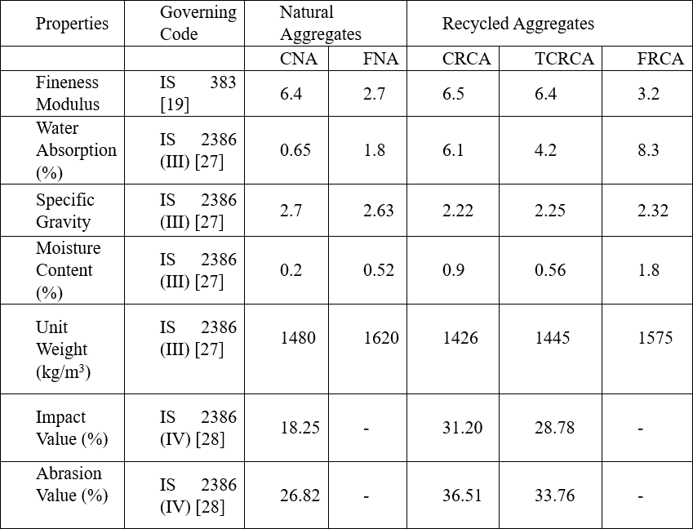

|  |  |
| --- | --- |
| Graphical user interface, application  Description automatically generated  (a) | Graphical user interface, application  Description automatically generated  (b) |

Fig. 5.1 Using a mild acid to treat CRCA.

* + 1. **XRD examination of aggregates**

Figures 5.2 and 5.3 depict the XRD findings of several aggregate varieties. Given that quartz (SiO2) is the most prevalent constituent of river sand, the XRD diffractogram of FNA demonstrates a predominance of quartz (SiO2). The magnitudes of the quartz and microcline spike declined as the assemblance of FRCA rose, with the lowest intensities occurring in FRCA.

Although the qualitative character of the XRD data, it appears that a considerable quantity of reacted cement paste attached to FRCA. As the FNA concentration declined, the magnitudes of the belite and portlandite peaks gradually rose, suggesting the existence of a few unreacted cement molecules in the adhered state of mortar. However, the non - availibility of portlandite spike in CRCA indicates that it had transitioned to the calcite or carbonated stage, as miniscule calcite traces (intensity spikes) are present in all RCA’s known form. According to another author, portlandite is freed from the hydrated cement paste when RCA is crushed into fine powder for XRD analysis. Portlandite undergoes rapid carbonation when subjected to CO2 in the atmosphere, resulting in the formation of calcite. Due to the geological origin of the great majority of natural aggregates, CRCA’s XRD measurement indicates the presence of a minute dolomite phase. Due to cement reaction, CRCA exhibited a little secondary spike of C-S-H gel (tobermorite).

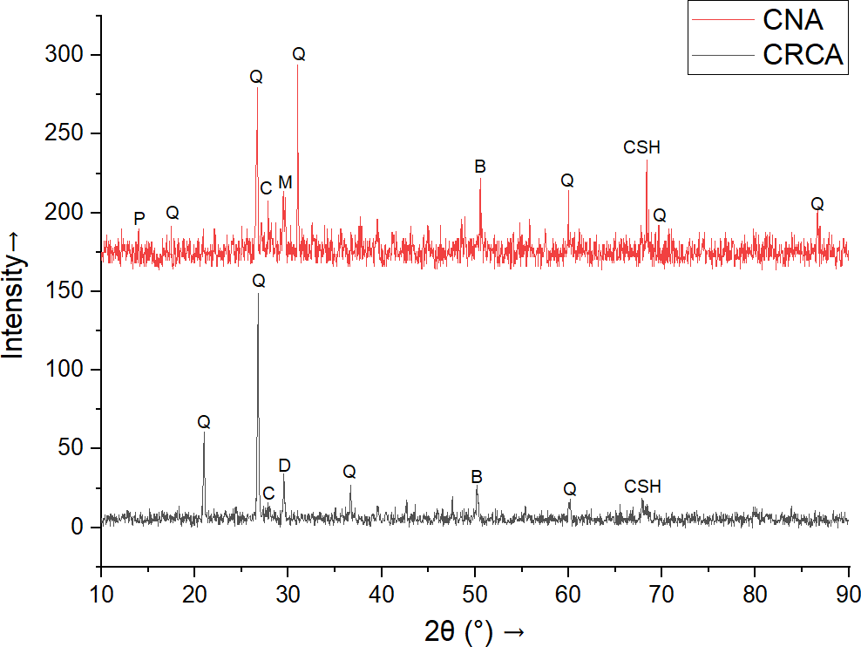

Fig. 5.2 XRD of CNA and CRCA aggregates using Origin© (B-Belite; C- Calcite; D-Dolomite; CSH-Calcium Silicate Hydrate; Q-Quartz; P- Portlandite; M-Microcline)

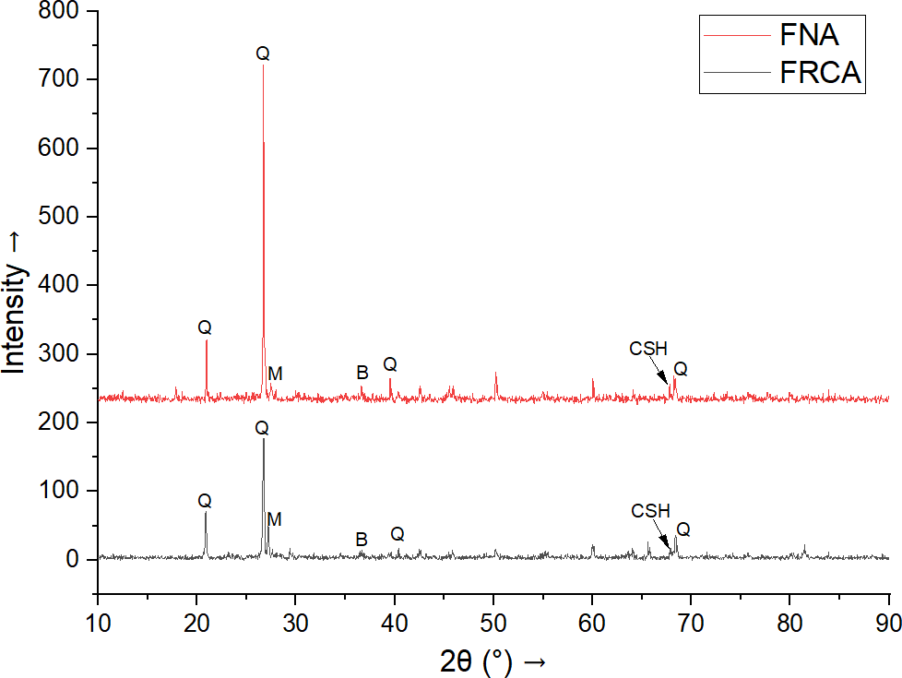

Fig. 5.3 XRD of FNA and FRCA aggregates using Origin© (B-Belite; C- Calcite; D-Dolomite; CSH-Calcium Silicate Hydrate; Q-Quartz; P- Portlandite; M-Microcline)

* + 1. **Fresh Concrete Characteristics**

In this section, characteristics of concrete like workability and unit weight of various samples are measured which are measured in concrete’s fresh state. For the purpose of determining workability, slump test is performed while unit weight is measured with the help of concrete mould and weighing balance.

* + 1. **Workability**

To compensate for the high-water absorption capacity of RCA, concrete containing RCA often contains additional water. This can be accomplished in one of two ways: either by prewetting the RCA or by continuously adding water until the concrete is well mixed (equal to the RCA's water absorption). The most difficult aspects of pre-saturating RCA are predicting the amount of water necessary and knowing how to get there.

According to Sadagopan et al., the RCA absorbs more than 90 percent of the water consumed in a 24-hour period in just 15 minutes. In the absence of corrective actions, the significant water absorption that occurs in RCA  diminishes the concrete mixture's efficient moisture-to-cement ratio, resulting in a reduce in its functionality.

Sadagopan et al. proposed the use of a soaking method for  (RCA) where just fifty percent of the water that is soaked by RCA in 15 minutes is used. This method aims to achieve a workability level similar to that of standard  (RAC).

The quantity of water compensation in the water compensation approach is decided by the size of the RCA and the workability criterion (more water is compulsory in FRCA than in CRCA). Concrete should not be combined with a amount of additional water equal to the FRCA's 100 percent water absorption capacity, since doing so might result in bleeding.

Moreover, when concrete is rapidly mixed, FRCA may not be able to quickly absorb this extra water. Furthermore, extra water accumulates in the interfacial transition zone, weakening the connection among aggregates and paste matrix. So, Bouarroudj et al. and Zhao et al. suggested employing FRCA in a dry environment to improve the interaction between the cement matrix and aggregates.

Through autoclave curing hot curing, or the use of a polycarboxylate- founded high-range water reducer, it is feasible to alleviate the complications produced by the adding of more water during concrete mixing. There are several possible explanations for complicated phenomena, such as the workability of concrete with FRCA, which is the flow behaviour of FRCA-incorporated concrete, and each explanation must be tested by tests.

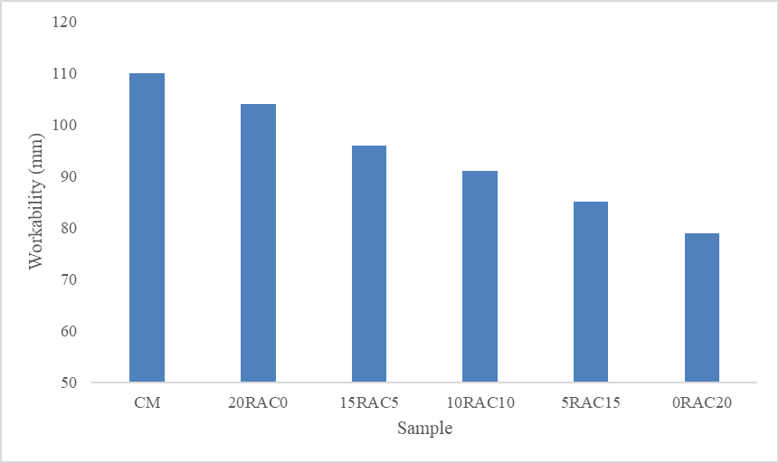

Fig. 5.4 Graph illustrating the workability of several samples.

* 1. **Hardened Concrete Attributes**

In this section, characteristics of concrete are measured in hardened state, these includes compressive and flexural testing. For the experimental purpose, cubes of 150mm size are casted for compressive strength, whereas for bending strength test purpose beam of dimension 100x100x500 mm are casted taking into account the maximum nominal size of aggregates was less than 38mm. These beams were then tested using 2 - point flexure test.

* + 1. **Compressive strength**

Figure 5.5 depicts the variation in compressive strength among several samples. The control mix (CM) was designed with a target strength of 34.26MPa, which is greater than the required target strength of 31.60MPa, as it was intended to have a characteristic strength of 25MPa. Further analysis reveals that 20RAC0 had the highest replacement ratio, with a strength 7.44% lower than CM. Since there was a general tendency for strength to reduce as FRCA elevationd, 0RAC20 had the lowest strength of all the samples, which was 12.72 percentage points below CM.

Regardless of concrete series or curing age, the addition of RCA lowered compressive strength, as seen in Figure 5.5. There was a higher difference in compressive strength between CM and reused concrete at early ages (7 and 28 days) compared to later ages (56 days). In addition, this pattern reveals that the sensitivity of these materials to FRCA reduces as the curing age elevations.

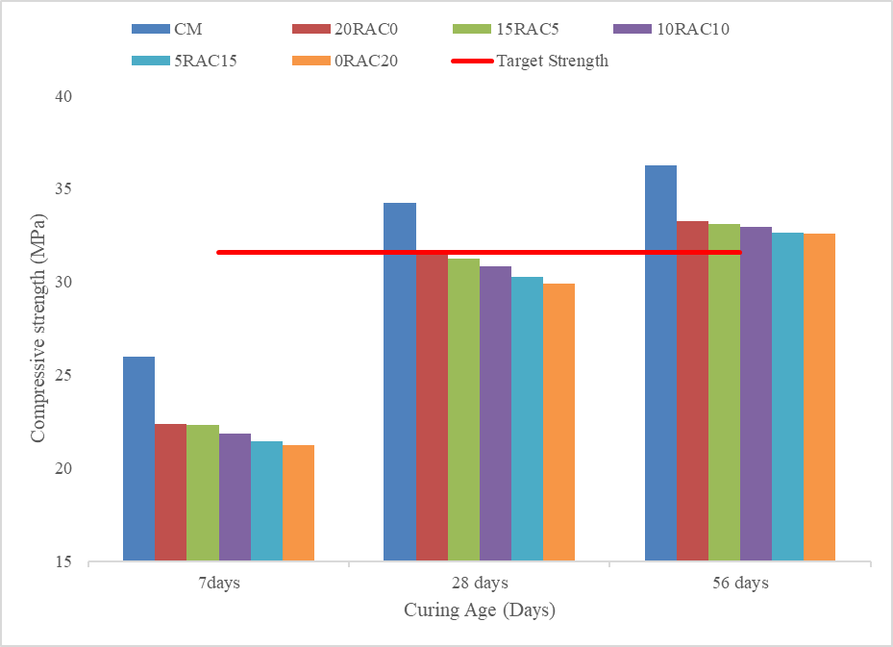

Fig. 5.5 Variation of Compressive strength

1. **CONCLUSION**

Due to the complexity of FRCA, the great bulk of previous research has focused only on the influence of CRCA on the characteristics of concrete. To limit the total replacement to 20%, the authors felt compelled to estimate the consequence of varying FRCA and CRCA ratios on the characteristics of concrete holding them. Significant conclusions may be taken from the performed trials:

* The treatment of CRCA with a moderate acid greatly improves its mechanical and physical characteristics, although they continue to be inferior to CAN. The CRCA absorbs water nine to ten times better than CNA (without treatment) and six to seven times better after treatment. FRCA absorbs four-and-a-half times the amount of water as compared to FNA.
* The workability and fresh density of samples (xRACy) diminish when FRCA concentration elevations. However, all types of concrete can be designated as "ordinary concrete."
* Regardless of curing age, all samples between 20RAC0 and 0RAC20 have lower strengths than CM, but subsequent curing may be sufficient to compensate for the strength loss. Among different variables tested, flexural strength showed least effected by RCA inclusion in concrete. As the curing period extends, the detrimental properties of FRCA on concrete strength begin to reduce. Prolonged curing, however reduced the detrimental effects caused by inclusion of FRCA.
* As the extra ratio of FRCA grows, the water permeability of the sample elevations, with the 'k' values of 20RAC0 and 0RAC20 being 2.57 and 4.94 times greater than those of the control mixture (CM), respectively.
* As the FRCA ratio elevations concrete becomes more porous, indicating less durability, with 0RAC20 water penetration being 4.5-4.7 times more than that of CM.
* The 20RAC0 sample preparation was the least expensive, costing 7.39 percent less than the CM sample, according to the sample cost study. The least costly sample was 0RAC20, which cost 3.29 percent less than CM.
* Both CRCA and FRCA can be integrated into concrete at the same time if expedited curing, which mitigates the detrimental impacts of C&D waste, is undertaken.
* Therefore, it is practical to assume that the integration of C&D waste into concrete not only reduces building costs, but also promotes waste recycling and effective utilisation.

1. **REFERENCES**
2. A. Pandey, B. Kumar, “A comprehensive investigation on application of micro silica and rice straw ash in rigid pavement”, Construct. Build. Mater., 252 (2020), 10.1016/j.conbuildmat.2020.119053
3. Advancing Sustainable Materials Management: 2018 Fact Sheet, United States Environmental Protection Agency (2020), pp. 1-24
4. F. Cartuxo, J. De Brito, L. Evangelista, J.R. Jiménez, E.F. Ledesma, “Rheological behaviour of concrete made with Fine Demolished Concrete Aggregates - influence of the superplasticizer”, Construct. Build. Mater., 89 (2015), pp. 36-47, 10.1016/j.conbuildmat.2015.03.119
5. J.A. Bogas, J. De Brito, D. Ramos, “Freeze-thaw resistance of concrete produced with Fine Demolished Concrete Aggregates”, J. Clean. Prod., 115 (2016), pp. 294- 306, 10.1016/j.jclepro.2015.12.065
6. S.A. Zareei, F. Ameri, P. Shoaei, N. Bahrami, “Reused ceramic waste high strength concrete containing wollastonite particles and micro-silica: a comprehensive experimental study”, Construct. Build. Mater., 201 (2019), pp. 11-32, 10.1016/j.conbuildmat.2018.12.161
7. D. Pedro, J. de Brito, L. Evangelista, “Structural concrete with simultaneous incorporation of fine and Coarse Demolished Concrete Aggregates: mechanical, durability and long-term characteristics”, Construct. Build. Mater., 154 (2017), pp. 294- 309, 10.1016/j.conbuildmat.2017.07.215
8. P. Pereira, L. Evangelista, J. De Brito,“The effect of superplasticisers on the workability and compressive strength of concrete made with Fine Demolished
9. Concrete Aggregates”, Construct. Build. Mater., 28 (2012), pp. 722-729, 10.1016/j.conbuildmat.2011.10.050
10. S.A. Zareei, F. Ameri, N. Bahrami, P. Shoaei, H.R. Musaeei, F. Nurian, “Green high strength concrete containing reused waste ceramic aggregates and waste carpet fibers: mechanical, durability, and microstructural characteristics”, Journal of Building Engineering, 26 (2019), p. 100914, 10.1016/j.jobe.2019.100914
11. L. Berredjem, N. Arabi, L. Molez, “Mechanical and durability characteristics of concrete based on reused coarse and fine aggregates produced from demolished concrete”, Construct. Build. Mater., 246 (2020), p. 118421, 10.1016/j.conbuildmat.2020.118421
12. Hanaa Khaleel Alwan Al-Bayati, Prabir Kumar Das, Susan L. Tighe, Hassan Baaj, “Evaluation of various treatment methods for enhancing the physical and morphological characteristics of Coarse demolished concrete aggregate” Construct. Build. Mater., Volume 112, 1 June 2016, Pages 284-298, https://doi.org/10.1016/j.conbuildmat.2016.02.176