**Secure Entry --Smart Receptionist with Smart Lock System**

*1R.SRINIVASA RAO,2K.POOJITHA,3G.HARSHAVARDHAN,4K.KUSHAL KUMAR*

*1AssociateProfessor,2,3,4B.Tech Students*

*DEPARTMENT OF ELECTRONICS AND COMMUNICATION ENGINEERING*

*ACE Engineering College,Ankushapur (V),Ghatkesar (M),Medchal(Dist.)-5501 301*

# ABSTRACT:

# Security and safety are increasing day by day and with improvements brought in the past decade and innovations to bring comfort in our lives. In today’s world technology has become a part of an integrated part of the society and therefore the security of an individual home, office, or organization has to be considered with utmost priority. Smart Receptionist with a smart lock system is therefore mainly designed and developed for security system purposes. The smart security system is used in situations to see visitors when the main door of an office or organization is closed. The purpose of this system is to control the door lock using RASPBERRY Pi. In this system whenever a person enters the office door, the image of a person is captured by the Pi camera module and sends this image to the user’s E-Mail. The owner can lock/unlock the door depending on the person’s image by sending confirmation amil to the system. If the system detects the wrong person, it will activate the alerts

# INTRODUCTION

* 1. **INTRODUCTION OF THE PROJECT:**

Nowadays, the security one of the most consent challenges in every aspect of the industry as well as for the normal human being there has been numerous approaches which was implemented by using Internet of Things (IOT) applications. These applications they provided the security by using Raspberry-pi smart reception list with smart lock system is the proposed system which identifies the user phase and then opens the door by using smart Artificial Intelligence (AI). By using these applications, we are giving the authorized persons which are used for security system. The authorized persons can be verified the authorized from any Remote location by using with live streaming video. If the person is authorized the security system will be coming into access for the verification process by using the Internet of Things (IOT) application. Here in this approach a Raspberry-pi micro control is used and python program is used for live streaming. Remote.it app is an app that enables us to control the door access by designing the graphical interface in the apps according to the specific function to perform

# Fig1 : Architecture diagram

**1.2 The main objectives of the project are:**

* The controlling of the door (open/ close) is done wirelessly.
* Using REMOTE.IT Wed/mobile applications.
* Audible and visible alerts using Buzzer.
* Person alerts using mail.
* Using pi camera for live streaming.
* Relay based solenoid door lock/unlock.
* Using raspberry pi zero w to achieve this task

**2** **System Function**

1. Smart Lock Circuit – The interfacing circuit of the smart receptionist and smart lock system is implemented. Raspberry Pi runs on standard Raspbian Linux distribution with Wi-Fi dongle, GPIO library and programs written in Python Language. Raspberry Pi GPIO4, GPIO17 and GPIO25 are connected with resistors R3, R2 and R1 respectively, to make the logic level low.

1. The controlling device of the whole system is a raspberry pi3 processor; it has an inbuilt Ethernet. Pi-camera, Relay along with solenoid lock, Buzzer, switch and LEDs is interfaced to the raspberry pi processor. Raspberry pi Zero w processor continuously takes the live streaming from pi camera.

1. Smart Lock - Whenever a person rings the bell, it is recognized by raspberry pi3 and the processor sends the alerts mail to the owner along with Buzzer . Also the live streaming from pi is sent to the REMOTE.IT web application. After your visitor is identified, you may open the door by pressing the Lock tab on the Web browser and the door opens. 4) SMTP Library – We have used SMTP Library to send the mail to the user’s device.

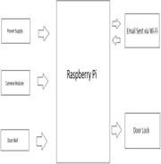

Fig2 : Sematic diagram

Power supply: A power supply takes the AC from the wall outlet, converts it to unregulated DC, and reduces the voltage using an input power transformer, typically stepping it down to the voltage required by the load.

Camera module: The camera works with all models of Raspberry Pi models. It can be accessed through the MMAL and V4L APIs, and there are numerous third-party libraries built for it, including the Picamera Python library. See the Getting Started with Picamera resource to learn how to use it.

Door bell: A doorbell is a signaling device typically placed near a door to a building's entrance. When a visitor presses a button, the bell rings inside the building, alerting the occupant to the presence of the visitor.

Raspberry pi: The Raspberry Pi is a low cost, credit-card sized computer that plugs into a computer monitor or TV, and uses a standard keyboard and mouse. It is a capable little device that enables people of all ages to explore computing, and to learn how to program in languages like Scratch and Python.

Email alert: Email alerts are emails generated by an automated process and sent to designated recipients. These actions consist of the standard text and list of recipients for an email.

Door lock: you have to choose a type of door lock that you think is best for your home.

**2.1 Hardware Requirement**

* Doorbell Switch: It is the first sensor of project which will start the process when it gets pressed. The doorbell which we are using is selected in such way that its output voltage signal is around 3 volts.
* Raspberry pi : It comes with various operating system like android, FreeBSD, Linux, PLAN 9 and many more out of this in this project Linux operating system is used. Raspberry pi is the main block in the project it control all the components which used in this project. All models feature a Broadcom System on chip (SOC), which includes an ARM compatible Centre Processing Unit (CPU) and on chip Graphics

Processing Unit (GPU). CPU speed range from 700MHZ to 1.2 GHz for the pi3 and on-board memory range from 256 MB to 1 GB RAM.

* Pi Camera: 5 MP camera which can directly be plugged into raspberry pi board. This camera module is compatible with all the models of raspberry pi. When the doorbell is pressed camera is also switched on and it capture image and send it to raspberry pi using CSI bus
* Push Button: Push buttons can be explained as simple power controlling switches of a machine or appliance.
* Hookup Wires
* Power Supply: As all the components used works on the low voltage power supply provided is 6 volts. It is used to give the power supply to the Raspberry Pi.
* Relay: It is the electronic switch which is used to provide 12v dc supply from one metal rod to the solenoid lock connected to the door. When the relay flips, the voltage is passed to the solenoid lock and the door opens.
* Solenoid Lock: 12v Solenoid lock are basically electromagnets they are made up of big coil of copper wire with an armature in the middle. When the coil is energized, the slug is pulled into the centre of the coil.
* Wood &Glue for

Construction.

Fig3 : Block Diagram

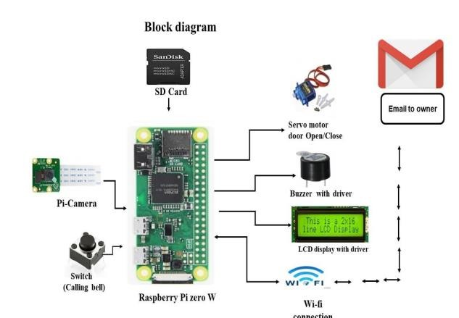

**2.2 Software Requirement**

* Express PCB – for designing circuit: Express PCB is a software tool to design PCBs specifically for manufacture by the company Express PCB (no other PCB maker accepts Express PCB files). It is very easy to use, but it does have several limitations.
* Linux OS: The Linux Standard Base (LSB) is a joint project by several Linux distributions under the organizational structure of the Linux Foundation to standardize the software system structure, including the file system hierarchy used in the GNU/Linux operating system. The LSB is based on the POSIX specification, the Single UNIX Specification, and several other open standards, but extends them in certain areas.
* Proteus 7 (Embedded C) – for simulation part

1. **Implementation**

There are many kinds of Wi-Fi door lock available in the market which makes your home more secure and saves time in finding the keys. We previously built a smartphone-controlled Door lock. Here we are using the same solenoid door lock and controlling it using Raspberry Pi based webserver. The webpage will have two buttons to Open and Close the door lock.

Fig5 : Smart door locking alaraming system

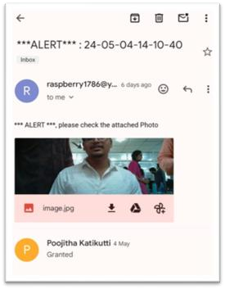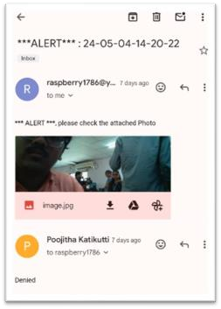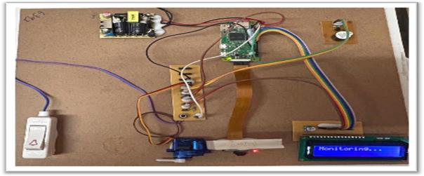

1. **Result**

As a result, we have implemented the smart receptionist and smart lock system using raspberry pi, camera module, doorbell switch and servomotor lock with low cost and low power. The system will allow known persons only when the receptionist approves the visitor when received as a Mobile application if not the visitor cannot enter the organization and the system will remain locked

1. **Conclusion**

The Smart Lock System could run properly and stably. It could implement all the designed and needed features and functions. This could be achieved only by proper software and hardware development, as well as multiple test and debug procedures. The System is self reliant and can decide on its own to allow the visitor or not. Only the unknown visitor is granted permission by the owner itself. The main entrance of the work place is controlled by the system autonomously. Unwanted visits and confrontation can be avoided using this system.

**6 Future Scope**

Our project Smart Door Receptionist with Smart Lock System is mainly intended to design an intelligent security system for door access/denies.

We can extend this project by using Spoofing is the act of disguising a communication from an unknown source as being from a known, trusted source. Spoofing can apply to emails, phone calls, and websites, or can be more technical, such as a computer spoofing an IP address, Address Resolution Protocol (ARP), or Domain Name System (DNS) server.

**References**

The sites which were used while doing this project -

* [www.wikipedia.com](http://www.wikipedia.com)
* [www.allaboutcircuits.com](http://www.allaboutcircuits.com)
* [www.microchip.com](http://www.microchip.com)
* [www.howstuffworks.com](http://www.howstuffworks.com)
* http://www.theregister.co.uk/2012/06/12/raspberry_pi _ drone/
* http://www.zdnet.com/raspberry-pi-designer-hints-at- future- version-4010025712/
* http://janbierens.com/2012/05/22/raspberry-pi-andthe- future/
* <http://en.wikipedia.org/wiki/Raspberry_Pi>
* http://www.pcpro.co.uk/reviews/desktops/374290/rasp berry-pi-model-b
* http://www.techrepublic.com/blog/european- technology/raspberry-pi-five-ways-business-can-use-it/61