**HERITAGE RESILIENCE IN THE MODERN AGE: BALANCING TRADITION AND PROGRESS**

Fevy Joy A. Gebilaguin

ORCID Number: 0009-0002-0723-905X

Graduate School of Government and Management, University of Southeastern Philippines,

Philippines

**_____________________________________________________________________________________________**

**ABSTRACT**

This study sought to understand how Davao City, a rapidly developing urban center in the southern part of the Philippines, balances preserving its cultural heritage with embracing progress in rapid urbanization. This study examines the roles of various stakeholders, including local communities, government agencies, indigenous people, and other organizations, in promoting heritage resilience in Davao City. It also examines strategies like education, community engagement, and policies regulated by the city government to help in the preservation of distinct cultural identities while ensuring continued growth and prosperity. The study uses exploratory factor analysis to identify key factors in balancing tradition and progress in Davao City.

**Keywords:**

Cultural heritage, urbanization, heritage resilience, preservation, cultural identity

_____________________________________________________________________________________________

**INTRODUCTION**

Legarda (2023) stated that "Culture is the narrative that binds us as a nation, and we owe it to our ancestors and heroes who built the Philippines as it is today. It is important to protect our way of living and heritage that we will also pass on to our children and our children's children."

Embodied in the form of ancient archaeological sites and historic buildings, collections of antiquities, artworks, artifacts, and archives, and as the lifeways of contemporary communities, cultural heritage comprises features of continuing existence and past accomplishment recognized by a social group as an enduring symbol of its identity (Kurin, 2022). Davao City is a melting pot for all cultures: its geography and surroundings, its colorful history, the rich diversity of its culture and tradition, and the gatherings and festivities like the [Kadayawan Festival](http://davaocitybybattad.blogspot.com/2011/08/kadayawan-festival.html) (Battad, 2011). The continuity of civilization and culture is closely intertwined. Culture plays a significant role in the continuity and sustainability of a civilization, and in turn, civilizations influence and shape the evolution of culture (Yadav, 2023).

By delving into the City’s culture and heritage, be it tangible or intangible culture, the study aims to shed light on the strategies and approaches to preserve, conserve, and protect these amidst the rapid economic growth. This research analyzes the City’s efforts to balance tradition and progress, examining the challenges and benefits of heritage preservation in a modernizing city. Through this exploration, this research contributes to the understanding of heritage resilience in the modern age, specifically aimed at Davao City.

**METHODOLOGY**

Exploratory Factor Analysis (EFA) was utilized in this research. Exploratory factor analysis is used to check dimensionality and is often used in the early stages of research to gather information about the interrelationships among variables (Noora Shrestha, 2021). For the purpose of this study, a research questionnaire consisting of 30 questions was distributed to 150 residents of Davao City. A combination of printed and electronic questionnaires was used in the data collection to achieve the total number of respondents. According to Torrentira (2020), an online survey is a process of distributing the instrument or the questionnaire to the target respondents using online platforms through google forms.

Each item in the questionnaire is anchored on the study of balancing tradition and the progress of our cultural heritage in the modern age. The data gathered was then tallied and subjected to statistical treatment using SPSS Statistics. This then yielded results for the Kaiser-Meyer-Olkin (KMO) Measure of Sampling Adequacy and Bartlett’s Test of Sphericity, where KMO measures the suitability of the data for factor analysis, and Barlett’s Test of Sphericity test the null hypothesis (Noora Shrestha, 2021).

**RESULT AND DISCUSSIONS**

Table 1 presents the results of the Kaiser-Meyer-Olkin (KMO) Measure of Sampling Adequacy and Bartlett’s Test of Sphericity. The KMO score of 0.949 indicates that the data is highly suitable for factor analysis. Additionally, Bartlett’s Test of Sphericity yielded a value of 4979.026 and a significant value smaller than .001, indicating that the null hypothesis is rejected, suggesting an underlying structure of heritage resilience in the modern age, considering the balance between tradition and progress.

***Table 1. KMO and Bartlett’s Test***

| Kaiser-Meyer-Olkin Measure of Sampling Adequacy. | .949 |
| --- | --- |
| Approx. Chi-Square | 4979.026 |
| Bartlett's Test of Sphericity df | 435 |
| Sig. | .000 |

**Scree Plot**

The Scree Plot illustrated the total variance and Eigenvalues plotted against all factors in a graphical manner. This plot depicts the decreasing trend of Eigenvalues and helps determine the significance of each component. The Scree Plot is a valuable tool for deciding the number of factors to retain, with the inflection point indicating where the curve flattens. In this study, the curve starts to flatten at component number 3 as Eigenvalues of less than one begin to appear. If the items of each dimension fall below the minimum threshold, the dimension will be eliminated. Consequently, the analysis retained only two factors.

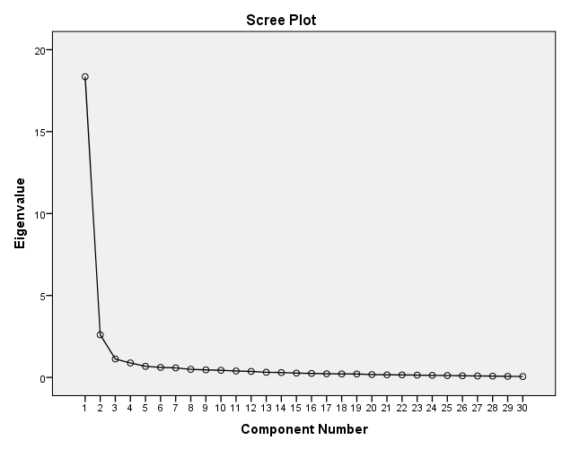

***Figure 1. Scree Plot***

**Rotated Component Matrix**

There are two factors generated using the SPSS Statistics Software. Table 2 shows the attribute “Multifaceted Nature of Preserving Cultural Heritage.” The data shows that participants rated Item No. 25 with a score of 0.864, highlighting the overall identity and pride Davaoeños feels when the city’s efforts to preserve cultural heritage are enhanced. Preserving cultural heritage is not merely a choice but an obligation. Our cultural heritage is a testament to our identity, history, and values. It connects us to our roots and provides a foundation for future innovations (GGI Insights, 2024). Cultural heritage is central to protecting our sense of who we are. It gives us an irrefutable connection to the past – to certain social values, beliefs, customs, and traditions- allowing us to identify ourselves with others and deepen our sense of unity, belonging, and national pride (U.S. Embassy Manila, 2021).

Items 15, 11, 12, 23, 24, and 3 focus on the government's and various stakeholders' efforts in preserving cultural heritage. As stated by an article by the U.S. Embassy in Manila (2021), preserving cultural heritage is not solely the responsibility of governments and institutions. Engaging local communities in preservation efforts is essential for creating sustainable solutions and fostering a sense of ownership over cultural heritage.

***Table 2. Rotated Component Matrix grouped under the multifaceted nature of preserving cultural heritage***

| **Item** | **Attributes** | **Loading** | **Factor** |
| --- | --- | --- | --- |
| Item 25 | Preserving cultural heritage enhances the overall identity and sense of pride among the citizens of Davao City. | .864 | multifaceted nature of preserving cultural heritage |
| Item 14 | Cultural heritage resilience should be considered in urban development planning procedures in the country. | .863 |
| Item 23 | The Davao City government should strictly implement regulations that protect our cultural heritage sites from urban development. | .863 |
| Item15 | Local communities should be involved in heritage conservation and modernization decision-making processes. | .848 |
| Item10 | I believe modern technology can contribute positively to preserving cultural heritage. | .843 |
| Item 11 | Education is crucial in instilling an appreciation for Filipino cultural heritage while embracing modernization. | .837 |
| Item 24 | The Davao City government should invest more in restoring and maintaining historical buildings and landmarks. | .829 |
| Item 26 | Traditional art forms and performances should be integrated into the modern events and festivals of Davao City. | .827 |
| Item 22 | Integration of indigenous knowledge into modern sustainability practices may enhance cultural heritage resilience in Davao City. | .823 |
| Item 29 | Cultural heritage sites should be protected from excessive commercialization and development. | .813 |
| Item 21 | Embracing cultural diversity enhances the resilience of heritage in Davao City in the face of modern challenges. | .804 |
| Item 13 | I believe traditional festivals and celebrations should be preserved and promoted alongside modern cultural events in the country. | .802 |
| Item 28 | Preserving cultural heritage is essential in the modern age. | .797 |
| Item 9 | I believe that tourism may have a beneficial impact on the resilience of cultural heritage sites. | .792 |
| Item 8 | Modernization efforts should prioritize the preservation of landmarks and monuments. | .790 |
| Item 12 | We can support heritage resilience projects through funding strategies such as public-private partnership. | .784 |
| Item 4 | It is important to prioritize supporting heritage resilience efforts alongside economic growth. | .761 |
| Item 20 | Technology can play a significant role in bridging generational gaps and facilitating the transmission of cultural knowledge across different age groups in Davao City. | .739 |
| Item 7 | Heritage preservation efforts should be inclusive and representative of Davao City’s diverse cultural identities. | .728 |
| Item 27 | Davao City should prioritize the protection of indigenous languages as part of its endeavors to preserve cultural heritage. | .714 |
| Item 3 | Community engagement and participation are crucial for safeguarding intangible cultural heritage while embracing modernity. | .710 |
| Item 5 | Climate change poses significant challenges to the resilience of cultural heritage in Davao City. | .600 |

Table 3 shows the attributes grouped under the “effective preservation and promotion of cultural heritage.” It includes various approaches taken by the government to preserve cultural heritage. To strengthen the conservation and protection of our cultural heritage, the Philippine government has enacted Republic Act No. 11961, “An Act Strengthening the Conservation and Protection of Philippine Cultural Heritage through Cultural Mapping and an Enhanced Cultural Heritage Education Program, amending for the Purpose Republic Act No. 10066, Otherwise Known as the “National Cultural Heritage Act Of 2009”.

***Table 3. Rotated Component Matrix grouped under the effective preservation and promotion of cultural heritage***

| **Item** | **Attributes** | **Loading** | **Factor** |
| --- | --- | --- | --- |
| Item 18 | The Davao City government's urban planning initiatives effectively balance its growth and preservation of its cultural heritage. | .827 | effective preservation and promotion of cultural heritage |
| Item 19 | The Davao City policies adequately support the conservation of heritage sites. | .816 |
| Item 17 | The Davao City effectively preserves and promotes the Davao City's cultural heritage. | .810 |
| Item 1 | Davao City has sufficient cultural heritage resources, such as museums and festivals. | .804 |
| Item 6 | I trust that our government officials will effectively balance safeguarding cultural heritage and modernization. | .747 |
| Item 2 | Public awareness campaigns in Davao City effectively promote the importance of cultural heritage conservation. | .713 |
| Item 16 | The Davao City’s cultural heritage fosters a seamless connection between the past, present, and future environmental context. | .602 |

**STUDY FRAMEWORK**

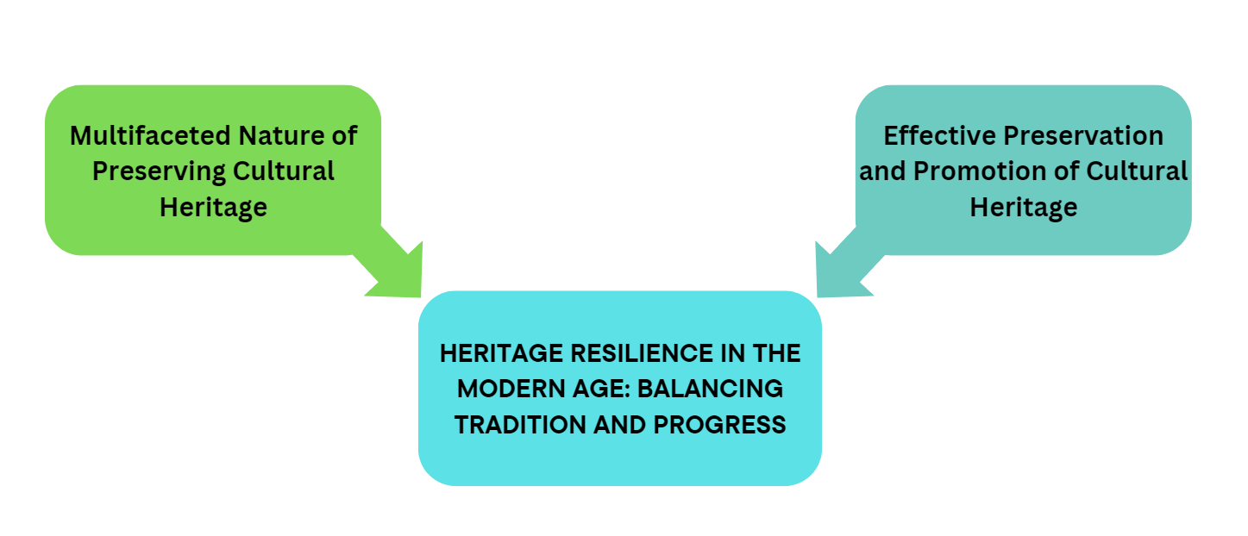

***Figure 2. Factors of Heritage Resilience in the Modern Age: Balancing Tradition and Progress***

**CONCLUSION**

The findings led the researcher to conclude that heritage resilience in the modern age is primarily characterized by factors such as the multifaced nature of cultural heritage and the effective preservation and promotion of cultural heritage. By acknowledging the intricate relationship between cultural heritage and modernization, these statements highlight the need for balanced strategies that respectfully honor the past while also welcoming the future.

**REFERENCE**

[1] An Act Strengthening the Conservation and Protection of Philippine Cultural Heritage through Cultural Mapping and an Enhanced Cultural Heritage Education Program, amending for the Purpose Republic Act No. 10066, Otherwise Known as the “National Cultural Heritage Act Of 2009” Republic Act No. 11961 (July 25, 2023), https://www.officialgazette.gov.ph/2023/08/24/republic-act-no-11961/

[2] Austria, K. (2023, March 21). LGUs to participate in preserving PH cultural assets. Philippine Information Agency.

<https://mirror.pia.gov.ph/news/2023/03/21/lgus-to-participate-in-preserving-ph-cultural-assets>

[3] Battad, D. (2011, April 23). Davao Cultural Heritage. Blogspot. <https://davaocitybybattad.blogspot.com/2011/04/cultural-heritage.html>

[4] GGI Insights (2024, May 27). Cultural Preservation: Ensuring our Legacy Endures. Gray Group International.. <https://www.graygroupintl.com/blog/cultural-preservation#:~:text=dignity%20and%20identity.-,The%20Imperative%20of%20Preservation,a%20foundation%20for%20future%20innovations>.

[5] Kurin, R. (2022, February 22). Why Social Science? Because It Can Help Preserve Cultural Heritage Important for Understanding and Social Benefit. Why Social Science. <https://www.whysocialscience.com/blog/2022/2/22/because-it-can-help-preserve-cultural-heritage-important-for-understanding-and-social-benefit>

[6] Shrestha, N. (2021). Factor Analysis as a Tool for Survey Analysis. American Journal of Applied Mathematics and Statistics. 9(1), 4-11. DOI:[10.12691/ajams-9-1-2](http://dx.doi.org/10.12691/ajams-9-1-2)

[7] Torrentira, M. C. Jr. (2020). Online Data Collection as Adaptation in Conducting Quantitative and Qualitative Research during the Covid-19 Pandemic. European Journal of Education Studies, 7(11), 78-84. http://dx.doi.org/10.46827/ejes.v7i11.3336

[8] U.S. Embassy Manila (2021, June 9). Cultural Heritage Preservation. U.S. Embassy. <https://ph.usembassy.gov/cultural-heritage-preservation/>

[9] Yadav, Dibakar (2023, September 14). Why We must Preserve Our Culture. LinkedIn <https://www.linkedin.com/pulse/why-we-must-preserve-our-culture-dibakar-yadav/>