**FABRICATION AND TESTING OF COMPOSITE MATERIAL USING SILK COCOON’S THREADS**

1. **Bhargav1, Ch. Raju2, P. Pavan Kumar Reddy3 Mattaparthi Sairahul4, K. Jaison Sarkar5, S. Vishnu Vardhan6**

1,2 Assistant Professor, Department of Mechanical Engineering, Ace Engineering College

3,4,5 &6 Students, Department of Mechanical Engineering, Ace Engineering College

**ABSTRACT**

The fabrication of composite materials using silk cocoon threads represents a convergence of tradition and innovation, offering a wide range of applications across industries. This project provides a comprehensive and detailed examination of the fabrication process, covering each step from material selection and preparation to impregnation, curing, and testing. Beginning with an overview of the unique properties of silk cocoon threads, including their strength, lightweight nature, flexibility, and biocompatibility, it explores the various types of silk cocoons available, such as mulberry silk, wild silk, and tussah silk, and discusses their respective properties and suitability for specific applications. The project then deals with resin options for impregnating silk cocoon threads, considering factors such as curing mechanisms, processing considerations, and compatibility with silk fibers. Fiber reinforcement options, including carbon fibers, glass fibers, aramid fibers, and natural fibers, are also explored for enhancing the mechanical properties of composite materials. The preparation of silk cocoon threads, including impregnation and bonding with the resin matrix. Testing and evaluation procedures, including tensile testing, elongation testing, hardness testing, microstructure testing, and impact testing, are thoroughly discussed to ensure the integrity, reliability, and performance of the composite materials. Safety and environmental considerations are followed throughout the fabrication process, with a focus on minimizing risks, reducing environmental impact, and promoting sustainable practices.

**Keywords:**

**INTRODUCTION**

A composite material is a combination of two materials with different physical and chemical properties. When they are combined, they create a material which is specialized to do a certain job, for instance to become stronger, lighter or resistant to electricity. They can also improve strength and stiffness.

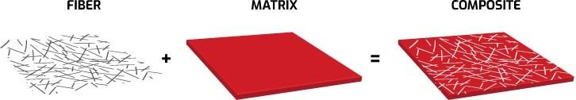

**Fig: 1.1** Composite Material

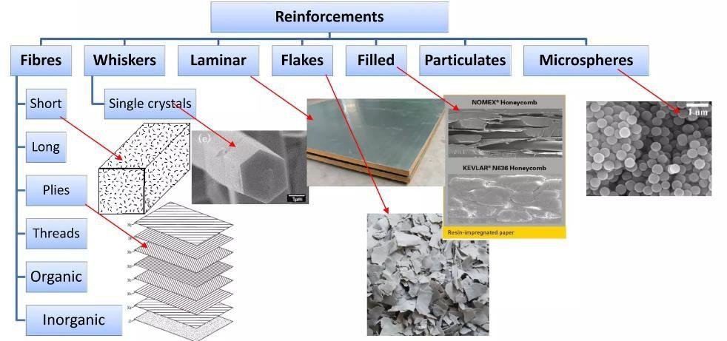

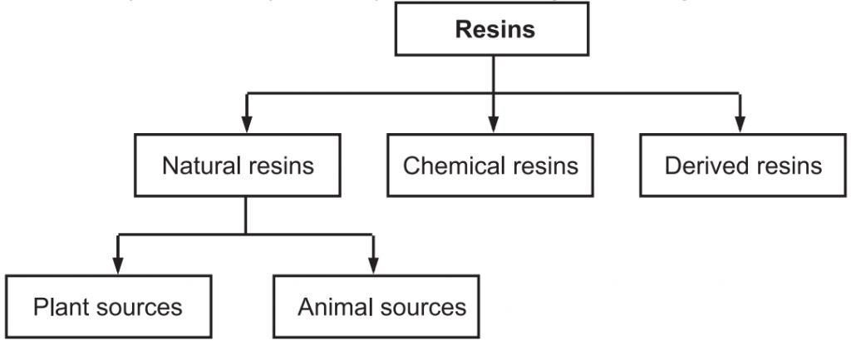**Fig: 1.2** Types of Composite Materials

**Fig: 1.3** Types of Resins

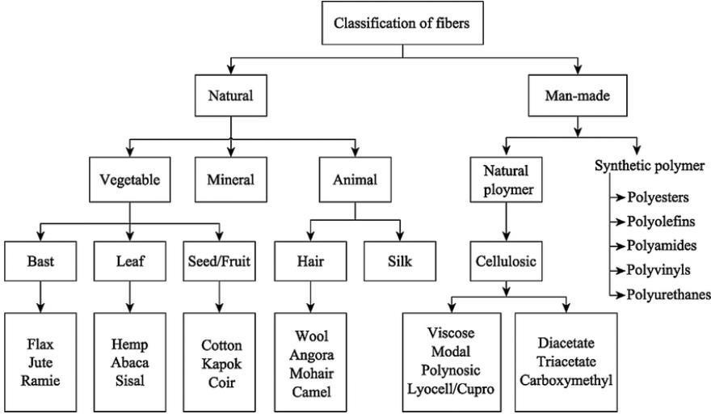

**Fig: 1.4** Types of Fibers

**COMPOSITE MATERIALS USING NATURAL MATERIALS:**

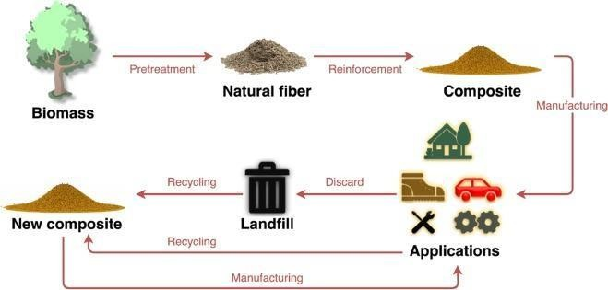Natural composite materials are formed by combining different elements from the natural world to create substances with enhanced properties. These materials have been utilized by humans for various purposes throughout history.

**Fig: 1.5** Composite using Natural Materials

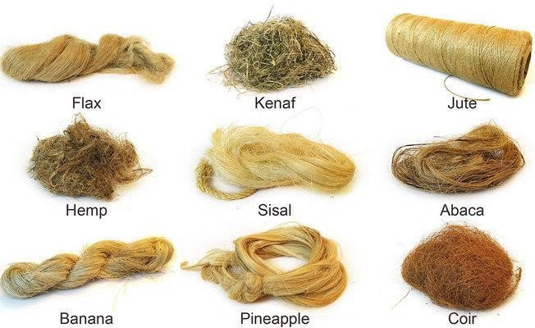

**Fig: 1.7** Natural Fiber.

* + 1. **Stifling & Sorting:**

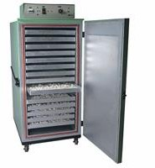T stop the pupa inside the cocoons from hatching and breaking the silk cocoon, the pupa will have to be killed. This process is called stifling and is usually done using hot air or steam. Stifling also dries out the cocoon so that it can be preserved longer. The cocoons can then be sorted based on quality and characteristics such as the length, shape, colour, and luster of the silk fiber.

**Fig: 1.15** Stifling

* + 1. **Boiling:**

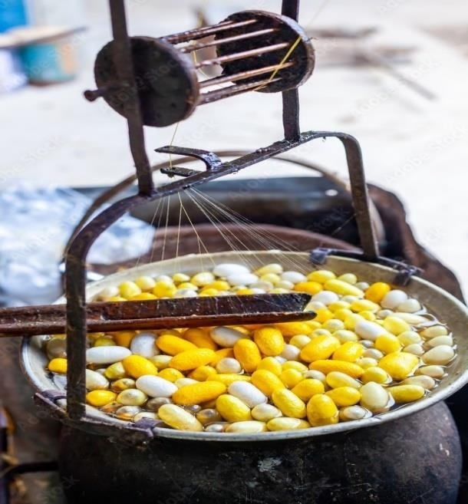After stifling, the cocoons will be exposed to heat once again to prepare them for unreeling. The cocoons are put in boiling water to soften them. Cooking them makes it easier to find the end of the single silk fiber that makes up the cocoons. It also makes it simpler to unwind them.

**Fig: 1.16** Boiling

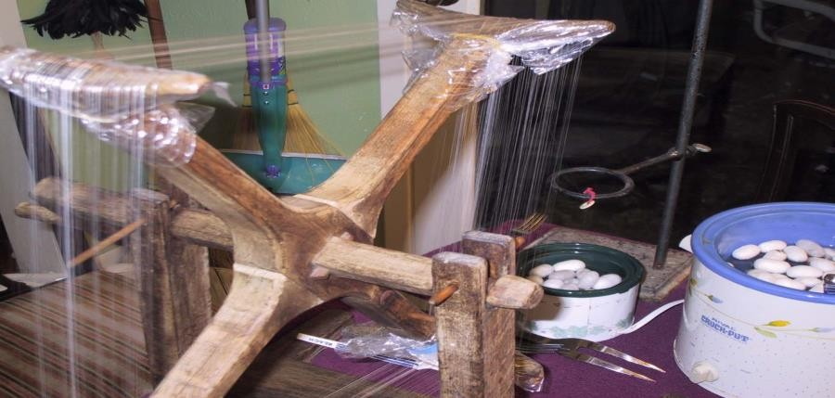

**Fig: 1.17** Reeling



**Fig: 1.18** Twisting

* + 1. **Weaving:**

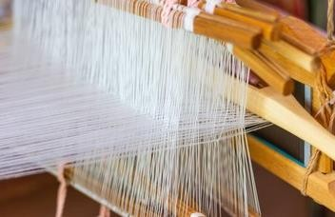Silk yarn is transformed into a silk fabric by weaving the threads. There are many ways to weave silk. One of the most popular methods for weaving silk is called charmeuse, also known as satin. The charmeuse weave is a tight weave that results in a smooth and shiny silk fabric. Silk charmeuse fabrics have a glossy surface and a dull back. This look is achieved by floating the lengthwise thread over three or more transverse threads.

* 1. **LITERATURE REVIEW:**
     1. **Daiqi Liab, Bin Tang a b, Xi Luc, Wu Chena, Xiongwei Donga, Jinfeng Wang b: Hierarchically carbonized silk/ceramic composites for electro-thermal conversion:** This research simplified the process of making carbon fiber/ceramic composites by combining the steps of carbonizing fibers and ceramizing ceramic precursors into one. They used silk fabric and silkworm cocoons as raw materials and heated them together to make the composites. This method created both carbonization and mullite formation simultaneously in a nitrogen environment. The resulting composites made from three-layer silk fabric heated to over 100°C in 30 seconds and stabilized at 239°C after 540 seconds when a 10V voltage was applied. These composites also had stable heating cycles, even heat distribution, and electromagnetic shielding properties, suggesting potential for use in various applications, especially in electro-thermal conversion.
     2. **Sanyukta Gupta: Preparation and characterization of waste Silk fiber reinforced polymer composites:** Synthetic fiber-reinforced polymer composites offer high stiffness and strength-to- weight ratio but face declining use due to cost and environmental concerns. Natural fibers, including silk, are gaining attention for being biodegradable, low-cost, and strong. Waste silk fibers from silk manufacturing, known locally as "Ghincha," are being explored for value-added applications. This study investigates the preparation and characterization of epoxy composites with varying amounts of waste silk fibers. Experiments were conducted under different environmental conditions, and shear strength was evaluated. The erosion wear behavior of silk fiber composites and hybrids with jute and synthetic fiber glass was also studied. Results suggest potential applications in partition boards, false ceilings, doors, and window panels due to their environmental resilience and improved erosion resistance through hybridization.
     3. **Fritz Vollrath, Fujia Chen and David Porter: silks and their composites:** Silk polymers have evolved as key structural components in a wide range of animal constructions. Examination of both silk fibres and silk structures, be they gossamer webs or paper-like cocoons, reveals intriguing insights into Nature’s way of making materials and composites of considerable potential for novel insights with practical implications.
     4. [**Feng Wang**](https://pubmed.ncbi.nlm.nih.gov/?term=Wang%20F%5BAuthor%5D)**,** [**Chengchen Guo**](https://pubmed.ncbi.nlm.nih.gov/?term=Guo%20C%5BAuthor%5D)**,** [**Chunmei Li,**](https://pubmed.ncbi.nlm.nih.gov/?term=Li%20C%5BAuthor%5D)[**Ping Zhao**](https://pubmed.ncbi.nlm.nih.gov/?term=Zhao%20P%5BAuthor%5D)**,** [**Qingyou Xia**](https://pubmed.ncbi.nlm.nih.gov/?term=Xia%20Q%5BAuthor%5D) **and** [**David L. Kaplan**](https://pubmed.ncbi.nlm.nih.gov/?term=Kaplan%20DL%5BAuthor%5D)**: Protein composites from silkworm cocoons as versatile biomaterials:** The research is exploring innovative ways to utilize both fibroin and sericin proteins from silk in biomedical applications. By creating fibroin-sericin protein composites directly from whole cocoons, you're leveraging the beneficial properties of both components while simplifying the fabrication process. This approach could indeed open up new possibilities for materials in biomedical contexts, offering advantages in terms of processing and resulting properties.
     5. **S. M. Darshan, B.Suresha, G.S.Divya: Waste Silk Fiber Reinforced Polymer Matrix Composites:** A Review: Researchers, engineers, and scientists are increasingly interested in using natural fibers as an alternative to synthetic fibers in fiber reinforced polymer composites (FRPCs). Natural fibers, like silk, are appealing because they are inexpensive, have good mechanical properties, are environmentally friendly, and biodegradable. Silk, in particular, is highly valued and has various uses, including in textiles and as reinforcement in composite parts for automotive applications. This paper examines the use of waste silk fibers in FRPCs, discussing processing methods, mechanical properties, and challenges in characterization. The findings can contribute to advancements in the automotive sector.
     6. **Sanyukta Gupta: Preparation and characterization of waste Silk fiber reinforced polymer composites:** Synthetic fiber-reinforced polymer composites offer high stiffness and strength-to- weight ratio but face declining use due to cost and environmental concerns. Natural fibers, including silk, are gaining attention for being biodegradable, low-cost, and strong. Waste silk fibers from silk manufacturing, known locally as "Ghincha," are being explored for value-added applications. This study investigates the preparation and characterization of epoxy composites with varying amounts of waste silk fibers. Experiments were conducted under different environmental conditions, and shear strength was evaluated. The erosion wear behavior of silk fiber composites and hybrids with jute and synthetic fiber glass was also studied. Results suggest potential applications in partition boards, false ceilings, doors, and window panels due to their environmental resilience and improved erosion resistance through hybridization.
     7. **Jiayun Hu, Yan Zhang, Chunling Liang, Ping Wang, Dongmei Hu:** The preparation and chara-cteristics of high puncture resistant composites inspired by natural silk cocoon: Bombyx mori cocoon, a natural nonwoven material has excellent puncture resistance and unique structure. Based

on the structure of cocoon, this paper designed a biomimicry composite, aiming to improve the static puncture resistance through [polyurethane](https://www.sciencedirect.com/topics/materials-science/polyurethane) impregnated treatment. In this article, four different types of [polyurethane](https://www.sciencedirect.com/topics/materials-science/polyurethane) (TPU 85 A, TPU 90 A, PEUR 855 A, PEUR 991 A) are selected and five concentration gradients (5, 7, 9, 11, 13 wt%) are set. The tensile and static puncture resistance of the impregnated composites and damaged morphology after puncture are systematically studied. The results show that the static puncture resistance of nonwovens impregnated by polyurethane is improved obviously. This study provides a new way to design better static puncture resistant materials.

**MATERIALS**

**PREPARATION OF MATRIX MATERIAL**

The preparation of the matrix material is a critical step in the fabrication of composite materials using silk cocoon threads.

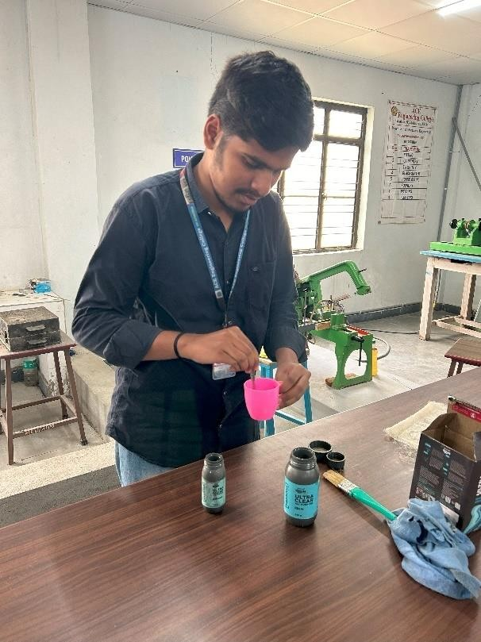

**Fig: 5.1** Mixing Resin

Fabrication process

The fabrication process of composite materials using silk cocoon threads involves a series of steps aimed at combining the reinforcement fibers (silk cocoon threads) with a matrix material (resin) to produce a composite structure with enhanced mechanical properties and performance.

* 1. **MOLD PREPARATION**

Mold preparation is a crucial step in the fabrication process of composite materials using silk cocoon threads. A well-prepared mold ensures the accurate shaping and curing of the composite structure, ultimately determining the quality and integrity of the final product.

The mold serves as the negative form into which the composite materials are placed and shaped during the fabrication process. Proper mold preparation is essential to achieve the desired shape, surface finish, and dimensional accuracy of the composite part. The type of mold used (e.g., rigid, flexible) and the mold surface treatment can significantly influence the fabrication process and the properties of the final composite.

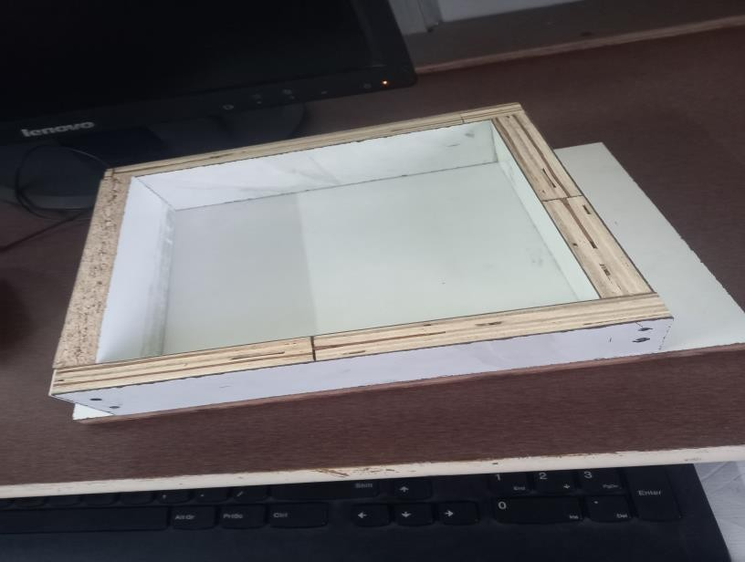

**Fig: 6.1** Mold preparation

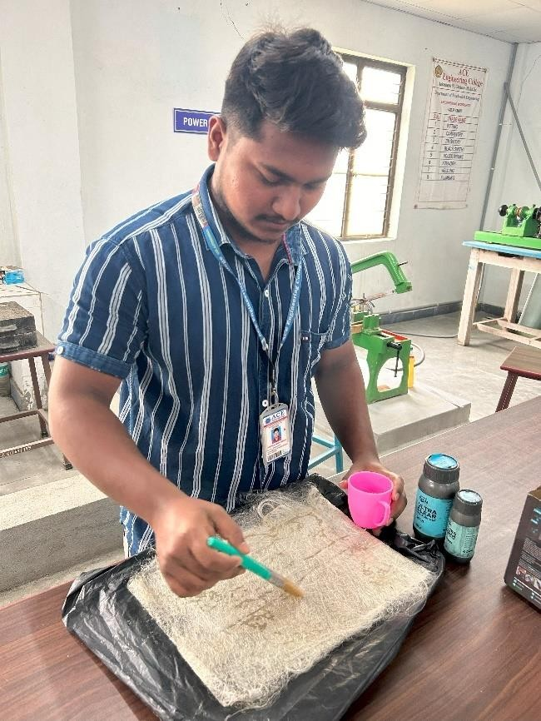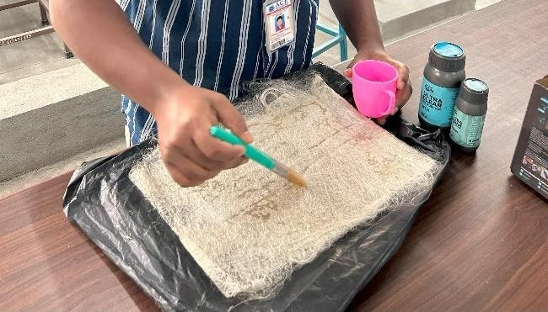

**Fig: 6.14** Applying resin to cocoon matrix

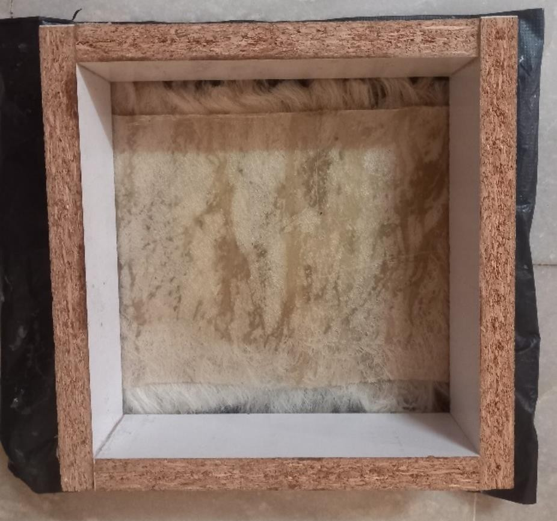

**Fig: 6.15** Before Curing

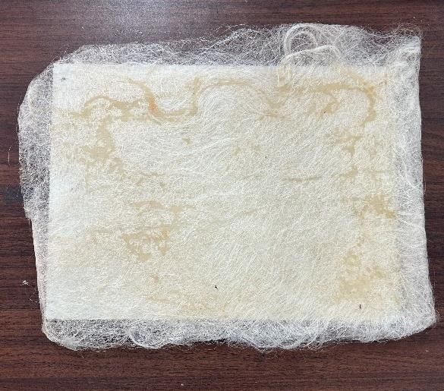

**TESTING AND EVALUVATION**

Testing and evaluation are essential aspects of the fabrication process for composite materials using silk cocoon threads. They ensure that the final composite products meet specified standards for mechanical performance, dimensional accuracy, and overall quality.

* 1. **TENSILE TEST**

A tensile test, also known as tension test, is a common mechanical test used to evaluate the mechanical properties of materials, including composite materials fabricated using silk cocoon threads. Here's an introduction to the tensile test:

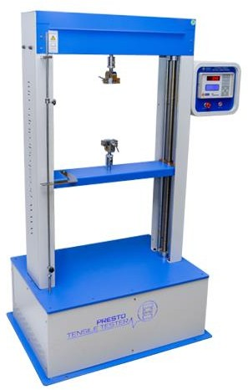

**Fig: 7.1** Universal Testing Machine

* + 1. **Purpose:**

The purpose of a tensile test is to determine how a material responds to axial stretching forces, allowing for the measurement of key mechanical properties such as tensile strength, elongation at break, modulus of elasticity, and yield strength.

* + 1. **Procedure:**
       - Specimen Preparation:

Test specimens are prepared from the composite material, typically in the form of flat or cylindrical samples with standardized dimensions. Care is taken to ensure that the specimens are free from

defects and manufactured according to relevant standards.

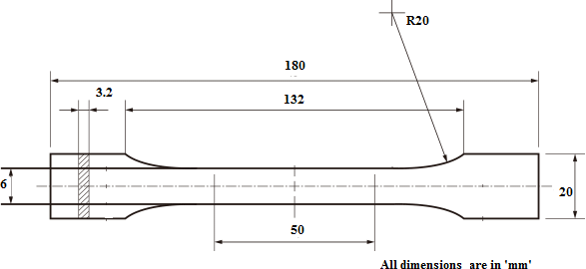

* + - * Mounting the Specimen:

**Fig: 7.2** Specimen size

The specimen is securely mounted onto the grips of a tensile testing machine, which applies a controlled axial load to the specimen. The grips ensure proper alignment and distribution of the applied force.

* + - * Application of Load:

The tensile testing machine applies a gradually increasing tensile force to the specimen at a constant rate. The rate of loading is specified by relevant testing standards and can vary depending on the material and desired test parameters.

* + - * Measurement of Load and Deformation:

Throughout the test, the tensile testing machine continuously measures the applied load and the corresponding deformation (strain) experienced by the specimen.

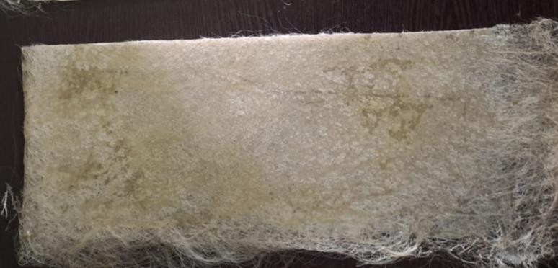

**Fig: 7.3** Before Tensile Test

* + - * Analysis of Results:

The tensile test generates a stress-strain curve, which plots the relationship between applied stress (force per unit area) and strain (deformation) experienced by the specimen. Key parameters such as tensile strength, yield strength, modulus of elasticity, and elongation at break are determined from the stress-strain curve.

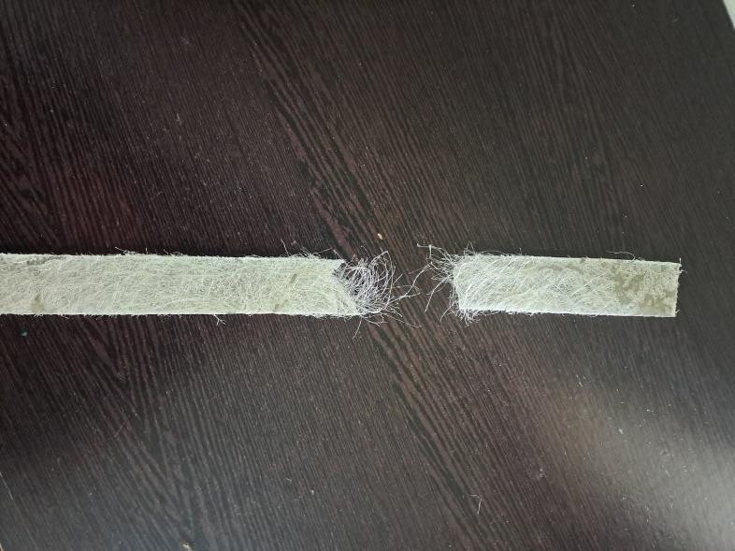

* + - * Failure Analysis:

**Fig: 7.4** After Tensile Test

The test continues until the specimen fractures or breaks. The mode of failure, whether it's a sudden rupture or gradual necking, provides valuable insights into the material's behavior under tension and its structural integrity.

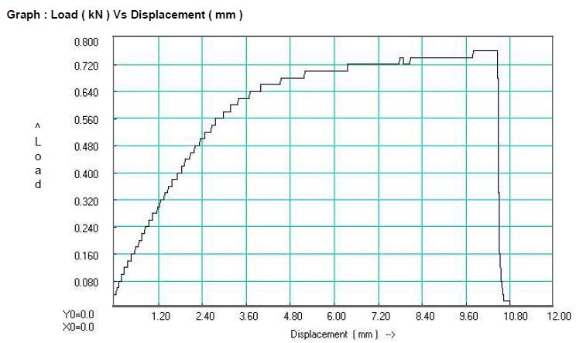

**Fig: 7.5** Load vs Displacement graph

* + 1. **Significance:**
       - Tensile testing provides valuable data on the mechanical properties of composite materials, including their strength, stiffness, ductility, and toughness.
       - The results of tensile tests help engineers and designers understand how materials behave under tension and inform material selection, structural design, and performance optimization.
       - Tensile testing is widely used in quality control, material certification, research, and development across various industries, including aerospace, automotive, construction, and manufacturing.
  1. **ELONGATION TEST**

An elongation test, also known as an elongation at break test or simply elongation test, is a mechanical test used to measure the extent to which a material stretches or deforms before breaking under tension.

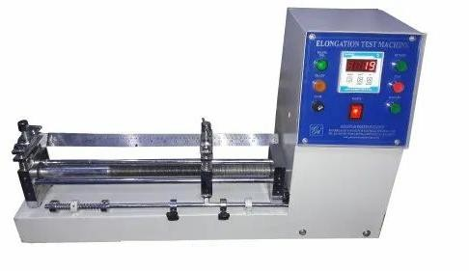

**Fig: 7.6** Elongation Testing equipment

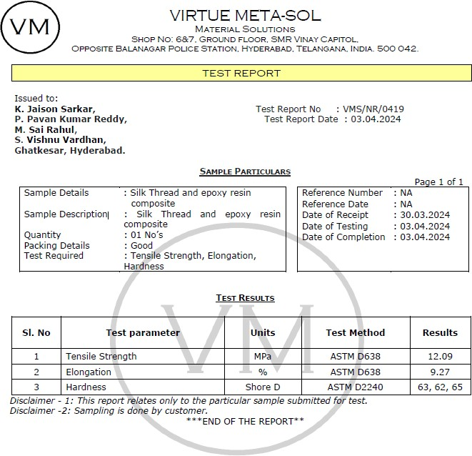

F**ig 7.8** Test report

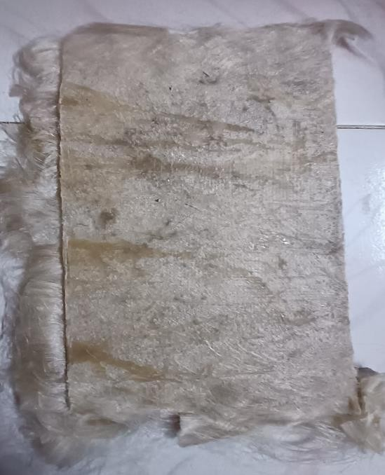

**Fig: 7.12** Before Impact Test

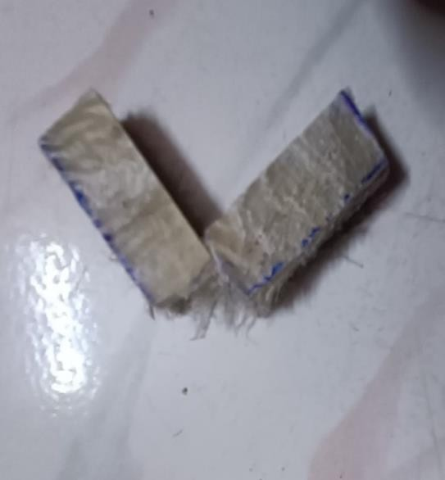

**Fig: 7.13** After Impact Test

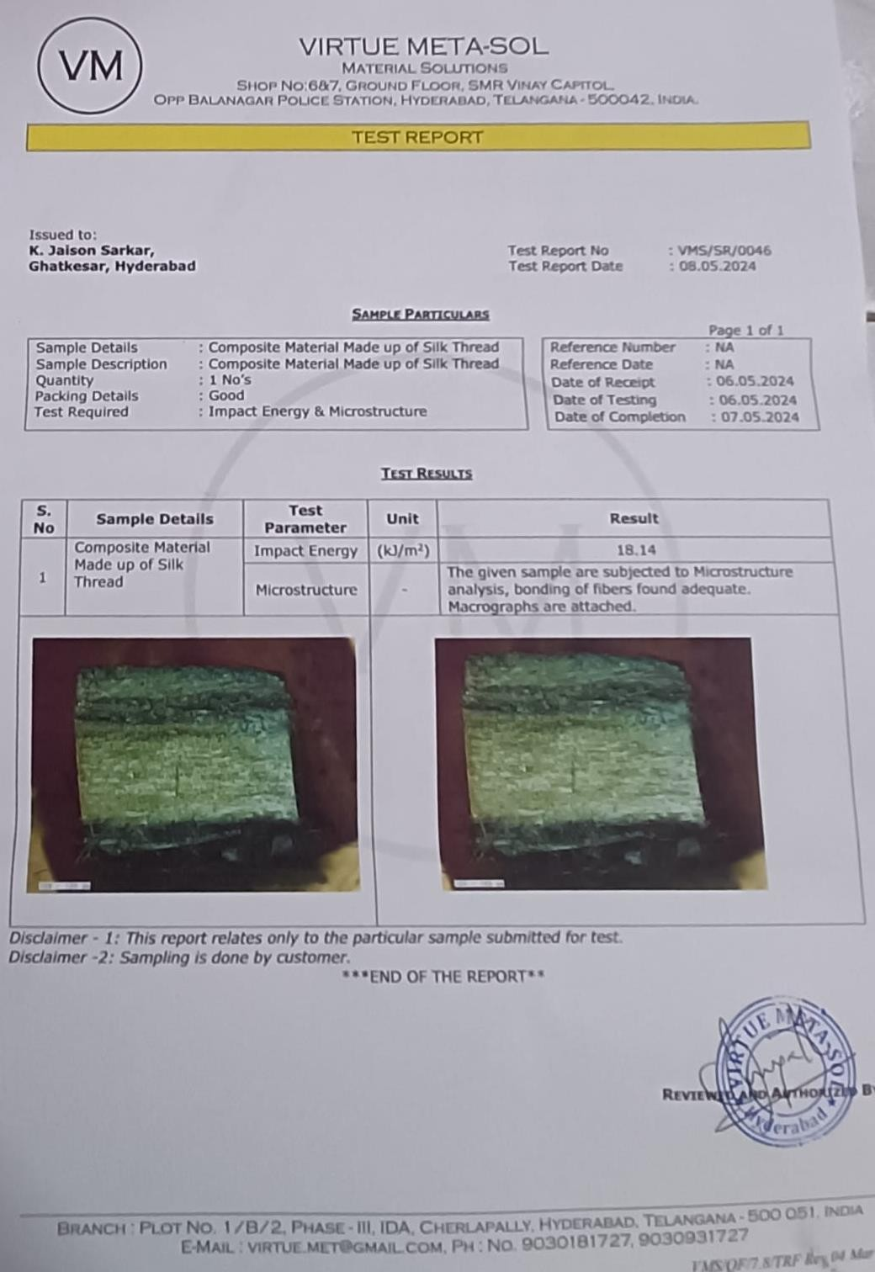

**Fig: 7.15** Test result

**CONCLUSION**

In conclusion, the fabrication of composite materials using silk cocoon threads presents a versatile and promising avenue for innovation across various industries. Through meticulous attention to detail and adherence to best practices, manufacturers can harness the unique properties of silk cocoon threads to create composite materials with exceptional strength, lightweight, flexibility, and biocompatibility.

This project has highlighted the comprehensive process involved in fabricating composite materials using silk cocoon threads, covering crucial aspects such as material selection, preparation, impregnation, curing, and quality control. Additionally, it has explored various testing methods and considerations, including tensile testing, elongation testing, hardness testing, microstructure testing, as well as safety and environmental considerations.

The wide range of applications for these composite materials, spanning aerospace, automotive, biomedical, sporting goods, architectural, and construction industries, underscores their versatility and potential impact. Furthermore, the future scope of research and development offers exciting opportunities for advanced manufacturing techniques, functionalization, biomedical innovations, sustainable materials development, and integration of smart materials.

It is essential to emphasize the importance of safety and environmental considerations throughout the fabrication process and product life cycle. By prioritizing safety measures, selecting eco- friendly materials, and adopting sustainable practices, manufacturers can ensure the responsible production and use of composite materials fabricated using silk cocoon threads, thereby contributing to a more sustainable and environmentally conscious future.

In summary, the fabrication of composite materials using silk cocoon threads represents a convergence of tradition and innovation, offering endless possibilities for enhancing performance, efficiency, and sustainability across industries. With continued research, collaboration, and technological advancement, these composite materials are poised to revolutionize various sectors and drive positive change in the global landscape.

**REFERENCES**

[1] Singh, R., & Sagar, M. P. (2023). "Protein composites from silkworm cocoons as versatile biomaterials." ScienceDirect.

[2] Ling, S., & Kaplan, D. L. (2023). "Silk-based bioinspired structural and functional materials." ScienceDirect.

[3] Zhan, Y., et al. (2024). "Flat-Silk-Cocoon-Based Wearable Flexible Piezoresistive Sensor and Its Performance." Polymers.

[4] Mahesh, S., & Venkatesh, R. (2023). "Review on Fabrication and Application of Regenerated Bombyx mori Silk." De Gruyter.

[5] Park, J., & Lee, S. (2023). "Fabrication, Structure, and Properties of Nonwoven Silk Fabrics Prepared with Different Cocoon Layers." International Journal of Molecular Sciences.

[6] Rajkhowa, R., et al. (2023). "Optimization of mechanical properties of silk fiber-reinforced composites." SAGE Journals.

[7] Chen, X., & Shao, Z. (2023). "Silk microfiber-reinforced silk composite scaffolds: Fabrication and evaluation." Springer.

[8] Zhang, X., et al. (2023). "Design and Fabrication of Silk Templated Electronic Yarns and Textiles." ScienceDirect.

[9] Jovicic, D., et al. (2024). "Antibiotics-free wound dressing combating bacterial infections using silk cocoon shells." ScienceDirect.

[10] Wang, Y., & Cheng, Q. (2023). "Polypyrrole coated silk fibroin microfibers for wearable sensors." Elsevier.

[11] Yao, J., et al. (2023). "Synthesis and application of silk fibroin-based nanocomposites." Wiley Online Library.

[12] Li, C., et al. (2023). "Fabrication of silk fiber-based composite sponges for efficient oil-water separation." Springer.

[13] Guo, J., et al. (2023). "Electrospun silk fibroin nanofibers for tissue engineering applications." MDPI.

[14] Tang, S., et al. (2024). "Development of bio-based composites using silk fibroin and natural polymers." Springer.

[15] Wu, X., & Huang, Y. (2023). "Characterization of silk fibroin-based biodegradable composites." Elsevier.

[16] Chen, Z., et al. (2023). "Preparation and properties of silk fibroin/hydroxyapatite composite scaffolds." Wiley Online Library.

[17] Fan, L., & Gao, C. (2023). "Biodegradable silk fibroin-based hydrogels for drug delivery." MDPI.

[18] Zhao, Y., et al. (2023). "Enhancing the mechanical properties of silk fibroin films with graphene oxide." ScienceDirect.

[19] Wang, F., et al. (2023). "Development of silk fibroin-based films for food packaging applications." Springer.

[20] Kim, H., & Park, K. (2023). "Electrochemical sensors based on silk fibroin composites for biomedical applications." Wiley Online Library.