**Bluetooth Control Mars Rover**

Shaibaz Sheikh, Pritam Dabekar, Prof Manas M Ramteke

Department of Electronics and Telecommunication Engineering,

Shri Sai College of Engineering and Technology Bhadrawati , Maharashtra, India

# 

# Abstract

This project presents the development of a Bluetooth-controlled off-roading robot designed for applications in challenging environments such as mines and space exploration. The robot utilizes an Arduino Uno microcontroller, an HC-05 Bluetooth module, and six 12V gear motors arranged in a rover-type structure with improved stability and traction. The motors are controlled through a motor driver module, enabling precise speed and direction control. The HC-05 Bluetooth module enables wireless communication with the robot, allowing remote control using a Bluetooth-enabled device. The project highlights the successful integration of the Arduino platform, Bluetooth communication, and off-roading capabilities into a single robot system. Future enhancements may include the incorporation of obstacle detection sensors for autonomous navigation and adapting the robot for extreme environmental conditions. The versatility and adaptability of the developed robot make it a promising solution for off-roading applications in mines and space exploration, providing remote control capabilities in challenging terrains.

***Keywords****: Arduino UNO, Arduino IDE, Bluetooth Module, Li ion Battery, BMS*

# Introduction

In the field of robotics, there is a growing need for versatile and rugged robots capable of navigating rough and challenging terrains. Such robots find applications in environments like mines and space exploration, where traditional wheeled robots often struggle to maneuver effectively. This project aims to address this need by developing a Bluetooth-controlled off-roading robot capable of traversing rough surfaces with ease.

The robot utilizes an Arduino Uno microcontroller, an HC-05 Bluetooth module, and a unique rover-type structure with six wheels instead of the conventional four. The six-wheel configuration provides enhanced stability and traction, allowing the robot to overcome obstacles and tackle uneven terrain.

The integration of an HC-05 Bluetooth module enables wireless control of the robot from a Bluetooth-enabled device, such as a smartphone or a computer. This wireless control functionality allows operators to remotely navigate the robot through challenging environments, reducing the need for direct human intervention and enhancing safety in hazardous conditions.

By combining the power of Arduino for motor control, the convenience of Bluetooth communication, and the robustness of the six-wheel rover design, this project aims to create a versatile and reliable off-roading robot suitable for applications in mines and space exploration.

## Objectives

The main objective of this project is to design and develop a Bluetooth-controlled off-roading robot capable of navigating rough terrains in applications such as mines and space exploration. The specific goals include:

1. Designing a robust rover-type structure with six wheels to provide enhanced stability and traction on challenging surfaces.
2. Integrating an Arduino Uno microcontroller to control the six 12V gear motors for precise speed and direction control.
3. Incorporating an HC-05 Bluetooth module for wireless communication, enabling remote control of the robot from a Bluetooth-enabled device.
4. Ensuring the robot's capability to traverse rough terrains and adapt to challenging environments, allowing it to operate effectively in mines and space exploration settings.
5. Exploring the potential for future enhancements, such as the integration of obstacle detection sensors for autonomous navigation or modifications to adapt the robot for extreme environmental conditions.

By achieving these objectives, the project aims to provide a versatile and reliable off-roading robot platform that can be remotely controlled and deployed in challenging terrains, contributing to advancements in industries such as mining and space exploration.

**Block Diagram**

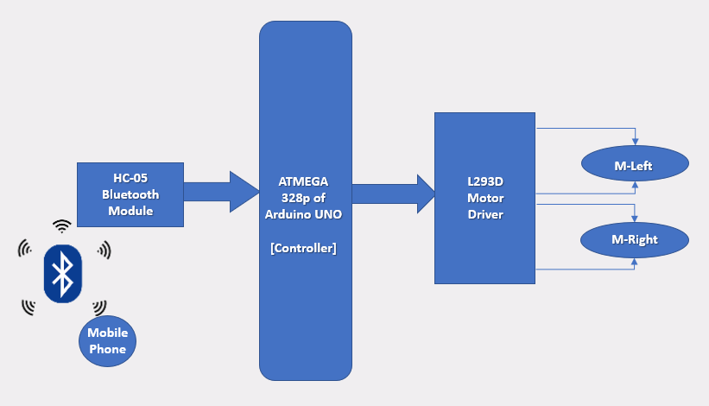

### Circuit Diagram

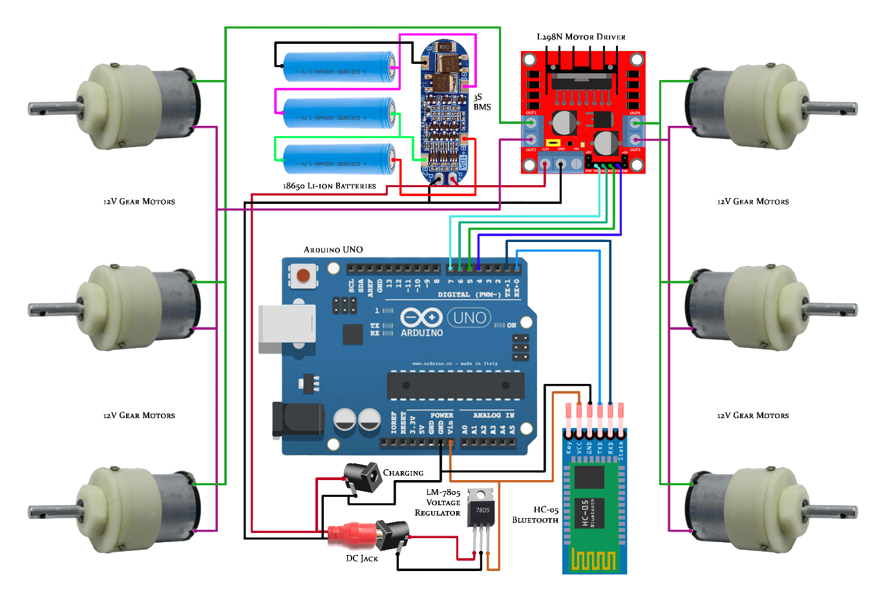

### Working

The Bluetooth module HC05 is connected to the Arduino board through simple single strand wires. The transmission pin of the Bluetooth module is connected to the receiver pin of Arduino and the receiver pin of the Bluetooth module is connected to the transmission pin of the Arduino. The Digital output pins 9, 10, 11 and 12 of Arduino board are connected to the pins 4, 10, 7 and 2 of the L298N motor driver IC respectively.

Two rechargeable batteries as supply is used which is connected to motor driver and Arduino respectively. When the circuit is energized, we will have to first pair the android phone with the Bluetooth module through the phones Bluetooth setting. The default password of the Bluetooth module will be 1234. Once the phone gets paired open the application "Bluetooth Remote Controller" which we can downloaded from Google play store. After connecting the mobile to HC05, four options will appear on the application-Controller mode, Switch mode, Dimmer mode and Terminal mode. We have to select the Controller mode from it. The controller mode will provide us a joystick interface. We will send ASCII values from the application to the Bluetooth module. As the user presses any control buttons, the controller will run programs move forward, backward, right, left, depending on the data sent by the mobile and the car moves likewise. The Arduino also stores the program in its memory so it does not require re uploading of Program. The IN1, IN2, IN3 and IN4 are the inputs for the motor driver that receives command from the Arduino for the two motors respectively. The motor driver should be grounded with the Arduino ground pin (GND). The motor driver requires minimum of 6v and above to run, any voltage below 6v the motor remains off. The RXD pin of the Bluetooth module is for receiving commands from the Android devices and sends to Arduino through this pin and the TXD is for transmitting or sending dates or information's It is supplied with a 5v de source from the Arduino 5v pin. The main part of the above circuit diagram is Arduino UNO. The power supply section is very important. It should provide constant voltage to the devices for successful working of the project.

## Conclusions

In conclusion, this project successfully achieved the design and development of a Bluetooth-controlled off-roading robot for applications in rough terrains such as mines and space exploration. The integration of an Arduino Uno microcontroller, HC-05 Bluetooth module, and a rover-type structure with six wheels enabled the robot to navigate challenging environments with enhanced stability and traction.

Through this project, we demonstrated the feasibility of remote-control using Bluetooth technology, allowing users to wirelessly operate the robot from a Bluetooth-enabled device. The robot showcased its capability to traverse rough terrains and adapt to various challenging surfaces, showcasing its potential for off-roading applications.

The developed Bluetooth-controlled off-roading robot serves as a promising platform for further research and development in the field of robotics, particularly in mining operations and space exploration

## Future Scope

Future enhancements for this robot could include the integration of obstacle detection sensors, such as ultrasonic or infrared sensors, to enable autonomous navigation and obstacle avoidance. Additionally, modifications to withstand extreme environmental conditions, such as temperature and low visibility, could be explored to further enhance its utility in specific applications.

**References**

[1]. Jignesh Patolia, Haard Mehta, Hitesh Patel, Patel.V.T. “Arduino Controlled War Field Spy Robot Using Nightvision Camera And

[2] Android Application”. Department of Electronics And Communication of Engineering,Charotar University of Science And Technology, Changa, Anand, Gujarat - 388421,India.(2015)

[3]. Mohammad Shoeb Shah, Borole. P.B. “Surveillance And Rescue Robot Using Android Smart Phone And Internet”. International Conference on Communication And Signal Processing, India. (2016)

[4]. Manish Yadhav, Vibha Singh, Vinay Uniyal, Manish Singh. “Smart Aero Amphibian Surveillance System” Department of Electronics Engineering, Thakur College Of Engineering And Technology, Mumbai, India.(2016)

[5]. Chinmay Kulkarni, Suhas Grama, Pramod Gubbi Suresh, Chaitanya Krishna, Joseph Antony. “Surveillance Robot Using Arduino Microcontroller, Android Apis and Internet”. Department of Electronics And Communication Engineering, National Institute of Technology, Karnataka, Surathkal, Mangalore, India.(2014)

[6]. Dr. Shaik Mahaboob Basha, Abdul Khayyum. S.K, Amarendra.B, Sajid.S.K. “Design Of Security Robot in Night Vision Using Wireless Video Camera And Ultrasonic Sensor” Geethanjali Institute of Science And Technology, Nellore, Andhra Pradesh, India.(2017)

[7]. Shaik Shoeb Maroof Nasima, Ansari Asgar Ali Shamshul Haque Shakina. “Surveillance Robot Controlled Using An Android Application”. Department of Computer Engineering, School Of Engineering and Technology, Anjumaan-I- Islam’s Kalsekar Technical Campus, Mumbai, India. (2015)

[8]. m Merlin Ruby.K.M, Anne Jenefer.F, Vidhya.D. “Study of Arduino Controlled Robotic System” Department of Electronics and Communication Engineering, Panimalar Engineering College, Chennai, India. (2016)