**Using Machine Learning Algorithms for Efficient Missing Person Search and Rescue Operations with VisiSearch**

**S. Mohamed Fahad 1 , S. Nirmala Sugirtha Rajini 2**

**1. PG Student 2. Professor**

**1.** [**mofadh0@gmail.com**](mailto:mofadh0@gmail.com) **2. nirmalasugirtharajini.mca@drmgr.ac.in**

**Department of Computer Applications**

**Dr. M.G.R. Educational and Research Institute, Chennai – 95.**

**ABSTRACT**

In recent years, a rise in missing person cases has posed challenges for law enforcement. This article explores the persistent mystery surrounding many unresolved cases and aims to uncover contributing factors. Using a detailed analysis of police records, our study identifies patterns and challenges in resolving missing person cases. By understanding these dynamics, law enforcement agencies can refine strategies to enhance the likelihood of resolution, emphasizing the critical need for effective measures in addressing the growing issue of missing persons. Additionally, this article proposes an innovative approach to locating missing persons using Machine Learning algorithms, specifically SVM and KNN. Utilizing facial expressions as the basis for model training, our system swiftly and accurately identifies known individuals. The system, fed with a missing person dataset from Kaggle, outputs the person's identity based on features like gender, age, and location. Results are then communicated to the police for further investigation. This streamlined approach enhances the efficiency of the search and identification process, contributing to more effective resolutions of missing person cases. The proposed system serves as a valuable tool for law enforcement in expediting investigations and addressing the critical issue of missing persons in a timely and efficient manner.

**Keywords**: Missing person Machine Learning, Support Vector Machine, k-Nearest Neighbors, Face recognition, Identification, Classification, Facial expressions, Virtual search.

**I.**  **INTRODUCTION**

Machine learning algorithms are increasingly being used for missing person search and rescue operations. These algorithms can be utilized to analyse large datasets and identify correlations and patterns, particularly in the analysis of behavioural patterns of missing persons prior to their disappearance. The vanishing of individuals is a complex issue with various implications, impacting both public safety and law enforcement resources. It also imposes emotional distress on the families of the missing individuals. Law enforcement agencies often face challenges in conducting searches, often with uncertain outcomes [1]. We used two algorithms, namely K-Nearest Neighbors, Support Vector Machine

Current methods for locating missing persons, such as word of mouth, media announcements, and social media, are slow and ineffective, particularly in time-sensitive situations. Because of that many of cases remain unresolved for years. So that Implementing a facial recognition system with deep learning capabilities could significantly expedite the search process for Police agencies and concerned friends and families [2].

For that Image classification is employed to match similar images and discern image properties based on predefined patterns. This involves segmenting specific regions of an image and comparing them with existing images. Similar portions of images are identified through pixel clustering based on threshold values. This entails matching segmented images with predefined database images. The proposed technique offers a promising solution for locating missing individuals involved in illicit activities [3].

Face recognition is a biometric technology that analyses an individual's facial features and stores the data as a face print, using Machine Learning to generate a feature vector representing the face. Major organizations like Google and Facebook utilize this technology to establish digital profiles for their users; by using face recognition technology, these criminals can be identified from images or video frames captured by cameras installed in various locations, and it can also aid in identifying missing children. However, a challenge arises from the often blurred and unclear images captured [4]. Thats why we use KNN and SVM to compare and predict the result with good accuracy.

The public can upload images of suspicious children to a centralized portal along with relevant details. These images are then automatically compared with registered photos of missing children in a repository. The input child image undergoes classification, and the best match is selected from the missing children database. While child recognition is performed by a trained SVM classifier, we create a model that is robust to various factors such as noise, illumination, occlusion, and age of the child, surpassing previous methods in identifying missing children based on facial recognition [5]. This model incorporates an automated facial recognition system designed for identifying missing individuals, particularly children, and stores their data in a database. The system then categorizes individuals based on factors like age group, presence of distinguishing marks, and facial hair. When a missing person is found after an extended period, the system conducts a matching process based on these categories and provides the corresponding results.

**II. LITERATURE SURVEY**

Shin et al. (2021) introduced a novel approach to locating missing individuals utilizing face-recognition technology and deep learning that presents the development of a real-time face-recognition system which enhances face verification accuracy and identification by integrating data reinforcement for face recognition and convolutional neural network (CNN)-based image learning. After image preprocessing, which occurs upon transmission from a mobile device, the system effectively identifies missing persons. Results indicate that the model trained on both original and blur-processed data achieved the highest performance [6].

Ruiz-Rizzo et al. (2022) in his case study shows, Missing persons, especially older adults, pose significant challenges for society. This study used machine learning to predict whether missing older adults would be found, analysing data from Colombia spanning from 1930 to June 2021. The best-performing algorithms were gradient boosting methods, showing notable improvements in predicting outcomes compared to basic models. Key factors influencing predictions included the duration of disappearance, location, age, and gender of the missing individual. These findings offer valuable insights and potential applications for locating missing older adults [7].

Singh et al. (2022) employs a challenging endeavour despite the prevalence of social media. It offers a solution that accelerates the procedure, benefiting both law enforcement and the general public by employing face recognition as the search method. When a person goes missing, their guardian can upload a photograph to the system, where it is stored. The facial recognition model then scans the database for a match. Upon finding a match, both the police and the guardian are promptly notified [8].

Keshava et al. (2020) states that a novel deep learning method is used to locate individuals. Users upload suspect images to a platform, which verifies them against a database of missing persons. Deep learning models trained for accurate recognition, especially in facial recognition, are employed. Convolutional neural networks (CNNs) and robust techniques extract features and match them with missing person images. This approach ensures high precision despite variations in lighting, pose, and other factors [9].

Sai et al. (2022) emphasizes a VGG16 deep learning model for matching person images. VGG-16, a pre-trained model trained on millions of images, provides the weights utilized in our work. This methodology involves several steps: data preprocessing, data augmentation, VGG-16 implementation, and model training and testing. The model achieves a training accuracy of 90.01% and a testing accuracy of 85.21% [10].

**III. PROPOSED SYSTEM**

We propose a comprehensive system architecture tailored for police stations, integrating an advanced face recognition algorithm based on the K-Nearest Neighbors (KNN) approach. This hybrid system streamlines the identification process, allowing prompt actions by law enforcement and informing citizens about incidents in their vicinity. The workflow involves uploading photos and details of missing persons, encoding and classifying images (e.g., by age group, presence of spectacles) using KNN or SVM algorithms. Face detection and data storage occur when a person files a complaint at the police station. When a missing person is located, their image is compared with stored images using KNN. If a match is found, the status is updated; otherwise, a new complaint is stored.

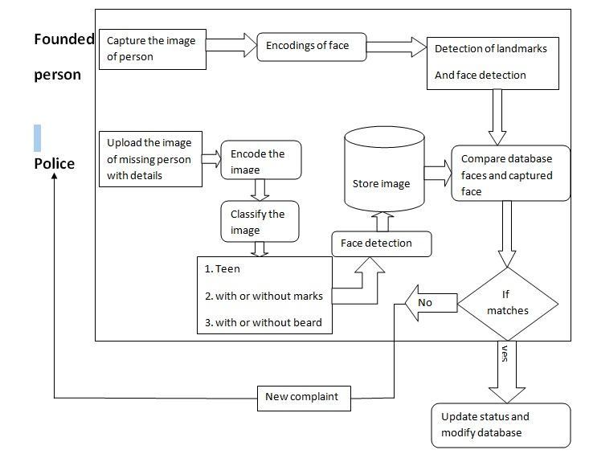

***Figure 1: Architecture of the proposed system***

Figure 1. demonstrates the architecture diagram for the proposed system. This system works by uploading the photo of the missed person then the captured image undergoes encoding phase. After encoding, the classified image is then stored to the database. The photo taken from the surveillance system or uploaded by another person also undergoes the encoding process and it stores to the database. After storing, the captured image is compared with the database to found a match. If the match is found, it returns information of the person otherwise it asks file new complaint.

**INPUT PARAMETERS**

Our model for locating missing individuals has been trained using a dataset obtained from Kaggle. This dataset encompasses various input features essential for analysis, which includes: Name, Age, Fathers name, mobile, Facial Image. Utilizing these input parameters from the Kaggle dataset, our model has been trained effectively using machine learning algorithms, specifically KNN (K-Nearest Neighbors) and SVM (Support Vector Machine), to aid in the identification of missing persons.

**MODULES**

The KNN algorithm cross-checks vectors with the database using Euclidean distance to find matches for a new face. SVM, a supervised learning algorithm, excels in classification by determining a hyperplane in an N-dimensional space to distinctly classify data points.

The modules are:

1.Registering Case

Initially, the user upload the images and details of missing person. Police take it as complaint and store it in the database.

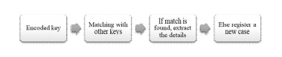

***Figure 2. Registering case***

2. Capturing Facial Landmarks

After capturing the image, it recognizes the facial points of the image and encode the facial characteristic and then store the encoded key in the database



***Figure 3. Encoding the key***

3. Navigating a Database

After generating the encoded key it is then compared with the keys of other photos. When a photo of the identified individual is captured, the system initiates the face encoding and detection process. Subsequently, it compares the captured photo with stored images. If a match is identified, the status is updated. In case of no match, the system registers it as a new complaint and stores the information accordingly.

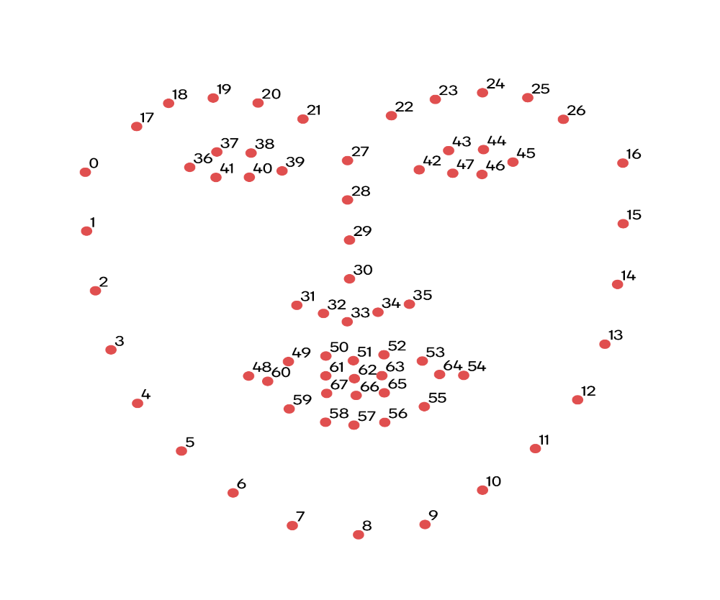

***Figure 4. Look Through Database***

**ALGORITHMS USED:**

1. **KNN ALGORITHM**

The K-Nearest Neighbors (KNN) algorithm is a fundamental and versatile machine learning approach. It falls under the category of supervised learning and is primarily used for classification tasks, though it can be adapted for regression as well. The central concept behind KNN is based on proximity - it classifies a data point by considering the labels of its k-nearest neighbours in the feature space. The algorithm calculates distances, often using metrics like Euclidean distance, to identify the nearest neighbours. Once the neighbours are determined, the majority class among them is assigned to the target data point. KNN's simplicity and effectiveness make it valuable for various applications, such as image recognition, recommendation systems, and anomaly detection. However, its performance can be sensitive to the choice of the distance metric and the value of k, requiring careful consideration in the model development process.

# KNN Algorithm

from sklearn.neighbors import KNeighborsClassifierfrom sklearn.model_selection import train_test_splitfrom sklearn.metrics import accuracy_scoreX_train, X_test, y_train, y_test = train_test_split(features, labels, test_size=0.25, random_state=42)knn_classifier = KNeighborsClassifier(n_neighbors=3)knn_classifier.fit(X_train, y_train)accuracy = accuracy_score(y_test, knn_classifier.predict(X_test)

1. **SVM ALGORITHM**

The Support Vector Machine (SVM) stands out as one of the most widely utilized algorithms in Supervised Learning. It finds application in both Classification and Regression tasks, though its primary domain lies in Classification within the realm of Machine Learning.

Essentially, the SVM algorithm aims to establish an optimal line or decision boundary capable of delineating n-dimensional space into distinct classes. This ensures seamless categorization of new data points in subsequent instances. Termed a hyperplane, this optimal decision boundary is pivotal to SVM's operation.

SVM strategically selects the extreme points or vectors crucial for delineating the hyperplane. These critical instances are termed support vectors, hence lending the algorithm its name, Support Vector Machine. Refer to the diagram below illustrating the classification of two distinct categories using a decision boundary o hyperplane

#SVM algorithm

from sklearn import svm

from sklearn.model_selection import train_test_split

x_train, x_test, y_train, y_test= train_test_split(x, y, test_size= 0.25, random_state=0)

#feature Scaling

from sklearn.preprocessing import StandardScaler

st_x= StandardScaler()

x_train= st_x.fit_transform(x_train)

x_test= st_x.transform(x_test)

**IV. RESULTS AND DISCUSSION**

An exhaustive examination of the dataset was conducted, and diverse results were obtained during the testing phase to assess the accuracy of the model. This process aimed to formulate a system capable of finding the missing person on the gathered insights.



***Figure 5. Home Page***

This picture of the home page shows us the available menu that shows the user the proecdure to identifying the person. First step is to Register new case;



***Figure 6. Register Person***

After selecting “new case” this screen will show up here we enter details of the missing person such as name, age, fathers name, mobile and facial image



***Figure 7. Detecting the Missing Person***

This show us the missing person picture is matched with image uploaded by someone who upload these image like they found them as lost person in any location

***Figure 8. Detected Person Not Found***

This shows us if the missing person picture is not matched with the database then it will automatically register with the new case in our database.

**CONCLUSION**

Globally, the number of missing persons continues to rise each day, with over half of them remaining unaccounted for, susceptible to various harmful situations. In this project, we introduce a Missing Person Identification system aimed at assisting in identifying missing individuals. Our proposed system relies on face detection and classification algorithms. Using the KNN algorithm, we categorize data to aid in identifying missing persons, even if years have passed since their disappearance and changes have occurred. Individuals who went missing long ago can be easily recognized and relocated to safety. The system streamlines the process for law enforcement and those involved in searching for missing persons by comparing captured photos with stored images. Upon finding a match, the status is updated; otherwise, a new complaint is registered and stored for further investigation by the police.

**REFERENCES**

1. De la Hoz Domínguez, Enrique José, and Silvana Mendoza-Brand(2021), "A predictive model for the missing people problem" , Facultad de Ingeniería, Universidad Tecnológica de Bolívar, Cartagena, Colombia.

2. Imoh N, Vajjhala N R & Rakshit S (2022). “Experimental face recognition using applied deep learning approaches to find missing persons”, In *Proceedings of International Conference on Frontiers in Computing and Systems: COMSYS 2021* (pp. 3-11).

3.  Alagarsamy S, Sudheer Kumar K V, Vamsi P, Bhargava D and Hemanth B D (2022), "Identifying the Missing People using Deep Learning Method," *2022 7th International Conference on Communication and Electronics Systems (ICCES).*

4. Ayyappan S and Matilda S (2020), “Criminals and missing children identification using face recognition and web scrapping” IEEE ICSCAN 2020.

5.Kumar K, Anupama K, Naveen P, & Poojitha S (2020), “Missing Child Identification System using Deep Learning and Multiclass SVM”. *Vol 8, Issue 2, ISSN*, 0975-4520.

6. Shin J H, Park C M, Lee H J, Lee S H, and Lee J K (2021), “A Design and Implementation of Missing Person Identification System using face Recognition,” *Journal of the Korea Society of Computer and Information* , vol. 26, no. 2, pp. 19–25, Feb. 2021.

7. Ruiz-Rizzo, Adriana L, Mario E, Archila-Meléndez and José John Fredy González Veloza (2022), "Predicting the probability of finding missing older adults based on machine learning." *Journal of Computational Social Science* 5, no. 2 (2022): 1303-1321.

8.Singh, Mayank Kumar, Pooja Verma, and Ajay Shanker Singh (2022). "Implementation of Machine Learning and KNN Algorithm for Finding Missing Person", International Conference on Advance Computing and Innovative Technologies in Engineering (ICACITE), pp. 1879-1883. IEEE, 2022.

9. Keshava M, Chenna C, Srilakshmi Prasanna V, Kavitha K., Mahima V, Padmavathi, and Srinivasulu P (2022), "Missing Person Identification System Using Deep Learning Algorithm (CNN) and Machine Learning Classifiers" , International Conference on Machine Learning, Advances in Computing, Renewable Energy and Communication: pp. 267-276.

10. Sai P N H, Kiran V S, Rohith K and RajeswaraRao D (2022), “Identification of missing person using convolutional neural networks” International conference on sustainable computing and data communication systems (ICSCDS) (pp. 485-489). IEEE.