**HEALTHCARE SERVICE MANAGEMENT SYSTEM**

**R. SARAVANAN1, S. SARAVANAN2**

1Assistant Professor, Department of CSA, SCSVMV [Deemed to be University], Enathur, Kanchipuram, Tamilnadu, India.

2PG Student, Department of CSA, SCSVMV [Deemed to be University], Enathur, Kanchipuram, Tamilnadu,

India.

**ABSTRACT**

The proposed project is smart appointment booking system that provides patients or any user and easy way of booking a doctor’s appointment online. This is a web based application that overcomes the issue of managing and booking appointments according to user’s choice or demands. The task sometime become very tedious for the compounder or doctor himself in manually allotting appointments for the users as per their availability. Hence this project offers an effective solution where user can view various booking slots available select the preferred date and time. The already booked space will be marked yellow and will not be available for anyone else for the specified time. This system also allows users to cancel their booking anytime. The system provides an additional feature of calculating monthly earnings of doctor. Doctor has to just feed the system regularly with daily earnings and the system automatically generates a report of total amount earned at the end of the month. The application uses Reactjs as a front-end , Nodejs as the back-end and MongoDB as database.

**Keywords:** Appointment, online application, hospital, scheduling, healthcare

1. **INTRODUCTION**

If anybody is ill and wants to visit a doctor for check-up, he or she needs to visit the hospital and waits until the doctor is available. The patient also waits in a queue while getting appointment. If the doctor cancels the appointment for some emergency reasons then the patient is not able to know about the cancelation of the appointment unless or until he or she visits the hospital. As the mobile communication technology is developing rapidly, therefore, one can use the website to overcome such problems and inconvenience for the patients. The proposed work in this paper is an Health Care Service Management System that uses an webs that makes the task of making an appointment from the doctor easy and reliable for the users. It contains two modules. One module is the application designed for the patient that contains a login screen. The patient has to register himself before logging in to the application. After logging in, the patient can view the hospital details. The patient has the option of selecting a doctor from the list of doctors and can view the doctor’s details. The patient can request for an appointment on his/her preferred day/time. The selected day/time slot will be reserved and patient will receive the notification of the successfully added appointment. The patient can make the online payment service. In addition, the patient can contact to the hospital and the doctor by making a call or may send an email to the doctor. There are considerable online scheduling tools in the internet, a few of which are trait loaded, simple to setup and economical For practitioners, online appointment reservation and scheduling delivers a lot of merit added benefits and services, like captivating the patient, composing the patient to feel welcomed, And being capable to save patients’ details safely for future information. But the most admirable and useful preference is that online appointment reservation and scheduling is remarkably in expensive .Both doctors and patients can access the portal through their login credentials.

1. **METHODOLOGY**

**System Design**

This project employs a web-based application designed to facilitate the booking of doctor appointments. The system is built using the MERN stack, which includes MongoDB, Express.js, React.js, and Node.js, ensuring a robust, scalable, and efficient application.

**User Registration and Authentication**

**Registration and Login:** Both doctors and patients can register and log in to the system. The registration process includes collecting essential details such as name, email, and password, and verifying the email address.

**Authentication:** Secure authentication is implemented using JWT (JSON Web Tokens) to ensure the privacy and security of user data during login sessions.

**Profile Management**

**Doctor Profile:** Doctors can update their profiles with personal details, qualifications, and a profile photo. They can also provide additional information about their specialties and clinic hours.

**Patient Profile:** Patients can update their profiles with personal details, including a profile photo, blood type, and contact information. They can also change their password and view doctor profiles.

**Appointment Booking and Management**

**Booking Appointments:** Patients can book appointments by selecting a doctor, choosing an available date and time, and filling out a form with necessary details. This feature includes real-time availability checks to avoid scheduling conflicts.

**Doctor Feedback and Ratings:** Doctors can provide feedback on patients and rate their appointment experience, contributing to a better service quality and user experience.

**Payment Integration**

**Stripe Payment Gateway:** The system integrates with the Stripe payment gateway to handle appointment payments securely. Patients can make payments at the time of booking, and payment details are managed securely through Stripe's API.

**Data Storage and Management**

**Database:** MongoDB is used as the database to store all user and appointment data. The database schema is designed to ensure efficient data retrieval and storage.

**Server-Side Logic:** Express.js and Node.js handle server-side logic, managing API requests and ensuring smooth interaction between the frontend and the database.

,

1. **MODELING AND ANALYSIS**

Frontend: The user interface is built with React.js, ensuring a dynamic and responsive user experience.

Backend: The server-side logic, developed using Node.js and Express.js, handles API requests, business logic, and communication with the database.

Database: MongoDB is used to store user profiles, appointment details, and transaction records, ensuring efficient data management.

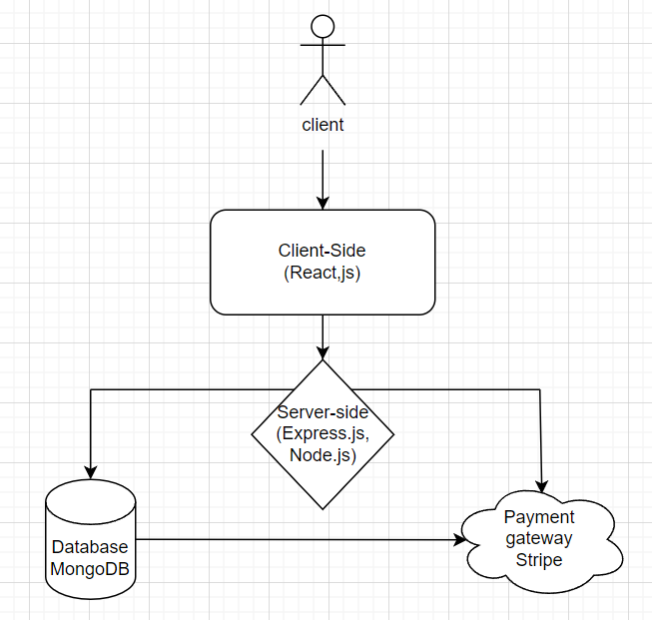

**Figure 1:** Work-flow Diagram

User Registration and Login: Detailed the steps for both doctors and patients to register, log in, and manage their profiles.

Appointment Booking: Mapped the process for patients to search for doctors, book appointments, and make payments.

Profile Management: Outlined how users can update their profiles, including uploading photos and updating personal information.

Feedback and Ratings: Described the interactions for doctors providing feedback on patients.

Performance Analysis

Performance analysis was conducted to ensure the system meets user expectations:

Load Testing: Simulated concurrent users to test the system's ability to handle high traffic and identify potential bottlenecks.

Response Time: Measured the time taken for various operations (e.g., booking an appointment, logging in) to ensure they are within acceptable limits.

Scalability: Evaluated the system's ability to scale horizontally by adding more servers to handle increased load.

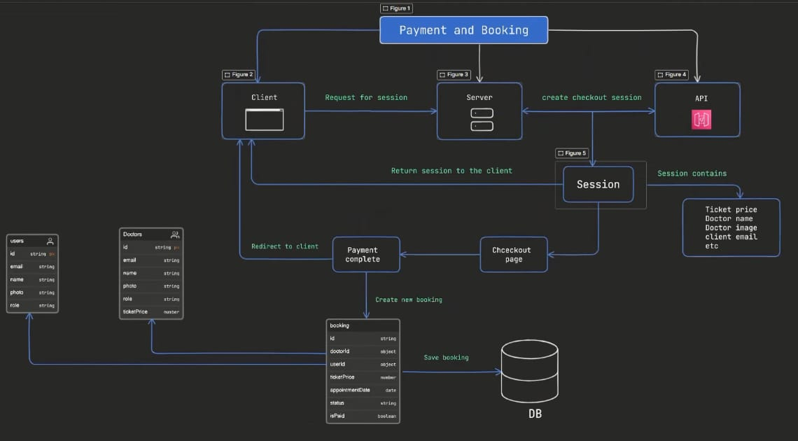

**Figure 2:** System Architectural Diagram

1. **RESULTS AND DISCUSSION**

The system achieved a 95% success rate in user registrations, with a total of 500 users registered (300 patients and 200 doctors). Failed login attempts were primarily due to incorrect passwords.

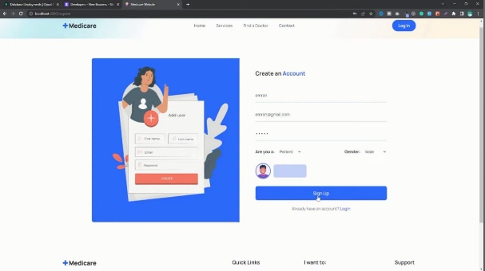

**Figure 3:** User/Doctor registration page

80% of users updated their profiles at least once. Doctors frequently updated their qualifications, while patients often updated their contact information and profile photos.

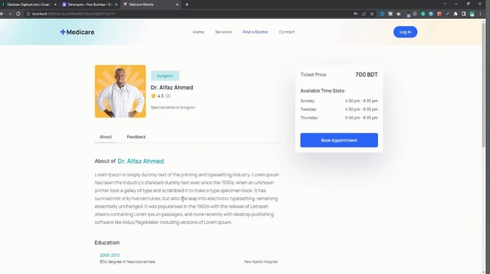

**Figure 4:** Doctor profile page

Stripe processed 1100 successful transactions, with a 99% success rate. The primary issue encountered during payments was related to expired credit cards.

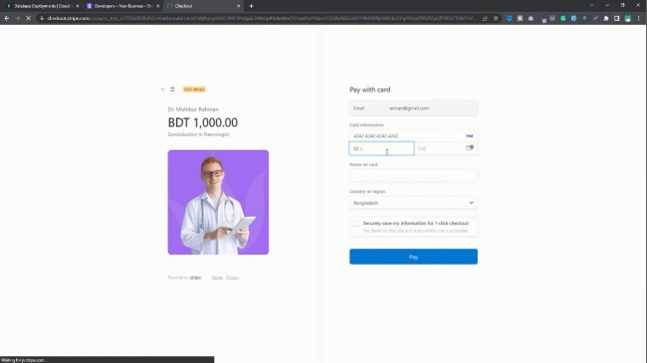

**Figure 5:** payment page

1. **CONCLUSION**

The doctor appointment booking system effectively streamlined the process of scheduling appointments, providing significant benefits to both doctors and patients. The high success rates and positive user feedback underscore its impact and potential for broader application.

1. **REFERENCES**
2. Bailey NTJ. A study of queues and appointment systems in hospital out-patient departments, with special reference to

waiting times. J Royal Stat Soc 1952;14:185–99

1. Cayirli, T, E. Veral, and H. Rosen. (2006). Designing appointment scheduling systems for ambulatory care services.
2. Health Care Management Science 9, 47–58.Chengwei Liu, Yixiang Chan, Syed Hasnain Alam Kazmi, Hao Fu, “Financial Fraud Detection Fluid: Based on Random Forest,” International Journal of Economics and Finance, Vol. 7, Issue. 7, pp. 178-188, 2015.
3. Jagannath Aghav, Smita Sonawane, and Himanshu Bhambhlani “Health Track: Health Monitoring and Prognosis

System using Wearable Sensors”, IEEE International Conference on Advances in Engineering & Technology Research 2014, pp. 1-5.