**Smart Dustbin with GSM module using Solar**

Pooja Apte, Aashish Rohankar, Pallavi Tajane, Supriya Thool, Prof S.P.Lodey

Department of Electronics and Communication Engineering,

Shri Sai College of Engineering and Technology Bhadrawati , Maharashtra, India

# 

# Abstract

Also, we see present day, many times Dust bin are placed near public places in the cities/villages are filled due to increase in the waste every day. So efficient method to dispose the waste has been designed with GSM system. In this proposed designed System only one big dustbin is located beside the building or society because from building a pipe is connected to dustbin through building. Where garbage is easily can throw in the dustbin. These dustbins are provided with ultrasonic sensor which helps in level of the garbage bins and so that it is easy to identify which garbage bin is full. When the level reaches the Maximum limit, the ultrasonic sensing device will transmit the level along with the message of dustbin these details can be accessed by the concern authorities or garbage van driver of that particular area from their place with the help of GSM Module and an immediate action can be made to clean the dustbins.

This system will be powered by self-sustainable energy by using solar panel so the system can work in maintaining a healthy environment for 365 days.

***Keywords****: GSM, Arduino, Arduino IDE, Ultrasonic Sensor*

# Introduction

The world today is moving fast along with the rapid flow of technology. A long with it, people have to move fast so it does not miss out by modernity technology that available in the world today. Now with changing this time is needed to make some application or product that very useful for all segment of society without thinking their status.

If seen in the market most of dustbins are manually operated and it will use leg and hand for open the cover of dustbin that can allow a person to dispose the rubbish. But it very difficult for the persons with disabilities. This dustbin is not user –friendly system dustbin because it only can use for normal people and not for person with disabilities.

In the hypermarket it will more of dustbin that be prepared, it will make easy to people for dispose of rubbish. But some time, when the rubbish is overloading the management team clean-up is slow to take the action for the collected rubbish. This is because cleaner does not accept the instruction or information about the overflow rubbish inside the dustbin. For monitoring the dustbin, it still uses the old-fashioned way, and it is not very efficient for this age, so created this project can make the work clean faster and easier.

Other problem that can see is many people not interested to use dustbin for littering because they are not interesting to came near the dustbin. So, this project can attract attention people to use dustbin because it very easy to use and it is a very modern system.

# Scope of project

The project is about monitoring the dustbin inside the hypermarket. This project is more suitable for area inside hypermarket or in the specific area. The focus of this project is made easy for cleaner collect the overload garbage without waste of time, they will came collect when get the message.

The projects have use Arduino Uno Board because it can control the sensor, motor and GSM to run the function. This project has use software and hardware component. For the software application it will apply to active the component and run the application GSM to make the connection between dustbin and management. The message full rubbish will send to supervisor for the information and will be notified to cleaner for collect the rubbish.

On the order hand, to order word the limitation of this project

* This project is focus on the hypermarket or specific area.
* The dustbin will operate when human approaching the sensor and the cover will open.
* This dustbin will only send the message to department of cleaning management.
* The project will become user-friendly that can use for all type of people whether normal or persons with disabilities.

**Flow Chart**



### Major Components

### Arduino IDE

The Arduino Integrated Development Environment (IDE) is the main text editing program used for Arduino programming. It is where you’ll be typing up your code before uploading it to the board you want to program. Arduino code is referred to as sketches.

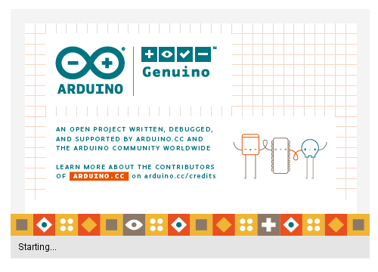

## Arduino UNO:

The Arduino Uno is a microcontroller board based on the ATmega328.It has 14 digital input/output pins (of which 6 can be used as PWM outputs), 6 analog inputs, a 16 MHz ceramic resonator, a USB connection, a power jack, an ICSP header, and a reset button. Arduino board designs use a variety of microprocessors and controllers.

## SIM800 GSM Module:

Whether you want to listen to what happens in your house that’s miles away from you or activate sprinkler system in your garden just with a silent call; Then SIM800L GSM/GPRS module serves as a solid launching point for you to get you started with IoT!

SIM800L GSM/GPRS module is a miniature GSM modem, which can be integrated into a great number of IoT projects. You can use this module to accomplish almost anything a normal cell phone can; SMS text messages, Make or receive phone calls, connecting to internet through GPRS, TCP/IP, and more! To top it off, the module supports quad-band GSM/GPRS network, meaning it works pretty much anywhere in the world.

## SIM800L Module Hardware Overview - LED Indicator, u.fl Connector, Helical AntennaSIM800L Module Hardware Overview - Micro SIM Socket, Direction to Insert SIM

## Ultrasonic Sensor:

An ultrasonic sensor is an instrument that measures the distance to an object using ultrasonic sound waves. An ultrasonic sensor uses a transducer to send and receive ultrasonic pulses that relay back information about an object's proximity.

The ultrasonic sensor works on the principle of SONAR and RADAR system which is used to determine the distance to an object. An ultrasonic sensor generates the high-frequency sound (ultrasound) waves. When this ultrasound hits the object, it reflects as echo which is sensed by the receiver. Ultrasonic sensors work by emitting sound waves at a frequency too high for humans to hear.

## C:\Users\balji\Downloads\fe\th.jpg

## Solar Panel

Solar panels are devices that convert light into electricity. A solar panel is a collection of solar cells. Lots of small solar cells spread over a large area can work together to provide enough power to be useful. The more light that hits a cell, the more electricity it produces.

Solar Photovoltaic (PV) is a technology that converts sunlight (solar radiation) into direct current electricity by using semiconductors. When the sun hits the semiconductor within the PV cell, electrons are freed and form an electric current.

**Rechargeable Battery (18650)**

An electric battery is a device consisting of one or more electrochemical cells with external connections provided to power electrical devices such as flashlights, and electric cars. When a battery is supplying electric power, its positive terminal is the cathode, and its negative terminal is the anode. The terminal marked negative is the source of electrons that will flow through an external electric circuit to the positive terminal. When a battery is connected to an external electric load, it supplies power to the load and any device connected as the load will power up for a limited period of time but in our case, it will be charging by solar panel continuously to keep the system running without any interruptions.

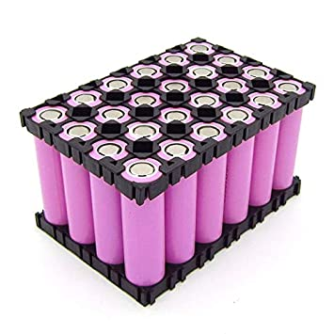

**Conclusion**:

this smart dustbins in our “swach bharat abhiyaan” with the high density of people and traffic issues the introduction of smart bins would make a significant impact in country like INDIA they can also improve waste management in any large volume of area or any remote locations such as parks camp sided and beach side areas which will be helpful for everyone and make our country clean.

**Future Scope:**

# This project is made for demo concern, it can be taken to product level. υ it can be made durable, by making it compact and cost effective. υ two bins can be placed to collect wet and dry waste separately. υ wet waste can be decomposed and used for making biogas.

# References

1. *“*S.S. Navghane, M.S. Killedar, Dr.V.M. Rohokale, IoT Based Garbage and Waste Collection Bin, May 2016.
2. Ghose, M.K., Dikshit, A.K., Sharma, S.K. A GIS based transportation model for solid waste disposal – A case study on Asansol municipality. Journal of Waste Management.
3. Guerrero, L.A., Maas, G., Hogland, W.: Solid waste management challenges for cities in developing countries. Journal of Waste Management.
4. Alexey Medvedev, Petr Fedchenkov, ArkadyZaslavsky, Theodoros, Anagnostopoulos Sergey Khoruzhnikov, Waste Management as an IoT-Enabled Service in Smart Cities.
5. Meghana K C, Dr. K R Nataraj, IOT Based Intelligent Bin for Smart Cities.
6. KasliwalManasi H., SuryawanshiSmitkumar B, A Novel Approach to Garbage Management Using Internet of Things for Smart Cities.
7. Vishesh Kumar Kurrel, Smart Garbage Collection Bin Overflows Indicator using Internet of Things
8. Monika K A, Nikitha Rao, Prapulla S B, Shobha G, Smart Dustbin-An Efficient Garbage Monitoring System.