**SIGN LANGUAGE DETECTION USING YOLONAS**

**Ms R. Thirumahal1, Surya Arvindh M 2, Danish L3**

1Assistant Professor, Department of Computer Science and Engineering,

PSG College of Technology, Coimbatore, Tamil Nadu, India.

2,3 PG Scholars, Department of Computer Science and Engineering,

PSG College of Technology, Coimbatore, Tamil Nadu, India.

# ABSTRACT

The advancement of a gesture text translation system with deep learning and YOLO NAS (Neural Architecture Search) is a technological breakthrough, which helps hearing impaired persons to be include into common everyday communication. The YOLO NAS for real-time sign language recognition can integrate this model by having the ability to precisely localize and detect sign language gestures. The deep learning component has used recurrent neural networks (RNNs), transformer models, or any other similar model to convert into texts the characters that have been recognized. This breakthrough presents a multipurpose approach, especially suitable for deaf and hard-of-hearing people, thus enabling them to be full participants of the hearing society. However, this method is the state-of-the-art but inherited the limitations of its applicant methods. YOLO NAS serves as a tool and ingredient to develop an efficient and accurate system for sign language translation. Written language for the hearing disabled happens to be a pioneer in the communication sector that is researched using computer science and engineering. Uses the modern technologies of computer vision and natural language processing to segregate signs into written or spoken words together in the real time. Here, the paper is aimed at maximizing recognition accuracy to ensure that the system refers to different communication channel and this makes it inclusive and accessible. The model we devised proved to have an accuracy of 90.8% in American sign language dataset and several evaluation metrics were performed over the data for fine tuning the model.

# INTRODUCTION

The purpose of the project is to develop a system with the capability of deciphering which letter of the American Sign Language (ASL) alphabet is being signed as an image of the signing hand is presented. The aim of this project is to accomplish a designing of the sign language translator, which can convert sign language to text. This translator will significantly reduce the communication barriers for many of the deaf and mute present to be able to talk with others in everyday transactions. Isolation is the main thing that makes realization of this objective necessary. Isolation and depression are usually more frequent among the deaf community, especially when they live in a hearing society. Large such impediments that create a great difficulty in life come through communication gaps between deaf and hearing persons. For example, censorship can lead to information deprivation, limitation of social connections, and difficulty integrating in the society. A wide spectrum of research implementations using depth maps generated by depth camera and high-resolution images has been employed in this activity. The purpose of this project was to determine if the developed system could recognise the ASL (American Sign Language) letters from hand images taken with a webcam of a personal device such as a laptop.

* 1. **Objectives**

For the real-time detection of sign language, the YOLO NAS architecture is chosen due to its capability to simultaneously detect multiple objects in an image efficiently. Variants like YOLOv5 or YOLOv8 can be selected based on hardware capability and performance requirements. The model is set up with pre-trained weights from large datasets like COCO and further trained on a labelled sign language dataset using transfer learning to leverage generalizable features. A custom loss function, combining Mean Squared Error (MSE) for bounding box regression and Cross-Entropy for classification, is employed. The model's performance is evaluated on a separate validation dataset using metrics like precision, recall, F1-score, and mean Average Precision (mAP), supplemented by qualitative visual analysis. Fine-tuning involves adjusting hyper parameters, network architecture, and training procedures based on evaluation results, optimizing the model for real-time performance on specific hardware. Finally, the trained model is deployed, considering latency and memory constraints, into a user-friendly software solution such as a mobile app or web service for effective sign language recognition.

* 1. **Challenges in sign language detection**

Sign languages around the world are deeply influenced by their cultural and geographical contexts, each possessing unique lexicons, grammar, and syntax, which necessitates language-specific models and data for accurate detection, making a universal sign language detector challenging to develop. Recognizing sign languages involves interpreting complex sequences of hand movements, facial expressions, and body gestures, which is difficult due to the subtlety and fluidity of these signals. Data scarcity is another issue, as sign language datasets are limited compared to spoken languages, and creating accurate recognition models requires extensive annotated data, particularly for specific or variant signs. Additionally, interpreters often work in environments with background noise, occlusion, and cluttered settings, complicating the clear visibility and interpretation of signs. The inherent ambiguity and context dependency of sign languages, where facial expressions and body movements convey meaning, add to the challenge as individual signs can have multiple meanings influenced by their context and the signer’s intent. Moreover, achieving real-time detection with low latency is crucial for effective sign language interpretation and assistive technologies, as delays can hinder communication.

# LITERATURE REVIEW

Paper [1] explores two areas of growth in Deaf people's lives: recognizing and transcribing sign language systems in real time. A key role of these systems using advanced technologies such as computer vision and artificial intelligence focuses on furthering equality of communication and enabling real-time interaction. Such improvements are of great importance in various personal and professional fields and provide a useful platform for the students who are deaf or face difficulties in hearing in these educational matters. Nevertheless some problems arise including operatively, that is the requirement of the device to be adapted to the individual needs of sign language users, low level of support provided to rare sign languages, the possible cost factor and the issue of privacy. The article will aid the perpetual discussion of how to make the designs, implementation, and ethical implications of technology better to serve best the deaf and hard of hearing.

The paper [2] is concerned with the hand-spelling of American Sign Language (ASL), and it presents an automatic translator that perceives the hand movements. This system is based on a glove that is equipped with these sensors to interpret the alphabet and so far has 96% accuracy on average on the letters identification. Given that precision is easy to measure, the paper discuss the technical solutions on how to enhance accuracy in the difficult measurements. The main goal of this system is to be convenient and work seamlessly with the newest devices, incorporating flex sensors, contact sensors, accelerometers, and gyroscopes for hand gesture recording. The available choices of wired and wireless displays are both included, where the maintaining of system operation is been achieved via software which initializes hardware and sensor information quantization. With that, such a paradigm might contribute a lot to mute/deaf people.

In paper [3], the author focuses on understanding of ASL by using computers and AI techniques for object recognition. To begin with, the author listed the absence of expertise in sign language coupled with machine learning as the tools to collect numeral data for their object detection algorithms comprehension. Problems such as data collection and training the model were noted in the whole post and the author talked about their results along with results obtained by other ASL translation technologies. Despite failing to reach most of the intended goals, a remarkable report on learning was shown.

In paper [4], the author deals with EMG. Electromyography (EMG) gesture recognition is another field of research and the studies suggest that when wrist EMG signals are used they show better performance than when forearm EMG signals are used in HG recognition. Using wrist EMG signals excites professionals to find out more about real time applications with high accuracy rates and better than non-fine motor movements for forearm signals. 92% represent the average accuracy which were depicted with the underlying wrist EMG signals. 1% finger(s) gestures single percent, and others' fingers gesture 91%. Seventy-nine percent for thumb strokes, eight percent for multifinger gestures, and only two percent for the rest, which is used by the touchscreen. 21% for both gesture language of conventional wrist gestures. With this, it is revealed that a wrist EMG signal can really be used for practical gesture recognition, based on the results achieved thus far. Gesture recognition using hand gesture is rapidly growing in medical application, smart homes, and virtual reality applications.

Paper[5] suggests one integrated solution can be implemented in form of a glove with some four key components such as the arm rings and a three-dimensional flex sensor, which can record complex motions from the whole arm and knuckles. Another automated deep neural network design using the convolutional filtering network idea would join different sensor data and pick out shallow and deep features. Residual module is present to avoid overfitting and gradient vanishing, simultaneously LSTM was able classify intricate hand movements. Here the system shows specific adaptability and thus shows better performance, especially in ASL, with the precision rate of 99. 93% if English and Chinese Sign Language (CSL) with precision 96.1 %.

In paper [6], the authors applied machine learning approaches, particularly Artificial Neural Networks (ANN) and Support Vector Machines (SVM) for elevating accuracy of ASL word recognition than the results using Hidden Markov Model (HMM) methods. The system uses wearable motion sensors and suggests future research to allow for more gestures in the current dictionary and use non-manual cues so that accuracy will be improved. This approach, including visual based systems and extended totally ASL recognition by HMM is considered research directions for further investigation.

Paper [7] deals with the area of research that includes 2D and 3D pose estimation, decision tree algorithm optimization, and sign language recognition. The mission is to form bridges for the communication of deaf and dumb individuals by interpreting them from signs into text. This type of voice-activated sign language translator could be helpful for many people, for example in public places and classroom scenarios.

Paper [8] author uses an Approach Set Up with Several Architecture of Deep Learning solves the challenge of Isolated Dynamic Gestures Recognition, which Respects to Hand Segmentation, Hand Shape Feature Representation, and Gesture Sequence Recognition. The framework utilizes DeepLabv3+ for hand semantic segmentation, CSOM (single layer) model for hand shape feature extraction, and BiLSTM (deep recurrent model) for sequence recognition. One expects better performance in DeepLabv3+ by training on pixel-labelled hand images to extract hand from the video frames. This parameter improves the need for pre-trained convolutional neural networks. The BiLSTM model can accurately repoint the extracted sequences of feature vectors. This is proven by getting the best results compared to other methods on sign language Arabic dataset.

In paper [9], a system based on a single myo armband equipped with accelerometer, gyroscope, magnetometer and surface electromyography (semg) sensors which allow to capture spatial information on hand signs. The armband is worn and its raw data are handled in the MATLAB platform, using wavelet denoising and segmentation. Different Time Series and period features are extracted, and a neural network based classifier classifies these signals with an average rate of 97%. a 12%-ward, 48-word sign exactly English (SEE-Ill) lexicon. Substantial efforts were made to understand this new language. This approach acts as a signification of the functional wakening of the utilization of wearable technology and digital signal processing for the purpose of striking communication balance between hearing and deaf individuals.

Paper [10] deals with the subject of designing the thin and sensitive stretchable sensors for wearable robotics including and especially artificial skin gets an idea with Skintech (SkinGest). The system applies machine-learning algorithms and stretchable film sensors to specifically detect gesture of the human hand. The sensor is sandwich like with two layers of elastomer and one soft electrode layer, which makes it thick 150 µm without dropping the gauge factor. Machine learning algorithms based on LDA, KNN, and SVM classifiers help to improve the gesture recognition process within the overall SkinGest system. The subjects' experimental data, involving the correct recognition of ASL to 1–9 through this system, has revealed an average accuracy of 98%. It sheds light on SkinGest capabilities and future purpose in virtual and real universe.

In Paper [11], a signal recognition algorithm of finger language implemented with a multi-layer ensemble artificial neural network is presented on a wristband consisting of an 8-channel surface electromyography sensor. The algorithm involves acquisition of signals, filtering, integration, feature extraction, and then employing the E-ANN classifier to classify these features. What was studied was a recognition of huru language that has 14 consonants, 17 vowels, 7 numbers, and it took 17 subjects. E-ANN's performance was shown to depend positively on the number of classifiers (1-10) and data size (50-1500), peaking at a recognition rate of 80%. This configuration exhibited encouraging performance in task of finger language recognition.

The study proposed in the paper [12] has a device with distributed sensors along the fingertips for hand gesture recognition which allows humans to control various systems via their movements. With the help of two bending sensors and a single-chip STM32, the system is able to produce position of fingers. The BP neural network establishes a correspondence between two kinds of networks by combining the properties of template matching and back-propagation. This increase the accuracy of recognition process. This low-cost and highly flexible device as it is designed under Keil5 and VC++6 specifies a very high precision and adjustability. The study presents the energy based gesture recognition, experimental influence of environmental factors, and the effect under real life situations bringing up it to be a robust and flexible wearable sign language recognition system.

Paper [13] illustrates a smart sign language interpreter located on a device that is worn on hand and could help deaf and speech-impaired individuals in communication. Flex-sensors 5 in a row, 2 pressure sensors, and global multiaxial motion sensor that reads the signs in the American Sign Language alphabet. It comprises three main modules: the data sensing module, a wearable or portable device, the processing module, and a mobile app module. An integrated support vector machine classifier perceives the gathered data coming from the sensor, with nameless characters being dispersed to a mobile phone through Bluetooth transmission. Next the Android app simply reads the text out loud in an audible voice production. Initially, no pressure sensors have been installed; 65 amounts to the ideal. undefined The middle finger was aced with precision systems offering 98% accuracy. 2% communication barrier, this system has shown its efficiency of overcoming communication problems for the individuals possessing hearing and speech issues.

Paper[14] studies developing a subword level recognition system of Chinese Sign Language using sEMG, ACC and GYRO sensors. This paper studied these sensors' ability to discriminate among subword units of CSL, and created a tree-based algorithms which optimized CSL short-vowel recognition rate. The testing, which involved eight subjects who were exposed to 150 CSL subwords in six different environments, showed that the three-sensor combination (sEMG, ACC, and GYRO) surpassed the accuracy of single or paired sensor combinations. Overall, the system has become proficient in various recognition tasks, showing an error rate of only around 7%. More than 31% says they are about user-specific products whereas 87% connect clothing with self-expression. With 02% recognition accuracy in hands-free tests, the results of the model foreshadowed a full-scale deployment of CSL as a feature of a large-vocabulary speech recognition system.

Paper [15] shows a sign language-equipped kiosk with a purpose of conducting a research among deaf users as well. It includes, e.g., computer-vision-based sign language recognition, automatic speech recognition (ASR), and a touchscreen for inputs, that can output sign language through a 3D signing avatar and a Deaf-specific touchscreen GUI. Learned how to find the train information, the "kiosk" can be used for different applications such as the sign language techniques and book's dictionary. It guarantees user accessibility of the deaf and hard-of-hearing persons who make use of ASR and sign language recognition systems that produce outputs in various languages by means of a signing avatar or text. The system is capable of entertaining conversations between a human and a computer through a computer-generated dialogue.

The article [16] explores the application of Arabic Sign Language Recognition (ArSLR) technology to facilitate the deaf community`s communication. It compares two continuous ArSLR techniques: The results showed a significant improvement in the recognition rates when using modified k-Nearest Neighbour (KNN) and Hidden Markov Models (HMMs) algorithms with new datasets of 40 Arabic sentences collected using the Polhemus G4 motion tracker and a camera, together with the current glove-based dataset. The research reveals the same accuracy in motion captured sensor wrist and hand motion data. Notwithstanding the decrease in Modified KNN computing power, studying ArSLR can be carried out offering a valuable dataset for other experimentations, thus solving a previously underexplored issue in sign language recognition.

Paper [17] presents a scalable method that utilizes weakly-aligned subtitles and keyword spotting to localize 1,000 temporarily in 1,000 hours of videos. Some contributions presented are usage of annotated data from mouthing cues to construct the BSL-1K dataset of British Sign Language signs which prove its superiority in training sign recognition models with and excessing state-of-the-art in MSASL and WLASL benchmarks. The study also offers the possibility of new datasets for large-scale evaluation on identifying and recognition. These developments inevitably expand the horizons of sign language studies, furnishing masses of data and models for adequate training and validation.

The paper [18] targets using hand gesture recognition among many others like sign language translation, video games and tele surgery. The system under consideration makes use of diverse deep learning architectures which are aimed at hand segmentation; body configuration; shape representation and gesture sequence modelling. The proposed approach has been assessed on a dataset of 40 dynamic gestures under an unconstrained environment. A comparative analysis shows a much better result than that of the state-of-the-art methods. The system employs OpenPose for hand detection, facial detection, and body graphs ratios and utilizes two 3DCNN (3D Convolutional Neural Networks) instances for coarse and fine features capturing. MLP and auto encoders won't lose these features and SoftMax classifies these. We look further into other temporal modelling approaches, and real-time recognition for now.

The paper [19] reflects the challenges the Deaf have when it comes to technological human-computer interaction by suggesting the application of RF sensors for American Sign Language(ASL)recognitions. The medical approach in the college centers on the multi-frequency RF sensor system for non-invasively capturing the ASL signings and regardless of the light conditions. Through short-time amplitude spectrograph employing a Short-Time Fourier Transform, the micro-Doppler effect in RF data manifests itself. ‘Micro-Doppler effect’ is revealed in the time-frequency domain. Machine learning has shown that the information content of ASL signing is way more than that it is for other actions. The occurrence of features based on RF has highly diverse with respect to native a sl sign and non-signers, accomplishes 72. They demonstrated 5% capabilities to identify 20 native signs in American Sign Language. The study points out the necessity of sourcing ASL native data for developing effective machine learning tools; the RF sensing application provides a prelude to deaf-striken smart ecology.

The paper [20] attempts to establish a boundary between the different types of K-RLS signs with diverse non-manual parameters. This study included recording full sentences from five native signers off who gave 5200 isolated sign samples of most frequently used 20 signs in the K-RSL that signify almost same manual forms of handshapes but they are different in facial expressions, height of eyebrows, mouth and head orientation. The results of evaluations proved that adding non-manual components next to manual signs helped in improving recognition of signs. Logistic Regression was the method with the best results having a precision of 78. The 20-sign dataset got an accuracy of 2% and 77% for the 1-aleph dataset. 5.9% for 2-class dataset. The relevant study points out the key non-manual features required for an advanced computerized sign language recognition system.

**Table 1: Comparison of Sign Language Detection Techniques**

|  |  |  |  |  |
| --- | --- | --- | --- | --- |
| **Paper**  **No** | **Methodology** | **Pros** | **Cons** | **Result** |
| **1.** | HMM , RNN , CNN | Compares and suggests the most efficient method for SLR | Improvisation of accuracy concerns vision-based SLR is required | The accuracy of the vision based SLR model is significantly lower than that of the speech recognition model and lower than that of the sensor-based method. |
| **2.** | Data Acquisition and Control (DAC) system using a smart glove with sensors | Allows integration with smartphones for convenient display | Requires calibration for flex sensors to reduce sensitivity to environmental changes. | Recognition accuracy of 96% for the interpreted letters. |
| **5.** | CNN (Convolutional Neural Network) and LSTM (Long Short-term Memory) | Wearable gloves based hand gesture recognition model. | Real-time live data-based analysis with the uncontrolled environment not performed to prove the validity | Recognition accuracy: 99.93% for ASL and 96.1% for CSL. |
| **6.** | ANN, SVM, and HMM | Functioning ability on a PC with Bluetooth Low-Energy (BLE)  connections. | The limitation is not considered non-manual, and dictionary size is  limited. | 1. ANN: 93.79%, 2. HMM:  85.90%, and3. SVM:  85.56% |
| **8.** | Convolutional SOM, deep Bidirectional LSTM network, and DeepLabv3+. | Signers independent combinational sign recognition model. | Experimentation performed with a limited number of signers. | Accuracy without segmentation: 69.0% and with segmentation accuracy: 89.5%. |
| **10.** | K-Nearest Neighbor, Linear Discriminant Analysis, and Support Vector Machines. | Less interference stretchable and wearable comfort. | The model was not robust in nature. Hysteresis characteristics and noise present in the sensor lead to misclassification. | LDA accuracy: 97.81%,  KNN accuracy: 97.86%,  SVM accuracy: 97.89%, and ASL recognition for0- 9 average accuracy: 98% |
| **11.** | Ensemble Feedforward Neural Networks. | Easy to wear, adaptable to portable devices. | Selection of hyper parameter was not addressed, suffered by convergence and computation problem. | E- ANN with 8 Classifiers accuracy: 97.4% |
| **12.** | Template Matching, BP neural network, and Combined Model. | High recognition rate data glove. | Dynamic gesture recognition based research was not performed, a glove barrier is there, and only a single background effect considered for the experiment fail to generalize in other background. | 1. Template Matching accuracy: 96.7%, 2. Feedforward Neural Network accuracy: 98.4%, combined model accuracy: 99.8% |
| **19.** | Principal Component Analysis (PCA), short term Fourier transform, and RBF (Radial Basis Function) associated SVM (Support Vector Machine). | Contactless sensing, environment independent | The author can not perform a comparative analysis with the existing method. | Recognition accuracy for 20 sign, 150 features:72.5% and for 5 sign: 95%. |
| **20.** | Logistic Regression | Non-manual components considered as input lead to better accuracy. | Need improvement concern to accuracy. | Accuracy: 78.2% |

1. **PROPOSED METHODOLOGY:**

The system includes the process of the diverse dataset of sign language gestures in which it should cover different signs, hand orientations and lighting conditions. Thus, the exact feature is that of the fusion of YOLONAS, a real time object detection model, for the recognition of sign language. This boosts in the speed and accuracy of interpretation and filling gaps of traditional systems.

**3.1 YOLONAS – You Only Look Once Neural Architecture Search**

The Deci AI’s development team invented a cutting-edge computer vision model named YOLO-NAS. It is the upshot of modern Neural Architecture Search system, and it is designed to address the pitfalls of old YOLO models. Due to the advanced quantization support and accuracy-latency negotiations, YOLO-NAS was a major breakthrough of a new level in the objects detection task.

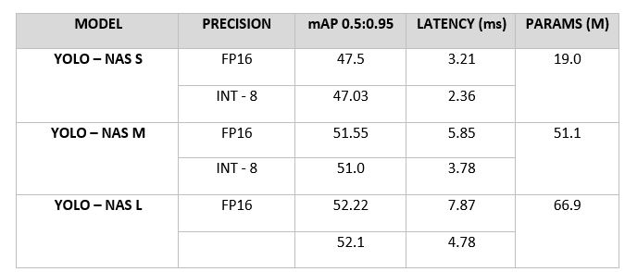

**Fig 3.1 Existing models in YOLONAS**

Fig 3.1 shows variants of YOLO-NAS. YOLONAS-S is just like its main counterpart, YOLONAS but made small, faster, and more efficient. It is generally simpler than bigger versions, and a few layers and parameters usually characterize it. That is why it is often implemented on embedded devices such as smartphones where computation resources are limited. Through the employment of a smaller model, the corresponding accuracy of detection will be maintained. YOLONAS-Medium (YOLONAS-M) is a smaller version of YOLONAS with the aim to hit the medium ground between speed, precision, and model size. In general, the purpose for this network as compared to YOLONAS-Small is higher layers and parameters. This is useful when you want to acquire better results in the rest of object detection situations. YOLONAS-Medium is very often seen in the cases, where the speed of learning is not so important as obtaining a good accuracy. YOLONAS-Large (YOLONAS-L) is the biggest of the YOLONAS line that holds the ability to maximize precision, but diminishes speed and takes a lot of computing resources. It usually entails the use of a bigger and deeper structure with even more parameters. YOLONAS-Large thrives in situations in which exactness is imperative, for instance in situations of high object detail, or when there is a complex scene.

YOLO-NAS is able to use both quantization-aware blocks and selective quantization to achieve optimal performance. The converted model seems to have small precision loss, represented by its INT8 quantized version, but it displays major improvement over other models, which proves that it is a significant progress. These developments therefore result in the construction of an elite faculty having an improved and dynamic performance of object detection. YOLO- NAS takes a friendly block that was introduced as quantization friendly into its innovative area. This is a clear minus point of the latter. YOLO-NAS reaches best performance with the help of first using complex schemes for training and then quantization after the training is done. YOLO-NAS is an AutoNAC optimized pre-trained network that was trained employing COCO, Objects365 and Roboflow 100 dataset. These pre-training, therefore, enables the model deployment in a production environment and make it ready for different downstream tasks of object detection. Ultralytics also provide YOLO-NAS models such that you can integrate and run their python module in your applications. This package comes with a user-friendly Python API to ensure the process is easier.

#### **3.2 Architecture**

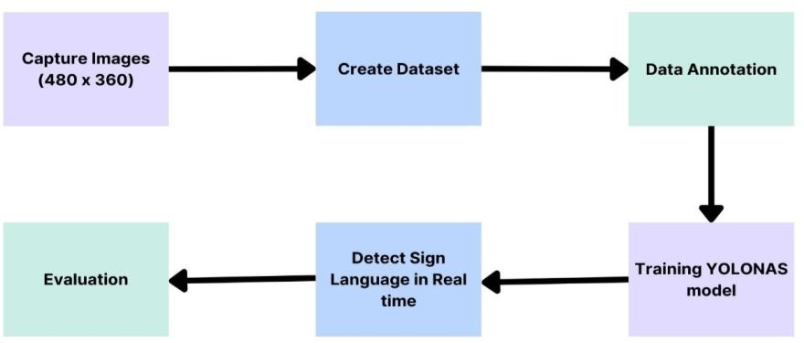

**Fig 3.2 Architecture of Sign Language Detector**

Fig 3.2 depicts the various stages involved in the YOLONAS sign language detection which have been discussed, in the section below.

#### **3.2.1 Data Collection:**

The auto-capture function of the camera will start to select photos when the hands of a person who made the signs are either of the palm or the single finger raised before the base instalment of the OpenCV package which already at the desktop or the laptop is enabled to run. This brings us to the point of specifying the datasets for training. We look for only the recordings of the actors who master sign language and unanimously. Roboflow ASL dataset used in this paper is the modern American Sign Language, which is the sign language of the deaf. As a result, it will be composed of approximately 1728 different images, where 1512 images are used for training, 144 images are used for validating and 72 images are left for testing. This corresponds to transforming pictures to 26 labels (e.g., A, B, ... , Z). Also additionally, 5 labels has been included namely Hello, Yes, No, ILoveYou and Thanks with 50 images for each label.

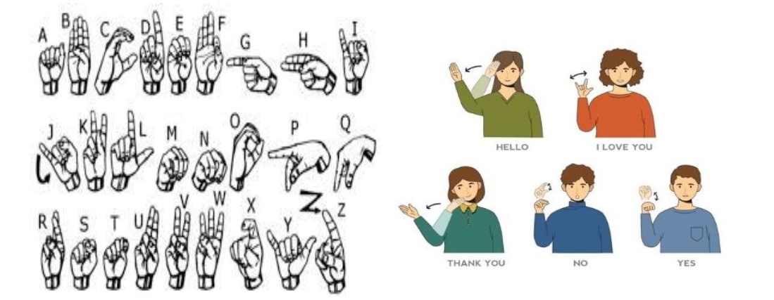

**Fig 3.3 Sign Language dataset**

Fig 3.3 consists of the sign language representation of the classes alphabets A, B, C, …, Z and gestures like Hello, I Love You, Thank You, Yes and No.

#### **3.2.2 Data Annotation:**

The gesture is illustrated in the dataset by photos. Without class labels (of items and boundary box) the training in YOLO cannot be started. In this case, "box" value or annotation box coordinate should be normalized, between 0 and 1. One of the most popular open-source graphical image annotation software named LabelImg is typically used by annotation for labelling and annotating images for machine learning related applications. LabelImg can achieve annotating sign language var as an image on LabelImg manually and then training the machine learning models related to real-time sign language detection.

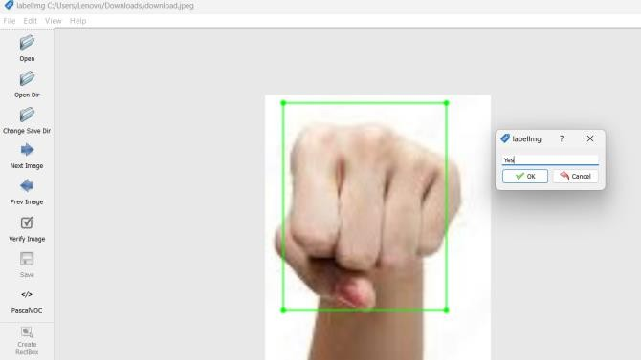

**Figure 3.4 LabelImg**

#### **3.2.3 Data Uploading:**

When the images have been labelled, update the label map which is the visual representation of the dataset. The annotations are stored as SXML files in the PASCAL VOC format and the actual images are in the JPG images. From the pictures that are already available, the training and testing data sets can be generated respectively. By using the data partitioning approach, you can certainly solve the small bounding box fitting problem that you are facing. Height and depth of the image once generated and specified as the bounding region are in the XML files for these images. Create the custom dataset and now we can use the extracted dataset in YOLO for running model training and testing.

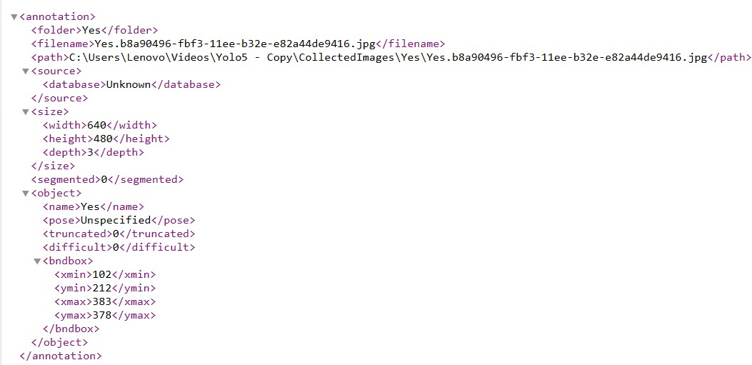

**Fig 3.5 Annotations Sample**

#### **3.2.4 Training Model:**

#### The strategy is to make a small change to the already trained YOLONAS model and use the adapted data. Transfer learning is now applied to train the extended dataset. Various upscaling schemes including HSV, color space, mosaic and scaling were also used to update the original image. In this description, we use the COCO dataset with a learning rate of 0.01, a weight distribution of 0.0005, and an SGD optimizer with 500 epochs for an image size of 416 and a group size of 16. By the 300th epoch, the model is largely established and becomes accurate Python 3.8 in PyTorch 1.8.1 reacts with an output of 0.5 and then develops with a 12GB NVIDIA Tesla K80 GPU and a Colab laptop included in the training software. The running second and last second properties of the YOLO model are stored in the files "best.pt" and "last.pt", which are generated when the training is skipped. The model can be loaded with these checkpoint files to continue the training process, or can be used to infer fresh information. "best.pt" refers to the checkpoint file containing the model parameters derived from the smallest training loss during training. Because it is the best performing model in the validation set, it is often chosen for model evaluation in a formal extended test. In general, the one with the lowest validation loss is selected as the final model, which in turn indicates the generalization tendency of the model to new data. Two models were developed for best.pt and last.pt. Since yolo has already created detect.py, we just need to give best.pt path, image size and confidence 0.5 and enjoy text images as source images. After saving, run and preview all captured images.

#### **3.2.5 Real Time Prediction:**

Python can signalize real-time predictions with diverse instruments like PyTorch. Let us start with the training, it will load the trained model into your Python operations. Real-time prediction necessary to be made continuously does require the data be directly streamed input. The visual will be provided as video. In order to adapt this data to the demand of the processors of your model, the pre-processing will be at the rendezvous. The data that is already pre-processed then is made available for the model to load it for the inference process. If the model is fed with the relevant input data, it will produce such predictions as well as forecast the results.

# RESULTS AND DISCUSSION

The system was used to recognize the A-Z of American languages ​​and recognizes gestures such as Hello, Yes, No, Thank you and I love you. Example observations are shown in Figure 4.1. The probability of correct detection is shown in the bounding box.The model requires training the data images for at least 100 time periods to ensure better detection. Training losses and performance metrics are saved to Tensor disk during training and to the log file defined above with the --name flag. A confidence level of 0.5 is applied to the results. Initial results showed that even with minimal data we averaged 0.987 map@0.5 and 0.985. The result file is drawn after training in png format, shown in Figure 4.2. A validation accuracy of 90.64% and a training accuracy of 90.93% showed that the sign language recognition system was more successful than the YOLANAS prototype. The system parameters are adjusted according to the size of the training data set, which we continuously reduce and evaluate the accuracy effect. The problem with perception was that symbols that are almost similar tend to be misperceived and lead to poor performance, especially when we try to combine alphabets and gestures with the same pattern for practice. The following are some of the evaluation metrics used:

**Fig 4.1 Sign Language Detections**

Precision measures how accurately the model inside identifies the abandoned object. The more the mark precision, the less the wrong area is recognized as an abandoned object.



Recall measures how good the model finds all the objects that should be detected. The more tall the recall value, the more little missed objects.



Accuracy measure so far where the detection model object is correct in all categories. However, accuracy gives a general description of model performance, and it is necessary to remember that in case of an imbalanced class, accuracy Possible No reflects Good model performance.

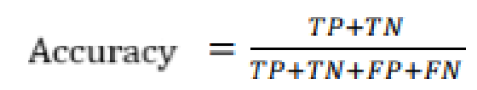

where TP – True Positive, FP – False Positive, TN – True Negative, FN – False Negative

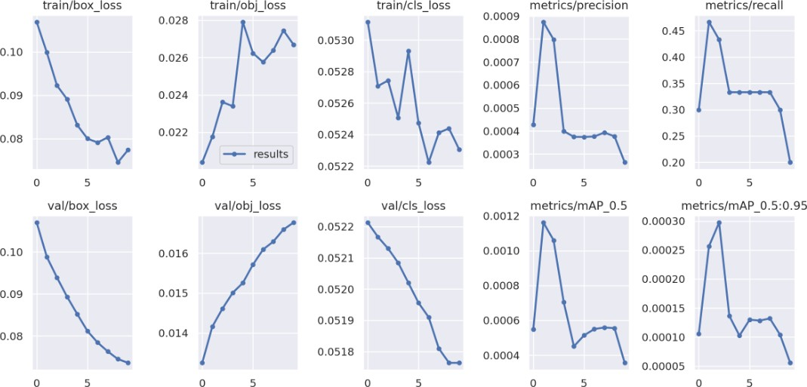

**Fig 4.2 Detector Performance**

# CONCLUSION AND FUTURE WORK

The primary objective of this project was to enhance communication efficiency for the deaf community, whether in personal or professional contexts. This involved developing a solution that could be integrated seamlessly into various platforms, particularly video conferencing applications, to facilitate smooth communication. The implementation was successful and in a way gave good detection outputs but there were some hindrances in the detection which have to be addressed in the future works.

One strategy to improve detector performance is to use a high-resolution data set and retrain it for more epochs. However, this approach requires an efficient computing infrastructure due to its computational intensity. Another option to consider is to adopt separate models for alphabets and gestures and treat them as separate modes in the sensor used for video calls. Using this approach, users are presented with two options: alphabets and gestures. They can choose the mode that best suits their communication needs. This flexibility allows users to use the appropriate mode based on the communication context, whether they need to write specific words in sign language or convey messages through gestures. This dual-mode feature improves the usability and efficiency of the communication tool and is more responsive to user preferences and requirements. of.

# REFERENCES

1. D. M. Madhiarasan and P. P. P. Roy, “A Comprehensive Review of Sign Language Recognition: Different Types, Modalities, and Datasets,” arXiv: 2204.03328, 2022.
2. Elmahgiubi, M., Ennajar, M., Drawil, N. and Elbuni, M.S., “Sign language translator and gesture recognition”, Global Summit on Computer & Information Technology(GSCIT)(pp. 1-6), 2015, IEEE.
3. G. MacMaster, “Sign Language Translation Using Machine Learning and Computer Vision,” UVM Patrick Leahy Honors College Senior Theses, Jan. 2020.
4. Botros, F.S., Phinyomark, A. and Scheme, E.J., “Electromyography-based gesture recognition: Is it time to change focus from the forearm to the wrist?”, IEEE Transactions on Industrial Informatics, 18(1), pp.174-184, 2020.
5. Yuan, G., Liu, X., Yan, Q., Qiao, S., Wang, Z. and Yuan, L., “Hand gesture recognition using deep feature fusion network based on wearable sensors”, IEEE Sensors Journal, 21(1), pp.539-547, 2020.
6. Fatmi, R., Rashad, S. and Integlia, R., “Comparing ANN, SVM, and HMM based machine learning methods for American sign language recognition using wearable motion sensors”, IEEE 9th annual computing and communication workshop and conference (CCWC) (pp. 0290-0297), 2019.
7. Vishwas, S., Hemanth, G.M. and Vivek, C.H., “Sign language translator using machine learning”, International Journal of Applied Engineering Research, 2018.
8. Aly, S. and Aly, W., “DeepArSLR: A novel signer-independent deep learning framework for isolated arabic sign language gestures recognition.”, IEEE Access, 8, pp.83199-83212, 2020.
9. Jane, S.P.Y. and Sasidhar, S., “Sign language interpreter: Classification of forearm emg and imu signals for signing exact English”, IEEE 14Th international conference on control and automation (ICCA) (pp. 947-952), 2018.
10. Li, L., Jiang, S., Shull, P.B. and Gu, G., “SkinGest: artificial skin for gesture recognition via filmy stretchable strain sensors”, Advanced Robotics, 32(21), pp.1112- 1121, 2018.
11. Kim, S., Kim, J., Ahn, S. and Kim, Y., “Finger language recognition based on ensemble artificial neural network learning using armband EMG sensors”, Technology and Health Care, 26(S1), pp.249-258, 2018.
12. Yin, S., Yang, J., Qu, Y., Liu, W., Guo, Y., Liu, H. and Wei, D., “Research on gesture recognition technology of data glove based on joint algorithm.”, International Conference on Mechanical, Electronic, Control and Automation Engineering (MECAE 2018) (pp. 41-50), Atlantis Press, 2018.
13. Lee, B.G. and Lee, S.M., “Smart wearable hand device for sign language interpretation system with sensors fusion.” IEEE Sensors Journal, 18(3), pp.1224-1232, 2017.
14. Yang, X., Chen, X., Cao, X., Wei, S. and Zhang, X., “Chinese sign language recognition based on an optimized tree-structure framework”, IEEE journal of biomedical and health informatics, 21(4), pp.994-1004, 2016.
15. Hrúz, M., Campr, P. and Karpov, A., “Input and output modalities used in a sign-language-enabled information kiosk.” SCREEN, 1(C3), p.C2, 2009.
16. Hassan, M., Assaleh, K. and Shanableh, T., “Multiple proposals for continuous Arabic sign language recognition.” Sensing and Imaging, 20, pp.1-23, 2019.
17. Albanie, S., Varol, G., Momeni, L., Afouras, T., Chung, J.S., Fox, N. and Zisserman, A., “ BSL-1K: Scaling up co-articulated sign language recognition using mouthing cues”, Computer Vision–ECCV 2020: 16th European Conference, Glasgow, UK, August 23–28, 2020, Proceedings, Part XI 16 (pp. 35-53), Springer International Publishing, 2016.
18. Al-Hammadi, M., Muhammad, G., Abdul, W., Alsulaiman, M., Bencherif, M.A., Alrayes, T.S., Mathkour, H. and Mekhtiche, M.A., “Deep learning-based approach for sign language gesture recognition with efficient hand gesture representation”, IEEE Access, 8, pp.192527-192542, 2020.
19. Gurbuz, S.Z., Gurbuz, A.C., Malaia, E.A., Griffin, D.J., Crawford, C.S., Rahman, M.M., Kurtoglu, E., Aksu, R., Macks, T. and Mdrafi, R., “American sign language recognition using rf sensing.”, IEEE Sensors Journal, 21(3), pp.3763-3775, 2020.
20. Mukushev, M., Sabyrov, A., Imashev, A., Koishibay, K., Kimmelman, V. and Sandygulova, A., “Evaluation of manual and non-manual components for sign language recognition.”, 12th Language Resources and Evaluation (ELRA), 2020.