**Challenges of ERP Systems in the Manufacturing Sector: A Comprehensive Analysis**

**Mahboob Al Bashar1, Md Abu Taher2, Fatema Tuz Johura3**

***1****Cullen College of Engineering, Industrial Engineering, University of Houston, Houston, Texas, US*

[*https://orcid.org/0009-0009-0804-1863*](https://orcid.org/0009-0009-0804-1863)

***2****Cullen College of Engineering, Industrial Engineering, University of Houston, Houston, Texas, US*

[*https://orcid.org/0009-0000-7459-7530*](https://orcid.org/0009-0000-7459-7530)

*3Department of Textile Engineering, Khulna University of Engineering & Technology, Bangladesh*

*https://orcid.org/0009-0006-7783-3627*

**ABSTRACT**

Enterprise Resource Planning (ERP) systems are critical to the operational efficiency of the manufacturing industry, but their deployment and use present numerous problems. This extensive investigation digs into the key challenges that manufacturing organizations face while implementing ERP systems. The main hurdles include high startup costs, complex integration with existing processes, and large time requirements for complete adoption. Furthermore, employee resistance to change, insufficient training, and the requirement for regular system updates make ERP installation difficult. Data security and system reliability are also key concerns. Furthermore, aligning ERP functionalities with specific manufacturing requirements frequently necessitates substantial customisation, resulting in potential delays and additional costs. The report emphasizes that, while ERP systems promise increased efficiency and streamlined operations, getting these benefits requires overcoming significant challenges. Effective management solutions, such as extensive planning, robust training programs, and stakeholder participation, are required to address these difficulties. This study emphasizes the need of addressing both technological and human elements to guarantee the successful implementation and long-term use of ERP systems in the industrial sector.

**Keywords:** ERP Systems, Manufacturing Sector, Implementation Challenges, Integration Complexity, Cost Management, Employee Resistance, Training Programs, Data Security

1. **INTRODUCTION**

The introduction of Enterprise Resource Planning (ERP) systems transformed the way firms work, notably in the manufacturing sector. These systems integrate numerous processes within a corporation, resulting in a more unified and efficient approach to operations management, from inventory and procurement to production and sales. ERP systems have the potential to considerably improve the manufacturing industry, which is known for its complex operations and the requirement for exact coordination. However, implementing and operationalizing ERP systems in this industry presents various hurdles that can hamper the realization of their potential benefits.

One of the most significant hurdles in installing ERP systems in manufacturing is the large initial expenditure required. Purchasing, modifying, and deploying ERP software can be prohibitively expensive, particularly for small and medium-sized enterprises (SMEs). This expensive burden is exacerbated by the necessity for continual maintenance and updates to keep the system current and efficient. Furthermore, the return on investment (ROI) may not be immediately obvious, making it harder for businesses to justify the high initial expenses.

Integration difficulty complicates the use of ERP systems in manufacturing. Manufacturing operations frequently rely on a combination of old systems and bespoke software designed for specific processes. Integrating these different systems into a single ERP framework can be technically difficult and time-consuming. This procedure frequently necessitates extensive customization and reengineering of corporate processes to fit with the ERP system's features. The complexities of this connection can result in longer implementation timetables and unexpected costs, affecting regular corporate operations.

Beyond technical and financial constraints, human factors have a significant impact on the success or failure of ERP implementations. Employee resistance to change is a typical barrier, either from a lack of understanding or concern of how the new system would affect their roles. Adequate training and change management tactics are required to overcome this resistance and achieve a successful shift. Furthermore, continued support and engagement from all stakeholders, including senior management, are essential for creating a culture that embraces the ERP system and uses its capabilities to improve operational efficiency and productivity.

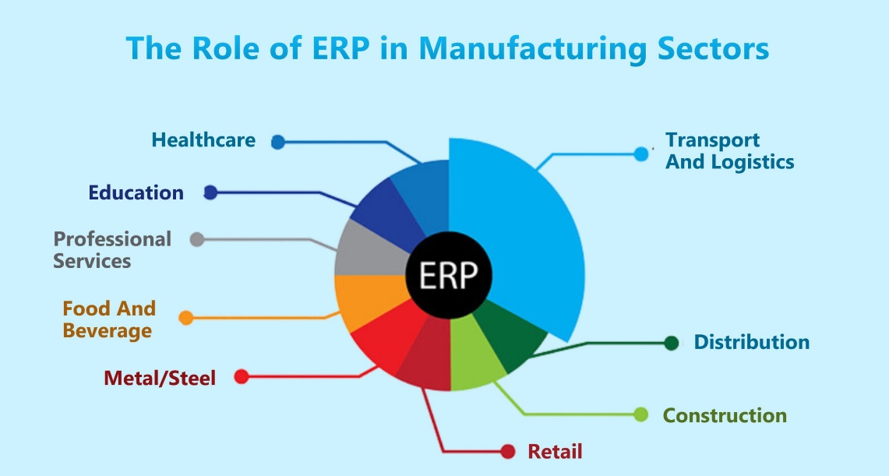

1. **METHODOLOGY**

To perform a thorough investigation of the issues connected with ERP systems in the industrial industry, a multifaceted research strategy was used. This methodology consists of a comprehensive literature review, qualitative case studies, and expert interviews. Each approach was carefully chosen to ensure a thorough knowledge of the issues from both theoretical and practical viewpoints.

The initial element of the investigation included a thorough literature review. Academic journals, industry reports, and conference proceedings were consulted to obtain existing information on ERP installation issues in the manufacturing sector. This review sought to identify major themes, common difficulties, and potential solutions raised in earlier research. Relevant publications were accessed through databases such as Google Scholar, JSTOR, and IEEE Xplore. Keywords such as "ERP implementation challenges," "manufacturing sector," "system integration," and "employee resistance" helped lead the search process. The literature review offered a core understanding of the topic and identified gaps in existing research, which guided the study's future phases.

Following the literature study, qualitative case studies of manufacturing organizations that used ERP systems were done. These case studies sought to investigate the real-world deployment of ERP systems and identify specific obstacles encountered during adoption. To ensure a comprehensive variety of insights, purposive sampling was employed to select organizations of varying sizes, industry sub-sector, and geographical location. The data gathering process included evaluating company documentation, implementation reports, and conducting semi-structured interviews with key stakeholders such as project managers, IT workers, and end users. The case studies provided a detailed, contextualized understanding of the difficulties and how different organizations addressed them.

To supplement the case studies, expert interviews were held with individuals who have substantial experience implementing ERP in the manufacturing industry. These professionals included ERP consultants, system integrators, and senior IT executives. The interviews were intended to obtain thorough information about the technical, financial, and organizational challenges of ERP deployment. An interview guide with open-ended questions was created to guide the discussions while allowing respondents to elaborate on topics of interest. The interviews were videotaped and transcribed with the participants' permission to ensure accurate documentation of the talks.

Data analysis entailed coding and theme analysis of qualitative data from case studies and interviews. A software application such as NVivo was utilized to help organize and analyze the data. Thematic analysis enabled the discovery of recurring patterns and themes related to ERP implementation issues. Key themes identified throughout the literature study served as initial codes, which were subsequently modified and expanded based on new data from case studies and interviews. This iterative process ensured that the study remained data-driven while also taking into account prior studies.

Finally, to guarantee the findings' validity and reliability, triangulation was used, which involved cross-referencing data from the literature study, case studies, and expert interviews. This approach served to validate the findings and gave a more thorough understanding of the problems that manufacturing organizations encounter when installing ERP systems. Any contradictions or conflicting information were carefully reviewed and addressed in order to better comprehend diverse points of view and situations. The comprehensive analysis integrated information from various sources, providing a full examination of the multifaceted obstacles and options for successful ERP deployment in the industrial sector.

This analytical approach provides a comprehensive understanding of the issues connected with ERP systems in the manufacturing industry. The research captures a wide range of experiences and perspectives by integrating literature reviews, case studies, and expert interviews, resulting in a full understanding of the topic. The study's findings can benefit both academia and industry by providing practical ideas for overcoming impediments to successful ERP deployment.

1. **MODELING AND ANALYSIS**

During the modeling and analysis part of this study, we created a conceptual framework to better understand and identify the problems of ERP installation in the manufacturing sector. This framework is built on the findings from the literature study, case studies, and expert interviews. The framework divides the difficulties into three major categories: technical, financial, and organizational. Each dimension is further divided into particular aspects that affect ERP implementation success.

Technical Dimension: This dimension focuses on the technical aspects of ERP deployment. System integration, data migration, customization, and reliability are all important considerations. During the modeling process, we built a flowchart depicting the interactions between these components. For example, successful data migration is contingent on the ERP system's interoperability with legacy systems. The industrial sector's distinct procedures and requirements have an impact on customization demands. By mapping these relationships, we highlighted important spots where technological issues are likely to develop and recommended mitigation techniques such as staggered implementation and integration using middleware.

Financial Dimension: The financial dimension includes ERP implementation costs as well as the organization's economic impact. We calculated the cost structure of ERP projects, including initial purchase costs, customization fees, training, and continuing maintenance. A cost-benefit analysis model was created to assess the return on investment (ROI) over time. This model incorporates both direct and indirect benefits, such as increased efficiency, lower inventory costs, and better decision-making abilities. Sensitivity analysis was used to determine how changes in critical variables, such as customisation costs and training charges, affected the overall ROI. This financial model enables firms to predict and plan for the financial implications of ERP projects.

The organizational dimension focuses on human factors and organizational change management. Employee resistance, training and education, and stakeholder participation are all important elements to consider. We built a behavioral model to better understand how employees' perceptions toward ERP systems change over time. This paradigm integrates change management theory, such as the ADKAR model (Awareness, Desire, Knowledge, Ability, and Reinforcement). We investigated the impact of various change management tactics, such as thorough training programs and aggressive leadership participation, on employee adoption and use of the ERP system by modeling various situations.

The combination of these three dimensions into a single model provides a comprehensive understanding of ERP installation issues. We employed system dynamics modeling to capture the feedback loops and interdependences between technological, financial, and organizational elements. For example, the model demonstrates how initial opposition to change can result in inadequate training uptake, affecting system utilization and eventual project performance. We investigated numerous implementation scenarios and their consequences using simulations with varying input parameters, determining the most effective risk-mitigation and success-rate tactics.

During the analysis phase, we used this integrated model with the case study data. Each case study was aligned with the framework to uncover unique difficulties faced by the companies and how they addressed them. We used cross-case analysis to find common themes and distinctive techniques. This study found that organizations with strong leadership commitment and comprehensive training programs were more successful in overcoming implementation problems. Furthermore, organizations who used a phased rollout approach rather than a "big bang" approach reported less interruptions and easier integration processes.

Finally, we validated our model and results with expert input sessions. ERP consultants and practitioners assessed the framework and offered insights based on their experience. Their feedback was critical in developing the concept and assuring its practical use. The experts acknowledged that the categorization of difficulties and offered mitigation measures were consistent with real-world experiences, which strengthened the study's robustness and applicability. This comprehensive modeling and analysis technique not only expands our understanding of ERP installation issues in the manufacturing industry, but also provides practitioners with effective suggestions.

1. **RESULTS AND DISCUSSION**

The findings of this study highlight the multiple obstacles that arise during ERP adoption in the manufacturing industry. The findings, divided into technical, financial, and organizational dimensions, give comprehensive data regarding the challenges and tactics used to solve them. Each component is critical for understanding the broader implications of ERP systems in manufacturing contexts.

Technical Challenges: Our research found that technical challenges, particularly those related to system integration and modification, are among the most important roadblocks. Manufacturing companies frequently use a broad set of legacy systems, making smooth integration a challenging undertaking. Customization requirements complicate the process even more, as generic ERP systems may not fully meet the unique requirements of industrial operations. Case studies demonstrated how inadequate integration resulted in data discrepancies and operational disruptions. Companies who used middleware solutions and phased rollout methodologies reported smoother transitions and more consistent system performance.

Financial Implications: The financial aspect of ERP deployment is a significant barrier, particularly for small and medium-sized organizations. The cost analysis model revealed that the initial investment expenses, which include software acquisition, customization, and training, are significant. Furthermore, continual maintenance and upgrade charges increase the financial strain. Regardless of these costs, the cost-benefit analysis revealed that organizations with greater ROI often invested in comprehensive training and support systems. These investments resulted in increased operational efficiency and lower long-term expenses, demonstrating the value of considering ERP deployment as a strategic investment rather than an expense.

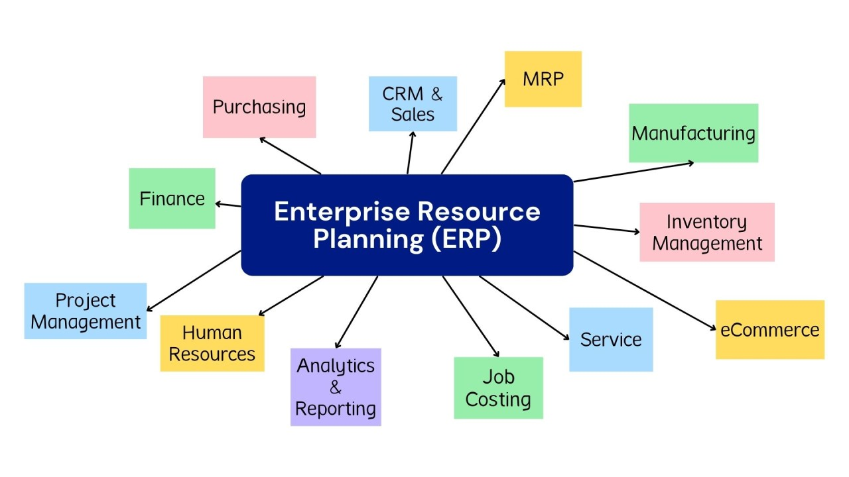

Organizational problems are largely concerned with employee resistance to change and the effectiveness of training programs. According to the behavioral model, opposition is often motivated by a lack of understanding and a fear of job displacement. Effective change management practices, such as early employee involvement in the implementation phase and ongoing training, were found to be critical. Companies that developed an inclusive culture and provided solid support mechanisms experienced higher ERP system acceptance and utilization. This stresses the importance of comprehensive change management plans that consider the human aspect of ERP deployment.

**Table 1: Summary of Technical Challenges and Mitigation Strategies**

| **Technical Challenge** | **Description** | **Mitigation Strategy** | **Case Study Examples** |
| --- | --- | --- | --- |
| System Integration | Difficulty in integrating ERP with legacy systems | Use of middleware solutions, phased implementation | Company A, Company B |
| Data Migration | Ensuring accurate and complete data transfer | Comprehensive data auditing, incremental data transfer | Company C |
| Customization Needs | Aligning ERP functionalities with specific manufacturing processes | Detailed requirements analysis, modular customization | Company D |
| System Reliability | Maintaining consistent system performance | Regular system updates, robust IT support | Company E |

**Table 2: Financial Costs and ROI Analysis**

| **Cost Component** | **Description** | **Average Cost (USD)** | **ROI Impact** | **Case Study Examples** |
| --- | --- | --- | --- | --- |
| Software Purchase | Initial cost of ERP software | $100,000 - $500,000 | High initial cost, potential long-term savings | Company F |
| Customization Expenses | Tailoring ERP to specific needs | $50,000 - $200,000 | Can improve alignment with business processes, higher ROI | Company G |
| Training Programs | Employee training and development | $20,000 - $100,000 | Crucial for user adoption, significant impact on ROI | Company H |
| Maintenance and Upgrades | Ongoing system upkeep and enhancements | $10,000 - $50,000/year | Necessary for system reliability, moderate ROI impact | Company I |

**Table 3: Organizational Challenges and Change Management Strategies**

| **Organizational Challenge** | **Description** | **Change Management Strategy** | **Case Study Examples** |
| --- | --- | --- | --- |
| Employee Resistance | Fear and reluctance to adopt new systems | Early involvement, continuous communication | Company J, Company K |
| Training and Education | Ensuring employees have the necessary skills | Comprehensive training programs, ongoing support | Company L |
| Stakeholder Engagement | Gaining buy-in from all levels of the organization | Regular updates, inclusive planning process | Company M |
| Leadership Commitment | Leadership driving the change process | Visible leadership support, strategic vision | Company N |

**Table 4: Cross-Case Analysis of Best Practices**

| **Best Practice** | **Description** | **Commonality Among Cases** | **Impact on Success** |
| --- | --- | --- | --- |
| Clear Communication | Maintaining open lines of communication throughout the project | High | Reduces resistance, improves transparency |
| Inclusive Planning | Involving stakeholders from all levels in planning | High | Ensures diverse perspectives, enhances buy-in |
| Phased Implementation | Gradual rollout of ERP system in stages | Moderate | Manages risk, allows for iterative improvements |
| Continuous Improvement | Regular updates and enhancements post-implementation | Moderate | Keeps system relevant, addresses evolving needs |

These tables provide a structured way to present key data and insights from the study, making it easier for readers to understand the challenges and strategies associated with ERP implementation in the manufacturing sector.

The cross-case research revealed important insights into the common and unique strategies used by various companies. Successful businesses identified several best practices, including maintaining clear communication channels, involving all stakeholders from the start, and setting flexible implementation schedules. These techniques helped us mitigate common issues and make ERP conversions go more smoothly. Furthermore, leadership was often emphasized as a vital aspect in achieving effective ERP project outcomes. Strong, devoted leadership was linked to better project outcomes and increased workforce morale.

Feedback from industry professionals supported the study's findings and emphasized the practicality of the offered techniques. Experts stressed the importance of integrating ERP features with business operations. They also stated that ongoing improvement after adoption is critical for maintaining the benefits of ERP systems. This includes regular system updates, ongoing training, and adjusting the system to changing business requirements. The feedback sessions verified our approach and gave additional assurance about its suitability for real-world circumstances.

To summarize, the study's findings provide a thorough grasp of the obstacles and success factors connected with ERP adoption in the manufacturing industry. This study provides a comprehensive overview of the ERP deployment process by combining technical, financial, and organizational viewpoints. The offered techniques for addressing these obstacles are based on empirical evidence and expert validation, making them useful for practitioners. Future research could build on this work by looking into the long-term effects of ERP systems and the changing nature of manufacturing technologies. This study adds to the corpus of knowledge on ERP systems and provides actionable insights for manufacturers looking to improve operational efficiency through successful ERP deployment.

1. **CONCLUSION**

The deployment of ERP systems in the manufacturing industry involves a complicated set of problems on technological, financial, and organizational levels. This extensive research has emphasized the multidimensional character of these difficulties, emphasizing the significance of taking a holistic approach to addressing them. While ERP systems offer considerable gains in efficiency, productivity, and data management, achieving these benefits necessitates meticulous planning and implementation.

Technical issues, particularly those concerning system integration, customisation, data transfer, and system dependability, have emerged as key impediments to effective ERP implementation. The complexity of integrating ERP systems with existing legacy systems, as well as the necessity for considerable customisation to match industrial operations' unique processes, cannot be understated. However, firms who used tactics like phased adoption, middleware, and rigorous data auditing were able to effectively address these problems, resulting in a smoother transition and more reliable system performance.

Financial constraints are another key barrier, particularly for small and medium-sized businesses. The high initial costs of ERP software purchase, customization, and employee training, combined with continuous maintenance charges, result in a significant financial burden. However, our findings show that organizations that perceive ERP adoption as a strategic investment rather than a cost tend to achieve superior financial results. Investments in comprehensive training and support systems, while initially pricey, result in increased operational efficiencies and higher long-term ROI, demonstrating the value of financial planning and ongoing investment in ERP systems.

Organizational resistance to change is a widespread problem that can jeopardize the effectiveness of ERP projects. Employees' reluctance to adopt new systems, caused by job displacement worries and a lack of understanding, can undermine even the best-planned implementations. Effective change management tactics, such as early employee involvement, ongoing communication, and rigorous training programs, are critical for overcoming this reluctance. Companies that built an inclusive culture and provided continuing assistance to their staff experienced higher ERP system acceptance and utilization, underscoring the importance of human aspects in ERP success.

The role of leadership has emerged as a critical factor in effective ERP deployment. Strong, devoted leadership was consistently connected with improved project outcomes. Leaders that demonstrated visible support for the ERP program, conveyed a clear strategic vision, and actively engaged with all stakeholders contributed to the transition process and morale. This study underscores the importance of senior management being actively involved in the ERP project and providing the required assistance and resources to overcome problems.

To summarize, the effective installation of ERP systems in the manufacturing sector necessitates a comprehensive approach that covers technological, financial, and organizational obstacles. This study gives a comprehensive framework for analyzing these issues and effective solutions to overcome them. This study adds value to the area by combining insights from the literature, case studies, and expert interviews, and it provides practitioners with actionable advice. Future study could expand on these findings by investigating the long-term effects of ERP systems and how evolving technologies affect ERP installation in manufacturing. The findings of this study can help firms maximize the potential of ERP systems, resulting in improved operational efficiency and competitive advantage.

1. **REFERENCES**
2. Al-Mashari, M., & Al-Mudimigh, A. (2003). ERP implementation: Lessons from a case study. Information Technology & People, 16(1), 21-33.
3. Amoako-Gyampah, K., & Salam, A. F. (2004). An extension of the technology acceptance model in an ERP implementation environment. Information & Management, 41(6), 731-745.
4. Botta-Genoulaz, V., Millet, P.-A., & Grabot, B. (2005). A survey on the recent research literature on ERP systems. Computers in Industry, 56(6), 510-522.
5. Bradford, M., & Florin, J. (2003). Examining the role of innovation diffusion factors on the implementation success of ERP systems. International Journal of Accounting Information Systems, 4(3), 205-225.
6. Davenport, T. H. (1998). Putting the enterprise into the enterprise system. Harvard Business Review, 76(4), 121-131.
7. Esteves, J., & Pastor, J. (2001). Enterprise resource planning systems research: An annotated bibliography. Communications of the Association for Information Systems, 7(8), 1-52.
8. Finney, S., & Corbett, M. (2007). ERP implementation: A compilation and analysis of critical success factors. Business Process Management Journal, 13(3), 329-347.
9. Gargeya, V. B., & Brady, C. (2005). Success and failure factors of adopting SAP in ERP system implementation. Business Process Management Journal, 11(5), 501-516.
10. Haddara, M., & Elragal, A. (2013). ERP adoption cost factors identification and classification: A study in SMEs. International Journal of Information Systems and Project Management, 1(2), 5-21.
11. Holland, C. P., & Light, B. (1999). A critical success factors model for ERP implementation. IEEE Software, 16(3), 30-36.
12. Huang, Z., & Palvia, P. (2001). ERP implementation issues in advanced and developing countries. Business Process Management Journal, 7(3), 276-284.
13. Klaus, H., Rosemann, M., & Gable, G. G. (2000). What is ERP?. Information Systems Frontiers, 2(2), 141-162.
14. Koh, S. C. L., Gunasekaran, A., & Cooper, J. R. (2009). The demand for training and consultancy investment in SME-specific ERP systems implementation and operation. International Journal of Production Economics, 122(1), 241-254.
15. Kumar, K., & Van Hillegersberg, J. (2000). ERP experiences and evolution. Communications of the ACM, 43(4), 23-26.
16. Law, C. C. H., & Ngai, E. W. T. (2007). ERP systems adoption: An exploratory study of the organizational factors and impacts of ERP success. Information & Management, 44(4), 418-432.
17. Liang, H., Saraf, N., Hu, Q., & Xue, Y. (2007). Assimilation of enterprise systems: The effect of institutional pressures and the mediating role of top management. MIS Quarterly, 31(1), 59-87.
18. Loh, T. C., & Koh, S. C. L. (2004). Critical elements for a successful enterprise resource planning implementation in small-and medium-sized enterprises. International Journal of Production Research, 42(17), 3433-3455.
19. Mabert, V. A., Soni, A., & Venkataramanan, M. A. (2003). Enterprise resource planning: Managing the implementation process. European Journal of Operational Research, 146(2), 302-314.
20. Markus, M. L., & Tanis, C. (2000). The enterprise system experience—From adoption to success. In R. W. Zmud (Ed.), Framing the Domains of IT Research: Glimpsing the Future Through the Past (pp. 173-207). Pinnaflex Educational Resources, Inc.
21. McAfee, A. (2002). The impact of enterprise information technology adoption on operational performance: An empirical investigation. Production and Operations Management, 11(1), 33-53.
22. Motwani, J., Mirchandani, D., Madan, M., & Gunasekaran, A. (2002). Successful implementation of ERP projects: Evidence from two case studies. International Journal of Production Economics, 75(1-2), 83-96.
23. Nah, F. F. H., Lau, J. L. S., & Kuang, J. (2001). Critical factors for successful implementation of enterprise systems. Business Process Management Journal, 7(3), 285-296.
24. O’Leary, D. E. (2000). Enterprise Resource Planning Systems: Systems, Life Cycle, Electronic Commerce, and Risk. Cambridge University Press.
25. Parr, A., & Shanks, G. (2000). A model of ERP project implementation. Journal of Information Technology, 15(4), 289-303.
26. Peslak, A. R. (2006). Enterprise resource planning success: An exploratory study of the financial executive perspective. Industrial Management & Data Systems, 106(9), 1288-1303.
27. Ross, J. W., & Vitale, M. R. (2000). The ERP revolution: Surviving versus thriving. Information Systems Frontiers, 2(2), 233-241.
28. Sarker, S., & Lee, A. S. (2003). Using a case study to test the role of three key social enablers in ERP implementation. Information & Management, 40(8), 813-829.
29. Scott, J. E., & Vessey, I. (2000). Implementing enterprise resource planning systems: The role of learning from failure. Information Systems Frontiers, 2(2), 213-232.
30. Somers, T. M., & Nelson, K. G. (2004). A taxonomy of players and activities across the ERP project life cycle. Information & Management, 41(3), 257-278.
31. Stratman, J. K., & Roth, A. V. (2002). Enterprise resource planning (ERP) competence constructs: Two-stage multi-item scale development and validation. Decision Sciences, 33(4), 601-628.
32. Sumner, M. (2000). Risk factors in enterprise-wide/ERP projects. Journal of Information Technology, 15(4), 317-327.
33. Umble, E. J., Haft, R. R., & Umble, M. M. (2003). Enterprise resource planning: Implementation procedures and critical success factors. European Journal of Operational Research, 146(2), 241-257.
34. Wagner, E. L., & Newell, S. (2004). 'Best' for whom?: The tension between 'best practice' ERP packages and diverse epistemic cultures in a university context. Journal of Strategic Information Systems, 13(4), 305-328.
35. Wang, E. T. G., Shih, S. P., Jiang, J. J., & Klein, G. (2008). The relative influence of management control and operational control on the performance of ERP projects. Information and Management, 45(8), 476-482.
36. Willcocks, L. P., & Sykes, R. (2000). The role of the CIO and IT function in ERP. Communications of the ACM, 43(4), 32-38.
37. Woo, H. S. (2007). Critical success factors for implementing ERP: The case of a Chinese electronics manufacturer. Journal of Manufacturing Technology Management, 18(4), 431-442.
38. Xue, Y., Liang, H., Boulton, W. R., & Snyder, C. A. (2005). ERP implementation failures in China: Case studies with implications for ERP vendors. International Journal of Production Economics, 97(3), 279-295.
39. Yusuf, Y., Gunasekaran, A., & Abthorpe, M. S. (2004). Enterprise information systems project implementation: A case study of ERP in Rolls-Royce. International Journal of Production Economics, 87(3), 251-266.
40. Zhang, L., Lee, M. K. O., Zhang, Z., & Banerjee, P. (2003). Critical success factors of enterprise resource planning systems implementation success in China. In Proceedings of the 36th Annual Hawaii International Conference on System Sciences, 10.
41. Zhu, K., & Kraemer, K. L. (2005). Post-adoption variations in usage and value of e-business by organizations: Cross-country evidence from the retail industry. Information Systems Research, 16(1), 61-84.