“SMART FOOTPATH CONSTRUCTION”

**1Prof. Sachin Manjarwal, 2Shubham Bhagwat, 3Pranav Sanap, 4Laxmi Patil, 5Nikita Bagore**

**Sandip Institute Of Technology And Research Centre Nashik, Maharashtra, India**

***Abstract:-*** Traffic congestion has been one of the major issues. India is one of the fastest and largest growing economy in the world. Since, there is a huge population living in India there are huge number of private vehicles running on the road, which in turn causes the problem in control of the traffic. So,to counter act this problem we have introduced the new way. In the times of an emergency, on the road side if there is a huge traffic congestion and there is need to give a path to an emergency vehicle. By using screw traffic reduce system i.e. use of screw mechanism underneath the footpath, we can allow the vertical movement of footpath so that vehicles can easily crawl on to it and clear their way. By introducing this system while constructing of the new road we can make it cost effective and also this will help in the times of emergency. Hence, we can minimize the traffic congestion in the unstable circumstances and emergencies. The purpose of traffic control is to assign the right-of-way to drivers and thus to facilitate highway safety and efficiency by ensuring the orderly and predictable movement of all users of the roadway systems, including highways, streets, and bikeways

. **I. INTRODUCTION**

That phase of engineering which deals with planning geometric design and traffic operation of roads and streets highways, their networks, terminals ,abutting lands Relationship with other modes of transportation for the achievement of safe, Efficient and convenient movement of person and goods As vehicular traffic began to increase the congestion on the streets began to hamper the safe and efficient movement of traffic. More and more accident were caused and serious problems of parking and Environmental pollution began to be felt. It was therefore, necessary to give increasing attention to the operational Characteristic of highway transportation and study the need for better geometricdesign Capacity, intersection, traffic regulation, signals, traffic signs, and roadway markings Parking facilities, design of bus stands and truck terminals and street lighting..

**II. LITERATURE SURVEY**

**Title1** :**Control System Development of the One-axis Screw**

**Road Simulator Using QFT**

Author:Kim Jin Wan; Xuan Dong Ji; Zhang Jing Yi

**Abstract:**

This paper presents the one-axis screw road simulator control technology for reproducing the random input signal to implement the real road data. The simulator consists of the screw pump, servo valve, screw actuator and its control equipments. The force control system using QFT is utilized to control the simulator effectively and illustrates a tracking performance of the closed loop controller with low order transfer function Gi(s) and pre-filter F(s) for a parametricuncertain plant. A force controller is designed to communicate the control signal between simulator and digital controller. Tracking specification is satisfied with upper and lower bound tolerances on the steep response of the system to the reference signal. The efficacy of the QFT force controller is verified through the numerical simulation, in which combined dynamics and actuation of the screw servo system are tested. The simulation results show that the proposed control technique works well under uncertain screw plant system. The Labview software is used to make up for the real controller in the real-time basis, and the experimental works show that the proposed algorithm works well for the one axis screw road simulator..

**Title 2: Characteristion of electromagnetic clutch screw power steering for**

**heavy vehicles** Author:HaobinJiang;Hui Zhao

**Abstract:**

Screw power steering (HPS) is generally used in heavy vehicles. For the purpose of reducing the energy consumption of HPS as well as improving high-speed stability and low-speed maneuverability of heavy vehicles, the electromagnetic

clutch screw power steering (ECHPS) is proposed, which is characterized by an electromagnetic clutch to control the steering pump. The electromagnetic clutch consisting of primary motor, secondary motor and slip power recovery

device is designed and modelled with ANSOFT. Simulation results show ECHPS enhances high- speed stability and low-speed maneuverability of heavy vehicles in steering condition and reduces energy consumption in straight running

condition. The prototype of primary motor, which is the key part of ECHPS, is developed and tested. Test results verify the performance of primary motor and the accuracy of electromagnetic clutch design. ECHPS can both guarantee the

variable assist characteristic and energy-saving ability of heavy vehicles.

**Title 3:**

**Global Optimization of the Screw-Electromagnetic Energy-Harvesting Shock Absorber for Road Vehicles With**

**Human-Knowledge-Integrated Particle Swarm Optimization Scheme**

**Author:**QuanZhou;SijingGuo;LinXu;XuexunGuo;HuwWilli

ams;HongmingXu;Fuwu Yan

**Abstract:**This article proposes a human-knowledge- integrated particle swarm optimization (Hi-PSO) scheme to globally optimize the design of the screw electromagnetic energy-harvesting shock absorber (HESA) for road vehicles. A

newly developed k-fold swarm learning framework is the key to the Hi-PSO scheme, which runs k groups (folds) of individual local optimization (using a selected learning cycle), and validation (using the other k-1 testing cycles) with the concept of digital twin introduced into the design of the HESA. It aims to achieve the optimum energy recovery

efficiency globally in both learning cycles and testing cycles. Within the learning framework, a nearest-neighborhood particle swarm learning algorithm is developed to incorporate human knowledge (e.g., ISO standards) for local

optimization so that the computational load can be reduced through downsizing of the learning spaces. Experiments have been conducted to evaluate the energy recovery and damping performance under both local conditions (duty cycles used

for learning) and global conditions (six duty cycles covering the main equivalent amplitudes and frequencies of the suspension's operation). Compared with the conventional PSO algorithm, Hi-PSO is shown to be more robust by achieving a 5.17% higher mean value in 10 trials while achieving the same maximum energy efficiency. The global optimum result is obtained under 20 mm/1.5 Hz condition and achieves an average energy efficiency of 59.07%.

**Title 4: Screw Jack System Installed in Footpath for Reducing Traffic in Case of Emergency, Automatic Street Light Control System Based On LDR (LightDependent Resistor) For Minimize the Electricity Consumption**

Author: Ms. Nida Aafreen Aslam Khan1, Ms. Komal Sunil Pise2

Abstract: -India is one of the fastest growing economies in the world. The average income of Indians is growing and thereby the number of privately owned vehicles is rising. Hence traffic control problems are arising. Screw Jack System

Installed in Footpath for Reducing Traffic in Case of Emergency, Automatic Street Light Control System Based On LDR (Light Dependent Resistor) For Minimize the Electricity Consumption. This is the one of best solution to control

the traffic. Highway paving materials, under normal operating conditions, are subjected to various forces. Motor vehicles, of necessity, have at least one set of driving wheels which exert tractive forces on the surface of the paving. The

remaining wheels do not exert this tractive force but merely roll on the surface of the paving.

**Title 5** :“Automated Intelligent Traffic control system”

**Author:**Rashid Hussian, SandhyaSharma,Vinita Sharma.

**Abstract:** The Concept Proposed in this paper involves use of Wireless sensor network technology to sense presence of Traffic near any circle or junction and then able to route the Traffic based on Traffic availability or we can say density inSMART FOOTPATH CONSTRUCTION desire direction. This system does not require any system in vehicles so can be implemented in any Traffic system quite easily with less time and less expensive also. This system uses Wireless sensor networks Technology to sense vehicles and a microcontroller based routing algorithm programmed for excellent Traffic management

**III.OBJECTIVES**

The main objective of the study is to solve the traffic congestion problem in cities. The other objectives are given below:

a. To minimize the traffic in unstable circumstances.

b. To speed up traffic flow.

c. To use footpath as an extra lane in case of emergency.

d. To reduce traffic congestion and make easy flow of traffic.

**IV.SYSTEM ARCHITECTURE**

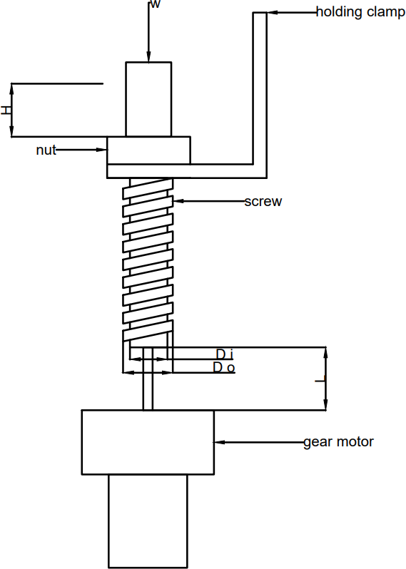

**FEATURES & Benefits** ---> High quality & professional,

finished look; Don't change color under the sun; Easy clean and

waterproof; Mothproofing, moisture proofing, heat resistance; Widely

use range; Nice and modern appearance, no need finish.

**APPLICATION** --->Aluminium Square Tubes are used for various DIY Crafts where lightweight and corrosion resistance is a primary concern. Ideal for custom manufacturing projects such as

DIY air intake, frames, boat building, model making, crafts, gardening products, general manufacturing and shop

fittings.

**WELL PACKED** --->Aluminium Square Tubes comes very well

packaged so that it could not be bent or twisted in any way.

1. Good corrosion resistance in many applications. A smooth raw finish, can be buffed for a polished finish Good dimensional stability - Easily formed and worked with, drilled and good weldability.

2. A strong and lightweight material and easily cut with a regular hacksaw High quality material.

3. Easy clean and waterproof, Moisture proofing, Widely use range, Nice and modern appearance, no need finish. 4. These high quality products are easy to install for everyone from the DIY-er to the professional contractor.The DPDT Rocker Momentary Switch is generally used to make the Clockwise as well as the anti-clockwise motion of the motor, by changing the polarity of supply. This switch is generally used for “Polarity Reversal” DPDT. It has momentary action where the switch can toggle to two poles on Press & Hold action and returns to the middle (OFF) position with it spring action and hence you can quickly change the polarity of your application like a motor to rotate them in both directions.

**V. CASE STUDY**

Introduction In many countries, the increasing use of private cars has generated various social, environmental and economic problems. Therefore, the development of nonmotorised transport systems has been taken into consideration. In addition, if in the twentieth century the development and vitality criterion of a city was the wide-open public

green space and wide appropriate footpaths, in the present century areas and urban footpath networks are one of the most important spaces of leisure and the obvious evidence of the use of engineering design knowledge in the process of the development of cities. Any activity that is done in the city and its physical system requires decision making. One of the

services that urban management has special attention in recent years is examining the capacity of urban footpaths in administrative and commercial districts, since simultaneous with the aim of facilitation in pedestrian traffic, service level increase, cost reduction and economic growth are also maintained. This paper assesses the importance of the capacity of

urban footpaths to clarify whether the capacity of footpaths in the Farhang street in Sari, Iran with the current traffic volume can provide a suitable level of service (LOS) for pedestrians or the traffic flow of vehicles in Farhang street should be prevented and the whole street should be allocated to pedestrians.

2. Research history Bhuyan and Mohanty (2013) researched a walkable environment for pedestrians with minimum pedestrian–vehicle interaction. In this research study, LOS was a measure to determine the compatibility of bicycles, pedestrians, vehicles and so on. This study was carried out to find the pedestrian LOS (PLOS) qualitatively and the results show that the qualitative method is a better method to determine LOS as it inputs the real-time response of people thus providing an option of achieving a better and more accurate result. Collected data were analysed by using inverse variance method and the LOS score table was obtained by determining the range for each LOS, which helped in the estimation of the LOS of the study area (Bhuyan and Mohanty, 2013). Kadali and Vedagiri conducted research on the importance of land-use criteria in PLOS, they showed that the behaviour of pedestrians will change with respect to the different land-use types and this change in behaviour further reflects change in the perceived LOS. The results highlighted the importance of land-use planning in designing a new set of pedestrian access facilities for unprotected mid-block cross-walks under mixed traffic conditions (Raghuram Kadali and Vedagiri, 2015). Rastogi et al. (2014) studied the development of LOS criteria for pedestrians. In this research study, pedestrian facilities are provided to encourage short-distance travel. The LOS criteria available in the literature for pedestrian facilities are more adaptable to the pedestrian scenarios in the United States than in a developing country like India. This paper presents the LOS criteria under two conditions, one for pedestrian movements along the carriageway on or at its side and the other for movement on a pedestrian facility. Data were collected in two different years (2007 and 2009) for the above-mentioned conditions. The LOS criteria were developed using results of this research study. It is observed that the pedestrian space criterion is more uniform and stable than the pedestrian flow criterion in defining the LOS of a facility. The suggested criterion for footpaths and wide footpaths will be very useful in revising the IRC codes on pedestrian facilities (Rastogi et al., 2014).

Sahani and Bhuyan (2013) in an article titled, ‘The Level of Service Criteria of Off-Street Pedestrians Facilities in Indian Context Using Affinity Propagation Clustering’ concluded that the LOS method had been developed for footpaths in recent years. As a result, a number of analyses in this regard has been developed. Most of the methods and analyses

have been achieved through combining models with other fields and as a result is notappropriate for universal applications. No suitable and developed method for access to PLOS is available in India. PLOS defined in this paper has considerable difference with PLOS mentioned in the US Highway Capacity Manual (TRB, 2016) due to the highly

heterogeneous traffic flow on main roads, poor implementation of traffic rules, difference in road geometry, activities of unauthorised vendors, unwanted barrier utilities and offstreet illegal parking (footpaths) (Sahani and Bhuyan, 2013).

3. PLOS criteria for footpaths HCM 2016 has suggested six LOS for pedestrians in both normal and group movement, which represents LOS on footpaths. It should be noted that this table does not apply to footpaths with a slope of more than 5% (Rahman et al., 2012). The status of waiting places such as public transport stations and pedestrian queuing in the corner of the signalised intersection is also described in terms of LOS. Waiting places need enough space to stand, and an extra space for the limited displacement of people (Desyllas et al., 2003; Hillier et al., 1993; Sandahl and Percivall, 1972). A brief explanation is in the following. & LOS A: Standing and free circulation through the queuing area is possible without disturbing others in the queue. & LOS B: Standing and partially restricted circulation to avoid disturbing others in the queue is possible. & LOS C: Standing and restricted circulation through the queuing area by disturbing others in the queue is possible. This density is within the range of personal comfort. & LOS D: Standing without contact is possible; circulation is severely limited in the queue and forward movement is only possible as a group; long-term waiting at this density is uncomfortable. & LOS E: Standing without physical contact with others is not possible; circulation in the queue is not possible; queuing at this density can be only sustained for a short period. & LOS F: Virtually all persons in the queue are standing in direct physical contact with others; this density is extrememovement is possible in the queue friction.

**VI**.**METHODOLOGY**

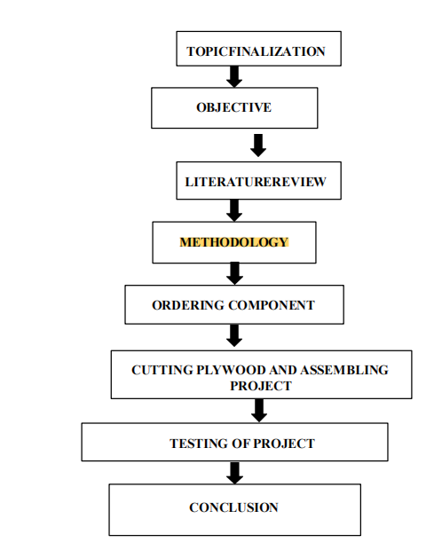

Traffic Condition In Nagpur City Generally traffic is defined as the movement of a person vehicles or any type of goods or person in between the site locations, and includes pedestrians and all types of vehicle. Traffic condition which is day by day leading a severe or worst problem of Nagpur city. In Nagpur city heterogeneous traffic conditions. Nagpur

is at present third largest city in Maharashtra which faces traffic congestion problems mostly in the different road intersection. In Nagpur rapidly, increasing population day by day. This used to reduce congestion on the particular intersections the Bus Bay is to be provided for the city buses moving on the particular section. The Noise pollution,

congestions and air pollution and the results in ill effects to the health. In this analysis respectively increase in demand for survey is to be taken for vehicle count and analysis is done to increase future development of transport network in Nashik city.Transportation is carrying civilization to a brighter future. Currently transportation is one of the most valuable problem in every area of the world. Every country try to resolve transportation issues as per the capability and resources. The traffic volume are steady. Traffic volume is simply the number of vehicle passing a section of a roadway during specified unit of time. In signal number of vehicle are staying one line back to back is known as queue, and their distance between first to last vehicle of the length is known as queue length.The definition of a pedestrian is a person who is walking along a road or some development area to get where he needs to go. The traditional way of designing public transfer station is based on rules of thumb. There rules deliver experience about the behavior of passenger in

transfer station. However, they only consider constant or still situation. Different type of pedestrian such as elderly people or parents with children needs different transfer time. The factor affecting the walking speed of pedestrian age, gender, size, health, etc. characteristics of the trip walking purpose trip length. The walking speed also depend on the pedestrian volume.Methodology A screw jack is a device used to raise or lower a large load by applying a small force. It

works by converting rotary motion into translatory motion using a power screw, which is similar to an inclined plane. The mechanical advantage of a screw jack is the ratio of the load applied to the effort applied. The height of the jack can be adjusted manually or by integrating an electric motor . The screw jack can have reinforced structural strength

through connection with external structures or adjacent screw jacks, which helps to increase its overall strength . In some cases, a 12V DC motor is used to eliminate the effort required to operate the screw jack, and the rotary motion is transferred from the motor to the lead screw through a worm gear drive . Additionally, a ball screw jack may include a

protective tube, a screw, a cylindrical ball nut member, a main drive member, a housing, a tapered roller bearing, and a cap to support the slope and compensate for height differences . Another type of screw jack, called a screw jack stretching bed, is used for physical exercise, fitness, and rehabilitation training, and can help prevent sinew contraction and related issues .A screw jack is a gearbox assembly (either worm gear or bevel gear) and a transmission product (lead screw, ball screw or roller screw) which through use of a motor is used to convert rotary into linear motion. They can be used to push, pull, tension, lock, unlock, tilt, pivot, roll, slide and lift or lower loads, anything from a few kilos to thousands of tonnes.SCREW JACK WORKING PRINCIPLEThe main components of screw jacks are; trapezoidal lifting screw also known as lead screw, worm screw, worm gear and gear housing. A worm screw is rotated manually or by a motor. With the rotation of the worm gear, the lead screw in it moves upwards or downwards linearly. The feed rate of the screw depends on the turning speed, the number of teeth of the gears and the size of the screw pitch.

In some models of jackscrews, The lifting screw does not move up and down. It only rotates around its axis. A lifting nut (also known as a travelling nut) moves along the lead screw. The lifting nut of

the screw jack is made of bronze

**VII.EXPERIMENTAL RESULTS**

Applications:

1. Traffic reducing system

2. Screw systems are easy to control and accurate. .

3. Screw systems are simpler and easier to maintain because these systems use less moving parts.

4. Only screw systems can deliver constant torque or force regardless of speed changes.

5. Easy to spot fault of a screw system.

6. Traffic control devices direct, guide, and inform drivers by offering visual or tactile indicators. Devices fall into four main categories: signs; signals; road design and marking; and barriers or channelizers.

5.2 Advantages:

1. Easy to control the screw system to accelerate and decelerate, Instant stop and running and accuracy is very good.

2. Heavy weight controlling capability through small components.

3. Screw motor and pump can be installed under water.

4. Fast forward and reverse capability.

5. Single pump can control multiple actuators and screw motors.

6. Screw system has No short circuit possibility.

7. Due to Overflow, over pressure have no risk. System is always safe because of screw safety relief valves.

8. Footpaths (or sidewalks) reduce crash risk by separating vehicles and pedestrians and help to promote walking as an alternative to motorized transport.

5.3 DISADVANTAGES:

The screw system easily collapse .It will lose its needed pressure and will

fail..

. **IX.CONCLUSION**

hat it can reduce traffic congestion in the futureTraffic congestion has been a worldwide issue which results into wastage of time, energy and causes environmental pollution. Identification of congestion is the initial step for selecting appropriate method to avoid this situation. To understand congestion in simple way it is classified into different categories. There are number of reasons for the congestion problem. There are numerous potential congestion administration procedures. The suggested two related measures are for traffic management are; Regularity measures and Economic measures. Regularity measures are access management and parking management and pricing policies

are economic measures. Overall, we can use this mechanism to solve the problems. I am confident t.

**VI.FUTURE WORK**

By adopting this concept of using screw jack underneath the footpath for construction of new roads in modern world we can help to reduce the traffic congestion problems. Traffic control devices, such as signs and markings, are

best thought of as stimuli that prompt appropriate driving and walking behavior. These prompts have the weight of law, and failure to respond to them can result in consequences. These devices are best viewed as

for the availability of citations, point loss, direct loss of driving privileges, and, in the case of negligence, criminal penalties. They may also function to control behavior through rule governance.Several rules should be followed for prompts to be effective or to maintain their efficacy (Van Houten, 1998). One important rule involves the timing of the

prompt. Prompts work best when they occur just before the behavior should occur. The second rule is that prompts should be located where they will be seen or heard. For example, a prompt that instructs someone how to use a new

crossing feature should be placed where a pedestrian who could take advantage of the feature is likely to be looking when near the feature. Placement of the prompt not only increases the probability that the stimulus will be perceived but

also can improve the timing of the prompt. Third, the prompt should be specific. General prompts that do not specify the behavior that is expected are less likely

to succeed.

**X. REFERENCES**

1. WATTON, J. 1989. Fluid power systems. Modeling, simulation, analog\ and microcomputer control. Prentice Hall International (UK) Ltd. ISBN 0-13-323197-6.

2. BACKÉ, W., 1984. Servohydraulik. RWTH Aachen.

3. MURRENHOFF, H. 2008. Servohydraulik -GeregeltehydraulischeAntriebe. IFAS RWTH Aachen. Shaker Verlag GmbH. ISBN 978-3-8322-7067-4.

4. GUNDLACH, M. Efficient Regeneration. In: Proceedings of the 21stInternational Conference on Screws and Pneumatics. June 1st-3rd 2011, Ostrava,Czech Republic,

pp. 21-28. ISBN 978-80-248-2430-7.

5. KOŇAŘÍK, P.Syntézaří zenímecha tronického systémus využitímsimulačníchmetod a prostorovychmodelůvirtuální reality. (ControlAlgorithm Synthesis of Mechatronic System with the use of Simulation Methods and 3_D Virtual Reality Model’s. In Czech). Disertation. VŠBTechnical

University of Ostrava, 2009.

6. Jones, Natasha (February 17, 2011). .Retrieved June 3, 2013.

7. . www.gov.uk. Department for Transport. October 2013. Retrieved 15 December 2014.

.

8. [1] A. Stevanovic, C. Kergaye, J. Stevanovic, “Evaluating robustness of signal timings for varying traffic flows”, Transp. Res. Rec.: J.

9. Transp. Res.Board (2259) (2011) 141–150.

10. Chandrasekhar.M, Saikrishna.C, Chakradhar.B, phaneendra kumar.p, sasanka.c, “Traffic Control Using Digital Image Processing” ,

12. International Journal of Advanced Electrical and Electronics Engineering ISSN 2278-8948, Vol.2, May 2013

13, Ekinhan Eriskin, Sebnem Karahancer, Serdal Terzi, Mehmet Saltan,“Optimization of Traffic Signal Timing at Oversaturated

14.Intersections Using Elimination Pairing System”,10th International Scientific

Conference Transbaltica 2017: Transportation Science