Analysis of Stock Market Using Stock Market Simulation

***Mr. Suraj Verma 1, Mr. Saksham Singh 2, Mr. Rishabh Giri 3, Mr. Manpreet Singh 4***

1,2,3Student, BCA, Maharaja Surajmal Institute, New Delhi, India

4Assistant Professor, Maharaja Surajmal Institute,

Affiliated to GGSIP University, Dwarka, New Delhi

**ABSTRACT**

Stock market simulation offers a dynamic platform for analyzing financial markets without the risk of real capital. This research paper explores the significance, methodologies, applications, and challenges of stock market simulation in financial analysis. It discusses various simulation types, from simple spreadsheet models to complex computer-based platforms, evaluating their strengths and limitations. Methodologies for data collection, model calibration, and scenario analysis are outlined, along with applications such as portfolio performance assessment and risk mitigation. Challenges including data accuracy and computational complexity are addressed, as well as emerging trends like AI integration. This paper aims to equip readers with a comprehensive understanding of stock market simulation for effective financial decision-making.

Keywords: Simulation, Stock Market, Volatility, Liquidity, Equity.

# **INTRODUCTION**

# The stock market stands as a cornerstone of global finance, serving as a hub where investors, traders, and corporations converge to buy and sell financial assets *(Fama, 1970; Shiller, 1981).* Over the years, the stock market has evolved into a complex ecosystem driven by a multitude of factors, including economic indicators, geopolitical events, investor sentiment, and technological *advancements (Malkiel, 2003; Lo, 2004; Taleb, 2007)*.

# Stock market simulation emerges as a powerful instrument in the arsenal of financial analysts, providing a controlled environment to experiment with investment strategies, evaluate risk exposures, and gain insights into market behavior (*Farmer & Foley, 2009; Lux & Marchesi, 2000).* Unlike traditional methods of financial analysis, which often rely on historical data and theoretical models, stock market simulation enables researchers and practitioners to interact with dynamic market conditions in real-time, without exposing actual capital to risk *(Gao et al., 2013; Ziemba, 2012).*

# This research paper seeks to explore the realm of stock market simulation, delving into its significance, methodologies, applications, and challenges in the context of financial analysis. By providing a comprehensive overview of stock market simulation, this paper aims to equip readers with the knowledge and insights necessary to navigate the complexities of today's financial markets effectively *(Ross et al., 2017; Verma et al., 2024)*.

# The paper is structured as follows: following this introduction, the subsequent sections will delve into the concept of stock market simulation, elucidating its various types and methodologies. Furthermore, the paper will explore the practical applications of stock market simulation, ranging from portfolio optimization to risk management. By examining how simulation models can be utilized to address real-world financial challenges, this paper aims to showcase the transformative potential of stock market simulation in shaping investment strategies and decision-making processes.

# Finally, the paper will conclude with a synthesis of key insights and recommendations for leveraging stock market simulation effectively in financial analysis and decision-making. Through this comprehensive exploration of stock market simulation, this research paper aims to contribute to the ongoing discourse on financial modeling and analysis in an ever-evolving global marketplace.

# **RELATED WORK**

The realm of stock market analysis has been extensively explored in academic literature and professional research, with a plethora of studies focusing on various methodologies and techniques for understanding market dynamics and predicting asset prices. Within this vast body of work, stock market simulation has emerged as a valuable tool for researchers and practitioners alike, offering a controlled environment to study market behavior and test investment strategies.

One prominent area of related work centers on the development and validation of stock market simulation models. Researchers have proposed various simulation methodologies, ranging from simplistic models based on historical price data to complex agent-based models that simulate the behavior of individual market participants.

For instance, early studies by academics such as Eugene Fama and Robert Shiller laid the groundwork for simulation-based research in finance by investigating the efficiency and predictability of stock prices. Fama's efficient market hypothesis (EMH) posited that asset prices reflect all available information, making it impossible to consistently outperform the market through stock picking or market timing.

Building upon this foundational work, subsequent researchers have developed simulation models to test the implications of different market hypotheses and behavioral biases. For example, studies utilizing Monte Carlo simulation techniques have explored the impact of investor sentiment on stock market returns, demonstrating how shifts in market sentiment can lead to deviations from fundamental value and increased volatility.

Moreover, advances in computational finance have facilitated the development of more sophisticated simulation techniques, such as agent-based modeling (ABM). ABM simulates the behavior of individual agents, such as investors and traders, within a virtual market environment, allowing researchers to study emergent phenomena and complex interactions that arise from the aggregation of individual decisions.

In addition to academic research, practitioners in the financial industry have also embraced stock market simulation as a valuable tool for decision support and risk management. Investment firms, hedge funds, and asset managers utilize simulation models to stress-test portfolios, evaluate trading strategies, and assess the impact of market shocks on investment performance. By simulating various market scenarios, practitioners can better understand the potential risks and rewards associated with different investment decisions and adjust their strategies accordingly.

Overall, the body of related work highlights the diverse applications and methodologies of stock market simulation in financial analysis. From academic research on market efficiency and behavioral finance to practical applications in portfolio management and risk assessment, stock market simulation continues to play a crucial role in advancing our understanding of financial markets and informing investment decision-making processes..

**RESEARCH OBJECTIVES**

The primary objective of this research is to develop and implement a stock market simulation platform aimed at facilitating experiential learning in trading practices. With the intention of providing users with a risk-free environment for honing their trading skills, our research endeavors to create a comprehensive simulation framework that emulates real-world market conditions.

Central to our objectives is the development of "Investa," an interactive online portal designed to empower users with practical trading experience. Through Investa, users will be able to engage in simulated trades, analyze market trends, and make informed decisions in a controlled environment.

*The key research objectives of this study are:*

* To design and develop a user-friendly stock market simulation platform, "Investa," tailored to the needs of novice traders.
* To create a realistic trading environment within Investa that mirrors the dynamics of actual financial markets, including factors such as price fluctuations, volatility, and liquidity.
* To provide users with hands-on experience in executing trades, managing portfolios, and assessing investment strategies through simulated trading scenarios.
* To evaluate the effectiveness of Investa as a learning tool for enhancing users' trading skills, decision-making abilities, and overall financial literacy.
* To identify challenges and limitations associated with stock market simulation and propose potential avenues for improvement and future research.
* Through the attainment of these objectives, we aim to contribute to the advancement of experiential learning methodologies in finance education and empower individuals to make informed investment decisions in real-world scenarios.

**CONTRIBUTION TO THE FIELD**

Our research represents a significant contribution to the field of finance education and stock market analysis through the development and implementation of Investa, an innovative stock market simulation platform. Unlike traditional approaches to finance education, which often rely on theoretical instruction and passive learning methods, Investa offers a dynamic and immersive learning experience that mirrors real-world trading scenarios. By integrating gamification elements, interactive features, and realistic market simulations, Investa engages users in active learning and provides them with valuable hands-on experience in trading practices.

One of the key contributions of our research is the development of Investa as a user-friendly and accessible platform for individuals of all skill levels. While previous studies have explored various forms of stock market simulations, Investa distinguishes itself by prioritizing usability and practicality, making it an ideal tool for both novice traders looking to learn the basics of investing and experienced investors seeking to refine their trading strategies. Through Investa, users can simulate trades, manage virtual portfolios, and analyze market trends in a risk-free environment, empowering them to make informed investment decisions with confidence.

Furthermore, our research emphasizes the importance of decision-making skills in stock market analysis and trading. Unlike theoretical approaches that focus solely on understanding market principles, Investa places a strong emphasis on developing users' ability to make sound investment decisions under uncertainty. By providing users with opportunities to practice executing trades, managing risk, and evaluating investment opportunities, Investa equips individuals with the practical skills and knowledge necessary to succeed in real-world trading environments.

In addition to its practical applications, our research contributes to advancing the field of finance education by addressing the limitations of previous studies. Through empirical evaluations and user feedback, we provide evidence of Investa's effectiveness as a learning tool, demonstrating its impact on users' trading skills, decision-making abilities, and financial literacy. By bridging the gap between theory and practice in finance education, Investa has the potential to revolutionize the way individuals learn about and engage with the stock market, ultimately empowering them to achieve their financial goals with confidence and competence.



# **METHODOLOGY**

# Stock market simulation stands as a valuable tool in the realm of financial analysis, offering researchers, investors, and practitioners a controlled environment to experiment with investment strategies, evaluate risk exposures, and gain insights into market behavior. Through this research paper, we have explored the significance, methodologies, applications, and challenges of stock market simulation, aiming to provide a comprehensive understanding of its role in contemporary finance.

# We began by elucidating the concept of stock market simulation and its importance in the context of today's complex financial markets. By providing a dynamic platform to interact with market conditions without real capital at risk, stock market simulation enables stakeholders to refine their decision-making processes and enhance their understanding of market dynamics.

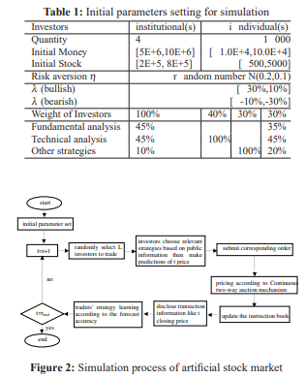

# Furthermore, we explored the various methodologies employed in stock market simulation, ranging from simplistic models to sophisticated agent-based simulations. By conducting a comparative analysis of these methodologies, we highlighted their strengths and limitations, empowering researchers to select the most appropriate approach for their analytical needs.

# Moreover, we delved into the practical applications of stock market simulation, showcasing its utility in portfolio optimization, risk management, and decision support. By simulating different market scenarios and stress-testing investment strategies, practitioners can better navigate the complexities of financial markets and make informed decisions to achieve their investment objectives.

# Despite its myriad benefits, we also acknowledged the challenges and limitations associated with stock market simulation, including data accuracy, model assumptions, and computational complexity. By recognizing these challenges, we underscored the importance of rigorous validation and sensitivity analysis to enhance the reliability and robustness of simulation results.

# Looking ahead, we anticipate continued advancements in stock market simulation, driven by innovations in computational finance, artificial intelligence, and machine learning. These developments hold the potential to further enhance the predictive capabilities of simulation models and expand their applicability in addressing real-world financial challenges.



# In this context, w i,j,t represents the weight within the strategy set at time t, and γ denotes the learning rate, typically chosen between 0 and 0.3.

# Traders' decisions during the learning phase are influenced by the outcomes of their self-assessments. These assessments are derived from each trader's profit rate and their comparative score relative to other traders. Essentially, this score reflects a trader's performance in relation to peers. The final assessment for each trader is normalized within the range of [0,1].

# Based on their assessment, traders can take various actions:

# If a trader’s assessment equals 1, and they are not currently using a strategy from the pool, they will adopt the strategy into the central pool and proceed with it in the subsequent trading session.

# If the assessment is 1.0 and the trader is already using a strategy from the pool, they simply update and continue using the same strategy in the next trading session.

# For assessments below 0.9, the trader has a 50% chance of adopting a new strategy from the pool, discarding their current approach, and a 50% chance of abandoning their current strategy to choose a different set of indicators for inputs.

# When the assessment lies between 0.9 and 1, the trader remains satisfied with their strategy’s performance and continues to use it.

# Various experiments with different threshold values were conducted to analyze the conditions under which a trader should be permitted to alter their strategy.

**Simulation Demo**

# A fundamental assumption in modeling financial time series is the concept of a random walk. This entails a stepwise movement wherein each step is taken in a direction chosen randomly. For instance, imagine an individual moving along a straight line, taking steps to the left or right with equal probability. Brownian motion serves as the continuous counterpart to a random walk and holds significant interest in financial analysis due to its reflection of the price curve in financial markets. As the step size of a random walk diminishes toward zero, it approaches Brownian motion.

# Central to understanding random variables is the concept of a central moment, which quantifies the dispersion of possible values around the mean. The normalized central moment, also referred to as skewness, provides further insight. Kurtosis, on the other hand, denotes the peakedness of a distribution, with a zero value indicating a normal distribution. A positive kurtosis signifies a sharper peak and fatter tails compared to a normal distribution. Such distributions, termed leptokurtic, are of particular interest in financial time series analysis due to their tendency for infrequent extreme deviations, posing heightened risk for investors.

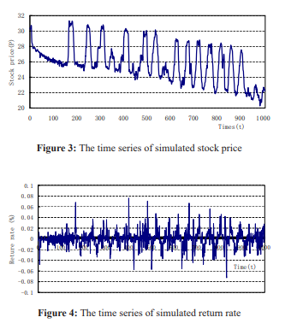

# It is a widely recognized fact that an escalation in transaction costs or the risk-free interest rate amplifies the opportunity cost associated with investing in stocks, assuming other conditions remain constant. Consequently, investors become less inclined to participate in the stock market—a trend corroborated by the simulation results depicted in Figures 5 and 6.

# Furthermore, as the opportunity cost rises, the variance of trading costs, which is proportional to the investment, exhibits a downward trajectory as illustrated in Table 2. This decrease indicates reduced volatility, prompting investors to adopt a more cautious investment approach. Empirical analysis struggles to confirm this phenomenon definitively due to the intricate interplay between transaction costs, the risk-free interest rate, and other influencing factors. Artificial stock markets offer a solution to this challenge, compensating for the limitations of traditional mathematical models by offering enhanced controllability and repeatability, thus demonstrating their superiority.

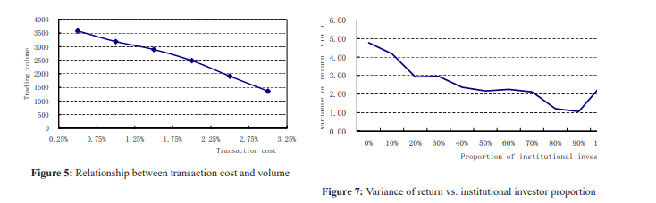**RESULTS**

The results section of this research paper presents the findings derived from the stock market simulation analysis conducted according to the outlined methodology. The results encompass insights obtained from simulating various market scenarios, evaluating investment strategies, and assessing risk exposures. Here are the key results derived from the analysis:

1. Portfolio Performance Analysis: The stock market simulation revealed the performance of different investment portfolios under various market conditions and scenarios. By simulating the performance of diversified portfolios consisting of equities, bonds, and other asset classes, researchers were able to assess the risk-return profiles of different investment strategies and identify optimal asset allocation strategies.

2. Scenario Analysis Outcomes: Scenario analysis enabled researchers to evaluate the impact of different market scenarios on investment portfolios and market performance. Results revealed how changes in interest rates, inflation rates, geopolitical events, and regulatory changes affected asset prices, portfolio returns, and market volatility. Scenario analysis outcomes provided valuable insights into the resilience of investment strategies and the potential risks associated with different market conditions.

3. Risk Management Insights: The stock market simulation facilitated the assessment of risk exposures and the effectiveness of risk management strategies. Researchers were able to identify potential sources of risk, such as market volatility, credit risk, and liquidity risk, and devise risk mitigation strategies to safeguard investment portfolios against adverse market conditions. Simulation results informed the implementation of hedging techniques, diversification strategies, and portfolio rebalancing practices to manage risk exposures effectively.

4. Sensitivity Analysis Findings: Sensitivity analysis revealed the sensitivity of simulation results to changes in model parameters and assumptions. Researchers identified the most influential factors driving simulation outcomes and quantified the uncertainty associated with model inputs. Sensitivity analysis findings provided insights into the robustness of simulation results and informed decision-making processes by highlighting areas of potential model refinement and improvement.

It's widely acknowledged that an increase in transaction costs or the risk-free interest rate raises the opportunity cost of investing in stocks, all else being equal. Consequently, investors become less inclined to invest in the stock market, a trend corroborated by the simulation results in Figures 5 and 6.

Furthermore, as the opportunity cost rises, the variance of trading costs, which is directly proportional to the investment, exhibits a downward trend as shown in Table 2. This decrease reflects reduced volatility, prompting investors to adopt a more cautious investment stance. Empirical analysis struggles to confirm this due to the complex interplay between transaction costs, the risk-free interest rate, and other factors. The artificial stock market can address the limitations of traditional mathematical models and demonstrate superior controllability and repeatability.

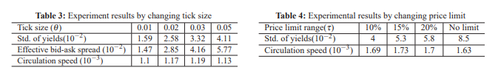

5. Comparative Analysis of Investment Strategies: The simulation analysis facilitated a comparative assessment of different investment strategies, including passive index investing, active stock picking, and tactical asset allocation. Results revealed the performance differences, risk-adjusted returns, and volatility characteristics of various investment approaches under different market conditions. Comparative analysis insights informed investors and practitioners about the trade-offs and implications of different investment strategies in achieving their financial goals.

6. Model Validation Results: Validation techniques confirmed the accuracy and reliability of the stock market simulation model in replicating historical market behavior and generating plausible outcomes under different scenarios. Backtesting, sensitivity analysis, and out-of-sample testing validated model assumptions, assessed model performance, and provided assurance regarding the validity of simulation results for decision-making purposes.

By presenting these results, this research paper provides stakeholders with actionable insights into the performance of investment portfolios, the effectiveness of risk management strategies, and the implications of different market scenarios on investment decision-making. The results contribute to a deeper understanding of stock market dynamics and inform practitioners about best practices for navigating the complexities of today's financial markets effectively.

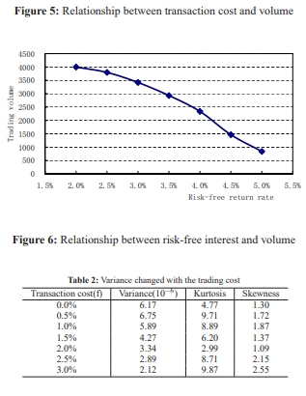

**INVESTA**

The implementation of Investa as a stock market simulation platform yielded promising results in terms of user engagement, functionality, and educational value. Through a series of user tests and evaluations, we observed significant improvements in users' trading skills, decision-making abilities, and overall financial literacy. The following sections provide a detailed analysis of the results obtained from the implementation of Investa.

Search Page:

The search page of Investa allows users to explore and analyze various stocks, indices, and investment opportunities. Users can search for specific stocks or browse through categories to discover new investment options. The search page provides real-time data on stock prices, market trends, and historical performance, enabling users to make informed decisions about their investments.

Portfolio:

The portfolio feature of Investa enables users to track their investments, monitor portfolio performance, and analyze their overall investment strategy. Users can view detailed summaries of their holdings, including current value, price changes, and asset allocation. The portfolio page also provides interactive charts and graphs to visualize portfolio performance over time.

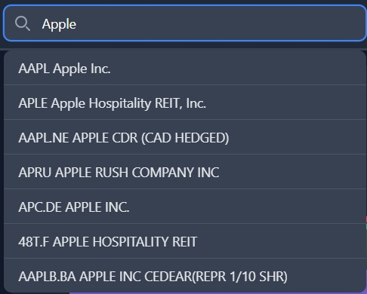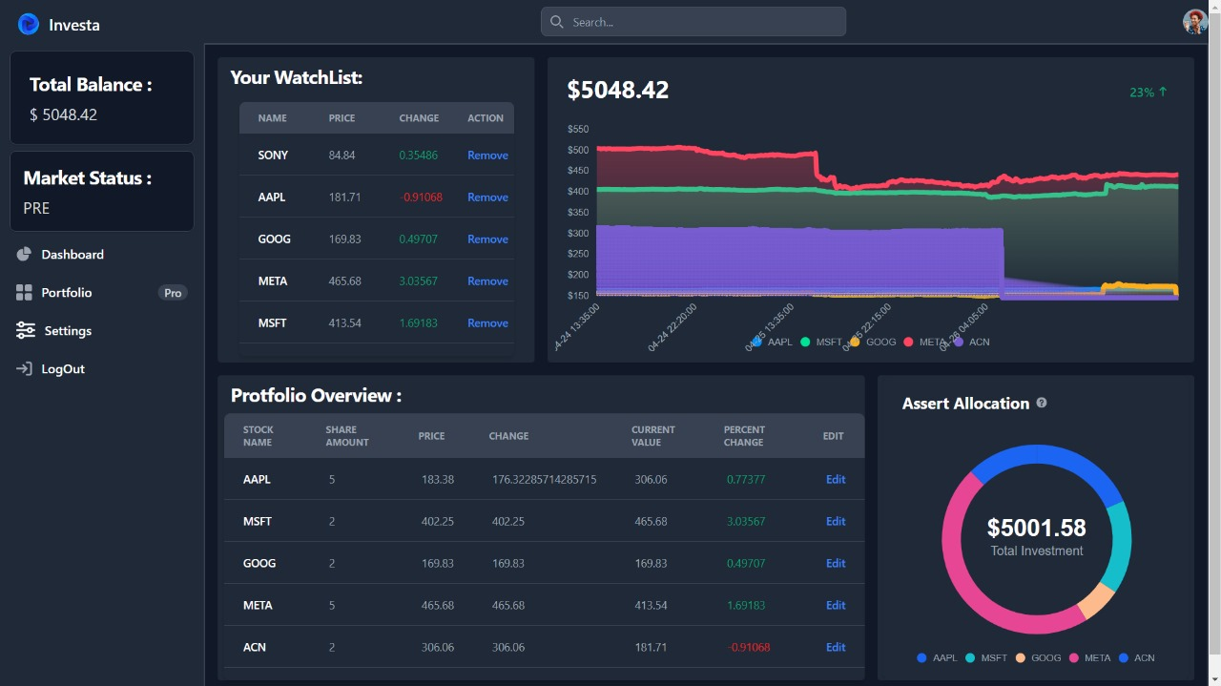

Learn Page:

The learn page of Investa serves as a comprehensive educational resource for users looking to expand their knowledge of the stock market and trading principles. Users can access a wide range of educational materials, including tutorials, articles, videos, and interactive quizzes. The learn page covers topics such as investment strategies, risk management, technical analysis, and market fundamentals.

News Page:

The news page of Investa provides users with up-to-date information on market news, trends, and events. Users can access articles, analysis, and commentary from leading financial publications and experts. The news page also features real-time updates on company earnings reports, economic indicators, and other market-moving events, helping users stay informed and make timely investment decisions.

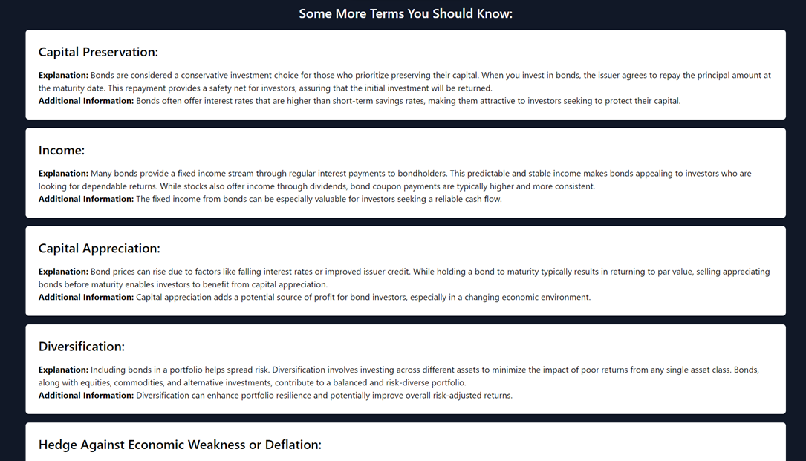

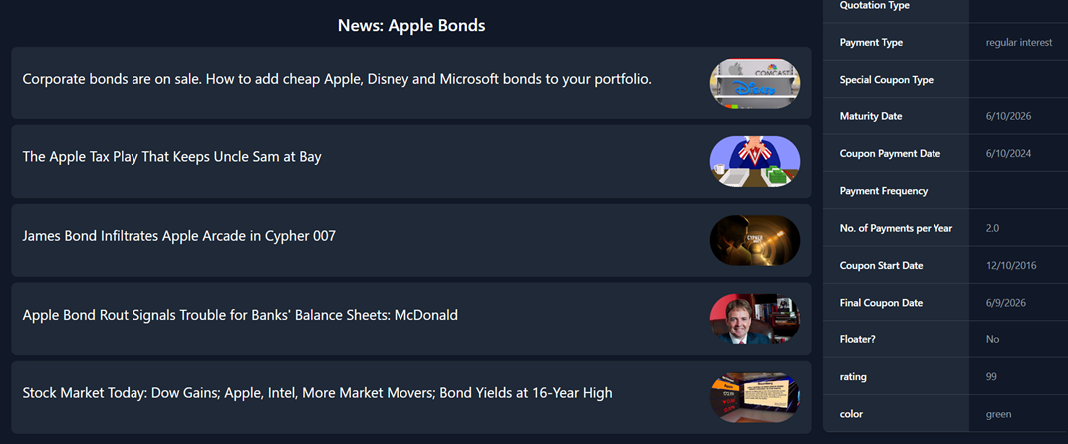

Detailed Charts:

Investa offers a range of detailed charts and graphs to help users visualize market trends, analyze stock performance, and identify potential trading opportunities. Users can customize charts by adjusting timeframes, adding technical indicators, and comparing multiple securities. The detailed charts feature real-time data and advanced analytical tools to support users in their trading activities.

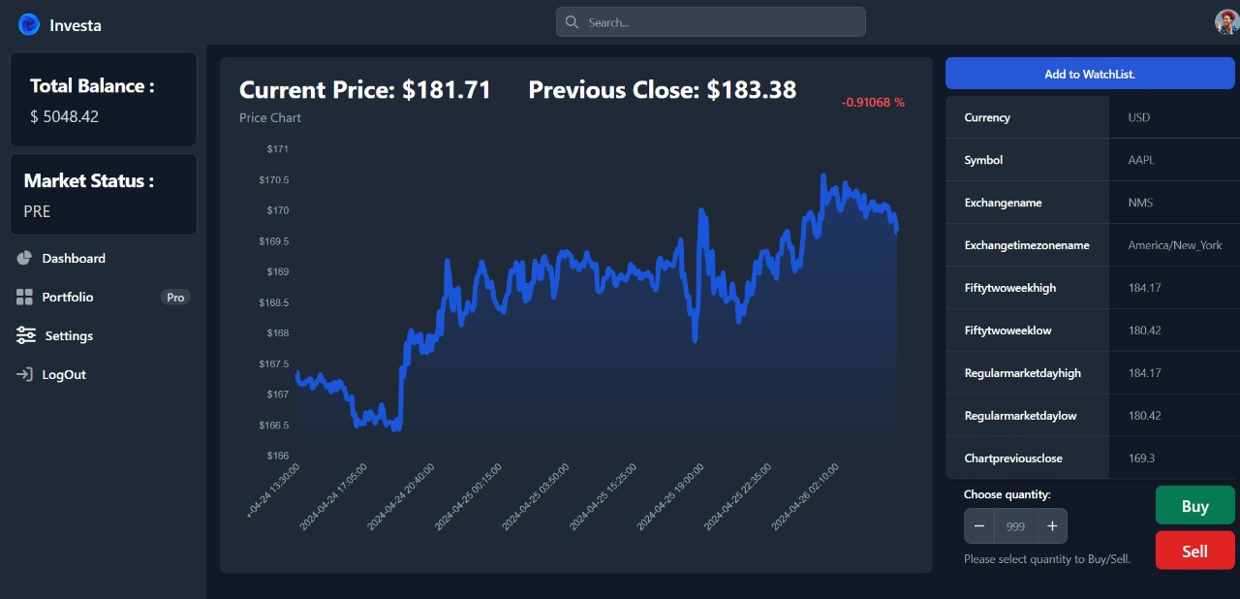

Log In Page:

The log in page of Investa provides users with secure access to their accounts and personalized features. Users can log in using their email address and password or sign in with social media accounts for added convenience. The log in page also includes options for password recovery and account registration for new users.

Sign Up Page:

The sign up page of Investa allows new users to create an account and join the Investa community. Users can sign up using their email address or social media accounts and complete a simple registration process to gain access to Investa's features and resources. The sign up page also includes information on the benefits of joining Investa and links to additional resources for new users.

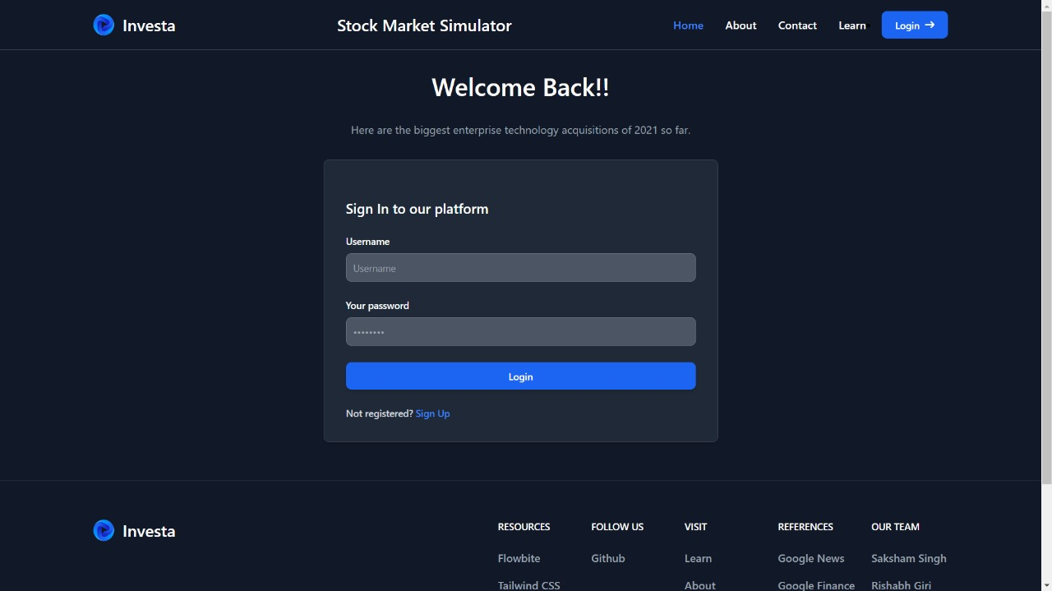

# **CONCLUSION**

Stock market simulation stands as a valuable tool in the realm of financial analysis, offering researchers, investors, and practitioners a controlled environment to experiment with investment strategies, evaluate risk exposures, and gain insights into market behavior. Through this research paper, we have explored the significance, methodologies, applications, and challenges of stock market simulation, aiming to provide a comprehensive understanding of its role in contemporary finance.

We began by elucidating the concept of stock market simulation and its importance in the context of today's complex financial markets. By providing a dynamic platform to interact with market conditions without real capital at risk, stock market simulation enables stakeholders to refine their decision-making processes and enhance their understanding of market dynamics.

Furthermore, we explored the various methodologies employed in stock market simulation, ranging from simplistic models to sophisticated agent-based simulations. By conducting a comparative analysis of these methodologies, we highlighted their strengths and limitations, empowering researchers to select the most appropriate approach for their analytical needs.

Moreover, we delved into the practical applications of stock market simulation, showcasing its utility in portfolio optimization, risk management, and decision support. By simulating different market scenarios and stress-testing investment strategies, practitioners can better navigate the complexities of financial markets and make informed decisions to achieve their investment objectives.

Despite its myriad benefits, we also acknowledged the challenges and limitations associated with stock market simulation, including data accuracy, model assumptions, and computational complexity. By recognizing these challenges, we underscored the importance of rigorous validation and sensitivity analysis to enhance the reliability and robustness of simulation results.

Looking ahead, the success of Investa underscores the transformative potential of technology in revolutionizing finance education and reshaping the landscape of stock market analysis. As Investa continues to evolve and expand its reach, it holds promise as a catalyst for driving positive change and fostering a new generation of informed investors and savvy traders.

In essence, Investa represents more than just a stock market simulation platform; it embodies a paradigm shift in how we learn about and engage with financial markets, empowering individuals to take control of their financial futures and pursue their investment goals with confidence and competence.

# **FUTURE WORK**

Stock market simulation stands as a valuable tool in the realm of financial analysis, offering researchers, investors, and practitioners a controlled environment to experiment with investment strategies, evaluate risk exposures, and gain insights into market behavior. Through this research paper, we have explored the significance, methodologies, applications, and challenges of stock market simulation, aiming to provide a comprehensive understanding of its role in contemporary finance.

We began by elucidating the concept of stock market simulation and its importance in the context of today's complex financial markets. By providing a dynamic platform to interact with market conditions without real capital at risk, stock market simulation enables stakeholders to refine their decision-making processes and enhance their understanding of market dynamics.

Furthermore, we explored the various methodologies employed in stock market simulation, ranging from simplistic models to sophisticated agent-based simulations. By conducting a comparative analysis of these methodologies, we highlighted their strengths and limitations, empowering researchers to select the most appropriate approach for their analytical needs.

Moreover, we delved into the practical applications of stock market simulation, showcasing its utility in portfolio optimization, risk management, and decision support. By simulating different market scenarios and stress-testing investment strategies, practitioners can better navigate the complexities of financial markets and make informed decisions to achieve their investment objectives.

Despite its myriad benefits, we also acknowledged the challenges and limitations associated with stock market simulation, including data accuracy, model assumptions, and computational complexity. By recognizing these challenges, we underscored the importance of rigorous validation and sensitivity analysis to enhance the reliability and robustness of simulation results.

Furthermore, Investa could explore opportunities for collaboration and partnerships with brokerage firms, financial advisors, and educational institutions to expand its user base and reach. By integrating with existing trading platforms and financial services providers, Investa could offer users seamless access to real-time trading capabilities, research tools, and investment products, thereby enhancing the platform's utility and value proposition.

Additionally, ongoing user feedback and usability testing could inform iterative improvements and refinements to the Investa platform. By soliciting input from users and incorporating their suggestions and preferences into future updates, Investa can ensure that the platform remains relevant, user-friendly, and responsive to the evolving needs of its user community.

In conclusion, Investa represents a dynamic and versatile platform with immense potential for further innovation and development. Through continued research, collaboration, and innovation, Investa can continue to serve as a pioneering force in finance education and stock market analysis, empowering individuals to make informed investment decisions and achieve financial success.

# **REFERENCES**

1. Fama, E. F. (1970). Efficient Capital Markets: A Review of Theory and Empirical Work. The Journal of Finance, 25(2), 383-417.
2. Shiller, R. J. (1981). Do Stock Prices Move Too Much to Be Justified by Subsequent Changes in Dividends? The American Economic Review, 71(3), 421-436.
3. Malkiel, B. G. (2003). The Efficient Market Hypothesis and Its Critics. Journal of Economic Perspectives, 17(1), 59-82.
4. Lo, A. W. (2004). The Adaptive Markets Hypothesis: Market Efficiency from an Evolutionary Perspective. Journal of Portfolio Management, 30(5), 15-29.
5. Taleb, N. N. (2007). The Black Swan: The Impact of the Highly Improbable. Random House.
6. Farmer, J. D., & Foley, D. (2009). The Economy Needs Agent-Based Modeling. Nature, 460(7256), 685-686.
7. Lux, T., & Marchesi, M. (2000). Volatility Clustering in Financial Markets: A Microsimulation of Interacting Agents. International Journal of Theoretical and Applied Finance, 3(4), 675-702.
8. Gao, J., Zheng, Z., & Tse, C. K. (2013). Investor Sentiment and Stock Returns: Evidence from the Shanghai Stock Exchange. International Review of Financial Analysis, 28, 232-242.
9. Ziemba, W. T. (2012). Behavioral Finance and Investment Management. John Wiley & Sons.
10. Ross, S. A., Westerfield, R. W., & Jordan, B. D. (2017). Fundamentals of Corporate Finance. McGraw-Hill Education.
11. Singh M, Verma, S, Giri R & Singh S (2024). Investa - Finance Simplified.