AN OVERVIEW OF PLANNING AND SCHEDULING IN THE CONSTRUCTION PROJECT MANAGEMENT

## P.Pratish1, Dr.M.Narmatha2

1M.Tech Construction Engg and Management, Dept. of Civil Engg, Dr.M.G.R. Educational & Research Institute, India

2Professor, Department of Civil Engg, Dr. M.G.R. Educational & Research Institute, Chennai, India

# ABSTRACT

Planning, scheduling is an important part of the construction management. Planning and scheduling of construction activities helps engineers to complete the project in time and within the budget. The term ‘Construction’ does not only denotes physical activities involving men, materials and machinery but also covers the entire gamut of activities from conception to realization of a construction project. Thus, management of resources such as men, materials, machinery requires effective planning and scheduling of each activity. Planning is the most important technique of the management. Planning means “Looking ahead”.Planning is necessary to ensure proper utilization of human and material resources to achieve the objectives of the project. In any project, the plan includes the estimates, the budget, and time schedule, man power planning and the plant and equipment.Planning is therefore a course of action to achieve the desired results. It may be defined as a rational, sequential and appropriate way of directing the construction activities. It is an administrative process which translates the policy into a method of achieving the desired goal.

**Keywords:** Planning, Scheduling , Constrcution Management, Organization

# INTRODUCTION

Management is the science and art of planning, organizing, leading and controlling the work of organization members and of using all available organization resources to reach stated organizational goals. Construction management deals with economical consumption of the resources available in the least possible time for successful completion of construction project. ‘Men’, ‘materials’, ‘machinery’ and ‘money’ are termed as resources in construction Management. Construction management involves planning, budgeting, coordinating, and supervising construction projects from start to finish. As a construction manager, you may work on various construction projects, including buildings, roads, bridges, and other structures. Construction management is a professional service that provides a project’s owner(s) with effective management of the project's schedule, cost, quality, safety, scope, and function. Construction management is compatible with all project delivery methods. No matter the setting, a Construction Manager’s (CMs) responsibility is to the owner and to a successful project. At its core, a capital project is made up of three parties (excluding the CM): The owner, who commissions the project and either funds the project directly or finances it through a variety of methods. The architect/engineer, who designs the project. The general contractor, who oversees day-to-day operations and manages subcontractors. The CM represents the owner’s interest and provides oversight over the entire project directly for the owner. His/her mandate is to work with all parties to deliver the project on time, at or under budget, and to the owner’s expected standard of quality, scope, and function.CMs are uniquely qualified through combined education and experience to work with the owner, architect, general contractor, and other stakeholders to determine the best possible sequence of construction operations and develop a detailed schedule and budget, while also establishing plans for project safety and security and helping the owner manage risk. This requires using project management information systems (PMISs) and complex planning techniques, like critical path method, as well as knowledge of construction methods.A 2013 study by McGraw-Hill Construction and supported by the CMAA Foundation showed that using professional CMs saved money, avoided or mitigated problems, and produced higher quality results for owners.Professional CMs use industry-standard practices to manage projects successfully. The CM Body of Knowledge and Standards of Practice address all six areas of construction management services: schedule, cost, safety, quality, function, and scope.

## Functions of Construction Management:

The functions of construction Management are (a) Planning (b) Scheduling (c) Organizing (d) Staffing (e) Directing (f) Controlling (g) Coordinating

## (a) Planning in Construction Management:

It is the process of selecting a particular method and the order of work to be adopted for a project from all the possible ways and sequences in which it could be done. It essentially covers the aspects of ‘What to do’ and ‘How to do it’.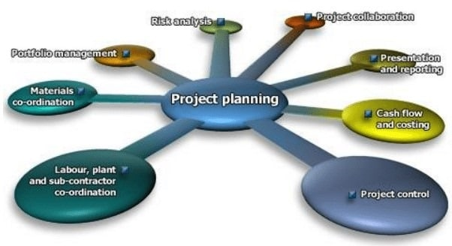

### **Fig.1 Importance of construction project planning:**

* Planning helps to minimize the cost by optimum utilization of available resources.
* Planning reduces irrational approaches, duplication of works and inter departmental conflicts.
* Planning encourages innovation and creativity among the construction managers.
* Planning imparts competitive strength to the enterprise.

## b) Scheduling in Construction Management:

Scheduling is the fitting of the final work plan to a time scale. It shows the duration and order of various construction activities. It deals with the aspect of ‘when to do it’.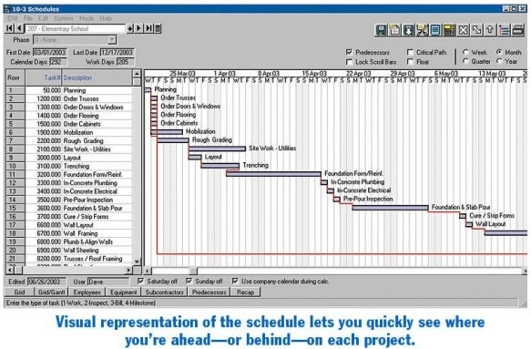

### Importance of construction project scheduling:

Scheduling of the programming, planning and construction process is a vital tool in both the daily management and reporting of the project progress.

**c) Organizing:** Organizing is concerned with decision of the total construction work into manageable departments/sections and systematically managing various operations by delegating specific tasks to individuals.

**d) Staffing:** Staffing is the provision of right people to each section / department created for successful completion of a construction project.

**e) Directing:** It is concerned with training sub ordinates to carryout assigned tasks, supervising their work and guiding their efforts. It also involves motivating staff to achieve desired results.

**f) Controlling:** It involves a constant review of the work plan to check on actual achievements and to discover and rectify deviation through appropriate corrective measures.

**g) Coordinating:** It involves bringing together and coordinating the work of various departments and sections so as to have good communication. It is necessary for each section to aware of its role and the assistance to be expected from others.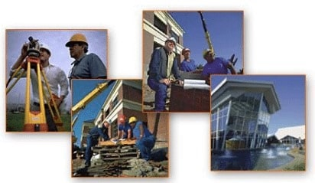

### **Fig.2 project planning:**

## Importance of Construction Management:

* Construction management practices invariably lead to “maximum production at least cost”. A good construction management, results in completion of a construction project with in the stipulated budget.
* Construction management provides importance for optimum utilization of resources. In other words, it results in completion of a construction project with judicious use of available resources.
* Construction management provides necessary leadership, motivates employees to complete the difficult tasks well in time and extracts potential talents of its employees.
* Construction management is beneficial to society as the effective and efficient management of construction projects will avoid, escalation of costs, time overrun, wastage of resources, unlawful exploitation of labor and pollution of environment.

# Project management activities

* Proposal writing.
* Project planning and scheduling.
* Project costing.
* Project monitoring and reviews.
* Personnel selection and evaluation.
* Report writing and presentations.

## 5.Project Management: Official Definition

* Project management is a set of principles and tools for
* Defining
* Planning
* Executing
* Controlling . . . and
* Completing a PROJECT

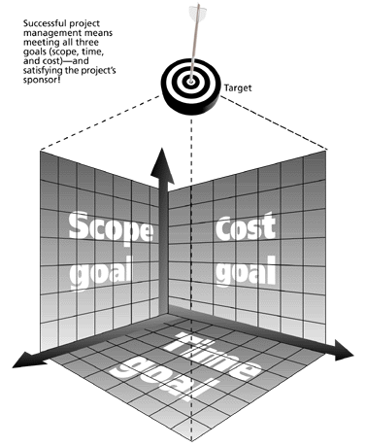

## Fig .3 The constraint of project PLANNING

## KEY CONSTRUCTION PROJECT MANAGEMENT ACTIVITIES:

* Planning.
* Scheduling.
* Control

## Project Planning:

* Establishing objectives.
* Defining Project.
* Creating work breakdown structure.
* Determining resources.
* Forming organization.

## Project Scheduling:

* Identifying precedence relationships.
* Sequencing activities.
* Determining activity time and costs.
* Estimating material and worker requirement.

## Project scheduling Techniques:

* Gantt chart.
* Critical Path Method (CPM).
* Program Evaluation & Review Technique (PERT).

## Project Controlling:

* Quality.
* Schedule.
* Budget.
* Safety.
* Environment.

# PLANING FOR A PROJECT:

* **Planning Date collection –** Studying relevant documents.
* **Planning time** 
  + Define scope of work
  + WBS into activities
  + Developing network plans
  + Scheduling work
  + Charting site layout

**3. Planning Resources**

* + Forecasting resources requirement
  + Planning manpower requirement
  + Planning materials procurement
  + Planning equipment procurement
  + Budgeting costs
* **Planning Implementation** 
  + - Designing control system
    - Formulating monitoring system
    - Developing project management information system

**8. LITERATURE REVIEW**

To increase safety in project implementation and factories production in the face of possible and unpredictable events, time builders will be placed in different parts of projects and activities to prevent the negative effects of auctuations in activities on the project’s critical chain which will otherwise lead to a delay in the whole project. Three types of builders are used, called the Project Builder, Feeding Builder, and Resource Builder. The project builder is placed at the end of the project’s critical chain to maintain the project delivery date (Goldratt, 1997). Builder management can be considered as the most important measure in implementing the critical chain scheduling, because if short builders are allotted, we will need to re-schedule the project repeatedly until the end of the project, and if long builders are allotted, all concepts used in scheduling will be violated (Zohrehvandi et al., 2020).

A construction project is a series of activities related to building efforts according to the desired cost, time and quality constraints. The success of the project can be seen based on the planning, namely planning and scheduling. Scheduling a project is known as a way so that during the construction process it runs smoothly in accordance with the stipulated time for the implementation of work items. Construction project scheduling must be planned carefully and optimally so as to minimize delays in time or duration of project activity implementation and other unwanted impacts. Proper planning and in accordance with the characteristics of the project is needed to deal with uncertain project conditions so that the project can be carried out and run efficiently according to the planned time and cost.

Construction projects are reflected as activities that involve resources so as to achieve goals based on a certain period of time until the goals are achieved perfectly. The project does not become a routine or operational activity because it is only temporary so that a project has a characteristic that is there is a timeline (between the starting point and the measurable end point), there are resources in the form of capital and labor, there are tools to run the project and special techniques for Gantt Charts. and S curves, and there are diverse teams from fields & functions (Rosanti et al., 2016).Effectiveness is defined as a series of inputs, processes and outputs in looking at certain things. A program or series of activities is said to be effective if the resulting output meets the desired goals. Effectiveness is the condition when choosing the expected goals and the means or equipment used along with the desired goals can be achieved with satisfactory results. Factors that affect the suitability of project time and schedule include materials, labor, equipment, finance, contractors, partners, consultants, and external factors. Effectiveness is also interpreted as a measure that describes the quantity, quality and time achieved due to good management and the target has been determined beforehand. Effectiveness is always related to expected results and desired goals so that effectiveness will contribute to future activities (Soleha & Ismail, 2018).

**9.KEY ELEMENTS OF CONSTRUCTION MANAGEMENT**

There are many elements to construction management. It’s a major endeavor, as you can imagine, that oversees the entire construction project as a proxy for the owner. But for this introduction to construction management, we boiled down those elements to a few key ones, which are discussed below.

**9.1 Construction Delivery Methods**

There are five common delivery methods in construction projects. Design-bid-build, also known as traditional building, is probably the most used method. There are three phases: design, bid and build. This is often found in commercial construction projects and while lengthy, it gives owners the opportunity to work with architects and engineers to get a good price for the project.Design-build (D-B) reduces the timeline that’s associated with design-bid-build by having a single party replace the designer and the contractor. This design-builder is usually an architect, engineer or contractor and works with the owner. This fosters better communication but puts many responsibilities on the shoulders of the design-builder.Another delivery method is construction manager at risk (CMAR or CM at risk). It’s similar to the design-bid-build method, but the construction manager (CM) is hired by the owner to oversee the project. This is great for owners who need expert help managing the project and often allows the owner to remove themselves from the process. Then there’s job order contracting (JOC), which works at completing a number of predefined construction tasks. It tends to be used in small-to-medium construction projects, such as repairs, renovations and maintenance. It’s ideal for short timelines and fixed budgets, but not new construction. Multiple award task order contract (MATOC) is often found in military or government construction work. It involves long-standing contracts for multiple projects, all of which are under a single master contract. There could be multiple contractors at work, there could also only be one.

**9.2 Construction Bidding Process**

The bidding process in construction allows the construction manager to review contractors to hire for the project. Of course, price is a factor, but risk is also assessed. It’s important to look over the safety, financial and insurance resources of these contractors to ensure they’re professional and best suited for the job.This process begins with a request for general contractors to bid on the project. These general contractors then get bids from subcontractors. There’s a back and forth as questions are answered about the project until the deadline when bids must be submitted and a contractor selected. This leads to contract negotiations and when agreed on, the contract is signed and distributed to the project team. The general contractor who won the bid will then make the final selection of subcontractors.

**9.3 Construction Contracts**

Construction contracts are legally binding documents that are signed by the winning bidder and the owner and outlines the scope of work, risks, duties and legal rights for both parties. There are many different types of contracts, such as a lump sum contract in which the owner pays upon completion of the project. But there are many more, such as percentage rate, item rate, cost plus fixed fee and so on. You have to determine which contract is right for you and the job being done.

**10. THE CONSTRUCTION MANAGEMENT PROCESS**

Construction management follows project management methodology in order to deliver the project on time and under or within the agreed-upon budget. After the bidding process and the contract has been signed, it’s time to build. Construction projects have phases, and there are five basic phases to the construction management process.

**10.1 Initiation**

Before any planning is started, an objective for the construction project has to be decided upon. There is also a need to do a feasibility project to ensure that the construction is even viable. That is, there’s a return on investment and the project can be delivered on time and within a reasonable budget. You’ll also need to have a schematic design at this phase. Once this is done, a project initiation document (PID) is made, which will provide the groundwork for the construction plan.

**10.2 Preconstrucion**

This first step is to assemble a project team who will look at all the work that must be done in order to complete the project. A work breakdown structure (WBS) is often used to divide the larger job into small, more manageable deliverables and tasks. Time is planned in a schedule of activities that includes the costs for executing tasks and the resources needed to do them. This is called preconstruction. At this point, the schedule, budget, risk management plan and communication plan are all finalized. Though, these are living documents that must be reviewed and revised throughout the life cycle of the project.

**10.3 Procurement**

Now, the project team orders, purchases or rents everything it needs for the construction project. This includes tools and services that’ll be necessary to complete the project. Depending on the scope of the project, this can be demanding. Good communication is vital between the owner, contractor and vendors to ensure everything is done properly. Poor communication leads to bad purchasing and inventory that’s lacking or overstocked; either scenario is bad for business.

**10.4 Construction**

This is when the project is executed. During this phase of the process, the general contractor and subcontractors carry out all the planning and procuring of resources that had been done in the previous steps. The construction manager, architect, engineers and project manager will all work together to perform quality control inspections, respond to requests for information (RFIs) and review and approve technical submissions. This is all done to make sure the construction meets the design requirements while keeping to schedule, budget and quality.

**10.5 Close-Out**

The final phase involves a punch list, where the contractor and owner look over the job and catch errors or items that still need to be completed. Once the project has been successfully delivered, however, there’s still work to do. Resources are demobilized, rentals are returned, the worksite is cleaned and subcontractors’ contracts are closed so they can move on to other projects.

**11. CONSTRUCTION PLANNING SCHEDULES**

**11.1 Schedules For Monthwise Quantity**

In this Schedule the activities involved in the project are listed and the quantity for the various works month wise is calculated. This Schedule helps in the month wise mobilization of materials, Plant & Machinery and Manpower.

\

11.2 **Schedules For Monthwise Invoicing**

In this Schedule the invoicing month wise is calculated. The average rates are taken from the Bill of Quantities from which the month wise Invoice is calculated.

11.3 **Cash Flow Chart (Cumulative & Monthwise**)

The Invoicing is done for each month and from these data the Cash flow chart is prepared Month wise and cumulative for

the entire Project Duration. This cash flow helps in the allocation of funds.

11.4 **Schedule Of Manpower Requirement**

The manpower required for the project includes the skilled labours like Barbender, Carpenter and Mason and the

unskilled labours working in the project. By this Schedule the number of skilled and unskilled labours required for the

project in each man day is calculated. This schedule helps in the mobilization of the manpower and also for their optimum utilisation.

**11.5 Schedule Of Bulk Material Requirement**

The Bulk materials in the project includes materials like Cement, Steel, fine aggregate, coarse aggregate, blocks, bricks etc. Using the standard coefficients the bulk material quantities are calculated month wise. This schedule helps in the mobilization of the Bulk materials and also for their optimum utilisation.

**11.6 Schedule Of Specialized Agencies**

The specialized agency includes the agency that are doing special works like waterproofing, joineries manufacture, external finishes like ACP cladding etc. So it is important to prepare a schedule which enables the project completion without delay with complete Quality requirements.

**CONCLUSION**

Scheduling research has made a significant impact in production systems. This chapter has described how the production scheduling concepts and models that have brought so much success to the shop floor can be applied to task sequencing issues that impact human performance. Existing approaches to human performance improvement including work-rest scheduling, job rotation scheduling, cross-training, teamwork and shift-work scheduling have been surveyed along with practical implementation guidelines. The literature survey revealed that classical scheduling research has done little to specifically address human task sequencing. Consequently, a framework for characterizing the human element in scheduling models has been described as well as promising new multi-disciplinary research opportunities. Consideration of human characteristics as resource attributes in scheduling models will potentially inspire a new generation of scheduling research and practice. Planning is the most important process for the successful completion of the project. By the method of Time planning it is ensured that the Project is completed within the allocated Time without any delay. In case of any delay or hindrance in the Project alternative solutions are being arrived at for the successful completion.

**REFERENCE**

[1] “Basic Introduction to Project Planning & Scheduling” by Jackie Gilliland emphasis - which the Project

planning, scheduling and control and project management is explained in Detail.

[2] “Project Planning & Scheduling” by Gregory T Haugan did the Studies and makes all planning methods and tools available to project managers at all levels easy to understand... and use.

[3] “Project Planning, Scheduling & Control” by James P Lewis - Thoroughly updated to encompass the

tremendous technological and workplace changes of the past decade--with exceptional illustrations and graphics to illuminate key points--this clearly written, applications-oriented project management blueprint reveals easy-to-follow.

[4] “Planning, Scheduling , Monitoring& Control” by Simon Addy manin his book offers practical guidance on all planning aspects of preparing to undertake a project, executing a project, controlling its delivery to budget, time and quality, and delivering it safely.

[5] “Construction Planning& Scheduling” by Andrew Baldwin & David Bordoli -presents the key issues of

planning and programming in scheduling in a clear, concise and practical way.

[6] “Construction Project Scheduling & Control” by Saleh A Mubarak – The study provides a comprehensive

examination of the analytical methods used to devise a reasonable, efficient, and successful schedule for

construction projects of all sizes