Text-Summarization Using Deep Learning Techniques

¹ S. Tarun Kumar, ² V. Tarun Sri, ³ Ch.Trupti,⁴ J.Tharuni, ⁵ O.Siddu, ⁶ Md.Shafi
¹²³⁴⁵ Student, ⁶ Professor
School of Engineering – IIIrd year AI&ML-ZETA
¹2111cs020585@mallareddyuniversity.ac.in ² 2111cs020587@mallareddyuniversity.ac.in
³2111cs020590@mallareddyuniversity.ac.in ⁴ 2111cs020588@mallareddyuniversity.ac.in
⁵2111cs020586@mallareddyuniversity.ac.in
Department of Artificial Intelligence & Machine Learning
Malla Reddy University, Kompally, Hyderabad, India

1.ABSTRACT

The aim of the project is to create a model for Abstractive Text Summarization, with the RNN encoder-decoder serving as the foundational model. From there, we learn about the efficacy of various attention strategies in abstractive summarization. In order to achieve an ideal abstractive summary, the model must first fully comprehend the text before attempting to convey it in brief possibly utilizing brand-new words and phrases. To create a summary from a given text, we have applied the idea of an encoder-decoder recurrent neural network with LSTM units and attention. To create a summary from a given text, we have applied the idea of an encoder-decoder recurrent neural network with LSTM units and attention. The practice of creating a succinct and fluid summary of a text while maintaining the main ideas and meaning is known as text summarizing. Text summarizers that can comprehend the meaning of the full text and generate impressive outcomes have been created using deep learning models. Importing libraries, reading the dataset, preprocessing the data, setting up the tokenizer, creating the model, and enhancing the model's functionality are all steps in the process.
Keywords: Deep Learning Techniques, RNN encoder-decoder, Attention Mechanisms, LSTM.

2.INTRODUCTION

Text summarization serves as a pivotal tool for condensing voluminous textual content into concise, yet informative summaries, while retaining the core essence and significance of the original text. This project delves into the realm of abstractive text summarization, where the emphasis lies on comprehending the contextual intricacies of the text and articulating it succinctly, potentially employing alternative lexical choices and sentence structures. The project initiates with a fundamental model employing an RNN encoder-decoder architecture, dependencies and semantic representations in text. incorporating LSTM units for sequential data processing. Various attention mechanisms are explored to ascertain their efficacy in augmenting the summarization process, aiming to enhance the model's capability to discern the subtle nuances within the input text and generate coherent and precise summaries. The ultimate goal of abstractive summarization entails a comprehensive understanding of the document's content, followed by the articulation of the essence in a condensed form, possibly introducing novel expressions and terminologies. Leveraging deep learning methodologies holds promise in achieving this objective, empowering models to discern intricate patterns and correlations within textual data. This project outlines the fundamental steps involved in constructing an abstractive text summarization model, encompassing data preprocessing, architectural design, and performance optimization. Through the fusion of sophisticated neural network architectures with effective attention mechanisms, the endeavor aims to forge a robust and proficient summarization model capable of delivering high-quality summaries across diverse textual domains and sources.

3.LITERATURE REVIEW

[1]This section of the manuscript discusses various deep learning-based methods for text summarization. Some models are applied to different languages like Bengali, Vietnamese, and Arabic. Thu et al. [2] introduced a supervised learning approach for Vietnamese text summarization, utilizing neural networks. The technique categorizes words into nouns and other sets, reducing the matrix dimensions. A three-layer feedforward neural network was utilized by Thu [3], creating a Vietnamese text corpus. To compare, a baseline technique was used due to the lack of prior work in Vietnamese text summarization. The algorithm used is standard for the English language. Vietnamese text summarization does not involve language-specific techniques. Abuobieda et al. [4] introduced an opposition base learning (OBL) approach to enhance evolutionary search with quality improvement. OBL utilizes an evolutionary algorithm (EA) to enhance performance, saving intermediate states during computation. These states help OBL understand the search space behavior. The proposed method generates the optimal solution, with performance tuning in the evolutionary algorithm improving accuracy compared to random algorithms. Kabeer et al. [5] presented traditional and graph-based techniques for constructing summaries of Malayalam documents. A statistical technique is used to analyze and rank sentences, while the graph-based technique extracts sentence semantics from a word set. The first phase of graph generation involves extracting the subject, predicate, and object, with graphs generated based on these parameters. Sub-graphs are then created using these components to generate the summary. Hong et al. [6] utilized a logistic-regression-based model called RegSum.
In the first phase, a regression-based approach is used to identify the keyword. The weight of a word is determined by taking into account its location, position, type, and relative rank. The set of words present in the whole human-generated summary is labelled as gold standard keywords. The determinant point process (DPP) outperforms the method on R1 Score. Fatteh [7] introduced a hybrid model that combines a maximum entropy model, a Naive Bayes classifier, and a support vector machine. Statistical tools are employed to enhance the choice of material to be summarized. The dimension of the text, phrases of key value, text occurrence score throughout the entire document, the initializers, sentence relative position, and the frequency of less important information are among the features used to generate an effective summary. Other features include the similarity of words between sentences and paragraphs. The three parts of the approach developed by Zhong et al.

4. PROBLEM STATEMENT

Problem statement for the project on text summarization using LSTM encoder-decoder architectures:
Text summarization aims to condense large documents or articles into concise and informative summaries, facilitating efficient information retrieval, comprehension, and decision-making for users. While traditional rule-based and statistical methods have been employed for text summarization, they often struggle to capture the nuanced semantics and contextual dependencies present in natural language text.

To address these challenges, the proposed project focuses on leveraging deep learning techniques, specifically LSTM (Long Short-Term Memory) encoder-decoder architectures, for text summarization tasks. LSTM networks are well-suited for sequential data processing and have shown promise in capturing long-range dependencies and semantic representations in text.

Given a large corpus of textual documents, the task is to develop a deep learning model capable of automatically generating concise and informative summaries for these documents. The goal is to create abstractive summaries that capture the key points and main ideas of the input text while maintaining coherence and readability. The model should be able to handle documents of varying lengths and topics, producing summaries that effectively distill the essential information while minimizing redundancy.

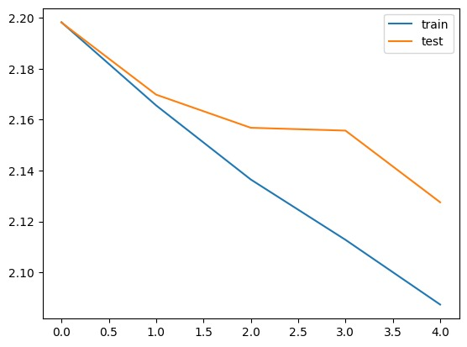
5. METHODOLOGY

To summarize Amazon reviews using deep learning, start by preparing the data—cleaning up unnecessary characters and splitting it into training and testing sets. Next, convert words into numerical vectors using word embeddings like Word2Vec or GloVe. Then, build a sequence-to-sequence model using TensorFlow or PyTorch, consisting of an encoder to process input reviews and a decoder to generate summaries. Incorporate attention mechanisms to improve summarization accuracy. Train the model on the training dataset, adjusting parameters to avoid overfitting. Evaluate performance using metrics like ROUGE on the testing set, refining the model as needed. Once optimized, deploy the model to automatically generate summaries for new Amazon reviews in real-time.

The existing systems for text summarization encompass a spectrum of methodologies ranging from traditional rule-based and statistical approaches to more modern deep learning techniques. Rule-based and statistical methods often rely on predefined heuristics or features to extract salient information from the text and condense it into summaries. Extractive summarization techniques, such as TF-IDF and TextRank, select important sentences or phrases directly from the input document based on their relevance or importance scores. In contrast, abstractive summarization approaches aim to generate novel summary sentences that may not exist verbatim in the source text. These methods often involve statistical language models or rule-based natural language generation (NLG) techniques.
The proposed system for text summarization aims to
leverage LSTM (Long Short-Term Memory) encoder-decoder architectures to generate concise and informative summaries from input documents. This system involves several key components and processes. Firstly, the input text data undergoes preprocessing, including tokenization, lowercasing, and potentially lemmatization or stemming, to prepare it for processing by the LSTM model. Next, an LSTM-based encoder processes the input document, capturing its semantic information and encoding it into a fixed-length context vector. The decoder LSTM then utilizes this context vector to generate the summary by attending to relevant parts of the input text using an attention mechanism. Additionally, the proposed system may incorporate techniques for handling challenges such as long documents, domain-specificity, and bias, to improve its performance and robustness across diverse text sources.

ARCHITECTURE

The architecture diagram of text summarization using deep learning typically consists of several key components. Firstly, there's the input layer where the raw text data is fed into the model. This data is then processed by the encoder, which extracts relevant features from the input text using recurrent neural networks (RNNs), Long Short-Term Memory (LSTM) networks. The encoder produces a fixed-length context vector that captures the important information from the input. This context vector is then passed to the decoder, which generates the summary by decoding the context vector into a sequence of words. Attention mechanisms may be incorporated into the architecture to help the model focus on relevant parts of the input text while generating the summary. Finally, the output layer produces the summarized text. The entire architecture is trained using a dataset of paired input-output examples, with the goal of minimizing a loss function such as cross-entropy loss. Through training, the model learns to generate summaries that capture the salient points of the input text.

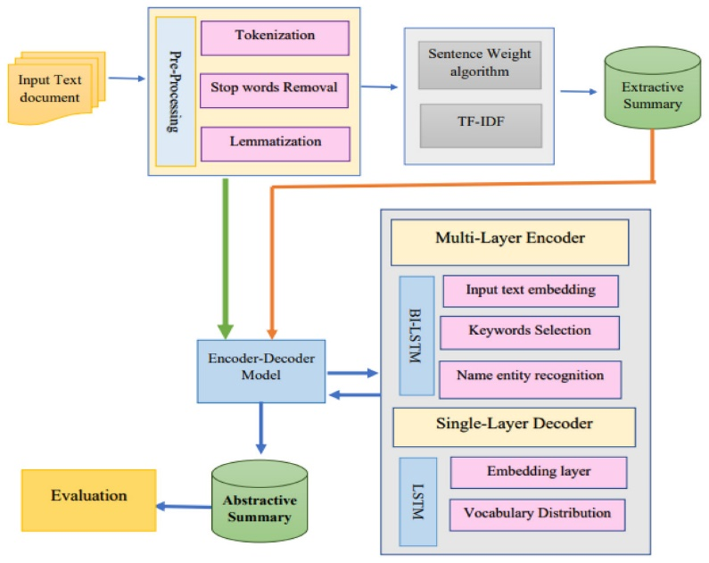

6. EXPERIMENTAL RESULTS

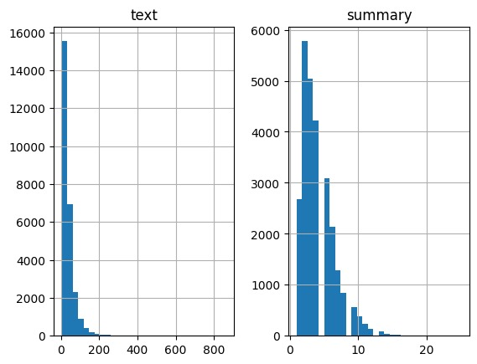

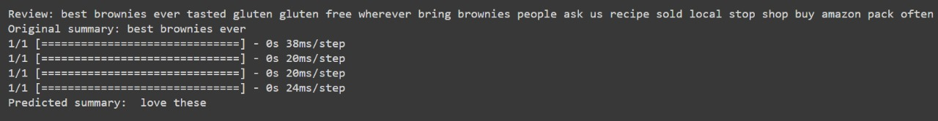
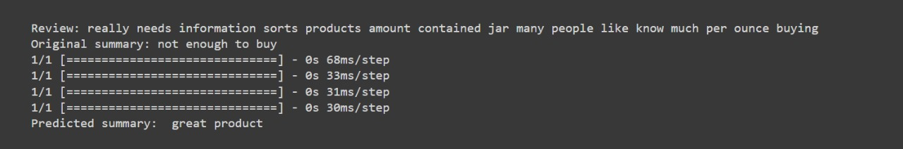
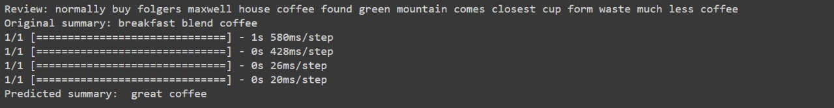

7. CONCLUSION

Our text summarization project utilizes advanced deep learning techniques, like LSTM or Transformer models, to efficiently distill information from large text volumes while maintaining coherence and relevance. It aims to improve information processing and accessibility across domains by providing coherent and relevant summaries.This project contribute to better information processing and accessibility across a range of areas by offering a tool that can effectively extract information from massive amounts of text while preserving coherence and relevance. Modern deep learning architectures and methodologies, such Transformer or LSTM models, have allowed us to successfully capture the text's context and semantics, producing summaries that are logical and pertinent.

8. REFERENCES

[1] Gambhir, M.; Gupta, V. Recent automatic text summarization techniques: A survey- 2017, 47, 1–66.
[2] Gupta, S.; Gupta, S.K. Abstractive summarization: An overview of the state of the art.. 2019, 121, 49–65
[3] Thu, H.N.T.; Huu, Q.N.; Ngoc, T.N.T. A supervised learning method combine with dimensionality reduction in Vietnamese text summarization. In Proceedings of the 2013 Computing, Communications and IT Applications Conference (ComComAp), Hong Kong, China, 1–4 April 2013; pp. 69–73.
[4] Kabeer, R.; Idicula, S.M. Text summarization for Malayalam documents—An experience. In Proceedings of the 2014 International Conference on Data Science & Engineering (ICDSE), Chicago, IL, USA, 31 March–4 April 2014; pp. 145–150
[5] Song, S.; Huang, H.; Ruan, T. Abstractive text summarization using LSTM-CNN based deep learning. 2019, 78, 857–87

