SMART CHARITY INNOVATING THROUGH BLOCKCHAIN TECHNOLOGY

# P. Soujanya*1, N. Snigdha*2, G. Shiva Prasad*3, B. Vivek*4

## *1Assisstant Professor, Information Technology, ACE Engineering College, India.

*2,3,4Student, Information Technology, ACE Engineering College, India.

# ABSTRACT

Charity plays an essential part in our society, and constantly recognized as a type of social debt, leading to the gyration of a significant amount of capitalist worldwide. We have witnessed increased growth of marketable associations and public charity finances through recent times, collecting donations for various philanthropic conditions. Unfortunately, charity finances constantly gain important traction from the unconscionable association, performing in significant damage for security's character, reducing trust position, affecting the capability to raise donations. We strongly believe that exercising blockchain technology will boost trust, increase effectiveness, and encourage farther donations. A blockchain-predicated charity foundation platform that facilitates the trusting network's conformation and is responsible for collecting donation finances. The blockchain network would be comprised of publically known, trusting, and prestigious associations. All associations operations within the platform will come fully transparent and visible, using parcels of stability, provenance, non-repudiation.

**Keywords:** Blockchain, Charity

# INTRODUCTION

Charity is a fundamental aspect of society, embodying compassion and generosity towards those in need. It plays a crucial role in providing essential services, promoting social justice, and fostering positive change. From local initiatives to global campaigns, charity efforts aim to uplift and empower individuals, embodying the values of kindness, empathy, and social responsibility. Blockchain incorporates various techniques implementing distributed, an immutable append-only log of ordered transactions, where everyone involved agrees on transactions order participating in a distributed consensus algorithm. Hyperledger Fabric is one of the most prominent implementations

of permissioned blockchain that introduces novel architecture suitable for enterprise-grade applications.

We believe that the platform will enable:

* Engage the broader community to participate in philanthropy projects, who was hesitant before due to lack of trust.

* Alleviate effect of dishonest organizations’ malicious activities that might jeopardize the trust level of the platform and charity foundation participating in it.

Why Hyperledger Fabric

Currently, most blockchain projects within non-profit organizations utilize permissionless blockchains, which provide limited control over the validators ensuring transaction authenticity. The Karma project showcases a unique approach by implementing permissioned blockchain technology on a public charity platform.

Hyperledger Fabric stands out as a premier permissioned blockchain framework, featuring an innovative architecture designed specifically for enterprise-level applications.

Networks based on Hyperledger Fabric are governed by a consortium of organizations. This consortium establishes the network configuration, defines the fundamental rules for organizational interaction, and manages the addition or exclusion of member organizations.

# LITERATURE SURVEY

Charity commission, how can we rebuild public trust in charities[1]

This paper discusses the significant decline in public trust in charities, reaching its lowest point since 2005, likely due to various economic and political challenges. It examines differing opinions on the causes of this decline, whether media-driven or reflective of broader issues. The paper emphasizes the need for a strong response from charities to address this trust deficit. It highlights the critical role charities play in fostering community cohesion and supporting those in need, noting that public confidence is essential for their legitimacy and effectiveness.

Hyperledger fabric: a distributed operating system for permissioned blockchains: Elli Androulaki, Artem Barger, Vita Bortnikov, Christian Cachin, Konstantinos Christidis, Angelo De Caro, David Enyeart, Christopher Ferris, Gennady Laventman, Yacov Manevich[2]

This paper discusses Hyperledger Fabric, a modular and extensible open-source system for deploying and operating permissioned blockchains. Fabric supports modular consensus protocols, allowing customization for various use cases and trust models. Unlike other blockchain platforms, Fabric can run distributed applications written in standard programming languages and does not rely on a native cryptocurrency. The paper details Fabric's architecture, design decisions, implementation aspects, and application programming model. Additionally, it evaluates Fabric's performance, demonstrating its capability to process over 3500 transactions per second with sub-second latency, scaling effectively to over 100 peers.

Blockchain standards for compliance and trust: Ashiq Anjum; Manu Sporny; Alan Sill[3]

This paper discusses the broader implications of blockchain technology beyond cryptocurrency applications. It explores emerging uses in various fields such as supply chain management, manufacturing, agricultural product tracking, advertising verification, the Internet of Things, healthcare, and the pharmaceutical industry. The paper emphasizes the potential of blockchain to enhance compliance and trust in these sectors through its distributed ledger methods.

CCharity transgressions, trust and accountability: arolyn J. Cordery and Rachel F. Baskerville[4]

This paper discusses how sustained charity fraud persists due to weak accountability to stakeholders. It argues that while increased regulation can help, it often overlooks the diverse needs of stakeholders. The research investigates how beneficiaries and donors escalate their demands for accountability. The paper criticizes charities for favoring powerful stakeholders over legitimate ones and calls for better stakeholder understanding to fulfill moral obligations and reduce fraud.

1. **SYSTEM ARCHITECTURE**

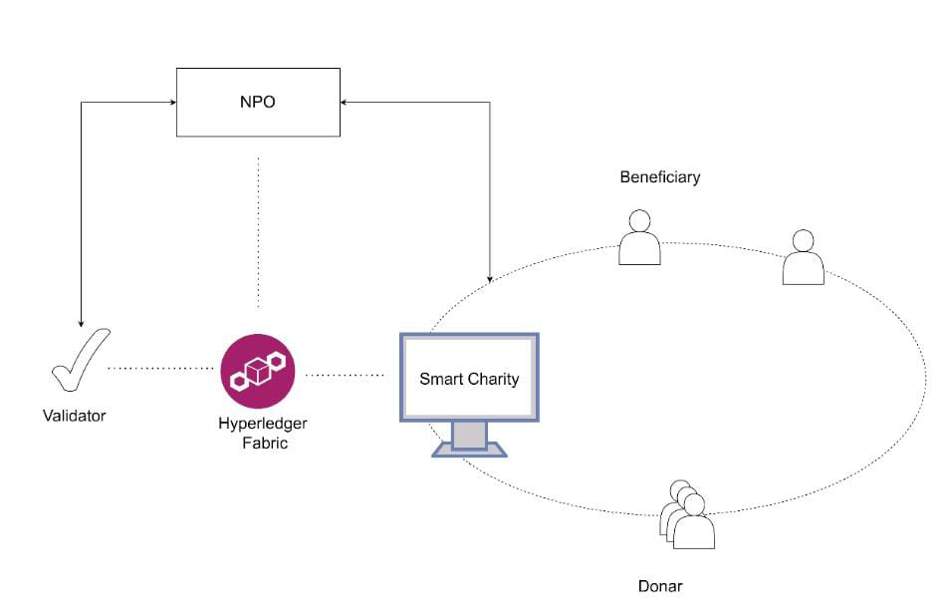

Smart Charity ensures transparency and trust among contributors, charity organizations, and beneficiaries. The platform is tasked with verifying the non-profit organizations that register with it. Additionally, there are validating nodes that act on behalf of the platform, ensuring transaction accuracy by endorsing them.

Non-Profit Organizations (NPOs) post projects to collect donations and are responsible for providing reports and analytics on fund allocation and spending.

Donors contribute to these open projects and can track the flow of funds within the projects they choose to support.

Validators are well-known and trusted organizations involved in the transaction process, attesting to the validity of transactions through an endorsement mechanism.

2

# COMPARISION ANALYSIS

|  |  |  |  |  |
| --- | --- | --- | --- | --- |
| **S.No** | **Paper Title** | **Work done on paper** | **Future work** | **Drawbacks** |
| **1** | Charity Commission: How Can We Rebuild Public Trust in Charities | The paper examines the drop in public trust in charities, noting the lowest score since 2005. It explores causes and stresses the need for a strong response from charities. | Future research should identify strategies for rebuilding trust, such as using blockchain for transparency, improving accountability, and better public communication. Longitudinal studies tracking trust changes are also needed. | The paper lacks detailed data and case studies. It offers few actionable recommendations and doesn't address regional or charity type variations in trust levels. |
| **2** | Hyperledger Fabric: A Distributed Operating System for Permissioned Blockchains | Describes Fabric's architecture, design, implementation, and programming model. Benchmarks show 3500+ TPS and sub-second latency, scaling to 100+ peers.  for intermediaries. | Optimize performance, integrate more identity systems, expand use cases, and develop more consensus protocols. | Does not address real-world challenges like interoperability, maintenance, and learning curve. Large-scale impacts need study. |
| **3** | Blockchain Standards for Compliance and Trust | Explores emerging blockchain applications in supply chain, manufacturing, agriculture, advertising, IoT, healthcare, and pharmaceuticals. | Develop industry-specific blockchain standards, improve interoperability, and study long-term impacts on compliance and trust. | Limited discussion on real-world implementation challenges and potential regulatory issues. |
| **4** | Charity Transgressions, Trust, and Accountability | Analyzes how weak accountability supports charity fraud and the tactics stakeholders use to demand accountability. | Develop policies for better stakeholder understanding and create processes to meet diverse accountability needs. | Lacks detailed strategies for implementing stakeholder-focused accountability and doesn't address regulatory limitations. |

3

1. **FUTURE SCOPE**

# The future potential for a blockchain-based charity platform is vast and significant. As blockchain technology advances, the transparency and trust it provides to charitable operations are expected to draw in more donors, increasing the overall donations received. The immutable nature of blockchain ensures that all transactions and fund allocations are permanently recorded and accessible to the public, significantly reducing the risk of fraud and misuse. This heightened transparency will rebuild and strengthen public trust in charitable organizations, making it easier to secure funding for various philanthropic activities. Moreover, blockchain's global reach can facilitate cross-border donations, broadening the donor base. Smart contracts can automate and streamline processes such as fund distribution and reporting, enhancing efficiency and cutting down administrative costs. As blockchain technology becomes more widely accepted, it is anticipated that more charitable organizations will adopt it, leading to a more interconnected and transparent global charity network. This shift will not only boost the credibility and effectiveness of individual charities but also promote greater collaboration and resource sharing among them, ultimately amplifying the impact of their efforts worldwide.

# CONCLUSION

Many people are currently reluctant to contribute donations due to lack of transparency and full visibility where gathered funds are invested. Progressing to the blockchain will significantly improve confidence, provide provenance, warrant nonrepudiation and manifest fundraising expenses into charity. Most blockchain projects in NPOs are utilizing permissionless blockchain, thus have limited control over validators responsible to vouch for the transactions’ validity. Smart Charity is the first of the kind approach leveraging permissioned blockchain technology to implement the public charity platform.

4

# REFERENCES

[1] Charity commission, how can we rebuild public trust in charities. Https// charity commission.blog.gov.uk/2016/06/28/ style-can- we rebuild- public-trust- in- charities/.

[2] Why has the trust in charities been declining. Https//theconversation.com/why-has-trust-in-charities-been-declining 49825.

[3] E. Androulaki , A. Larger , V. Bortnikov , C. Cochin , K. Christi dis , A. De Caro’D. Entered , C. Ferris , G. Laurentian , Y. Makovich, et al. Hyperledger fabric a distributed operating system for permissioned blockchains. In Proceedings of the thirteenth Euros conference, runners 1 –15, 2018.

[4] A. Album , M. Sporty, and. Sill. Blockchain norms for compliance and trust. IEEE Cloud Computing, 4 (4) 84 –90, 2017. [5] D.Z. Basil and. M. Herr. Dangerous donations? The goods of cause related marketing on charity station. Journal of Nonprofit & Public Sector Marketing, 11 (1) 59 –76, 2003.

[6] C.J. Cordero and. F. Baskerville. Charity transgressions, trust and responsibility. Voluntary International Journal of Voluntary and Nonprofit Associations, 22 (2) 197 –213, 2011.

[7] C.J. Cordero and. G. Morgan. Special issue on charity account, reporting and regulation, 2013.

[8] D. McDonnell and. C. Rutherford. Promoting charity responsibility Understanding exposure of serious incidents. In Accounting forum. Elsevier, 2018.

[9] R.M. Titus and. R. Over. Particular fraud The victims and the swindles. Crime Prevention Studies, 12133 –152, 2001.

5