**INVESTIGATION INTO THE USE OF HYBRID FIBRE REINFORCEMENT IN HIGH STRENGTH CONCRETE.**

**MOHD SOHAIL1, MR.RAVINDER PANWAR2**

**1** M.Tech Scholar,Ganga Institute Of Technology & Management Kablana Jhajjar,India

*Sohail.125@gmail.com*

2 Assistant Professor, Ganga Institute Of Technology & Management Kablana Jhajjar,India

[ravinderpanwar7043@gmail.com](mailto:ravinderpanwar7043@gmail.com)

## **ABSTRACT**

This study examines the application of hybrid fibre reinforcement in high-strength concrete, with a specific emphasis on improving its mechanical characteristics and long-term resilience. Hybrid fibre reinforcement is the process of integrating various types of fibres, including steel, glass, and synthetic fibres, to take advantage of their combined benefits and overcome the restrictions of utilising only one type of fibre.

The study assesses the effectiveness of high-strength concrete that is reinforced with different combinations of hybrid fibres. The research seeks to comprehend the influence of hybrid fibre combinations on fundamental characteristics of high-strength concrete, such as compressive strength, tensile strength, flexural strength, and durability in various climatic situations.

Concrete samples were subjected to experimental tests using various hybrid fibre combinations. The findings demonstrate that incorporating hybrid fibres into high-strength concrete greatly improves its mechanical characteristics. For example, the incorporation of steel and synthetic fibres enhanced the ability of the material to withstand stretching and bending forces, while the addition of glass fibres improved its ability to resist cracks and increased its longevity. The hybrid fibre reinforcement shown superior performance in reducing shrinkage and managing crack propagation in comparison to concrete reinforced with a single type of fibre.

Furthermore, the research investigates the real-world uses of hybrid fibre reinforced high-strength concrete in the field of building. The results indicate that using hybrid fibre reinforcement can result in the creation of concrete structures that are more resistant and long-lasting, especially in situations where there is a need for exceptional performance in the face of mechanical strain and unfavourable environmental circumstances.

To summarise, this study emphasises the capacity of hybrid fibre reinforcement as a successful approach to improve the characteristics of high-strength concrete. The study suggests conducting additional research to optimise the combination of fibres and evaluate the long-term effectiveness of hybrid fibre reinforced concrete in different construction settings.

**Key Words:** High strength concrete, Hybrid fiber reinforcement, Fiber-reinforced concrete, Mechanical properties, Flexural strength

# INTRODUCTION

In concrete structure develops durability and strength are frequently deemed to be the most important characteristics. When subjected to normal pressures and shock loads and concrete is regarded as brittle its breaking strength is individually around 10% of its strength when compressed. Concrete flexible components are not able to sustain the usual loads encountered throughout their service life because of these characteristics. Many concrete buildings now in existence fail to fulfill contemporary design criteria due to insufficient design and construction. The insufficient performance of these structures is a significant concern for public safety due to the growing population and purchasing power. The demand for raw materials needed for structural reinforcement to meet global market needs is increasing rapidly. Portland cement concrete has certain attributes. Its extensible strength is modest, but its capacity for compression is great. and it has a tendency to be brittle. To address the weakness in tension, conventional rod reinforcing may be used together with a suitable amount of fibersIn order to improve the concrete's compressive and tensile Characteristics, threads are added. They also act as a unique adhesive that enables the cement to bond with cemented composites.

**High Strength Concrete**

The mixture known as masonry is composed of particles and a paste of cement, which can include pozzolans. Concrete strength is explained by the strength of its workings their distortion qualities, and the bond among the paste and aggregate surface. It is possible to use the simplest materials to produce concretes having compressive strength of 120MPa by strengthening the cement paste. Controlling the strength of cement paste may be achieved by selecting the w/c ratio and the kind and quantity of admixtures used. Current improvements in concrete along with the use of different inorganic and chemical intermixtures and superplasticizers, have made it imaginable to yield commercially available Compression strength concrete of up to 100MPa using regular aggregates while maintaining an acceptable level of consistency. To manufacture high-strength concrete (HSC), it is essential to use quality ingredients, reduce the water-binder ratio, increase the proportion of fine compared to coarse material, use smaller coarse aggregate size, and include acceptable admixtures with their optimal doses. The advancements have resulted in the widespread use of HSC globally.

**Fiber Reinforced Concrete**

FRC is concrete that contains randomly scattered fibers, as described by ACI 116R, Cement and Concrete Terminology. Concrete is naturally fragile when subjected to stretching forces, but its mechanical characteristics may be enhanced by adding small fibers in random orientations. These fibers help to prevent or regulate the formation, spread, or joining of fractures. The performance of the FRC is influenced by the characteristics of both the concrete and the fibers. Fiber concentration, shape, orientation, and dispersion are the key features of interest in fibers. The fiber concentration in a structural concrete component typically ranges from 1-4% in relation to the amount of cement.

Fiber reinforcement enhances the mechanical qualities of a construction material that would otherwise be inappropriate for practical use. Fiber modifies the response of concrete when a fracture forms by spanning the cracks, hence enhancing post-cracking toughness. The presence of fibers intersecting the fracture ensures a certain amount of stress transmission among both sides of the crack, contributing to the composite material's residual strength.

**Fibers**

Utilizing fibers for reinforcement is a longstanding notion. The horses hairs and straws used to be utilized to make clay mortar and bricks, respectively. In the early years of the 1900s, fibers of asbestos were added to concrete. When composite materials became popular in the 1950s, fiber reinforced concrete became the center of attention. A substitute for asbestos in concrete and other building materials was required as soon as the chemical's health risks were discovered. Concrete was mixed with glass, stainless steel, and synthetic fibers like polyethylene in the early 1960s. Research on creating novel forms of fiber-reinforced concrete is still ongoing,concrete.

Fibers are often used into concrete to manage cracking caused by plastic shrinkage and drying shrinkage decrease concrete permeability, and minimize water bleeding. Specific types of fibers improve the material's ability to resist effect, scraping, and shattering. The fiber volume percentage usually falls among 0.1% and 3% [3]. Fibers mainly regulate fracture growth and restrict crack widths. High elastic modulus fibers recover the flexural durability of concrete. Fibers contribute significantly to concrete after the matrix has cracked by bridging the spreading fissures. High doses of added fibers may lead to drawbacks such as reduced workability and increased costs.

**Artificial Fibers**

Currently, the typical fibers used in composites are steel, glass carbon and aramid. Due to their distinctive one-dimensional geometry, these forms are considered ideal for creating composites that provide laminates with greater stiffness and strength compared to three-dimensional FRP designs. This is because mono-dimensional designs have a lower number of flaws compared to three-dimensional structures.

**Steel fiber**

Steel fibers were used as an alternative to secondary reinforcing or for crack control in less essential concrete components. Steel fibers take a much greater Young's modulus compared to extra kinds of fibers. This might enhance the ability to manage cracks.

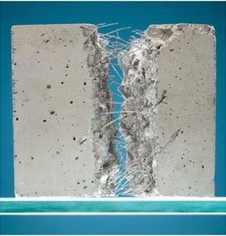

Figure 1.1 Steel fiber in concrete

Yet, drawbacks of a huge concentration of steel fibers in concrete contain issues related to electric conduction increased magnetic fields and rust. Research has shown that combining 2 or 3 distinct kinds of steel fibers in a cement system may create a compound with improved engineering presentation and superior automatic qualities. Figure 1.1 displays the steel fiber used in concrete.

**Carbon fiber**

Carbon fibers are used for their exceptional presentation due to their high Young's modulus of elasticity and superior strength. They exhibit brittle failure Characteristics with lower energy absorption and higher failure strength in contrast to both aramid and fibers of glass. Carbon fibers have lower susceptibility to creep-rupture and fatigue, with a little decrease in long-term tensile strength. Carbon fiber reinforced polymer is a very durable, lightweight, but costly composite material. Figure 1.2 displays the use of carbon fiber in building.

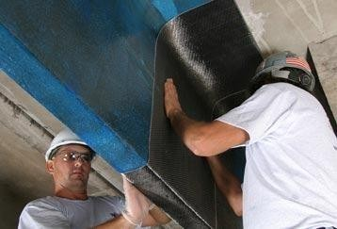

Figure 1.2 Use of carbon fiber

**Glass fiber**

Naval and industrial sectors often use glass fibers to create high- performance composites. They are distinguished by their exceptional strength. Glass is mostly composed of silicon arranged in a tetrahedral form. Figure 1.3 displays the widely accessible glass fiber. Thin sheets of glass fiber are also known as mats. A mat may consist of long continuous and short fibers placed haphazardly and held together by a chemical link.

# OBJECTIVES

* Identify the most effective combination of hybrid fibres to improve the mechanical characteristics of high strength concrete.
* Assess the flexural, tensile, and compressive strength of high strength concrete reinforced with hybrid fibres.
* Analyse the durability characteristics, such as resistance to abrasion, chloride penetration, and freeze-thaw cycles.
* Examine the efficacy of hybrid fibre reinforcement in managing cracks and the behaviour of materials once cracks have formed.
* Evaluate the adhesive strength between hybrid fibres and the concrete matrix.
* Assess the efficiency, cost-efficiency, and environmental friendliness in comparison to traditional concrete blends.

# LITERATURE REVIEW

Mizanur Rahman M et al (2007) concluded that because of their benefits to the ecology and economy, regenerated fibres including coir might be utilised as strengthening elements for inexpensive composites. Strength of the fiber improved significantly after UV treatment.

Li et al (2007) used multilayer coir meshes mats to perform a controlled study of the fraction of the fiber volume and fiber surface treatments with a moisturizing agent for coir meshes reinforcement masonry . Slab samples underwent bending at four points tests as part of the investigation. It was determined that the greatest bending strain was improved by 40% in the composite supplemented with a total of three layers of 1.8 percent content of fiber coir mesh.

Wu Yao et al (2002) have observed the machine-driven assets of cement with a minimal volume percentage. The compression strength, breaking tensile force, and bending characteristics of concretes with several kinds of blended fibers at a comparable volume percentage (0.5%) were evaluated. The investigation revealed that it was feasible to produce material with greater power and enhanced durability at little fiber capacity percentage.

Sabu Thomas et al (2004) examined natural rubber reinforced with sisal and palm fibers. The tensile strength and tear resistance increased with the inclusion of sisal and palms fiber, according to the research. After treating the cellulose fibers with alkali, it was discovered that the degree of adhesion among the fiber and rubber matrix increased. Compared to untreated composite materials, the mechanical characteristics of the alkali-treated fibers demonstrated superior flexibility.

Handong et al (1999) presented an investigational study on the result of silica fume and steel used in high strength concrete. According to the test findings, steel fiber was able to successfully regulate the start and spread of fractures during an extremely strong cement structure's collapse. The interface zone's fragility was removed the frequency and size of fractures were decreased, and the steel fibers' capacity to withstand cracking and limit damage was increased by the silica fume. It was determined that adding steel yarns and silicon dioxide may significantly improve how well HSC performed when exposed to effects and endurance.

Mazloom M et al (2004) conducted an examination of the mechanical characteristics of high-strength concrete with silica fume over the short and long terms. The percentages of silica fume that replaced cement by 0%, 6%, 10%, and 15% were determined in the experiment.

The results of recent, historical, and ongoing studies and developments for the efficient use Aziz M. A. et al. have provided descriptions of natural fibres (1981). Mixing proved challenging and fibres tended to group together at volume fractions higher than 4% which resulted in an insufficient binding and a decrease in strength. The fibre served as crack arresters preventing the expansion of faults in the concrete matrix under stress and turning them into noticeable fissures that would eventually cause collapse.

# METHODOLOGY

**Materials And Methods**

The current research is focused on investigating the mechanical and structural Characteristics of the high strength hybrid fiber concrete. The cementitious matrix is collected of cement silica fume fine aggregate course aggregate super plasticizer water and different fibers. The Characteristics of materials used in producing HFRHC are as follows.

**Ordinary portland cement**

In this study, the initial mix concrete was created using regular Portland cement. The whole quantity needed was determined, bought at nearby vendors, and protected with tarpaulin cloth within the manufacturing plant in a dry location to prevent setting. All of the study was conducted using Ramco 43-grade cement. Table 4.1 displays the physical characteristics of the cement based on tests carried out in accordance with IS 4031:1988 standards.

**Table 4.1 Physical Characteristics of 43 grade cement**

|  |  |  |  |
| --- | --- | --- | --- |
| **Sl. No** | **Physical Characteristics** | **Tested Value** | **Reference Code** |
| 1 | Specific gravity. | 2.98 | .IS:1727-1967. |
| 2 | .Standard. consistency | 29.20% | .IS:4031-1988 Part 4. |
| 3 | setting time (Initial) | 57 mint. | .IS:4031-1988 Part 5. |
| 4 | setting time (.Final) | 4 hours | .IS:4031-1988 Part 5. |
| 5 | .Soundness test. | 0.95mm | .Le-chatelier’s apparatus. |
| 5 | Strength in compression | 43.30Mpa | ----- |

**Chemical characteristics of portland cement**

Cement has less Mg oxide sulfuric anhydride free lime and alkaline oxide than what AS 3972 and ASTM C150 allow. The structural integrity of the cement may vary if certain compounds are present in excess. Large amounts of sulfuric anhydride and magnesium oxide may cause cement to expand over time. An alkali- silica reaction among the cement's high alkaline oxide concentration and the mixture's reactive particles is likely to occur. Normal additions of cement chloride speed up early strength and shorten setting times. Table 4.2 provides information on the chemical makeup of regular Portland cement.

**Table 4.2 Chemical characteristics of Ramco 43 grade OPC**

|  |  |  |
| --- | --- | --- |
| **/ data/** | **/Avg. %/** | **/Permissible limits/** |
| (SiO2) | 19 | ---- |
| (Al2O3) | 5.2 | 5%, max |
| (Fe2O3) | 5.9 | 5.8%, max |
| (CaO) | 61.89 |  |
| (MgO) | 1.21 | 4.9% |
| S(SO3 | 1.29 | 4.1% |
| Loss on ignition | 1.25 | 5\4.8% |
| Alkalies | 0.9 | 1.7% |
| Chlorides | 0.011 |  |
| Lime saturation factor | 0.79 | 0.57-1.1 |

**Fine aggregate**

Fine river gravel that has passed though a 4.75 millimeter screen was employed as the fine particles in this experimentTable 4.3 provides a breakdown of sizes of particles. The sandy experiments took place in accordance with IS: 2386-1963(III). Zone II sand was utilized in this instance. In Figure 4.1, the grading curve is shown. and physical Characteristics of fine aggregate are presented in Table 4.4.

**Table 4.3 /Sieve analysis of fine aggregate/**

|  |  |  |  |  |
| --- | --- | --- | --- | --- |
| **/Sieve size (mm)/** | **/Weight of material retained**  **(grams)/** | **/Percentage Weight of material retained (grams)/** | **/Cumulative**  **% weight of material retained/** | **/%age weight of material/** |
| 4.75 | 0 | 0 | 0 | 100 |
| 2.36 | 56 | 5.6 | 5.6 | 94.4 |
| 1.18 | 346 | 34.6 | 40.2 | 59.8 |
| 0.6 | 145 | 14.5 | 54.7 | 45.3 |
| 0.3 | 320 | 32 | 86.7 | 13.3 |
| 0.15 | 133 | 13.3 | 100 | 0 |

**Course aggregate**

A number of studies is passed to determine the physical characteristics of coarse gravel which are specified in accordance with IS 383- 1970, using locally accessible broken blue basalt metal material with dimensions of twenty millimeters and lower. and the test outcomes are shown in Table 4.5.

**Table 4.4 Physical Characteristics of fine aggregate**

|  |  |  |
| --- | --- | --- |
| **S. No** | **Physical Characteristics** | **Tested values** |
| 1 | Specific gravity | 2.6 |
| 2 | Fineness modulus | 2.66 |
| 3 | Water absorption | 0.75% |
| 4 | Bulk density (kg/m3) | 1654 |
| 5 | Free moisture content | 0.10% |

**Figure 4.1 .Grading curve of fine aggregate**

100

90

80

70

60

50

40

30

20

10

0

0.1

1

**Sieves in (mm)**

**percentage Passing (%)**

**Table 4.6 /Physical Characteristics of coarse aggregate/**

|  |  |  |
| --- | --- | --- |
| **S.No** | **Physical Characteristics** | **Tested value** |
| 1 | Specific gravity | 2.70 |
| 2 | Fineness modulus | 6.18 |
| 3 | Percentage voids | 37.04% |
| 4 | Crushing value | 24% |
| 5 | Water absorption | 0.50% |
| 6 | Colour | Dark |
| 7 | Shape | Angular |

**Water**

The study was conducted using drinking water. The substance content was less than the permissible limits as stated in IS: 456-2000. Table 4.6 displays the findings of inspection testing conducted on freshwater.

**Table 4.7 /Outcomes of water quality analysis/**

|  |  |  |  |
| --- | --- | --- | --- |
| **S.NO** | **.Description of test.** | **.Water sample.** | **.Maximum permissible limit.** |
| 1 | .pH value. | 8.6 | 6.0-9.0 |
| 2 | .Hardness. (ppm) | 413 | 980 |
| 3 | .Sulphate. (ppm) | 120 | 390 |
| 4 | .Chloride. (ppm) | 148 | 490 |

**Super Plasticizer**

* Specific gravity-1.220 to 1.225 at 300c
* Chloride content- Nil
* Air entrainment-Approx. 1% additional air is entrained.

**Silica Fume**

The result of the metal silicon or the ferrosilicon alloy is silica fume. Electric arc burners are used to create silicon dioxide and its alloys. Wood clips coal, and quartz are the raw ingredients. Instead of being thrown away, the exhaust that emerges from the combustion process is gathered and sold as silica fume. Amorphous silicon dioxide with an average granule diameter of 0.15–0.2 µm, makes up the majority of silica fume. It is a light to dark grey or blue green–grey powder that is created during the production of silicon or the ferrosilicon alloy. Similar fly ashes, it is round, but due to its small fragments, huge area of surface, and high sio2 content, it is a hundred times more active. In building materials, silica fume is a very reactive pozzolan. Simultaneously, the fumes of silica can still be utilized as a fillers to increase productivity in general and increase strength and endurance in refractor and ceramics manufacturing.

The micro silica fume, obtained from Elkem, Micro Silica Limited, Tirunelveli. The chemical composition and physical Characteristics are specified in the Table 4.7. Figure 4.2 shows the silica fume use in this investigation.

**Table 4.8 Chemical composition & physical Characteristics of silica fume**

|  |  |
| --- | --- |
| SiO2 | Minimum 75.0% |
| H2O | Maximum 1.2 % (when packed) |
| C | Maximum 3.5 % |
| LOI | Maximum 3.0 % |
| Bulk density | 590– 690 |

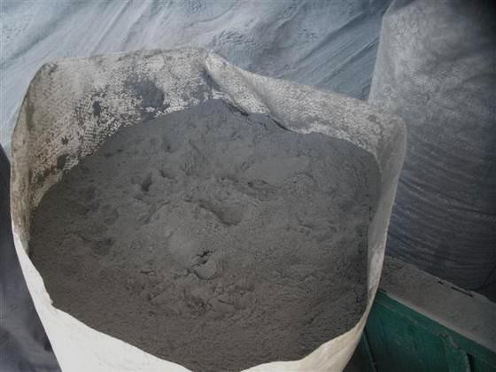

**Figure 4.2 Silica fume**

**Hybrid Fibers**

In this experiment, hybrid fiber a blend of copper and natural fiber has been employed In the present project mixtures of steel and natural fiber coir and palm are employed. While natural fiber provides increased endurance versus shrinkage in plastic and catastrophe spalling, steel fiber gives structural benefits. Raising the fiber fractions causes the fibers to be distributed more uniformly and densely across the concrete, which lessens cracking due to shrinkage and boosts the strength of the concrete once they have healed. To stop microcracks and macrocracks in, accordingly, a mixture of low and high modulus fibers is essential. Fibers are often added to concrete to minimize transparency and, therefore, water bleeding, as well as to prevent cracking caused by dryness and shrinking plastic. In concrete, sure fiber kinds result in increased impact, abrasion, and shatter protection. Normally, the volume of the portion falls among 0.1 percent and three percent.

**Table 4.9 Characteristics of steel fiber**

|  |  |
| --- | --- |
| **Fiber Characteristics** | **Tested value** |
| Average fiber length (mm) | 50 |
| Dia. (mm) | 1 |
| Aspect ratio | 50 |
| T.strength | 1100 |
| G | 7.85 |

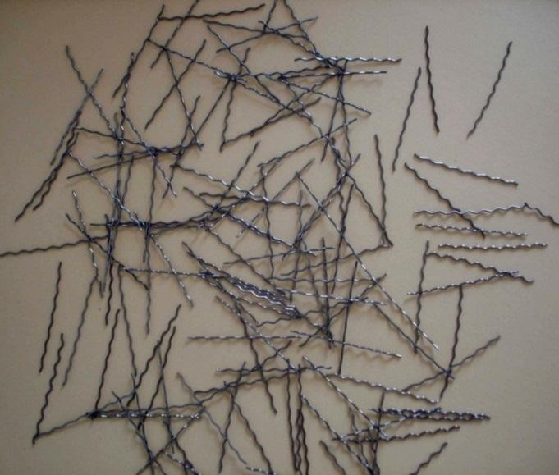

**Figure 4.3 Corrugated type steel fiber**

1. **RESULT**

**Cube compressive strength**

A combined total of seventy-two cube samples have been made and their durability evaluated. In accordance with IS 516-1959, compression assessments were performed on standard 150 mm cubic samples at 7, 28, and 90 days following curing for each mix. The sample was positioned precisely at the point of loading head's spherical seated upper block's center of thrust. Up to the specimen's total failure, the load had been used consistently. Figure 5.1 depicts the cube sample examination.

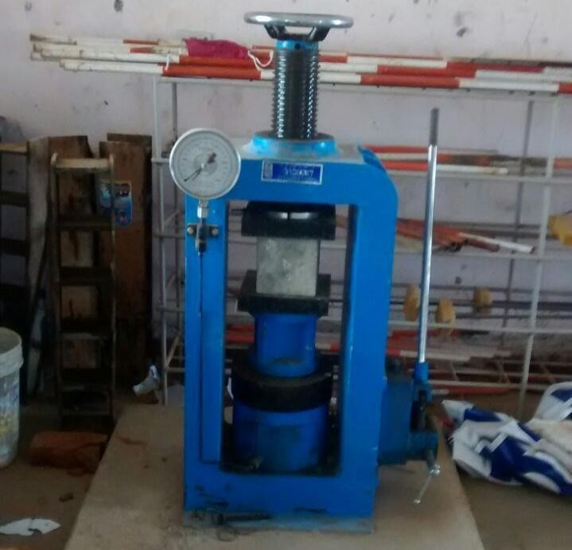

**Figure 5.1 Compression test on cube specimen**

Table 6.1 displays the mean strength in compression data for the various concrete mixtures. For varying ages, the test sample M1 mix's strength at compression increased from 5.49 to 6.17% more than the control mix (CC). It was discovered that the high strength concrete reinforced with hybrid fibers had a better compressive strength than the concrete made solely of steel fibers. After 28 days, mix M2's compressive strength increased by 6.86% and by 8.75% above that of the control concrete (CC). From the Table 5.1 there is an improvement of compressive strength from 5.62% to 8.59% is obtained for M3 compare to CC for different ages.The mix M7 mix has a compressive strength higher than that of CC by about 9.92% – 4.29 % in different ages.

**Table 5.1 Compressive strength of cube specimens**

|  |  |  |  |  |  |  |
| --- | --- | --- | --- | --- | --- | --- |
| **Specimen Type** | **Fiber volume fraction (%)** | | | **Compressive strength (N/mm2)** | | |
| **steel fiber** | **palm fiber** | **coir fiber** | **7 Days** | **28 Days** | **90 Days** |
| **CC** | - | - | - | 34.64 | 53.83 | 62.14 |

|  |  |  |  |  |  |  |
| --- | --- | --- | --- | --- | --- | --- |
| **M1** | 1 | - | - | 36.58 | 56.96 | 66.25 |
| **M2** | 0.5 | 0.5 | - | 37.90 | 57.80 | 68.10 |
| **M3** | 0.5 | - | 0.5 | 37.15 | 57.04 | 67.98 |
| **M4** | 0.5 | 0.25 | 0.25 | 41.28 | 65.8 | 74.92 |
| **M5** | 0.25 | 0.5 | 0.25 | 40.49 | 62.56 | 70.16 |
| **M6** | 0.25 | 0.25 | 0.5 | 41.12 | 63.63 | 70.57 |
| **M7** | - | 0.5 | 0.5 | 37.42 | 59.76 | 64.93 |

**Figure 5.2 Compressive strength test result**



80

70

60

50

40

30

20

10

0

7 Days

28 Days

90 Days

CC M1 M2 M3 M4 M5 M6 M7

**Specimen Type**

**Compressive strength in Mpa**

The compressive strength of hybrid composite has increased from CC about 13.95% and 15.4% in 28 days and 11.43% and 11.94% for 90 days respectively for mix M5 and M6. The average compresive strength of M4 mix is the highest compared to other type of mixes.The compressive strength has increased about 18.19% in 28 days and 17.05 % in 90 days compared to CC specimen.

**Flexural Toughness**

The capacity of composite fiber concrete reinforced to transmit stress over a fractured portion is one of its most crucial characteristics, and it is primarily defined by its durability principle. The ability of hybrid fiber reinforced concrete materials to absorb energy after distortion may be regarded as a measure of their toughness. Area under the curve of load deflection for a beam up to a certain point—up to 3.5 mm of deflection has been taken into consideration in this study—is used to determine the flexural hardness of the beam. Table 5.2 provides an overview of the computed flexural stiffness.

**Table 5.2 Flexural toughness of specimens**

|  |  |  |  |
| --- | --- | --- | --- |
| **Specimen Type** | **Ultimate load KN** | **Ultimate deflection mm** | **Flexural toughness KN.mm** |
| **CC** | 70 | 4.20 | 134.58 |
| **M1** | 82 | 5.06 | 138.99 |
| **M2** | 80 | 4.25 | 142.69 |
| **M3** | 80 | 4.68 | 135.12 |
| **M4** | 90 | 5.41 | 137.40 |
| **M5** | 77 | 5.10 | 135.68 |
| **M6** | 78 | 5.09 | 143.42 |
| **M7** | 74 | 4.26 | 141.00 |

The result shows that the toughness is increased for all types of fiber combinations compared to CC. The fibers influence the cement's post peak bending softness response by spanning over the microcrack and decreasing its width. Moreover the load vs displacement response depends much on the type of the added fibers and their combinations.

**Flexural Toughness KN.mm**

The flexural toughness of various specimens is presented in Figure 5.2.

**200**

**150 134.58 138.99 142.69 135.12 137.40 135.68 143.42 141.00**

**100**

**50**

**0**

**CC**

**M1**

**M2 M3**

**M4**

**M5**

**M6**

**M7**

**Specimen Type**

1. **CONCLUSION**

According to the yield strength result, adding only 1% of steel fiber (M1) raises the compression strength by around 6.2%. However, as opposed to regular concrete, the maximum compressive strength rises by around 17.15% for the mix M4, which contains 0.5% steel and 0.25% palm and coir fiber mixture. The mechanical link among the fiber and matrix is what makes this possible.

In comparison to both of the hybrids combinations, the mix M7 that only consists of natural fiber in the mixture of 0.5% palm and 0.5% coir has shown a decrease in compression strength. This is because fibers made from nature have a low degree of rigidity, which lowers their total strength during compression.

The growth in split tensile strength is nearby 11.41% once M4 containing the mixture combination of 0.5% of steel with 0.25% palm and coir fiber is used in the concrete. This is attributed by the ability of concrete with hybrid fibers to bridge the cracks efficiently. Thus the increase in split tensile strength is promising for all the hybrid mixes.

The mix M4 with 0.5% steel, 0.25% palm and 0.25% coir gives flexural toughness as 9.54Mpa, which is high compared to the conventional concrete of CC mix by 6.1Mpa. For all hybrid composites examined under flexure, the flexural strength increased due to a positive interaction among steel and natural fibers.

Similar flexural strength is obtained for all the mixes irrespective of fiber combination. However the flexural toughness of the mix M2 with 0.5% steel and 0.5% palm exhibit the best flexural toughness performance. The steel fiber provides reasonable first crack strength, while the palm improves the toughness strength in post cracking zone.

The ductility is usually expressed as a ratio of deflection. The mix M4 with hybrid combination 0.5% steel, 0.25% palm and 0.25% coir fiber hybrid beam has sufficient ductility and the failure zone is particularly larger than that of conventional beams. The results of the research show that adding steel fibre to organic fibre solely increases post peak opposition, which greatly enhances the flexibility characteristics of concrete made using these hybrids fibres.

This research evaluates a untraditional method to the forecast of the structural Characteristics of hybrid fiber reinforced high strength beams based on ANN technology. The system performed rather well in predicting not just the physical Characteristics of testing mixes that are unknown to the neural network model, but also the characteristics of mixtures of concrete utilised in its training phase.

1. **REFERENCES**
2. Ali, M, Liu, A & Sou, H 2012, ‘Mechanical and dynamic Characteristics of coconut fiber reinforced concrete’, Construction and Building Materials, vol. 30, pp. 814–825.
3. Aziz, M.A, Paramasivam, P & Lee, S.L 1981, ‘Prospects for natural fiber reinforced concretes in construction’, International Journal of Cement Composite Lightweight Concrete, vol. 3, pp. 123–32.
4. Banthia, N & Sappakittipakorn , M 2007, ‘Toughness enhancement in steel fiber reinforced concrete through fiber hybridization’, Cement and Concrete Research, vol. 37, pp. 1366 –1372.
5. Baruah, P & Talukdar, S. A 2007, ‘comparative study of compressive, flexural, tensile and shear strength of concrete with fibres of different origins’, Indian Concress, vol. 81, no. 7, pp. 17-24.
6. Behrouz Ahmadi-Nedushan 2012, ‘Prediction of elastic modulus of normal and high strength concrete using ANFIS and optimal nonlinear regression models’, Construction and Building Materials, vol. 36, pp. 665–673.
7. Bindiganavile, V, Banthia, N, Majdzadeh, F & Wu, J 2014, ‘Fiber synergy in Hybrid Fiber Reinforced Concrete (HyFRC) in flexure and direct shear’, Cement & Concrete Composites, vol. 48, pp. 91–97.
8. Cengiz Duran Atis & Okan Karahan 2009, ‘Characteristics of steel fiber reinforced fly ash concrete’, Construction and Building Materials, vol. 23, pp. 392–399.
9. Cook, D.J, Pama, R.P & Weera 1978, ‘Coir fiber reinforced cement as a low-cost roofing material’, Building Environment, vol. 13, pp. 193–198.
10. Defoirdt, N, Biswas, S, De Vries, L, Tran, L.Q.N , Van Acker, J, Ahsan, Q, Gorbatikh, L,Van Vuure, A & Verpoest, I 2010, ‘Assessment of the tensile Characteristics of coir, bamboo and jute fibre’, Composite part A, vol. 41, pp. 588–595.
11. Eduardo, B. Pereira, Gregor Fischer, Joaquim, A.O & Barros 2012, ‘Effect of hybrid fiber reinforcement on the cracking process in fiber reinforced cementitious composites’, Cement & Concrete Composites, vol. 34, pp. 1114–1123.
12. Eethar Thanon Dawood & Mahyuddin Ramli 2012, ‘Durability of high strength flowing concrete with hybrid fibres’, Construction and Building Materials, vol. 35, pp. 521–530.