**A RESEARCH STUDY ON THE USE OF WASTE MATERIALS IN THE MANUFACTURING OF CONCRETE**

**RAMOLI1, DR.TINKU BISWAS2**

**1** M.Tech Scholar,Ganga Institute Of Technology & Management Kablana Jhajjar,India

*ramoli0062@gmail.com*

2 Assistant Professor, Ganga Institute Of Technology & Management Kablana Jhajjar,India

[tinkubiswaseqd.iitr@gmail.com](mailto:tinkubiswaseqd.iitr@gmail.com)

## **ABSTRACT**

This research study investigates the integration of waste materials into the production of concrete, with the goal of improving sustainability and minimising environmental harm. The project aims to tackle waste disposal and resource depletion challenges by including different industrial and agricultural by-products into concrete mixes. This approach also aims to enhance the mechanical qualities and durability of concrete.

The investigation centres on several waste products, such as fly ash, blast furnace slag, silica fume, and agricultural wastes including rice husk ash. The selection of these materials was based on their accessibility, cost-efficiency, and ability to improve the performance of concrete. The study assesses the impact of these waste elements on fundamental characteristics of concrete, including its capacity to withstand compression, tension, and environmental factors, as well as its workability and durability.

Concrete samples with different quantities of waste materials were subjected to experimental tests. The findings suggest that the inclusion of specific waste materials can greatly enhance the mechanical characteristics of concrete. For example, the addition of fly ash and silica fume was discovered to increase the compressive and tensile strength of concrete. Similarly, the inclusion of blast furnace slag enhanced the longevity of concrete by protecting it against sulphate assault and chloride penetration. In addition, the utilisation of agricultural leftovers such as rice husk ash resulted in decreased shrinkage and enhanced resilience to thermal cracking.

The study also investigates the ecological and financial advantages of utilising waste materials in the production of concrete. Evidence indicates that adopting this method can result in significant decreases in carbon emissions, reduced manufacturing expenses, and diminished dependence on new, unused resources.

Ultimately, this study illustrates the practicality and advantages of using waste materials into the manufacturing of concrete, thereby fostering a building sector that is more environmentally conscious and sustainable. Additional research is advised to enhance the composition of concrete mixes and examine the durability of concrete that incorporates different waste elements over an extended period of time.

**Key Words:** Super Absorbent Polymers, Self-Sealing Concrete, Construction, Durability, Innovation, Cracking, Waterproofing

Top of Form

# INTRODUCTION

The primary building material now in use is concrete. Concrete is made up of water, fine aggregate, coarse aggregate, and binding ingredient (cement). Aggregates are naturally obtainable but are being over-exploited for development purposes, which causes their availability to diminish day by day. Aggregates won't be readily available in the near future due to rising demand because of their limited stack. It is beneficial to look for alternatives to the naturally occurring aggregate. Demolition waste is created in significant amounts due to increased construction activity and structure renovation, and it is stored in enormous numbers in low-lying areas or at disposal sites. The land that demolition wastes are dumped on is permanently unavailable for further uses. Increased demolition waste production, a persistent lack of dump sites, rising land transportation costs, and most importantly, environmental concerns are all contributing factors.

**Background History**

Waste generation is increasing as a result of the accelerated expansion of industry and metropolitan areas, which is detrimental to the environment. There are currently 27.8% more people living in cities in India than there were in 1947, a 13.8% increase. Due to the development of new infrastructure, there is a (55x103) million m3 shortfall, which indicates that aggregate demand will rise in the future. To meet the demand of the road sector, an additional 750 million m3 of aggregate is needed. There is a big imbalance among the supply and demand for aggregates because of the high need for these materials in contemporary building and transportation. Waste produced during construction weighs among 40 and 60 kilogrammes per square metre. The amount of waste produced during remodelling, repair, and maintenance constructions ranges from 40 kg/m2 to 50 kg/m2. The most of all material are produced during a building's destruction. About 300 kg/m2 of waste is produced when permanent buildings are demolished, while 500 kg/m2 of waste is produced when semi-permanent buildings are demolished.

**Recycle Aggregate**

Aggregates made from previously used building materials like concrete or masonry are known as recycled aggregates. Broken or powdered inert mineral materials like gravel and sandstone make up recycled aggregates. They are frequently produced during building and demolition projects, including those involving roads, bridges, remodelling, and other projects. The non-biodegradable materials including concrete, plaster, metal, wood, and polymers make up most of the waste created by these activities. Most of this material is often dumped in municipal waste streams. These wastes take up a lot of room in bins or waste cans because of their bulkiness, high density, and weight. Large piles of waste frequently end up on the roads as a result, especially during major construction projects, which causes traffic congestion and disturbance. Small-scale generators of waste, such as one-off home construction or demolition projects, frequently dump their debris into local municipal waste storage depots or bins. The overall weight is increased by this additional waste, which also makes it less suitable for composting or energy recovery. When this garbage enters surface drains, it can occasionally clog them up as well. Except for waste coming from major building projects, small generator waste normally makes up 10 to 20% of municipal solid waste. These wastes take up a lot of room in dumpsters or by the side of the road because of their bulkiness, weight, and high density. Large and sizable heaps of this waste are frequently seen on streets, especially during big building projects, which causes traffic congestion and in conveniences. Small-scale generators' waste makes its way into local municipal storage depots, bins, or vats, such as individual home construction or demolition projects. This extra waste makes the whole amount heavier and less suitable for further processing, such as composting or energy recovery. This waste, once it enters surface drains, frequently causes repeated obstruction. If waste from sizable construction projects is excluded, it makes up roughly 10 to 20 percent of municipal solid waste. An estimated 10 to 12 million tonnes of garbage are produced annually in India's construction industry. According to projections, the housing sector needs about 55x103

million cubic metres (cu.m) fewer aggregates than are now on hand. To achieve its goals, the road sector would also require an additional 750 million cubic metres of aggregates. Recycling aggregate from demolition and building waste could help balance out the demand and supply in both sectors. However, despite the presence of reused materials like bricks, wood, metal, and tiles, concrete and masonry waste, which makes up over In India, routinely just half of the garbage generated from demolition and building operations is now being reused.

Reprocessing techniques for concrete and masonry waste are used in nations including the United Kingdom, the United States, France, Denmark, Germany, and Japan. The report suggests creating standards for recycled aggregate concrete and components in order to remedy this. By enabling manufacturers to produce goods of the desired quality and giving consumers the assurance of a minimum standard, this would promote consumer adoption.

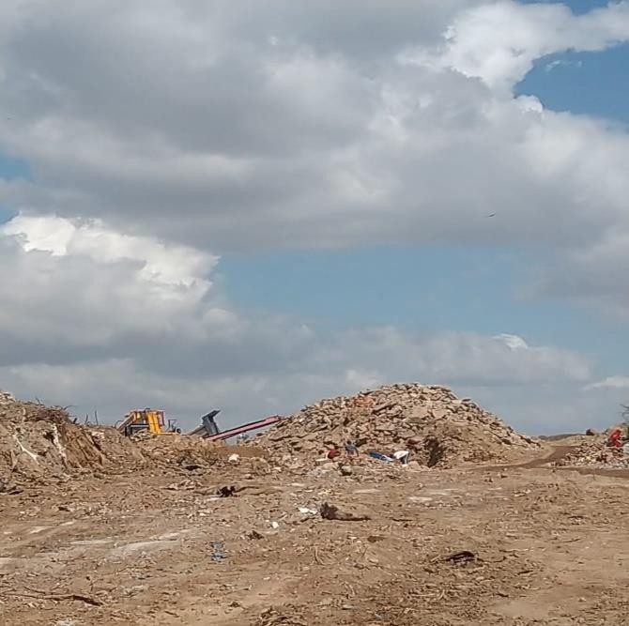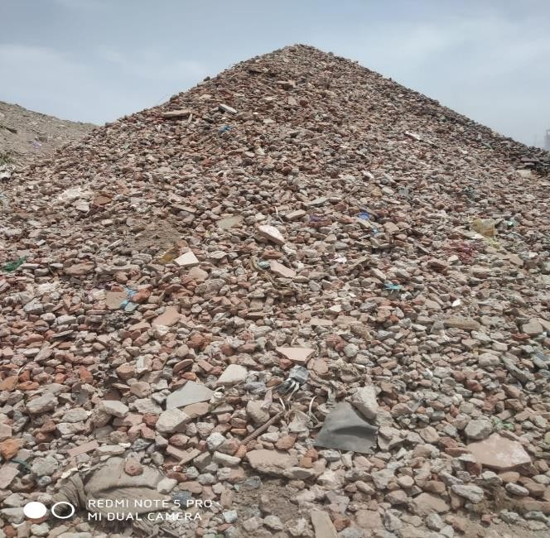

**Fig 1.1 Demolition Waste Fig 1.2 Demolition Waste**

**Features Of Demolition Waste**

Depending on the particular materials and structures involved, demolition waste can have a variety of different Features. Nevertheless, some typical traits of demolition waste include:

* + 1. Demolition waste often consists of a variety of materials, including concrete, bricks, wood, metal, plaster, glass, plastics, and other building supplies.
    2. Due to the size and composition of the materials used, such as concrete blocks, beams, and major structural components, demolition materials can be bulky and take up a lot of room.
    3. Non-biodegradable: A large portion of demolition waste is made up of non- biodegradable materials including plastic, metal, and concrete that do not break down over time.
    4. Contamination: Particularly in older buildings, demolition waste may contain contaminants like asbestos, lead-based paint, or dangerous chemicals. In order to prevent environmental and health problems, these contaminants must be handled and disposed of properly.
    5. Concrete and metal are two examples of materials that can be heavy and dense and contribute to the weight and volume of demolition waste.
    6. Recoverable Materials: Despite its varied composition, demolition waste frequently contains salvageable components that can be recycled or utilised again in different manufacturing or construction processes, such as wood, metal, and bricks.
    7. Potential for Hazardous Waste: Debris from demolished structures could also contain hazardous waste, such as chemicals, batteries, or electrical parts, which calls for specific management and disposal techniques.

It's crucial to remember that different nations and regions may have different rules and procedures for handling and managing demolition waste materials. To reduce the negative effects on the environment and maximise the recovery of valuable materials from demolition waste, proper sorting, recycling, and disposal techniques should be used.

**Need for recycled aggregate**

1. Natural resources are being depleted at a rapid rate due to urbanisation and population increase.
2. Due to the lack of inexpensive, high-quality aggregates that are readily available, the building sector is experiencing difficulties.
3. Expensive compared to recycled aggregates for high-quality broken aggregates.
4. A significant increase in waste production and a lack of disposal facilities.
5. The price of transportation and disposal have significantly increased as a result of the scarcity of dumping sites.
6. Increased disposal costs result from the need to remove demolished material from construction sites quickly.

**Scope Of Recycle Aggregate**

Beyond ordinary levels of waste output, the building industry is expanding quickly over the world. However, this waste can be recycled and changed into useful forms, which has a positive impact on the environment either directly or indirectly. Examples of available recycled aggregates include the following:

1. As the disposal of waste from demolished structures declines, there is more land that is becoming available.
2. When building roads, recycled aggregate can be used as fill material.
3. Rigid pavements can be built effectively using recycled aggregate.
4. Ballast for railroads can be made from recycled aggregates.
5. Natural aggregate can be replaced with recycled aggregate, which has superior Features.

**Source Of Recycle Aggregate**

1. Conflict-related damage, disaster-related construction waste, demolition-related waste, and the replacement of existing buildings with new ones for future development are all examples of damage.
2. Pavement broken from Portland concrete.
3. lab sampless that were tested.
4. Using ready-mix concrete factories and pre casting facilities, concrete is produced.
5. Deteriorated rail ballast

**production of recycle aggregate**

**recycling process**

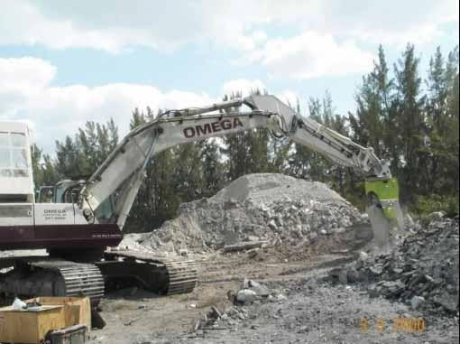Long boom arm mechanical hydraulic crusher: The concrete and steel reinforcing are broken down by the crushers using a long boom arm equipment.

**Fig 1.3 Long Boom Arm Hydraulic Crusher**

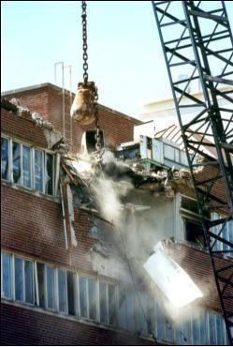**Destroying ball:** The Destroying ball, which is suspended from a crawler crane, uses its impact energy to destroy the building.

**Fig 1.4 Destroying Ball**

**TRANSPORTATION**

Buildings and cement pavements are torn down, and the discarded concrete is then processed at recycling plants. The building and demolition materials are transported using roll-off containers and dump body trailers since they are economical and effective. Closed box trucks and covered containers are frequently used for this.

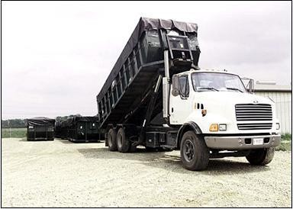

**Fig 1.5 The Roll-off Container**

**CRUSHING PLANT**

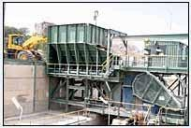The first step in turning construction and demolition waste into repurposed material is crushing. In this procedure, fragments of the concrete waste are broken . Jaw crushers or impacting mill crushers are typically the equipment used for the crushing operation. The primary jaw crusher will reduce the concrete waste to a size of around 3 inches. The materials will be broken to their largest size, which varies among 34 and 2 inches, using the secondary cone crushers. To extract all the scrap metal, magnetic conveyors are installed in every recycling crusher.

**Fig 1.6 Load in the Primary Crusher.**

# OBJECTIVES

* 1. To comprehend the features of demolition waste aggregate and the newly formed and hardened Features of demolition waste concrete using destructive and non-destructive methods.
  2. To determine the effect of demolition material on concrete strength.
  3. To determine the ideal replacement rate using demolition material.

# LITERATURE REVIEW

**Poon and Chan (2006)** Assess the viability of utilising RCA and broken clay brick as a sub-base material for roads without binding agents. The study evaluates the viability of integrating these repurposed materials into road infrastructure to promote sustainable and reduces dependence on renewable resources. The authors assess the mechanical qualities, compacted features, and draining efficiency of mixes containing recycled aggregates and broken clay brick through laboratory evaluation and evaluation. The outcomes provide helpful insights into the possible use of RCA and broken clay brick in road sub-base construction, emphasising possibilities for responsible growth of infrastructure and waste reduction in the constructing sector.

**Limbachiya, Leelawat, and Dhir (2000)** examine the application of RCA in HSC. The study seeks to investigate the practicality of integrating RCA as an environmentally-friendly substitute for natural aggregates in the production of high-strength concrete mixtures. The authors evaluate the mechanical capabilities, durability, and microstructural Features of HSC with different amounts of RCA using laboratory tests and analyses. Their discoveries offer useful perspectives on the prospective advantages and difficulties linked to employing RCA in HSC, encompassing its influence on compressive strength, tensile strength, and resistance to environmental variables. This investigation makes a valuable contribution to the improvement of sustainable construction practices. It provides information on how to optimise mix designs and enhance the Quality of high-strength concrete. AdditionallyIt aids in mitigating the adverse environmental consequences of concrete manufacturing.

**Hansen and Narud (1996)** analyse the structural Features of recycled Concrete composed of coarse stones formed from broken concrete.. The study goals to examine the mechanical qualities and Quality of reused concrete used as aggregate, with a focus on its innovative method to recycling. The authors conduct thorough experimental investigations, including tests to measure compressive strength and assess durability, to Investigate the feasibility and efficiency of using broken concrete as a coarse aggregate in the creation of new concrete. Their investigation provides valuable information on the viability of using recycled concrete as a sustainable substitute for conventional aggregates. It offers detailed analysis of its strength development, durability, and prolong Quality . This investigation makes a noteworthy contribution to the field of sustainable building by establishing the foundation for future investigation and Utilisation of reused resources in the production of concrete. This, in turn, helps to reduces waste and minimise the environmental effects in the construction sector.

**Tam and Le's (2007)** investigation focuses on identifying the optimal strength in compression of structural concrete that includes a high proportion of recycled RA. The project investigates the possibility of including a substantial amount of recycled aggregates in concrete manufacturing, while ensuring that the structural integrity is not compromised. This is in response to the increasing interest in sustainable construction techniques. The authors conduct laboratory experiments and investigation to examine how different levels of RA content impact the strength in compression of concrete mixes. The investigationers investigate the impact of variables such as aggregate grading, w/c ratio, and curing conditions on the mechanical Features of reused aggregate concrete. The study's objective is to offer practical assistance to engineers and practitioners on how to maximise the use of recycled materials in structural concrete. This will be achieved by discovering the best combination of proportions and manufacturing procedures, while also ensuring that the concrete meets Quality criteria and standards. In summary, this investigation enhances the comprehension and use of sustainable practices in the construction sector.

**Etxeberria, Vázquez, and Marí (2000)** examine the influence of the amount and manufacturing techniques of RCA on the qualities of RAC. They conduct thorough experiments to evaluate the mechanical, durability, and microstructural Features of RAC using varied amounts of RCA and various production methods. The results highlight the substantial impact of the RCA quantity on the strength in compression elastic modulus, and resistance to deterioration of RAC. In addition, the study examines how manufacturing practices, such as pre-soaking aggregates or adjusting mixing protocols, impact the Quality of RAC. The investigation provides useful insights into optimising RAC mix designs for sustainable construction by clarifying these links. This resource offers pragmatic advice for engineers and concrete manufacturers that seek to optimise the use of recycled materials while simultaneously preserving or enhancing the Quality and durability of concrete. In summary, the study enhances comprehension of sustainable methods for producing concrete and encourages the use of recycled aggregates in building. This contributes to the preservation of the environment and the efficient use of resources.

**Kou, Poon, and Etxeberria (2007)** investigate the impact of using RA on the enduring mechanical Features and distribution of pore sizes in concrete. The study examines the impact of including RA on the prolong mechanical strength and internal pore structure of concrete, using a series of experiments and analysis. The authors analyse different aspects, including the content of RA the distribution of particle sizes, and the circumstances of curing, in order to comprehend their effects on the Quality of concrete. Their discoveries illuminate the steady development of the physical Features and pore structure of concrete that includes RA as time progresses. This offers valuable understanding into the long-lastingness and eco-friendliness of such concrete. The investigation aims to clarify these relationships in order to enhance the efficiency of using reused aggregates in concrete manufacturing, while also guaranteeing the prolong structural stability. This work contributes to the field of sustainable concrete technology and encourages the use of recycled materials in building, This is helpful in safeguarding biodiversity and optimise resource utilisation.

**Xiao, Li, Zhang, and Zhang (2015)** examine the mechanical Features and long-lasting nature of concrete that includes RA obtained from various sources. The investigation aims to examine the influence of different sources of RA on the prolong durability of concrete. with a specific focus on its mechanical strength and durability Features. The authors conduct thorough experimental investigations, which involve mechanical tests and durability assessments, to examine how the Features of RA affect the qualities of concrete. They examine elements such as the overall composition, distribution of particle sizes, and surface Features to clarify how they affect the Quality of concrete. The findings offer useful insights into the appropriateness of using RA from different sources in concrete production. They provide suggestions on how to optimise mix designs and improve the prolong Quality of concrete made with RA. The study enhances sustainable construction methods and encourages the usage of recycled Constituents used in the production of concrete leading to a reduces in environmental effect and the preservation of natural resources.

**Ganjian and Najimi (2009)** investigate the impact of using RA on the mechanical Features and prolong Quality of concrete. The investigation seeks to gain insights into how the integration of RA affects both the structural Quality and prolong durability of concrete. The authors conduct a thorough set of experiments, which involve mechanical testing and durability assessments, to analyse how the Features of RA such as particle size distribution, aggregate shape, and surface qualities affect the Features of concrete. The total Quality of concrete containing RA is evaluated by analysing Features such as strength in compression, tensile strength, chloride penetration resistance, and freeze-thaw resistance. The findings provide useful insights into the possible advantages and difficulties of employing RA in concrete production, offering suggestions for optimising mix designs and improving the sustainability of construction practices.

**Poon and Chan (2007)** concentrate on the application of RCA and broken clay brick in the creation of paving blocks. The study investigates the viability and efficacy of integrating these reclaimed materials into the production processes of paving blocks. The authors conduct experimental investigations and analysis to evaluate the mechanical qualities, durability, and Quality Features of paving blocks that contain RCA and broken clay brick. Their investigation offers useful insights into the possible uses of recycled materials in the creation of paver blocks, emphasising the potential for sustainable construction methods and waste reduction. The study enhances understanding in sustainable construction by explaining the advantages and drawbacks of utilising RA in the production of paving blocks. Additionally, it encourages the use of environmentally friendly materials in infrastructure development.

# METHODOLOGY

**MATERIAL**

**CEMENT**

The most widely utilised cement in the nation right now is of this grade. In RCC building where the concrete grade is up to M25, OPC 43 is utilised. Additionally, it is employed in the construction of precast items like blocks, tiles, and asbestos- containing products like sheets and pipes, as well as in non-structural projects like flooring and plastering.

Regular Ultra Tech Company Portland Cement of Grade 43, a locally available product, was employed for the experiment. Care was taken to guarantee that the procurement was made from single batching in airtight containers to avoid being influenced by atmospheric conditions.

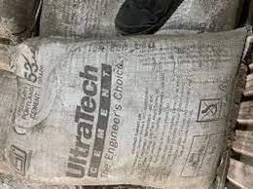

**Fig 4.1 Ultratech Cement**

The cement obtained in this way was evaluated the physical requirements in accordance with IS: 12269 respectively. The physical Features of cement are listed below in Table 4.1

**Table 4.1 Physical Features of Cement**

|  |  |  |  |
| --- | --- | --- | --- |
| S.No | Features | Test Result | Remarks |
| 1 | IST | 130 min | Should not be less than 30 min as per IS:12269 |
| 2 | FST | 450 min | Should not be more than 10 hours as per IS:12269 |
| 3 | Standard consistency | 32% | As per IS:4031-Part4-1988 |
| 4 | Specific gravity | 3.15 | Specific gravity of cement As per is code IS: 4031 part 11 |

**FINE AGGREGATE**

M Sand is a granular material used in construction that is mostly made up of mineral and stony fragments that have been finely split. It is therefore utilised as fine aggregate in concrete.

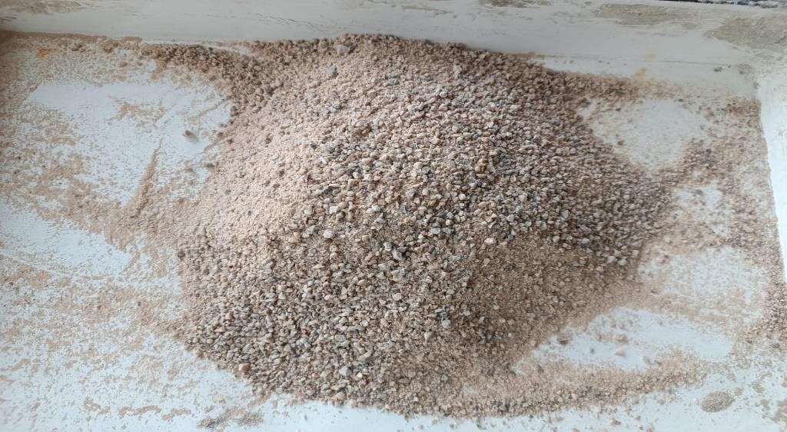

**Fig 4.2 Fine Aggregate**

The aggregate that is examined Regarding the material's specifications, the parameters include progression, fineness modulus, amount of moisture, and specific gravity, and water absorption.

**Table:4.2 Test on Fine Aggregate**

|  |  |  |  |
| --- | --- | --- | --- |
| S.No | Features | Test Result | Governing Code |
| 1 | M sand zone | Zone- II | IS 383 |
| 2 | Fineness modulus | 2.6 | IS 383  [19] |
| 3 | Moisture content | 0.51% | IS 2386 Part 3  [27] |
| 4 | Water absorption | 1.9% | IS 2386 Part 3  [27] |
| 5 | Specific gravity | 2.65 | IS 2386 Part 3  [27] |
| 6 | Unit weight kg/m3 | 1610 | IS 2386 Part 3  [27 |

**COARSE AGGREGATE**

The term "coarse aggregate" often refers to the materials that are large enough to pass through a 4.75mm sieve. Local resources are employed to create the coarse aggregate. For this experimental with broken angular material with diameters of 10 mm and 20 mm are used.

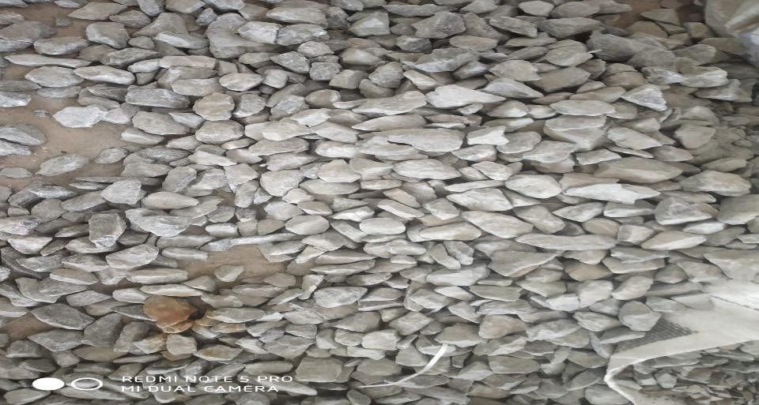

**Fig 4.3 Coarse Aggregate**

The aggregate which are tested for its physical requirement such as fineness modulus, moisture content, specific gravity, water absorption, Impact test, unit weight and Abrasion Value.

**Table 4.3 Test on Coarse Aggregate**

|  |  |  |  |
| --- | --- | --- | --- |
| S.No | Features | Test Result | Governing Code |
| 1 | Fineness modulus | 6.4 | IS 383  [19] |
| 2 | Moisture content | 0.95% | IS 2386 Part 3  [27] |
| 3 | Specific gravity | 2.74 | IS 2386 Part 3  [27] |
| 4 | Water absorption | 0.7% | IS 2386 Part 3  [27] |
| 5 | Impact test | 18.25% | IS 2386 Part 4  [27] |
| 6 | Unit weight | 1475 kg/m3 | IS 2386 Part 3  [27] |
| 7 | Abrasion value | 26.82% | IS 2386 Part 4  [28] |

**WATER**

Water has a big impact on the durability of concrete. It needs around 3/10th of its weight in water in order to be completely hydrated. A minimum w/c ratio of 0.35 is required for normal concrete, according to practical experience. Chemical reactions among cement and water result in the formation of a cement paste, which binds to both large and small particles. The segregation and bleeding caused by excessive water use might make concrete weaker. The majority of the water is nonetheless absorbed by the fibres, which can aid in reducing bleeding. Blood can bleed from excessive water content, while insufficient water use results in poor workability.

Potable water is used as a resource throughout the mixing and hydration stages of the manufacturing of concrete. To obtain the intended result in this situation, a water-to- cement ratio of roughly 0.44 was used.

**DEMOLITION WASTE**

Aggregate waste is a product of the dismantling of concrete structures. The recycled aggregate for this study is sourced from an Indo Enviro Integrated Solution Limited facility in Shastri Park called the MCD Construction and Demolition Waste Recycling Process Plant. After strictly passing through 20mm and keeping 10mm IS sieve, this material is used. When compared to natural coarse aggregate, the waste from demolished concrete has a higher water absorption rate. The percentages of 0%, 10%, 20%, 30%, 40%, 50% and 100% separately were used to partially replace the coarse aggregate left over from demolished concrete. The aggregates' physical Features, including gradation, fineness modulus, specific gravity, moisture content impact test, unit weight, water absorption and Abrasion Value, were evaluated.

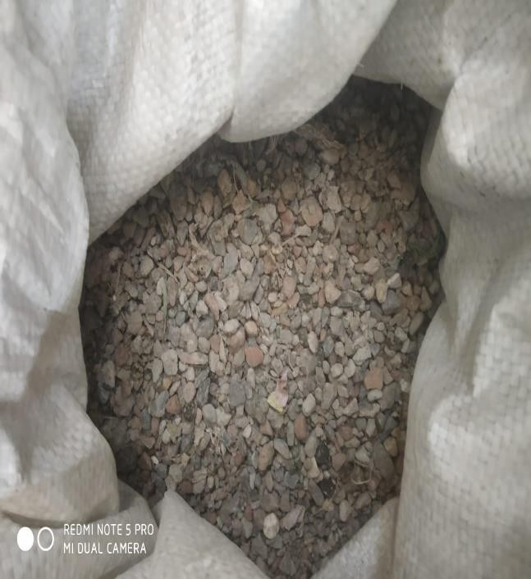 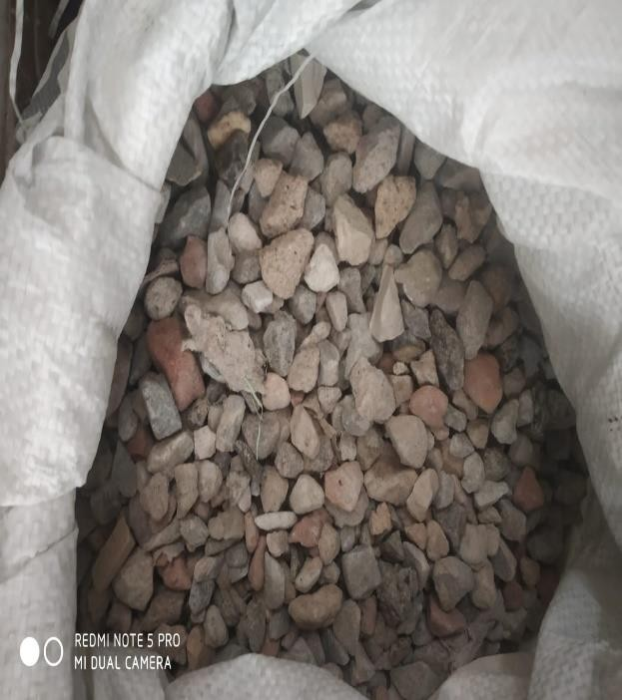

**Fig 4.5 Demolition Waste of 10mm Fig 4.6 Demolition Waste of 20mm**

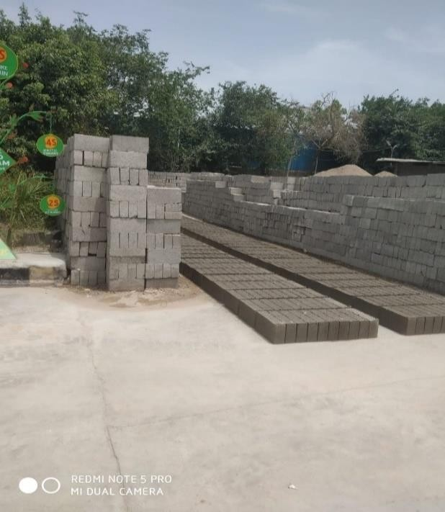

V

**Fig 4.7 Transportation of Demolition Waste Fig 4.8 Made building blocks using**

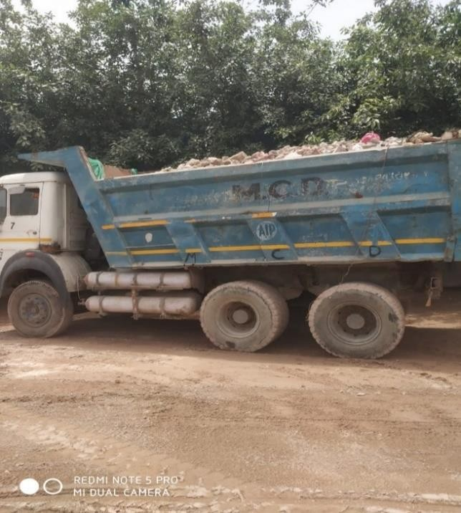**Demolition waste**

**Table 4.4. Physical Features of Recycle Coarse Aggregate**.

|  |  |  |
| --- | --- | --- |
| S.No | Physical Property | Test Result |
| 1 | Fineness modulus | 6.4 |
| 2 | Moisture content | 3.85% |
| 3 | Water absorption | 5.85% |
| 4 | Specific gravity | 2.46 |
| 5 | Impact test | 31.20% |
| 6 | Unit weight | 1426kg/m3 |
| 7 | Abrasion value | 36.51% |

**TEST TO BE CONDUCTED ON FRESH CONCRETE**

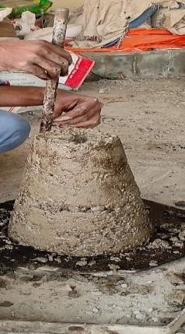WORKABILITY: Workability is a term used to indicate how easily a material may be mixed, carried, placed, and finished without any segregation or undue resistance. This term is generally used in reference to concrete or other construction materials. It evaluates how easily a material can be handled and moulded throughout the construction process. Several elements, including water quantity, aggregate size and shape, cement content, admixtures, and the presence of any extra additives, affect workability. A material with good workability is frequently required because it makes construction operations more effective and efficient.

Fig. 4.9 Slump test

**TEST TO BE CONDUCTED ON HARDENED CONCRETE**

1. XRD test
2. Compressive strength test
3. Split tensile strength test
4. Rebound hammer test
5. **RESULT**

The results of numerous tests performed on concrete sampless, including strength in compression and tensile strength tests, are presented in this chapter. Additionally, X-ray diffraction (XRD) investigation was done as part of microscopic investigations. In the chapter's conclusion, the findings and conclusions of the investigation are presented using graphs, tables, and microscopic image.

**SLUMP TEST**

The results of measuring the slump of the concrete with recycled coarse materials are shown below in Table 5.1

**Table 5.1 Workability Comparisons Among Different % Replacement of RCA**

|  |  |  |  |
| --- | --- | --- | --- |
| S.No | Types of concrete | % of Replacement  of RCA | Slump Value in  (mm) |
| 1 | Normal Concrete | 0 | 100 |
| 2 | RCA Concrete | 10 | 95 |
| 3 | RCA Concrete | 20 | 93 |
| 4 | RCA Concrete | 30 | 88 |
| 5 | RCA Concrete | 40 | 85 |
| 6 | RCA Concrete | 50 | 80 |
| 7 | RCA Concrete | 100 | 70 |

120

100

80

60

40

20

0

0

10

20

30

40

50

100

% Replacement of RCA

**Fig 5.1 Slump Value of Different % Replacement of RCA**

Slump value in mm

The slump value is reduces as the percentage of replacement of RCA increase.

**STRENGTH FEATURES OF OBTAINED HARDENED CONCRETE**

The results from the mechanical strength tests specified below are discussed in details in subsequent stanzas.

* + 1. Compressive strength test
    2. Split tensile strength test
    3. Rebound hammer test
    4. XRD test

**COMPRESSIVE STRENGTH TEST**

Cube compression tests were performed to determine the effects of replacing the coarse aggregate with demolition waste. Replacement ratios of 0%, 10%, 20%, 30%, 40%, 50%, and 100% were taken into account. Both the 7 and the 28 days were used for the examinations.

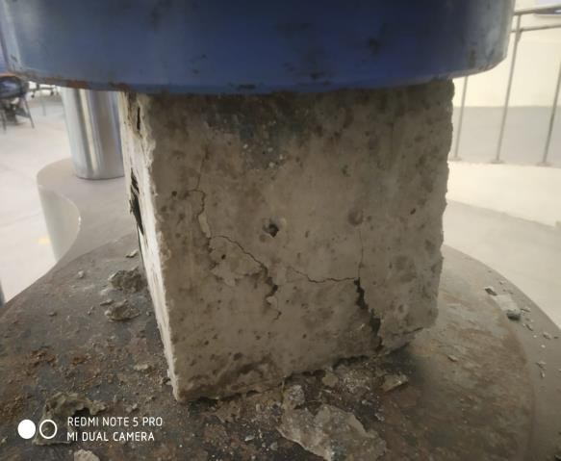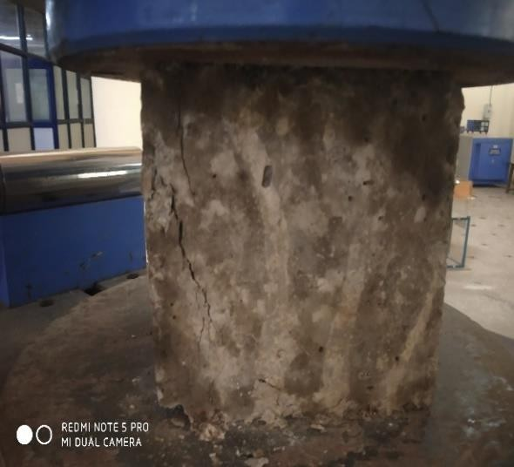

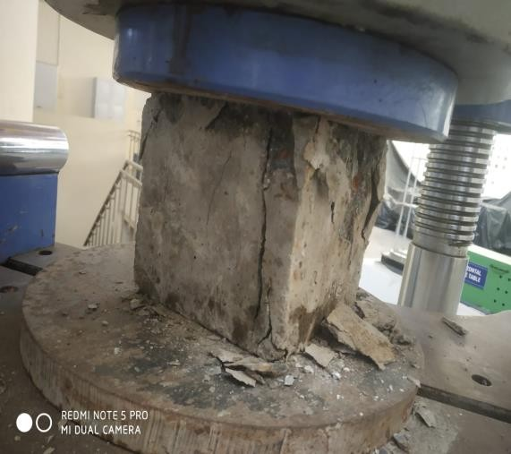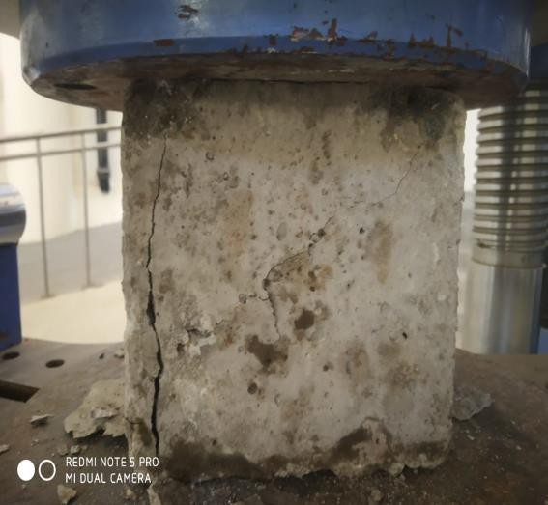**Fig 5.2 Different Types of Cracks**

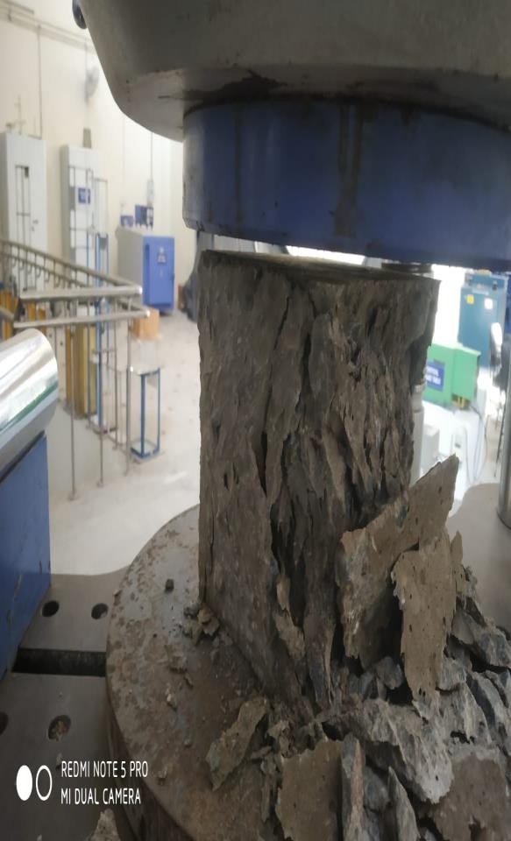 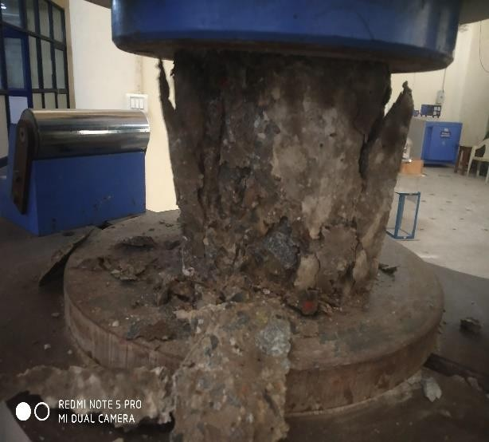

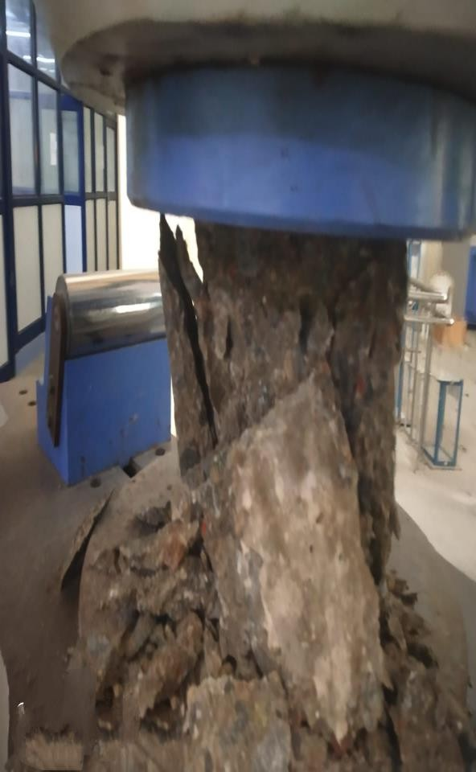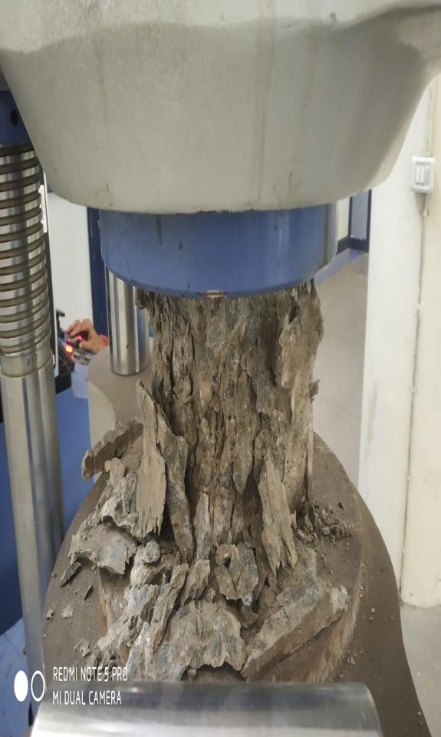

**Fig 5.3 Different Types of Rupture**

**Table 5.2 Average Compressive Strength Value of Cube**

|  |  |  |  |  |
| --- | --- | --- | --- | --- |
| S.No | Types of Concrete | % Replacement of RCA | 7 days strength (MPa) | 28 days strength (MPa) |
| 1 | Normal concrete | 0 | 22.62 | 34.36 |
| 2 | RCA Concrete | 10 | 24.63 | 34.52 |
| 3 | RCA Concrete | 20 | 24.65 | 34.74 |
| 4 | RCA Concrete | 30 | 24.18 | 34.41 |
| 5 | RCA Concrete | 40 | 21.03 | 27.36 |
| 6 | RCA Concrete | 50 | 20.84 | 27.04 |
| 7 | RCA Concrete | 100 | 11.19 | 24.43 |

**Fig 5.4 Average Strength Variation for Various % Replacement of RCA in Cube**

40

35

30

25

20

15

10

5

0

0

10

20

30

% Replacement of RCA

40

50

100

7 Days Strength

28 Days Strenhth

Compressive Strength MPa

1. **CONCLUSION**

The following conclusion can be drawn from the study.

* + 1. The slump value reduces as the proportion of demolition waste used for replacement increases. Other parameter such as water absorption, moisture content, Specific gravity, impact test, abrasion value and unit weight are also affected.
    2. At 100% replacement of natural aggregate with RCA the compressive strength of concrete reducesd by approximately 28.89% after 28 days.
    3. The ideal replacement rate for natural aggregate with demolition waste is 30%.
    4. Split tensile strength and compressive strength of concrete are sufficient up to 30% replacement, however after that point demolition aggregate reduces the strength's value.
    5. The sample containing 30% recycled concrete aggregate (RCA) was found to be the most cost-effective, with a cost 9% lower than the control mix sample, according to the results of the sample cost analysis.
    6. Therefore, it is logical to conclude that adding (C&D) waste to concrete not only lowers construction costs but also promotes waste recycling and effective utilisation.

1. **REFERENCES**
2. T.C. Hansen, “Recycling of demolished concrete and masonry,” RIELM Report No. 6, pp.29-32, April 2014.
3. P.K. Mehta and P.J.M Monteiro, “Concrete: Structures, Features and materials. New Jersey,” vol. 3, pp. 82-87, August 2014.
4. Erdema, M.a Blankson, “Environmental Quality and mechanical analysis of concrete containing recycled asphalt pavement (RAP) and waste precast concrete as aggregate” Journal of Hazardous Materials, vol.2, no.2 pp. 403–410 November 2016.
5. R.Kumar, P. K. Mehta and V.Srivastava, “Effect of Metakaoline and Recycled Fine Aggregate on Workability and Compressive Strength of Concrete” J. Environ. Nanotechnol, vol. 3, no.3 pp. 82-87, September 2014.
6. M. C. Limbachiya, T. Leelawat, R. K. Dhir “Use of recycled concrete aggregate in high-strength concrete” J. Material and Structure, vol.33, no.9 pp.1-18, November 2000.
7. R.K. Dhir, M.C. Limbachiya and T. Leelawat, “Suitability of recycled concrete aggregate for use in BS 5328 designated mixes” Proc. of Civil Engg. Struct. Build, vol.134, no.3 pp.257-274, August 1999.
8. J. S. Ryu. “An experimental study on the effect of recycled aggregate on concrete Features” J. Magazine of Concrete Investigation, vol.54, no.1pp. 7-12, February 2002.
9. M. Khatib, “Features of concrete incorporating fine recycled aggregate,” Cement and Concrete Investigation, vol. 35, no. 4, pp. 763–769, April 2005.
10. M. Bravo, J. Brito, and L. Evangelista, “Thermal Quality of Concrete with Recycled Aggregates from CDW Plants,” Applied Sciences, vol. 7, no. 7, p. 740, July 2017.
11. Oluwafemi, A. Ede, O. Ofuyatan, S. Oyebisi, and D. Bankole, “Recycling of Concrete Demolition Waste: pathway to sustainable development,” IOP Conference Series: Materials Science and Engineering, vol. 640, no. 1, p. 012061, November 2019.
12. A. Katz, “Features of concrete made with recycled aggregate from partially hydrated old concrete,” Cement and Concrete Investigation, vol. 33, no. 5, pp. 703–711, May 2003.
13. A. Ait Mohamed Amer, K. Ezziane, A. Bougara, and M. Adjoudj, “Rheological and mechanical behavior of concrete made with pre-saturated and dried recycled concrete
14. aggregates,” Construction and Building Materials, vol. 123, pp. 300–308, October 2016.