Sevarohi: Integrated Web Solution for Emergency Medical Assistance

# Soma Bera

*Usha Mittal Institute of Technology SNDT Women’s University*

Mumbai 400049, India [somabera0403@gmail.com](mailto:somabera0403@gmail.com)

# Arti Bhandari

*Usha Mittal Institute of Technology SNDT Women’s University*

Mumbai 400049, India [b2002arti@gmail.com](mailto:b2002arti@gmail.com)

# Dr Anita Morey

*Usha Mittal Institute of Technology SNDT Women’s University*

Mumbai 400049, India [Anita.More](mailto:Anita.Morey@umit.sndt.ac.in)[y@umit.sndt.ac.in](mailto:y@umit.sndt.ac.in)

***Abstract*—Sevarohi, a web-based emergency medical assistance system aimed at enhancing the efficiency of emergency response. Sevarohi enables users to register, provide critical information such as location and destination, and dispatch alerts to nearby ambulances through a user-friendly interface. Ambulance drivers receive and acknowledge alerts via a dedicated interface, while hospitals are promptly notified of incoming patients along with patient’s health data. Real-time data collection during ambulance transit further enhances the system’s effectiveness. Through Se- varohi, we address the challenges of timely emergency response, contributing to improved patient outcomes and healthcare system efficiency.**

***Index Terms*—*Emergency medical assistance, Web-based sys- tem, Ambulance dispatch, Hospital communication, Real-time data transfer, Patient care, Healthcare system efficiency.***

1. INTRODUCTION

In the realm of emergency medical services, the timely delivery of assistance plays a critical role in patient outcomes. Traditional emergency response systems often encounter inefficiencies and delays due to fragmented communication channels and manual processes. In response to these challenges, this paper introduces Sevarohi, an innovative web- based platform designed to streamline the emergency medical assistance process. By leveraging modern web technologies, Sevarohi aims to enhance communication and data exchange between users, ambulance services, and hospitals, thus optimizing the response to medical emergencies. The motivation behind the development of Sevarohi stems from the pressing need to improve the efficiency and effectiveness of emergency medical response systems. Existing systems frequently suffer from delays in dispatching ambulances, inadequate coordination between emergency responders, and limited access to crucial patient information. Sevarohi addresses these shortcomings by providing a unified platform that enables users to swiftly request assistance, dispatch alerts to nearby ambulances, and communicate patient data to receiving hospitals in real-time.

Sevarohi offers a comprehensive solution to streamline emergency medical assistance by harnessing modern web technologies. Its user-friendly interface allows users to quickly dispatch alerts to nearby ambulance services, initiating a prompt response. Ambulance drivers receive real-time alerts,

enabling them to acknowledge alerts, navigate efficiently to the user’s location, and communicate with hospitals. Hospitals receive alerts along with essential patient data, facilitating preparedness and resource allocation. Real-time data collection during ambulance transit ensures informed decision-making by healthcare providers upon the patient’s arrival. Through these features, Sevarohi aims to optimize emergency response processes, mitigate critical situations, and improve patient outcomes.

1. LITERATURE REVIEW

Smart ambulance has been proposed to improve the perfor- mance of emergency service. Smart ambulance uses technolo- gies such as Internet-of-things, real-time data communication and video streaming, big data, biomedical sensing and body area networks to improve the emergency service, minimize response time, and provide medical support with the least possible delay [1]

Role of ambulance response times in improving survival [2] is very important.

In contemporary society, the delivery of public services, particularly healthcare, is crucial, particularly in rural regions. Residents of rural areas rely on consistent access to public facilities. Nonetheless, the availability of these services often falls short of meeting demand, leaving gaps in accessibility during critical times. [3]

Emergency ambulance transportation, provided by licensed ambulance services, involves swiftly moving individuals from the scene of a sudden accident to the nearest hospital equipped to deliver essential emergency healthcare services. This vital service ensures that individuals receive prompt medical atten- tion following unforeseen incidents. [4]

An effective and resilient emergency referral transport sys- tem is a fundamental requirement for ensuring a country’s robust emergency infrastructure. The expansion of ambulance services has been remarkable since the initiation of the National Ambulance Services within the framework of the National Health Mission (NHM) a decade ago. [5]

The ’Golden Hour’ principle underscores the critical need to transport a road accident victim to a hospital within an hour, significantly boosting survival odds. However, India’s preva- lent congested traffic conditions pose substantial challenges for

ambulance services during emergencies such as road accidents and cardiac arrests.[6]

Delayed medical assistance and poor ambulance manage- ment are major factors that contribute to preventable deaths.[7]

1. METHODOLOGY

The development of Sevarohi followed a structured ap- proach, encompassing the design and implementation of three distinct Flowcharts: the user interface flowchart, the ambulance interface flowchart, and the hospital interface flowchart. Each workflow delineates the sequence of actions and interactions within Sevarohi, ensuring seamless communication and effi- cient response to medical emergencies.

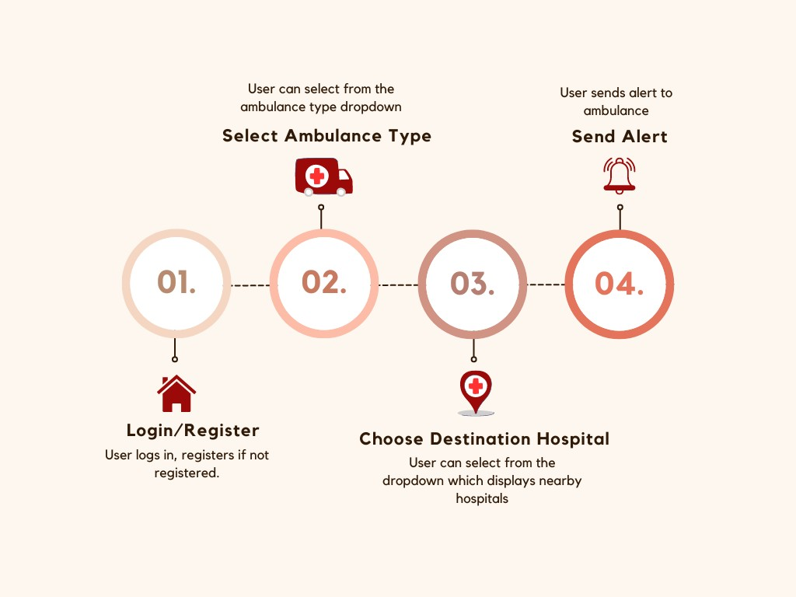

Fig. 1. Fowchart for User

1. *User Interface Flowchart*

The user interface workflow of Sevarohi begins with a streamlined login or registration process. Users must authenticate themselves to access the system, ensuring that only authorized individuals can use the service. For new users, the registration process is straightforward, requiring essential details to create an account. Returning users can simply log in with their credentials. This initial step is crucial as it secures the system and personalizes the user experience.

Once logged in, users are directed to a selection screen where they can choose the type of ambulance they require. This might include options such as basic life support, advanced life support, or specialized ambulances equipped for neonatal or cardiac emergencies. The selection is guided by the user’s specific needs, which can be influenced by the severity and nature of the medical situation.

After selecting the appropriate ambulance type, users are prompted to specify the destination hospital. This step ensures that the ambulance is directed to the correct medical facility, streamlining the process of getting the patient the necessary care as quickly as possible. Users can either choose from a list of nearby hospitals.

Upon confirming their choices, users proceed to send an alert. This alert is a critical component of the workflow, as it triggers the dispatch system. The user’s location, along with the details of the requested ambulance and destination hospital, is transmitted to the dispatch team. This initiates the immediate mobilization of the ambulance to the user’s location, ensuring rapid response times. The user interface may also provide real- time updates on the status of the dispatched ambulance, offer- ing peace of mind and transparency throughout the process.

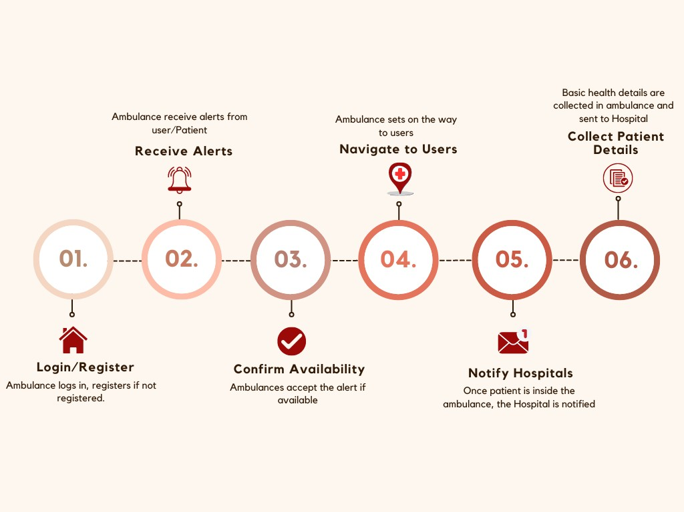

Fig. 2. Fowchart for Ambulance

1. *Ambulance Interface Flowchart*

In the ambulance interface workflow of Sevarohi, ambulance drivers initiate the process by engaging in a login or registration protocol to gain access to the system’s interface. This authentication step is critical for ensuring that only authorized personnel are able to respond to emergency requests, thus maintaining the security and integrity of the service. Upon successful authentication, the system dispatches alerts to drivers, notifying them of proximal requests for assistance. Each alert encapsulates essential information pertaining to the nature of the emergency and the requisite response, enabling drivers to swiftly evaluate the situation.

Upon arrival at the user’s location, ambulance drivers utilize the interface to notify the user of their presence, thereby en- suring effective communication during these critical moments. This notification mitigates user anxiety and prepares them for the subsequent procedural steps. Post-patient acquisition, drivers are required to input and transmit patient details to the designated hospital through the interface. This information exchange is pivotal for the hospital’s preparatory processes, ensuring that the medical team is adequately prepared to de- liver immediate care upon the patient’s arrival. The structured workflow inherent in the Sevarohi interface significantly en- hances the operational efficiency and efficacy of the emergency medical response, thereby improving patient outcomes and overall system performance.

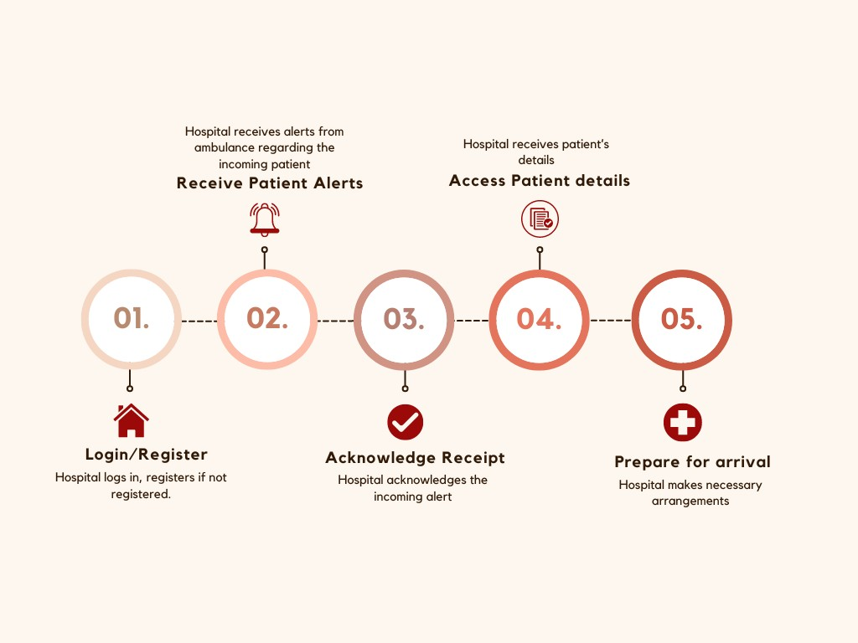

Fig. 3. Fowchart for Hospital

1. *Hospital Interface Flowchart*

The hospital interface workflow in Sevarohi begins with a rigorous login or registration process for hospital personnel, granting them secure access to the system’s interface. This authentication step is paramount for ensuring that only authorized medical staff can interact with the platform, thereby safeguarding patient information and maintaining system integrity. Upon successful login, hospital personnel receive alerts regarding incoming patients. These alerts contain vital details about the patient’s condition.

Following the acknowledgment of the patient alerts, hospital personnel can access comprehensive patient details provided through Sevarohi. This information is crucial for the hospital to prepare adequately for the patient’s arrival, ensuring that all necessary medical resources and personnel are mobilized in advance. Upon the patient’s arrival, the hospital is thus primed to deliver prompt and effective medical assistance, significantly facilitated by the prior information relayed through the Sevarohi system. This structured workflow enhances the readiness and response efficiency of the hospital, ultimately contributing to improved patient care outcomes and operational efficacy.

The project began by identifying the essential functionalities required for effective emergency medical assistance through extensive stakeholder consultations and comprehensive literature review.

1. RESULTS AND ANALYSIS

Sevarohi’s implementation has made significant strides in key areas critical to its effectiveness:

* 1. User Friendly Interface: Sevarohi’s interface is easy to navigate and understand, making it simple for people of all backgrounds to use.
  2. Real time Data Collection: Sevarohi excelled in collecting data in real-time, which was essential for fast emergency responses. When someone asked for help, Sevarohi quickly sent alerts to nearby ambulances, speeding up the response process. This swift data collection ensured that responders got crucial information right away, helping them act faster and save more lives.
  3. Accurate Location Finding: Sevarohi’s ability to find locations accurately was crucial for getting help where it was needed. It pinpointed user locations precisely, giving ambulance services detailed directions to reach them quickly. This accuracy helped responders get to people in need faster, providing help when it mattered most.
  4. Increased Accessibility: The adoption of Sevarohi enhances accessibility to emergency medical services. By leveraging technology to connect users with nearby ambulance services and hospitals, the platform bridges geographical barriers, ensuring prompt assistance irrespective of location.
  5. Data Sharing with emergency services: Sevarohi’s Seamless data exchange and collaboration between ambulance services, hospitals, and other healthcare providers enhance the overall effectiveness of emergency medical assistance delivery.

TABLE I

SEVAROHI FEATURES

|  |  |
| --- | --- |
| **Feature** | **Description** |
| User Friendly  Interface | Sevarohi’s interface is easy to navigate and understand, making it simple for people of all  backgrounds to use. |
| Real-time Data Collection | Sevarohi excelled in collecting data in real-time, which was essential for fast emergency responses. When someone asked for help, Sevarohi quickly sent alerts to nearby ambulances, speeding up the response process. This swift data collection ensured that responders got crucial information right away,  helping them act faster and save more lives. |
| Accurate Location Finding | Sevarohi’s ability to find locations accurately was crucial for getting help where it was needed. It pinpointed user locations precisely, giving ambulance services detailed directions to reach them quickly. This accuracy helped responders get to people in need faster, providing help when it  mattered most. |
| Increased Accessibility | The adoption of Sevarohi enhances accessibility to emergency medical services. By leveraging technology to connect users with nearby ambulance services and hospitals, the platform bridges geographical barriers, ensuring prompt assistance  irrespective of location. |
| Data Sharing with Emergency Services | Sevarohi’s seamless data exchange and collaboration between ambulance services, hospitals, and other healthcare providers enhance  the overall effectiveness of emergency medical assistance delivery. |

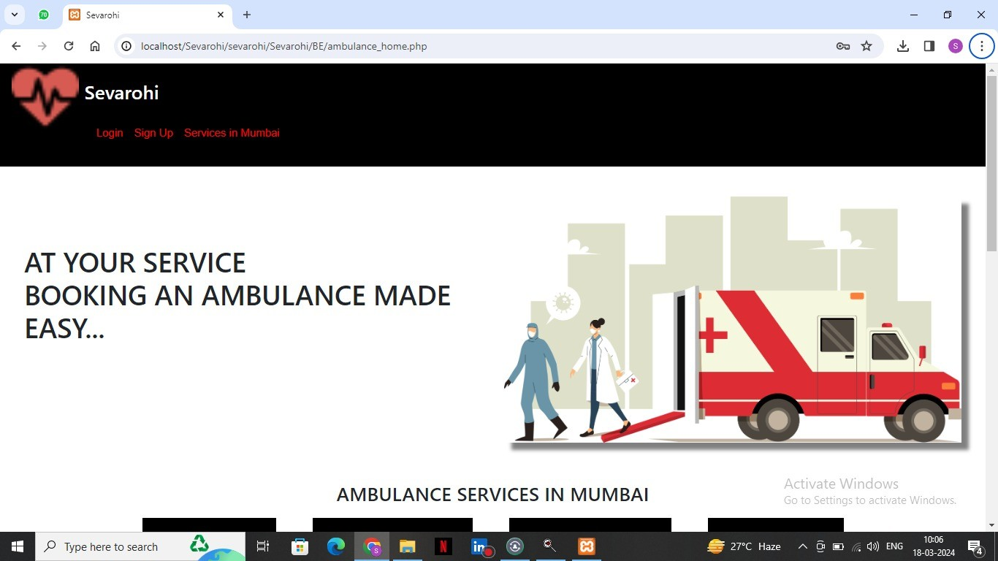

Fig. 4. Home page

The home page serves as the entry point for users, providing access to the login and registration functionalities. Upon accessing the home page, users are presented with a clean and intuitive interface that prompts them to either log in or register for a new account. For existing users, the login section allows them to input their credentials. For new users, the registration section guides them through the process of creating a new account. Once users have successfully logged in or registered, they are redirected to the appropriate dashboard or landing page within the Sevarohi system

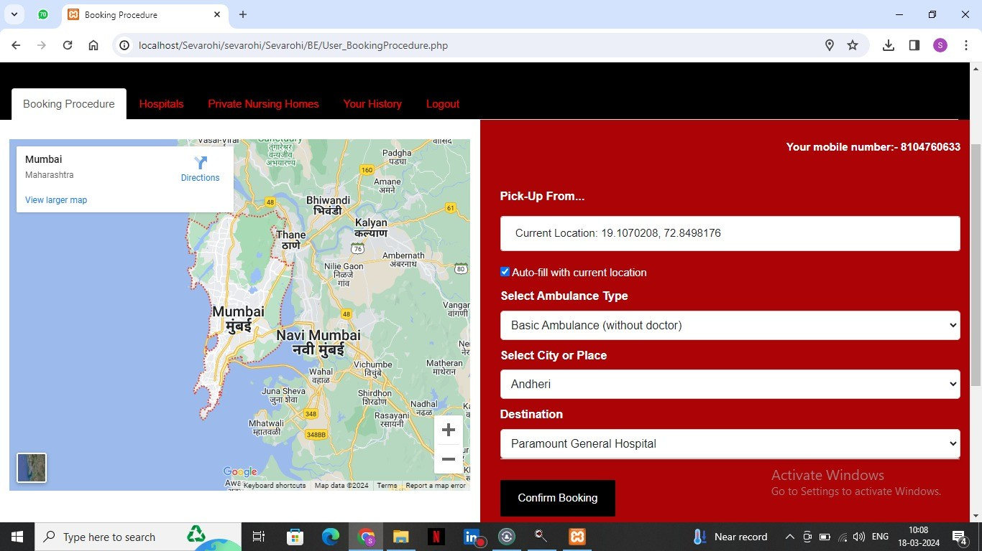

Fig. 5. Booking page

Upon reaching the booking page after logging in or regis- tering, users are met with a streamlined interface facilitating the request for emergency medical assistance. Here, users input vital information regarding their situation. Firstly, they provide their current pickup location, either manually or through GPS coordinates, ensuring accurate dispatch of emergency services. Secondly, users select their desired destination hospital from a list of nearby options. Additionally, users specify the city or region where the emergency is occurring, further assisting in directing the request to the appropriate emergency response services. Following this, users choose the type of ambulance required based on the severity and nature of the medical emergency. Finally, users confirm their booking by clicking a designated button, triggering the immediate transmission of the request to the Sevarohi system. This prompt action initiates the dispatch of the selected ambulance type to the user’s pickup location. Upon confirmation, users receive assurance that assistance is en route, while simultaneously, the ambulance

service receives detailed alerts containing the user’s pickup location, destination hospital, and other pertinent information. This comprehensive process ensures both swift user access to critical aid and enables emergency responders to effectively coordinate and deliver the necessary medical assistance.

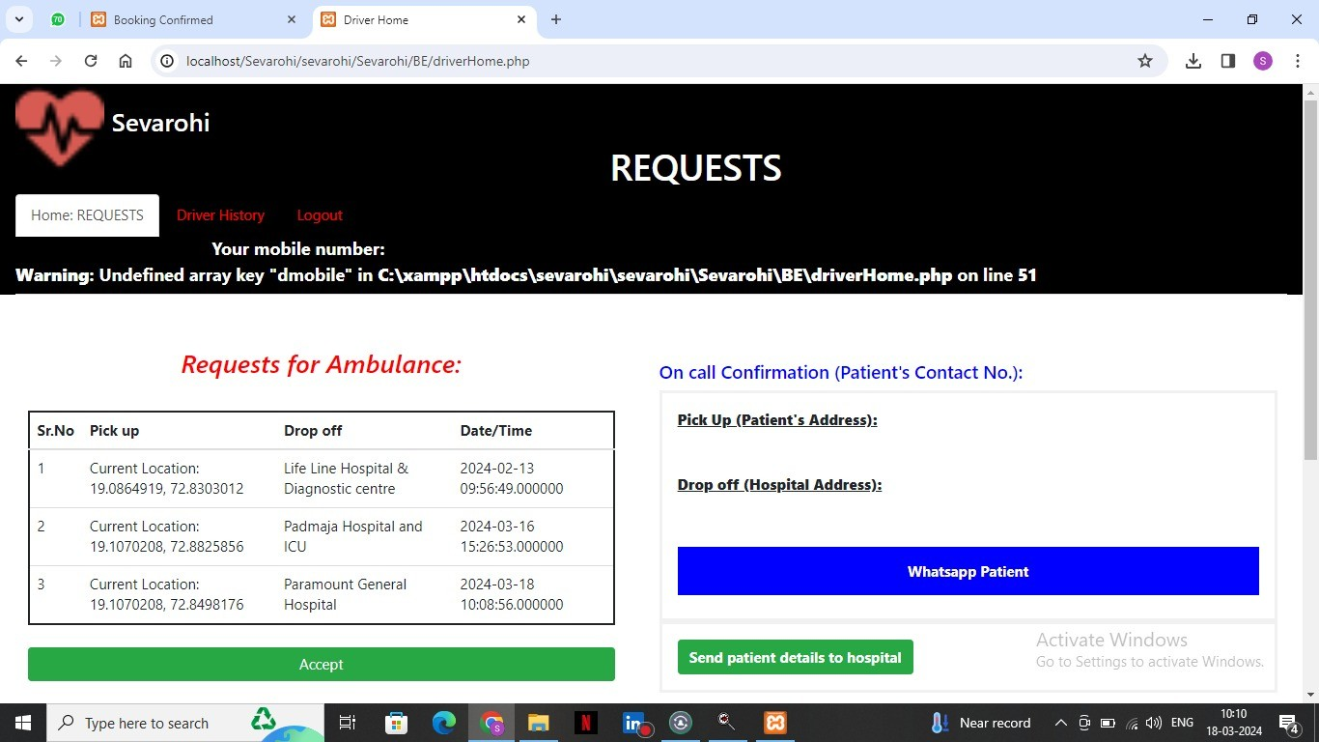

Fig. 6. Ambulance interface

Upon logging in, drivers are presented with a dashboard displaying incoming alerts for nearby emergencies, along with pertinent details such as the location of the incident, type of assistance required, and any additional notes from the user. From this interface, drivers can quickly acknowledge their availability to respond, access real-time navigation assistance to reach the user’s location swiftly, and communicate with dispatch and other emergency services as needed. The intuitive design and seamless integration of features in the ambulance interface streamline the response process, enabling drivers to provide timely and efficient medical assistance to those in need. Also after picking up the patient, some set of data is collected which is sent to the desired hospital before ambulance reaches.

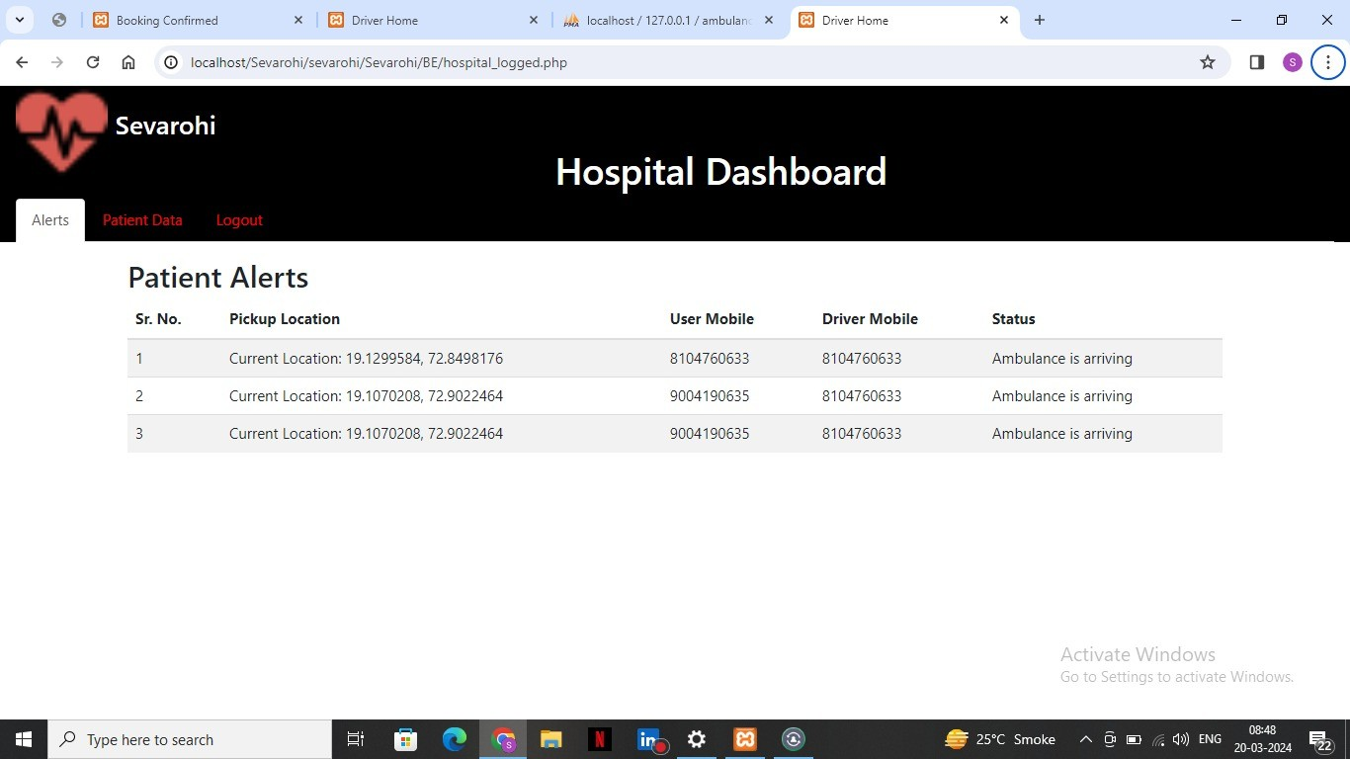

Fig. 7. Patient alerts to hospital

The hospital dashboard in Sevarohi provides a streamlined interface for healthcare providers to manage incoming patient alerts and access critical data collected by ambulance services. With a user-friendly design, hospital staff can efficiently prioritize and prepare for incoming patients by reviewing real- time information regarding the nature of the emergency and the patient’s condition. Additionally, access to detailed data collected en route, including vital signs and medical history,

equips hospital personnel with valuable insights to optimize patient care upon arrival. This centralized hub enhances com- munication and collaboration between emergency responders and healthcare providers, ultimately improving the overall efficiency and effectiveness of emergency medical services.

V. CONCLUSION & FUTURE SCOPE

In conclusion, Sevarohi plays a pivotal role in expediting emergency response efforts and potentially saving lives. By providing a user-friendly interface for individuals to request assistance during medical emergencies, Sevarohi ensures that help is just a click away, regardless of the situation’s severity or urgency. This immediate access to emergency services can make a crucial difference in critical situations, such as heart attacks, accidents, or other life-threatening incidents, where every second counts. Its digital platform ensures eq- uitable access to timely and life-saving care, irrespective of geographical location or socioeconomic status. Furthermore, Sevarohi strengthens community bonds by fostering collabo- ration among emergency responders, healthcare providers, and local authorities. Sevarohi promotes inclusivity by bridging gaps in access to emergency medical assistance, particularly in underserved or remote areas.

As for the future scope, Sevarohi aims to continually enhance its capabilities. This includes integrating additional tools and features such as AI-driven algorithms for predictive analytics to optimize resource allocation and telemedicine functionalities for remote medical consultations. Furthermore, the platform will explore the incorporation of IoT devices and wearables for real-time health monitoring, preemptively alerting users and emergency services to potential medical crises. Through these advancements, Sevarohi will solidify its position as a pioneering force in emergency medical assistance, advancing its mission of safeguarding lives and promoting well-being in communities worldwide.

ACKNOWLEDGMENT

We extend our sincere appreciation to Dr. Anita Morey for her exceptional guidance and support throughout our project. Her insightful suggestions and unwavering encouragement have been instrumental in shaping the direction and quality of this paper. Additionally, we express our gratitude to our colleagues, friends, and family members for their continuous support and understanding. Their belief in our abilities has served as a source of motivation during challenging times. Lastly, we are thankful to all individuals and organizations who have played a role, directly or indirectly, in the success of this project. Their collective efforts have been invaluable in achieving our goals.

1. B. Isong, N. Dladlu, and T. Magogodi, “Mobile-based medical emer- gency ambulance scheduling system,” *International Journal of Computer Network and Information Security*, vol. 8, pp. 14–22, 11 2016.
2. P. Veeraragaavan, S. A. D. Ali, K. A. Subaiya, V. H. Vaigundam, and

M. J. Mani, “Accident alert system and intimation for ambulance and hospital using lora,” in *international journal of engineering research & technology (ijert) eclectic*, 2020.

1. K. Pawalia, M. Diksha, A. Kothari, and H. Bhushan, “National ambulance services in india: A narrative review.”
2. J. Maddi, A. KS, and S. M P, “Health monitoring system for ambulance,” vol. 7, pp. 2321–9653, 06 2019.
3. M. Nithyashree, K. P. Nadgir, N. Pavithra, and R. S. Rajendran, “Smart ambulance management system with real-time patient monitoring,” in *2023 International Conference on Network, Multimedia and Information Technology (NMITCON)*. IEEE, 2023, pp. 1–6.

REFERENCES

1. C. S. Lim, R. Mamat, and T. Braunl, “Impact of ambulance dispatch poli- cies on performance of emergency medical services,” *IEEE Transactions on Intelligent Transportation Systems*, vol. 12, no. 2, pp. 624–632, 2011.
2. C. O’Keeffe, J. Nicholl, J. Turner, and S. Goodacre, “Role of ambulance response times in the survival of patients with out-of-hospital cardiac arrest,” *Emergency medicine journal*, vol. 28, no. 8, pp. 703–706, 2011.