**Bluetooth Smart Floor Cleaner Robot**

Snehal Tatkondawar, Sujata Mohitkar, Vaishnavi Kosare ,Arti Nagrale, Prof Rashmi Rajurkar, Prof Manas M Ramteke

Department of Electronics and Communication Engineering,

Shri Sai College of Engineering and Technology Bhadrawati , Maharashtra, India

# 

# Abstract

The robotics and automation industry which is ruled the sectors from manufacturing to household entertainments. It is widely used because of its simplicity and ability to modify to meet changes of needs. The project revolves around the creation of Bluetooth-enabled floor cleaning devices. The goal of this project is to create and test a model for cleaning wet and dry floor surfaces. It comes n handy for scrubbing damp flooring. Cleaning floors is important for our health, and this floor cleaning equipment decreases the amount of labour necessary. As a result, this project is quite valuable in our daily lives. It's straightforward to put together and operate. This equipment simple to operate. This floor cleaning equipment has a sponge mop, swiping brushes, and a fan that helps to speed up the cleaning process. This machine's overall cost similarly low. These machines are commonly employed for this purpose, although they operate on different principles and are quite expensive.

***Keywords****: Arduino Uno, Arduino IDE ,Bluetooth Module,BMS*

# Introduction

This project aims to address this need by developing a Bluetooth-controlled cleaning robot capable of cleaning surfaces with ease. The robot utilizes an Arduino Uno microcontroller, an HC-05 Bluetooth module. The integration of an HC-05 Bluetooth module enables wireless control of the robot from a Bluetooth-enabled device, such as a smartphone or a computer. This wireless control functionality allows operators to remotely navigate the robot through challenging environments, reducing the need for direct human intervention and enhancing ease and comfort. By combining the power of Arduino for motor control, the convenience of Bluetooth communication, and the robustness of the design, this project aims to create a versatile and reliable cleaning. In the following sections, we will discuss the methodology, implementation, functionality, and potential future enhancements of the Bluetooth-controlled cleaning robot.

## Objectives

The main objective of this project is to design and develop a Bluetooth-controlled cleaning robot. The specific goals include:

* + 1. Integrating an Arduino Uno microcontroller to control the six 12V gear motors for precise speed and direction control.
    2. Incorporating an HC-05 Bluetooth module for wireless communication, enabling remote control of the robot from a Bluetooth-enabled device.
    3. Ensuring the robot's capability to handle load of water and able to clean challenging environments, allowing it to operate effectively on water spilled surfaces.
    4. Exploring the potential for future enhancements, such as the integration of obstacle detection sensors for autonomous navigation or modifications to adapt the robot for extreme conditions.

**Flow Diagram**

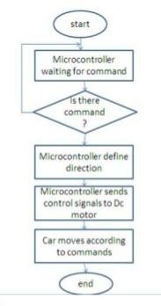

**Block Diagram**

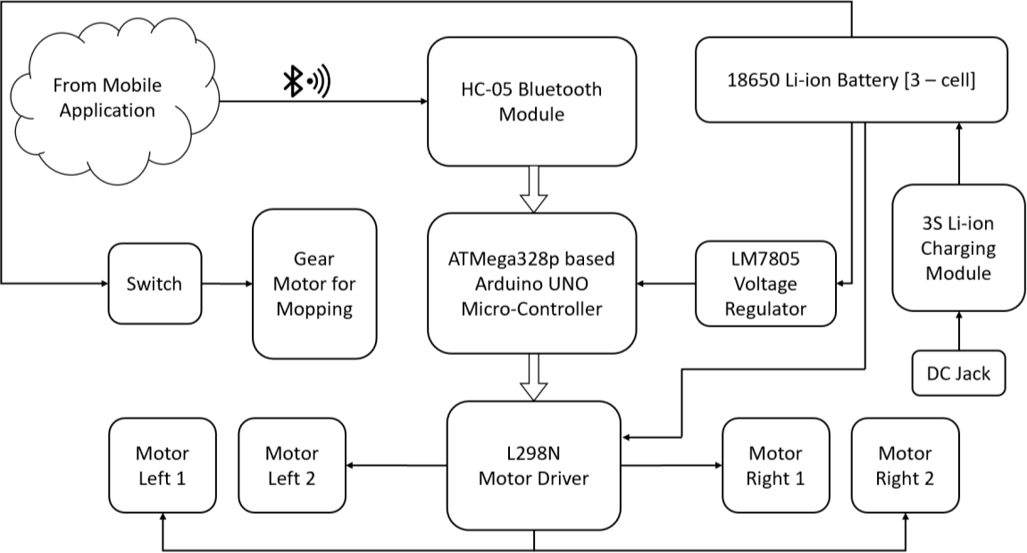

**Circuit Diagram**

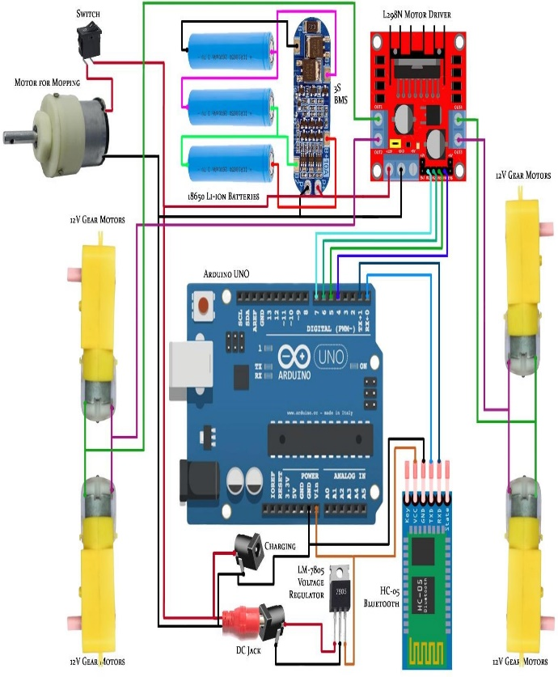

**Working**

The Bluetooth module HC-05 is connected to the Arduino board through simple single strand wires. The transmission pin of the Bluetooth module is connected to the receiver pin of Arduino and the receiver pin of the Bluetooth module is connected to the transmission pin of the Arduino. The Digital output pins 9, 10, 11 and 12 of Arduino board are connected to the pins 4, 10, 7 and 2 of the L298N motor driver IC respectively.

Two rechargeable batteries as supply is used which is connected to motor driver and Arduino respectively. When the circuit is energized, we will have to first pair the android phone with the Bluetooth module through the phones Bluetooth setting. The default password of the Bluetooth module will be 1234. Once the phone gets paired open the application "Bluetooth Remote Controller" which we can downloaded from Google play store. After connecting the mobile to HC-05, four options will appear on the application-Controller mode, Switch mode, Dimmer mode and Terminal mode.

We have to select the Controller mode from it. The controller mode will provide us a joystick interface. We will send ASCII values from the application to the Bluetooth module. As the user presses any control buttons, the controller will run programs move forward, backward, right, left, depending on the data sent by the mobile and the car moves likewise. The Arduino also stores the program in its memory so it does not require re uploading of Program. The IN1, IN2, IN3 and IN4 are the inputs for the motor driver that receives command from the Arduino for the two motors respectively. The motor driver should be grounded with the Arduino ground pin (GND). The motor driver requires minimum of 6v and above to run, any voltage below 6v the motor remains off. The RXD pin of the Bluetooth module is for receiving commands from the Android devices and sends to Arduino through this pin and the TXD is for transmitting or sending dates or information's It is supplied with a 5v de source from the Arduino 5v pin. The main part of the above circuit diagram is Arduino UNO. The power supply section is very important. It should provide constant voltage to the devices for successful working of the project.

**Conclusion**:

In conclusion, this project successfully achieved the design and development of a Bluetooth- controlled cleaning robot. The integration of an Arduino Uno microcontroller, HC-05 Bluetooth module, and a rover-type structure with six wheels enabled the robot to navigate challenging environments with enhanced stability and traction.

Through this project, we demonstrated the feasibility of remote-control using Bluetooth technology, allowing users to wirelessly operate the robot from a Bluetooth-enabled device. During a power outage, a manually operated floor cleaning machine is a viable alternative to an automatic floor cleaning equipment. The design is basic straightforward to make. Overall, the concept is highly useful, and the portions provide a lot of room for modification. They'll keep optimising until they find the greatest one. Overall, the project achieves its goal and undoubtedly alter the robotics and floor cleaning eras. The algorithm for automation is meant to achieve 90% efficiency, which is far too high in the current situation. In the subject of sensing, progress can be made.

## Future Scope

Future enhancements for this robot could include the integration of obstacle detection sensors, such as ultrasonic or infrared sensors, to enable autonomous navigation and obstacle avoidance. Additionally, modifications to withstand extreme environmental conditions, such as temperature and low visibility, could be explored to further enhance its utility in specific applications.

# References

[1]. Dr. Akash Rathee, Ishant Jalan, Lakshita Nandwani,Tanya Sharma Automatic Smart Floor Cleaning Robot Using Arduino – UNO 2020 International Journal for Research in Engineering Application & Management (IJREAM).

[2]. Uman Khalid, Muhammad Faizan Baloch, Haseeb Haider, Muhammad Usman Sardar, Muhammad Faisal Khan, Abdul Basit Zia and Tahseen Amin Khan Qasuria. Smart floor cleaning robot-2018-Researchgate- 327837948

[3]. R.Senthil Kumar, Vaisakh KP, Sayanth A Kumar, GauravDasgupta “Remote Controlled Autonomous FloorCleaning Robot” International Journal of Recent Technology and Engineering (IJRTE) ISSN: 2277- 3878,Volume-8, Issue-2S11,

September 2019 Mohd. IShahba

[4]. z Khan, Nagageetha, M.Gurunadha Babu “Bluetooth Cleaning Robot using Arduino” International Journal of Innovative Technology and Exploring Engineering (IJITEE)

ISSN: 2278-3075, Volume8, Issue-11S2, September 2019

[5]. Nikhil Murlidhar Chopade Student, Mechanical Department, DES’sCOET Dhamangaon Rly, India “Modified Floor Cleaning Machine” International Journal of Emerging Technologies in Engineering Research (IJETER) Volume 5, Issue 4, April (2017)

[6]. R.Balamurugan*, P.Kirubha, S.ArunKanna, E.R.Hariprasath, C.Anupriya Department of EEE/Karpagam College of Engineering/Coimbatore, India “Bluetooth Based Automatic Floor Cleaning System” International Journal of ChemTech Research CODEN (USA): IJCRGG, ISSN: 0974-4290, ISSN(Online):2455-9555 Vol.11 No.04, pp 55-62, 2018

[7]. AadilArshad2, Nandkishor S. Kale3, Ansari M Bilal4, Prof. D. M. Ugle5 Muhammad Kashif Shaikh Ghaffar1, M. Department of Mechanical Engineering, STC SERT Shegaon “DESIGN AND DEVELOPMENT OF FLOOR CLEANINGMACHINE”International Journal of Advance Engineering and Research Development Volume 5, Special Issue 06, April-2018 (UGC Approved)

[8]. Mr. S. Rameshkumar1, M. Selvakumar2, S. Senthilkumar3, P. Surya4, I. Thilagavathi5 “Design and Fabrication of Multipurpose Floor Cleaning Machine”

International Journal of Advanced Science and Engineering Research Volume: 3, Issue: 1, 2018 ISSN: 2455-9288.

[9]. S Monika, K Aruna Manjusha, S V S Prasad, B.Naresh “ DESIGN AND IMPLEMENTATION OF SMART FLOOR CLEANING ROBOT USING ANDROID

APP” . 2019-International Journal of Innovative Technology and Exploring Engineering (IJITEE).

[10]. Bhumika T, Harshitha U, Meghana S, Dr. Ganashree “ TTIDDY - AN ARTIFICIAL INTELLIGENCE BASED FLOOR CLEANING ROBOT ” 2020-august International Journal of Trend in Scientific Research and Development (IJTSRD).

[11]. Raveena Ishalavath M, Sandhyashree N, Rakshitha R, Arpitha Shankar “ DESIGN AND DEVELOPMENT OF AN AUTOMATED FLOOR CLEANING ROBOT FOR DOMESTIC APPLICATION” 2020 International Journal of Engineering Research & Technology (IJERT)

[12]. Meghana K , Harshitha V , Mahima Padmanabha B, Nagesh N Dikshit , B R Santosh Kumar. “ A Survey On Automatic And Manual Floor Cleaning Robot” 2019 JETIR April 2019, Volume 6, Issue 4

[13]. Yuda Irawan, Muhardi Muhardi, Rian Ordila, Roni Diandra. “AUTOMATIC FLOOR CLEANING ROBOT USING ARDUINO AND ULTRASONIC SENSOR” 2021-

Journal of robotics and control(JRC) Vol2 no-4.