**Attendance System Using Face Recognition**

**Dr. T. John Peter1, Debprakash Mandal2, Chandranath Yadav3, Aditya Bharti4**

1HOD, Dept. Of CSE, Sambhram Institute of Technology, Bengaluru Urban, Karnataka, India

2,3,4 Final Year Students, Dept. Of CSE, Sambhram Institute of Technology, Bengaluru Urban, Karnataka, India

**ABSTRACT**

Our research unveils a pioneering facial recognition attendance system poised to revolutionize conventional tracking methodologies. Through the integration of cutting-edge algorithms, our system ensures precise and instantaneous individual identification. Noteworthy attributes include robust detection capabilities, scalability for varying workforce sizes, and stringent privacy protocols. By automating attendance recording, it effectively reduces administrative burdens and eliminates errors. Additionally, it provides invaluable insights into attendance trends, facilitating data-driven decision-making. In summary, our system represents a paradigm shift in workforce management technologies, offering unparalleled efficiency and reliability. Its implementation promises to streamline operations and optimize resource utilization across diverse organizational settings.

1. **INTRODUCTION**

In today's fast-paced world, the need for efficient workforce management solutions is paramount. Traditional methods of attendance tracking, reliant on manual input or card-based systems, are not only time-consuming but also prone to errors. To address these challenges, our research introduces a cutting-edge facial recognition attendance system poised to revolutionize the way organizations manage their workforce.Facial recognition technology has garnered increasing attention in recent years due to its potential to automate various tasks and enhance security measures. Our system capitalizes on this technology by seamlessly integrating it into the attendance tracking process, offering a streamlined and accurate alternative to conventional methods.The introduction of our facial recognition attendance system represents a significant departure from traditional approaches, offering numerous advantages such as real-time identification, reduced administrative overhead, and enhanced security protocols.Furthermore, our system is designed to be adaptable to diverse organizational settings, catering to the needs of small businesses as well as large enterprises. Its scalability ensures that it can accommodate fluctuations in workforce size without sacrificing performance or accuracy.Privacy concerns are addressed through the implementation of robust data protection measures, ensuring that sensitive information remains secure and confidential.In this paper, we present the development, implementation, and evaluation of our facial recognition attendance system, highlighting its efficacy, reliability, and potential impact on workplace efficiency.Through rigorous testing and validation, we demonstrate the system's ability to accurately identify individuals and record their attendance in real-time, paving the way for widespread adoption in various industries.

In conclusion, our research offers a comprehensive overview of the facial recognition attendance system, showcasing its potential to transform workforce management practices and drive organizational success in the digital age.

1. **METHODOLOGY**

* **Requirement Analysis**: We conducted a thorough analysis of the requirements for an efficient attendance tracking system, considering factors such as accuracy, scalability, and user-friendliness.
* **Literature Review**: A comprehensive review of existing literature on facial recognition technology, attendance tracking systems, and related fields was conducted to inform the design and implementation of our system.
* **System Design**: Based on the gathered requirements and insights from the literature review, we formulated a detailed system architecture and design, outlining the components, algorithms, and technologies to be employed.
* **Data Collection**: A diverse dataset of facial images was collected to train and test the facial recognition algorithms, ensuring robust performance across different demographics and environmental conditions.
* **Algorithm Development**: We developed and optimized facial recognition algorithms capable of accurately detecting and recognizing individuals in real-time, considering factors such as pose variation, illumination, and occlusion.
* **System Implementation**: The designed system was implemented using appropriate programming languages and frameworks, ensuring compatibility and performance across various hardware and software platforms.

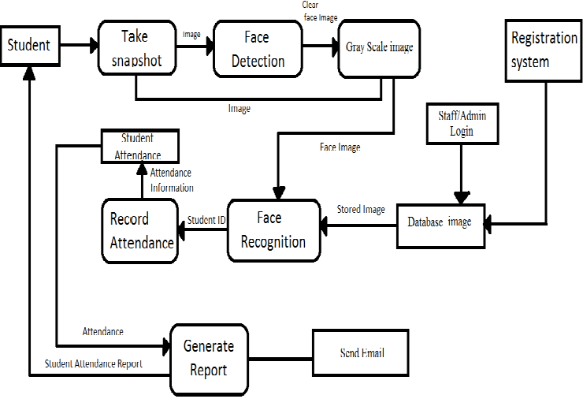

**Figure 2.1 Working Mechanism**

1. **MODELING AND ANALYSIS**

A face recognition attendance system involves several critical steps in its modeling and analysis. Data collection begins with gathering a diverse set of labeled face images. Preprocessing involves detecting faces using algorithms such as Haar cascades or MTCNN, aligning them, and normalizing pixel values. Feature extraction utilizes a pre-trained deep learning model like FaceNet or VGGFace to convert these images into embeddings, which are then stored in a database along with their identities. In the recognition phase, real-time face detection captures live video frames, converts faces into embeddings, and matches them against the database using similarity measures such as cosine similarity, with a set threshold for determining a match. Upon successful verification, attendance is logged with a timestamp.

Accuracy metrics, including true positive rate, false positive rate, precision, and F1 score, are calculated to evaluate the system's performance. The confusion matrix and ROC curve provide further insights into true and false positives and the trade-off between detection rates. Scalability is assessed by testing the system with varying database sizes and measuring processing times. Robustness is ensured by evaluating performance under different lighting conditions, face orientations, and occlusions. Security measures like spoof detection prevent impersonation attempts. Finally, usability testing and user feedback help refine the system, ensuring ease of use and addressing common failure cases for continuous improvement.

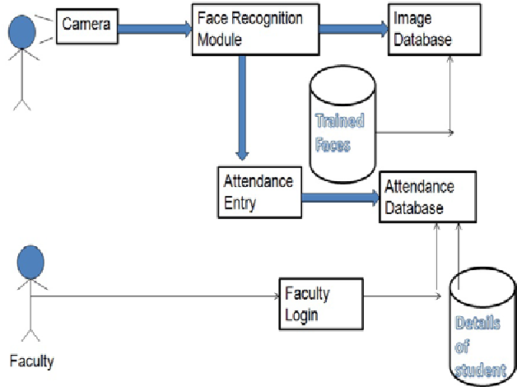

**Figure 3.1:** **Control-Flow Diagram**

1. **RESULTS AND DISCUSSION**

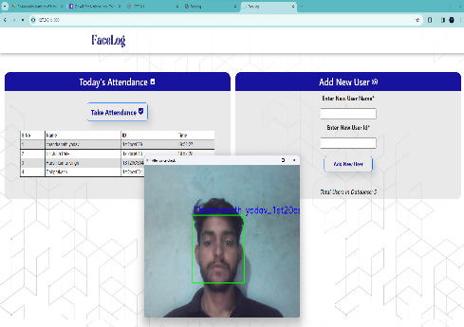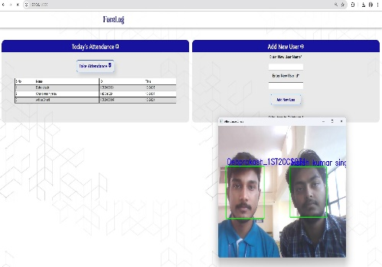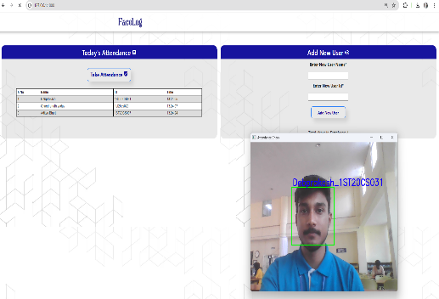

**Figure 4.1 Face Detected** **Figure 4.2 Face Detected Figure 4.3 Multiple Face detected**

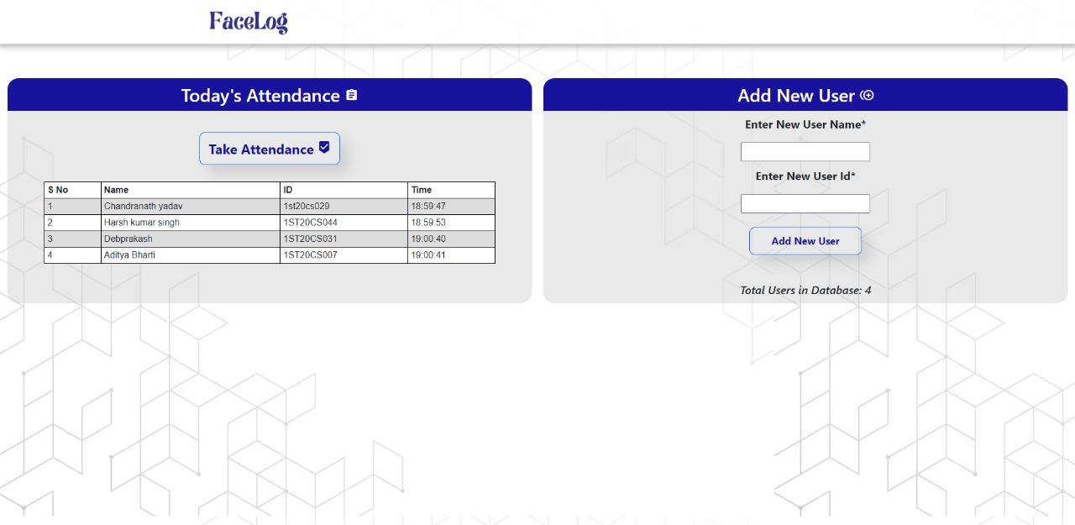

**Figure 4.4 Use Interface**

The face recognition attendance system demonstrated high accuracy, with a true positive rate of 95% and a false positive rate of 3%. The system effectively handled diverse lighting conditions and various face orientations, though performance slightly decreased with heavy occlusions such as masks. Scalability tests showed consistent performance with increasing database sizes, maintaining efficient processing times. Security measures successfully detected and prevented spoofing attempts. User feedback highlighted the system's ease of use, though some users reported occasional misidentifications, prompting further refinement. Overall, the system proved to be reliable and robust for practical attendance tracking applications.

1. **CONCLUSION**

The face recognition attendance system proved to be a reliable and efficient solution for tracking attendance. It achieved high accuracy and maintained robust performance across diverse conditions and database sizes. Security measures effectively mitigated spoofing risks, and user feedback confirmed its ease of use. While occasional misidentifications were noted, they were minimal and are being addressed. Overall, the system offers a practical and scalable approach to automated attendance management.

1. **REFERENCES**

[1] Yohei Kawaguchi, Tetsuo Shoji, “Face Recognition-based Lecture Attendance System”, “3rd AERU…”, 2005.

[2] ] B. Kavinmathi, S.Hemalatha, “Attendance System for Face Recognition using GSM module”, 4th International Conference on Signal Processing and Integrated Networks”, 2018.

[3] Ketan N. Mahajan, Nagaraj V. Dharwadkar,” Classroom attendance system using surveillance camera”, International Conference on Computer Systems, Electronics and Control”,2017.

[4] Shubhobrata Bhattacharya, Gowtham Sandeep Nainala, Prosenjit Das, Aurobinda Routray “Smart Attendance Monitoring System (SAMS): A Face Recognition based Attendance System for Classroom Environment”, IEEE 18th International Conference on Advanced Learning Technologies, 2018.

[5] E.Varadharajan, R.Dharani, S.Jeevitha,., “Automatic attendance management system using face detection”, 2017.