**Alexa and Google Assistant Based Smart Home Automation Using Node MCU**

Bhagyashree Chanekar, Mrunal Sayankar, Prof P R Yelekar, Prof Manas M Ramteke

Department of Electronics and Telecommunication Engineering,

Shri Sai College of Engineering and Technology Bhadrawati , Maharashtra, India

# 

# Abstract

Home automation structures have gotten commonness of late, paralleling advances in the possibility of the Internet of Things. The current endeavour exhibits the utilization of an unobtrusive home computerization system, inside the structure of assistive advancement. The system utilization relies upon the NodeMCU microcontroller along with Wi-Fi correspondences capacity, and it is proposed for use by the elderly and people with insufficiencies. The structure is anything but difficult to use, with an instinctual interface executed on an Android based propelled cell phone. Showings exhibit that the structure empowers control of home devices, lights, warming, cooling systems and security devices by the arranged customers, i.e., the elderly and crippled.

***Keywords****: Alexa, Google Assistant ,Node MCU ESP8266,Arduino IDE*

# Introduction

Home robotization frameworks have gotten inescapability beginning late, paralleling the advances in the likelihood of Internet of Things. Notwithstanding the manner in which that robotization for business structures is a make improvement, computerization applications for habitations are a decently new upgrade, which is being gotten a handle on by customers. Home robotization joins the checking and control of exercises, for example, lighting, warming, ventilation, cooling (HVAC), electrical mechanical gatherings, sound frameworks, perception cameras, passage shocks, and cautions. Home robotization has various focal points, for instance, comfort, extended security, and essentialness viability.

In this age the gadgets that we're the utilization of are getting to be more brilliant and littler. they're connecting relatively without issue, and they might demonstrate to us that in almost every and everything of our regular daily existences. This new reality this is there inside the period—is alluded to as the net of things—it's miles about adapting to and gathering the enormous amount of certainties that we are capable picking up from these developing networks of these hardware and sensors, which strategy such measurements, and furthermore share it with all the distinctive entomb related issues. it's miles a modern period, anyway we are plausible of having it with these now found in keen sensors from our product associations, inside the security structures and inside nature we can control structures in our homes, and furthermore in our vehicle's capacities for self-observing.



## Objectives

1. To assembling a remote home robotization structure constrained by gadget associated with the web.
2. Integrate the contraption to the controller: The overwhelming need that must be recollected when developing a Smart Home is that it must be savvy. The contraption controller must be humbly organized with the machines in the house with a foundation.
3. Test the set up and analyse the data: After the system is set-up, with the help of a mobile phone and a controller, tests are driven while data is recorded and inspected.
4. To arrangement and execute monetarily adroit home robotization structure yet a capable one.
5. To plan an easy to use and a guaranteed structure to control home machines particularly planned to support the more prepared individuals and weakened.

**Block Diagram**

### 

### Major Components

### Arduino IDE

The Arduino Integrated Development Environment (IDE) is the main text editing program used for Arduino programming. It is where you’ll be typing up your code before uploading it to the board you want to program. Arduino code is referred to as sketches.



### Alexa

Alexa is a virtual assistant developed by Amazon, designed to perform various tasks and interact with users through voice commands. It is part of the broader Amazon Echo ecosystem, which includes smart speakers equipped with microphones for voice input and speakers for audio output. Alexa utilizes natural language processing and artificial intelligence to understand and respond to user commands, enabling hands-free control of connected smart devices and access to a wide range of services and information.

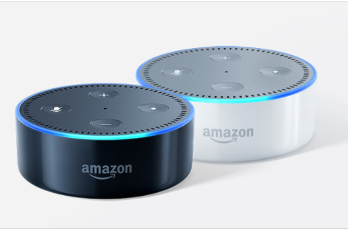

### Google Assistant

Google Assistant is a virtual assistant developed by Google, capable of performing various tasks and responding to user commands through voice interaction. It is accessible on a wide range of devices, including smartphones, smart speakers, smart displays, and other smart home devices. Google Assistant uses natural language processing and artificial intelligence to understand and execute user requests, providing personalized assistance and access to a vast array of services, information, and smart home controls.

### Sinric Pro Assistant

Sinric Pro is a cloud-based platform that allows for seamless integration of smart home devices with voice assistants such as Amazon Alexa and Google Assistant. It provides an easy-to-use API that enables developers to connect their IoT devices to the Sinric Pro platform, allowing users to control these devices using voice commands through Alexa or Google Assistant.

The function of Sinric Pro in a NodeMCU home automation project is to facilitate communication between the NodeMCU-based smart home devices and the voice assistants. When a user issues a voice command to their Alexa or Google Assistant device, Sinric Pro interprets the command and sends the corresponding instructions to the NodeMCU devices via the internet. This allows users to remotely control their smart home devices using voice commands, such as turning lights on or off, adjusting thermostat settings, or activating custom routines.

Overall, Sinric Pro enhances the user experience by providing a convenient and intuitive interface for controlling smart home devices using voice commands. It adds versatility and accessibility to the NodeMCU-based home automation system, allowing users to interact with their devices hands-free and from anywhere within range of their voice assistant-enabled devices.

.

## Arduino Libraries

### NodeMCU ESP8266

The NodeMCU ESP8266 development board comes with the ESP-12E module containing ESP8266 chip having Tensilica Xtensa 32-bit LX106 RISC microprocessor. This microprocessor supports RTOS and operates at 80MHz to 160 MHz adjustable clock frequency. NodeMCU has 128 KB RAM and 4MB of Flash memory to store data and programs. Its high processing power with in-built Wi-Fi / Bluetooth and Deep Sleep Operating features make it ideal for IoT projects.

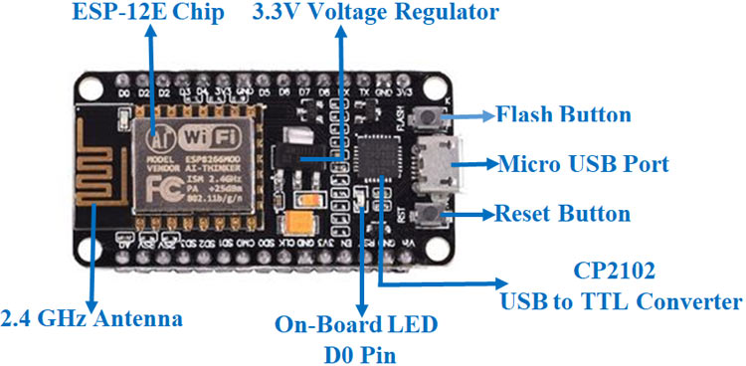

**Conclusion**:

This project is about wireless home automation using Android mobile helps us to implement such a fantastic system in our home at a very reasonable price using cost-effective devices. Thus, it overcomes many problems like costs, inflexibility, security etc. In addition, will provide greater advantages like it decrease our energy costs, it improves home security. In addition, it is very convenient to use and will improve the comfort of our home. The project has proposed the idea of smart homes that can support a lot of home automation systems. C# programming language and Node microcontroller have been used to connect the sensors circuit to the home.

**Future Scope:**

* There are a variety of enhancements that could be made to this system to achieve greater accuracy in sensing and detection.
* There are a lot of other sensors that can be used to increase the security and control of the home like pressure sensor that can be put outside the home to detect that someone will enter the home.
* Changing the way of the automated notifications by using the GSM module to make this system more professional.

# References

1. *“Smart Energy Efficient Home Automation System using IOT”, by* Satyendra K. Vishwakarma, Prashant Upadhyaya, Babita Kumari, Arun Kumar Mishra.
2. *“IOT Based Smart Security and Home Automation”, by* Shardha Somani, Parikshit Solunke, Shaunak Oke, Parth Medhi, Prof. P. P. Laturkar.
3. *“A Dynamic Distributed Energy Management Algorithm of Home Sensor Network for Home Automation System”, by* Tui-Yi Yang, Chu-Sing Yang, Tien-Wen Sung; in 2016 Third International Conference on Computing Measurement Control and Sensor Network.
4. *“Enhance Smart Home Automation System based on Internet of Things”, by* Tushar Churasia and Prashant Kumar Jain; in Proceedings of the Third International Conference on I-SMAC (IoT in Social, Mobile, Analytics and Cloud) (I-SMAC 2019) IEEE Xplore Part Number:CFP19OSV-ART; ISBN:978-1-7281-4365-1
5. *“Visual Machine Intelligence for Home Automation”, by* Suraj, Ish Kool, Dharmendra Kumar, Shovan Barman.
6. *“A Low-Cost Home Automation System Using Wi-Fi based Wireless Sensor Network Incorporating internet of Things”, by* Vikram.N, Harish.K.S, Nihaal.M.S, Raksha Umesh, Shetty Aashik Ashok Kumar; in 2017 IEEE 7th International Advance Computing Conference.
7. *“Voice Controlled Home Automation System using Natural Language Processing and Internet of Things”, by* Mrs. Paul Jasmin Rani, Jason Bakthakumar, Praveen Kumaar.B, Praveen Kumaar.U, Santhosh Kumar; in 2017 Third International Conference on Science Technology Engineering & Management (ICONSTEM)
8. Wikipedia(2009). HomeAutomation. From https://en.wikipedia.org/wiki/Home_automation
9. Theory of IOT from :https://internetofthingsagenda.techtarget.com/definition/Internet-of-Things-IoT
10. About Node MCU from: https://lastminuteengineers.com/esp8266-nodemcu-arduino-tutorial/