**Voice and Manual Control Smart Home Automation Using Node MCU**

Pallavi Ganfade, Shreyas Hepat, Prof Manasvi Lodey, Prof Manas M Ramteke

Department of Electronics and Communication Engineering,

Shri Sai College of Engineering and Technology Bhadrawati , Maharashtra, India

**Abstract:** In this project, we design the development of a firmware for smart control which can successfully be automated minimizing human interaction to preserve the integrity within whole electrical devices in the home. We used Node MCU, a popular open source IOT platform, to execute the process of automation. Different components of the system will use different transmission mode that will be implemented to communicate the control of the devices by the user through Node MCU to the actual appliance. The main control system implements wireless technology to provide remote access from smart phone. We are using a cloud server-based communication that would add to the practicality of the project by enabling unrestricted access of the appliances to the user irrespective of the distance factor. We provided a data transmission network to create a stronger automation. The system intended to control electrical appliances and devices in house with relatively low-cost design, user-friendly interface, and ease of installation. The status of the appliance would be available, along with the control on an android platform. This system is designed to assist and provide support in order to fulfil the needs of elderly and disabled in home. Also, the smart home concept in the system improves the standard living at home.

**Introduction**: In these present days home computerization is persuading the chance to be vital to improve our life conditions. Comfort and straightforwardness of utilizing home machines is the thing that home robotization is progressing. Home robotization offers a bleeding edge lifestyle in which an individual finds the opportunity to control his whole house utilizing a pushed wireless, from turning on a TV to locking/opening sections; it in like way offers a competent utilization of centrality. By the by, to get or verify such framework exhibited will cost a great extent of cash and that is the authentic reason of why home computerization has not gotten much premium and thought, adding to that in like way the multifaceted thought of displaying it and engineering it. Therefore, it is essential to bode well and simple to organize, if this is allowed to individuals, they will gain it in their homes, workplaces, and schools. In a way, a framework alteration for the home computerization is required with the genuine goal to chop down the cost of applying it to houses. In addition, home computerization offers ease of cerebrum and body to injured or potentially progressively settled individuals in their homes by only a single tick to do what they require as imparted as of now.



## Why are Smart homes needed?

### Savings-

With all the connected electrical devices that are inclusive of getting to know coolers, sprinklers which might be clever, lights which might be wireless enabled, tracking the electricity retailers in addition to water heating and cooling modules that will also reduce energy and water use.

### Control-

Many of the today’s apparatuses in a household, from broilers and fridge to deadbolts and cooling gadgets, might be controlled naturally by means of projects in PCs, phones, and pills. In many occurrences, the control of every one of these gadgets works when you are out of the house as well and can transform them, which implies you could close the entry via the air terminal, check at the pooch from any of the nation, or affirm that you turned off your stove from the commercial centre or some other store.



### Convenience-

Having most of your lounge and room lightings interchanged as you achieve your property remotely, the home theatre and TV machine consequently betting your favoured melody and the front entry opens naturally when you approach it with hands total of acquiring stuff, is maybe the end rich highlights of the astute and home. in any case, solace and harmony isn't about sumptuous and simple life, shrewd locks can likewise give you a chance to allow with the privilege of section of the particular people at exact examples and not generally, so you don't must remain at home as well as supply out a key. so also, a sensor lets you know while your fridge vacant or out of stock encourages you to "arrangement" your entrance or leave entryway from wherever inside this world.

### Security-

They are so clear, connected responses for wellbeing for the sharp home that are sensibly estimated choices for each checking security verified frameworks. remote empowered CCTV cameras, associated development sensors notwithstanding astute smoke cautions might be observed from interior or outside a local utilizing a video live, electronic mail and ready writings.

### Safety

Sensors that are verified that can discover spillage of water, phase of stickiness, carbon dioxide, development, warmness, and each ecological issue that could be envisioned assistance keep occurrence from transforming into catastrophes as they could speak with proprietor legitimately, on each event you're, wherever you need. Senior autonomy Automate sound update notwithstanding voice actuated ready frameworks are just a group of the elements of local mechanization that help seniors' have free existence for a greater drawn-out timespan. moreover, cameras connected to the Wi-Fi with - way report may furthermore help friends and family hold a watch on the senior inhabitants when they can't go and real beware of them.

**Circuit Diagram**

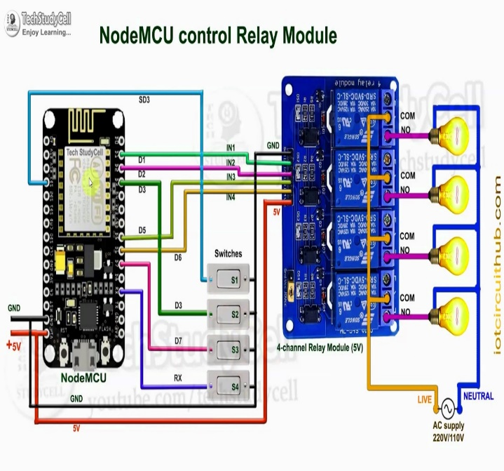

## Benefits

The benefits of an established wireless remote switching system of home appliances include:

### No legal issues

Obtaining access to or traversing properties with hard lines is extremely difficult.

### Reduced wiring issues.

Considering the increase in price of copper, thus increases the possibility of the wire to be stolen. The use of a wireless remote system to control home appliances means no wire for thieves to steal.

### Extended range

As the system establishes control over Wi-Fi, it was a generally considered descent range. That is 150 feet indoors. Outdoors it can be extended to 300 feet, but since the application is of a HAS, an indoor range is considered.

### Security

As the connection of the control of the HAS is established over a secure network the system ensures security to the maximum extent.

## Conclusion

While wearing down this endeavour we have grabbed a lot of finding out about various modules being used in this errand. We are glad we can participate as a gathering in this endeavour and set up new musings. We believe the assignment completes as needed and the data grabbed during this period will be used in our future corporate life. Additionally, we might want to include that home computerization is the fate of places of new world.

## Future Scope

The going with stage for home robotization advertise will happen subject to a couple of key overhauls in the progression open in Automation, for example, improvement in Automation blueprints and moreover bringing down of regard appears as the market starts perceiving home mechanization use in more noteworthy volumes. A couple of examples that we foresee for this time of the business are.

* Big associations like Philips, Siemens and Schneider will as time go on bring out truly mass-market mechanization things with interfacing with UI in any case at lower esteem point as contrast with today, and more people will be able to bear the cost of the things.
* Solution commitments will bit by bit move to a more straightforward structure, where next to two or three key parts, customers will have the ability to buy and use the Automation things themselves without the guide of any specific ace.
* Some remote players will have claim to fame in awesome motorization and focus on the prevalent market.

**References**

1. *“Smart Energy Efficient Home Automation System using IOT”, by* Satyendra K. Vishwakarma, Prashant Upadhyaya, Babita Kumari, Arun Kumar Mishra.
2. *“IOT Based Smart Security and Home Automation”, by* Shardha Somani, Parikshit Solunke, Shaunak Oke, Parth Medhi, Prof. P. P. Laturkar.
3. *“A Dynamic Distributed Energy Management Algorithm of Home Sensor Network for Home Automation System”, by* Tui-Yi Yang, Chu-Sing Yang, Tien-Wen Sung; in 2016 Third International Conference on Computing Measurement Control and Sensor Network.
4. *“Enhance Smart Home Automation System based on Internet of Things”, by* Tushar Churasia and Prashant Kumar Jain; in Proceedings of the Third International Conference on I-SMAC (IoT in Social, Mobile, Analytics and Cloud) (I-SMAC 2019) IEEE Xplore Part Number:CFP19OSV-ART; ISBN:978-1-7281-4365-1
5. *“Visual Machine Intelligence for Home Automation”, by* Suraj, Ish Kool, Dharmendra Kumar, Shovan Barman.
6. *“A Low-Cost Home Automation System Using Wi-Fi based Wireless Sensor Network Incorporating internet of Things”, by* Vikram.N, Harish.K.S, Nihaal.M.S, Raksha Umesh, Shetty Aashik Ashok Kumar; in 2017 IEEE 7th International Advance Computing Conference.
7. *“Voice Controlled Home Automation System using Natural Language Processing and Internet of Things”, by* Mrs. Paul Jasmin Rani, Jason Bakthakumar, Praveen Kumaar.B, Praveen Kumaar.U, Santhosh Kumar; in 2017 Third International Conference on Science Technology Engineering & Management (ICONSTEM)
8. Theory of IOT from :https://internetofthingsagenda.techtarget.com/definition/Internet-of-Things-IoT
9. About Node MCU from: https://lastminuteengineers.com/esp8266-nodemcu-arduino-tutorial/