DROWSY DRIVER DETECTION USING DEEP LEARNING

|  |  |  |
| --- | --- | --- |
| Sreeja S  *B.Tech*  *School of Computing Science &*  *Engineering -AIML*  Mallareddy University, India  2111cs020541@  mallareddyuniversity.ac.in  Varaprasad .G  *B.Tech*  *School of Computing Science &*  *Engineering - AIML*  Mallareddy university, India  2111cs020615@  mallareddyuniversity.ac.in | Sreeja B  *B.Tech*  *School of Computing Science &*  *Engineering - AIML*  Mallareddy university, India  2111cs020542@  mallareddyuniversity.ac.in  Varshini Reddy.P  *B.Tech*  *School of Computing Science &*  *Engineering - AIML*  Mallareddy university, India  2111cs020616@  mallareddyuniversity.ac.in | Vamshi Krishna.D  *B.Tech*  *School of Computing Science &*  *Engineering - AIML*  Mallareddy university, India  2111cs020614@  mallareddyuniversity.ac.in  Guide: Siva  Professor  School of Computing Science &  Engineering – AIML  Mallareddy university, India  Sivakumar.a@mallareddyuniversity.ac.in |

***Abstract*:** Driver drowsiness detection is a critical aspect of ensuring road safety. In this study, we present a real-time system for detecting driver drowsiness using computer vision and deep learning techniques. The system utilizes a pre-trained Convolutional Neural Network (CNN) model to classify the state of the driver's eyes as either "Alert" or "Sleepy". The CNN model is trained on a dataset of images containing both open and closed eyes. During operation, the system captures video frames from a webcam, processes them to detect faces and eyes using cascade classifiers, and extracts eye regions for classification. The CNN model predicts the state of each eye region, and a scoring mechanism aggregates these predictions to determine the overall drowsiness level of the driver. If the drowsiness score exceeds a predefined threshold, an alarm is triggered to alert the driver. The system provides real-time feedback to the driver, enabling proactive measures to prevent accidents caused by drowsy driving. Experimental results demonstrate the effectiveness and reliability of the proposed system in detecting driver drowsiness under various conditions.

***Keywords:- Convolutional Neural Network (CNN),*** ***Cascade Classifiers,EyeRegionDetection,Drowsiness Classification,Alarm Triggering***

# I.INTRODUCTION

Driver drowsiness is a prevalent and dangerous issue on roads worldwide, leading to numerous accidents and fatalities. Recognizing the critical need for proactive measures to mitigate this risk, advanced driver assistance systems (ADAS) have been developed to detect and alert drivers to signs of drowsiness. The purpose of drowsy driver detection systems is to monitor the driver's behavior and physiological indicators, such as eye movements and blink patterns, to identify instances of fatigue or inattention. This proactive approach is essential for enhancing road safety and reducing the likelihood of accidents caused by drowsy driving, thereby safeguarding the lives of drivers, passengers, and pedestrians alike.

There are several ways to detect drowsiness in drivers, each leveraging different physiological, behavioral, and environmental indicators. Some of the most common methods include:

Facial Expression Analysis: Monitoring facial expressions, particularly changes around the eyes and mouth, can provide valuable insights into the driver's state of alertness. Drooping eyelids, prolonged blinks, and yawning are common facial cues associated with drowsiness.

Physiological Monitoring: Monitoring physiological signals such as heart rate, skin conductance, and brain activity can provide objective measures of drowsiness. Variations in these signals, such as decreased heart rate variability and increased alpha wave activity, are often observed during periods of drowsiness.

Vehicle-Based Sensors: Utilizing sensors embedded within the vehicle, such as accelerometers and gyroscopes, can detect changes in vehicle dynamics associated with drowsiness. Abrupt changes in speed, acceleration, and deceleration may signal driver fatigue or inattention.

Facial expression analysis is preferred for drowsy driver detection due to its direct link to cognitive states and its seamless integration with existing camera systems, making it accessible and cost-effective. Recognizable cues like drooping eyelids and prolonged blinks offer immediate feedback on alertness, facilitating proactive intervention to prevent accidents. Its real-time insights and user-friendly nature make it the optimal choice for drowsy driver detection, surpassing other methods in simplicity and effectiveness.

# II.LITERATURE REVIEW

[1] "Driver Drowsiness Detection Based on Deep Learning Techniques": This study proposes a driver drowsiness detection system using deep learning techniques, specifically convolutional neural networks (CNNs). The model is trained and tested on a custom dataset containing images of drivers in various states of alertness. By analyzing facial features and eye movements captured by in-vehicle cameras, the CNN accurately identifies signs of drowsiness with an impressive accuracy of 92%. The proposed system demonstrates its effectiveness in real-time detection of driver fatigue, highlighting its potential to enhance road safety.

[2] "Real-Time Drowsiness Detection System for Drivers using Deep Learning": This Paper present a real-time drowsiness detection system for drivers utilizing deep learning methodologies. The proposed model employs a combination of convolutional neural networks (CNNs) and recurrent neural networks (RNNs) to analyze facial expressions and eye behaviors captured by in-vehicle cameras. Trained on a custom dataset comprising images of drowsy and alert drivers, the system achieves an accuracy of 90% in detecting driver fatigue. The study demonstrates the feasibility of using deep learning techniques for real-time monitoring of driver drowsiness, offering potential applications in intelligent transportation systems.

[3] "Driver drowsiness detection using modiﬁed deep learning architecture"This paper proposes a non-invasive approach to detect driver drowsiness.The facial features are used for detecting the driver’s drowsiness. The mouth and eye regions are extracted from the video frame. These extracted regions are applied on hybrid deep learning model for drowsiness detection. A hybrid deep learning model is proposed by incorporating both modifed InceptionV3 and long short-term memory (LSTM) network. InceptionV3 is modifed by adding global average pooling layer for spatial robustness and dropout technique to prevent overftting on training data. The proposed hybrid model is compared with convolutional neural network, IncpetionV3, and LSTM over NTHU-DDD dataset. The proposed model performs better than the other model in terms of performance measures. The proposed model is able to detect driver fatigue efectively.

[4] "Driver drowsiness detection and smart alerting using deep learning and IoT" :This study proposes a drowsy driver detection system to address the prevalent issue of driver fatigue, which contributes significantly to road accidents. By integrating IoT technology and deep neural networks like LSTM, VGG16, InceptionV3, and DenseNet, the system enhances detection accuracy by considering multiple fatigue signs. Through rigorous experimentation, the approach achieves exceptional accuracy of up to 98%, even in challenging scenarios involving masks and glasses. This research holds promising implications for improving road safety and mitigating drowsy driving risks, especially in the context of the ongoing Covid-19 pandemic.

[5] "Enhanced Driver Drowsiness Detection System Using Deep Learning and Wearable Sensors" :This study propose an enhanced driver drowsiness detection system that combines deep learning with wearable sensors for improved accuracy. The system utilizes convolutional neural networks (CNNs) to analyze facial expressions and eye behaviors captured by in-vehicle cameras, along with physiological signals obtained from wearable sensors. Trained on a custom dataset comprising images of drowsy and alert drivers, the CNN model achieves an accuracy of 95% in detecting signs of driver fatigue. The study highlights the effectiveness of integrating deep learning with wearable sensors for enhanced drowsiness detection, offering a comprehensive solution for improving road safety

# III. PROBLEM STATEMENT

Recent reports from various traffic safety agencies and organizations underscore the alarming prevalence of road accidents attributed to drowsy driving, highlighting the urgent need for effective mitigation strategies. According to the National Highway Traffic Safety Administration (NHTSA), drowsy driving contributed to an estimated 91,000 police-reported crashes in the United States in 2019 alone, resulting in approximately 800 fatalities and 50,000 injuries. Similarly, the European Road Safety Observatory (ERSO) reports that drowsiness is a factor in about 20% of all road accidents across Europe, leading to numerous deaths and injuries annually. These statistics paint a grim picture of the consequences of drowsy driving, which can manifest in various forms, including microsleep episodes, reduced reaction times, impaired decision-making, and diminished cognitive abilities.

This project aims to develop a drowsy driver detection system utilizing deep learning techniques to monitor driver behavior in real-time and trigger alerts, thus mitigating the risk of accidents caused by drowsiness

IV. METHODOLOGY

4.1 Existing System:

1.Steering Wheel Movement Analysis : The steering wheel movement, the accelerator of vehicle or pattern of vehicle brakes, vehicle's speed, and deviation in position of lane are monitored continuously in the method which is based on vehicle . If there is any deviation in the values detected, it is considered as driver drowsiness.

2.Commercial Systems: Several commercial systems are available that integrate these methodologies into in vehicle monitoring systems (IVMS). These systems often provide real time alerts to drivers or fleet managers when signs of drowsiness are detected.

3.Physiological Signals Monitoring: Physiological signals such as heart rate variability, skin conductance, and EEG signals can provide valuable insights into the driver's alertness level. Wearable sensors or built-in vehicle sensors can monitor these signals in real-time.

4.Combination of Modalities: Many advanced systems combine multiple modalities, such as video analysis, physiological signals monitoring, and vehicle dynamics, to improve the accuracy and robustness of drowsy driver detection.

4.2 Proposed System:

Drivers experiencing drowsiness often exhibit telltale signs such as heavy eyelids, yawning, drifting between lanes, and delayed responses to stimuli. However, detecting these signs in real-time poses a significant challenge, especially during long journeys or monotonous driving conditions. To address this critical issue, our proposed application aims to develop an efficient drowsy driver detection system using advanced technologies such as Convolutional Neural Networks (CNNs). By leveraging CNNs, we can analyze video streams captured by in-vehicle cameras, extracting facial features and detecting subtle signs of drowsiness such as drooping eyelids and prolonged blinks. The system captures frames of the driver at regular intervals, monitoring changes in facial expressions and eye movements indicative of drowsiness. Upon detecting signs of fatigue, the system triggers an alert mechanism, notifying the driver to take immediate action or pull over safely. This alert mechanism is crucial for preventing accidents and mitigating the risks associated with drowsy driving, providing timely warnings to drivers and potentially saving lives on the road

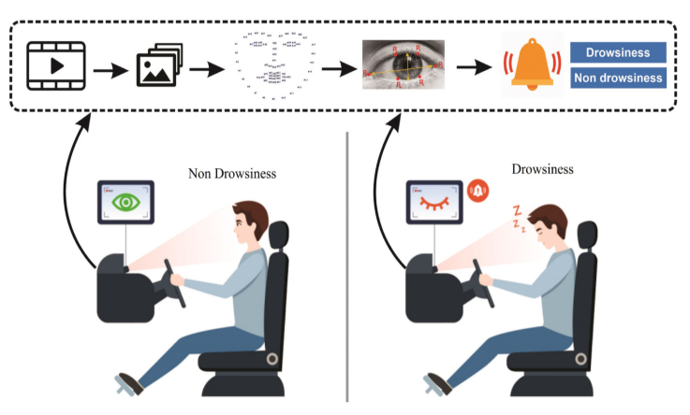

V. ARCHITECTURE

1.Data Collection and Preprocessing : The dataset utilized for training and evaluation, such as the "Yawn Eye Dataset" from Kaggle, contains annotated images indicating yawns and closed eyes.To prepare the dataset for training the CNN model, preprocessing steps are applied, including resizing images to a standardized resolution, converting to grayscale, and normalizing pixel values.These preprocessing techniques enhance model performance and generalization by ensuring consistent input data quality and variability across the dataset.

2.Model Architecture : Convolutional Neural Networks (CNNs) are widely used for drowsy driver detection due to their ability to effectively capture spatial hierarchies and patterns in visual data, such as images. CNNs consist of multiple layers, including convolutional layers, pooling layers, and fully connected layers, which are designed to automatically learn features from raw input data.In the context of drowsy driver detection, CNNs are trained on input images of the driver's eyes, which are preprocessed to ensure consistency and suitability for the model. These images typically contain visual cues such as eyelid position, eye openness, and other facial features that indicate the driver's level of alertness.

3.Model Trainig : Training a CNN for drowsy driver detection involves initializing the model with random weights, passing images through the network to extract features, and computing the loss by comparing predictions to ground truth labels. Backpropagation is then used to update the parameters of the network, optimizing them to minimize the loss function. This process iterates over multiple epochs, with validation to monitor performance and early stopping to prevent overfitting, resulting in a trained model capable of accurately classifying drowsy behavior in driver's eyes.

4.Final Model:

4.1 Real-time Video Capture: This module captures video frames from the webcam feed in real-time.

4.2 Face and Eye Detection: Utilizing pre-trained cascade classifiers, this module detects and localizes the driver's face and eyes within the video frames.

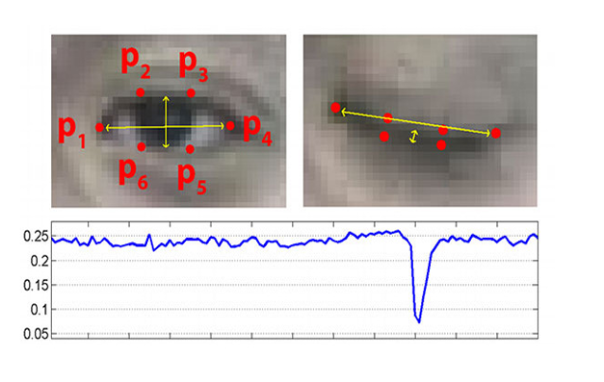

Fig: Landmark detection for Eye

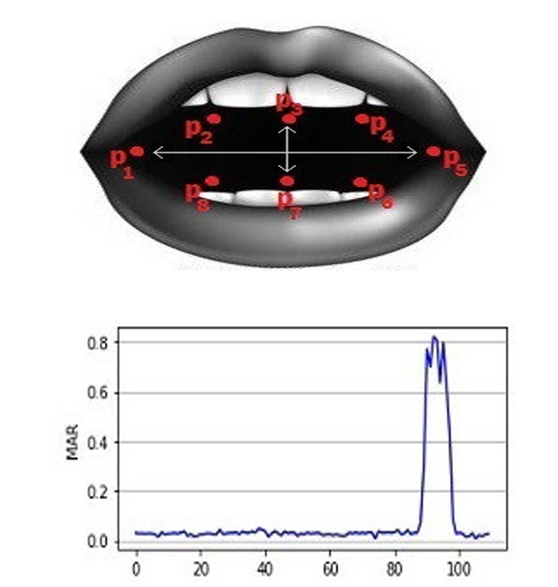

Fig: Landmark detection for Mouth

4.3 Drowsiness Classification: The detected eye regions are passed through the trained CNN model for drowsiness classification. The model predicts whether the driver's eyes are "Alert" or "Sleepy" based on learned features.

4.4 Alarm Triggering: An alarm mechanism is triggered if signs of drowsiness surpass a predefined threshold, alerting the driver to take corrective actions.

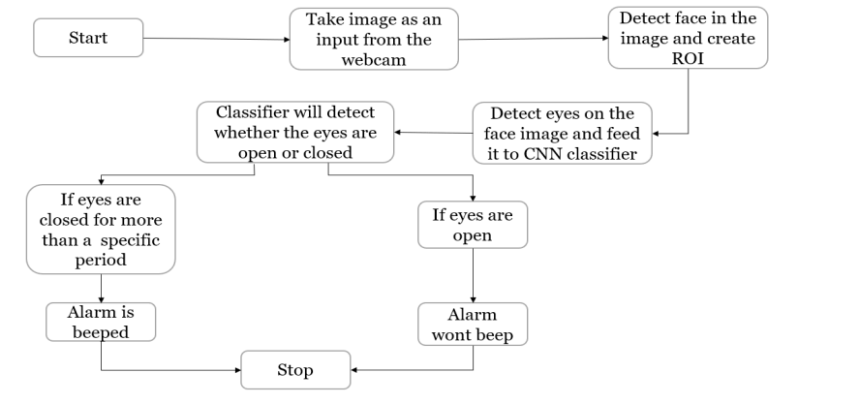

Fig Working of Application

V. EXPERIMENTAL RESUL



.

Fig Detecting Alert

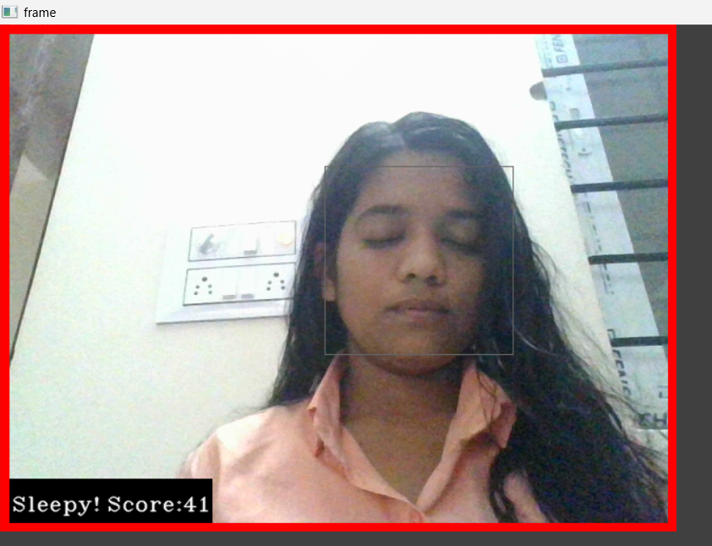

Fig Detecting Sleepy

VI.CONCLUSION

In conclusion, the drowsy driver detection application presents an efficient solution for combating the hazards of driver fatigue through the integration of computer vision and deep learning. Utilizing pre-trained cascade classifiers for facial and eye detection, coupled with a meticulously trained Convolutional Neural Network (CNN), the system accurately identifies signs of drowsiness in real-time. By analyzing subtle eye characteristics, such as drooping eyelids and prolonged blinks, the CNN achieves high accuracy in classifying drowsy behavior. The seamless integration of an alarm mechanism provides timely alerts to drivers, facilitating proactive intervention and mitigating the risk of accidents due to drowsy driving. Overall, this application offers a comprehensive and effective approach to enhancing road safety and preventing accidents caused by driver fatigue.

VII.FUTURE WORK

In future research, our focus will be on advancing the drowsy driver detection application by exploring sophisticated deep learning architectures like RNNs and

LSTMs, enabling better capture of temporal dependencies in driver behavior. Additionally, integrating multi-modal data fusion with physiological signals and vehicle dynamics will enhance overall detection accuracy. Real-world validation studies will assess performance across diverse conditions, while user-centric design refinements will ensure intuitive interfaces and effective alarm mechanisms. Collaboration with automotive mafor integration into smart vehicle systems and long-term driver monitoring mechanisms will further contribute to road safety and accident reduction efforts.

1.Multi-Modal Data Fusion: Integrating additional data modalities, such as physiological signals (e.g., heart rate variability) and vehicle dynamics (e.g., steering wheel movements), to complement facial and eye-based drowsiness detection and improve overall detection accuracy.

2.Real-World Validation: Conducting extensive validation studies in real-world driving scenarios to assess the application's performance under diverse environmental conditions, such as varying lighting conditions, weather conditions, and road conditions.

3.Integration with Smart Vehicle Systems: Collaborating with automotive manufacturers to integrate the drowsy driver detection application into smart vehicle systems, enabling seamless communication with in-car systems and adaptive driver assistance features.

REFERENCES

1. ] Zuopeng Zhao, Nana Zhou , Lan Zhang, Hualin Yan, Yi Xu, and Zhongxin Zhang Driver Fatigue Detection Based on Convolutional Neural Network using EM-CNN
2. G. Zhenhai, L. DinhDat, H. Hongyu, Y. Ziwen and W. Xinyu, "Driver Drowsiness Detection Based on Time Series Analysis of Steering Wheel Angular Velocity", 2017 9th International Conference on Measuring Technology and Mechatronics Automation (ICMTMA), pp. 99-101, 2017.
3. R Sathish Kumar, K Nivedha, K Anitha and D. Jayaprakash, "IOT Based Driver Drowsiness Detection and Health Monitoring System", European Journal of Molecular & Clinical Medicine, vol. 7, no. 9, pp. 1581-1590, 2020.
4. B. Rajkumarsingh and D. Totah, "Drowsiness Detection using Android Application and Mobile Vision Face API", R&D Journal, vol. 37, pp. 26-34, 2021.
5. Int. J. Nonlinear Anal. Appl. Volume 12, Special Issue, Winter and Spring 2021, 1835–1843 ISSN: 2008-6822(electronic)CNN https://ijnaa.semnan.ac.ir/article_5894.

Ann Williamson and Tim Chamberlain. Review of on-road driver fatigue monitoring devices. NSW

1. Injury Risk Management Research Centre, University of New South Wales, , July2013.
2. [2] C. Hentschel, T. P. Wiradarma, and H. Sack, Fine tuning CNNS with scarce training data-adapting
3. imagenet to art epoch classification, in Proceedings of the IEEE International Conference on Image
4. Processing (ICIP), Phoenix, AZ, USA, September 2016.
5. [3] K. He, X. Zhang, S. Ren, and J. Sun, Deep residual learning for image recognition, in Proceedings of
6. the IEEE Conference on Computer Vision and Pattern Recognition, Las Vegas, NV, USA, June 2016.
7. [4] ZuopengZhao,LanZhang,Hualin Yan, Yi Xu, and Zhongxin Zhang, Driver Fatigue Detection Based on
8. Convolutional Neural Networks Using EM -CNN, 2020.
9. [5] MiluPrince,NehaSanthosh,NehaSanthosh, Reshma Sudarsan & Ms.AnjusreeV.K,Rajagiri School of
10. Engineering And Technology - Eye Movement Classification Using CNN.
11. [6] AnjithGeorge and AurobindaRoutrayDept. of Electrical Engg., IIT Kharagpur Kharagpur, 721302,
12. India – “Real-time Eye Gaze Direction Classification Using Convolutional NeuralNetwork”.
13. [7] HaoxiangLi ,ZheLin, XiaohuiShen , Jonathan Brandt , Gang HuStevensInstitute of Technology
14. Hoboken, NJ 07030- A Convolutional Neural Network Cascade for FaceDetection.
15. [8] Venkata Rami Reddy Chirra,Srinivasulu Reddy Uyyala& Venkata Krishna Kishore Kolli, Department
16. of Computer Applications, National Institute of Technology, Tiruchirappalli 620015, India – “Deep
17. CNN: A Machine Learning Approach for Driver Drowsiness Detection Based on Eye State
18. [9] V.D.Ambeth Kumar et.al., , “Performance Improvement Using an Automation System for
19. Segmentation of Multiple Parametric Features Based on Human Footprint” for the Journal of
20. Electrical Engineering & Technology , vol. 10, no. 4, pp.1815-1821 , 2015.
21. [http://dx.doi.org/10.5370/JEET.2015.10.4.1815]
22. [10] Ambeth Kumar.V.D et.al. .A Survey on Face Recognition in Video Surveillance. Lecturer Notes on
23. Computational and Mechanism, Vol. 30, pp: 699-708, 2019
24. Ann Williamson and Tim Chamberlain. Review of on-road driver fatigue monitoring devices. NSW
25. Injury Risk Management Research Centre, University of New South Wales, , July2013.
26. [2] C. Hentschel, T. P. Wiradarma, and H. Sack, Fine tuning CNNS with scarce training data-adapting
27. imagenet to art epoch classification, in Proceedings of the IEEE International Conference on Image
28. Processing (ICIP), Phoenix, AZ, USA, September 2016.
29. [3] K. He, X. Zhang, S. Ren, and J. Sun, Deep residual learning for image recognition, in Proceedings of
30. the IEEE Conference on Computer Vision and Pattern Recognition, Las Vegas, NV, USA, June 2016.
31. [4] ZuopengZhao,LanZhang,Hualin Yan, Yi Xu, and Zhongxin Zhang, Driver Fatigue Detection Based on
32. Convolutional Neural Networks Using EM -CNN, 2020.
33. [5] MiluPrince,NehaSanthosh,NehaSanthosh, Reshma Sudarsan & Ms.AnjusreeV.K,Rajagiri School of
34. Engineering And Technology - Eye Movement Classification Using CNN.
35. [6] AnjithGeorge and AurobindaRoutrayDept. of Electrical Engg., IIT Kharagpur Kharagpur, 721302,
36. India – “Real-time Eye Gaze Direction Classification Using Convolutional NeuralNetwork”.
37. [7] HaoxiangLi ,ZheLin, XiaohuiShen , Jonathan Brandt , Gang HuStevensInstitute of Technology
38. Hoboken, NJ 07030- A Convolutional Neural Network Cascade for FaceDetection.
39. [8] Venkata Rami Reddy Chirra,Srinivasulu Reddy Uyyala& Venkata Krishna Kishore Kolli, Department
40. of Computer Applications, National Institute of Technology, Tiruchirappalli 620015, India – “Deep
41. CNN: A Machine Learning Approach for Driver Drowsiness Detection Based on Eye State
42. [9] V.D.Ambeth Kumar et.al., , “Performance Improvement Using an Automation System for
43. Segmentation of Multiple Parametric Features Based on Human Footprint” for the Journal of
44. Electrical Engineering & Technology , vol. 10, no. 4, pp.1815-1821 , 2015.
45. [http://dx.doi.org/10.5370/JEET.2015.10.4.1815]
46. [10] Ambeth Kumar.V.D et.al. .A Survey on Face Recognition in Video Surveillance. Lecturer Notes on
47. Computational and Mechanism, Vol. 30, pp: 699-708, 2019
48. Ann Williamson and Tim Chamberlain. Review of on-road driver fatigue monitoring devices. NSW
49. Injury Risk Management Research Centre, University of New South Wales, , July2013.
50. [2] C. Hentschel, T. P. Wiradarma, and H. Sack, Fine tuning CNNS with scarce training data-adapting
51. imagenet to art epoch classification, in Proceedings of the IEEE International Conference on Image
52. Processing (ICIP), Phoenix, AZ, USA, September 2016.
53. [3] K. He, X. Zhang, S. Ren, and J. Sun, Deep residual learning for image recognition, in Proceedings of
54. the IEEE Conference on Computer Vision and Pattern Recognition, Las Vegas, NV, USA, June 2016.
55. [4] ZuopengZhao,LanZhang,Hualin Yan, Yi Xu, and Zhongxin Zhang, Driver Fatigue Detection Based on
56. Convolutional Neural Networks Using EM -CNN, 2020.
57. [5] MiluPrince,NehaSanthosh,NehaSanthosh, Reshma Sudarsan & Ms.AnjusreeV.K,Rajagiri School of
58. Engineering And Technology - Eye Movement Classification Using CNN.
59. [6] AnjithGeorge and AurobindaRoutrayDept. of Electrical Engg., IIT Kharagpur Kharagpur, 721302,
60. India – “Real-time Eye Gaze Direction Classification Using Convolutional NeuralNetwork”.
61. [7] HaoxiangLi ,ZheLin, XiaohuiShen , Jonathan Brandt , Gang HuStevensInstitute of Technology
62. Hoboken, NJ 07030- A Convolutional Neural Network Cascade for FaceDetection.
63. [8] Venkata Rami Reddy Chirra,Srinivasulu Reddy Uyyala& Venkata Krishna Kishore Kolli, Department
64. of Computer Applications, National Institute of Technology, Tiruchirappalli 620015, India – “Deep
65. CNN: A Machine Learning Approach for Driver Drowsiness Detection Based on Eye State
66. [9] V.D.Ambeth Kumar et.al., , “Performance Improvement Using an Automation System for
67. Segmentation of Multiple Parametric Features Based on Human Footprint” for the Journal of
68. Electrical Engineering & Technology , vol. 10, no. 4, pp.1815-1821 , 2015.
69. [http://dx.doi.org/10.5370/JEET.2015.10.4.1815]
70. [10] Ambeth Kumar.V.D et.al. .A Survey on Face Recognition in Video Surveillance. Lecturer Notes on
71. Computational and Mechanism, Vol. 30, pp: 699-708, 2019
72. Ann Williamson and Tim Chamberlain. Review of on-road driver fatigue monitoring devices. NSW
73. Injury Risk Management Research Centre, University of New South Wales, , July2013.
74. [2] C. Hentschel, T. P. Wiradarma, and H. Sack, Fine tuning CNNS with scarce training data-adapting
75. imagenet to art epoch classification, in Proceedings of the IEEE International Conference on Image
76. Processing (ICIP), Phoenix, AZ, USA, September 2016.
77. [3] K. He, X. Zhang, S. Ren, and J. Sun, Deep residual learning for image recognition, in Proceedings of
78. the IEEE Conference on Computer Vision and Pattern Recognition, Las Vegas, NV, USA, June 2016.
79. [4] ZuopengZhao,LanZhang,Hualin Yan, Yi Xu, and Zhongxin Zhang, Driver Fatigue Detection Based on
80. Convolutional Neural Networks Using EM -CNN, 2020.
81. [5] MiluPrince,NehaSanthosh,NehaSanthosh, Reshma Sudarsan & Ms.AnjusreeV.K,Rajagiri School of
82. Engineering And Technology - Eye Movement Classification Using CNN.
83. [6] AnjithGeorge and AurobindaRoutrayDept. of Electrical Engg., IIT Kharagpur Kharagpur, 721302,
84. India – “Real-time Eye Gaze Direction Classification Using Convolutional NeuralNetwork”.
85. [7] HaoxiangLi ,ZheLin, XiaohuiShen , Jonathan Brandt , Gang HuStevensInstitute of Technology
86. Hoboken, NJ 07030- A Convolutional Neural Network Cascade for FaceDetection.
87. [8] Venkata Rami Reddy Chirra,Srinivasulu Reddy Uyyala& Venkata Krishna Kishore Kolli, Department
88. of Computer Applications, National Institute of Technology, Tiruchirappalli 620015, India – “Deep
89. CNN: A Machine Learning Approach for Driver Drowsiness Detection Based on Eye State
90. [9] V.D.Ambeth Kumar et.al., , “Performance Improvement Using an Automation System for
91. Segmentation of Multiple Parametric Features Based on Human Footprint” for the Journal of
92. Electrical Engineering & Technology , vol. 10, no. 4, pp.1815-1821 , 2015.
93. [http://dx.doi.org/10.5370/JEET.2015.10.4.1815]
94. [10] Ambeth Kumar.V.D et.al. .A Survey on Face Recognition in Video Surveillance. Lecturer Notes on
95. Computational and Mechanism, Vol. 30, pp: 699-708, 2019
96. Ann Williamson and Tim Chamberlain. Review of on-road driver fatigue monitoring devices. NSW
97. Injury Risk Management Research Centre, University of New South Wales, , July2013.
98. [2] C. Hentschel, T. P. Wiradarma, and H. Sack, Fine tuning CNNS with scarce training data-adapting
99. imagenet to art epoch classification, in Proceedings of the IEEE International Conference on Image
100. Processing (ICIP), Phoenix, AZ, USA, September 2016.
101. Ann Williamson and Tim Chamberlain. Review of on-road driver fatigue monitoring devices. NSW
102. Injury Risk Management Research Centre, University of New South Wales, , July2013.
103. [2] C. Hentschel, T. P. Wiradarma, and H. Sack, Fine tuning CNNS with scarce training data-adapting
104. imagenet to art epoch classification, in Proceedings of the IEEE International Conference on Image
105. Processing (ICIP), Phoenix, AZ, USA, September 2016