

**ELIMINATION OF ADDITIONAL CHARGES DUE TO VEHICLE HAULING IN CUSTOMER AND TRANSPORTER AT DSV GLOBAL LOGISTICS**

**AN PROJECT REPORT SUBMITTED TO**

**VELS INSTITUTE OF SCIENCE, TECHNOLOGY AND ADVANCED STUDIES**

**(VISTAS)**

**(Estd. U/s 3 of the UGC Act, 1956)**

***In partial fulfilment of the requirement***

***For the award of the degree of***

***MASTER OF BUSINESS ADMINISTRATION***

***SHIPPING AND LOGISTICS MANAGEMENT***

***Submitted by***

**Dinesh H**

**Reg Number (22302138)**

**Under the guidance of**

**Dr. G. VEERAMANI**

**PROFESSOR - MBA**

**SCHOOL OF MANAGEMENT STUDIES**

**VISTAS**

**P.V. VAITHIYALINGAM ROAD,**

**OLD PALLAVARAM CHENNAI-600 117**

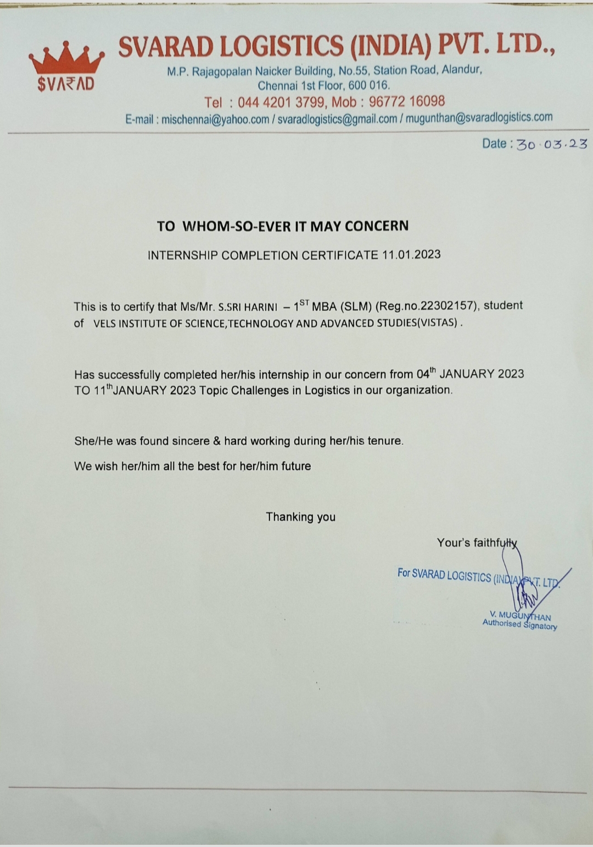**(2022-2024)**



**SCHOOL OF MANAGEMENT STUDIES**

**BONAFIDE CERTIFICATE**

This is to certify that Project report on **ELIMINATION OF ADDITIONAL CHARGES DUE TO VEHICLE HAULING IN CUSTOMER AND TRANSPORTER AT DSV GLOBAL LOGISTICS, and CHENNAI** is a Bonafide record of work carried out by **DINESH.H, 22302157. School of Management Studies** under **VISTAS** submitted in partial fulfilment of the requirements for the award of the degree of **Master of Business Administration in Shipping and Logistics Management** for the fourth semester during 2022-2024 under our guidance.

**Dr. G. Veeramani Dr. D. Anitha Kumari**

**Professor -MBA Associate Professor**

**Internal Guide Programme Coordinator– MBA SLM**

**CII GUIDE and FACULTY**

**MR.THILAKRAJAN**

**EXTERNAL GUIDE**

**Dr. P. G. Thirumagal Dr. P.R. Ramakrishnan**

**HOD -MBA Dean**

**School of Management Studies and Commerce**

**INTERNAL EXAMINER EXTERNAL EXAMINER**

**`**

**Project Completion Certificate**

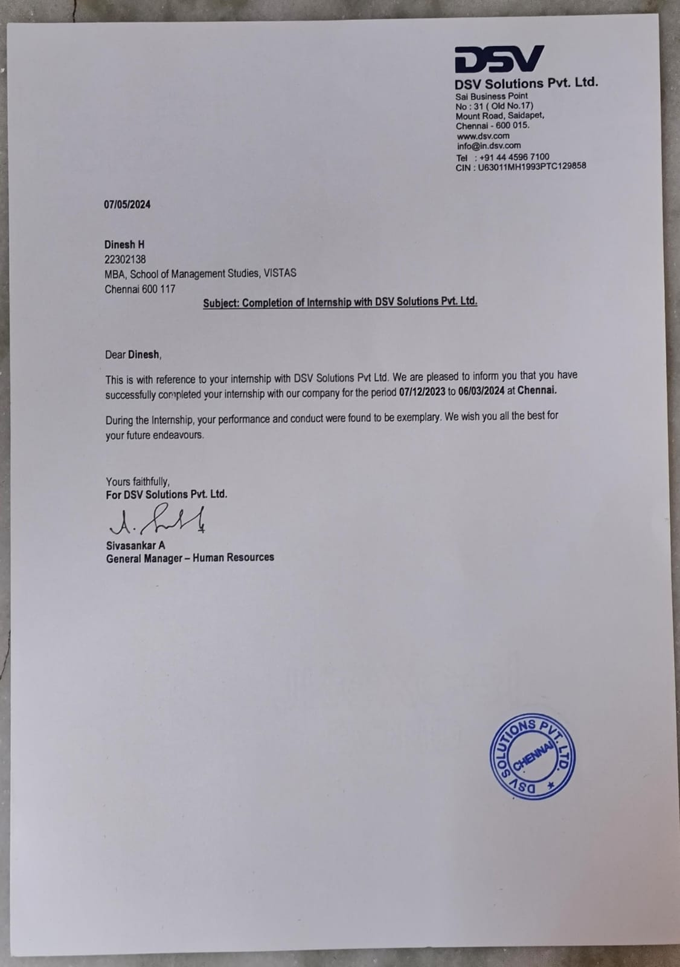

**DECLARATION**

I, **DINESH H**, Reg number **(22302138**), a student of MBA - Shipping and Logistics Management, SCHOOL OF MANAGEMENT STUDIES, VISTAS here by, declare that the PROJECT work titled **ELIMINATION OF ADDITIONAL CHARGES DUE TO VEHICLE HAULING IN CUSTOMER AND TRANSPORTER AT DSV GLOBAL LOGISTICS** submitted to the VISTAS in partial fulfilment of the requirement for the award of the degree of **Master of Business Administration in Shipping and Logistics Management** is a record of Bonafide research carried out by me under the guidance of **Dr. G. VEERAMANI , Professor –MBA,** **SCHOOL OF MANAGEMENT STUDIES, VISTAS** and no part of it has been submitted for any other degree or diploma.

**Place: Chennai**

**Date:**

**DINESH H**

**ACKNOWLEDGEMENT**

I am very much grateful to our Chancellor **Dr. Ishari K Ganesh,** **Dr. A. Jothi Murugan**, Pro Chancellor – Planning & Development, **Dr. Arthi K Ganesh**, Pro Chancellor – Academics and **Dr. Preethaa Ganesh**, Vice President for giving us an opportunity to study and encouraged us in all our efforts during the program.

I would like to express my deep gratitude to our Vice Chancellor **Dr.S.Sriman Narayanan,** Pro Chancellor **Dr. M. Bhaskaran** our Registrar **Dr. P.Saravanan** and Controller of Examinations **Dr. A. Udayakumar**, for all their endeavour in educating us in this esteemed organization.

I wish to express my gratefulness to **Dr. P.R Ramakrishnan**, Dean, School of Management Studies and Commerce, for the encouragement and guidance during the Internship. I would like to thank **Dr. P.G.Thirumagal,** AssociateProfessor & Head of the department, and **Dr. D. Anitha Kumari ,Associate Professor -Programme Coordinator,** MBAShipping and Logistics Management, School of Management Studies for nurturing with a conducive environment and for her professional insights and updates to complete my Internship successfully.

I wish to express my humble thanks to my internal guide **Dr. G. Veeramani, Professor – MBA,** School of management studies, VISTAS and External Guide **CII Faculty - Mr. Thilak Rajan** with Designation for her guidance throughout the Project.

I am indebted to my Company Guide Mr. Yogesh Babu.

**Dinesh H**

**TABLE OF CONTENT**

|  |  |  |
| --- | --- | --- |
| **CHAPTER NO.** | **TITLE** | **PAGE NUMBER** |
| **I** | **1.1 INTRODUCTION** | **1 – 4** |
| **1.2 INDUSTRY PROFILE** | **4 – 7** |
| **1.3 COMPANY PROFILE** | **8 – 10** |
| **1.4 OBJECTIVES OF THE STUDY** | **11** |
| **1.5 NEED FOR THE STUDY** | **12** |
| **1.6 SCOPE OF THE STUDY** | **13** |
| **1.7 STATEMENT OF PROBLEM** | **14** |
| **II** | **REVIEW OF LITERATURE** | **16 – 22** |
| **III** | **3.1 RESEARCH METHODOLOGY** | **24 – 25** |
| **3.2 RESEARCH DESIGN** | **25** |
| **3.3 SAMPLING TECHNIQUE** | **25 – 26** |
| **3.4 DATA COLLECTION METHOD** | **26** |
| **3.5 QUESTIONAIRE DESIGN** | **27** |
| **3.6 STATISTICAL/ANALYTICAL TOOLS USED** | **27** |
| **3.7 LIMITATIONS OF THE STUDY** | **27 - 28** |
| **IV** | **4.1 DATA ANALYSIS AND INTERPRETATION** | **30 - 49** |
|  | **4.2 CHI SQUARE TEST** | **50 - 51** |
| **4.3 WEIGHTED AVERAGE** | **52** |
| **V** | **5.1 FINDINGS OF THE STUDY** | **54 – 55** |
| **5.2 RECOMMENDATIONS AND SUGGESTIONS** | **56 -** |
| **5.3 CONCLUSION** | **58** |
|  | **5.4 BIBLIOGRAPHY / REFERENCES** | **58** |
|  | **5.7 APPENDIX** | **59** |

|  |  |  |
| --- | --- | --- |
| **Table**  **No** | **TITLE** | **PAGE NO** |
| **4.1** | **Do you think that the availability of e-waybills directly impacts the speed of loading operations?** | **30** |
| **4.2** | **In your opinion ,does the availability of loading handlers play a critical role in minimizing delays at loading locations?**   |  | | --- | |  | | **31** |
| 4.3 | **Do you agree that a lack of material readiness is a primary cause of delays in loading operations?** | **32** |
| **4.4** | **Do you believe that investing in more loading handlers is a viable solution to overcome issues at loading locations ?** | **33** |
| **4.5** | **Do you feel that improvements in material readiness can significantly reduce problems associated with loading locations?** | **34** |
| **4.6** | **Do you believe that reducing delays for drivers is crucial for transportation optimization?** | **35** |
| **4.7** | **Do you think remaining neutral about the significance of reducing delays waiting time in transportation is justified?** | **36** |
| **4.8** | **Do you believe that minimizing waiting time in transportation is essential for efficiency?** | **37** |
| **4.9** | **Can you illustrate situations where minimizing waiting time in transportation led to tangible benefits?** | **38** |
| **4.10** | **Do you believe that having drivers available at the gate improves transportation efficiency?** | **39** |
| **4.11** | **Do you believe that reducing delays for drivers is a priority in transportation management?** | **40** |
| **4.12** | **Do you think that warehouse space optimization affects driver satisfaction levels?** | **41** |
| **4.13** | **Do you think that remaining neutral about correlation between warehouse space optimization and driver satisfaction is valid?** | **42** |
| **4.14** | **Do you believe that warehouse space optimization significantly influences driver satisfaction?** | **43** |
| **4.15** | **Are you neutral about the relationship between warehouse space optimization and driver satisfaction?** | **44** |
| **4.16** | **Is the availability of sufficient space to unload materials critical for avoiding delays and complications?** | **45** |
| **4.17** | **Do you think that addressing the issues of space and unloading handler’s availability can significantly minimize problems at unloading locations?** | **46** |
| **4.18** | **Is the optimization of space usage at unloading locations a crucial step for enhancing unloading efficiency?** | **47** |
| **4.19** | **Do you believe that a lack of clear material requirements often leads to unloading inefficiencies?** | **48** |
| **4.20** | **In your opinion, does the presence of adequate unloading handlers directly affect the efficiency of unloading operations?** | **49** |

|  |  |  |
| --- | --- | --- |
| **Table**  **No** | **TITLE** | **PAGE NO** |
| **4.1** | **Do you think that the availability of e-waybills directly impacts the speed of loading operations?** | **30** |
| **4.2** | **In your opinion ,does the availability of loading handlers play a critical role in minimizing delays at loading locations?**   |  | | --- | |  | | **31** |
| 4.3 | **Do you agree that a lack of material readiness is a primary cause of delays in loading operations?** | **32** |
| **4.4** | **Do you believe that investing in more loading handlers is a viable solution to overcome issues at loading locations ?** | **33** |
| **4.5** | **Do you feel that improvements in material readiness can significantly reduce problems associated with loading locations?** | **34** |
| **4.6** | **Do you believe that reducing delays for drivers is crucial for transportation optimization?** | **35** |
| **4.7** | **Do you think remaining neutral about the significance of reducing delays waiting time in transportation is justified?** | **36** |
| **4.8** | **Do you believe that minimizing waiting time in transportation is essential for efficiency?** | **37** |
| **4.9** | **Can you illustrate situations where minimizing waiting time in transportation led to tangible benefits?** | **38** |
| **4.10** | **Do you believe that having drivers available at the gate improves transportation efficiency?** | **39** |
| **4.11** | **Do you believe that reducing delays for drivers is a priority in transportation management?** | **40** |
| **4.12** | **Do you think that warehouse space optimization affects driver satisfaction levels?** | **41** |
| **4.13** | **Do you think that remaining neutral about correlation between warehouse space optimization and driver satisfaction is valid?** | **42** |
| **4.14** | **Do you believe that warehouse space optimization significantly influences driver satisfaction?** | **43** |
| **4.15** | **Are you neutral about the relationship between warehouse space optimization and driver satisfaction?** | **44** |
| **4.16** | **Is the availability of sufficient space to unload materials critical for avoiding delays and complications?** | **45** |
| **4.17** | **Do you think that addressing the issues of space and unloading handler’s availability can significantly minimize problems at unloading locations?** | **46** |
| **4.18** | **Is the optimization of space usage at unloading locations a crucial step for enhancing unloading efficiency?** | **47** |
| **4.19** | **Do you believe that a lack of clear material requirements often leads to unloading inefficiencies?** | **48** |
| **4.20** | **In your opinion, does the presence of adequate unloading handlers directly affect the efficiency of unloading operations?** | **49** |

**CHAPTER I**

**ELIMINATION OF ADDITIONAL CHARGES DUE TO VEHICLE HAULING IN CUSTOMER AND TRANSPORTER AT DSV GLOBAL LOGISTICS**

**1.1 INTRODUCTION**

**TRANSPORT & LOGISTICS**

Transport and logistics is a collection of processes involved in the production, storage, inventory, delivery, and distribution of specific goods or services. Sometimes referred to as transportation and logistics, it is an integral element of the whole supply chain and it involves proactive procedures to move products safely and efficiently from the manufacturers to the sellers, and up to the end users or the consumers.

The primary goal of managing transport and logistics—especially for businesses and those in cargo consolidation—is to properly oversee the flow of supply from point A to point B, and for customers to receive products on time, damage-free, and according to expectations.

The logistics industry is responsible for moving products domestically and internationally and is therefore a huge contributor to economic development. According to a report released by Allied Market Research, the transport and logistics market is projected to grow to $12,975.64 billion by the year 2027.

**TRANSPORT & LOGISTICS DOCUMENTS**

**Lorry Receipt (LR)**

The full form of LR in transportation/logistics is a lorry receipt. It is an important document that acknowledges the receipt of goods by a carrier (usually a lorry or truck) for transportation from one location to another. People commonly refer to LR as guilty. It is important for both consignors and consignees. The truck driver and consignee receive duplicate copies of the original LR, called LR copies. These copies contain the same information as the original.

**Invoice:**

An invoice is used to keep track of shipments and ensure that payments are made promptly. An accurate and up-to-date invoicing system is essential for efficient operations. When goods are sold or shipped, an invoice is generated.

**Bill Of Entry:**

Abill of entry is a legal document that is filed by importers or customs clearance agents on or before the arrival of imported goods. It's submitted to the Customs department as a part of the customs clearance procedure. Once this is done, the importer will be able to claim ITC on the goods.

**E-Way Bill:**

The e-Way bill system is for GST-registered persons / enrolled transporters to generate the waybill (a document to be carried by the person in charge of conveyance) electronically on commencement of movement of goods exceeding the value of Rs. 50,000 concerning supply or for reasons other than supply or due to inward supply from an unregistered person.

**IMPORTANCE**

Companies utilize transportation and logistics for various reasons and optimizing them offers significant advantages not just for the company but for the supply chain in general. Transport and logistics’ main role can also vary per business, but its importance and benefits generally include the following:

Increases efficiency – Just like any other business practice that aims to simplify processes, optimizing transportation and logistics increases operational efficiency. Actively tracking the movement of products helps spot errors and discrepancies in the supply which in turn enables businesses to address them proactively. Lowers costs – Managing transport and logistics properly provides better visibility in the supply chain. This allows businesses to avoid unnecessary purchases, eliminate unproductive activities, implement recognized areas for improvement, and overall manage costs better. Improves production turnout – An optimized transport and logistics process helps streamline operations, reduce downtime, and generally improve business performance. Enhances inventory management – Greater supply chain visibility prevents material stockout and material overstock, avoids damages to products, and enables businesses to manage inventory more efficiently.

Prevents disruption in the supply chain – As an integral unit of the supply chain, an organized transport and logistics system helps spot inefficiencies in the process. It also enables companies to address issues before they cause disruption and significantly affect business operations. To summarize, when executed properly, an optimized transport and logistics system can improve customer experience and give businesses a stronger industry reputation.

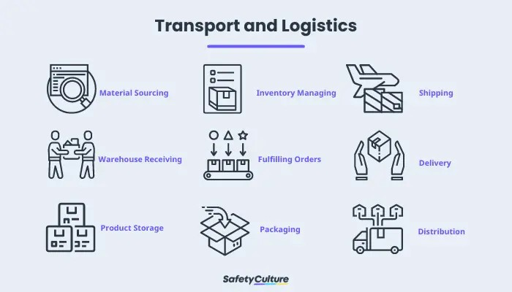

**Transport and Logistics:**

* material sourcing
* warehouse receiving
* product storage
* inventory managing
* fulfilling orders
* packaging
* shipping
* delivery
* distribution

**TOP CHALLENGES**

Diverse industries encounter significant challenges for various reasons and the sector of transport and logistics also face them. Based on the report released by the International Finance Corporation (IFC), both small-to-medium and large logistics companies experienced setbacks caused by the Covid-19 pandemic. Other challenges faced by the industry include:

**Rising fuel prices:**

Although there can be several reasons for rising fuel prices, the most prominent as of the moment is the current conflict that has now impacted one of the largest oil producers. The effect is felt rather instantly on an international scale. Seasonal changes, global issues, and conflicts between major oil and gas producers significantly affect the transportation and logistics industry that is responsible for the flow of products and goods worldwide.

**Driver shortages:**

According to a report released by the American Trucking Association, the United States experienced a historic increase of 80,000 truck driver shortage in 2021. Aside from the pandemic and from the profession itself being a demanding job, a New York Times article also revealed that stress and loneliness are major reasons for the reduced numbers of truck drivers on the road.

To combat the ongoing driver shortage, Representatives in the US Congress introduced a bipartisan bill titled “Strengthening Supply Chains Through Truck Driver Incentives Act,” that aims to attract and retain new drivers through a set of short-term, fast, and straightforward incentives.

**Meeting customer satisfaction**

Big retail services drastically changed the way customers experience product delivery in the last few years. As a result, the transportation and logistics industry needs to keep up with various consumer expectations such as fast delivery, easy tracking, and direct communication with delivery drivers.This can pose a visible impact if processes are not modified to be at par with customer demands.

**Sustainability concerns**

It is revealed that a growing number of consumers prefer purchasing from companies that are actively engaging in sustainable practices. Integrating potential reduction of greenhouse gas and carbon emission is also becoming a priority to businesses.

The transportation and logistics industry can implement various strategies to observe business sustainability such as utilizing alternative fuels, replacing engines for better performance, or tracking and properly reporting emissions. This entails financial commitment as it can be costly at first, but it also offers endless growth opportunities in the long run toward sustainable logistics.

Aside from implementing the best industry practices, transportation and logistics companies can also utilize tools that can help monitor, track, and inspect processes to ensure that every step in the operation is done efficiently and effectively.

**1.2 INDUSTRY PROFILE**

Transportation is a multifaceted system that encompasses the movement of people, goods, and services from one location to another, serving as a cornerstone of modern society and global connectivity. It involves a complex interplay of various modes, infrastructure, regulations, and technologies, all working together to facilitate the efficient and effective transfer of individuals and resources across different geographical distances. From the humble beginnings of footpaths and animal-drawn carts to the sophisticated networks of highways, railways, air routes, and maritime lanes that span the globe today, transportation has evolved significantly over time, driven by advancements in technology, infrastructure development, and changing societal needs.

At its core, transportation fulfils several fundamental functions essential to the functioning of economies, societies, and individuals. Economically, it enables trade and commerce by facilitating the movement of goods between producers, suppliers, and consumers, thus driving economic growth and development. Moreover, transportation serves as a vital link in global supply chains, allowing businesses to access raw materials, distribute products, and reach markets worldwide, thereby fostering international trade and economic integration.

Socially, transportation plays a pivotal role in connecting people and communities, enabling individuals to access education, employment, healthcare, and recreational opportunities beyond their immediate vicinity. It promotes social inclusion and cohesion by reducing geographic barriers, facilitating cultural exchange, and fostering interaction among diverse populations. Additionally, transportation contributes to the vitality of urban centers by enabling the efficient movement of people within cities, supporting the functioning of businesses, institutions, and public services.

From a personal perspective, transportation influences daily routines, lifestyle choices, and quality of life. It provides individuals with the freedom to travel for work, leisure, or personal reasons, expanding their horizons and enriching their experiences. Whether commuting to work, visiting friends and family, or embarking on leisure trips, transportation empowers individuals to pursue their goals, fulfil their obligations, and enjoy recreational activities, thereby enhancing their overall well-being and satisfaction.

However, transportation also presents various challenges and complexities, including congestion, environmental impact, safety concerns, and equity issues. Addressing these challenges requires a holistic approach that integrates technological innovations, policy interventions, and behavioural changes to promote sustainability, efficiency, and inclusivity in transportation systems. Moreover, transportation serves as a vital link in global supply chains, allowing businesses to access raw materials, distribute

**Additional Charges of Vehicle Halting:**

When a vehicle halts in a roadway unexpectedly or without proper authorization, it can lead to various additional charges and costs. Some of these may include:

1. Traffic Violation Fines: Halting a vehicle in a roadway where it obstructs traffic or violates traffic regulations can result in fines or penalties imposed by law enforcement authorities. These fines vary depending on the severity of the violation and local regulations.
2. Towing Fees: If the vehicle halts in a position that obstructs traffic flow or poses a safety hazard, it may need to be towed away. Towing companies typically charge fees for removing vehicles from roadways, and these fees can vary based on factors such as distance towed and time of day.
3. Vehicle Impoundment Fees: In some cases, vehicles that are unlawfully halted in roadways may be impounded by authorities. Vehicle owners are usually required to pay impoundment fees to retrieve their vehicles, along with any associated storage fees for the time the vehicle was held in impound.
4. Traffic Citation or Summons: In addition to fines for the traffic violation itself, the driver of the halted vehicle may receive a traffic citation or summons requiring them to appear in court or pay additional fines.
5. Emergency Response Costs: If the halted vehicle obstructs emergency response vehicles or causes a traffic incident that requires emergency services, the vehicle owner or driver may be liable for any costs associated with the emergency response, such as fire department or ambulance services.
6. Property Damage Costs: If the halted vehicle causes damage to public or private property (e.g., road signs, barriers, other vehicles), the owner may be responsible for covering the costs of repairs or restitution.
7. Legal Fees: If the halting of the vehicle results in legal proceedings or disputes, the owner or driver may incur legal fees for hiring an attorney or resolving the legal matter.
8. Loss of Time and Productivity: Halted vehicles can cause traffic congestion and delays for other motorists, leading to a loss of time and productivity for those affected by the traffic disruption.

Logistics in transportation refers to the management and coordination of the movement of goods, materials, and resources from their point of origin to their final destination. It involves planning, implementing, and controlling various activities such as transportation, warehousing, inventory management, packaging, and information exchange to ensure the efficient flow of goods through the supply chain.

**Key components of logistics in transportation include:**

1. Transportation Management: This involves selecting the appropriate modes of transportation (e.g., truck, rail, air, sea) based on factors such as cost, transit time, and the nature of the goods being transported. It also includes routing, scheduling, and tracking shipments to optimize delivery routes and ensure timely delivery.
2. Warehousing and Distribution: Logistics in transportation involves the strategic placement of warehouses and distribution centres to facilitate the storage, consolidation, and distribution of goods. This includes inventory management, order fulfilment, and cross-docking operations to streamline the flow of goods through the supply chain.
3. Inventory Management: Efficient inventory management is essential for minimizing carrying costs while ensuring product availability. Logistics professionals use various techniques such as demand forecasting, safety stock management, and just-in-time inventory practices to optimize inventory levels and prevent stockouts or excess inventory.
4. Packaging and Handling: Proper packaging and handling of goods are crucial for protecting products during transportation and storage. Logistics professionals oversee the design and implementation of packaging solutions that meet regulatory requirements and minimize damage or loss during transit.
5. Information Systems and Technology: Logistics in transportation relies heavily on information systems and technology to track shipments, monitor inventory levels, and exchange data with supply chain partners. Advanced technologies such as GPS tracking, RFID tagging, and transportation management systems (TMS) enable real-time visibility and control over logistics operations.
6. Risk Management: Logistics in transportation involves identifying and mitigating risks associated with transportation operations, such as delays, disruptions, and security threats. This may include developing contingency plans, implementing supply chain resilience strategies, and securing insurance coverage to protect against potential losses.

Overall, logistics in transportation plays a critical role in ensuring the smooth and efficient movement of goods through the supply chain, ultimately contributing to customer satisfaction, cost savings, and competitive advantage for businesses.

**Roadways play a crucial role in today's environment for several reasons:**

1. Accessibility and Connectivity: Roadways provide a ubiquitous and flexible transportation network, allowing for easy accessibility to various locations, including rural areas, where other modes of transportation may be limited. They facilitate connectivity between communities, businesses, and essential services, promoting economic development and social integration.
2. Efficient Movement of Goods: Roadways are essential for the transportation of goods, supporting supply chains and facilitating the movement of freight between production sites, distribution centres, and markets. Trucks are a common mode of transportation for freight, and roadways provide the infrastructure necessary for efficient and timely deliveries of goods.
3. Mobility and Personal Transportation: Roadways enable personal mobility, allowing individuals to commute to work, access education and healthcare facilities, and participate in recreational activities. They provide flexibility and convenience for travellers, offering various transportation options such as cars, buses, and motorcycles.
4. Emergency Response and Public Safety: Roadways serve as critical routes for emergency vehicles such as ambulances, fire trucks, and police cars to respond promptly to accidents, medical emergencies, and natural disasters. Well-maintained roadways contribute to public safety by providing reliable access for emergency services.
5. Infrastructure Development: The construction and maintenance of roadways contribute to infrastructure development, creating employment opportunities and stimulating economic growth. Investments in road infrastructure improve transportation efficiency, reduce travel times, and enhance overall accessibility, thereby supporting economic activities and regional development.
6. Environmental Considerations: While roadways have environmental impacts such as air and noise pollution, they also offer opportunities for mitigating environmental challenges. For example, advancements in technology have led to the development of electric and hybrid vehicles, reducing greenhouse gas emissions and promoting cleaner transportation options on roadways.

Overall, roadways provide numerous benefits in today's environment by supporting economic growth, facilitating transportation and mobility, ensuring public safety, and promoting sustainable development.

**1.3 COMPANY PROFILE**



DSV is a Danish transport and logistics company offering global transport services by road, air, sea and train. Since its foundation in 1976 by nine independent Danish hauliers, the company has achieved rapid expansion and international presence, predominantly through a series of strategic competitor acquisitions, some of the most important ones being Samson Transport (1997), DFDS Dan Transport Group (2000), J.H.Bachmann (2004), Frans Maas (2006), ABX LOGISTICS (2008), UTi Worldwide, Inc. (2016), Panalpina Welt transport (Holding) AG (2019) and Agility Global Integrated Logistics (GIL) (2021).

With headquarters in Headhouse (near Copenhagen), Denmark, and offices in more than 80 countries, DSV employs more than 75,000 people and collaborates with partners and agents globally. The company is listed on NASDAQ OMX Copenhagen (Copenhagen Stock Exchange) and included in the OMXC25 index as one of the 25 most traded stocks.

The company is structured in three divisions, Road, Air & Sea, and Solutions. Its main activities lie within road transport (trucking) networks in Europe, North America and South Africa, global air and sea freight forwarding business, and contract logistics across the globe. As part of an asset-light financial strategy to maintain fixed costs at a minimum and be able to quickly respond to market fluctuations, the group does not own any ships or aeroplanes and only a relatively small fleet of trucks and trailers.

Jens Bjørn Andersen became CEO in August 2008. In 2022, the company reported a net revenue of DKK 235,665 million. In 1976, Leif Tullberg and nine independent haulers established DSV, an initialism for "De Sammensluttede Vognmænd a 13-7 1976 A/S" (The Joint Hauliers of 13-7 1976). Leif Tullberg remained CEO until his retirement in 2005.

He was succeeded by Kurt Larsen who became chairman of the board of directors in 2008 when Jens Bjørn Andersen took over as CEO.During the first decade the company mainly functioned as a cartage department for the owners, handling contract haulage and deliveries.

Seeking a foothold on the international market, DSV bought two competing export companies in 1989, Borup Auto transport A/S and Hammerer A/S-Bech Trans. The next acquisitions on the road to becoming Pan-European were Samson Transport Co. A/S in 1997 and Svex Group A/S in 1999.

The purchase of the DFDS Dan Transport Group in 2000 provided DSV with important road transport activities in Scandinavia, the UK, several Mainland European countries and the Baltics plus a global network including a logistics set-up.The purchase of J.H. Bachmann in 2005 reinforced the company's position within international air and sea transport.

The acquisition of the Dutch Frans Maas Group in 2006 placed DSV as a truly Pan-European road transport and logistics supplier – and one of the three largest in Europe. With the acquisition of ABX LOGISTICS in 2008, DSV got a foothold in South America and is now represented on six continents. With the acquisition of UTi Worldwide, Inc. in 2016 and Panalpina welt transport (Holding) AG in 2019, the company became one of the world's four largest transport and logistics companies).

On 1 April 2019, an acquisition agreement with Swiss Panalpina was announced valued at CHF 4.6 billion (€ 4.1 billion). On 19 August 2019, DSV announced that the acquisition of Panalpina was completed. In July 2020, DSV announced its plans to invest approx. DKK2bn in a new logistics centre near Horsens, Europe's largest with just one leaseholder.

In December 2020, DSV announced they would acquire Globe flight Worldwide Express, a South African-based courier company. The deal was completed in May 2021. DSV offers two prepaid services in South Africa through their DSV Direct website, DSV Locker and DSV Courier, allowing users to send packages without an account.[11]On 27 April 2021, DSV announced its plans to acquire "Agility Global Integrated Logistics (GIL)". The acquisition was completed 19 August 2021. With this acquisition, the company gained a stronger foothold in the Middle East and added additional capacity to all its divisions: Air & Sea, Road and Solutions.

**Purpose:**

Keeping supply chains flowing in a world of change. We acknowledge our role as part of the critical infrastructure driving world trade and as a key enabler for the sustainable growth of all our stakeholders, including customers, shareholders and societies at large.

We conduct our business with integrity, respecting different cultures and the dignity and rights of individuals. We believe in contributing our fair share to the societies and local communities in which we operate while reducing the environmental footprint from our operations.

We take advantage of technology and digitalisation. Our workflows are highly digitalised and our IT systems are integrated with both customers and suppliers. In a world of change, this enables us to continuously optimise our customers’ supply chains and supports efficient workflows for our employees.

**Vision:**

We help our customers grow by keeping their supply chains flowing. We create efficient solutions for all businesses with focus on reliability, environmental impact and cost – regardless of industry and size. We provide equal growth opportunities for all employees. People drive the success of our company, so the more we provide healthy and safe workplaces – as well as strong growth opportunities – the greater is our chance of achieving our ambitious growth targets.We help societies grow. We conduct our business with integrity, respecting different cultures and the dignity and rights of individuals in all countries. We grow shareholder value. We want to continue to be a leading global supplier, fulfilling the customer needs for transport and logistics services. We target extensive growth - organic and through acquisitions - and aim to be among the most profitable in our industry.

**Mission:**

World trade drives world prosperity, but seamless trade is not a given. Through our persistent focus on transparency, productivity and scalability, we create more efficient global trade flows for all business. We design our infrastructure – physical and digital – to support high service levels and efficient workflows. Operational excellence goes hand in hand with sustainability. A well-planned supply chain is also a greener supply chain. We are forwarders. Doers. People who get things done. We take ownership and show initiative. We always seek to find the better and rational solutions to the challenges we face.

**1.4 OBJECTIVES OF THE STUDY**

**Primary Objective**

To understand the process to make the driver or the transportation company to be available at the gate and clear the process on time.

**Secondary Objective**

● to analyse the problems in unloading location is material requirements, space to unload the materials and unloading handlers’ availability.

● To reduce the delays in transportation drivers.

● to analyse the dissatisfaction of transporter and driver, because of the customer warehouse space optimization issues.

● To understand the problems in loading location is material readiness, invoice & e-way bill preparation and loading handlers’ availability.

**1.5 NEED FOR STUDY**

Need for the study of eliminating additional charges due to vehicle halting in a customer's place and transportation at DSV Global Logistics, it is essential to consider various aspects such as customs clearance, tariffs, and value-added services offered by DSV.

DSV Global Logistics provides services like customs clearance, which involves handling duty and tax documents directly to streamline the process and potentially reduce additional charges. Additionally, understanding DSV's tariffs can help in managing costs associated with transportation.

Moreover, DSV offers buyer's consolidation services, which optimize container utilization and reduce costs by turning multiple less-than-container-load (LCL) shipments into full-container-load (FCL) shipments. This service can lead to fewer charges related to handling and transportation.

Studying these aspects within the context of DSV Global Logistics can provide insights into strategies for minimizing additional charges due to vehicle halting at a customer's place and during transportation.

**1.6 SCOPE FOR THE STUDY**

Scope for the Study: "Elimination of Additional Charges due to Vehicle Halting in Customer's Place and Transportation at DSV Global Logistics".

To delve into the study focused on eliminating additional charges related to vehicle halting at a customer's place and during transportation at DSV Global Logistics, several key areas can be explored:

**Customs Clearance Efficiency:**

1, Investigate how streamlining customs clearance processes can reduce delays and associated charges.

2, Understanding DSV's Tariffs:

Analyze DSV's tariff structures to identify opportunities for cost optimization during transportation.

3, Buyer's Consolidation Services:

Explore how DSV's buyer's consolidation services can help optimize container utilization and reduce handling charges.

4, Market Dynamics and Trends:

Consider how market trends, such as geopolitical instability and protectionism, impact transportation costs, and potential additional charges.

5, Supply Chain Optimization:

Evaluate strategies for optimizing supply chains to minimize halting-related charges, including dual sourcing, buffer inventory management, and supply chain visibility.

By examining these aspects within the context of DSV Global Logistics, the study can provide valuable insights into effective strategies for eliminating additional charges associated with vehicle halting at customer locations and during transportation processes.

**1.7 PROBLEM STATEMENT**

Shipping from: Mannur

Shipping to: Chettipet

Seller: DB Sankar

Buyer: DB Sankar

Starting Date: 25 February

Ending Date: 27 February (not reached)

Reached Time: 28 February

Reason: Customer fault

Need to reach Timing: 27 February, before 6pm need to reach.

Vehicle: Multi XL Lorry (32 feet)

Material: Bearing

Material Condition: Good

Abstract: Shipping date started in 25 February and the ending date in 27 February, before 6pm need to reached. But unfortunately, the transport reached the destination in 28 February because of the customer fault. The fault is the customer don’t have enough space for loading the product. Main reason is customer need to aware about the Warehouse space and cargo loading area. The customer needs to pay halting charges Rs: 2500.

Finally, customer fault needs to know about the quantity they order the product and their warehouse space. This is why happening there in the warehouse.

**CHAPTER II**

**2.1 REVIEW OF LITERATURE**

**Lumir peceny, Pavol Mesko, Jozef Gasparik 2020.** Enhances the quality of business processes and makes it possible for businesses to respond to customer and market demands more quickly. The article discusses the optimisation of transport processes within a logistic chain. Generally speaking, optimisation methods are used more and more frequently to manage logistic chains because their outcomes bring suggestions to improve business processes. Benefits of optimisation methods include the reduction of costs associated with transport charges, storage, or production processes. In addition to the optimisation process's financial merit, it also increases the efficiency of the time required for logistics. The article's objective is to develop a proposal of measures within transport processes using the information gathered from an analysis of the current status of a chosen portion of a chosen business's logistic chain, and then to evaluate those measures from an economic perspective. To accomplish the purpose, the job needs to be separated into a the application portion and the theoretical-methodological portion. The optimisation process focuses on making better use of human resources, technology, and modes of transportation. The application section includes a transport route analysis and optimisation utilising operational research techniques. Vogel's Approximation Method and the Nearest Neighbour Methods are used in the work**.**

**Anna Borucka 2020.** Transport businesses compete in a market that is always evolving. Sustaining the current position and growing further necessitates tailoring the quality of services to meet consumer demands and requirements in addition to regularly monitoring, surveying, and fine-tuning the strategy in place. There are various approaches to this kind of examination. Logistic regression is suggested in this article. The study was carried out on the cornerstone of a trading and distribution business that supplies vehicle spare parts. Local auto repair shops are the most profitable group of consumers; hence this group was the focus of investigation.

Delivery time was taken into account when evaluating the quality of the service. It was established that the predictor's dichotomous form had two values: late delivery and on-time delivery. Regressors with statistically significant influence among the potential candidates and whose alteration was feasible were chosen. By identifying which of them—and to what extent—have an impact on the dependent variable, the research made it possible to adjust the plan of action and introduce fresh ideas that will increase the proportion of happy clients**.**

**Somuya, Oyesiku , augest 2011.** The report used a descriptive analysis to describe the reasons for the necessity for logistics and transportation research as well as its problems and advantages. This is based on the idea that local solutions that are fundamentally distinct are needed to address transport and logistics issues in emerging nations. The current road environment varies frequently, and weather conditions have a big impact on both performance and design. The most vulnerable road users are frequently put in danger when motorcycles, pedal cycles, and other non-motorized transportation compete with cars, trucks, and pedestrians for the utilisation of the limited road space. But research has been successful in coming up with creative and affordable ways to provide access and facilitate transport services that satisfy the impoverished’ s desire for more mobility and safe, sustainable access. Even after more than 50 years of independence, Nigeria continues to depend on industrialised countries for the research needed to address its transportation-related issues. It would seem that the country would be better off making the relatively little expenditure of cash required for solution research.

In light of this, the paper aims to provide instances of the advantages of funding research in the transport industry and outlines initiatives intended to support innovation and research in the field in developing countries, determines the need for research, and makes recommendations about how organisations in recipient and donor countries can help set up a framework for doing research**.**

**Liudmyla Boldyrieva, Halyna Zelinska, Valentyna Krapkina, Anna Komelina january 2019.** There are several generalised methods for defining "transport logistics." The claim that one of the primary expenses of the logistics system is transportation has been supported. The Presented is the category apparatus of transport logistics, which reveals the fundamentals of these categories: general function, purpose, task (building transport systems, coordinating transportation and production processes, planning transportation processes jointly, guaranteeing technological unity of the transport-warehouse process, selecting a vehicle guaranteeing technological unity of the transport process, choosing a reasonable delivery route, resolving conflicts between purposes, cutting transportation costs, and objectives of raising warehouse costs)Specifically, the following roles in transport logistics have been proposed: system-forming, integrating, regulating, resulting, and reproducing. The elements that contributed to the allocation of transport into a distinct logistics functional area has been described. These include the fact that transportation accounts for a sizable amount of all logistical expenses, the necessity of transportation for material flow, and the inability of organisation. The three categories of transport-logistic systems are delivery, service, and transport. It has been established that components like warehouses and inventories connect transport logistics to other logistics systems. There are nine categories of worldwide issues related to Ukraine's transport logistics, including financial, technical, technological, informational, economic, international, customs, environmental, and labour issues.

The primary strategies for resolving issues with money, technology, information, trade, international relations, customs, the environment, and labour have been developed. The idea is to calculate a region's transport service market capacity by adding up all the volumes of transport services that are offered by local transport companies, transport companies operating in other regions, non-transport enterprises' own vehicles, the population, etc., and transport services that carriers are unable to provide because of insufficient transportation capacity**.**

**Darja TOPOLSEK, kristina CIZIUNIENE, Tina CVAHTE OJSTERSEK dec 2018.** The transportation and logistics industry encompasses a wide range of ideas, including forwarding, transportation, logistics, and transport. Additionally, there are other academic programmes and fields to choose from, including logistics management, transport economics, and logistics logistics. The substance of plans, planning, organisation, management, and control over the flow of people, things, information, and money are frequently linked to all of these titles. But in actuality, they are frequently abused and connected. It is crucial to appropriately characterise these ideas as a result. This article addresses the idea of transport logistics in a variety of disciplines and research areas and is based on a variety of scientific publications. It was determined by the analysis's findings that there isn't a single logistic term.

In the transportation and logistics industry, there are numerous concepts: transportation, logistics, term. This study aims to define the notion of logistics and transport firms as it is applied in business in the Baltic States. The study's findings have demonstrated that various people have differing understandings of the idea of transport logistics. Thus, the goal of this essay is to define transport logistics using the findings of qualitative research and the examination of scientific literature**.**

**Jurgita Barysiene, Darius Bazaras 3rd march 2015.** Changes in company processes are determined by the world that is changing quickly. Transportation and logistics are two fields that are always evolving. Analysing the existing transport and logistics issues in light of the shifting environment is therefore crucial. The specialists in the Department of Logistics and Transport Management at Vilnius Gediminas Technical University's Faculty of Transport Engineering have been doing research in Lithuania's Baltic Sea Region (BSR) as well as other nations for a long time.

This study aims to enhance logistics and the entire supply chain to achieve economic, social, and ecological competitiveness; to make the transport system more attractive and competitive in the context of sustainable development; to examine the effects of the transport system on the social and economic well-being of society; and to make the transport sector more attractive and competitive by enhancing the legal framework and utilising cutting-edge technologies (including IT) in the transportation industry with the goal of achieving social and economic integration objectives. Some of the main points of the research mentioned above are covered in this article.

**James H. Bookbinder and Tiffany A. Matuk september 2009.** The sequence of steps that transform raw materials into components, subassemblies, and finished commodities before being transported via a distribution network to the final user or consumer of the manufactured good is known as a supply chain. Nodes in the network are where product transformation and storage take place. When those are situated differently Logistics and transportation (between nodes) become significantly more crucial in certain nations or regions of the world. Several research papers are reviewed and compared in this session. Everyone has an international focus. Every article highlights one or more choices or actions that set apart an international supply chain.

Certain decisions, like choosing a supplier and location, are crucial for domestic supply chains but get more complex when dealing with international ones. Exchange rates and border crossings are two major variations. Certain decisions, like moving production from one nation to another, are specific to the global market and may be impacted by local content laws, tariffs, and quotas. In accordance with our justification for the selected subset of literature, those articles are examined, grouped, and contrasted in multiple complimentary manners. An evaluation of the research done thus far is provided. It is proposed that more research be done that could be beneficial.

**M. Grazia Speranza august 1st, 2016.** Long before computers and Operational Research (OR) became accessible to enhance decision making, problems in transportation and logistics had to be solved. Following the initial optimisation models, since its development, OR has made a significant impact on the efficiency of transportation systems and the competitiveness of businesses dealing with complicated logistics and transportation issues. Technology has changed throughout time, and OR has followed with. This article will provide a brief overview of the history of issues and OR contributions in the fields of logistics and transportation, as well as the development of technology. Next, possible contributions from OR will be examined along with upcoming developments in this field.

**Tawfik Borgi, Mourad Abed, Nasrine Zoghlami january 2017.** Digitalization and the adoption of new information techniques are necessary to satisfy the demands of the modern information technologies period, compete globally, and meet current requirements have turned into a must for all organisations and transport and logistics corporations looking to enhance their operations. Big Data, a term coined to describe the massive and continuously expanding sets of voluminous data with high velocity and diverse data sources that are the result of the digital revolution of the transport and logistics sectors.

These massive datasets can be effectively harvested to carry out important operational improvements and generate new business values in the transport and logistics sectors with the use of new manipulation and management infrastructures, more real-time analysis methods, and other tools.

This study reviews big data in the transportation and logistics industries, talks about the difficulties facing current research, and highlights some of the paths for additional study.

**Yung-yu TSENG, Michael A P TAYLOR, Wen Long YUE.** The effectiveness of moving goods is determined by how well transportation functions. Advancements in methodologies and principles of management yield improvements in moving loads, delivery times, service quality, operational expenses, facility utilisation, and energy conservation. Transportation requires a vital component in the logistic manipulation process. Examining the state of affairs, a robust system requires an understandable logistics framework as well as appropriate transport tools and methods to connect the producing processes. The purpose of this study is to outline the function of transport in logistics as a guide for future development. The goal of the study was to help transportation planners, researchers, and logistics managers identify and understand the fundamental concepts of logistics, as well as the different applications of logistics and the connections between them.

**Nina sirina,valery zubkov 2021.** A logistics and transportation system is created by the procedures used to manage transportation services. The distribution of resources and the forecasting and planning of cargo flows have a major impact on how well these processes are managed. As the market for transportation services develops, the logistics and transportation system is impacted by numerous factors.

People and objects, the erratic nature of the demand for transport services, the exterior space variables' lack of responsibility, and the subjective interpretation of the interior environment. All of this causes an imbalance in the timing of the delivery of transport services, which impacts their efficacy. Optimisation is necessary for quality process management. By developing transport and logistics management techniques for transport services, a favourable optimisation outcome can be attained.

The study looks into logistics and transportation approaches for managing transportation services. The primary transport and logistical process's strategic functions and goal-setting principles are examined, and their investment periods are shown. The primary steps of this process' optimisation are defined, as well as the typology of efficiency criteria for the best management of correspondence flows in the goods traffic segment.

Methods related to logistics and transportation are offered for figuring out what standards are required to design and oversee transportation services. Advanced transport and logistics techniques for overseeing transport services have been adopted.

**M.Nandhini 2nd February 2023.** The issue with transport in Operations Numerous fields, including scheduling, production planning, inventory control, personal allocation, and more, can benefit from research. Reducing the cost of distributing a commodity from several sources or origins to multiple destinations is the goal. Because of this, transportation problems are typically tackled by specialised methods as opposed to simplex methods.

Dr. Kajal De A significant topic that has received a lot of attention in the field of operations research is the transportation problem. It has been researched to model several real-world issues. The applicability of this problem, in particular, to NP-Hard problems is extremely important. In this document, we provide a comparison of fuzzy and probabilistic uncertainties in the transportation problem. For reasoning under uncertainty, fuzzy logic is a computer paradigm that generalises conventional two-valued logic. This can only be accomplished by making the notation of membership in a set a matter of degree. By doing this, we are able to: (i) make it easier to describe human knowledge including nebulous notions; and (ii) improve our capacity to create practical, affordable solutions to problems in the actual world.

Fuzzy Sets' multi-valued structure makes it possible to handle hazy and unclear data. It is a deceptively simple way that hides Probability Theory. We compare the computation complexity of both methods and present comparative simulation results. To the best of our knowledge, this is the first study to compare fuzzy and probabilistic uncertainties in the transportation problem.

**M. S. R. Shaikh, S. F. Shah and Z. Memon 2018.** In order to minimise the cost of transportation, we have created an algorithm in this work that may be used to find the fundamental feasible solution of transportation problems. The suggested approach is contrasted with well-known current approaches, such as the Least-Cost Approach and

North-West Corner Method and is discovered to produce superior outcomes. The ideal solution is closest to the feasible solution obtained using the suggested method, and in certain numerical cases, the feasible solution is identical to the optimal solution.

**Dr. M. Rajeshwara Reddy 3rd march 2020.** We took into consideration the issue of moving rice, a vital material, from one location to another and developed the an issue as an LPP model. Using the EASYQUICK METHOD (EQM) and the NORTH-WEST CORNER METHOD (NWCM), we were able to acquire an IBFS for the problem. The findings were then compared and shown in tables. To arrive at the ideal answer, the main concept of EQM is to minimise the best possible combinations of the solution. In contrast, the suggested method performs faster than the current methods with less complexity and a minimal computing time by applying the EQM to find the best initial feasible solution to the transportation problem. For this reason, the suggested approach offers a compelling substitute for conventional approaches to issue solving. The EQM is a useful tool for addressing a wide range of transport issues across multiple academic disciplines. Lastly, the best solution for the suggested approach's efficacy was found using the MODI method.

**Mohamed H. Abdelati, Ali M. Abd-El-Tawwab, Elsayed M.Ellimony and M. Rabie 2023** as supply, demand, and transportation restrictions are taken into account, the transportation problem in operations research seeks to minimise costs by optimising the allocation of items from diverse sources to destinations. In order to ascertain the optimal distribution of truck feet for a private Egyptian enterprise, this article employs the multi-dimensional solid transportation issue technique.

A multi-objective method is used to give decision-makers a complete range of options to lower fuel consumption expenses during transportation or shorten the overall amount of time required for transportation. Using three multi-objective techniques—the Zimmermann Programming Technique, the Global Criteria Method, and the Minimum Distance Method—the study investigates the optimal compromise solution. For time and fuel consumption goals, optimal solutions are found, providing decision-makers with a wide range to choose from.It is made easier to identify the optimum compromise by using lingo codes. solution utilising several techniques. Moreover, non-dominated extreme points are determined by allocating weights to the various objectives. This method increases the possible ranges for improving the transfer problem, producing more thorough answers.

By practically addressing the transportation issue and using a multi-objective strategy to aid in decision-making, this research advances the field. The results offer important information for maximising truck foot distribution, lowering fuel expenses, and enhancing overall transportation efficiency.

**Ashutosh Mishra feb 8, 2017.** India is poised to become one of the world's and Asia's largest economic powers. Its economy is among the largest in the world. India is developing as a result of a number of major factors. Our attention has been on India's logistics and transportation network is vital to the country's economy. Building trade and economic ties with other nations as well as adjacent countries depends on transportation.

The study had three primary goals: first, it aimed to examine and determine the correlation between each independent variable—that is, policy, safety, civil aviation, infrastructure development, and each sector of logistics and transportation in our economy.

The Indian government is well aware that in order to draw in foreign direct investment, it is imperative to uphold democratic principles and rebuild and maintain infrastructure. The government has altered its policy regarding safety and civil aviation. Indian The most significant economic activity that makes up a corporate logistics system is the transport system. Transportation accounts for between one-third and two-thirds of the logistical costs incurred by businesses. India’s logistics and transportation network consists of a network of seaports, planes, roads, and railroads. Our analysis indicates that the most often used modes of transportation are seaports and railroads. According to the responder, the supply chain should be clearly visible and customer service should be given top priority in order for the logistics system in India to continue growing. The use of new technologies and digitization is another crucial component for the development of India's logistics and transportation networks.

**Wen Long Yue, Michael A P Taylor January 2005.** The effectiveness of moving goods is determined by how well transportation functions. Advancements in methodologies and principles of management yield improvements in moving loads, delivery times, service quality, operational expenses, facility utilisation, and energy conservation. Transportation requires A vital component in the logistic manipulation process. Examining the state of affairs, a robust system requires an understandable logistics framework as well as appropriate transport tools and methods to connect the producing processes. The purpose of this study is to outline the function of transport in logistics as a guide for future development. The goal of the study was to help transportation planners, researchers, and logistics managers identify and understand the fundamental concepts of logistics, as well as the different applications of logistics and the connections between them.

**B. Mallia, M. Das, C. Das June 5th, 2021.** A linear programming problem is the transportation problem. Similar to LPP, the transportation problem has a basic feasible solution (BFS), from which the ideal solution can be deduced. The construction of the dual of the TP yields the best solution among these BFS. The same iterative method yields the optimal solutions when complimentary slackness requirements are used. The technique is called the MODI (Modified Distribution) technique. We have covered every facet of the transit problem in this essay.

**Nina Sirina, Valery Zubkov 2021.** A logistics and transportation system is created by the procedures used to manage transportation services. The distribution of resources and the forecasting and planning of cargo flows have a major impact on how well these processes are managed. As the market for transportation services develops, the logistics and transportation system is impacted by numerous factors. People and objects, the erratic nature of the demand for transport services, the exterior space variables' lack of responsibility, and the subjective interpretation of the interior environment. All of this causes an imbalance in the timing of the delivery of transport services, which impacts their efficacy. Optimisation is necessary for quality process management. Forming transportation and logistics management strategies of transportation services might lead to a favourable optimisation outcome. The study looks into logistics and transportation approaches for managing transportation services. Goal-setting guidelines for the strategic roles of the primary transportation and logistic process is taken into account, and its investment durations are shown. The primary steps of this process' optimisation are defined, as well as the typology of efficiency criteria for the best management of correspondence flows in the goods traffic segment. Methods related to logistics and transportation are offered for figuring out what standards are required to design and oversee transportation services. Advanced transport and logistics techniques for overseeing transport services have found their use.

**CHAPTER III**

**3.1 RESEARCH METHOLOGY**

Research methodology refers to the systematic and structured approach used by researchers to design, conduct, and analyse a research study. It encompasses the theoretical framework, research design, data collection methods, data analysis techniques, and the overall framework within which the research is carried out. Research methodology guides researchers in making decisions about the most appropriate methods to achieve valid and reliable results that address the research objectives and questions. It involves determining what type of data to collect, from whom, how to collect it, and how to analyse it. Research methodology is crucial in ensuring the credibility, validity, and reliability of research findings by providing a clear plan for conducting research effectively and ethically.

The research methodology for investigating the elimination of additional charges due to vehicle halting in a customer's place and transportation can be structured based on the insights from the provided sources:

1) Cost Allocation Methods in Cooperative Transportation Planning

Utilize cooperative game theory methods for allocating operational costs among stakeholders like freight forwarders and municipalities. Consider using side payments to maintain cooperation, where the municipality pays additional costs. Compare and analyse cost allocations using methods like the Shapley value and the nucleolus.

Develop a conceptual framework for fair cost allocation and handling additional side costs generated from cooperation.

2) Future of Transport: User Study

Explore shared transport modes like bike sharing, car sharing, and demand-responsive transport (DRT) to understand user motivations and barriers. Identify motivators such as cost savings, independence, and flexibility in shared transport services. Address barriers like safety concerns, lack of awareness, and knowledge about shared services.

Focus on DRT for specific groups like older people, individuals with disabilities, and those in less densely populated areas.

3) Traffic Congestion: The Problem and How to Deal with It

Consider the impact of traffic congestion on additional costs imposed by vehicles entering the flow. Evaluate strategies to deal with traffic congestion and its associated costs to improve transportation efficiency.

4) Benefit-Cost Evaluation Method for Transit Stop Removal

Explore benefit-cost evaluation methods to assess the total benefits and costs of removing transit stops. Use stop-level bus performance data to analyze the implications of transit stop removal on riders and overall transportation efficiency.

5) Use of GPS-Data to Improve Transport Solutions

Utilize GPS data from trucks' fleet management systems to understand cost drivers in transport solutions. Consider leveraging GPS data to optimize transport routes, reduce costs, and improve environmental sustainability.

By integrating insights from these sources, a comprehensive research methodology can be developed to investigate the elimination of additional charges related to vehicle halting in a customer's place and transportation. This methodology should encompass cost allocation models, user studies on shared transport modes, strategies to address traffic congestion, benefit-cost evaluations for transit operations, and the use of GPS data for optimizing transport solutions.

**3.2 RESEARCH DESIGN**

Research design refers to the overall strategy and structure that guides the process of conducting research. It serves as a blueprint for how a study will be carried out, including the methods and techniques used to collect and analyse data. A well-designed research study is crucial for ensuring that research objectives are met, results are valid, and conclusions are reliable. Key elements of research design include defining research objectives, formulating research questions or hypotheses, determining data collection methods, sampling techniques, data analysis approaches, establishing a timeline, addressing ethical considerations, identifying resources, and planning data presentation and reporting. Research designs can vary, including experimental, observational, survey, case study, and longitudinal designs, each suited to different research questions and objectives. The choice of research design depends on the nature of the research, goals of the study, available resources, and ethical considerations. A strong research design leads to valid research outcomes, while weak designs may yield unreliable or irrelevant results.

To incorporate the elimination of additional charges due to vehicle halting in a research design, you could structure the study to compare outcomes before and after the implementation of this change. This could involve collecting data on customer satisfaction, cost savings, and operational efficiency before and after the elimination of these charges. Additionally, you could consider conducting surveys or interviews with customers and stakeholders to gather qualitative insights on the impact of this change.

**3.3 SAMPLING TECHNIQUES**

The elimination of additional charges due to vehicle halting in a customer's place and transportation is a crucial consideration in sampling techniques, particularly in scenarios where cost efficiency and accuracy are paramount. Sampling methods play a vital role in ensuring representative samples are obtained without introducing biases related to extra charges.

In the context of sampling issues in price collection, the use of statistically sound sampling techniques is highlighted as essential for producing accurate price indices within resource constraints. Challenges such as deficient sampling frames and unpredictable response rates can impact the accuracy of price index levels and measured price changes.

Systematic sampling, a method where individuals are chosen at regular intervals, can be efficient but vulnerable to biases if underlying patterns exist in the sampling frame. For instance, periodicities in the list can lead to unrepresentative samples, affecting the accuracy of the overall population representation.

Moreover, the choice between probability and non-probability sampling methods is crucial. Probability sampling, such as simple random sampling, ensures that each member of the population has an equal chance of being selected, reducing the risk of bias compared to non-random sampling methods.

On the other hand, non-probability sampling techniques like convenience sampling, which selects individuals based on accessibility and availability, can introduce bias but are quick to implement.

In summary, when addressing the elimination of additional charges due to vehicle halting in a customer's place and transportation within sampling techniques, it is essential to consider the method's ability to provide representative samples without introducing biases related to cost factors or logistical constraints. Probability sampling methods like simple random sampling offer a more controlled approach, while non-probability methods like convenience sampling prioritize ease of implementation but may introduce biases.

**3.4 DATA COLLECTION METHOD**

The data collection method involves gathering information systematically for research purposes. It can be qualitative or quantitative, depending on the type of data needed.

Quantitative Data Collection Methods: These methods involve structured and numerical data gathering, suitable for statistical analysis. Examples include surveys, experiments, observations, and analysing existing data.

Primary Data Collection: This process involves collecting original data first hand directly from the source for a specific research study. Methods include surveys, interviews, observations, experiments, and other techniques where data is collected directly from subjects or sources of interest.

A questionnaire is a research instrument used to collect data from individuals or groups of individuals. It typically consists of a set of questions designed to gather information about a specific topic or research question.

Based on the provided sources, the question about "Questioners" seems to be related to the methods and techniques used in data collection, particularly in research contexts. In the context of data collection, questioners play a crucial role in gathering information from individuals or groups. Here are some key points related to questioners in the data collection process:

Surveys and Questionnaires: Surveys and questionnaires are common methods for collecting data in research and studies. They involve asking individuals a series of questions to gather information about their opinions, beliefs, experiences, or behaviours. These structured tools can be administered through various means such as face-to-face interviews, telephone calls, mail, or online platforms.

Questioners, in the form of surveys, questionnaires, interviews, and focus group discussions, are essential tools in the data collection process, enabling researchers to gather valuable information from participants to address research questions and objectives effectively.

**3.5 QUESTIONNAIRE DESIGN**

In this questinonnaire, I have used five choices, agree, strongly agree, neutral, disagree and strongly disagree.

**3.6 SPSS (Statistical Package for the Social Sciences)**

SPSS (Statistical Package for the Social Sciences) is a software package used for statistical analysis in various fields, including monitoring and evaluation. It was originally developed in the late 1960s by IBM and has since become one of the most widely used statistical software packages, designed to be user-friendly and accessible to users with little or no programming experience. SPSS is commonly used for data management, descriptive statistics, inferential statistics, and data visualization. SPSS offers a wide range of statistical tools and techniques that can be used to analyse data, such as descriptive statistics, inferential statistics, and data visualization. Descriptive statistics are used to summarize and describe key features of a dataset, including calculating measures such as means, medians, and standard deviations, as well as creating histograms, scatterplots, and other visualizations.

**ANALYTICAL TOOLS USED**

Data collection and analysis tools are defined as a series of charts, maps, and diagrams designed to collect, interpret, and present data for a wide range of applications and industries. Various programs and methodologies have been developed in nearly any industry, ranging from manufacturing and quality assurance to research groups and data collection companies. Data analysis tools and techniques are used to explore, clean, process, and analyse data to extract valuable insights and knowledge.

**3.7 LIMITATION OF STUDY**

Research examining the removal of extra fees brought about by vehicles stopping at customers' locations and during transit may run into a number of obstacles. First off, there could be differences in the studies' scope, which could cause disparities in the results. Location, transit system, and cultural norms are a few examples of factors that can have a big impact on how feasible and successful it is to implement such policies.

Secondly, a careful analysis of the financial effects of doing away with extra fees is necessary. While it might save customers money, it might also have an impact on transportation companies' revenue streams, creating problems for operations or necessitating the use of different pricing strategies.

Moreover, the implementation and enforcement of the policy present a practical challenge. Careful planning and coordination are needed to ensure compliance from transportation service providers and handle any resistance or logistical challenges.

The effects on society and the environment should also be taken into account. Price structure changes have the potential to impact vehicle emissions and travel behaviour, so thorough analyses are required to minimize unforeseen effects.

Finally, the studies should take into consideration any unexpected outcomes that might occur, like modifications to the quality of services or accessibility for specific groups of people.

In conclusion, removing extra fees for vehicles that stop at customer locations and during transit has potential, but resolving these issues is essential for well-informed choices and effective execution.

**CHAPTER IV**

**4.1 Data analysis and interpretation**

Table 4.1:

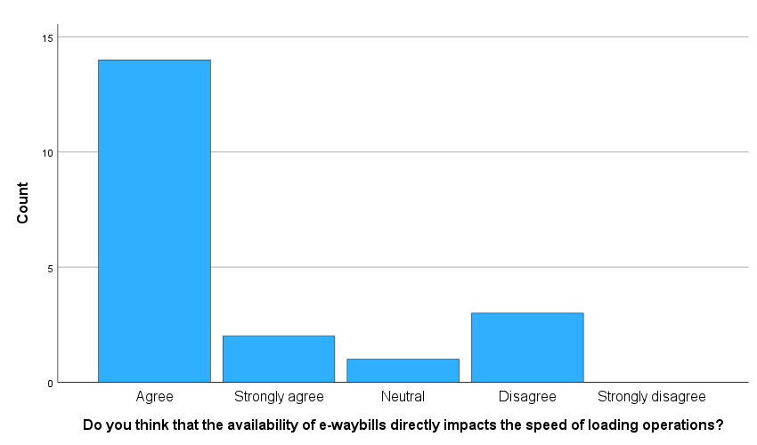

Chart 4.1:

|  |  |  |  |  |  |
| --- | --- | --- | --- | --- | --- |
| **Do you think that the availability of e-waybills directly impacts the speed of loading operations?** | | | | | |
|  | | Frequency | Percent | Valid Percent | Cumulative Percent |
| Valid | Agree | 14 | 70.0 | 70.0 | 70.0 |
| Strongly agree | 2 | 10.0 | 10.0 | 80.0 |
| Neutral | 1 | 5.0 | 5.0 | 85.0 |
| Disagree | 3 | 15.0 | 15.0 | 100.0 |
| Total | 20 | 100.0 | 100.0 |  |

INTERPRETATION: the above mentioned table, 70% responses agree, 15% responses disagree, 10% strongly agree and 5% responses neutral for the statement is the availability of e-waybills directly impacts the speed of loading operations.

Table 4.2:

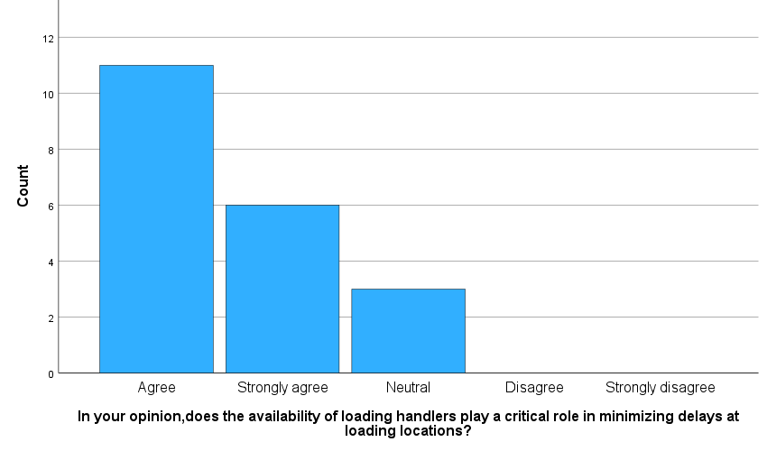

Chart 4.2:

|  |  |  |  |  |  |
| --- | --- | --- | --- | --- | --- |
| **In your opinion ,does the availability of loading handlers play a critical role in minimizing delays at loading locations?** | | | | | |
|  | | Frequency | Percent | Valid Percent | Cumulative Percent |
| Valid | Agree | 11 | 55.0 | 55.0 | 55.0 |
| Strongly agree | 6 | 30.0 | 30.0 | 85.0 |
| Neutral | 3 | 15.0 | 15.0 | 100.0 |
| Total | 20 | 100.0 | 100.0 |  |

INTERPRETATION: the above mentioned table, 55% responses agree, 30% responses strongly agree and 15% responses neutral for the statement for the availability of loading handlers play a crucial role in minimizing delays at loading locations.

Table 4.3:

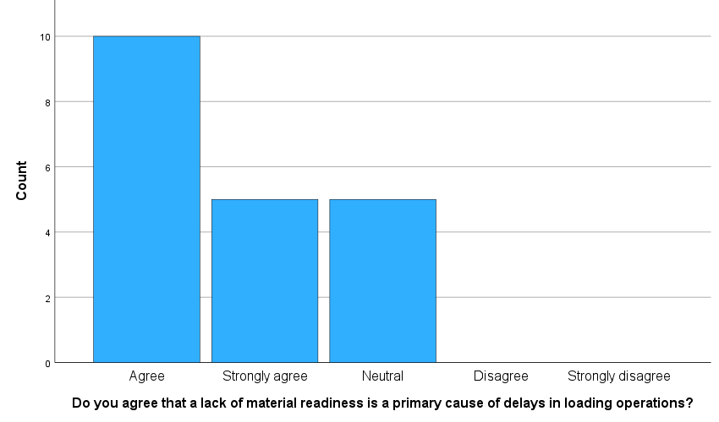

Chart 4.3:

|  |  |  |  |  |  |
| --- | --- | --- | --- | --- | --- |
| **Do you agree that a lack of material readiness is a primary cause of delays in loading operations?** | | | | | |
|  | | Frequency | Percent | Valid Percent | Cumulative Percent |
| Valid | Agree | 10 | 50.0 | 50.0 | 50.0 |
| Strongly agree | 5 | 25.0 | 25.0 | 75.0 |
| Neutral | 5 | 25.0 | 25.0 | 100.0 |
| Total | 20 | 100.0 | 100.0 |  |

INTERPRETATION: the above mentioned table, 50% responses agree, 25% responses strongly agree and 25% responses neutral for the statement for lack of material readiness is a primary cause of delays in loading operations.

Table 4.4:

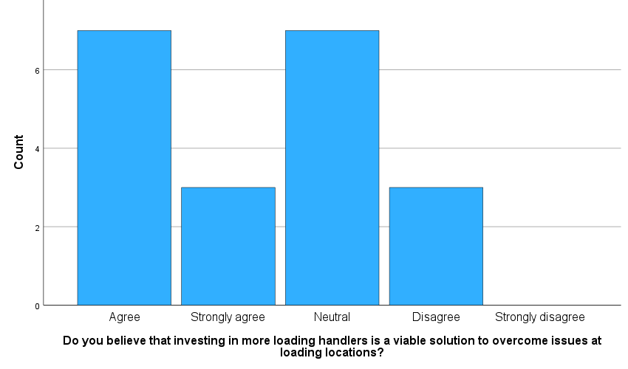

Chart 4.4:

**Do you believe that investing in more loading handlers is a viable solution to overcome issues at loading locations ?**

|  |  |  |  |  |  |
| --- | --- | --- | --- | --- | --- |
|  | | | | | |
|  | | Frequency | Percent | Valid Percent | Cumulative Percent |
| Chart 4.1: | Agree | 7 | 35.0 | 35.0 | 35.0 |
| Strongly agree | 3 | 15.0 | 15.0 | 50.0 |
| Neutral | 7 | 35.0 | 35.0 | 85.0 |
| Disagree | 3 | 15.0 | 15.0 | 100.0 |
| Total | 20 | 100.0 | 100.0 |  |

INTERPRETATION: the above mentioned table, 35% responses agree, 35% responses neutral,15% responses strongly agree and 15% responses disagree for the statement for investing in more loading handlers is a viable solutions to overcome issues at loading locations.

Table 4.5:

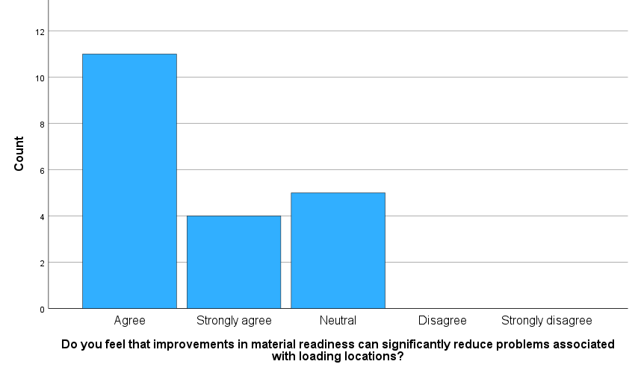

Chart 4.5:

|  |  |  |  |  |  |
| --- | --- | --- | --- | --- | --- |
| **Do you feel that improvements in material readiness can significantly reduce problems associated with loading locations?** | | | | | |
|  | | Frequency | Percent | Valid Percent | Cumulative Percent |
| Valid | Agree | 11 | 55.0 | 55.0 | 55.0 |
| Strongly agree | 4 | 20.0 | 20.0 | 75.0 |
| Neutral | 5 | 25.0 | 25.0 | 100.0 |
| Total | 20 | 100.0 | 100.0 |  |

INTERPRETATION: the above mentioned table, 55% responses agree, 25% responses neutral and 20% responses strongly agree for the statement for improvements in material readiness can significantly reduce problems associated with loading locations.

Table 4.6:

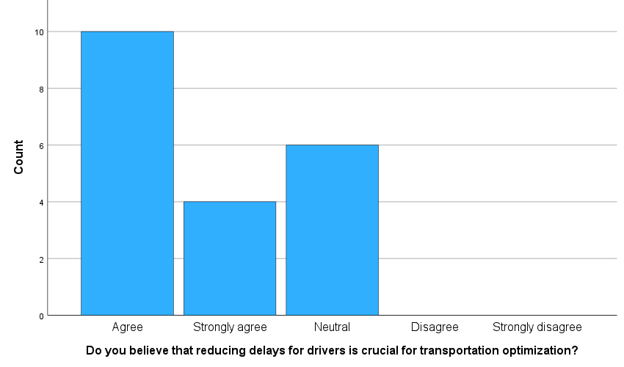

Chart 4.6:

|  |  |  |  |  |  |
| --- | --- | --- | --- | --- | --- |
| **Do you believe that reducing delays for drivers is crucial for transportation optimization?** | | | | | |
|  | | Frequency | Percent | Valid Percent | Cumulative Percent |
| Valid | Agree | 10 | 50.0 | 50.0 | 50.0 |
| Strongly agree | 4 | 20.0 | 20.0 | 70.0 |
| Neutral | 6 | 30.0 | 30.0 | 100.0 |
| Total | 20 | 100.0 | 100.0 |  |

INTERPRETATION: the above mentioned table, 50% responses agree, 30% responses neutral and 20% responses strongly agree for the statement for reducing delays for drivers is crucial for transportation optimization.

Table 4.7:

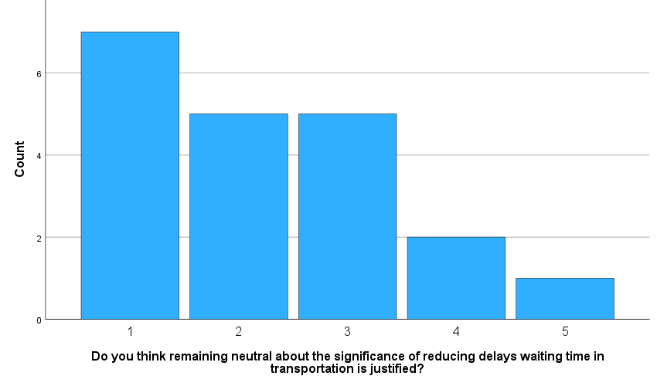

Chart 4.7:

|  |  |  |  |  |  |
| --- | --- | --- | --- | --- | --- |
| **Do you think remaining neutral about the significance of reducing delays waiting time in transportation is justified?** | | | | | |
|  | | Frequency | Percent | Valid Percent | Cumulative Percent |
| Valid | Agree | 7 | 35.0 | 35.0 | 35.0 |
| Strongly agree | 5 | 25.0 | 25.0 | 60.0 |
| Neutral | 5 | 25.0 | 25.0 | 85.0 |
| Disagree | 2 | 10.0 | 10.0 | 95.0 |
| Strongly disagree | 1 | 5.0 | 5.0 | 100.0 |
| Total | 20 | 100.0 | 100.0 |  |

INTERPRETATION: the above mentioned table, 35% responses agree, 25% responses strongly agree, 25% responses neutral, 10% responses disagree and 5% responses strongly disagree for the statement for remaining neutral about the significance of reducing delays waiting time in transportation is justified.

Table 4.8:

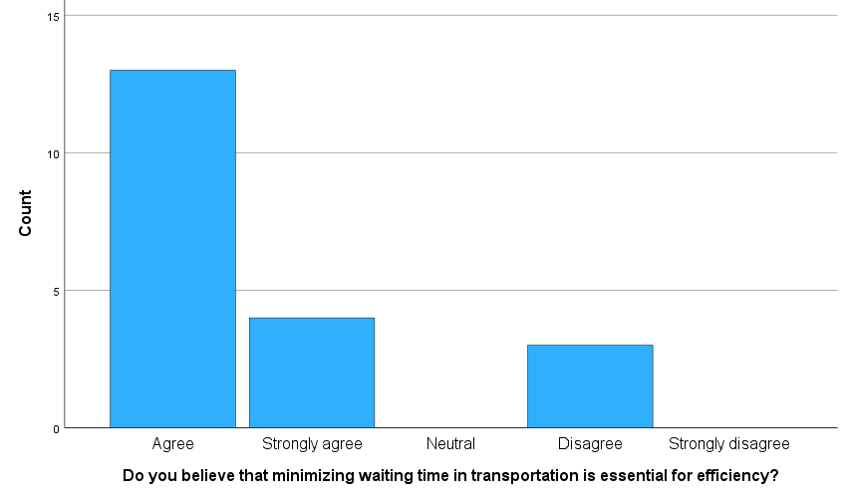

Chart 4.8:

|  |  |  |  |  |  |
| --- | --- | --- | --- | --- | --- |
| **Do you believe that minimizing waiting time in transportation is essential for efficiency?** | | | | | |
|  | | Frequency | Percent | Valid Percent | Cumulative Percent |
| Valid | Agree | 13 | 65.0 | 65.0 | 65.0 |
| Strongly agree | 4 | 20.0 | 20.0 | 85.0 |
| Disagree | 3 | 15.0 | 15.0 | 100.0 |
| Total | 20 | 100.0 | 100.0 |  |

INTERPRETATION: the above mentioned table, 65% responses agree,20% responses strongly agree and 15% responses disagree for the statement for minimizing waiting time in transportation is essential for efficiency.

Table 4.9:

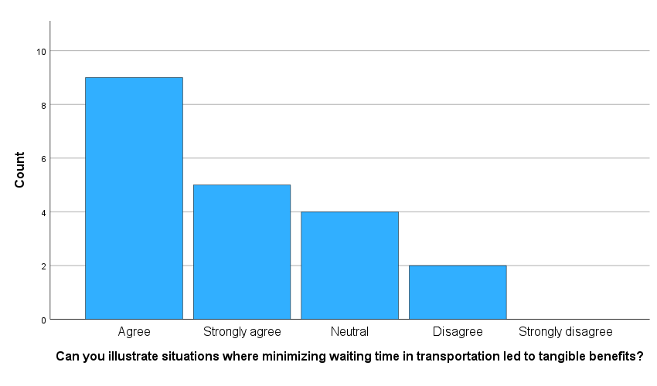

Chart 4.9:

|  |  |  |  |  |  |
| --- | --- | --- | --- | --- | --- |
| **Can you illustrate situations where minimizing waiting time in transportation led to tangible benefits?** | | | | | |
|  | | Frequency | Percent | Valid Percent | Cumulative Percent |
| Valid | Agree | 9 | 45.0 | 45.0 | 45.0 |
| Strongly agree | 5 | 25.0 | 25.0 | 70.0 |
| Neutral | 4 | 20.0 | 20.0 | 90.0 |
| Disagree | 2 | 10.0 | 10.0 | 100.0 |
| Total | 20 | 100.0 | 100.0 |  |

INTERPRETATION: the above mentioned table, 45% responses agree, 25% responses strongly agree, 20% responses neutral and 10% responses disagree for the statement for minimizing waiting time in transportation led to tangible benefits.

Table 4.10:

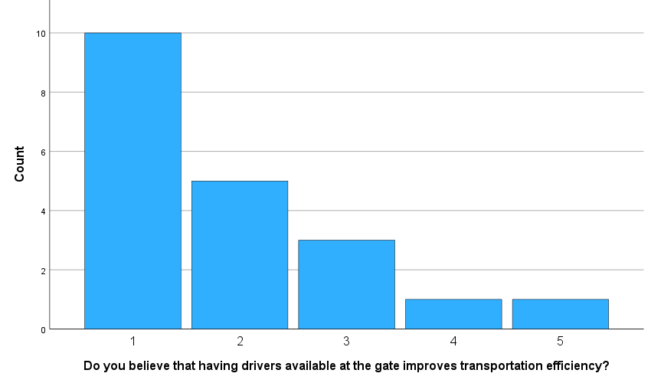

Chart 4.10:

|  |  |  |  |  |  |
| --- | --- | --- | --- | --- | --- |
| **Do you believe that having drivers available at the gate improves transportation efficiency?** | | | | | |
|  | | Frequency | Percent | Valid Percent | Cumulative Percent |
| Valid | Agree | 10 | 50.0 | 50.0 | 50.0 |
| Strongly agree | 5 | 25.0 | 25.0 | 75.0 |
| Neutral | 3 | 15.0 | 15.0 | 90.0 |
| Disagreed | 1 | 5.0 | 5.0 | 95.0 |
| Strongly disagree | 1 | 5.0 | 5.0 | 100.0 |
| Total | 20 | 100.0 | 100.0 |  |

INTERPRETATION: the above mentioned table, 50% responses agree, 25% responses strongly agree,15% responses neutral, 5% responses disagree and 5% responses strongly disagree for the statement for having drivers available at the gate improves transportation efficiency.

Table 4.11:

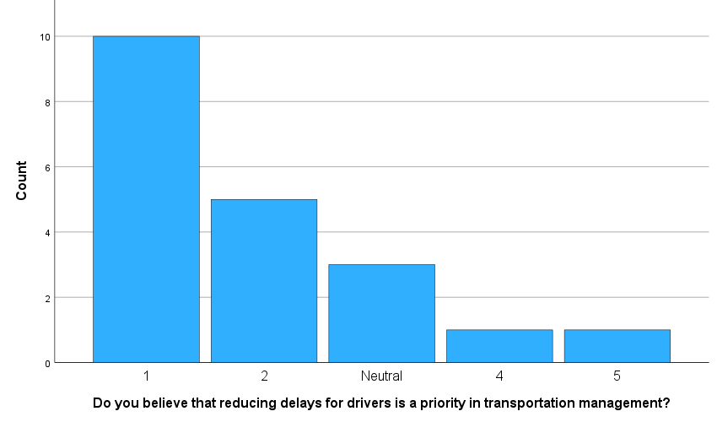

Chart 4.11:

|  |  |  |  |  |  |
| --- | --- | --- | --- | --- | --- |
| **Do you believe that reducing delays for drivers is a priority in transportation management?** | | | | | |
|  | | Frequency | Percent | Valid Percent | Cumulative Percent |
| Valid | 1 | 10 | 50.0 | 50.0 | 50.0 |
| 2 | 5 | 25.0 | 25.0 | 75.0 |
| 3 | 3 | 15.0 | 15.0 | 90.0 |
| 4 | 1 | 5.0 | 5.0 | 95.0 |
| 5 | 1 | 5.0 | 5.0 | 100.0 |
| Total | 20 | 100.0 | 100.0 |  |

INTERPRETATION: the above mentioned table, 50% responses agree, 25% responses strongly agree, 15% responses neutral, 5% responses disagree and 5% responses strongly disagree for the statement for reducing delays for drivers is a priority in transportation management.

Table 4.12:

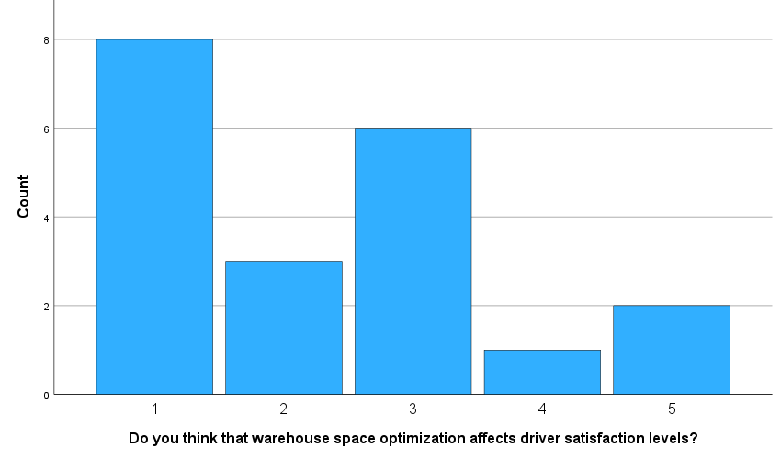

Chart 4.12:

|  |  |  |  |  |  |
| --- | --- | --- | --- | --- | --- |
| **Do you think that warehouse space optimization affects driver satisfaction levels?** | | | | | |
|  | | Frequency | Percent | Valid Percent | Cumulative Percent |
| Valid | 1 | 8 | 40.0 | 40.0 | 40.0 |
| 2 | 3 | 15.0 | 15.0 | 55.0 |
| 3 | 6 | 30.0 | 30.0 | 85.0 |
| 4 | 1 | 5.0 | 5.0 | 90.0 |
| 5 | 2 | 10.0 | 10.0 | 100.0 |
| Total | 20 | 100.0 | 100.0 |  |

INTERPRETATION: the above mentioned table, 40% responses agree, 15% responses strongly agree, 30% responses neutral, 5% responses disagree and 10% strongly disagree for thewarehouse space optimization affects driver satisfaction levels.

Table 4.13:

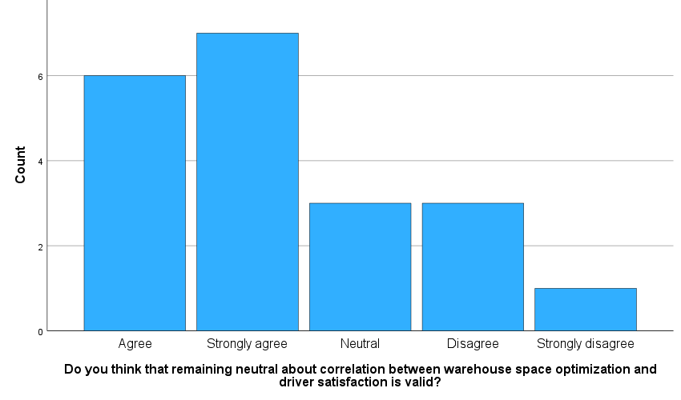

Chart 4.13:

|  |  |  |  |  |  |
| --- | --- | --- | --- | --- | --- |
| **Do you think that remaining neutral about correlation between warehouse space optimization and driver satisfaction is valid?** | | | | | |
|  | | Frequency | Percent | Valid Percent | Cumulative Percent |
| Valid | Agree | 6 | 30.0 | 30.0 | 30.0 |
| Strongly agree | 7 | 35.0 | 35.0 | 65.0 |
| Neutral | 3 | 15.0 | 15.0 | 80.0 |
| Disagree | 3 | 15.0 | 15.0 | 95.0 |
| Strongly disagree | 1 | 5.0 | 5.0 | 100.0 |
| Total | 20 | 100.0 | 100.0 |  |

INTERPRETATION: the above mentioned table, 35% responses strongly disagree, 30% responses agree, 15% responses neutral, 15% responses disagree and 5%responses strongly disagree for the statement forremaining neutral about correlation between warehouse space optimization and driver satisfaction is valid.

Table 4.14:

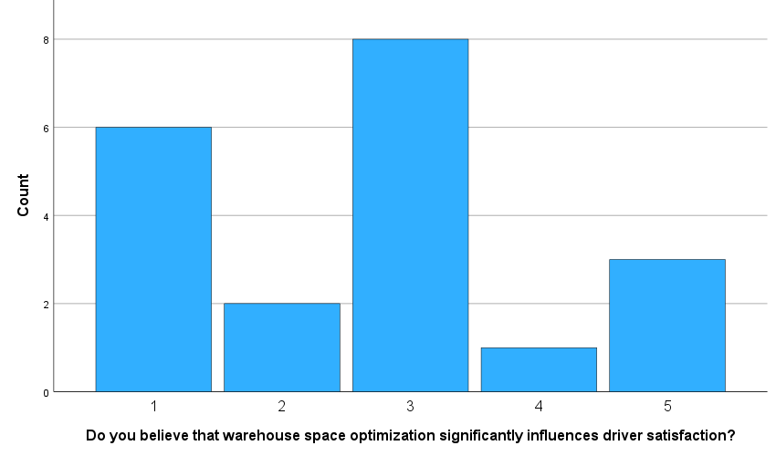

Chart 4.14:

|  |  |  |  |  |  |
| --- | --- | --- | --- | --- | --- |
| **Do you believe that warehouse space optimization significantly influences driver satisfaction?** | | | | | |
|  | | Frequency | Percent | Valid Percent | Cumulative Percent |
| Valid | 1 | 6 | 30.0 | 30.0 | 30.0 |
| 2 | 2 | 10.0 | 10.0 | 40.0 |
| 3 | 8 | 40.0 | 40.0 | 80.0 |
| 4 | 1 | 5.0 | 5.0 | 85.0 |
| 5 | 3 | 15.0 | 15.0 | 100.0 |
| Total | 20 | 100.0 | 100.0 |  |

INTERPRETATION: the above mentioned table, 40% responses neutral, 30% responses agree, 15% responses strongly disagree, 10% responses strongly agree and 5% responses neutral for the statement for that warehouse space optimization significantly influences driver satisfaction .

Table 4.15:

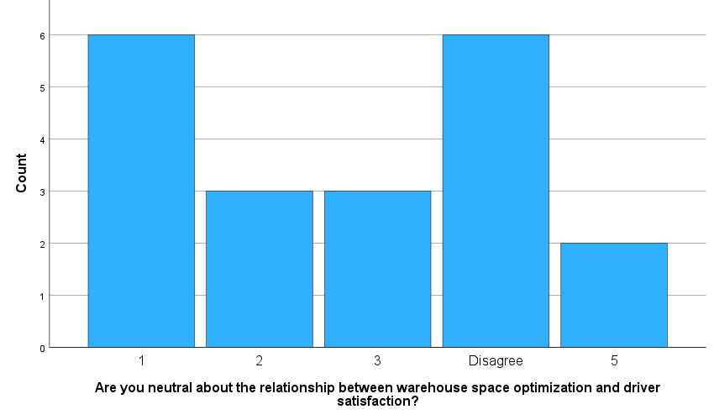

Chart 4.15:

|  |  |  |  |  |  |
| --- | --- | --- | --- | --- | --- |
| **Are you neutral about the relationship between warehouse space optimization and driver satisfaction?** | | | | | |
|  | | Frequency | Percent | Valid Percent | Cumulative Percent |
| Valid | 1 | 6 | 30.0 | 30.0 | 30.0 |
| 2 | 3 | 15.0 | 15.0 | 45.0 |
| 3 | 3 | 15.0 | 15.0 | 60.0 |
| 4 | 6 | 30.0 | 30.0 | 90.0 |
| 5 | 2 | 10.0 | 10.0 | 100.0 |
| Total | 20 | 100.0 | 100.0 |  |

INTERPRETATION: the above mentioned table ,30% responses agree , 30% responses disagree ,15% responses strongly agree , 15 % responses neutral and 10 % responses strongly disagree for the statement for the relationship between warehouse space optimization and driver satisfaction .

Table 4.16:

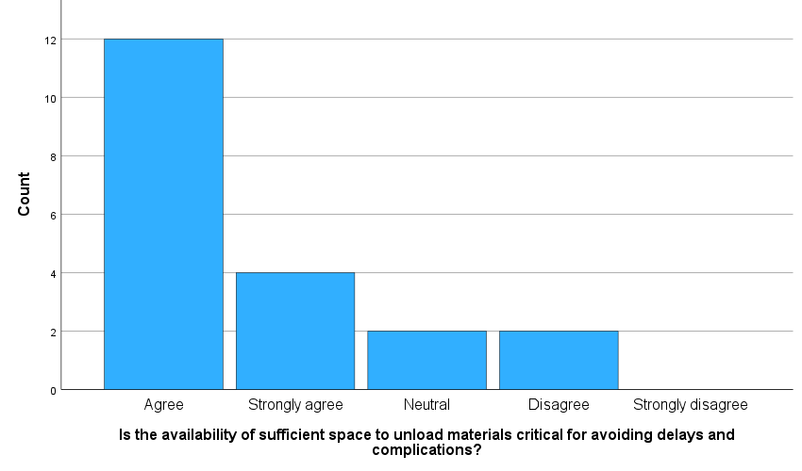

Chart 4.16:

|  |  |  |  |  |  |
| --- | --- | --- | --- | --- | --- |
| **Is the availability of sufficient space to unload materials critical for avoiding delays and complications?** | | | | | |
|  | | Frequency | Percent | Valid Percent | Cumulative Percent |
| Valid | Agree | 12 | 60.0 | 60.0 | 60.0 |
| Strongly agree | 4 | 20.0 | 20.0 | 80.0 |
| Neutral | 2 | 10.0 | 10.0 | 90.0 |
| Disagree | 2 | 10.0 | 10.0 | 100.0 |
| Total | 20 | 100.0 | 100.0 |  |

INTERPRETATION: the above mentioned table, 60 % responses agree, 20 % responses strongly agree, 10% responses neutral and 10% responses disagree for the statement foravailability of sufficient space to unload materials critical for avoiding delays and complications.

Table 4.17:

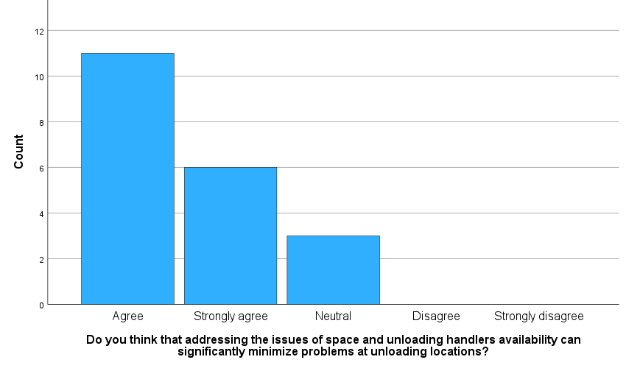

Chart 4.17:

|  |  |  |  |  |  |
| --- | --- | --- | --- | --- | --- |
| **Do you think that addressing the issues of space and unloading handler’s availability can significantly minimize problems at unloading locations?** | | | | | |
|  | | Frequency | Percent | Valid Percent | Cumulative Percent |
| Valid | Agree | 11 | 55.0 | 55.0 | 55.0 |
| Strongly agree | 6 | 30.0 | 30.0 | 85.0 |
| Neutral | 3 | 15.0 | 15.0 | 100.0 |
| Total | 20 | 100.0 | 100.0 |  |

INTERPRETATION: the above mentioned table, 55% responses agree, 30% responses strongly agree and 15% responses neutral for the statement for addressing the issues of space and unloading handler’s availability can significantly minimize problems at unloading locations.

Table 4.18:

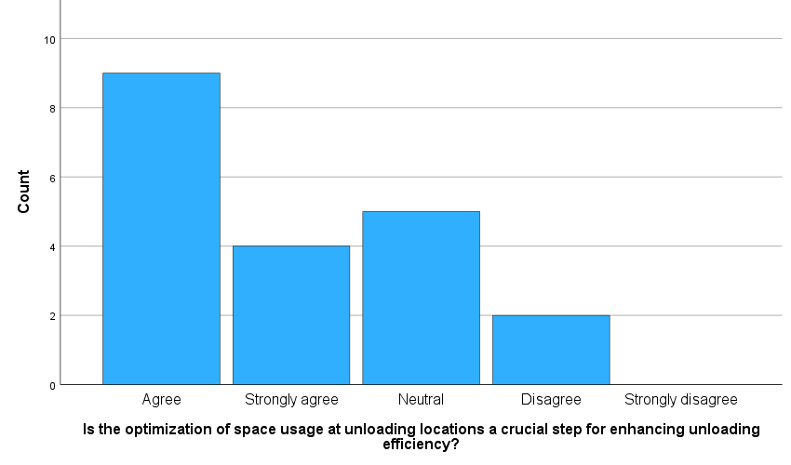

Chart 4.18:

|  |  |  |  |  |  |
| --- | --- | --- | --- | --- | --- |
| **Is the optimization of space usage at unloading locations a crucial step for enhancing unloading efficiency?** | | | | | |
|  | | Frequency | Percent | Valid Percent | Cumulative Percent |
| Valid | Agree | 9 | 45.0 | 45.0 | 45.0 |
| Strongly agree | 4 | 20.0 | 20.0 | 65.0 |
| Neutral | 5 | 25.0 | 25.0 | 90.0 |
| Disagree | 2 | 10.0 | 10.0 | 100.0 |
| Total | 20 | 100.0 | 100.0 |  |

INTERPRETATION: the above mentioned table, 45% responses agree, 25% responses neutral, 20% responses strongly agree and 10% responses disagree for the statement for the optimization of space usage at unloading locations a crucial step for enhancing unloading efficiency

Table 4.19:

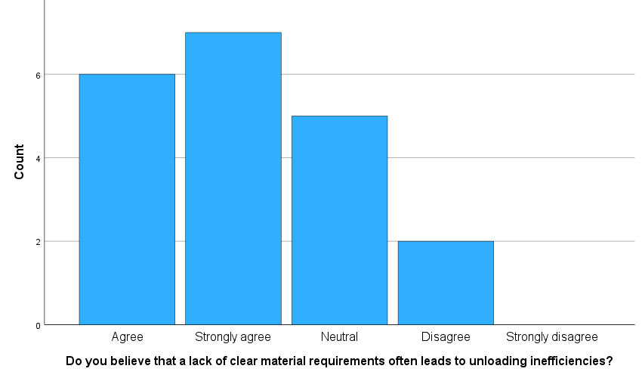

Chart 4.19:

|  |  |  |  |  |  |
| --- | --- | --- | --- | --- | --- |
| **Do you believe that a lack of clear material requirements often leads to unloading inefficiencies?** | | | | | |
|  | | Frequency | Percent | Valid Percent | Cumulative Percent |
| Valid | Agree | 6 | 30.0 | 30.0 | 30.0 |
| Strongly agree | 7 | 35.0 | 35.0 | 65.0 |
| Neutral | 5 | 25.0 | 25.0 | 90.0 |
| Disagree | 2 | 10.0 | 10.0 | 100.0 |
| Total | 20 | 100.0 | 100.0 |  |

INTERPRETATION: the above mentioned table, 35% responses strongly agree, 30% responses agree, 25% responses neutral and 10% responses disagree for the statement for lack of clear material requirements often leads to unloading inefficiencies.

Table 4.20:

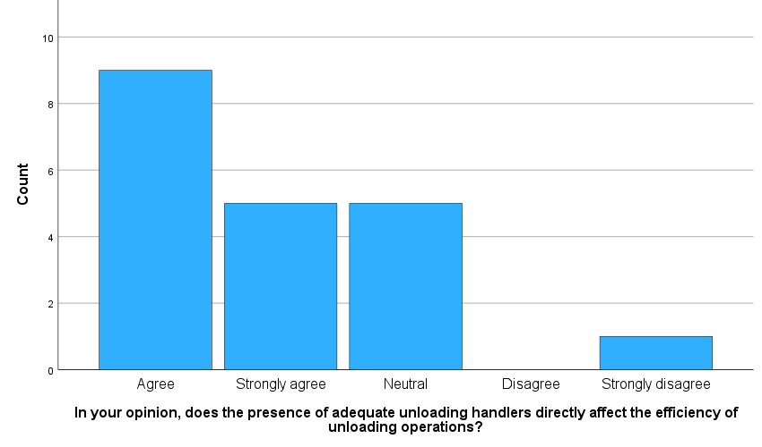

Chart 4.20:

|  |  |  |  |  |  |
| --- | --- | --- | --- | --- | --- |
| **In your opinion, does the presence of adequate unloading handlers directly affect the efficiency of unloading operations?** | | | | | |
|  | | Frequency | Percent | Valid Percent | Cumulative Percent |
| Valid | 1 | 9 | 45.0 | 45.0 | 45.0 |
| 2 | 5 | 25.0 | 25.0 | 70.0 |
| 3 | 5 | 25.0 | 25.0 | 95.0 |
| 5 | 1 | 5.0 | 5.0 | 100.0 |
| Total | 20 | 100.0 | 100.0 |  |

INTERPREATION: the above mentioned table, 45% responses agree, 25% responses strongly agree, 25% responses neutral and 5% responses strongly disagree for the statement for the presence of adequate unloading handlers directly affect the efficiency of unloading operations

**4.2 Chi- Square Test**

Generally, the chi- square test is a statistical test used to examine difference with categorical variables. There are a number of features of the social world we characterize through categorical variables – religion, political preferences etc. to examine hypotheses using such variables, use Chi- square test.

1. comparing the two variables is Do you think that the availability of e-waybills directly impacts the speed of loading operations? And do you believe that reducing delays for drivers is crucial for transportation optimization?

|  |  |  |  |
| --- | --- | --- | --- |
| **Chi-Square Tests** | | | |
|  | Value | df | Asymptotic Significance (2-sided) |
| Pearson Chi-Square | 9.040a | 6 | .171 |
| Likelihood Ratio | 10.152 | 6 | .118 |
| N of Valid Cases | 55 |  |  |
| a. 7 cells (58.3%) have expected count less than 5. The minimum expected count is .02. | | | |

INFERENCE:

The test was conducted to determine if there is a significant association between do you think that the availability of e-waybills directly impacts the speed of loading operations? And do you believe that reducing delays for drivers is crucial for transportation optimization? The Pearson Chi- square test statistic is 9. 040 and 6 degree of freedom. The like hood ratio test statistics is 10.152 and 6 degree of freedom. If the calculated value is 0.5> reject null (h0).

Result: Reject the null hypothesis and accepted the alternative hypothesis.

1. comparing the two variables is Do you believe that having drivers available at the gate improves transportation efficiency? And Can you illustrate situations where minimizing waiting time in transportation led to tangible benefits?

|  |  |  |  |
| --- | --- | --- | --- |
| **Chi-Square Tests** | | | |
|  | Value | df | Asymptotic Significance (2-sided) |
| Pearson Chi-Square | 8.278a | 12 | .763 |
| Likelihood Ratio | 9.908 | 12 | .624 |
| N of Valid Cases | 55 |  |  |
| a. 16 cells (80.0%) have expected count less than 5. The minimum expected count is .02. | | | |

INFERENCE:

The test was conducted to determine if there is a significant association between in Do you believe that having drivers available at the gate improves transportation efficiency? And Can you illustrate situations where minimizing waiting time in transportation led to tangible benefits. The Pearson Chi- square test statistic is 8.278 and 12 degree of freedom. The like hood ratio test statistics is 9.908 and 12 degree of freedom. If the calculated value is 0.5< accepted null (h0).

Result: Here, there is no association between in transportation flexible to changing the transport operations and mainly for without damage and delay. Accepted the null hypothesis and rejected the alternative hypothesis.

**4.3 WEIGHTED AVERAGE METHOD**

A weighted average is a measure that takes into account the influence of different components by assigning those varying degrees of importance, or weights. It's calculated by multiplying each component by its weight, summing these products, and then dividing by the sum of the weights. This method ensures that components with higher weights contribute more to the overall average.

1, Is the availability of sufficient space to unload materials critical for avoiding delays and complications?

|  |  |  |  |
| --- | --- | --- | --- |
| STATMENT | NO OF RESPONSE | WEIGHTED AVERAGE | NO OF RESPONSE * WEIGHTED AVERAGE |
| Strongly agree | 12 | 5 | 60 |
| Agree | 4 | 4 | 16 |
| Neutral | 2 | 2 | 4 |
| Disagree | 2 | 1 | 2 |
| Strongly disagree | 0 | 0 | 0 |
| Total | 20 |  | 82 |

Weighted average = Number of response* weighted average/ Sum of all the response

= 82/ 20

=4.1

Here, the weighted average for the statement is agree, most of the members agree for the availability of sufficient space to unload materials critical for avoiding delays and complications.

**CHAPTER V**

**5.1 FINDING OF STUDIES**

* 70% agree for the availably of e way bill directly impacts the speed of loading operations.
* 55% agree for the availability of loading handlers play a critical role in minimizing delays at loading locations.
* 50% agree that a lack of material readiness is a primary cause of delays in loading operations.
* 35% agree and neutral for the investing in more loading handlers is a viable solution to overcome issues at loading locations.
* 55% agree that improvements in material readiness can significantly reduce problems associated with loading locations.
* 50% agree that reducing delays for drivers is crucial for transportation optimization.
* 35% agree that remaining neutral about the significance of reducing delays waiting time in transportation is justified.
* 65% agree that minimizing waiting time in transportation is essential for efficiency.
* 45% agree that minimizing waiting time in transportation led to tangible benefits.
* 50% agree that having drivers available at the gate improves transportation efficiency.
* 50% agree that reducing delays for drivers is a priority in transportation management.
* 40% agree that warehouse space optimization affects driver satisfaction levels.
* 35% disagree that remaining neutral about correlation between warehouse space optimization and driver satisfaction is valid.
* 40% neutral in warehouse space optimization significantly influences driver satisfaction.
* 30% agree and disagree for that relationship between warehouse space optimization and driver satisfaction.
* 60% agree for the availability of sufficient space to unload materials critical for avoiding delays and complications.
* 55% agree that addressing the issues of space and unloading handler’s availability can significantly minimize problems at unloading locations.
* 45% agree that optimization of space usage at unloading locations a crucial steps for enhancing unloading efficiency.
* 35% disagree that a lack of clear material requirements often leads to unloading inefficiencies.
* 45% agree for the presence of adequate unloading handlers directly affect the efficiency of unloading operations.
* The test was conducted to determine if there is a significant association between do you think that the availability of e-waybills directly impacts the speed of loading operations? And do you believe that reducing delays for drivers is crucial for transportation optimization? The Pearson Chi- square test statistic is 9. 040 and 6 degree of freedom. The like hood ratio test statistics is 10.152 and 6 degree of freedom. If the calculated value is 0.5> reject null (h0).
* Result: Reject the null hypothesis and accepted the alternative hypothesis.
* Weighted average = Number of response* weighted average/ Sum of all the response
* = 82/ 20
* =4.1
* Here, the weighted average for the statement is agree, most of the members agree for the availability of sufficient space to unload materials critical for avoiding delays and complications.

**5. 2 RECOMMENDATIONS AND SUGGESTIONS**

**Simplify Communication Channels:** To guarantee efficient coordination and prompt updates on material readiness, space availability, and other requirements, establish clear channels of communication between the Transportation Company, drivers, loading/unloading handlers, and customers.

**Employ Technology Solutions:** To track the progress of shipments, optimize routes, and give drivers and customer’s real-time updates, make use of technology like GPS tracking, real-time monitoring systems, and mobile applications.

**Optimize Warehouse Space:** To reduce wait times and increase productivity during loading and unloading operations, work with clients to optimize warehouse space, storage facilities, and material handling procedures.

**Contract Negotiation:** To reduce the possibility of extra fees resulting from delays, negotiate contracts with clients to include provisions pertaining to timely space availability, material readiness, and adherence to loading/unloading schedules.

**Proactive Problem Resolution:** To reduce interruptions and prevent needless stops or delays, anticipate possible problems and proactively address them through resource allocation, collaboration with stakeholders, and contingency planning.

By implementing these recommendations, transportation companies can enhance operational efficiency, reduce costs associated with vehicle halting, and improve overall customer satisfaction.

**5.3 CONCLUSION**

The study concluded with the identification of important goals intended to address the issues related to extra fees resulting from vehicles stopping at the customer's location and transportation. Understanding the procedure to guarantee drivers' or transportation companies' availability at the gate and enabling prompt clearance processes were the main goals. Analysing problems at unloading and loading locations, such as material requirements, space availability, handler availability, material readiness, and paperwork preparation, was the focus of secondary objectives.

By achieving these goals, the study hoped to lessen transportation delays, handle driver and transporter discontent due to problems with warehouse space optimization, and identify the root causes of delays and extra fees. Streamlining communication channels, implementing technological solutions for tracking and monitoring, offering opportunities for training and development, optimizing warehouse space, negotiating contracts with clear clauses, and establishing proactive problem resolution mechanisms were among the recommendations made in order to achieve the desired outcome of eliminating additional charges.

Transportation companies can increase overall customer satisfaction, reduce the risk of delays and extra charges, and improve operational efficiency by implementing these recommendations. Furthermore, maintaining long-term success and accomplishing the main objective of getting rid of extra fees in the transportation process will require developing stakeholder collaboration and putting continuous improvement strategies into practice.

**5.4 BIBLIOGRAPHY/ REFERANCES**

1. Optimisation in Transport and logistics processes**,** Lumir peceny, Pavol Mesko, Jozef Gasparik 2020
2. Logistic regression in modeling and assessment of transport services**,** Anna Borucka 2020
3. Transport and logistics research and its impact on capacity building of local institutions in Nigeria**, Somuya**, Oyesiku , augest 2011
4. Problems and Solutions of Transport Logistics,Liudmyla Boldyrieva, Halyna Zelinska, Valentyna Krapkina, Anna Komelina january 2019
5. Defining transport logistics: A Literature review and practitioner opinion based approach**, Darja** TOPOLSEK, kristina CIZIUNIENE, Tina CVAHTE OJSTERSEK dec 2018
6. Analysis of the current logistics and transport challenges in the context of the changing environment, Jurgita Barysiene, Darius Bazaras 3rd march 2015
7. Logistics and Transportation in Global Supply chain: Review, Critique, and Prospects, James H. Bookbinder and Tiffany A. Matuk september 2009
8. Trends in transportation and logistics, M. Grazia Speranza august 1st, 2016
9. Big data for transport and logistics: A review**,** Tawfik Borgi, Mourad Abed, Nasrine Zoghlami january 2017
10. The role of transportation in logistics chain, Yung-yu TSENG, Michael A P TAYLOR, Wen Long YUE
11. Transport services management on transport and logistic methods**,** Nina sirina,valery zubkov 2021
12. A study on comparison of transportation problems in operations research**,** M.Nandhini 2nd February 2023
13. A comparative study of transportation problem under probbabilistic and fuzzy uncertainities**,** Dr. Kajal De
14. An improved algorithm to solve transportation problems for optimal solution**,** M. S. R. Shaikh, S. F. Shah and Z. Memon 2018
15. Study of a transportation problem of an essential item from various origins to different destinations by using EQM, Dr. M. Rajeshwara Reddy 3rd march 2020
16. Solving a multi-objective solid transportation problem: a comparative study of alternative methods for decision-making, Mohamed H. Abdelati, Ali M. Abd-El-Tawwab, Elsayed M.Ellimony and M. Rabie 2023
17. The Transportation and Logistics system in India, Ashutosh Mishra feb 8, 2017
18. The role of transportation in logistics bchain, Wen Long Yue, Michael A P Taylor January 2005
19. Fundamentals of Transportation problem, B. Mallia, M. Das, C. Das June 5th, 2021
20. Transport services Management on Transport and Logistics methods, Nina Sirina, Valery Zubkov 2021

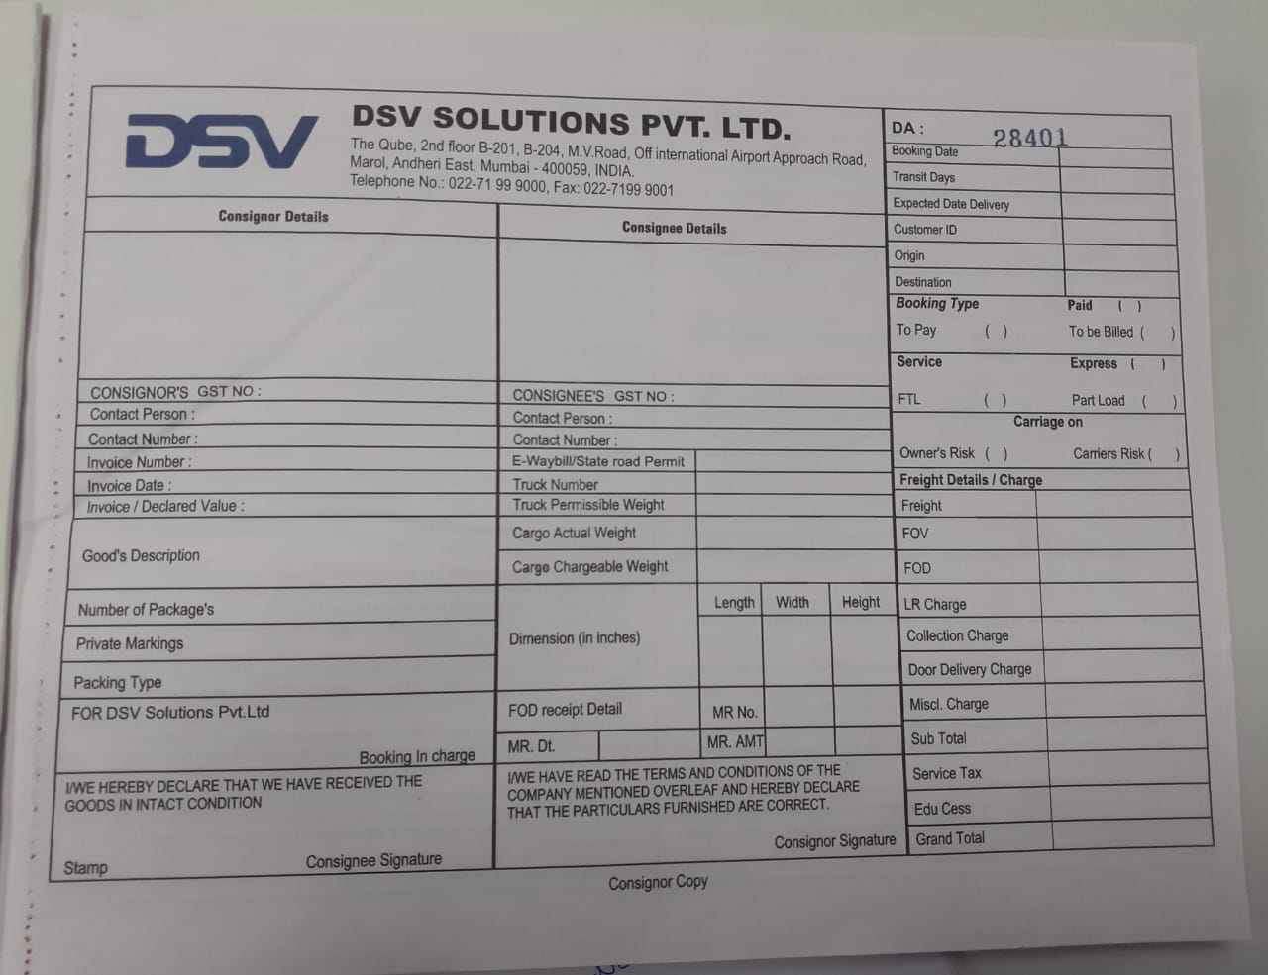**5.5 APPENDIX**

**BILL OF LADING**

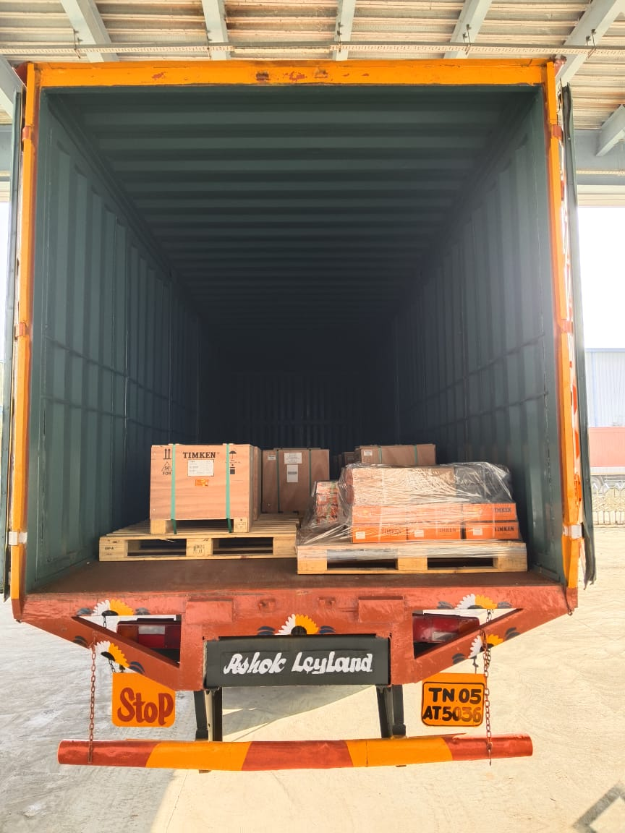

**STUFFING IMAGES IN DSV TRANSPORT COMPANY**