Multipurpose Spraying & Grass Cutting System Using Mobile Application

# PravinGoykar1,Aditya Sonawane2

1,2,3Student,Departmentof E&TC,MVP’SKBTCollegeofEngineering,Nashik,Maharashtra,India.

# ABSTRACT

For the manufacturing of a lawn knife we appertained colorful literature, papers etc. The review of former system used given below. In this field mower uses a grounded energy source, which is easier to use further profitable comparing to other energy sources. But our field knife is grounded on automatic hence and it's easy to work. So we made powered field knife. In this grounded lawn knife the advantage of powering a mower by energy rather than by gasoline is substantially ecological. We manufactured this lawn knife because it's veritably easy system and numerous overcome produced from. For the manufacturing of a lawn knife we appertained colorful literature, papers etc. The review of former system used given below. In this field mower uses a grounded energy source, which is easier to use further profitable comparing to other energy sources. But our field knife is grounded on automatic hence and it's easy to work. So we made powered field knife. In this grounded lawn knife the advantage of powering a mower by energy rather than by gasoline is substantially ecological. We manufactured this lawn knife because it's veritably easy system and numerous overcome produced from.

# INTRODUCTION

"Welcome to the future of lawn care! Our innovative Multipurpose Grass Cutting and Spraying System revolutionizes the way you maintain your outdoor spaces. With the power of technology at your fingertips, coupled with advanced machinery, we bring you unparalleled convenience and efficiency.

Imagine controlling your lawn maintenance tasks with just a few taps on your mobile device. Our cutting-edge system integrates seamlessly with a user-friendly mobile application, putting the power of precision lawn care directly into your hands.

Gone are the days of cumbersome equipment and tedious manual labor. Our system combines grass cutting and spraying functionalities into a single, versatile solution, designed to meet all your landscaping needs.

Join us as we embark on a journey to transform the way you care for your outdoor environment. Say goodbye to the hassle and hello to the future of lawn maintenance with our Multipurpose Grass Cutting and Spraying System."

# RELATED WORK

Creating a multipurpose spraying and grass-cutting system utilizing a mobile application involves an intersection of several fields such as agriculture, robotics, mobile application development, and possibly even environmental science. Here are some potential areas you might explore for related work:

Agricultural Robotics:

Research papers or projects on autonomous or semi-autonomous agricultural robots could provide insights into the design, control, and navigation algorithms relevant to your project.

Look for studies on robotic systems used for spraying pesticides, herbicides, or fertilizers, as well as those designed for grass cutting or maintenance tasks in agricultural settings.

Mobile Application Development:

Investigate mobile applications designed for remote control, monitoring, and management of various devices or systems. These could include agricultural equipment, home automation systems, or even industrial machinery.

Explore research papers or tutorials on developing mobile applications for IoT (Internet of Things) devices, as your system likely involves connectivity and remote control capabilities.

Precision Agriculture:

Creating a multipurpose spraying and grass-cutting system utilizing a mobile application involves an intersection of several fields such as agriculture, robotics, mobile application development, and possibly even environmental science. Here are some potential areas you might explore for related work:

Agricultural Robotics:

Research papers or projects on autonomous or semi-autonomous agricultural robots could provide insights into the design, control, and navigation algorithms relevant to your project.

Look for studies on robotic systems used for spraying pesticides, herbicides, or fertilizers, as well as those designed fontenr grass cutting or maiance tasks in agricultural settings.

Mobile Application Development:

Investigate mobile applications designed for remote control, monitoring, and management of various devices or systems. These could include agricultural equipment, home automation systems, or even industrial machinery.

Explore research papers or tutorials on developing mobile applications for IoT (Internet of Things) devices, as your system likely involves connectivity and remote control capabilities.

Precision Agriculture:

Precision agriculture involves the use of technology to optimize crop yields while minimizing resources like water, fertilizer, and pesticides. Research in this area might provide insights into efficient spraying techniques, sensor integration, and data analysis methods.

Look for studies on the use of drones, sensor networks, and other advanced technologies in precision agriculture, as some of the principles may be applicable to your project.

**2.1 CAUSES-** A multipurpose system controlled via a mobile application can offer users a high degree of customization and adaptability to suit their specific needs and preferences. Features such as adjustable cutting heights, variable spray patterns, and scheduling options enhance the flexibility and utility of the system, making it suitable for a wide range of applications and environments.

Overall, the causes for developing a multipurpose grass cutting and spraying system using a mobile application are driven by the desire to improve efficiency, reduce costs, enhance precision, increase convenience, promote sustainability, foster innovation, and provide customizable solutions for users in various sectors such as agriculture, landscaping, and lawn care.

1. **METHODOLOGY**

Working principle of the lawn knife is furnishing a high speed gyration to the blade, which helps to cut the lawn. Also electric lawn cutting machines are much easier to be used in theater , field and lawn fields. The main corridor of the lawn cutting machine are, Arduino grounded charge regulator, battery, dc motor for lawn slice, geared dc motor for bus, infrared handicap detector etc. Lawn knife machines have come veritably popular moment. Pollution is man- made and can be seen in our own diurnal lives, more specifically in our own homes. Herein, we propose a model of the automatic lawn cutting machine powered by battery. Automatic lawn cutting machine is a machine which is going to perform the lawn cutting operation on its own. This model reduces both terrain and noise pollution. Our new design for an old and outdated habit will help both client and the terrain. This design automatic powered lawn knife will fulfill the consumer demand and will reduce both environmental and noise pollution. This design is meant to be an alternate green option to the popular and environmentally dangerous energy powered field mower. Eventually, the consumer will be doing further for the terrain while doing lower work in their diurnal lives

# 3.1 BLOCK DIAGRAM

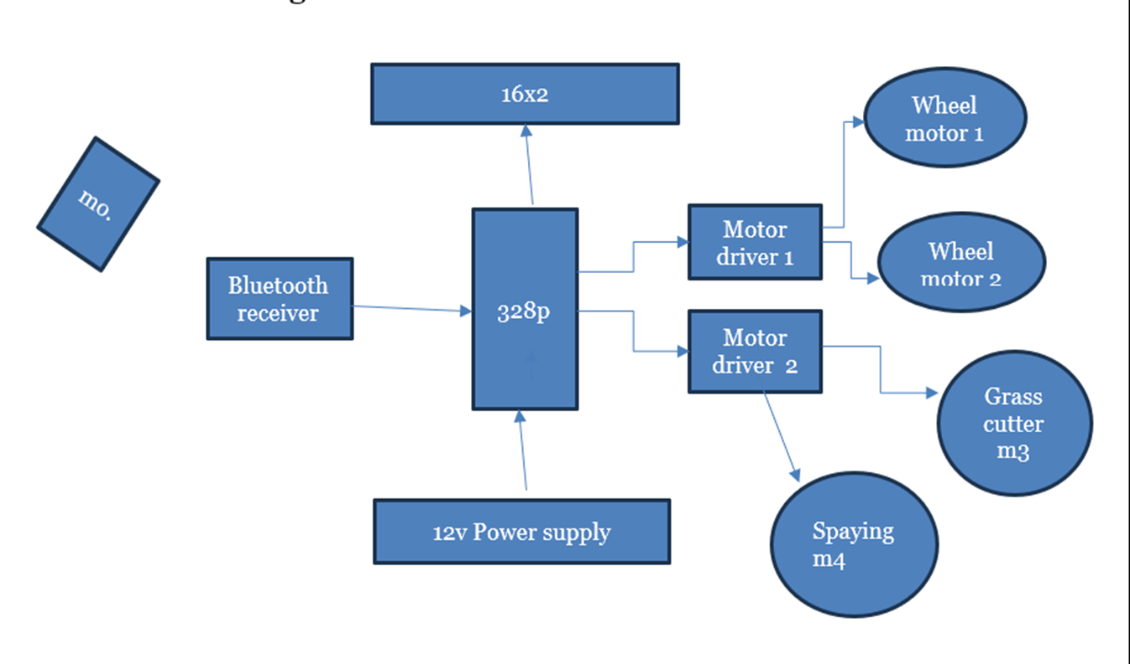

**3.2 FLOWCHART:**

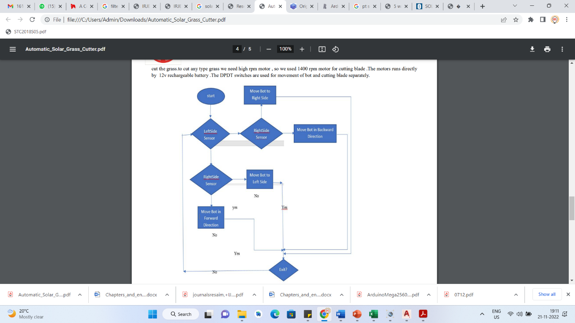

# RESULT

AfterCompletingandTestingtheprojectwehaveobservethefollowingresult.Asshown below .

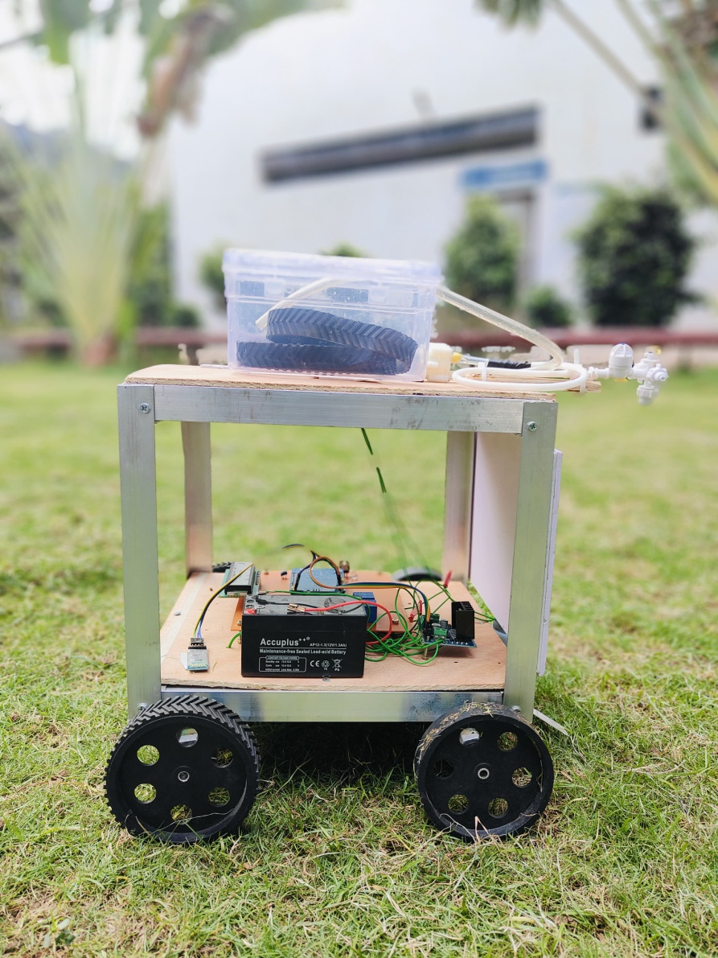

# CONCLUSION

# Working principle of the lawn knife is furnishing a high speed gyration to the blade, which helps to cut the lawn. Also electric lawn cutting machines are much easier to be used in theater , field and lawn fields. The main corridor of the lawn cutting machine are, Arduino grounded system regulator, battery, and sprinkler motor. Our design entitled Fabrication of battery powered lawn knife is successfully completed and our design entitled Fabrication automatic lawn knife is successfully completed and results attained are satisfactory. It'll be easier for the people who are going to take the design for the farther variations. This design is more suitable for a common man as it's having much further advantages i.e., no energy cost, no pollution and no energy residue, lower wear and tear and gash because of lower number of moving factors and this can be operated by using energy. This will give much further physical exercise to the people and can be fluently handled. As we're nearer to Equator.

# REFERENCES

1. SujendranS. and Vanithap., Smart Field Mower for Grass Trimming, International Journal of Science and Research,Vol. 3, 2014, 2319- 7064.
2. PrafulP. Ulhe, ManishD. Inwate, FriedD. Wankhede and KrushankumarS. Dhakle, revision of Lawn Cutting Machine, International Journal for Innovative exploration in Science and Technology,- 6010.
3. YogitaD. Ambekar, AbhishekU. Ghate, “ Grounded Lawn knife ”, Alternate International Conference on rearmost trend in engineering, wisdom, humanities and operation, runnerno. 322- 326, Feb- 2017