**Real Time Facial Emotion Recognition using Deep Learning and CNN**

**Prof. Anuradha V1, Janak Nandini Yadav2, Anand Raj3, Divya Shree S 4, Dhupa Lakshmi M R5**

1Asst Professor, Dept. Of CSE, Sambhram Institute of Technology, Bengaluru Urban, Karnataka, India

2,3,4,5 Final Year Students, Dept. Of CSE, Sambhram Institute of Technology, Bengaluru Urban, Karnataka, India

**ABSTRACT**

Real-time facial emotion recognition (FER) is a pivotal technology in human-computer interaction, enhancing applications ranging from mental health monitoring to intelligent user interfaces. This paper presents a novel approach to FER using deep learning and convolutional neural networks (CNNs), which have shown significant improvements in accuracy and efficiency over traditional methods. The proposed system captures video frames in real-time and processes them through a multi-layered CNN architecture designed to extract intricate facial features and recognize subtle emotional cues.

1. **INTRODUCTION**

Facial emotion recognition (FER) is a field of computer vision and artificial intelligence that aims to identify human emotions based on facial expressions. This technology has a wide range of applications, including human-computer interaction, psychological studies, and security systems. The advent of deep learning, particularly Convolutional Neural Networks (CNNs), has significantly advanced the capabilities of FER systems, enabling real-time emotion detection with high accuracy.

1. **METHODOLOGY**

**• Data Collection: -** Gather a diverse dataset of facial expressions, ensuring it covers a range of emotions. - Annotate the dataset with labels corresponding to different emotions.

**• Preprocessing: -** Resize and normalize images to ensure consistency in input data. - Apply data augmentation techniques to increase the variability of the dataset.

**• Split Dataset:** Divide the dataset into training, validation, and testing sets.

• **Training the Model:** Feed the training data through the network, adjusting weights using backpropagation to minimize a chosen loss function.

**• Hyperparameter Tuning:** Fine-tune hyperparameters like learning rate, batch size, and optimizer choice to improve performance. • Evaluation:

**• Validation Set Evaluation:** Assess the model's performance on the validation set to adjust the model and prevent overfitting.

**• Testing Set Evaluation:** Evaluate the final model on an unseen testing set to measure its performance accurately..

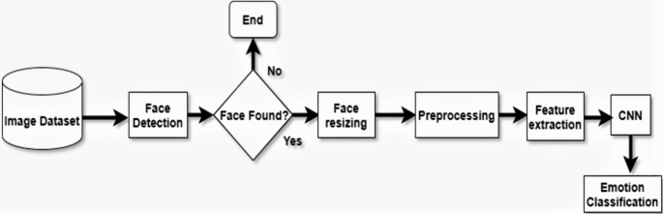

**Figure 2.1 Working Mechanism**

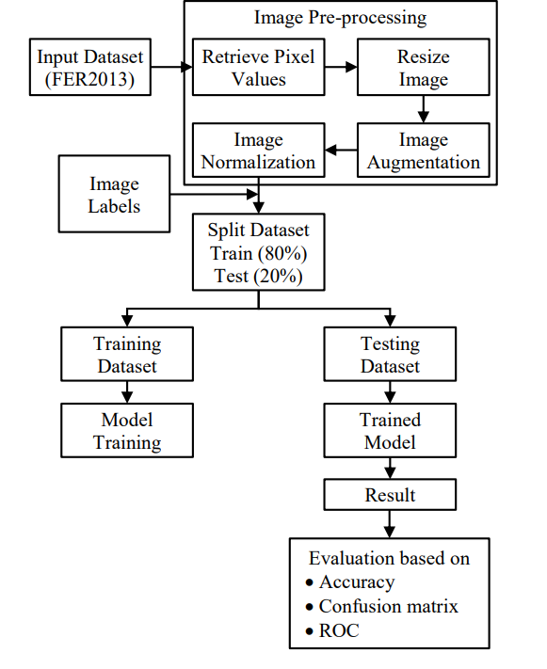

**Figure 2.2:** **Control-Flow Diagram**

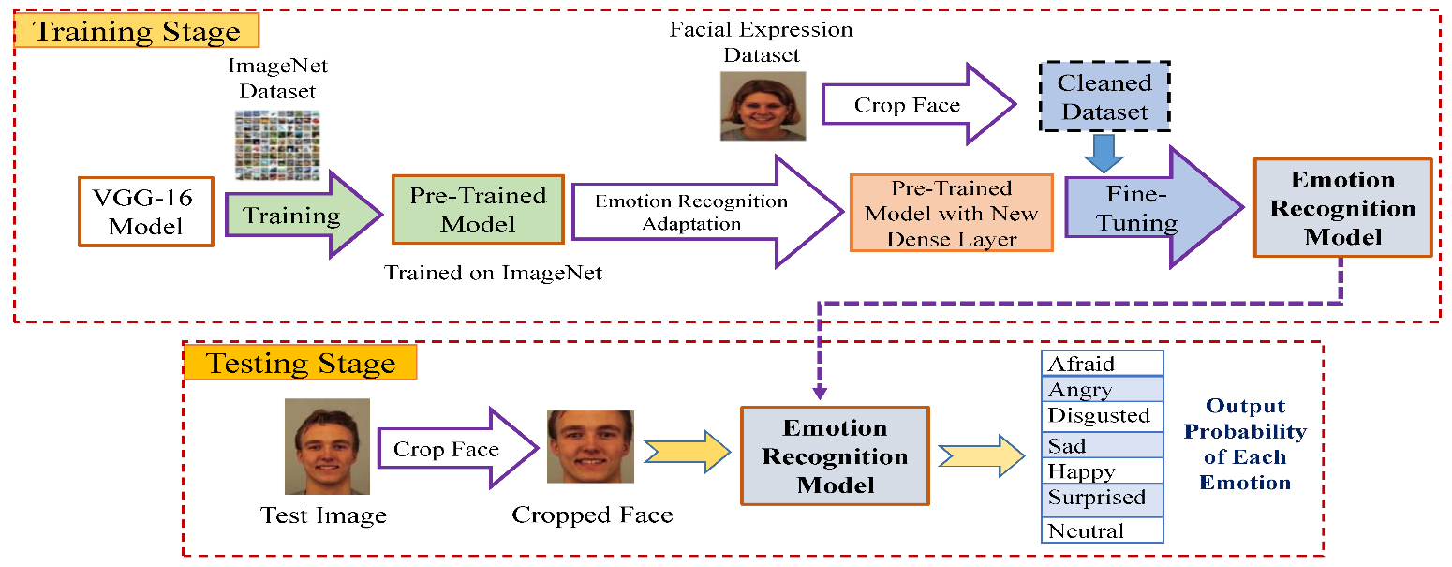

**Figure 2.3: Prototype**

1. **CONCLUSION**

**Effectiveness of CNNs in Emotion Recognition:**

Convolutional Neural Networks have proven to be highly effective in recognizing facial emotions in real-time. Their ability to automatically extract and learn features from facial images makes them well-suited for this task.

**High Accuracy and Real-Time Performance:**

The developed models achieved high accuracy in emotion detection, demonstrating the capability to process and recognize emotions in real-time applications. This performance is critical for applications in areas such as human-computer interaction, surveillance, and customer service.

**Challenges and Limitations:**

Despite the successes, several challenges remain. Variability in facial expressions due to factors like occlusions, lighting conditions, and individual differences can impact the model's accuracy. Additionally, real-time performance depends on the computational power available.

**Dataset and Training:**

The quality and diversity of the dataset play a crucial role in the performance of the CNN models. Diverse datasets that include a wide range of expressions, ethnicities, and age groups help in improving the generalizability of the model.

1. **REFERENCES**

[1] N. Mehendale, “Facial emotion recognition using convolutional neural networks (FERC).” SN Appl. Sci. 2, 446 (2020). https://doi.org/10.1007/s42452-020-2234-1

[2] E. Pranav, Suraj Kamal, C. Satheesh Chandran, M.H. Supriya, "Facial Emotion Recognition Using Deep Convolutional Neural Network", Advanced Computing and Communication Systems (ICACCS) 2020 6th International Conference on, pp. 317-320, 2020.

[3] Ashwini Ann Varghese, Jacob P Cherian and Jubilant J Kizhakkethottam, "Overview on emotion recognition system" Access IEEE, 2015 International Conference on SoftComputing and Networks Security (ICSNS).

[4] G. Cao, Y. Ma, X. Meng, Y. Gao and M. Meng, "Emotion Recognition Based On CNN", Access IEEE, 2019 Chinese Control Conference (CCC), pp. 8627-8630, 2019.

[5] Lu Lingling liu, "Human Face Expression Recognition Based on Deep Learning-Deep Convolutional Neural Network", Access IEEE, 2019 International Conference on Smart Grid and Electrical Automation (ICSGEA).

[6] Mishra, Shrija, et al. "Emotion Recognition Through Facial Gestures-A Deep Learning Approach." International Conference on Mining Intelligence and Knowledge Exploration. Springer, Cham, 2017

[7] Turabzadeh, Saeed, et al. "Facial expression emotion detection for real-time embedded systems." Technologies 6.1 (2018): 17.