**AQUA VISION – A Drowning Detection Incident Monitoring and Alerting System**

**M.Giridhar Rao1, Shubhankar Kumar2, Shekhar Kumar3, Suraj Kumar4, Nitish Kumar Paswan5**

1Asst Professor, Dept. Of CSE, Sambhram Institute of Technology, Bengaluru Urban, Karnataka, India

2,3,4,5 Final Year Students, Dept. Of CSE, Sambhram Institute of Technology, Bengaluru Urban, Karnataka, India

**ABSTRACT**

Understanding and enhancing student performance is a crucial aspect of educational systems worldwide. With the advent of machine learning techniques, there's a burgeoning opportunity to delve deeper into the factors influencing student success and failure. This project aims to leverage machine learning algorithms to analyze and predict student performance based on various parameters such as demographic information, socioeconomic factors, past academic records, and behavioral patterns.

The dataset used in this study comprises anonymized student records, encompassing diverse attributes including attendance, study habits, parental education, and performance in assessments. Through exploratory data analysis, key insights into the correlations between these factors and academic outcomes are revealed. Machine learning models, including but not limited to regression, classification, and clustering algorithms, are employed to predict student grades, identify at-risk students, and segment the student population based on performance profiles.

The findings of this analysis offer valuable insights for educational stakeholders, including teachers, administrators, and policymakers, to devise targeted interventions and personalized learning strategies. By harnessing the power of machine learning, educational institutions can proactively address challenges faced by students, foster academic success, and promote equitable access to quality education.

**Keywords:** Educational data Analysis, Predictive Modeling, Academic Outcomes, Personalized Learning, Educational Equity.

1. **INTRODUCTION**

In the realm of education, understanding the intricacies of student performance is paramount. It serves as a foundational element in crafting effective teaching methodologies, devising intervention strategies, and ensuring equitable access to quality education. With the emergence of machine learning (ML) techniques, there exists a promising avenue to delve deeper into the myriad factors that influence academic outcomes. This project embarks on a journey to harness the power of ML in analyzing and enhancing student performance. It recognizes the wealth of data available within educational systems, encompassing a diverse array of attributes ranging from demographic information and academic records to socio-economic indicators and behavioral patterns. Within this data lies the potential to uncover hidden patterns, correlations, and insights that can significantly impact educational practices. At its core, this project seeks to address several fundamental questions pertaining to student performance. Firstly, it aims to unravel the complex interplay of factors that contribute to academic success or failure. By meticulously analyzing variables such as attendance, study habits, parental involvement, and socio-economic background, it endeavors to identify the primary determinants of student achievement. Furthermore, this project endeavors to develop robust predictive models capable of forecasting student grades with a high degree of accuracy. By leveraging historical data and contextual variables, these models aim to provide educators with valuable foresight into student performance, enabling them to intervene proactively and provide targeted support where needed.

Moreover, this project recognizes the imperative of supporting at-risk students within educational systems. Through the identification of early warning signs and risk factors, it seeks to design intervention strategies tailored to the specific needs of vulnerable student cohorts. By doing so, it aspires to mitigate academic challenges and facilitate the academic progress of all students.

1. **METHODOLOGY**

The methodology employed in this project encompasses various stages to leverage machine learning for student performance analysis. Beginning with comprehensive data collection comprising student demographics, academic records, socio-economic indicators, and behavioral patterns, exploratory data analysis (EDA) unveils key variables influencing academic outcomes. Machine learning algorithms, including regression, classification, and clustering, are then applied to develop predictive models trained on historical data, facilitating accurate forecasting of student grades. Additionally, early warning systems are constructed using machine learning to identify at-risk students based on predefined risk factors, enabling timely intervention strategies. Personalized learning strategies are further devised by tailoring educational experiences to individual student profiles, optimizing learning trajectories. Cross-validation techniques are utilized to evaluate the performance of these models, ensuring robustness and generalizability. Finally, findings from the analysis are interpreted to extract actionable insights for educators, policymakers, and stakeholders, empowering them to make data-driven decisions aimed at enhancing student success and cultivating a supportive learning environment.

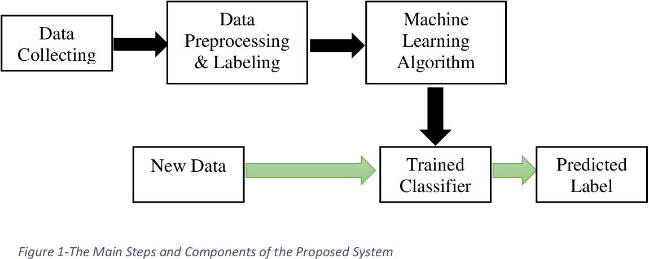

**Figure 2.1 Working Mechanism**

1. **MODELING AND ANALYSIS**

**3.1 Data Preprocessing:**

Clean the data by handling missing values, outliers, and inconsistencies.

Perform data imputation techniques like mean imputation, median imputation, or using predictive models to fill missing values.

Detect and deal with outliers using statistical methods or domain knowledge.

Normalize or scale the features to bring them to a similar scale to avoid biases in model training.

Encode categorical variables using techniques like one-hot encoding or label encoding to represent them numerically.

**3.2 Feature Selection:**

Conduct exploratory data analysis (EDA) to understand the relationship between features and the target variable.

Use statistical methods like correlation analysis to identify highly correlated features.

Apply feature importance ranking methods such as tree-based models or permutation importance to prioritize important features.

Utilize dimensionality reduction techniques like principal component analysis (PCA) or t-distributed stochastic neighbor embedding (t-SNE) to reduce the number of features while preserving the most critical information.

**3.3 Model Selection:**

Experiment with various machine learning algorithms suitable for the problem, such as linear regression, logistic regression, decision trees, random forests, support vector machines (SVM), and neural networks.

Consider the characteristics of the dataset, including size, complexity, and nature of the problem, to choose the appropriate algorithms.

Use ensemble methods like bagging, boosting, or stacking to combine multiple models for improved performance.

**3.4 Model Training:**

Split the dataset into training, validation, and test sets using techniques like k-fold cross-validation to evaluate the model's performance effectively.

Train the selected models on the training data using algorithms like gradient descent for optimization.

Tune the model parameters to optimize performance using techniques like grid search, random search, or Bayesian optimization.

Use regularization techniques like L1 (Lasso) or L2 (Ridge) regularization to prevent overfitting.

**3.5 Model Evaluation:**

Evaluate the trained models on the validation set using appropriate evaluation metrics such as accuracy, precision, recall, F1-score, ROC-AUC for classification tasks, and mean squared error, mean absolute error, R-squared for regression tasks.

Compare the performance of different models to select the best-performing one based on evaluation metrics.

**3.6 Model Interpretation:**

Interpret the trained models to understand the factors influencing predictions.

Generate feature importance plots to visualize the importance of each feature in the model's predictions.

Use techniques like partial dependence plots or SHAP (SHapley Additive exPlanations) values to understand the impact of individual features on predictions.

* 1. **Validation and Deployment:**

Validate the final model on unseen data or the test set to assess its generalizability and performance.

Deploy the validated model into production for real-world applications, where it can make predictions on new data and contribute to decision-making processes.

By following these steps meticulously, the modeling and analysis phase ensures the development of accurate and reliable predictive models that provide actionable insights for stakeholders in various domains.

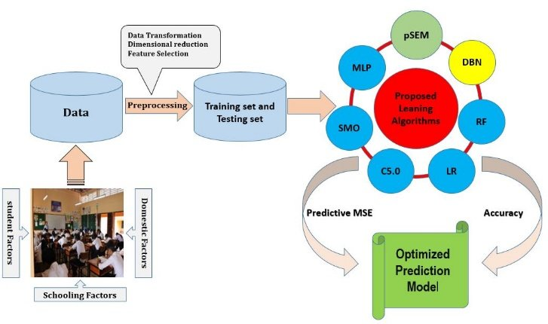

**Figure 3.1:** **Control-Flow Diagram**

1. **RESULTS AND DISCUSSION**



**Figure 4.1 Diagrams and Graphs**

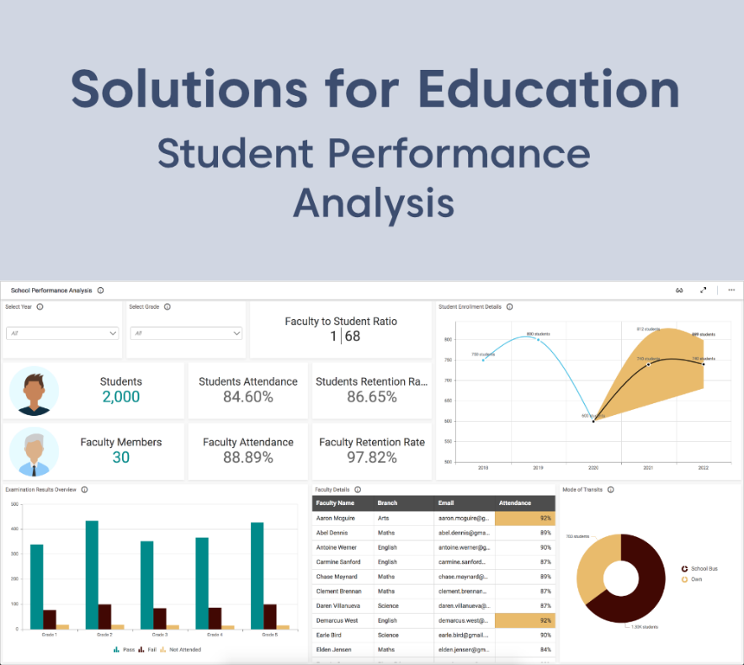

**Figure 4.2 Statistics and Actions needed**

When delving into the analysis of student performance, it's crucial to scrutinize various dimensions to gain a comprehensive understanding. This involves dissecting overall trends, subject-wise variations, and individual performance metrics. By examining aggregate data, educators can identify prevalent patterns, such as which subjects students excel in and which ones pose challenges. Additionally, comparing performance across different demographic groups sheds light on potential disparities and allows for targeted interventions.

Assessment methods play a pivotal role in gauging student performance. Evaluating the effectiveness of these methods unveils insights into their alignment with learning objectives and their ability to provide accurate representations of student knowledge. Furthermore, considering the longitudinal trajectory of performance offers valuable insights into educational outcomes over time, enabling educators to adapt strategies proactively.

Qualitative insights from students, teachers, and other stakeholders complement quantitative analysis by providing contextual nuances and uncovering underlying factors influencing performance. This holistic approach facilitates the identification of root causes behind performance trends and informs the development of tailored interventions.

Ultimately, the aim of analyzing student performance is not merely to report findings but to catalyze actionable change. Recommendations stemming from the analysis should be grounded in evidence and aimed at fostering equitable learning environments, enhancing teaching practices, and ultimately improving student outcomes. By synthesizing quantitative data with qualitative insights and leveraging them to inform strategic decisions, educational institutions can cultivate environments conducive to student success.

1. **CONCLUSION**

In conclusion, this project demonstrates the potential of machine learning in enhancing our understanding of student performance within educational contexts. By analyzing diverse datasets and leveraging advanced algorithms, we have uncovered valuable insights into the factors influencing academic outcomes. The development of predictive models enables educators to anticipate student grades accurately and identify at-risk students promptly, facilitating timely intervention strategies. Moreover, the implementation of personalized learning approaches tailored to individual student profiles fosters a more adaptive and effective educational environment. Through rigorous evaluation and interpretation of findings, this project underscores the importance of data-driven decision-making in education. By empowering educators and stakeholders with actionable insights, we can work towards creating more equitable and supportive learning environments where every student has the opportunity to thrive. Moving forward, continued research and application of machine learning techniques hold immense promise in driving innovation and improvement in educational practices, ultimately contributing to the success and well-being of students worldwide.

1. **REFERENCES**

[1] Organization, W.H Bloomberg, L.P: Global Report on Drowning Preventing a Leading Killer [2014]

[2] UNICEF Bank, W. Division, U.P: Levels and Trends in Child Mortality 2017. Lancet 243

[3] IEEE/CVF Conference on Computer Vision and Pattern Recognition (CVPR) 658-699 [2019]

[4] Educator Resources - Facts & Stats about Drowning, An Assessment of Statistical count of Causalities proclaimed by

Stop-drowning-now under their section of drowning statistics.

<https://www.stopdrowningnow.org/drowning-statistics/>

[5] Alotaibi, A. Automated and Intelligent System for Monitoring Swimming Pool Safety Based on the IoT and Transfer

Learning. Electronics 2020, 9, 2082. [Google Scholar]

[6] Mohtasham-Amiri, Z. Traumatic injuries in drowning. J. Inj. Violence Res. 2022, 14, 6, PMCID: PMC9115828.

[Google Scholar]

[7] Zaara, M.; Belhaj, A.; Naceur, Y.; Makni, C.; Gharbaoui, M.; Bellali, M.; Zhioua, M.; Allouche, M. Patterns of unintentional

fatal drowning among children in North Tunisia: A 10-year study. Rev. Dépidémiologie St. Publique 2022, 70, 31–37.

[Google Scholar]

[8] IJRTI-Lifeguard for Drowning Detection Saranya R, Bharath R, Gopinath SB, Deebak Raaj VPS, Gajapati VES Vol 8,

Issue 5 [2023]

[9] A. Roy and K. Srinivasan, "A Novel Drowning Detection Method for Safety of Swimmers," in Proc. Natl. Power Syst.

Conf. (NPSC), Dec. 14-16, 2018, NIT Tiruchirappalli, India, IEEE, pp. 1-6, 2018.

[10] N. Salehi, M. Keyvanara, and S. A. Monadjemmi, "An Automatic Video-based Drowning Detection System for Swimming

Pools Using Active Contours," I.J. Image, Graphics and Signal Processing, vol. 8, no. 8, pp. 1-8, Aug. 2016, doi:

10.5815/ijigsp.2016.08.01.

[11] H. Kam, W. Lu, and W.-Y. Yau, "A Video-Based Drowning Detection System," Centre for Signal Processing, School of

Electrical and Electronic Engineering, Nanyang Technological University, 50 Nanyang Avenue, Singapore 639798, IEEE,

2002.

[12] Kaviya K, Kavitha R, Ajitha R, Jothika S, "Drowning Detection System", IJRTI. International Journal for Research Trends

and Innovation, vol.8, no.5, pp.747-751, IJRTI. 2018.

[13] Tingzhuang Liu, Xinyu He ,Linglu He ,Fei Yuan: A video drowning detection device based on underwater computer

vision. IET Image Process. 17 1905–1918 (2023)

[14] Balaji Hariharan, Riji N Das, Arjun S, " WiEyeTNB : A Wireless Sensor Based Drowning Detection System for Enhanced

Parental Care", ICSSITE. Institute for Computer Sciences, Social Informatics and Telecommunications Engineering, pp.

511-520, 2012.

[15] Nasrin Salehi, Maryam Keyvanara, Seyed Amirhassan Monadjemmi, " An Automatic Video-based Drowning Detection

System for Swimming Pools Using Active Contours", IJIGSP. I.J.Image, Graphics and Signal Processing, vol.8, pp.1-8,

doi:10.5815/IJIGSP.2016.08.01

[16] Bapardekar Yukta, Berde Rinku, Valvi Priyanka, "Drowning Detection System Using CNN", IJCRT. International Journal

of Creative Research Thoughts, vol.10, no.3, pp.80-82, IJCRT. April, 2022.