**A STUDY ON FIXED ASSET MANAGEMENT**

1. Author: **M.VIJAYA LAKSHMI**, Asst. Prof., Dept. of MBA, SANTHIRAM ENGINEERING COLLEGE, NANDYAL

2. Author: **CH.V.MANIKANTA**, Student of MBA, SANTHIRAM ENGINEERING COLLEGE, NANDYAL

**ABSTRACT**:

Every company owns a fixed asset that is used in its business operations. To maintain a complete, accurate, and up-to-date fixed asset can be a challenge if tracking the asset without an automated process.

Fixed asset management is an accounting process that seeks to track fixed assets for the purposes of financial accounting, preventive maintenance and theft deterrence. Organizations face a significant challenge to track the location, quantity, condition, and maintenance and depreciation status of their fixed assets. Accounting of fixed assets must ensure control over the efficient use of industrial sites (lands), equipment’s, machinery, vehicles and other instruments of labor.

**INTRODUCTION**:

Fixed assets management is an accounting process that seeks to track fixed assets for the purposes of financial accounting, preventive maintenance, and theft deterrence. Organizations face a significant challenge to track the location, quantity, condition and maintenance and depreciation status of their fixed assets.

Fixed Asset management is crucial to the accounting process in any business. It can be difficult to find the time and the tools to devote the needed attention to assets that they deserve. The truth is that a company’s assets are the largest investments most companies make. Sound management of assets can yield substantial tax savings in depreciation deductions. Without thorough management of assets, the accuracy of financial reports will be threatened and there will be a negative impact on your bottom line. Establishing the highest standards of depreciation accuracy and best practices in fixed asset management will pay off in the form of savings and efficiency.

Asset management reports provide instant insight for tax planning, better use of existing assets and the purchase of future assets.

The term 'Fixed Asset' is generally used to describe tangible fixed assets. This means that they have a physical substance unlike intangible assets which have no physical existence such as copyright and trademarks.

In order for fixed assets to be recognized in the financial statements of an entity, the basic criteria for the recognition of assets laid down in the IASB Framework must be met:

• The inflow of economic benefits to entity is probable.

• The cost/value can be measured reliably.

A long-term tangible piece of property that a firm owns and uses in the production of its income and is not expected to be consumed or converted into cash any sooner than at least one year's time.

**Features of fixed assets**:

The Fixed Assets system includes the following features:

* Multiple depreciation books and methods
* Automated asset setup
* Asset search and location
* Insurance, financing, and warranty information
* Asset transfers, splits, and disposals
* Asset reports (standard and user-defined)

**REVIEW OF LITERATURE**:

The term 'Fixed Asset' is generally used to describe tangible fixed assets. This means that they have a physical substance unlike intangible assets which have no physical existence such as copyright and trademarks. Fixed assets are not held for resale but for the production, supply, rental or administrative purposes. Assets that held for resale must be accounted for as inventory rather than fixed asset.

An increasing trend in fixed assets turnover ratio is desirable because it means that the company has less money tied up in fixed assets for each unit of sales. A declining trend in fixed asset turnover may mean that the company is over investing in the property, plant and equipment. This ratio is usually used in capital-intensive industries where major purchases are for fixed assets.

Calculation (formula):

The formula for calculation of fixed asset turnover ratio is given below

Fixed Asset Turnover Ratio = Sales Revenue / Total Fixed Assets

The fixed assets usually include property, plant and equipment. The value of goodwill, long-term deferred tax and other fixed assets that do not belong to property, plant and equipment is usually subtracted from the total fixed assets to present a more meaningful fixed asset turnover ratio.

**Fixed assets policies and procedures**:

The basic goal and objective of this manual is to define and describe a set of standard procedures and policies necessary to record and control the changes in the fixed asset system in accordance with generally accepted accounting principles ensure that the asset is adequately protected from loss, theft, etc.

• Provide necessary documentation for the effective use, maintenance, management and reporting of the asset

• Facilitate the calculation and recording of depreciation for proprietary fund assets, and

• provide necessary documentation for insurance purposes Fixed asset record master files

**OBJECTIVES OF THE STUDY:**

• To study on different types of fixed assets.

• To study on repairs and maintenance cost on fixed assets.

• To study on relationship between fixed assets turnover and return on asset.

• To evaluate depreciation and method of depreciation adopted by LG Electronics India Pvt. Ltd,

**NEED FOR THE STUDY**:

The need is to evaluate that if fixed assets are liquidated, what proportion of it will contribute for the payment of owners fund and long-term obligations. The study is quickly create assets based on unlimited asset types, and report on them The study is required for the companies to evaluate fixed assets performance analysis time to time by comparing with pervious performance.

**RESEACH METHODOLOGY**

Research Design:

Research design is some statement or specification of procedures for collecting and analysing the information required for the solution of some specific problem. Here the explanatory research is used as investigation and is mainly concerned with determining the trends and returns in Fixed Assets Management.

Sources of Information: The sources of information are two types. They are

Primary Data:

• The primary data is not included in this study, only secondary data is taken in to account since it is a comparative analysis.

Secondary Data:

• The data gathering method is adopted purely form secondary sources

• The financial data and information is gathered from annual reports of the company internal records

**LIMITATIONS OF THE STUDY**

* The study is limited into the date and information provided by the LG Electronics India Pvt Ltd and its annual reports.
* The report may not provide exact fixed assets status and position of LG Electronics India Pvt Ltd it may be varying from time to time and situation to situation.
* The research is directly concerned with the companies fixed assets so achieving accurate data was not possible.
* The accounting procedure and other accounting principles are limited by the changes made by the company, may vary fixed assets performance.

**DATA ANALYSIS AND INTERPRETATION**:

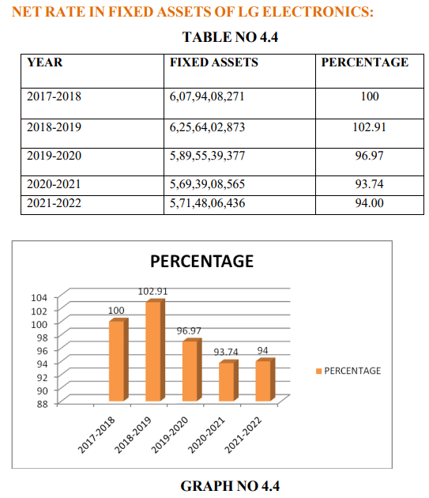

**INTERPRETATION**:

From the above table of LG Electronics Growth rate in fixed assets, the examination of the above table reveals analysis and interpretation.

• During the year 2017-2018 the assets investment was recorded at 6,07,94,08,271 and it is decreased to Rs 5,71,48,37,436 in 2021-2022 the fixed assets investment is quite satisfactory.

• The trend percentage in the year 2017-2018 is taken as the base year as 100% and it was decreased to 94.00% in the year 2021-2022.

• The average growth rate in fixed assets Rs.5, 92,90,306 in 5 years

**FIXED ASSETS RATIO**:

This ratio explains whether the firm has raised adequate long term funds to meet its fixed assets requirements and is calculated as under

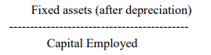

**FINDINGS:**

* The study states that fixed assets are not held for resale but for the production, supply, rental or administrative purposes. Assets that held for resale must be accounted for as inventory rather than fixed asset.
* The study states finds that economic life of the asset will be determined by such factors as technological progress and changes in demand.
* LG is the brand that is Delightfully Smart to resolve to relationship and to achieve the highest satisfaction for customers.
* There is high growth of sale in market due to booming in new technology and better service. Company should concentrate on long term assets are utilized for working capital problem will not arise in future.
* Fixed assets turnover ratio was increased the every year. Highest ratio was regarded at 2.40% in 2019-20.
* Return on grass capital employee highest ratio was regarded 5.7% in the year 2018-19

**SUGGESTIONS:**

* It is suggested to improve the position of the company by effective’s utilization of fixed assets.
* It should try to utilize the fixed assets to maintain maximum profit.
* LG should try new dealer who have the potential. So they can target more market.
* As there is a bottle neck competition between Samsung and LG, it is necessary to take measure steps to overcome the area of downfall in LG with respect to Samsung.
* The marketing managers should make better relations with dealers and reputation of the company.

**CONCLUSION**:

The project was based on the survey plan. The main objective of survey was to collect appropriate data, which work as a base for drawing conclusion and getting result

From the survey we can conclude that out that the majority of customers don’t buy consumer durables from exhibitions. Majority of customers do not want any financing scheme for purchasing the durables. There was heavy rush on weekends so large numbers of ISD’s were appointed that day. Also the live demo calls helps in selling. Exchange offers also generate sale. Customers are also now very choosy in buying the product and it is important for the company to make permanent customer of their brand. From the survey we can conclude that LG has captured maximum market share in every category. LG dominates CTV, LCD, and Refrigerator, and Washing machine, category. The Fixed asset management of the company is quite comfortable with a judicious mix of debt and equity. The overall assessment of financial statement signifies efficient utilization of the investments, loans and advances. The profitability of the company appears to be impressive, as judged by increase in reserves and surplus.

**BIBLIOGRAPHY**

**Books:**

* M.Y. Khan & P. K. Jain , Financial Management Fourth edition, published by TATA McGraw HILL New Delhi: 2001.
* Prof. Satish Inamdar, Financial Management published by Symbiosis center for distance learning, Pune,2020
* M. Pandey, Financial Management Second edition published by TATA McGraw HILL publishing company. New Delhi: 2018.
* Sashi K Sharma, Gupta, Financial Management, 10th Edition, Cengage Publication, Hyderabad, 2020.
* Nirmal, Gupta, Financial Management, 12th Edition, Cengage Publication, Hyderabad, 2017

**Website**

* [www.google.com](http://www.google.com)
* [www.ask.com](http://www.ask.com)
* [www.lg.com](http://www.lg.com)