REAL-TIME ATTENDANCE MONITORING WITH DEEP LEARNING TECHNIQUES.

M.Sri Kankshith B.Tech

School of Engineering Computer Science - AIML Malla Reddy University Hyderabad, India

H.SriSurya B.Tech

School of Engineering Computer Science -AIML Malla Reddy University

Hyderabad, India

A. Srivarshini B.Tech

School of Engineering Computer Science - AIML Malla Reddy University

Hyderabad, India

Y.Srikanth B.Tech

School of Engineering Computer Science - AIML Malla Reddy University Hyderabad, India

P.Srikar B.Tech

School of Engineering Computer Science -AIML Malla Reddy University

Hyderabad, India

Prof Siva Kumar B.Tech

School of Engineering Computer Science – AIML Malla Reddy University

Hyderabad, India

**ABSTRACT**

**Attendance management of students through the conventional methods had been a challenge in the recent years. In recent years, the problem of automatic attendance marking has been widely addressed through the use of standard biometrics. The manual attendance management system consumes more time and is difficult to maintain. This will be replaced by automatic attendance management system. Hence, this study utilizes an approach based on Convolutional Neural Networks (CNN). Here, the face recognition dataset is trained to the proposed CNN model. Using the Open CV face recognition approach, an input image will be processed and a face will be detected. This system uses Viola and Jones algorithm for detecting and recognizing the faces. The main elements of this technology are Face Detection, Face Recognition. This Proposed system improve the attendance management system using of our unique characteristics of their face. The Eigen faces algorithm is used for biometric facial recognition follow different steps of image processing are capturing, extracting, matching and comparing. The primary objective of this project is to develop and implement a facial recognition-based attendance management system in educational settings. The system aims to automate attendance tracking, enhance accuracy, and streamline management processes, ultimately saving time and improving efficiency for educators and administrators.**

1. **INTRODUCTION**

College attendance tracking is a crucial component of student involvement and engagement in the classroom. Roll call and manual login are two examples of traditional processes that are frequently ineffective and prone to error. These techniques need participant data to be manually entered into a database, which takes time and money that could be better spent. Traditional approaches also allow students to fraudulently record the presence of absent peers since they are vulnerable to proxy participation. As a response to this issue, biometric attendance systems have surfaced, which use distinctive identifiers like thumbprints to confirm student identity. These solutions do, however, also have drawbacks. For example, students must wait in line for biometric authentication, which can be inconvenient and time-consuming for the classroom. Modern attendance systems use technologies like facial recognition and transfer learning to overcome these problems. With the use of facial recognition technology, pupils can be automatically recognized as soon as they walk into the classroom, doing away with the need for human attendance tracking. Furthermore, these devices can guarantee that pupils are in class the entire time by keeping an eye on them. The efficiency and accuracy of attendance systems are further improved by the machine learning technology known as transfer learning. Attendance systems can swiftly adjust to new contexts and perform better without requiring a large amount of training data by using pre-trained models created for tasks like computer vision. This makes it possible for developers to design reliable attendance systems that can recognize students in a variety of settings. College attendance tracking is a crucial component of student involvement and engagement in the classroom. Roll call and manual login are two examples of traditional processes that are frequently ineffective and prone to error. These techniques need participant data to be manually entered into a database, which takes time and money that could be better spent. Traditional approaches also allow students to fraudulently record the presence of absent peers since they are vulnerable to proxy participation. As a response to this issue, biometric attendance systems have surfaced, which use distinctive identifiers like thumbprints to confirm student identity. These solutions do, however, also have drawbacks. For example, students must wait in line for biometric authentication, which can be inconvenient and time-consuming for the classroom. Modern attendance systems use technologies like facial recognition and transfer learning to overcome these problems. With the use of facial recognition technology, pupils can be automatically recognized as soon as they walk into the classroom, doing away with the need for human attendance tracking. Furthermore, these devices can guarantee that pupils are in class the entire time by keeping an eye on them. The efficiency and accuracy of attendance systems are further improved by the machine learning technology known as transfer learning. Attendance systems can swiftly adjust to new contexts and perform better without requiring a large amount of training data by using pre-trained models created for tasks like computer vision. This makes it possible for developers to design reliable attendance systems that can recognize students in a variety of settings.

We introduce a deep learning convolutional neural network (CNN) based facial recognition attendance system in this work. We apply transfer learning by training three pre-trained convolutional neural networks on our dataset, which consists of ten distinct classes with 20 face photos in each class. In order to train our model with facial emotions as well, the photos for the dataset were clicked in real time while the subjects were left, right, and center faced depending on their concern. The dataset consists of our face and each person with 20 clicks in various angles.

1. **LITERATURE REVIEW**

Deep learning approaches have been incorporated into real-time attendance systems, resulting in notable advancements that provide workforce management with unmatched accuracy and efficiency. In the past, manually recording attendance used inefficient and error- prone methods. On the other hand, the field of attendance management has seen a significant change due to the advent of deep learning, specifically Convolutional and Recurrent Neural Networks (RNNs). Recognizing faces and objects, two essential components of real-time attendance systems, is a task that CNNs excel at extracting spatial features from images. These devices do not require manual check-ins since they are able to precisely identify workers in real- time by using CNNs. RNNs can also accurately model sequential data, which allows them to predict future attendance patterns and capture temporal dependencies in attendance records. Employing CNNs and RNNs together ensures that attendance tracking is accurate both in terms of time and space, providing a comprehensive approach to workforce management. Moreover, attendance models can be continuously improved and adjusted through the use of deep learning, which results in increased flexibility and efficiency based on changing data patterns. Challenges like data privacy issues and model interpretability still need to be addressed despite the amazing progress. Techniques for reducing bias in attendance models, enhancing deep learning model interpretability, and integrating multimodal biometric data for increased accuracy and security are possible areas of future research.

Through the utilization of deep learning, real-time attendance systems possess significant potential to transform workforce management strategies and propel organizational achievements. However, despite the fact that face recognition technology has been used in a variety of sectors such as human identification systems, this work is the first to describe how the Face Recognition Technique can be integrated with a deep learning approach.[1] Advanced deep learning techniques can make the attendance system completely automated, highly secure, easier to use, and faster to implement than older systems. Nowadays, the Attendance System is becoming increasingly automated, resulting in time-saving, effective, and beneficial solutions that reduce the burden on administration and organizations.[2] The experimental results bring four short similarity situations of the classroom such as absence, delayed appearances, early leave, and unauthorized entry during class or session along with the name, student id, and section and passes this information to the attendance sheet which will evaluate the students/persons in the classroom.[3][4] This methodology saves time when compared to the traditional method of attendance marking, as well as allows organizations to conduct stress-free observations of students and staff.[5]

**3. PROBLEM STATEMENT**

Colleges are notorious for their protracted student roll calls, especially when there are a lot of them usually hundred or more. Under the semester system, instructors are required to call on students once or twice throughout each class period. A roll call becomes more significant when the total time invested in it is totaled. The conditions demand an intelligent, reliable, and efficient attendance system. Currently, the teachers either roll call or provide the students a document to sign. Both methods are time-consuming and susceptible to manipulation by students employing an attendance proxy.

Under the proposed system, students will use their face ID Under the proposed system, students will use their fingerprint or face ID to log in, along with the classroom location ID and date/time stamp. The system will only help with smart attendance; it will not aid in computing the total attendance for the duration of the semester. It will assist the teacher in calculating the list of defaulters who are unable to appear in the exam because of the university’s short attendance regulation.

This project addresses these issues by proposing a facial recognition-based attendance management system. The current landscape of attendance tracking systems often relies on outdated algorithms or manual input, leading to inefficiencies and security concerns. By utilizing unique facial characteristics, the system aims to distinguish individuals effectively, thus mitigating the risks associated with proxy attendance.

**4. METHODOLOGY**

**Data Collection:** Compile a collection of pictures featuring people whose attendance has to be monitored. Ideally, these pictures will showcase different lighting setups, viewpoints, and body positions.

**Data preprocessing:** Improve the quality and standardize the format by preprocessing the photos or the frames that are retrieved from images. To improve the dataset's variety, this may entail applying augmentation, normalization, and resizing approaches.

**Face Detection:** To identify and extract faces from the pictures or frames, use deep learning-based face identification techniques like Hear cascades or more sophisticated convolutional neural networks (CNNs).

**Face recognition:** Train a CNN-based or pre-trained deep learning model for face identification. Faces should be able to be embedded by this model into a high-dimensional feature space where different faces are placed far away and similar faces near to each other.

**Attendance Tracking:** After faces are identified and detected, compare the identified faces with a database of people you know to keep track of attendance. To find out if a recognized face matches a known person, a threshold might be specified.

**Monitoring and Maintenance:** To update the models with fresh data and increase their accuracy over time, continuously check the system's performance in real-world settings and carry out routine maintenance.

**Viola-Jones Algorithm:** This well-established algorithm is known for its speed and efficiency in real-time face detection. It's a popular choice for initial face localization within video frames, which is crucial for subsequent recognition steps.

**Eigen faces Algorithm:** This technique, while not the most advanced, provides a foundation for facial recognition. It involves creating a representation of faces (Eigen faces) based on captured images. By comparing an unknown face to the Eigen faces, the system can attempt to recognize the individual.

1. **PROTOTYPE/DESIGN**

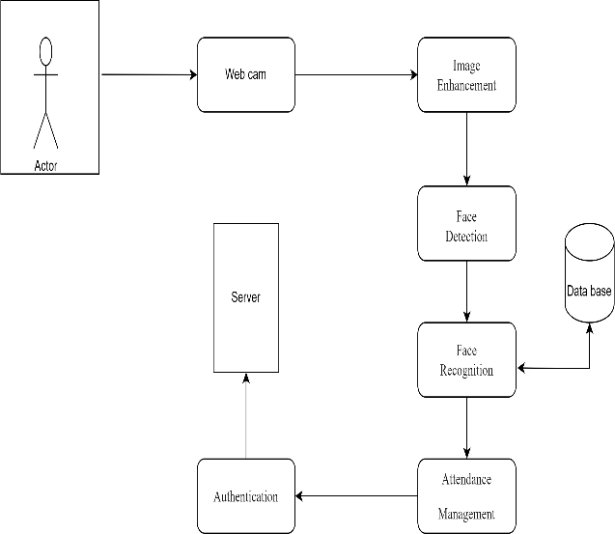

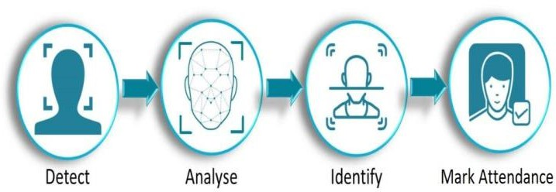

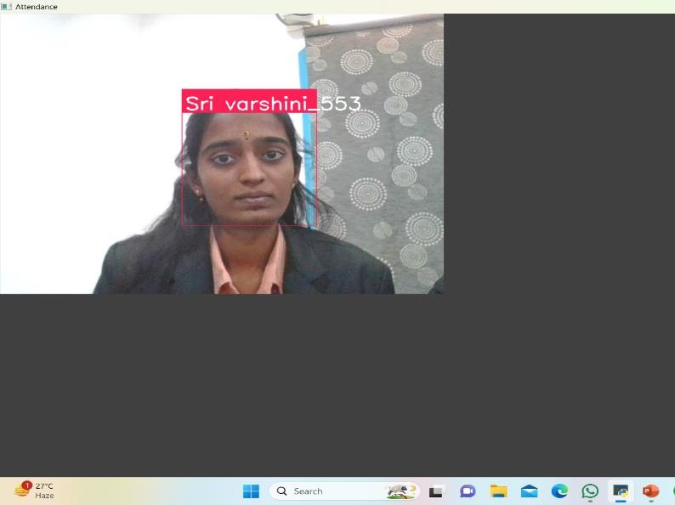There is a webcam installed at the door or entrance of the classroom so that when a student walks in, the webcam recognizes them, takes their picture, processes their input, and recognizes their face. The face is then recognized, the attendance is noted, and all of this information is saved on the server. The camera is used to identify and record a specific student's face as being in the database. Reports on attendance could also be created as needed.

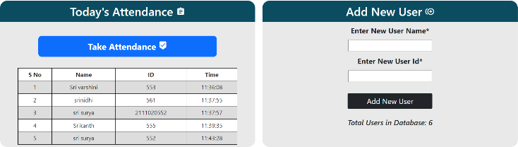**Detect Faces:** The system captures a live video stream using a webcam or camera. The first step involves using facial detection algorithms to identify the presence and location of faces within each video frame.

**Extract Facial Features:** Once a face is detected, the system focuses on the region of interest and extracts relevant facial features. These features may include the distance between the

eyes, the shape of the jawline, and the position of the cheekbones. **Recognize the Face:** The extracted facial features are then compared to a database of known faces. This database is likely created beforehand by collecting student images and associating them with their unique identification information. A deep learning model, typically a Convolutional Neural Network (CNN), performs this comparison. The CNN has been previously trained on a large dataset of faces and corresponding identities to recognize the specific features that distinguish one person from another.

**Match and Mark Attendance:** If a successful match is found between the extracted features and a known student in the database, the system marks the student as present. This process typically occurs in real-time, allowing for immediate attendance recording.

**Display Results (Optional):** The system might display the

recognized student’s information on the screen for confirmation or logging purposes.

1. 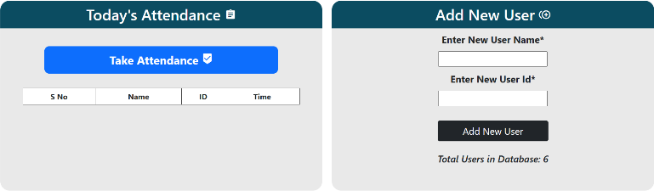**EXPERIMENTAL RESULTS**
2. **CONCLUSION**

Convolutional Neural Networks (CNNs), Transfer Learning, and Facial Recognition are examples of deep learning techniques that can be integrated to help the application identify people more accurately and robustly. These methods take advantage of deep learning to automatically identify pertinent aspects from face photos and determine attendance. Additionally, the application shows how machine learning and web development may be combined to produce useful answers for issues that arise in the real world. The program maybe able to track attendance more precisely in a variety of organizational and educational contexts with additional improvements and optimizations, such as enhancing the facial recognition model and putting more advanced deep learning techniques into use. Problems in the manual attendance system is that attendance of a particular person can be taken by a third party without the realization of the institution which violates the integrity of the data. Also, manual approach is too time consuming and creates a lot of hassle. So, the objective of this project was to make the attendance marking system automated and more efficient. In this project, a deep learning model is prepared for implementing an automated attendance management system for a college or any institutions. For now, this model incorporates a webcam that captures live video to detect face in real time, recognize the face and mark the attendance. Results of prediction showed that the model is working better but we need to improve it by feeding more data while training for higher level of accuracy.

An important step forward in the practical application of deep learning techniques is the incorporation of Convolutional Neural Networks (CNNs), Transfer Learning, and Facial Recognition into an automated attendance management system. Through the utilization of deep learning techniques, these approaches are able to efficiently extract pertinent features from face photos, which permits reliable and precise identification of people for the purpose of tracking attendance. By using CNNs, the system can automatically learn and recognize significant features from facial images, which enables it to recognize faces with a high degree of accuracy. By utilizing pre-trained models, transfer learning improves system performance even further and eliminates the need for large amounts of training data and computational resources. A key element of this system that is essential to the real- time identification of people is facial recognition. The system is able to identify faces in a webcam feed in real time, identify them, and then record attendance. When compared to manual methods, this automation greatly minimizes the time and effort needed for attendance management. Even with the encouraging outcomes thus far, there is still room for development and optimization. Adding more varied and substantial training data to the facial recognition model is one way to improve it. This procedure can help increase the model's robustness and accuracy, particularly when it comes to face recognition in a variety of settings and circumstances. Moreover, incorporating more sophisticated deep learning methods may improve the system's overall performance. The accuracy and effectiveness of the automated attendance management system can be further improved by investigating strategies like data augmentation, ensemble learning, and model fine-tuning. The necessity of automating these tasks using cutting-edge technologies like deep learning is highlighted by addressing the drawbacks of manual attendance systems, such as their susceptibility to unauthorized attendance marking and laborious procedures. To put it succinctly, the goal of this project is to develop an automated system for managing attendance that uses deep learning techniques to increase accuracy, reliability, and efficiency. The technology could completely transform attendance tracking in a variety of institutional and educational contexts by being improved and optimized on a constant basis.

1. **FUTURE ENHANCEMENTS**

**1. Student Self-Service Portal:** Create a student self-service portal so that students can check their attendance history, submit justifications for absences, and monitor their overall attendance standing for each course.

**2. Parent/Guardian Access:** To encourage openness and communication between the college and the families of its students, give parents or guardians restricted access to observe their child's attendance records.

**3. Attendance Challenges:** Plan competitions or challenges based on attendance amongst departments or classes to foster a sense of friendly rivalry and teamwork while boosting attendance.

1. **REFERENCES**
2. Hartley, R., Zisserman, A.: Multipleview geometry in computer vision. Cambridge university press (2003)
3. DiMaria, P.C., Madsen, J.: Biometrictime and attendance system with epidermal topographical updating capability (September 28 1999) US Patent 5,959,541.
4. Russell, S.J., Norvig, P.: Artificialintelligence: a modern approach. Malaysia;Pearson Education Limited, (2016)
5. Larochelle, H., Bengio, Y., Louradour, J., Lamblin, P.: Exploring strategies for training deep neural networks. Journal ofmachine learning research 10(Jan) (2009)
6. Haykin, S.: Neural networks. Volume 2.Prentice hall New