**SMART EXAMINATION OVERSIGHT SYSTEM**

**Prof. K. Jaya Bharathi *1, Shaik Ruha Jabeen*2, Raja Rohith*3, Nalamala Mahesh Babu*4**

1 Professor and Head Dept. of Information Technology, ACE Engineering College, Telangana, India.

2,3,4 Students, Information Technology, ACE Engineering College, Telangana, India.

**ABSTRACT**

The project titled Smart Examination Oversight System is a cutting-edge web application built using the MERN stack (MongoDB, Express.js, React.js, Node.js) aimed at enhancing the online examination experience. It incorporates with capabilities to ensure exam integrity and deter cheating during online assessments. Administrators can easily create, manage, and monitor exams while assigning proctors and maintaining exam security remotely. Students benefit from a user-friendly interface equipped with essential tools like timer display, question navigation, and submission alerts and audio alerts to enhance their exam-taking experience. The platform prioritizes security and privacy, implementing encryption protocols and data protection measures throughout the system. With a focus on automation, security, and user experience, Smart Examination Oversight System aims to revolutionize online examination processes for educational institutions and organizations, promising a more efficient and secure assessment environment. This project aims to revolutionize the way online examinations are conducted, making them more efficient, secure, and accessible. By harnessing the power of modern technologies, SMART EXAMINATION OVERSIGHT SYSTEM empowers educational institutions, recruiters, and certification bodies to conduct assessments with confidence and integrity in virtual environments.

**Keywords:** Online examinations, MERN stack, web application, Audio alerts.

1. **INTRODUCTION**

The landscape of education has undergone a rapid transformation in recent times, catalyzed by the global shift towards virtual learning and assessments. As educational institutions and organizations embrace online examinations to adapt to this new normal, the need for robust solutions to ensure exam integrity and prevent cheating has become paramount. In response to these challenges, the Smart Examination Oversight System project emerges as a groundbreaking web application, meticulously crafted using the powerful MERN stack—MongoDB, Express.js, React.js, and Node.js.

At its core, Smart Examination Oversight System represents a leap forward in enhancing the online examination experience. By adding audio alerts during proctoring capabilities, the platform not only guarantees exam integrity but also acts as a deterrent against cheating behaviors during online assessments.

Smart Examination Oversight System is an innovative proctoring system leveraging the MERN stack to enhance the integrity of online examinations. It incorporates AI algorithms for facial recognition and behavior analysis to detect test-taker’s suspicious activities in real-time. Administrators can easily create, manage, and monitor exams while assigning proctors and maintaining exam security remotely. With user-friendly interfaces and scalable architecture, Smart Examination Oversight System fosters trust in remote assessment practices, contributing to the advancement of online education.

The scope of the Smart Examination Oversight System project encompasses the development of a comprehensive proctoring system tailored for online examinations. It involves implementing AI-powered features like facial recognition and behavior analysis, seamless integration with existing learning management systems, intuitive user interfaces, scalability, stringent security measures, and support. By adhering to this scope, this project aims to provide a reliable solution for maintaining the integrity of remote assessments, meeting the evolving needs of educational institutions and organizations.

**Secure Authentication:** Users, including students and teachers, can securely log in to the system using their credentials, such as username and password. Authentication mechanisms should follow best practices to ensure the confidentiality and integrity of user accounts.

**Role-based Access Control:** Upon login, users are assigned specific roles (e.g., student or teacher) that determine their permissions and access levels within the system. Role management ensures that each user can only access functionalities relevant to their role.

**Exam Creation:** Teachers can create new exams within the system. They can define various parameters for the

exams, such as duration, question types, and grading criteria.

**Question Management:** Teachers can create and configure individual questions for exams. This includes defining question formats (e.g., multiple-choice, short answer) and adding relevant instructions or resources.

**Exam Access:** Students can view a list of available exams within the system. They have the capability to participate in exams for which they are eligible.

**Test Interface:** The exam interface for students displays questions, instructions, and a timer to monitor the remaining time. Additionally, the interface may include features such as auto-submit, which automatically submits the exam when the time limit is reached.

**Real-time Proctoring:** During exams, the system employs AI-based proctoring to monitor students in real-time. This involves analyzing webcam feeds to detect any suspicious behavior or irregularities and triggers the alerts.

**Cheating Behavior Detection:** The AI algorithms used for proctoring are trained to identify various cheating behaviors, such as the presence of mobile phones, multiple faces in the camera view, or the absence of detected faces indicating a potential attempt to hide from the camera.

**Incident Logging:** Incidents of detected cheating behaviors are logged by the system and made available to teachers through their dashboard. This allows teachers to review and take appropriate actions based on the logged incidents, such as investigating further or taking disciplinary measures.

1. **LITERATURE SURVEY**

As part of the Literature Survey, we have referred few project papers and the findings from them are:

Ai-Based Exam Proctoring System by Anubhav Kulshrestha (June 2023) [1].

This manuscript introduces a novel approach for the development of an Artificial Intelligence (AI)-based proctoring system tailored for online examinations. The methodology outlined herein aims to address the challenges encountered in maintaining the integrity of online assessments during the transition from physical to virtual learning environments, prompted by the COVID-19 pandemic. Similar to identifying products on supermarket shelves using computer vision, this approach utilizes advanced algorithms to ensure precise monitoring and supervision of online exams. By leveraging AI techniques such as image recognition and machine learning, the system can effectively detect and deter instances of academic dishonesty, thereby upholding the standards of the education system in the digital age.

Ai-Based Proctoring System for Online Tests by Vidhya (July 2022) [2].

This project introduces an innovative solution to address the challenges faced by educational institutions in proctoring online examinations amidst the COVID-19 pandemic. Drawing parallels to the method of identifying products on shelves using computer vision, our proposed approach involves the development of an AI-based integrated system aimed at preventing cheating during exams. Through a combination of techniques and tools, this system enables proctoring without the constant presence of an invigilator, thus offering a viable solution for the new normal of remote learning. Leveraging advanced AI algorithms, our model is designed to detect any instances of unfair practices during examinations, ensuring the integrity and reliability of online assessment processes.

Ai-Based Proctoring by Shakti Priya Saurav (March 2022) [3].

This article introduces a method for administering cheating-free online examinations using artificial intelligence. The approach leverages neural networks and machine learning to monitor exams without the constant presence of a proctor. The system employs advanced algorithms to detect any unfair means during the examination process. The innovation lies in automating proctoring tasks, significantly improving the integrity of online exams compared to traditional methods. Experimental results demonstrate that the proposed AI-based system outperforms existing proctoring techniques, ensuring a secure and reliable examination environment.

Proct-Xam – Ai Based Proctoring by Samuel Monteiro (October 2022) [4].

This article presents an AI-based online proctoring system designed to ensure integrity in online examinations. The approach employs Convolutional Neural Networks (CNNs) and Recurrent Neural Networks (RNNs) to monitor students via webcam, detecting suspicious activities such as eye movement, lip movement, and the presence of additional individuals in the frame. The system also includes screen sharing to ensure transparency. This AI-driven platform enables students to take exams from any location while maintaining exam integrity, addressing the rise in cheating during online assessments. The proposed system aims to provide a trustworthy and efficient solution for conducting online exams, enhancing confidence in the online education sector.

1. **METHODOLOGY**
2. 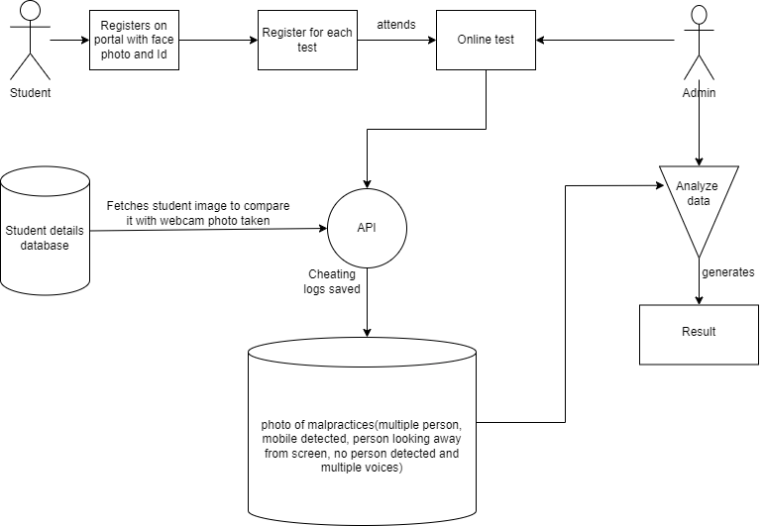 **ARCHITECTURE DIAGRAM**

**Figure 1:** Architecture Diagram

1. **DATASET**

We require a database to store usernames, passwords, exam results and proctor results. So we are using a MongoDB database to create and store usernames, passwords, exam results and proctor results to have a record of user details.

1. **ALGORITHMS**

**Step 1: Sign Up**

* User selects a role (Student or Teacher) and provides necessary details to create an account.
* Assign a unique user ID and store user information into the database.

**Step 2: Log In**

* User logs in with credentials.
* Authenticate the identity by matching it with stored data; upon successful verification, allow entry into the system.

**Step 3: Teacher Capabilities**

* Teachers can create exams and define questions.
* Providing teachers with tools for managing exams, including the creation and configuration of questions.
* Teachers can view the exam results.

**Step 4: Student Functionality**

* Students can access and engage in available examinations.
* The test page displays questions and a timer with an auto-submit feature.
* A message alert and an audio alert will be triggered in case of cheating.

**Step 5: Logout**

User can log out from the website easily.

1. 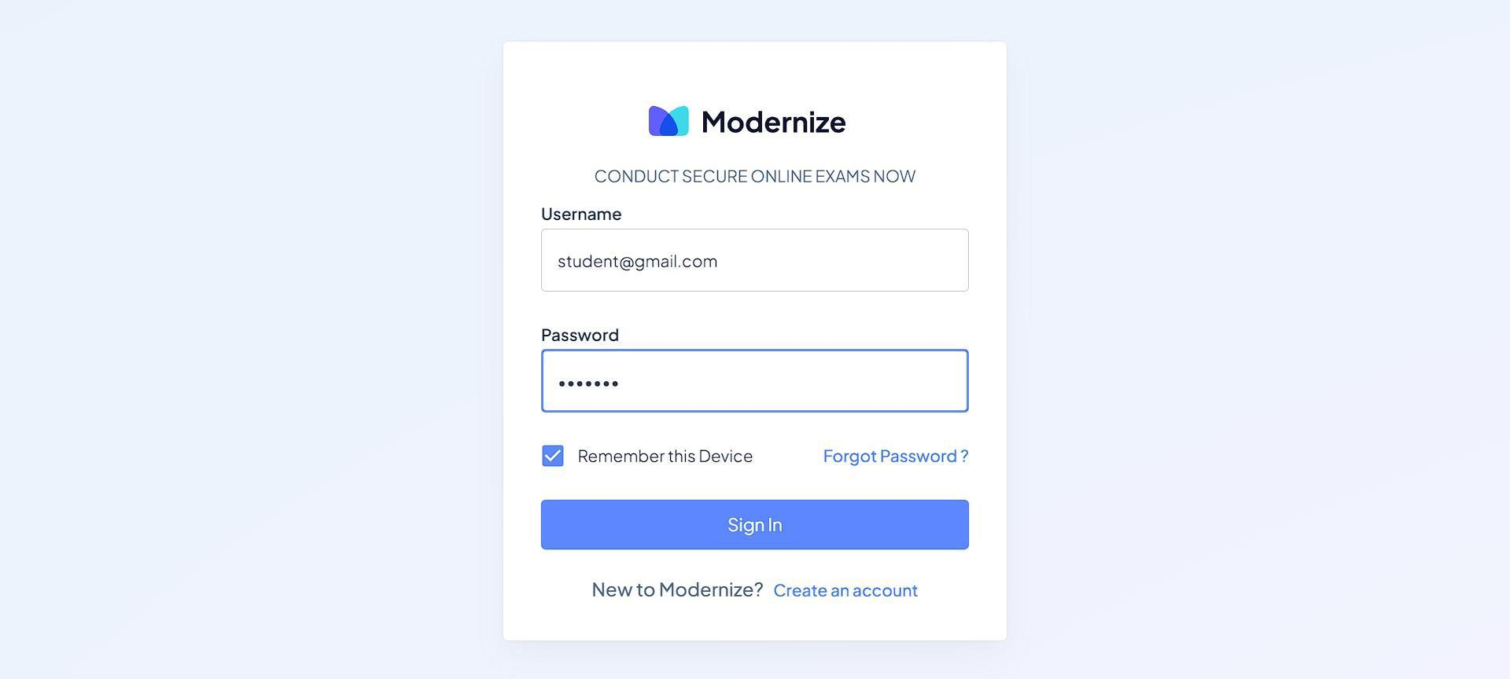**OUTPUT SCREENS**

**Figure 2:** Login Page

**Figure 3:** Registration Page

Figure 4:** Dashboard Page (Student)

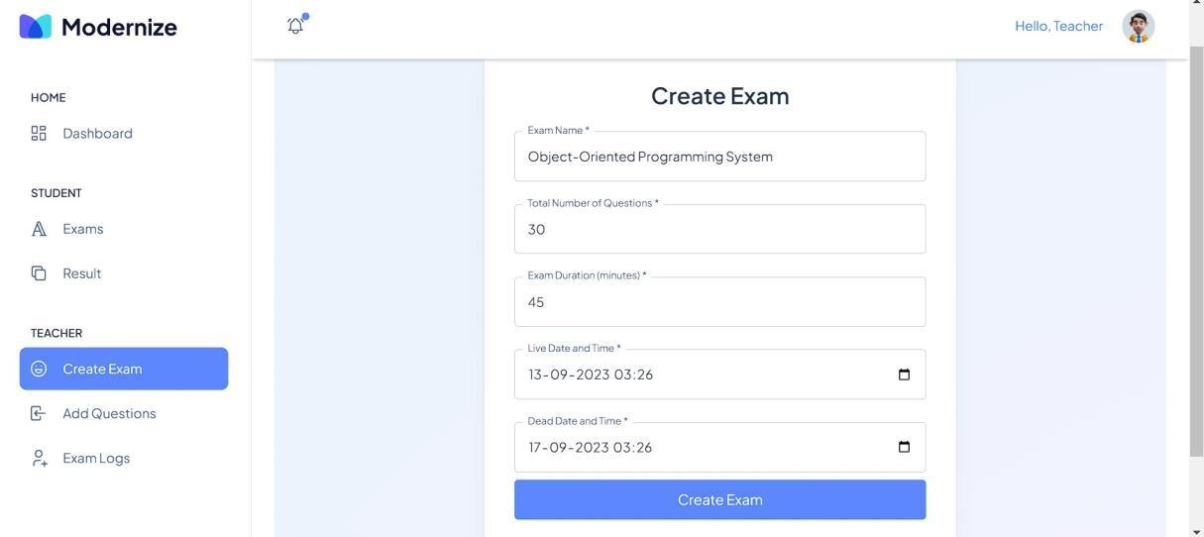**Figure 5:** Dashboard Page (Teacher)

**Figure 6:** Create Exam Page (Teacher)

**Figure 7:** Strat Exam Page (Student)

**Figure 8:** Alert Page 1 (Student)

**Figure 9:** Alert Page 2 (Student)

Figure 10:** Alert Page 3 (Student)

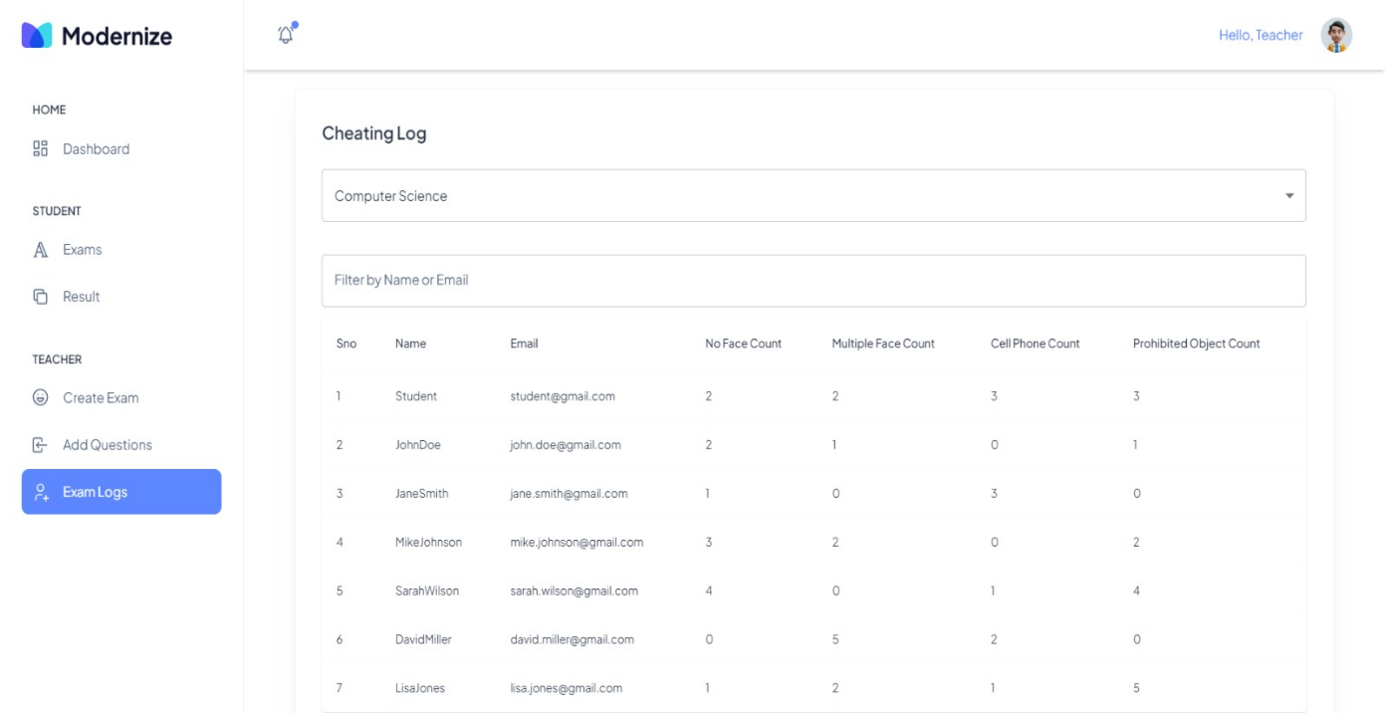**Figure 11:** Test Submitted (Student)

**Figure 12:** Cheating Logs (Teacher)

1. **CONCLUSION**

In conclusion, the Smart Examination Oversight System represents a significant advancement in the realm of online examinations. Utilizing the MERN stack, this web application offers a comprehensive solution to enhance the integrity and efficiency of online assessments. By integrating robust security measures, user-friendly interfaces, and automated processes, the platform addresses the challenges of exam security and user experience. It empowers administrators to seamlessly manage exams and ensures students have the necessary tools for a smooth exam-taking process. The Smart Examination Oversight System sets a new standard for online examination platforms, making secure and reliable assessments accessible to educational institutions, recruiters, and certification bodies worldwide. This innovative project is poised to transform the landscape of online examinations, fostering trust and integrity in virtual assessment environments.

1. **FUTURE SCOPE**

Future enhancements for the Smart Examination Oversight System focus on several key areas to further improve its functionality and user experience. The priority is to refine AI algorithms to enhance accuracy in detecting suspicious activities during exams. To address varying security needs, the implementation of adaptive authentication will provide a dynamic and responsive security framework. Seamless integration with Learning Management Systems (LMS) will facilitate smooth operations and data flow, ensuring a cohesive user experience. Customizable proctoring policies will allow institutions to tailor examination protocols to their specific requirements, enhancing flexibility and control. Robust reporting and analytics features will be developed to provide comprehensive insights and facilitate data-driven decision-making. The creation of mobile applications will offer added convenience, allowing users to access the platform from various devices. To cater to a diverse user base, support for multiple languages and localization will be incorporated, making the system accessible globally. Ensuring accessibility features will promote inclusivity, accommodating users with different needs. Regular updates will be maintained to ensure the highest levels of security and performance. Finally, establishing a user feedback mechanism will enable continuous improvement, allowing the platform to evolve based on user experiences and suggestions. These enhancements will collectively contribute to a more efficient, secure, and user-friendly online examination system.

1. **REFERENCES**
2. Ai-Based Exam Proctoring System by Anubhav Kulshrestha (June 2023).
3. Ai-Based Proctoring System for Online Tests by Vidhya (July 2022).
4. Ai-Based Proctoring by Shakti Priya Saurav (March 2022).
5. Proct-Xam – Ai Based Proctoring by Samuel Monteiro (October 2022).
6. Automated Online Exam Proctoring by Yousef Atoum (2017).
7. Students Online Exam Proctoring: A Case Study Using 360 Degree Security Cameras by Aiman A Turani (2020).
8. "Exploring the Effectiveness of AI-Based Remote Proctoring in Online Examinations" by Arindam Biswas, Arindam Sarkar, and Prasanta Bhattacharya. Published in the International Journal of Advanced Computer Science and Applications (IJACSA), this paper discusses the effectiveness and impact of AI-based remote proctoring systems on online examinations.
9. "A Survey on AI Techniques for Exam Proctoring in E-Learning Environments" by Thanh Hai Trinh, Dung Trong Nguyen, and Huyen Trang Tran. This survey paper provides an overview of various AI techniques used in exam proctoring systems within e-learning environments, highlighting their benefits and challenges.
10. "Implementation and Evaluation of an AI-Based Proctoring System for Online Exams" by Juan Carlos Ortega, Ricardo Quintero, and Juan Diego Gómez. Presented at the 2019 IEEE Global Engineering Education Conference (EDUCON), this paper discusses the implementation and evaluation of an AI-based proctoring system for online exams.
11. "AI-Based Proctoring Systems: A Comprehensive Review" by Anjali Arora, Vandana Bhalla, and Poonam Tanwar. Published in the International Journal of Computer Applications, this review paper provides a comprehensive analysis of AI-based proctoring systems, including their functionalities, technologies used, and future prospects.