|  |  |  |
| --- | --- | --- |
| **Chapter no.** | **Particulars** | **Page. No** |
| Chapter -1 | **Introduction**   1. Background of the topic (ABSTRACT) 2. Body of Research & Case Laws 3. Need/importance of the topic 4. Theoretical implication of the topic. 5. Recent trends related to the topic | **2-43**  1-6  7-39  40  41  43 |
| Chapter -2 | **Literature review** | 44-52 |
| Chapter -3 | **Company Profile & SWOT ANALYSIS** | 53-62;63-67 |
| Chapter -4 | **Research Design**   1. Statement of the problem& Research Gap 2. Need of the study 3. Hypothesis 4. Objectives of the study 5. Scope of the study 6. Research methodology 7. Limitation of the study  * Population * Sample design   + Sample size   + Sampling unit   + Sampling method * Method of data collection   + Primary data   + Secondary data   + Instrument for data collection   + Testing of Questionnaire / Pilot study   + Hypothesis (If Any)   + Data- analysis techniques | 68-72  68  40  69  69  70  71  72 |
| Chapter-5 | **Data Interpretation** | 73-84 |
| Chapter-6 | **Data Analysis** | 85-109 |
| Chapter-7 | **Findings** | 110-113 |
| Chapter-8 | **Recommendations** | 114-115 |
| Chapter-9 | **Conclusion** | 116-117 |
| Chapter-10 | **References** |  |
| Chapter-11 | **Annexure** |  |

**CHAPTER – 1**

**INTRODUCTION**

**Unveiling the Dynamics of Tax Compliance: A Comprehensive Analysis on Tax Avoidance, Planning, and Evasion Strategies and Practices in Bengaluru.**

**ABSTRACT:**

Tax evasion and tax avoidance pose significant challenges to economic development in India, undermining the government's ability to collect revenue and finance essential public expenditures. Tax evasion involves the intentional non-payment or under-reporting of taxes, while tax avoidance entails the legal manipulation of tax regulations to reduce tax liability. Both practices have adverse effects on economic growth, investment, and government revenue. Research utilizing secondary data from diverse sources highlights the detrimental impact of these practices on key economic indicators such as GDP growth, investment, and government revenue.

The findings indicate that tax evasion and tax avoidance have substantial negative consequences for India's economic development. Tax evasion leads to a reduction in government revenue, limiting resources available for critical sectors like education, healthcare, and infrastructure. On the other hand, tax avoidance distorts resource allocation and discourages foreign investment, ultimately hampering overall economic growth. This research underscores the urgent need for effective measures to combat tax evasion and tax avoidance to foster sustainable economic development in India.

In conclusion, the study emphasizes the significant detrimental effects of tax evasion and tax avoidance on India's economy. It provides compelling evidence supporting the implementation of robust measures to address these practices and promote a fair and efficient tax system. By tackling tax evasion and tax avoidance, India can enhance government revenue, facilitate investment in vital sectors, and foster sustainable economic growth.

**Keywords*:*** Tax Avoidance, Tax Evasion, Economic Development, Government Revenue.

CBDT, Professional services

**OBJECTIVES OF THE STUDY**

1. To analyse the various methods used by the individuals and businesses to evade or avoid taxes, assess the magnitude of revenue loss due to these activities, and evaluate the overall impact on Karnataka economy.
2. To study the need of corporate governance in proper payment of taxes.
3. To explore the potential policy measures and strategies to combat the tax evasion and tax avoidance.
4. **To understand the various loopholes in the tax system of the country & find out the evidence and determinants of tax evasion in the country.**

**SCOPE OF THE STUDY**

The scope of the study "Unveiling the Dynamics of Tax Compliance" in Bengaluru, focusing on tax avoidance, planning, and evasion strategies, perceptions, and practices, is broad and multifaceted. Here's a breakdown of its scope:

1. **Geographical Scope**
2. **Dimension of Tax Compliance**
3. **Perceptions and Practices**
4. **Qualitative and Quantitative Analysis**
5. **Policy Implications**
6. **Industry and Demographic Considerations**

**INTRODUCTION OVERVIEW**

The economic growth of a nation like India can be significantly impacted by two prevalent practices: tax evasion and tax avoidance. Tax avoidance is the use of legal strategies to lower tax liabilities, whereas tax evasion involves people or corporations avoiding paying taxes in an illegal manner. Each of these actions can have severe repercussions for a nation's economy.

The impact of tax evasion and tax avoidance on India’s economic growth is a key issue for consideration because of the substantial amount of revenue that is generally lost because of these practices. The Indian government mainly relies on tax revenue to pay for social programs, infrastructure improvements, and other efforts to promote economic growth. When individuals or businesses avoid paying taxes, it reduces the amount of revenue that the government can collect, which in turn can lead to budget deficits, reduced public services, and an overall slower pace of economic development.

Another study by the International Monetary Fund (IMF) highlights the adverse effects of tax evasion and avoidance on economic growth. The study suggests that tax evasion and avoidance lead to a decline in public trust in the government, reduced investment, and a decline in the quality of public services. These factors, in turn, lead to a decrease in economic growth and development. Further research has also revealed that tax evasion and avoidance have several underlying factors. These include inadequate tax administration, weak legal frameworks, and low taxpayer compliance. The lack of political will and corruption are also significant factors that contribute to tax evasion and avoidance in India.

Tax evasion is where individuals deliberately fail to pay the tax liability. For example, if the taxpayer fails to pay tax that is imposed on him or if he pays the tax less than the tax that is imposed on him it becomes an illegal act and it’s a tax fraud it is called tax evasion. Whereas tax avoidance means the taxpayer through the advantage of the legislature and through the loopholes in it he reduces the tax liability to pay. Tax avoidance is a legal method and it has not been prohibited by any law. Due to these common practices, it has a significant impact on the Indian economy. Due to the sizable amount of money that is typically lost as a result of these practices, the effect of tax evasion and tax avoidance on India's economic growth is an important factor to take into account. Tax evasion results in a decrease in the amount of money the government can bring in, which can result in budget deficits, a reduction in public services, and overall easing of the pace of economic expansion.

Tax evasion and tax avoidance by individuals in Karnataka can be a complex and multifaceted

issue. In general, tax evasion refers to the illegal act of deliberately not paying taxes owed, while tax avoidance involves legally minimizing tax liability through various strategies and loopholes.

Taxation is a crucial pillar of government finance, playing a pivotal role in generating revenue for funding public services and infrastructure. Here's an overview of its importance:

1. **Government Revenue**: Taxation serves as the primary source of revenue for governments at various levels (local, regional, national). This revenue is essential for financing government operations, including public services such as healthcare, education, transportation, defense, law enforcement, and social welfare programs.
2. **Redistribution of Wealth**: Taxes can be designed to redistribute wealth within society by imposing higher rates on those with higher incomes or wealth. This redistribution helps reduce economic inequality and promotes social cohesion.
3. **Economic Stability**: Taxation can be used as a tool for macroeconomic management. Governments can adjust tax rates to stimulate or cool down economic activity, helping to stabilize the economy during periods of boom or recession.
4. **Public Goods and Services**: Tax revenue funds the provision of public goods and services that may not be efficiently provided by the private sector due to market failures. These include infrastructure projects like roads, bridges, and utilities, as well as essential services like healthcare and education.
5. **Externalities and Regulation**: Taxes can be used to internalize externalities, such as pollution or congestion, by imposing taxes on activities that generate negative externalities (e.g., carbon taxes). Similarly, taxes can discourage certain behaviors deemed harmful to society, like smoking or excessive consumption of sugary drinks.
6. **Investment in Human Capital**: Tax revenue invested in education and healthcare contributes to the development of human capital, which is essential for long-term economic growth and competitiveness.
7. **Social Safety Net**: Taxes fund social safety net programs such as unemployment benefits, welfare, and social security, providing a cushion for individuals facing financial hardships.
8. **Infrastructure Development**: Tax revenue is instrumental in financing the construction and maintenance of infrastructure essential for economic development, including transportation networks, communication systems, and utilities.

Taxation plays a crucial role in government revenue generation and the provision of public services. Here's an overview of its importance:

1. **Primary Revenue Source:** Taxation is typically the largest source of revenue for governments at all levels (local, state, and federal). These funds are essential for financing government operations, including public services and infrastructure projects.
2. **Funding Public Services:** Tax revenue is used to finance various public services, such as education, healthcare, transportation, public safety (police and fire departments), social welfare programs, and environmental protection. These services are vital for the well-being and development of society.
3. **Redistribution of Wealth:** Taxation can be used as a tool for redistributing wealth within society. Progressive tax systems, where higher-income individuals are taxed at higher rates, help to reduce income inequality by transferring resources from the wealthy to the less affluent through social programs and services.
4. **Economic Stability:** Taxation can contribute to economic stability by providing governments with the necessary resources to implement countercyclical fiscal policies. During economic downturns, governments can increase spending on public services and infrastructure projects, funded by tax revenue, to stimulate economic growth and create jobs.
5. **Addressing Market Failures:** Taxation can be used to address market failures and negative externalities. For example, governments may impose taxes on activities that generate harmful effects on society, such as pollution (carbon taxes) or unhealthy behaviors (sin taxes on tobacco and alcohol). These taxes not only generate revenue but also discourage socially undesirable behavior.
6. **Investment in Infrastructure:** Tax revenue is crucial for financing infrastructure

development and maintenance, including roads, bridges, public transportation systems, and utilities. Adequate infrastructure is essential for economic growth and

competitiveness.

1. **Social Security and Retirement Benefits:** Taxes, particularly payroll taxes, fund social security and retirement benefits for eligible individuals. These programs provide financial support to retirees, disabled individuals, and survivors of deceased workers, ensuring a basic standard of living for vulnerable populations.

Overall, taxation is indispensable for financing government activities and providing essential public services that contribute to the well-being and development of society. Efficient and equitable tax systems are essential for promoting economic growth, social justice, and overall prosperity.

**BODY OF RESEARCH:**

***“A tax is a fine for doing right. A fine is a tax for doing wrong.”***

The confederation of Indian Industries published a “Desirable Code of Corporate Governance” in 1998 and a number of forward-looking companies took its recommendations on board. The poor governance practices lead to financial reporting, their accountability and proper payment of due in terms of tax liability. Any company or corporate major responsibility is to make economy very productive and serving economy in a well manner to get boost. So, in this way the corporate body should hold its responsibility over its society. Any corporate can fulfil its responsibility through paying taxes properly and it should not to be avoid/evasion. Corporate governance comes to prominence in the business world as a new phenomenon of the last 2 decades. Even corporate governance includes a complex area including legal, cultural, ownership and other structural differences and focusing on share holder value and approach, interest of diverse groups like employees, creditors, suppliers, customers and local community.

Tax evasion has always been one of the most difficult challenges for government all round the world. Tax evasion is done by individuals belonging to different strata of the society in different ways. As per the surveys and reports, there are many people who provide false income details to the tax authorities to reduce the amount of liability considered as tax evasion. Tax evasion is one of the basic causes to generate the black income. Therefore, various measures were undertaken to plug the loopholes in tax evasion.

The corporate governance framework also depends on the legal, tax, regulatory, and institutional environment. In addition, factors such as business ethics and corporate awareness of the environmental and societal interests of the communities in which a company operates can also have an impact on its reputation and its long-term success. Corporate governance is an integral part of everyday business life and its importance expanded to global context. Corporate governance is unconditionally mandatory to the company. Tax management is a value-maximizing activity, given that the benefit is only realized in the long run and can be uncertain.

Over the past two decades of experience to address the problem of low tax revenue collected from profitable companies. The concept of Minimum Alternative Tax (MAT) was first introduced in 1983 in India. In the direct tax system MAT came to make sure that companies having large profits and declaring substantial dividends to shareholders, but not paying tax to the concerned government, by getting benefit from several incentives, deductions and exemptions available in Income Tax Act. Preparation of Financial statements as per the provisions of parts II & III of schedule VI of the Companies Act, 1956 and the proposed DTC is very clear that to continue with MAT. MAT not applicable on or after 1-4-2006 to any SEZ under section 115JB (6) of IT Act.

In India, a significant portion of the population fails to fulfil their tax obligations, resorting to illicit means or exploiting legal loopholes. "Tax evasion" denotes the illicit tactics employed by individuals, corporations, trusts, and other entities to evade taxes. This entails intentionally deceiving tax authorities by misrepresenting business activities to reduce or eliminate tax liabilities, such as underreporting expenses or declaring lower incomes, profits, or gains than actually earned. Consequently, funds meant for societal and economic progress are diverted to nefarious activities, hindering the nation's development and fostering corruption and illicit financial practices. Tax evasion also relies on the expertise of chartered accountants and tax attorneys who aid entities in evading taxes. It is universally recognized as a criminal offense, subjecting offenders to fines and imprisonment in major nations.

Tax planning involves an intelligent application of the various provisions of the direct tax laws to practical situations in such a manner as to reduce the tax impact on the assesses to the minimum.

**Concept of tax planning:**

Tax planning is a strategic financial management activity aimed at minimizing tax liabilities through lawful and informed financial decisions. It involves leveraging available tax exemptions, deductions, concessions, rebates, allowances, and other benefits provided under tax laws. Effective tax planning requires a thorough understanding of the legal provisions and an ability to anticipate the tax implications of various financial arrangements.

Key aspects of tax planning include:

1. **Residential Status**: Adjusting the number of days of stay in a country to optimize residential status and benefit from favourable tax treatments for residents versus non-residents.
2. **Choosing Assessable Entities**: Selecting the appropriate form of assessable entity (e.g., Individual, Hindu Undivided Family (HUF), Firm, Cooperative Society, Association of Persons (AOP), Company, Trust) to maximize tax benefits. Different entities enjoy different tax rates and exemptions.
3. **Tax Regime Options**: For individuals, HUFs, AOPs, and Body of Individuals (BOIs), the choice between the default tax regime and the concessional tax regime under section 115BAC can significantly affect tax liabilities. Opting for or against section 115BAC should be based on a detailed comparison of tax outflows under both regimes.
4. **Corporate Tax Regimes**: Corporate taxpayers have options under sections 115BAA and 115BAB to pay taxes at reduced rates subject to certain conditions. These options might require foregoing specific exemptions or deductions but can result in lower overall tax liabilities.
5. **Investment Choices**: Selecting suitable investment forms (e.g., share capital, loan capital, leases, mortgages, tax-exempt investments) based on the availability of deductions for interest or dividend income.
6. **Asset Management**: Strategically replacing assets to benefit from depreciation provisions. Proper timing in replacing assets can optimize tax savings.
7. **Capital Asset Sales**: Timing the sale of capital assets to benefit from long-term capital gains deductions. Holding periods and applicable deductions should guide the decision on when to sell assets.
8. **Business Diversification**: Expanding into industries like hotel and agro-based industries to take advantage of specific profit-linked and investment-linked tax benefits available under the tax laws.
9. **Commercial Expediency**: Claiming deductions for business expenses based on the concept of commercial expediency. This means that expenditures made for the purpose of the business, even if not directly tied to immediate profits, can be deductible.

Effective tax planning requires careful consideration of various factors and a deep understanding of the tax laws. Tax advisors and planners must ensure that their strategies are robust, legal, and appear natural rather than contrived. This careful planning can result in significant tax savings and a reduced tax burden for taxpayer

In order to curb tax avoidance, provisions such as

* + applicability of transfer pricing provisions in respect of specified domestic transactions,
  + treating any transaction with the person located in the notified jurisdiction areas to be treated as international transaction,
  + General Anti-avoidance Rules,
  + provisions relating to furnishing of Tax Residency Certificate for claiming benefit of double tax avoidance agreements

have been introduced.

**TAX AVOIDANCE**

By using tax avoidance, we satisfy all legal requirements while simultaneously lowering our tax liability; we are not punished or fined for tax avoidance because we are not breaking any laws; rather, we are simply taking advantage of legal loopholes to reduce our tax burden. Tax avoidance is a legal means of reducing our tax liability by taking advantage of lack of provision in the law and it will result in less tax being paid by us. Since tax avoidance entails tax dodging and delays tax liability, it is regarded as immoral. Making adjustments to the accounts so that there are no tax laws broken is one method of tax avoidance. Although it is legal, tax avoidance may occasionally be regarded as fraud.

**REASONS FOR THE TAX EVASION & AVOIDANCE**

In both developed and developing nations, there are numerous explanations why people evade and avoid paying taxes. Since developed nations have high levels of tax awareness, the motivations behind tax avoidance and evasion there are different from those in less developed nations and nations in development. A major effect of tax avoidance and evasion is a drop in tax revenue for the government, undermining its integrity. Avoiding and evading taxes leads to lower government revenue, which increases the deficit and forces the government to print money or borrow it more currency, which causes inflation. Examining its circumstances is essential in order to Put forth ideas for reducing or eliminating them. The reasons for the tax evasion and avoidance are as follows:

**High tax rates:** High tax rates can create an incentive for individuals and businesses to engage in tax avoidance and evasion. When the tax burden is substantial, people naturally look for legal and illegal means to reduce the tax liability that is imposed on them. They also explore the offshore tax havens, trust or complex structures to legally minimize taxes or resort to illegal activities to evade the taxes altogether.

**Complexity of tax laws:** Tax codes are often intricate and complex, making it easier for individuals and businesses to exploit loopholes or engage in aggressive tax planning. The complexity can create confusion, enabling tax avoidance activities that exploit unclear provisions or mismatches between different tax ways.

**Lack of transparency in tax systems:** In some cases, there is lack of transparency in tax systems or weak enforcement mechanisms can encourage tax avoidance and evasion. Limited resources for tax authorities, bribery and corruption can undermine their ability to effectively monitor and enforce compliance. This creates an environment where individuals and businesses may feel they can evade taxes without severe consequences.

**Globalization and multinational corporations:** The globalized economy has led to increased opportunities for multinational corporations to exploit differences in tax laws and regulations across jurisdictions. Creating complex corporate structures, shifting profits to low-tax jurisdictions or engaging in transfer pricing manipulation, multinational corporations can legally reduce their tax liabilities significantly.

**Weak tax administration:** Inadequate enforcement and lack of resources for tax administration agencies increase the likelihood of tax evasion. Weak audit capabilities, limited monitoring and ineffective penalties fail to deter potential evaders.

**Corruption and bribery:** widespread corruption and bribery can undermine tax collection efforts. Bribes paid to tax officials can result in lenient treatment on tax matters or even complete exemptions, creating an unfair or non - transparent tax.

**Perceived unfairness:**

Some individuals may engage in tax evasion and tax avoidance due to perceived unfairness that the tax system is unfair or unjust They may argue that the taxes are not used efficiently or that they are disproportionately burdened compared to others, leading to a mindset of tax resistance.

**Informal economy:**

Countries that have large informal economies are more susceptible to tax evasion. In these cases, individuals and businesses may conveniently avoid declaring their income or transactions, which leads to a significant loss in tax revenue.

**Financial gain and greed:**

Tax avoidance and evasion often come down to financial gain and greed. Individuals and businesses seek to maximize their profits by minimizing tax obligations, regardless of the societal impact or ethical considerations. The prospect of retaining a higher share of income or profits can be enticing enough to prompt tax avoidance or evasion activities.

**Ineffective tax policies:**

Tax policies that do not adequately address the loopholes, exemptions or disparities can inadvertently contribute to tax avoidance or evasion. Poorly designed policies can create incentives for individuals and businesses to engage in aggressive tax planning or exploit the legal gaps.

**Regulatory competition:**

In a globalized economy, countries often compete to attract investment and businesses by offering competitive tax incentives. This may lead to a "race to the bottom" in which nations cut their tax rates, opening the door for tax evasion.

**Strategic tax planning:**

Individuals and businesses engage in careful tax planning to minimize them

taxes. This includes strategic decisions such as selecting tax-favorable investments, utilizing tax credits or deductions or structuring their affairs in a manner that reduces their taxable income.

In India, companies seek not to pay or dodge taxation in order to preserve cash for transactions or agreements with government offices and hirelings. Experts advise against paying taxes because of the high rates so as to save revenue for the future. Officials in the political and most of the time, other lawmakers avoid prosecution because their income mostly comes from fixes and illegal techniques. The actions of individual citizens, society norms on the market side, and flaws and deficiencies in the revenue or demand part of tax administration all lead to tax evasion and avoidance.

**Causes of tax evasion and avoidance: -**

1. Out of book transactions.

2. Manipulation of books of accounts, sales/receipts, expenses

3. Under reporting production

4. Manipulation of capital, closing stock and capital expenses

5. Financial market transactions, non-profit sector

6. Cash economy.

7. Parallel books of accounts

8. Low level of voluntary tax compliance

9. Weak enforcement of tax laws

**DIFFERENT WAYS OF TAX EVASION & AVOIDANCE**

The following are the most common methods used by individuals and companies in practice with the tax evaders to evade taxes.

**Underreporting income:** The income is deliberately concealed and some or all of their income is to pay less tax.

**Overstating Deductions:** Individuals may overstate their deductions by claiming expenses that are not legitimate or exaggerating the value of deductible items. Whereas this includes the inflating business, charitable donations or claiming personal expenses as business expenses.

**Offshore Accounts:** Tax evaders often set up offshore accounts in countries with tax laws to hide their assets and income. They keep their money in offshore banks, individuals aim to avoid reporting their income to tax authorities.

**Using shell companies:** Establishing shell companies, which are often fake companies without any real operations, can be used to hide income or underreport. Money funneled through these entities to avoid deduction or manipulate the appearance of their income.

**Transfer pricing:** Multinational corporations may manipulate transfer pricing by artificially inflating costs in high tax countries and reducing profits in low tax countries. This allows them to shift profits to jurisdictions with lower tax rates, reducing their overall tax liability.

**Tax Shelters:** High income individuals often invest in tax shelters, such as real estate partnerships or limited partnerships, which generates losses that offset their taxable income. These shelters are designed to exploit the loopholes in tax laws.

**Incorporating in tax havens:** Incorporating a company in a tax haven jurisdiction such as Bermuda allows individuals to benefit from lower tax rates, minimal reporting requirements and heightened privacy.

**Tax incentives and deductions:** Legally maximizing deductions, credits and incentives offered by tax laws to lower tax liabilities.

**Incorporating in tax- friendly jurisdictions:** Incorporating businesses in countries or states with lower tax rates or favorable tax laws.

**Charity and philanthropy:** Donating to charities, foundations, or social causes to qualify for tax deductions.

**Employee stock options:** Providing employees with stock options as a form of compensation, which can be taxed at a lower rate than regular stock options as a form of compensation which is subject to a lower tax rate than ordinary income.

**International tax planning:** Utilizing international structures and treaties to reduce overall tax obligations by taking advantage of varying tax rates and exemptions between countries.

**Double tax treaty abuse:** Some individuals may exploit double taxation agreements between countries to artificially reduce their tax liability by routing their funds through multiple jurisdictions so they avoid paying taxes in either of the countries.

**Paying Bribes:** Engaging in corrupt practices to avoid paying taxes or to receive preferential tax treatment.

**METHODS:**

Here are some of the most common methods of tax avoidance used by individuals and companies:

1) **Deductions and exemptions**: One of the most common methods of tax avoidance is to claim deductions and exemptions. The Income Tax Act allows for several deductions and exemptions, such as those for charitable donations, medical expenses, and home loan interest, which can be used to reduce taxable income.

2) **Transfer pricing**: Transfer pricing is a method used by multinational companies to shift profits from high-tax jurisdictions to low-tax jurisdictions. This is done by setting up subsidiaries in countries with lower tax rates and then transferring profits to those subsidiaries.

3) **Setting up shell companies**: A shell company is a company that has no real business activity and is set up only to channel funds to other entities. These companies are often used to evade taxes by transferring money to them and then transferring it to other entities to avoid detection.

4) **Offshore accounts**: Offshore accounts are bank accounts held in a foreign country. These accounts are often used to avoid taxes by hiding income from the tax authorities.

5) **Capital gains tax**: Capital gains tax is a tax on the profit earned from the sale of assets such as stocks, bonds, and real estate. One way to avoid capital gains tax is to hold on to assets for the long term, as the tax rate decreases over time.

**LEGAL PROVISIONS**

There are certain provisions related to tax avoidance in the Income Tax Act, 1961 related to tax avoidance which ensure that taxpayers pay their fair share of taxes. They provide the tax authorities with the necessary powers to investigate and prosecute cases of tax avoidance.

1. **General Anti Avoidance Rule (GAAR):** Section 96 of the Income Tax Act, 1961 provides for GAAR. It allows the tax authorities to declare any arrangement or transaction as an 'impermissible avoidance arrangement' if they are satisfied that the

arrangement was entered with the main purpose of obtaining a tax benefit. The tax authorities may then disregard such arrangement and assess tax as if the arrangement had not been entered into.2

2. **Transfer Pricing Regulations**: Section 92 of the Income Tax Act, 1961 deals with transfer pricing regulations. It requires that transactions between related parties be conducted at arm's length prices, i.e., the price that would have been charged if the transaction was between unrelated parties. If the transaction price is not at arm's length, the tax authorities may adjust the price to the arm's length price and assess tax accordingly.3

3. **Thin Capitalization Rules**: Section 94B of the Income Tax Act, 1961 deals with thin capitalization rules. It disallows the interest paid on excessive debt as a deduction for tax purposes. Excessive debt is defined as debt that exceeds twice the amount of equity capital in the company.4

4. **Tax Avoidance Schemes**: Section 97 of the Income Tax Act, 1961 covers tax avoidance schemes. It allows the tax authorities to disregard any transaction or arrangement that has no commercial substance and is entered into solely for the purpose of obtaining a tax benefit.5

**LEGAL PROVISIONS**

**Section 271H:** It deals with the late filing of the income tax return which can be classified as a type of tax evasion, this is a punishable offence under the Income Tax Act, 1961 with a penalty of Rs. 10,000 to 1,00,000 on the assessee.6

2. **Section 270A**: This section deals with the concealment of income from the income tax department, which is a very serious issue in tax evasion. In this offence, the assessing officer should be convinced that the assessee has concealed any income.7

3. **Section 271B**: It deals with a person who does not get his accounts audited as required under section 44AB of the Income Tax Act, 1961.8

4. **Section 234E**: It deals with the non-compliance of the assessee with the TDS rules. If a business or institution fails to submit tax deducted at source or tax collected at source (TCS) returns on time, they must pay a penalty of Rs 200 per day.

5. **Section 276C**: Under this, a person who intentionally tries to evade tax or understate their revenue in excess of Rs 25 lakh faces imprisonment for a minimum of six months and up to seven years, as well as a fine. When completing an ITR, it is illegal to provide false information, including PAN data.10

6. **Section 139A**: When completing an ITR, it is illegal to provide false information, including PAN data. PAN card IDs are required by all tax deductors, including employers. This information is used to collect TDS from payments.

**Criminal Offense:** Tax evasion is considered a criminal offense in many jurisdictions. It is not simply a civil matter but can lead to criminal charges, fines, and imprisonment.

**Legal Provisions:** Legal provisions related to tax evasion may include the following: **a. Criminal Charges:** Tax evasion can result in criminal charges against the individual or entity involved. The specific charges may vary, but common ones include fraud, false statements, and tax evasion itself.

**b. Penalties and Fines**: If found guilty, tax evaders may face significant penalties and fines. These can be based on a percentage of the evaded tax amount or can be a fixed amount specified in the tax laws.

**c. Imprisonment:** In some cases, tax evasion can lead to imprisonment. The length of imprisonment depends on the severity of the offense and the tax laws of the jurisdiction.

**d. Investigation and Audits:** Tax authorities have the power to investigate and audit individuals or entities suspected of tax evasion. They can request financial records, conduct interviews, and scrutinize tax returns to assess whether tax evasion has occurred.

**e. Asset Seizure:** Tax authorities may also have the power to seize assets and properties of individuals or entities involved in tax evasion. This is done to recover the evaded taxes or to compensate for the unpaid amounts.

**PENALTY FOR TAX AVOIDANCE IN INDIA**

Penalties for tax avoidance in India can vary depending on the specific circumstances and the amount of tax evaded. The Income Tax Act, 1961, outlines several provisions and penalties for tax avoidance.

**Penalty for underreporting of income**: Underreporting of income can result in a penalty equal to 50% of the tax payable on the underreported income.

**Penalty for concealing income or furnishing incorrect information:** Concealing income or furnishing incorrect information can result in a penalty ranging from 100% to 300% of the tax sought to be evaded.

**Penalty for failure to maintain proper books of account:** If a taxpayer fails to maintain proper books of account, they can be liable to pay a penalty of up to 2% of the average total sales or turnover.

**Penalty for failure to comply with tax provisions:** Non-compliance with various tax provisions, such as not filing tax returns or not paying tax dues, can result in a penalty of up to Rs. 10,000.

**Prosecution:** In severe cases of tax evasion, criminal prosecution may be initiated, which can lead to imprisonment for a term ranging from three months to seven years, along with a fine.

**PAN-Aadhaar linking**: The government has mandated linking the unique identification number (Aadhaar) with the Permanent Account Number (PAN), which is necessary for filing income tax returns. This linkage creates a comprehensive financial profile of individuals and businesses, enabling the government to monitor income sources, financial transactions, and tax liabilities more effectively. It helps identify discrepancies and under-reporting of income. Income Disclosure Schemes: The government has introduced various voluntary disclosure schemes, such as the Income Declaration Scheme (IDS) and the Pradhan Mantri Garib Kalyan Yojana (PMGKY). These schemes allow taxpayers to declare undisclosed income and assets, pay the required taxes and penalties, and avoid prosecution. Such schemes help increase tax compliance and bring unaccounted wealth into the formal economy.13

**Digital payment promotion**: The government has been promoting digital payment methods like Unified Payments Interface (UPI), National Electronic Funds Transfer (NEFT), and Immediate Payment Service (IMPS) to reduce cash transactions. Digital transactions leave a trail that helps authorities track income sources and detect tax evasion. Incentives like discounts, cashback, and tax benefits are provided to encourage digital payments.14

**Demonetization:** In 2016, the Indian government demonetized high-denomination currency notes (₹500 and ₹1,000) to curb black money, counterfeit currency, and tax evasion. This step forced people to deposit their unaccounted cash in banks, making it traceable and taxable.15 While the short-term impact led to cash shortages and economic disruptions, the long-term benefits included increased tax compliance and a shift toward digital payments.

**Tax information exchange agreements**: India has signed bilateral and multilateral agreements with various countries to exchange tax-related information, such as the Double Taxation Avoidance Agreements (DTAA) and the Automatic Exchange of Information (AEOI). These agreements enable cross-border collaboration in identifying tax evaders and recovering undisclosed income and assets.

**E-assessment**: The Indian government introduced a faceless e-assessment system to minimize corruption, discretion, and taxpayer harassment during income tax scrutiny. This system employs artificial intelligence and data analytics to select cases for scrutiny, ensuring a transparent and unbiased process. E-assessment eliminates direct contact between taxpayers and tax officials, reducing the scope for corruption and promoting a more efficient tax administration system.17

**Project Insight**: Launched by the Income Tax Department, Project Insight employs advanced data mining and analytics tools to analyse taxpayer information, identify tax evaders, and detect discrepancies in income declarations. The project helps the government monitor high-value transactions, detect patterns of tax evasion, and take corrective action. By leveraging big data, Project enhances the efficiency and effectiveness of tax administration.18

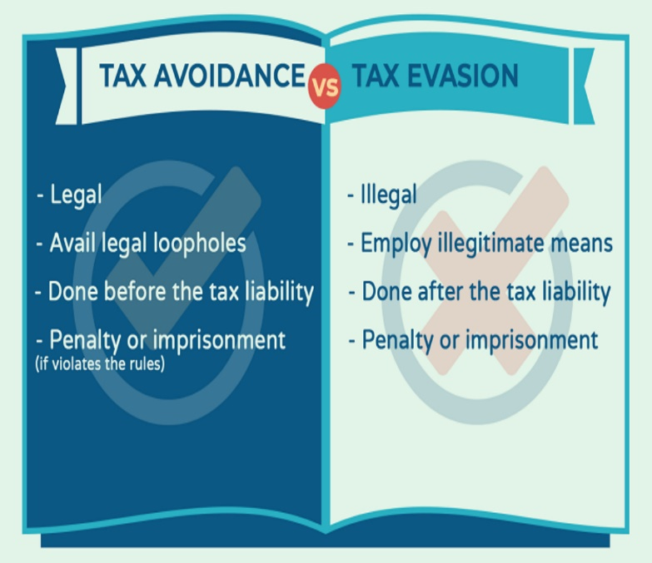**Harsh penalties**: The Indian government has introduced stringent penalties for tax evasion, including substantial monetary fines and imprisonment. These penalties act as a deterrent, encouraging taxpayers to comply with tax laws and regulations. For example, under the Income Tax Act, 1961, tax evasion can lead to imprisonment for up to seven years and a fine. The Black Money (Undisclosed Foreign Income and Assets) and Imposition of Tax Act, 2015, imposes even stricter penalties, including imprisonment for up to 10 years and a fine of up to 300% of the undisclosed foreign income or asset's value. These stringent measures aim to discourage tax evasion and promote a culture of tax compliance. This forced people to deposit unaccounted cash in banks, making it traceable and taxable. Long-term benefits included increased tax compliance and a shift towards digital payments.

**DIFFERENTIATE BETWEEN TAX EVASION & AVOIDANCE**

Tax planning and tax avoidance are very similar in that they are both entirely permissible under the law. It is the taxpayer's expectation to plan their taxes, while the government does not anticipate tax avoidance. The Income Tax Act of 1961, for instance, has some provisions that a taxpayer can most effectively use the deductions allowed by Sections 10 and 80C to minimize his or her tax liability to properly carry out tax planning, including Section 80U, Section 37, etc. Yet, in contrast, an organization moving its intellectual property from India to a nation with lower tax rates is a successful instance of tax evasion.

However, contrary to tax planning and avoidance, tax evasion is totally prohibited by law and is not supported in any way by any government. Tax evasion entails breaking the law and is tantamount to outright theft. One typical instance of tax evasion is cash income that was not disclosed. Discovered hidden during the 2016 demonetization campaign in numerous Indian homes. Money that was made unlawful and was unreported wealth that people had amassed through not paying taxes.

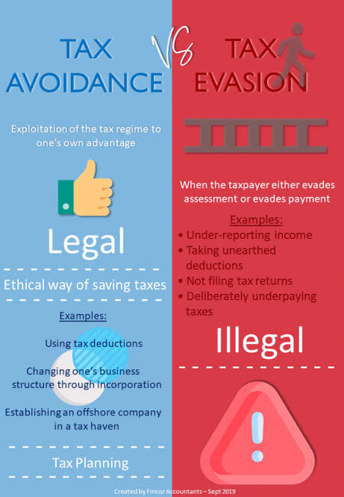

**Actionable steps taken by Government of India to combat problem of Tax Avoidance:**

The Government of India has taken several actionable steps to combat the problem of tax avoidance under the Income Tax act 1961 and Finance Act 2015. The following are the steps:

**Introduction of General Anti-Avoidance Rules (GAAR):** GAAR provisions were introduced in the Finance Act, 2015, to empower tax authorities to deny tax benefits to any arrangement that is deemed to be an impermissible tax avoidance arrangement. Under GAAR, tax authorities are granted the power to determine the legitimacy of tax positions that are overridden by commercial considerations. This means that if a taxpayer engages in transactions or arrangements primarily for the purpose of obtaining tax benefits, rather than for genuine commercial reasons, the tax authorities can disregard such arrangements and tax the taxpayer accordingly.

The implementation of GAAR is aimed at preventing arrangements or transactions that have the sole purpose of avoiding taxes by taking advantage of loopholes in the law. These provisions ensure that taxpayers cannot misuse legal provisions and artificially structure their affairs to avoid tax liability.

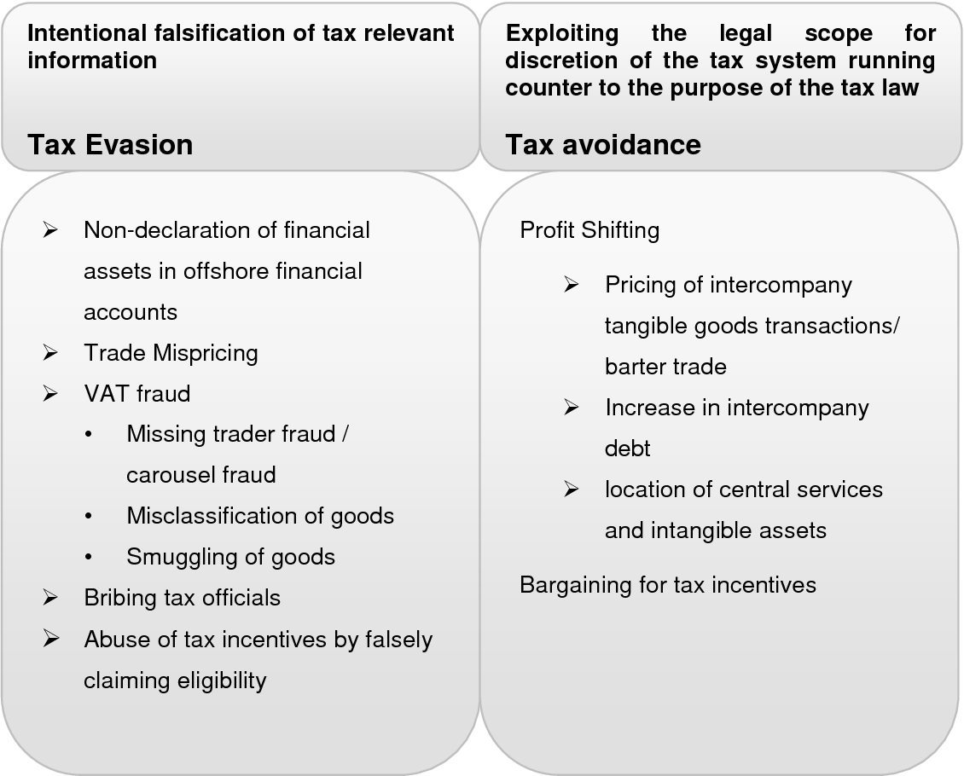The key feature of GAAR is that it empowers tax authorities to invalidate transactions or arrangements that are determined to be abusive or lacking in commercial substance. The tax consequences of such transactions can then be adjusted to prevent tax avoidance. The introduction of GAAR in India is a significant step towards curbing aggressive tax planning and promoting tax compliance. It provides tax authorities with the necessary tools to combat tax avoidance through the misuse of legal provisions and ensures that taxpayers pay their fair share of taxes.

**Base Erosion and Profit Shifting (BEPS) Implementing the Action Plan:**

India has been actively participating in the BEPS initiative led by the Organization for economic co-operation and development (OECD). The BEPS action plan aims to counter tax avoidance strategies used by multinational companies. India has taken measures to align its domestic legislation with the BEPS recommendations. One of the key objectives of the BEPS action plan is to ensure that profits are taxed where economic activities generating the profits are conducted and where value is created. To achieve this, India has introduced several measures to prevent profit shifting and base erosion.

Firstly, India has implemented country-by-country reporting (CyBC) requirements for multinational companies. Under these requirements, multinational companies are required to provide detailed information on their global activities, including their profits, taxes paid, and economic activities in each country. This helps tax authorities to gain better insights into the operations of multinational companies and identify any potential tax avoidance strategies. Secondly, India has implemented the Multilateral Instrument (MLI) developed by the OECD.

**Strengthening Transfer Pricing Regulations:**

Transfer pricing regulations have been strengthened to ensure that transactions between associated enterprises are conducted to ensure at arm's length prices. The government has introduced the concept of range to determine the arm's length price and more stringent documentation requirements have been imposed on taxpayers. The purpose of these strengthened regulations is to ensure that transactions between associated enterprises are conducted at arm's length prices. This means that the prices charged for the goods, services, or intellectual property transferred between the entities should be similar to what would be charged between unrelated parties in an open market.

**Widening the tax base:** The government has taken steps to increase the tax base by promoting digital transactions, implementing the Goods and Services Tax (GST), and encouraging voluntary compliance through campaigns like the Black Money Act. This is done to generate more revenue for the government and reduce the fiscal deficit. Several measures have been taken in India to achieve this objective.

**Promoting digital transactions:** The government has been actively promoting digital transactions as a way to widen the tax base. By encouraging people to use digital payment methods such as credit/debit cards, mobile wallets, and online banking, the government can track transactions more easily and reduce the scope for tax evasion. It also reduces the reliance on cash transactions, which are often unrecorded and can lead to tax evasion.

**Encouraging voluntary compliance:** The government has undertaken various campaigns and initiatives to encourage voluntary tax compliance. One such initiative is the Black Money (Undisclosed Foreign Income and Assets) and Imposition of Tax Act. This act aims to tackle black money, undisclosed foreign assets, and income earned from them. It offers a compliance mechanism for those who failed to disclose such assets or income in the past to come forward voluntarily and declare them, with payment of appropriate taxes and penalties.

Tax evasion and tax avoidance by individuals in Karnataka, as in any other region, are indeed

complex issues with significant relevance in the context of the state. Karnataka, being one of the most economically vibrant states in India, home to several industries including IT, biotechnology, manufacturing, and agriculture, faces specific challenges and implications related to tax evasion and avoidance. Here's a detailed explanation of the relevance of this topic in the context of Karnataka:

1. **Economic Impact:** Tax evasion and avoidance deprive the state government of crucial revenue that could otherwise be used for development projects, infrastructure, public services, and welfare programs. Karnataka, with its rapid urbanization and

industrialization, requires substantial funding for infrastructure development, education, healthcare, and other essential services. When individuals evade or avoid taxes, it affects the state's ability to meet these needs efficiently.

1. **Tech Hub and High-Income Individuals:** Karnataka, particularly Bengaluru, is often referred to as the Silicon Valley of India due to its thriving IT sector. The state hosts numerous multinational corporations, startups, and high-income individuals. Tax

evasion and avoidance among this demographic can significantly impact government revenue. Moreover, the complexity of income sources, including stock options, bonuses, and capital gains, makes tax compliance and enforcement challenging.

1. **Agriculture and Rural Economy:** While Karnataka's urban areas contribute significantly to its economy, agriculture remains a crucial sector, employing a significant portion of the population. Tax evasion and avoidance practices in agriculture, such as underreporting income or exploiting loopholes, can hamper the government's ability to support rural development, provide agricultural subsidies, and improve infrastructure in rural areas.
2. **Informal Sector and Small Businesses:** Karnataka, like many other states in India, has a substantial informal economy comprising small businesses and self-employed individuals. Tax evasion is prevalent in this sector due to factors such as cash

transactions, lack of awareness about tax regulations, and limited enforcement

capabilities. Addressing tax evasion in the informal sector is essential for broadening the tax base and ensuring fairness in the tax system.

1. **Real Estate Sector:** The real estate sector in Karnataka, particularly in Bengaluru, has witnessed rapid growth in recent years. However, it is also notorious for black money transactions, underreporting of property values, and tax evasion. These practices not only deprive the government of revenue but also contribute to inflation in property prices and distortions in the housing market.
2. **Cross-Border Transactions:** Karnataka's strategic location and economic ties with neighbouring states and countries make it susceptible to cross-border tax evasion and avoidance schemes. Individuals and businesses may engage in practices such as transfer pricing manipulation, tax haven utilization, and treaty shopping to minimize their tax liabilities. Addressing these issues requires cooperation and coordination between tax authorities at different levels and jurisdictions.
3. **Impact of the tax evasion and tax avoidance on National economy :** Loss of Government Revenue: Tax evasion and avoidance lead to a reduction in the amount of tax revenue collected by the government. This loss of revenue can negatively affect government budgets, leading to reduced funding for essential public services such as healthcare, education, infrastructure, and social welfare programs.
4. **Increased Budget Deficit:** The loss of tax revenue due to evasion and avoidance can contribute to a larger budget deficit. This, in turn, may result in higher government borrowing, increased public debt, and potential economic instability.
5. **Inequality and Unfairness:** Tax evasion and avoidance exacerbate income inequality and unfairness within a society. Those who can afford to engage in these activities often end up paying lower effective tax rates compared to individuals who cannot exploit such loopholes.
6. **Distorted Market Economy:** Tax evasion and avoidance can distort the functioning of the market economy. When some businesses or individuals can avoid taxes, they gain a competitive advantage over their counterparts who operate within the legal framework. This can create unfair competition, hinder market efficiency, and lead to market inefficiencies.
7. **Decreased Investor Confidence:** Widespread tax evasion and avoidance can erode investor confidence in a country's economic system. This is particularly true for foreign investors who may perceive a lack of legal and fiscal stability. The resulting decrease in foreign direct investment affects economic growth and job creation**.**
8. **Higher Tax Burden on Honest Taxpayers:** When individuals and businesses evade or avoid taxes, the burden of funding public expenditures falls more heavily on honest taxpayers. Governments may respond by increasing tax rates or introducing new taxes to compensate for lost revenue, which can place an additional burden on those who already pay their taxes honestly.
9. **Lack of Fiscal Space:** Tax evasion and avoidance can limit a government's ability to invest in infrastructure, public services, and other productive sectors. This limits the government's capacity to stimulate economic growth, reduce unemployment, and improve the overall standard of living for its citizens.

**Different ways of tax evasion:-**

**(i) Income from salaries** : - Salaried tax payers evades tax by using any of the following methods, like claiming higher rent receipts than the actual, claiming exemption for school fee, donations and other abnormal indirect expenses lide conveyance allowances, claiming for exemptions of certain perquisites like LTC, claiming HRA exemption though residing in own house etc.

**(ii) Income from house property** :- While computing total income from house property tax payers may evade taxes by claiming unrealized rent, vacancy allowance and also interest on borrowed capital by generating documents.

**(iii) Corporate tax evasion and professional income** :- Corporations and professional persons evade taxes generally by non-recording under reporting of receipts and claiming over stated deductions. Companies usually adopt over depreciation of assets, claiming exemption for amount spent on scientific research activities, advertising expenses, bad debts, issue of salaries and wages in the names of their family members, excess bonus fees and commission paid to employees. Professionals like doctor's, chartered accountants, lawyers, Engineers etc, evade taxes by not recording their receipt like consultation fees, gift given by patients and clients and over stating their personal expenses as professional expenses, claiming for depreciation of office equipment are which are hired or leased.

**(iv) Capital gain** :- Capital gain shall be one of the most important area of tax evasion because of the taxpayers adopt under valuation of properties sold and purchased for registration and evading the stamp duty by real estates and others, claiming for brokerage, stamp paper and other selling expenses more than the actual expenditure, purchasing another properties even though they are the owners of more than one property, declaring industries as sick unit and also transfer of industries to rural areas because of different rates of tax for long term capital gain and short-term capital gains.

**(v) Income from other sources** :- Since it is a residuary lead of income and tax payers follow self-assessment method of tax payments, don't disclose information on winning from lotteries, puzzles, gambling, betting, card games, interest on deposits royalty's interest on securities bond washing transactions, director fee and other additional revenues received by them in any financial year.

**(vi) Evasion under incentives as per the IT Act** :- Indian income tax Act 1961 provides various incentives to encourage general public for social savings under section 88 of the Act. The same provisions are misused by tax payers in the form of rebate in respect of tuition fees of children, expenditure on medical treatment of self and handicapped dependents, donations to various institutions, interest on educational loans, deduction for rent paid etc.

**Impact of tax evasion on Indian economy**: - Tax evasion and thereby establishment of parallel economy has been creating the following serious impact on the social and economic system of the country.

(a) Tax evasion has been causing reduction in country's economic growth.

(b) The direct effect of tax evasion is the loss of revenue and increase in inflation.

(c) Impact on morale.

(d) Increase in corruption.

(e) Increase in price of land and house.

(f) Tax evasion has resulted in transfer of funds from India to foreign countries through clandestine channels which decrease country's reputation globally.

(g) Tax evasion leads to poor standards of living of the rural masses and the people BPL as the government can not undertake welfare measures at the national level.

(h) It also brings disequilibrium in the economic condition of the country resulting in the rich becoming richer and the poor becoming poorer.

(i) Due to tax evasion of majority of the rich population, the government is forced to increase the rates of tax every assessment year for increasing its revenue which results in increased tax burden of those who pay taxes promptly.

(j) Majority of the development activities do not take place due to tax evasion.

Best ways to avoid tax evasion:-

(i) Reducing tax rates

(ii) Make more simplified laws and simplified system.

(iii) Design a well-organized tax administration structure.

The legal framework governing income taxation in Karnataka encompasses a complex set of national and state-level laws, regulations, and enforcement mechanisms. The Income Tax Act, supplemented by Finance Acts and state-specific legislation, provides the statutory basis for the assessment, levy, and collection of income tax. The Income Tax Department, supported various enforcement mechanisms and dispute resolution avenues, ensures compliance with tax laws and facilitates revenue collection. Tax practitioners play a crucial role in assisting taxpayers and navigating the intricacies of the tax system.

In Karnataka, like in the rest of India, income taxation is governed by a comprehensive legal framework comprising various laws, regulations, and enforcement mechanisms. Here's a detailed explanation of the key components of the legal framework governing income taxation in Karnataka:

1. **Income Tax Act, 1G61:** The primary legislation governing income taxation in India is the Income Tax Act, 1961. This Act provides the legal framework for the assessment, computation, and collection of income tax in Karnataka and across the country. It defines various types of income, sets out the rules for determining taxable income, and prescribes the rates at which income tax is levied on individuals, businesses, and other entities.
2. **Central Board of Direct Taxes (CBDT):** The CBDT is the apex authority responsible for administering the Income Tax Act and overseeing the implementation of income tax laws in Karnataka and other parts of India. It functions under the Department of Revenue in the Ministry of Finance, Government of India, and exercises supervisory control over the Income Tax Department.
3. **Income Tax Department:** The Income Tax Department is the primary enforcement agency responsible for assessing, collecting, and enforcing income tax laws in Karnataka. It comprises various regional offices, including the Karnataka and Goa region, which oversee tax administration and enforcement activities in the state. The department conducts tax audits, investigations, and prosecutions to ensure compliance with income tax laws and regulations.
4. **Taxation Authorities:** The Income Tax Act empowers designated officers, such as Income Tax Officers (ITOs), Assistant Commissioners of Income Tax (ACITs), and Commissioners of Income Tax (CITs), to exercise statutory powers related to tax assessment, collection, and enforcement in Karnataka. These authorities are responsible for conducting tax assessments, issuing tax notices, and resolving disputes related to income taxation.
5. **Taxpayer Identification Number (PAN):** The Permanent Account Number (PAN) is a unique alphanumeric identifier issued by the Income Tax Department to individuals and entities for tax purposes. PAN is mandatory for filing income tax returns, conducting financial transactions, and complying with various tax-related requirements in Karnataka.
6. **Tax Deduction at Source (TDS):** The Income Tax Act mandates the deduction of tax at source from certain types of payments, such as salaries, interest, dividends, rent, and professional fees, exceeding specified thresholds. Employers, financial institutions, and other entities are required to deduct TDS at the applicable rates and remit the tax to the government on behalf of taxpayers in Karnataka.
7. **Assessment and Appeals:** The Income Tax Act provides for a system of tax assessment, whereby taxpayers are required to file annual income tax returns disclosing their income, deductions, and tax liabilities. Tax authorities in Karnataka conduct assessments to verify the accuracy and completeness of tax returns and may issue assessment orders, demand notices, or tax assessments accordingly. Taxpayers have the right to challenge adverse assessment orders by filing appeals before appellate authorities, such as the Commissioner of Income Tax (Appeals) and the Income Tax Appellate Tribunal (ITAT).
8. **Taxpayer Services and Compliance:** The Income Tax Department in Karnataka provides various taxpayer services, including online tax filing facilities, taxpayer assistance centers, and outreach programs to promote tax compliance and awareness among taxpayers. Taxpayers are required to comply with filing deadlines, maintain accurate records, and cooperate with tax authorities to fulfill their tax obligations under the Income Tax Act.

Tax evasion is a significant issue in Karnataka, as it is in many other regions. Individuals may employ various methods and tactics to evade taxes, ranging from simple to sophisticated strategies. Here's a detailed discussion of common methods and tactics used by individuals to evade taxes in Karnataka:

1. **Underreporting Income:**
   * **Salary Income:** One common method of tax evasion is underreporting salary income. Individuals may receive a portion of their salary in cash or other non- taxable forms, which they fail to disclose to tax authorities. They may also understate their total salary earnings to reduce their tax liability.
   * **Business Income:** Self-employed individuals and businesses may underreport their business income by not recording all sales transactions or by maintaining dual sets of books—one for tax authorities and another showing actual income. They may also understate revenue by inflating expenses or claiming fictitious deductions.
   * **Investment Income:** Taxpayers may fail to report investment income, such as interest, dividends, capital gains, or rental income, earned from various sources, including bank accounts, stocks, mutual funds, real estate, and other investments.
2. **Inflating Expenses:**
   * Individuals may inflate business expenses or claim personal expenses as business deductions to reduce taxable income. Common expenses that may be inflated include travel, entertainment, vehicle, office supplies, and professional fees. Taxpayers may also overstate depreciation or amortization expenses to artificially reduce taxable income.
   * Inflating expenses not only reduces taxable income but also increases refund claims or decreases tax liabilities, resulting in tax evasion. Tax authorities may scrutinize expense claims through audits or investigations to detect fraudulent or overstated deductions.
3. **Engaging in Cash Transactions:**
   * Cash transactions are often used to conceal income and evade taxes, as they leave little or no paper trail for tax authorities to trace. Individuals may receive payments in cash for goods or services rendered and fail to report the income to tax authorities.
   * Cash-intensive businesses, such as restaurants, retail stores, construction contractors, and informal sector businesses, are particularly susceptible to tax evasion through unreported cash transactions. These businesses may underreport sales revenue or inflate cash expenses to evade taxes.
4. **Understating Asset Values:**
   * Individuals may undervalue their assets, such as real estate, jewelry, artwork, or other valuable properties, to reduce their tax liability. By understating asset values, taxpayers can lower their wealth tax or capital gains tax obligations.
   * Taxpayers may use various tactics to undervalue assets, such as providing inaccurate appraisals, citing outdated valuations, or concealing the true market value of assets. This practice not only evades taxes but also distorts asset pricing and valuation metrics.
5. **Holding Assets in Benami Names:**
   * Taxpayers may hold assets, such as properties, bank accounts, or investments, in the names of benami or proxy individuals to evade taxes and conceal ownership. Benami transactions involve using someone else's name to hold assets, thereby masking the true ownership and avoiding tax obligations.
   * By holding assets in benami names, taxpayers can evade taxes on income, capital gains, or wealth generated from those assets. Tax authorities have implemented measures to detect and prevent benami transactions through stringent enforcement actions and penalties.
6. **Misuse of Tax Deductions and Exemptions:**
   * Taxpayers may misuse tax deductions, exemptions, or incentives provided under the Income Tax Act to reduce their tax liability unlawfully. They may claim deductions for expenses that are not eligible under the law or manipulate transactions to avail of tax benefits.
   * Common deductions and exemptions that may be misused include those related to investments, charitable contributions, housing loans, education expenses, medical expenses, and retirement savings. Tax authorities conduct audits and reviews to verify the legitimacy of deductions claimed by taxpayers.
7. **Offshore Tax Evasion:**
   * High-net-worth individuals may engage in offshore tax evasion by holding undeclared assets or income in foreign bank accounts, shell companies, trusts, or other offshore entities. They may use complex structures and jurisdictions to conceal offshore assets and income from tax authorities.
   * Offshore tax evasion schemes may involve money laundering, tax havens, secret banking arrangements, and other illicit activities aimed at evading taxes and hiding wealth from domestic tax authorities. Tax authorities use international cooperation, information exchange agreements, and anti-money laundering measures to combat offshore tax evasion.
8. **Using Tax Havens and Complex Structures:**
   * Taxpayers may use tax havens, such as jurisdictions with low or zero tax rates, to hide income, assets, or transactions from tax authorities. They may establish offshore companies, trusts, or other entities in tax havens to shield income from taxation or to engage in tax planning strategies.
   * Complex structures, such as cross-border arrangements, transfer pricing schemes, and hybrid entities, may be used to shift profits, exploit tax loopholes, and reduce tax liabilities in Karnataka and other jurisdictions. Tax authorities employ anti-avoidance rules, transfer pricing regulations, and international tax treaties to counter tax evasion through complex structures.

**CASE LAWS:**

While specific cases of tax evasion, avoidance, and planning in Karnataka may not always be publicly disclosed due to confidentiality reasons, there have been instances in India where such cases have come to light and have involved entities operating in Karnataka.

Here are a few general examples that highlight the types of tax-related issues that have arisen in the state:

* **Real Estate Transactions**: Karnataka, particularly Bengaluru, has seen significant growth in the real estate sector. In some cases, individuals or developers have been found to underreport income or engage in transactions aimed at evading taxes. For instance, understating the value of property transactions to lower the stamp duty or capital gains tax liabilities.
* **IT and Technology Companies**: Given Bengaluru's status as a major IT hub, there have been cases where IT companies or professionals have been accused of tax evasion through various means, such as underreporting income, inflating expenses, or using complex offshore structures to shift profits and avoid taxation.
* **High Net Worth Individuals (HNIs)**: Karnataka is home to many high-net-worth individuals who may engage in sophisticated tax planning strategies to minimize their tax liabilities. This can include the use of tax havens, trusts, and other legal loopholes to reduce their tax burden. However, authorities have been increasingly vigilant in

scrutinizing such arrangements to ensure compliance with tax laws.

* **Businesses Engaged in Cash Transactions**: Some businesses in Karnataka, particularly in sectors like retail, hospitality, and small-scale manufacturing, may engage in cash transactions to evade taxes. This can involve underreporting sales,

suppressing income, or maintaining parallel account books to conceal actual profits from tax authorities.

* **Transfer Pricing**: Karnataka is home to numerous multinational corporations (MNCs) with subsidiaries or branches operating in the state. Transfer pricing manipulation, where related entities artificially inflate or deflate prices in cross-border transactions to shift profits to low-tax jurisdictions, has been a concern for tax authorities. Cases involving transfer pricing adjustments and disputes have occurred in Karnataka as well.
* **Stock Market Transactions**: Individuals or entities involved in stock market trading may attempt to evade taxes by not disclosing capital gains or manipulating trading records. Tax authorities monitor such transactions closely and may take enforcement actions against those found violating tax laws.

1. **Case Study: The Satyam Scandal**

**Parties Involved:** Satyam Computer Services Limited (now known as Mahindra Satyam), its founder and former chairman Ramalinga Raju, top executives, and auditors.

**Overview:** In 2009, one of the largest corporate scandals in India came to light when Satyam's founder, Ramalinga Raju, confessed to inflating the company's revenues, profits, and assets for several years. The fraud involved manipulating financial statements, falsifying invoices, and creating fictitious assets to overstate profits and deceive investors.

**Income Tax Implications:** The Satyam scandal had significant income tax implications, as the inflated profits and financial statements resulted in lower tax liabilities for the company. By overstating revenues and profits, Satyam evaded taxes and misled tax authorities, leading to potential penalties and fines for tax evasion.

 various offenses, including fraud, forgery, and criminal conspiracy. The case led to regulatory reforms and stricter enforcement measures to prevent corporate fraud and improve transparency in financial reporting.

1. **Case Study: Hawala Scam**

**Parties Involved:** Several individuals and businesses engaged in illegal money transfer operations, including politicians, businessmen, and hawala operators.

**Overview:** The Hawala scam, which surfaced in the late 1990s, involved a clandestine network of hawala operators facilitating illegal money transfers outside the formal banking system. The scam implicated politicians, businessmen, and other influential individuals who used hawala channels to evade taxes,

launder money, and engage in illicit financial activities.

**Income Tax Implications:** The Hawala scam had significant income tax implications, as individuals and businesses involved in illegal money transfers evaded taxes on undeclared income and illicit

transactions. Tax authorities launched investigations to trace the flow of illegal funds and identify tax evaders involved in the scam.

**Legal Outcome:** The Hawala scam led to arrests, prosecutions, and convictions of individuals involved in illegal money transfer operations. Tax authorities seized assets, imposed penalties, and initiated tax recovery proceedings against tax evaders implicated in the scam. The case underscored the need for stronger anti-money laundering measures and enhanced tax enforcement efforts to combat financial crimes.

1. **Case Study: Real Estate Black Money**

**Parties Involved:** Real estate developers, property owners, and investors engaged in black money transactions to evade taxes and conceal unaccounted wealth.

**Overview:** The real estate sector in Karnataka, like in other parts of India, has been plagued by black money transactions involving undeclared income, unaccounted cash payments, and property transactions conducted outside the formal banking system. Real estate developers, property owners, and investors often engage in tax evasion by underreporting property values, inflating expenses, and accepting unaccounted cash payments to evade taxes.

**Income Tax Implications:** Black money transactions in the real estate sector have significant income tax implications, as individuals and businesses involved in illegal property transactions evade taxes on capital gains, rental income, and property sales. Tax authorities conduct audits, surveys, and investigations to identify black money transactions and enforce tax compliance in the real estate sector.

**Legal Outcome:** Tax authorities in Karnataka have stepped up enforcement measures to curb black

money transactions in the real estate sector, including crackdowns on benami properties, unaccounted cash payments, and tax evasion schemes.

**Case studies of notable INCOME tax evasion cases in the KARNATAKA**

1. **DK Shivakumar Case**: DK Shivakumar, a prominent politician from Karnataka, was arrested by the Enforcement Directorate (ED) in 2019 on charges of tax evasion and money laundering. The case involved allegations of undisclosed income and unaccounted transactions. Shivakumar was accused of maintaining a network of people who helped him launder money and evade taxes.
2. **Café Coffee Day Case**: In 2019, the founder of Café Coffee Day, VG Siddhartha, was found dead under mysterious circumstances. It was later revealed that he left a note indicating pressure from lenders, income tax authorities, and private equity investors. Income tax authorities had reportedly conducted raids on Café Coffee Day premises prior to Siddhartha's disappearance, suggesting possible tax evasion issues.
3. **Real Estate Developers**: There have been instances where real estate developers in Karnataka were found to be involved in income tax evasion by underreporting sales proceeds and manipulating accounts. These cases often involve complex financial transactions and the use of shell companies to hide income.

These are just a few examples, and there may be other cases that have occurred in Karnataka involving income tax evasion. It's essential to refer to reliable news sources or legal databases for the most up-to- date information on such cases.

1. **Cafe Coffee Day**: The founder of Cafe Coffee Day, VG Siddhartha, was under investigation for alleged tax evasion in Karnataka before his tragic death in 2019.
2. **Real Estate Developers**: Several cases involving real estate developers in Bangalore and other parts of Karnataka have been reported for tax evasion related to undeclared income and property transactions.
3. **Mining Industry**: Karnataka's mining industry has faced scrutiny for tax evasion, particularly in cases involving illegal mining activities and underreporting of income.
4. **Educational Institutions**: Some educational institutions in Karnataka have been investigated for tax evasion, particularly regarding unreported income from donations and other sources.
5. **Film Industry**: There have been instances of tax evasion in Karnataka's film industry, including underreporting of income from movie productions and distribution.
6. **Retail Businesses**: Several retail businesses in Karnataka have faced allegations of tax evasion, especially regarding sales tax and income tax.
7. **Medical Professionals**: Some cases have emerged involving tax evasion by medical professionals, including doctors and hospitals, through underreporting of income and overstatement of expenses.
8. **IT Companies**: Given Bangalore's status as a major IT hub, there have been cases of tax evasion involving IT companies, including issues related to transfer pricing and offshore transactions.
9. **Jewellery Traders**: Karnataka, particularly Bangalore, has a significant presence of jewellery traders, and some cases of tax evasion have been reported in this sector.
10. **Transportation Sector**: Cases of tax evasion have also been reported in the transportation sector in Karnataka, including underreporting of income from logistics and freight services.

**Effectiveness of existing laws and policies in addressing tax evasion and avoidance in Karnataka:**

**Enforcement Mechanisms**: The effectiveness of laws largely depends on the enforcement mechanisms in place. Karnataka, like other states in India, has tax authorities responsible for investigating cases of tax evasion and avoidance. The Central Board of Direct Taxes (CBDT) and the Income Tax Department play crucial roles in enforcing tax laws. The efficiency, resources, and capacity of these agencies impact their ability to detect and deter tax evasion effectively.

**Legal Framework**: The legal framework, including the Income Tax Act, 1961, and related regulations, provides the foundation for addressing tax evasion and avoidance. The presence of robust laws and provisions aimed at preventing tax evasion, such as penalties for non-compliance and anti-avoidance provisions, is essential. Amendments to tax laws and regulations to address emerging issues and loopholes are crucial for maintaining relevance and effectiveness.

**Tax Administration**: The efficiency and transparency of tax administration influence the effectiveness of efforts to combat tax evasion. Processes related to tax assessment, audit, appeals, and dispute resolution should be streamlined to ensure timely and fair outcomes. Karnataka's tax administration plays a significant role in implementing tax laws and policies at the state level, complementing the efforts of central authorities.

**Technology and Data Analytics**: The use of technology and data analytics tools can enhance tax administration by improving data collection, analysis, and risk assessment. Implementing systems for data integration, information sharing, and real-time monitoring can help identify potential instances of tax evasion and target enforcement efforts more effectively. Karnataka, being a technologically advanced state with a thriving IT sector, has the potential to leverage technology for better tax administration.

**Public Awareness and Compliance Culture**: Promoting tax compliance through public awareness campaigns, education initiatives, and taxpayer assistance programs can contribute to reducing tax evasion. Building a culture of tax compliance requires fostering trust in the tax system, simplifying tax procedures, and providing support to taxpayers. Karnataka's government and tax authorities can collaborate with stakeholders to raise awareness about tax obligations and consequences of non-compliance.

**International Cooperation**: Tax evasion and avoidance often involve cross border transactions and offshore entities. Therefore, international cooperation and information exchange agreements are essential for combating these practices effectively. Karnataka, as a global business hub, can benefit from collaboration with other jurisdictions to address tax evasion and ensure compliance with international standards.

**Legal methods used by individuals to minimize their tax liability in Karnataka, such as claiming deductions, credits, and exemptions:**

* **Investment in Tax-Saving Instruments**: Individuals can invest in specific financial instruments such as Public Provident Fund (PPF), Equity Linked Savings Schemes (ELSS), National Savings Certificate (NSC), and tax-saving fixed deposits to avail deductions under Section 80C of the Income Tax Act. As of my last update, the maximum deduction allowed under this section is Rs. 1.5 lakh per financial year.
* **Health Insurance Premiums**: Payment of health insurance premiums for self, spouse, children, and parents can be claimed as deductions under Section 80D of the Income Tax Act. Individuals can claim deductions up to specified limits for premiums paid towards health insurance policies.
* **Home Loan Interest**: Individuals can claim deductions on the interest paid on home loans under Section 24 of the Income Tax Act. This deduction is available for both self-occupied and rented properties, subject to specified conditions.
* **Education Loan Interest**: Interest paid on education loans for higher studies, including for self, spouse, children, or a student for whom the individual is a legal guardian, is eligible for deductions under Section 80E of the Income Tax Act.
* **Donations to Charitable Institutions**: Contributions made to eligible charitable institutions or specific government relief funds qualify for deductions under Section 80G of the Income Tax Act. However, it's essential to ensure that donations are made to approved entities to claim deductions.
* **House Rent Allowance (HRA)**: Salaried individuals living in rented accommodation can claim deductions on the HRA received as part of their salary, subject to certain conditions. The deduction amount varies based on factors such as actual HRA received, rent paid, and salary structure.
* **Interest Income Deduction**: Individuals can claim deductions on interest income earned from savings accounts, fixed deposits, or recurring deposits under Section 80TTA or Section 80TTB of the Income Tax Act, depending on their age and type of income.
* **Income from Agricultural Activities**: Income derived from agricultural activities in Karnataka may be eligible for certain exemptions under the Income Tax Act, subject to specified conditions and limitations.

**Chapter- 1: INTRODUCTION**

1. Background of the topic:

The background of the topic "Unveiling the Dynamics of Tax Compliance: A Comprehensive Analysis on Tax Avoidance, Planning, and Evasion Strategies, Perceptions, and Practices in Bengaluru" revolves around understanding the intricate dynamics of tax compliance within the context of Bengaluru, one of India's major metropolitan cities. This research aims to delve into various aspects related to tax compliance behaviour’s, strategies, and perceptions among individuals and businesses operating in Bengaluru.

Tax, by nature, does not involve a direct quid pro quo. Non-payment of tax, on the other hand may attract fines and penalties. Every taxpayer would like to keep their tax payments to a bare minimum.

Tax evasion is generally understood to mean non-payment of taxes. While that is true, tax evasion can be better explained in contrast to tax avoidance. Tax avoidance means optimizing one’s tax liability by using loopholes in the tax law like an ambiguous provision or complicated corporate structures. Tax evasion means deliberately misinterpreting facts to reduce one’s tax liability. Tax evasion can include non-disclosure of income, overstating expenses, etc. Tax evasion, as discussed earlier, leads to loss to the government exchequer and thereby incapacitates the government from allocating funds for its development objectives. Like most countries, India struggles to counter tax evasion particularly direct tax evasion. Therefore, the focus of several commissions and committees set up to tackle tax evasion in India has been direct taxes.

various measures and schemes introduced by the Income Tax Department in India to combat tax evasion and benami transactions. These include:

1. **Income Tax Informants Reward Scheme, 2018**: Under this scheme, individuals providing information about substantial tax evasion could receive rewards up to ₹50 Lacs. It also incentivized reporting of undisclosed foreign income and assets under the Black Money (Undisclosed Foreign Income and Assets) and Imposition of Tax Act, 2015. Foreigners were eligible for rewards under this scheme, and the identity of informants was kept confidential.
2. **Benami Transactions Informants Reward Scheme**: Introduced to gather information about benami transactions and properties, this scheme offered rewards up to ₹1 crore for informants. Foreigners were also eligible, and informant identities remained confidential.
3. **Section 269ST**: This section of the Income-tax Act, effective from April 1, 2017, restricts cash transactions of ₹2 lacs or more.
4. **Amendment to Section 13A**: This amendment disallows tax exemption available to political parties if they receive donations exceeding ₹2000 in any form other than through specified banking channels or electoral bonds.
5. **Insertion of Section 50CA**: Effective from April 1, 2018, this section deems the fair market value of a capital asset as the sale consideration if the returned sale consideration is lower than the fair market value.

These measures and schemes reflect the government's efforts to strengthen tax compliance, curb tax evasion, and deter benami transactions through rewards, penalties, and regulatory amendments.

Key elements of the background include:

1. **Significance of Tax Compliance:** Tax compliance plays a crucial role in ensuring the financial health of both individuals and the government. Understanding the factors influencing tax compliance is essential for designing effective tax policies and enforcement mechanisms.
2. **Complexity of Taxation:** Bengaluru, being a hub for various industries and economic activities, experiences a complex tax environment. The diversity of taxpayers, including individuals, small businesses, and multinational corporations, adds layers of complexity to tax compliance dynamics.
3. **Emergence of Tax Planning and Evasion:** With increasing globalization and technological advancements, taxpayers have access to various strategies for minimizing their tax burden. This includes legitimate tax planning as well as illegal tax evasion tactics, both of which impact overall tax compliance levels.
4. **Perceptions and Practices:** Tax compliance is not only influenced by legal and economic factors but also by individuals' perceptions of fairness, trust in the tax authorities, and societal norms regarding tax obligations. Understanding these perceptions and practices is crucial for devising interventions to enhance tax compliance.
5. **Local Context:** Bengaluru's unique socio-economic characteristics, including its vibrant startup ecosystem, rapid urbanization, and cultural diversity, may influence tax compliance behaviours in distinct ways compared to other regions.

**Different Ways of Tax Evasion and Tax Avoidance**

The tax is unpaid by two means Tax evasion & tax Avoidance. Tax Avoidance is when a taxpayer payer finds loopholes which exempt them from paying more tax which helps them to lessen their tax liability. Tax Avoidance is not totally Illegal. Tax evasion is not paying tax at all which is declared illegal by law. Below stated are some of the ways by which the tax payers evade or avoid the taxes:

• Showing less incomes, Gains & Profits

• Showing more expenses

• Distribution of material without bill.

• Shifting of Income or assets.

• Clubbing of Income.

• Sheltering of income.

• Converting income into Capital

• Investing in tax free bonds.

• Converting capital expenditure in current expenditure.

• Long term Capital Gains.

• Storing wealth outside country.

• Smuggling

• Double taxation

• Usage of fake documents to claim exemptions

• Not showing income

**Reasons for Tax Evasion and Tax Avoidance**

The reasons for tax evasion & tax avoidance are not same in all countries. The reasons vary from country to country based their being developed, underdeveloped or developing. The Tax awareness in developed countries is high compared to developing country & underdeveloped countries. These reasons also vary according to the business & professions. Below stated are some of the Reasons of Tax Evasion & Tax Avoidance:

Improper tax structure

• Inaccurate number of tax payers

• Multiple / Double Taxation

• Economic Condition of tax payer

• Corruption in Tax administration.

• Psychology of the taxpayer.

• Unwillingness of taxpayer.

• Complexity in system of taxation.

• Inflation.

• Complexity of taxation laws.

• High tax rates.

• Non cooperative jurisdiction.

• Speedy mobilization of money.

• Mismanagement of revenues from taxes.

• Unequal distribution of amenities.

**Measures Taken by Government to Reduce Tax Evasion and Tax Avoidance**

There are multiple measures taken by government to stop tax avoidance and Tax evasion in country. Some of measures are mentioned below:

• Decreasing tax rates.

• Creating different exemption & allowances.

• Donation to political party is regulated.

• Spreading awareness amongst tax payers.

• Intelligent Investigations.

• Increasing surveys.

• PAN

• Compulsory maintenance of accounts.

• Audits to be performed.

• Agriculture Income exemptions.

• Changes in provisions of penal.

• Creating collaborations with banks & other offices with income tax department.

• Various changes forms of Income.

• Expenditure tax is reintroduced.

• Creating tax treaties for exchange of information regarding tax evasion.

**Policies Undertaken by Government to Deter Tax Evasion and Tax Avoidance**

• Expanding TDS net.

• Aadhaar to trace financial transactions.

• Assault on black money.

• Less cash economy.

• Enhance compliance by technology.

• Statutory Provisions are provided.

• Surveys are conducted.

• Penalties are imposed.

1. **Need/importance of the topic:**

Here's a breakdown of the need for tax evasion, planning, and avoidance:

**Tax Evasion:**

1. **Reducing Tax Liability:** Individuals or businesses may engage in tax evasion to reduce the amount of taxes they owe to the government.
2. **Increase Profit Margins:** By evading taxes, businesses can increase their profit margins, which can be crucial for their financial viability and competitiveness.
3. **Avoiding Detection:** Tax evasion is often motivated by the desire to avoid detection by tax authorities to evade legal consequences such as fines or imprisonment.
4. **Maintaining Confidentiality:** Some individuals or businesses may evade taxes to maintain confidentiality regarding their financial affairs, especially if they are involved in illicit activities.

**Tax Planning:**

1. **Maximizing Tax Efficiency:** Tax planning helps individuals and businesses maximize tax efficiency by utilizing legal strategies to minimize tax liabilities.
2. **Financial Goal Alignment:** Tax planning ensures that financial goals align with tax obligations, allowing individuals and businesses to optimize their financial resources.
3. **Compliance:** Proper tax planning ensures compliance with tax laws and regulations, reducing the risk of penalties or legal consequences.
4. **Asset Protection:** Tax planning often involves structuring financial affairs to protect assets from unnecessary tax burdens, ensuring long-term financial stability.

**Tax Avoidance:**

1. **Minimizing Tax Burden:** Tax avoidance aims to minimize tax burdens by taking advantage of legal loopholes, exemptions, and deductions.
2. **Resource Allocation:** By avoiding taxes through legal means, individuals and businesses can allocate resources more efficiently towards productive activities such as investment and innovation.
3. **Enhancing Competitiveness:** Tax avoidance can enhance competitiveness by reducing the cost of doing business, allowing companies to offer lower prices or invest in expansion.
4. **Preserving Wealth:** Tax avoidance strategies help individuals preserve and grow their wealth by minimizing the erosion caused by excessive taxation.

This breakdown can provide a structured framework for your research project on the need for tax evasion, planning, and avoidance.

1. **Theoretical implication of the topic.**

Theoretical implications of the topic "Unveiling the Dynamics of Tax Compliance: A Comprehensive Analysis on Tax Avoidance, Planning, and Evasion Strategies, Perceptions, and Practices in Bengaluru" extend to various fields of study, including economics, psychology, sociology, and public policy.

**Economic Theories:**

1. **Tax Behaviour Models:** The research can contribute to the development and refinement of economic models of tax compliance behaviour. By empirically testing factors influencing tax avoidance, planning, and evasion strategies, the study can enhance our understanding of taxpayer decision-making processes.
2. **Tax Policy Design:** Insights gained from the research can inform the design of tax policies aimed at promoting voluntary compliance while minimizing opportunities for tax evasion. Theoretical frameworks such as optimal tax theory and behavioural economics can be applied to analyse policy implications.

**Psychological Theories:**

1. **Perceptions of Fairness:** The study can shed light on psychological factors influencing perceptions of fairness in the tax system. Theoretical frameworks such as equity theory and social identity theory can be used to explore how perceptions of fairness impact tax compliance behaviour.
2. **Risk Perception:** Understanding individuals' perceptions of the risks associated with tax avoidance and evasion can contribute to theories of risk perception and decision-making. Limitations may arise from challenges in accurately measuring subjective perceptions of risk.

**Sociological Theories:**

1. **Norms and Social Influence:** The research can examine the role of social norms and peer influence in shaping tax compliance behaviour. Theoretical frameworks such as social control theory and institutional theory can help explain how societal norms influence tax compliance practices.
2. **Trust in Institutions:** The study can explore the relationship between trust in government institutions and tax compliance. Theoretical perspectives such as social capital theory and trust game theory can inform the analysis of trust dynamics and their implications for tax compliance.

**Public Policy Implications:**

1. **Policy Interventions:** Theoretical insights from the research can inform the design of policy interventions aimed at improving tax compliance. Limitations may arise from the complexity of translating theoretical findings into practical policy recommendations and assessing their effectiveness.
2. **Enforcement Strategies:** The study can provide theoretical support for the development of enforcement strategies targeted at reducing tax evasion and promoting voluntary compliance. Theoretical frameworks such as deterrence theory and rational choice theory can inform the design of enforcement mechanisms.
3. **SYNOPSIS:**

Tax is the compulsory public contribution and primary source of government revenue. Tax evasion is an unlawful action which results in inequality of income distribution and brings the economic growth to a halt, leading to economic instability. The act of tax evasion is usually associated with informal economy. The inequality in the income distribution widens the tax gap, the amount of unreported income of an individual.

This is sum of the total difference between amount to be reported and the actual amount reported. In contrast, the paper additionally concentrates on the standard of expense aversion and states how an individual or a corporate association can legitimately utilize charge regulations to decrease the taxation rate.

The research uses secondary data from various sources to analyse the impact of these practices on key economic indicators such as GDP growth, investment, and government revenue. The findings reveal that tax evasion and tax avoidance significantly negatively impact economic development. Tax evasion results in a decline in government revenue, which reduces the availability of public resources for investment in critical sectors such as education, healthcare, and infrastructure. Tax avoidance, on the other hand, distorts resource allocation and discourages foreign investment, leading to a decrease in overall economic growth. The study highlights the significant negative impact of tax evasion and tax avoidance on the economic development of India. It provides evidence to support the implementation of effective measures to combat these practices to promote sustainable economic development in India.

1. Recent trends :

**1. Behavioural Economics Perspective:** Recent research has increasingly drawn from behavioural economics to understand tax compliance behaviours. Concepts such as bounded rationality, loss aversion, and prospect theory have been applied to explain deviations from traditional economic models of tax behaviour. Limitations may include challenges in applying behavioural concepts to real-world tax compliance contexts and generalizing findings across diverse populations.

**2. Technology and Data Analytics:** Advancements in technology and data analytics have facilitated the analysis of large datasets to uncover patterns and trends in tax compliance behaviour. Machine learning algorithms and natural language processing techniques have been used to analyse tax data and identify potential instances of evasion or avoidance. Limitations may arise from issues related to data privacy, data quality, and algorithmic bias.

**3. Social Media and Online Communities:** The rise of social media and online communities has provided new avenues for studying tax compliance perceptions and practices. Researchers have explored how social media platforms shape individuals' attitudes towards taxation and influence tax compliance behaviour through social norms and peer pressure. Limitations may include challenges in accessing and analysing social media data while ensuring ethical compliance and protecting user privacy.

**4. Experimental Research Designs:** Experimental research designs, including randomized controlled trials and lab experiments, have been increasingly used to study tax compliance behaviour in controlled settings. These studies allow researchers to manipulate variables and test causal relationships between interventions and compliance outcomes. Limitations may include concerns about the external validity of experimental findings and the generalizability of results to real-world contexts.

**5. Cross-Cultural Perspectives:** There is growing interest in exploring cross-cultural variations in tax compliance behaviour and attitudes. Comparative studies across different countries and cultural contexts offer insights into the factors driving tax compliance and the effectiveness of policy interventions. Limitations may arise from methodological challenges in conducting cross-cultural research and interpreting cultural differences in tax attitudes and practices.

**6. Ethical Considerations and Transparency:** Recent trends emphasize the importance of ethical considerations and transparency in tax compliance research. Researchers are increasingly adopting ethical guidelines and practices to ensure the responsible conduct of research, protect participant confidentiality, and minimize potential harm. Limitations may include challenges in balancing the need for transparency with the protection of sensitive tax-related information.

**CHAPTER - 2**

**REVIEW OF LITERATURES**

1: **Singh and Sharma: A review on the avoidance and evasion of income tax by urban unorganized sector of Punjab, India (2007)**

**Name of the journal:** Gyan Management Journal (acspublisher.com/journals/index.php/gmj)

The factor analysis conducted by Singh and Sharma (2007) identified seven key components crucial to the effectiveness of the Indian tax system, encompassing reduced tax evasion, taxpayer support, rewards for compliance, tax base expansion, electronic filing, deductions, and the impact of exempt organizations. This underscores the significance of policies aimed at incentivizing compliance, streamlining processes, and leveraging exemptions to enhance tax administration. Such insights offer actionable pathways for policymakers to strengthen the Indian tax regime, fostering greater fairness, efficiency, and compliance among taxpayers.

2. Jitender &Neha (**2021)**: Causes of Tax Evasion and Avoidance-Facts from NCR of IndiaKumar

**Name of the journal:** **VISION Journal of Indian Taxation**

The study investigates tax evasion and avoidance causes through primary data from 202 respondents, employing statistical tools like arithmetic mean and factor analysis. Results reveal five primary factors: complex tax structure, lack of incentives for honest taxpayers, insufficient awareness/motivational programs, taxpayer illiteracy, and tax administration inefficiency. Notably, the first three factors contribute to 95.715% of the variance, indicating their significant impact. High correlation suggests a synergized effect of these factors on tax evasion and avoidance, highlighting the need for targeted interventions in tax policy and administration.

3. Marques, Carolina (2022): TAX AVOIDANCE AND TAX EVASION: THE THIN BOUNDARY BETWEEN TAX PLANNING AND FRAUD TO THE LAW.

**Name of the journal:** SSRN Electronic Journal. 10.2139/ssrn.1798326.

This article explores the blurred boundaries between tax avoidance, evasion, and planning, which have sparked debates in administrative and judicial circles. With definitions varying across doctrines, distinguishing between legitimate tax planning and unlawful evasion remains challenging. The study suggests assessing whether actions precede or follow taxable events as a crucial criterion. Additionally, it examines how anti-evasion norms might inadvertently hinder legitimate tax planning.

**4. M Chandrappa’s (2016)** “Tax Evasion and Black Money in India”

**Name of the journal:** Gyan Management Journal

This evasion leads to a decrease in tax revenue, posing a significant threat to the functioning of the public sector and its ability to cover essential costs. Chandrappa's study investigates various aspects surrounding tax fraud and proposes potential remedies to mitigate its prevalence. By addressing inquiries about the causes and consequences of tax evasion, the research aims to contribute to a deeper understanding of the issue and explore strategies to combat it effectively.

**5.** **Sahi Khushi Sharma (Nov,2023)** “UNVEILING THE CONSEQUENCES: EXPLORING THE EFFECT OF TAX EVASION AND TAX AVOIDANCE ON INDIA'S ECONOMIC PROGRESS.”

**Name of the journal:** Journal of Legal Research and Juridical Sciences

This paper emphasizes the extensive destruction that tax evasion and tax avoidance cause to India's economic growth. It offers indications in support of laying into action practical measures to stop these conducts in order to advance India's sustainable economic development.

6. Manjula Bai H (**:** Nov, 2023) “IMPACT OF TAX AVOIDANCE AND TAX EVASION IN INDIA- A STUDY”

**Name of the journal:** 2001ELk Asia Pacific journal Of Finance and Risk Management

Elaborates an overview of the repercussions of tax evasion and avoidance in the country. Despite governmental efforts, these issues persist, contributing to a slowdown in economic growth. The study aims to identify effective solutions to combat tax evasion and avoidance, thereby facilitating economic progress. It underscores the urgency of addressing these challenges to ensure sustained economic development in India.

7. **Mr. Manju & Mr. Sunil Naik (2021)** “IMPACT OF TAX EVASION & AVOIDANCE: INDIAN CONTEXT

**Name of the journal:** Journal of Emerging Technologies and Innovative Research (JETIR

Taxation is vital for societal development, redistributing wealth for collective welfare. Tax evasion and avoidance hinder this process, impacting economic stability and societal progress. A truly civilized society would ensure fair taxation, eliminating billionaires and homelessness through welfare initiatives. Tax payment is a civic duty, crucial for economic health. Computerized tax administration enhances efficiency, vital for combating tax-related malpractices and fostering national development. Addressing tax evasion is essential to ensure a robust economic system and societal advancement.

**8.** **Chitrakshi Gupta (2023)**  “Impact of Tax Evasion and Tax Avoidance on Indian Economy”

**Name of the journal:** Asia Pacific Journals

Gupta and Chitraksh's paper delves into the ramifications of tax evasion and avoidance on the Indian economy. Despite governmental efforts, these practices persist, leading to a slowdown in economic growth. The research aims to comprehend the underlying issues and identify feasible solutions. By exploring the impact of tax evasion and avoidance, the paper seeks to contribute to the development of effective strategies for addressing these challenges. It underscores the importance of finding sustainable solutions to ensure continued economic progress and stability in India.

9. **Anshika Vashist Nov, 2023 “The Concept of Tax Evasion and its Impact on National Economy”**

**Name of the journal:** International Journal of Creative Research Thoughts (IJCRT)

The author presents a detailed discussion on tax evasion, covering its definition, causes, evasion methods, and economic consequences. Highlighting its detrimental effects on societal and economic development, the article stresses the need for stringent government measures to combat tax evasion. Recommendations for addressing the issue include enhancing laws and administrative oversight while prioritizing the welfare of honest taxpayers. The article underscores the importance of concerted efforts to eliminate tax evasion and its associated disparities in society.

**10.** **Bandyopadhyay, Sankhanath (July 2012)** The Problem with Tax: Planning, Avoidance or Evasion?

**Name of the journal**: SSRN Electronic Journal

The Supreme Court's recent ruling on the Vodafone case underscores the need for India to reassess its offshore tax laws. Clear distinctions between tax evasion, avoidance, and planning are vital. The Standing Committee on Finance recommends implementing Controlled Foreign Corporations rules, Advance Pricing Agreements, and General Anti Avoidance Rules to align with international standards. While GAAR is crucial, establishing a Dispute Resolution Panel is necessary to mitigate potential abuse of power. Moreover, fostering bilateral negotiations like the Mutual Agreement Procedure can offer amicable resolutions to tax disputes, especially with nations lacking Limitations of Benefit clauses like Mauritius.

**11.** **Kumar S, Pratheesh &Priyadharshan, P (May 2023)**

**Implementing root cause analysis techniques to examine tax evasion**

**Name of the journal:** METROPOLITAN JOURNAL OF SOCIAL & EDUCATIONAL RESEARCH INSTITUTION

This paper investigates the causes of tax evasion and proposed solutions to lessen the problem. Root Cause Analysis (RCA) is used in various phases of analysis to address this issue. this study employs root cause analysis approaches to gather data that may be used by tax authorities, governments, and citizens to reduce tax evasion and its impact on economic variables, therefore increasing economic stability.

**12.** **Devarajappa S., Sep 2017:**  “Tax Evasion in India: A study of its impact on revenue of the government”

**Name of the journal:** International Journal of Research in Engineering, Science and Management

This study underscores the critical role of tax revenue in fueling government initiatives for national development and prosperity. However, rampant tax evasion poses a significant challenge to India's fiscal health, leading to issues like black money and a parallel economy. Drawing from secondary sources, it examines the concept of tax evasion and quantifies its prevalence in India, highlighting the imperative for proactive measures to safeguard the country's financial integrity.

13. Kirchler, Erich Hartmann, Andre; **2023 Nov**

Gaming the System: An Investigation of Small Business Owners’ Attitudes to Tax Avoidance, Tax Planning, and Tax Evasion

**Name of the journal**: Attribution-Non-Commercial-Share Alike 4.0 International

The study reveals a clear distinction between tax avoidance and tax evasion perceptions among respondents, with each driven by distinct factors. Weak personal norms regarding tax contributions were associated with both behaviours. Tax avoidance correlated with perceptions of unfairness within the tax system and the existence of exploitable loopholes in tax laws. Conversely, tax evasion was linked to the perception that evasion is a minor offense. This sheds light on the phenomenon of "creative compliance" and suggests avenues for future research to delve deeper into these nuanced behaviours within tax systems

**14.** **Kakkar, Rakesh Kumar, 2021:** An evaluation of tax avoidance and tax evasion techniques adopted in direct taxes and study of remedies against such techniques.

**Name of the journal:** Veer Narmad South Gujarat University

Created and maintained by INFLIBNET Centre

The passage emphasizes the perpetual nature of tax avoidance and evasion, suggesting that every generation of tax collectors and taxpayers must address these challenges. It stresses the importance of dedicated efforts to reduce tax leakage through reforms, improved tax administration, and public awareness. The excerpt underscores the need for a comprehensive approach to taxation that balances equity, efficiency, and enforcement.

15. **Narayanan, S Irani, P K (Guide); 2020**

An enquiry into the problems of avoidance and evasion of income tax with special reference to the loopholes in the law of income tax in India

**Name of the journal:** University of Mumbai Created and maintained by INFLIBNET Centre

This thesis serves to highlight techniques used to evade taxes, urging dedicated planning to mitigate tax leakage. while coercive power may exacerbate tax avoidance, taxpayer morality and ethical considerations remain significant in shaping compliance behavior.

**16.** **1 Ambasize Fred, 2 Dr Arinaitwe Julius, 3 Dr Ariyo Gracious Kazaara(2023 (OCT))**

TAX EVASION AND TAX AVOIDANCE ON THE ECONOMY. A CASE STUDY OF KALERWE MARKET (VOLUME 2 ISSUE 7).

**Name of the journal**: METROPOLITAN JOURNAL OF SOCIAL & EDUCATIONAL RESEARCH INSTITUTION

Fostering good leadership and governance is essential for cultivating a culture of voluntary compliance with tax obligations. By earning citizens' respect through transparent and effective governance, coupled with public awareness campaigns emphasizing tax morality as a civic duty, governments can encourage willing tax compliance without resorting to coercion or evasion tactics.

**17. Manveer Kaur Sukhbir Kaur (Guide); Feb 2023:** Evasion of direct taxes and role of central board of direct tax CBDT in India an analytical study.

**Name of the journal:** Department of LAW Panjab University Created and maintained by INFLIBNET Centre

The taxation system is vital for a nation's economic and infrastructural development, yet public undervaluation of income tax responsibilities often leads to tax evasion, a criminal and moral detriment to national progress. Despite efforts by authorities like the Central Board of Direct Taxes (CBDT) to simplify tax procedures and enhance compliance through technology, loopholes in tax laws persist, hindering India's battle against tax evasion and impeding its growth.

**18. Retnaningtyas Widuri Arja Sadjiarto; August 2023**

**Preventing Tax Evasion: The Moral Strength of Taxpayers and The Power of Tax Authorities**

This study reveals that coercive power, represented by tax sanctions and audit mechanisms, paradoxically increases tax avoidance due to taxpayer suspicion and distrust of authorities. Taxpayer ethics and intrinsic motivation play crucial roles in controlling fraudulent behavior, despite economic incentives for tax savings.

**19.** 1. Ayotunde Kikelomo ONIGBINDE

2. Godwin Emmanuel OYEDOKUN**; December 2023**

Effects of Tax Evasion and Avoidance on Oyo State’s Internally Generated Revenue

**Name of the journal:** Journal of Economics, Finance and Management Studies

ISSN (print): 2644-0490, ISSN (online): 2644-0504 The study concludes that resistance to tax obligations disrupts essential government services like healthcare, education, and infrastructure. It recommends urgent measures to enhance transparency, accountability, and combat corruption among public officials.

**20. Hamid Hussein Ali Ghawbar; June 2012**

Study of impact of tax audit u s 44 ab of income tax act 1961 0n tax evasion in India with special reference to selected cities in Maharashtra during the assessment year form 2005 2006 to 2009 2010

**Name of the journal:** Savitribai Phule Pune University

Created and maintained by INFLIBNET Centre

Tax evasion encompasses various tactics such as underreporting income, maintaining multiple account books, and misrepresenting expenses. Reasons for evasion include tax rates, social psychology, and corrupt tax administration. It spans all tax types, from income tax to excise duties, with methods tailored to each. Combating evasion demands addressing root causes and strengthening enforcement across all tax categories.

**21. M M Sury Jan 2017:** International Tax Avoidance and Evasion with Special Reference to India

**Name of the journal: VISION Journal of Indian Taxation 4(01) DOI:10.17492/vision. v4i01.9991**

International tax avoidance and evasion pose significant challenges for developing countries with evolving tax systems. While double taxation risks exist for international businesses, they also exploit avenues for tax avoidance and evasion. This paper explores methods such as tax treaties, havens, and transfer pricing, alongside their economic impact. In India, taxation law amendments focus on loophole closure rather than systemic reforms.Methods like tax treaties and havens exacerbate the issue, impacting the economy negatively. India's history of tax law amendments reflects a reactive approach, necessitating tougher laws and stricter enforcement to address root causes effectively. Structural changes are imperative to combat the persistent problem of international tax evasion.

**22. Erich Kirchler and Andre Julian Hartmann; Nov 2019**

**Gaming the System: An Investigation of Small Business Owners’ Attitudes to Tax Avoidance, T ax Planning, and Tax Evasion**

**Name of the journal:** Business School, University of Exeter, Streatham Court, University of Exeter, Rennes Drive, Exeter EX4 4PU, UK; d.onu@exeter.ac.uk (D.O.);

The study explores "creative compliance," where individuals selectively follow rules to circumvent legal principles, focusing on tax avoidance and evasion attitudes among small business owners. Findings suggest qualitative distinctions between the two, driven by perceptions of fairness, loopholes in tax law, and trivialization of evasion, offering insights for future research.

23. **Kamarudeen Babatunde Bello May 2023**

Evasion and Avoidance as Forms of Tax Non-Compliance: A Critical Review

**Name of the journal:** Department of Management Technology, Modibbo Adama University of Technology, P.M.B 2076, Yola, Nigeria

Taxation serves as a vital revenue source for financing development and social programs worldwide. However, individuals often engage in tax reduction behaviors, leading to debates on their legal, economic, and moral implications. This study reviewed international literature on tax compliance, distinguishing between intentional evasion and avoidance. While evasion is universally recognized as illegal, debates persist over the legality of avoidance.

Taxation is crucial for funding government programs and instilling a sense of civic duty in citizens. While some may seek to legally reduce tax liabilities, evasion or avoidance can harm the economy by reducing revenue. Sandmo (2005) suggests transparently disclosing transactions for legitimate reductions, ensuring compliance with both the letter and spirit of the law.

**24. Shukla, B. M; 2021:** An Evaluation of Tax Avoidance and Tax Evasion Techniques Adopted in Direct Taxes and Study of Remedies Against Such Techniques

**Name of the journal:** Veer Narmad South Gujarat University Created and maintained by INFLIBNET Centre

**Brief of the paper:** Taxation laws can be likened to a fisherman's net, aiming to catch taxable entities. Despite efforts, some evade taxation through loopholes, continually evolving with economic shifts. While tax avoidance and evasion are well-studied, ongoing research is vital given their perpetual nature. This study focuses on select techniques, acknowledging the vast scope for further exploration in combating tax avoidance and evasion.

Taxation laws can be likened to a fishing net, where the effectiveness is measured by the number of taxpayers caught. Despite diligent efforts, tax collectors cannot capture all taxable persons due to loopholes like avoidance and evasion. This research sheds light on these perpetual challenges, emphasizing the ongoing need for analysis and adaptation in combating tax noncompliance.

**25. Sarma, Anjan 2002: Behavioral responses of imperfectly competitive firms to tax changes**

**Name of the journal: Attribution-Non-Commercial -Share Alike 4.0 International**

This researcher delves into various techniques employed by taxpayers to legally minimize or evade their tax liabilities, highlighting loopholes and areas where legislative efforts fall short. Drawing from empirical studies and departmental surveys, the study offers insights and proposes amendments to the Income Tax Act, 1961.

The researcher has delved into various techniques employed by taxpayers to avoid or evade income tax liabilities, recognizing areas where legislative efforts have fallen short. It is hoped that policymakers will heed these recommendations to mitigate tax avoidance and evasion. The study maintains objectivity by considering perspectives from both taxpayers and tax collectors, ensuring a balanced analysis.

**Conclusion on literatures:**

This recommendation underscores the importance of fostering a culture of good governance and effective leadership to ensure voluntary compliance with tax obligations. When citizens perceive their government as trustworthy and transparent, they are more likely to willingly contribute their fair share through taxes.

By delivering essential public goods and services efficiently and transparently, governments can earn the respect and trust of their citizens. This trust is crucial for fostering a sense of civic duty and encouraging voluntary tax compliance.

Public awareness campaigns play a vital role in promoting tax morality and educating citizens about the importance of tax payments for the common good. When people understand the benefits derived from their tax contributions and perceive tax payment as a moral obligation, they are more likely to comply willingly without the need for coercion.

In summary, good leadership, transparency, and public awareness are essential elements in fostering a culture of tax morality and voluntary compliance, ultimately contributing to the overall well-being of society.

**Chapter- 3:**

**COMPANY PROFILE:**

ARU Advisers Private Limited is a legitimate firm, they would likely provide accounting and financial services, including auditing, tax planning, financial reporting, and business advisory services.

Industry : Financial Services

Company size :11-50 employees &14 associated members

**SERVICES OFFRED TO CLIENTS**

* GST filing
* Income tax return filing
* TDS filing
* Registrations
* Billing
* Business planning

**Company supports Theirs clientele with multiple services and compliance under Corporate, direct and indirect tax laws.**

The following are the few services we provide to business world

- Finance accounting

- Advisory

- Corporate Compliance

- Direct and indirect taxes

- HR Services

- Assurance services

We are serving clients spread across 5 continents including the counties of US, Middle east, etc.

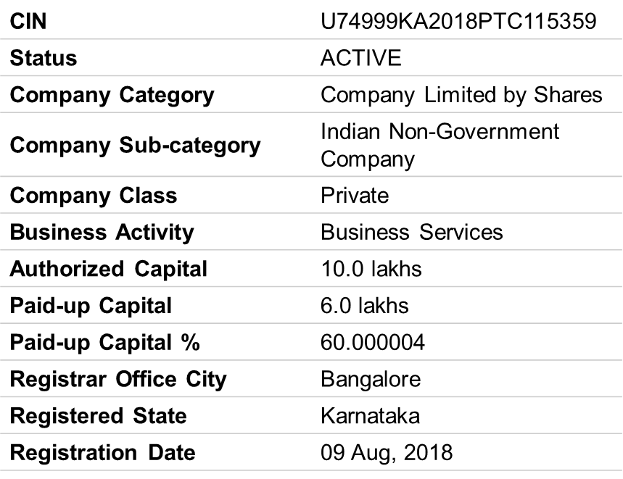

In public practice, typical work activities include:

* + liaising with clients and providing financial information and advice
  + performing tests to check financial information and systems
  + advising clients on tax planning and tax issues associated with activities
  + maintaining accounting records and preparing accounts and management information for
* small businesses
  + advising clients on areas of business improvement
  + detecting and preventing fraud
* In commerce and industry, typical work activities involve:
  + liaising with internal and external auditors
  + preparing financial statements
  + preparing financial management reports
  + advising on tax and treasury issues

**Product/Service line:**

Chartered Accountant firms render various types of services to their clients. According to the types and nature of the clients. The nature of service also differs from firm to firm, which includes corporate services, feasibility report, professional consultancy etc. The firm is dealing with;

* Auditing
* Taxation
* Management consultancy
* Professional consultancy
* Corporate services.

**Auditing:**

CA firms audit the accounts of their and check all the major books along with subsidiary books and vouchers with supporting evidence. After this process then they express their opinion upon the accuracy or inaccuracy of the accounts.

They write an audit report and also mention the various transactions, which are not duly verified. They also write audit report to the management in which they express any weakness of the management how to control these weaknesses. They are rendering for such services charges some fees.

**Taxation:**

The CA firm provides tax services to their clients. Some firms are specially deals in tax. The

client who needs the services regarding to tax pay fee for such services and the auditor gives him a very useful service by the tax returns.

**Management Consultancy:**

Kothari & Khatri (Chartered Accountants) 11

Firm provide management consultancy to their clients. In management consultancy include

development and implementation for accounting system, manuals and management information system. In order to make their management efficient they appoint staff may or may not have a professional auditor’s qualification. Sometimes the company independent auditors to conduct the internal audit of their accounts. The auditor checks the system and the policies of the management along with the books of accounts.

The auditor has to report to the management whether the policy and plans of activities prescribed by them have been implemented, whether the internal check and internal control established are adequate, whether the actual result are obtained and varying from the estimates, and to enable the management to achieve the objective of the company in a planned manner.

**Professional Consultancy:**

CA firm also provide the professional consultancy services to their clients. When appointed as consultants, they valuate sick units for the purpose of privatization.

CA firm s also provides the professional assistance in the establishment or the

organization.

**Corporate Services:**

The Chartered Accountant firms are also providing the corporate services in the connection with the corporate law authority.

* **Core values**
* Honesty
* Integrity
* Dependable
* Innovation
* Creativity
* Commitment
* Consistency
* Efficiency

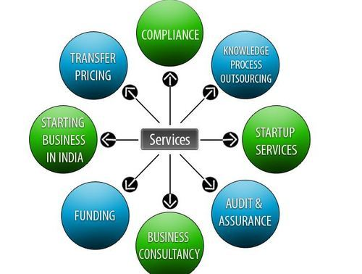

**Purpose:** The primary purpose of an audit office is to conduct independent and objective evaluations of an organization's financial statements, internal processes, and controls. The goal is to provide an unbiased assessment of the organization's financial health and compliance with legal and regulatory requirements.

**Learning Objectives:** These may include gaining a deeper understanding of accounting principles, learning auditing techniques and procedures, becoming familiar with relevant laws and regulations, and developing professional skills such as attention to detail, critical thinking, and effective communication.

**Responsibilities:** They can include assisting audit teams in conducting fieldwork, reviewing financial documents, performing data analysis, documenting audit findings, and preparing reports for senior auditors or management.

**Exposure to Different Industries:** Audit offices often work with clients from various industries, such as banking, manufacturing, healthcare, or technology. This diversity offers you the opportunity to gain exposure to different business models, processes, and challenges faced by organizations in these sectors.

**Professional Development:** Throughout internship, you'll have the chance to develop professional skills and build a network of contacts within the industry. You'll work closely with experienced auditors and may receive guidance and feedback on your work, helping you enhance your technical knowledge and refine your professional capabilities. Interning at an audit office allows you to develop essential professional skills. You can improve your attention to detail, analytical thinking, problem-solving abilities, and communication skills. Additionally, you will gain a better understanding of professional ethics, client relationship management, and the importance of confidentiality in the audit profession.

**Compliance and Ethics:** To uphold the highest standards of professionalism, integrity, and ethical conduct. Confidentiality and objectivity are critical in this field, as you'll be exposed to sensitive financial information and entrusted with the responsibility of maintaining client trust.

**Teamwork and Collaboration**: Audit offices typically foster a collaborative work environment, with auditors working in teams to complete assignments. Your internship will provide opportunities to collaborate with colleagues, share knowledge, and contribute to team goals. Effective teamwork and communication skills are highly valued in this setting.

**Exposure to Career Paths**: An internship in an audit office can provide valuable insights into potential career paths. You'll gain an understanding of the roles and responsibilities of auditors and may discover areas of specialization within the field, such as internal auditing, forensic accounting, or risk management.

**Responsibilities:** As an intern at an audit office, you may be assigned various tasks, including assisting with financial statement analysis, conducting research, preparing audit documentation, reviewing financial records, verifying data accuracy, participating in client meetings, and supporting senior auditors in their daily activities.

**Learning Opportunities:** Internships at audit offices offer valuable learning opportunities. You can gain hands-on experience in auditing methodologies, financial reporting standards, risk assessment, internal controls, and compliance procedures. You may also have the chance to work with auditing software and tools commonly used in the industry.

**Networking Opportunities:** An audit office internship provides a platform for networking with professionals in the accounting and auditing field. Building relationships with colleagues, supervisors, and managers can be beneficial for future job prospects or mentorship opportunities.

**Potential for Long-Term Employment:** Many audit offices use internships as a way to identify and recruit talented individuals for full-time positions. If you perform well during your internship, there may be possibilities for continued employment or consideration for future job openings within the organization.

**Services Offered :**

*Assurance Services :*

1. **Statutory Audits** : It is a type of audit to determine whether an organization is providing a fair and accurate representation of its financial position by examininginformation such as bank balances, bookkeeping records and financial transactions.
2. **Concurrent Audit** : It is a systematic and timely examination of financialtransactions on a regular basis to ensure accuracy, authenticity, compliance with procedures and guidelines. Lal & Associates has done various concurrent audits of banks like Oriental bank of commerce, Central bank of India etc.,
3. **Tax Audits:** It is a review of accounts of taxpayers with business or profession from an income tax point of view such as incomes, deduction, compliance with tax laws etc.,
4. **Internal and Management Audits:** These type of services helps organizations achieve their objectives. It is concerned with evaluating and improving the effectiveness of risk management, control and governance processes in an organization.
5. **Business Management Consultancy:** Present business environment is getting complicated due to multiple statutory obligations imposed upon by different authority. The entrepreneurs themselves cannot deal all such factors through their in-house capacity. Long experience to guide firm clients in the consultancy on the business management.

**Direct & Indirect Taxation:**

* Corporate and personal tax compliance including income-tax assessments, Appeals before the Commissioner (Appeals) and the Income-tax Appellate Tribunal.
* Filing of Income-tax and Wealth-tax returns of residents and non-residents individuals, domestic and foreign companies and other entities.
* Domestic Tax Planning.
* GST compliance.
* Personal Advisory Services.
* Personal financial planning.
* Insurance and pension planning.

Clients of the chartered accountant’s firm are mostly the taxpayers who want to file the return or avail any other service. Proprietors, Partnership firm, Service providers, manufacturing firms, commission agents are the clients who avail the service of accounting and regular filing of returns. These parties are the taxpayers and have to pay taxes under GST as per their registration under GST. Regular GSTIN holders have to approximately file 3 returns per month, so they have to avail the services of Chartered Accountants. Other taxpayers who opted for composition scheme under GST have to file taxes quarterly and these are also done by services of Chartered Accountants.

**Accounting & Related Consultancy:**

* Design, implementation and review of accounting manuals.
* Advice on various accounting issues.
* **Accounts preparation:** Facilitate firm clients by providing professional staff to prepare accounts of an entity in the compliance of all applicable accounting standard and laws of the state.

**Auditing Procedure:**

* Examination of the accounting system.
* Evaluation of internal controls.
* Simple checking of vouchers.
* Verification of assets and liabilities.
* Submission of auditor reports.

**The Operation of Audit:**

**1. TICKING:**

Ticking indicates the placing of a mark against an entry in the book to denote that the auditor has examined it for a certain purpose. Variously shaped marks are used to denote checking of additions, posting, carry-forward, tracing, extraction of balances etc.,

**2. CASTING:**

Casting refers to the checking of additions of books of accounts and financial statements. It is essential that arithmetical accuracy be checked so that frauds or errors (if any) may be detected. A junior member of audit staff normally does this job. Most of the auditors use mechanical appliances or adding machines to check the casting of the books of accounts.

**3. CALLING-OVER:**

A sizable part of the work of audit consists in the comparison of entries in two or more books of an entry in a book with its supporting evidence or voucher. This is usually carried out by two clerks, one reading the item to the other. Care should be used to see that the whole of the important detail of each item is checked and not merely the amount. Special care in checking postings to personal ledgers is needed as to names and title of account; otherwise, a wrong posting may remain undetected.

**4. VERIFICATION:**

When an auditor has couched the entries appearing in the books of account, his duty is not

thereby fully discharged. If appointed for audit under the act, he has to report whether or not the balance sheet exhibits a true and correct view of the state of affairs of the company.

**5. VOUCHING:**

The function of the voucher is to authenticate an entry and the auditor must satisfy himself that it does this. It must correspond in date and account to the entry in the books. It must be in respect of the entire client and entry must be correctly passed in the books. The act of vouching consists of checking the documentary evidence such as…

* Invoices
* Cash memos
* Bills
* Receipts
* Vouchers

**6. REPORTING:**

After the above steps have been carried out, the auditor will then be required to submit his report.

The form and the contents will depend upon several factors, e.g., the legal status of the appointing authority, the contract for the scope of work to be done, whether the audit is being conducted under the companies’ ordinance 1984. Banking companies’ ordinance 1962, insurance Act, 1938, etc. The points to be considered while drafting a report in respect of sole traders and partnership concerns.

**TAXATION:**

The rang of CA firm in the area of taxation covers personal and corporate tax planning

supplemented by representation on behalf to client before the central board of revenue obtaining clarification etc, and before Assessing and Appellate Authorities.

These services are in follows:

* Tax planning.
* Personal taxation.
* Corporate taxation

**SWOT ANALYSIS:**

SWOT analysis is a strategic planning tool used to evaluate the strengths, weaknesses, opportunities, and threats of an organization or a specific entity. In the case of an audit office, the SWOT analysis can be conducted as follows:

A SWOT stands for Strengths, Weaknesses, Opportunities, and Threats and is a tool used to identify the strategic risks and opportunities around the business or a project.

Organisations are using the tool to support and demonstrate their risk-based thinking approach to their management system and we often see it used for the Context of the Organisation element of the standards and also the Risks and Opportunities element.  On its own it will not fully demonstrate risk-based thinking and set out risks and opportunities for the organisation but it is a great starting point.

Strengths and weaknesses are typically influenced by internal factors of the business and opportunities and threats are typically external to the business. Organisations should identify the internal and external factors (context of the organisation) which can influence the business in a positive or negative manner and set a strategic goal around mitigating or exploiting these items (risks and opportunities).

I have highlighted below some of the consideration’s organisations could take when performing their SWOT, these are just generic and to help in understanding and are not necessarily applicable to every organisation.

**STRENGTHS:**

**Expertise and Knowledge:** An audit office typically consists of skilled professionals with extensive knowledge and expertise in auditing principles and practices.

**Independence and Objectivity:** Audit offices are designed to be independent and objective in their assessments, which enhances their credibility and integrity.

**Regulatory Compliance**: Audit offices play a crucial role in ensuring regulatory compliance within organizations, thereby contributing to transparency and accountability.

**Access to Information:** Audit offices have the authority to access relevant information and documentation, enabling them to conduct thorough and comprehensive audits.

“Characteristics of the business or project that give it an advantage over others”

These characteristics are things which you are good at, better than your competitors, ahead of the development curve or gives you that competitive edge. Often these things can be exploited as opportunities so you can maximize your chance of success.

In order to identify your strengths, get your team together and use a whiteboard or some paper and just brainstorm some ideas, to help focus the attention think about the following:

* Financial Strengths: cash flow, bank support, profit margins, financial growth, niche products.
* Customer strengths: customer growth, customer referrals, industry segments, customer relationships, good customer balance
* Internal strengths: personnel, systems, customer relationships, product mix or niche
* Learning and growth strengths: training and development programmes for employees,
* culture.

**WEAKNESS:**

**Resource Constraints:** Limited resources, such as staffing and budgetary constraints, can pose challenges to an audit office's ability to effectively carry out audits.

**Time Constraints:** Audits often require significant time and effort, and the pressure to meet deadlines can potentially compromise the thoroughness of the audit process.

**Lack of Authority:** While audit offices have the power to assess and report on findings, they may not possess the authority to enforce corrective actions, limiting their impact on organizational improvements.

* Financial Weaknesses: poor cash flow, no bank support, low-profit margins, cyclical business.
* Customer Weaknesses: all your eggs in one basket? Are your customers at risk themselves (maybe acquisition, moving to other locations, financial issues themselves).

**OPPURTUNITIES:**

**Technological Advancements**: Utilizing technological advancements, such as data analytics and automated auditing tools, can enhance the efficiency and effectiveness of audits.

**Expanded Scope:** Audit offices can explore opportunities to expand their scope beyond financial audits to include areas such as cybersecurity, environmental sustainability, and ethical practices.

**Training and Development:** Continuous professional development programs can help audit office staff stay up-to-date with evolving audit methodologies and regulatory requirements.

“Elements in the environment that the business or project could exploit to its advantage.”

When we mention the environment, this is a broad statement as it could be an internal or external environment. Opportunities are potentially strengths or weaknesses which could be exploited, for example, maybe you have weak cash flow in the business, what are the opportunities you could exploit to help you with this issue? What things in the future could transform your business

* Financial Opportunities: how could you improve cash flow? Are new product launches going to generate more money for your business? Exchange rate changes to be exploited?
* Customer Opportunities: where could you improve customer relationships, are there any opportunities with current customers or potential for new customers, can you upsell to your current customers, how can you improve the customer experience?
* Internal Opportunities: what process changes could be made? How can you improve the internal perception of the business
* Learning and Growth Opportunities: cross-training opportunities, how can you improve the culture, internal promotions, succession plans?
* Technological Opportunities: new equipment to differentiate you from the rest of the market, new systems coming onboard to improve processes

|  |  |
| --- | --- |
| **STRENGTHS** | **WEAKNESS** |
| Expertise and Knowledge | Resource Constraints |
| Access to Information | Time Constraints |
| Skilled work force | Lack of Authority |
| Team work management | Stiff competition from other leading industry players means restricted market share |
| Loyal customers | Weakness in retaining talents |
| Strong financial position | Minimal soft skills training |

|  |  |
| --- | --- |
| **OPPURTUNITIES** | **THREATS** |
| Technological Advancements | Customer Threats |
| Expanded Scope | Technological Threats |
| Training and Development | Government regulations |
| Business transparency | Legal and Regulatory Changes |
| Learning and Growth | Cybersecurity Risks |

**THREATS**

* **Legal and Regulatory Changes:** Changes in auditing standards, regulations, or laws can require audit offices to adapt their practices and ensure compliance.
* **Increasing Complexity:** Organizations are becoming increasingly complex, with diverse operations and structures, which can pose challenges for audit offices to assess and understand all aspects thoroughly.
* **Cybersecurity Risks:** As audit offices handle sensitive information, they may be vulnerable to cybersecurity threats and data breaches, potentially compromising the integrity of the audit process.
* Financial Threats: have you got some new low-cost competitors, economy putting pressure on the business, government changes?
* Customer Threats: market share erosion, customer acquisitions, contracts ending.
* Internal Threats: product recalls, new products not being adapted as planned, mergers and acquisitions internally, suppliers going out of business.

**Chapter- 4:**

**RESEARCH DESIGN**

1. STATEMENT OF THE PROBLEM:

The primary focus is on tax compliance in Bengaluru, which includes understanding tax avoidance, tax planning, and tax evasion strategies. It also aims to delve into the perceptions and practices surrounding these aspects of tax compliance.

1. RESEARCH GAP:
2. **Limited Localized Studies**: While there might be existing research on tax compliance at a national or global level, there could be a dearth of studies specifically focusing on Bengaluru. This research would contribute by providing insights into the unique dynamics of tax compliance within this specific urban context.
3. **Lack of Comprehensive Analysis**: Previous studies might have explored individual aspects of tax compliance such as avoidance, planning, or evasion, but there may be a lack of comprehensive analyses that integrate these dimensions. This study aims to fill this gap by offering a holistic examination of tax compliance strategies, perceptions, and practices.
4. **Understudied Perceptions and Practices**: Existing literature might have overlooked the perceptions and practices of taxpayers in Bengaluru regarding tax compliance. This study intends to address this gap by exploring the attitudes, beliefs, and behaviours of individuals and businesses towards tax compliance.
5. **Emerging Trends and Strategies**: Given the dynamic nature of tax systems and economic environments, there could be emerging trends and strategies in tax compliance that have not been adequately studied. This research aims to uncover these trends, providing insights into evolving tax avoidance, planning, and evasion strategies in Bengaluru.
6. **Policy Implications**: While some studies may have discussed the effectiveness of tax policies and enforcement measures, there could be a gap in understanding how these policies are perceived and responded to by taxpayers in Bengaluru. This study seeks to bridge this gap by examining the implications of tax policies on compliance behaviour and vice versa.

By addressing these research gaps, the proposed study aims to contribute significantly to the understanding of tax compliance dynamics in Bengaluru, providing valuable insights for policymakers, tax authorities, and researchers.

1. HYPOTHESIS OF THE STUDY:

* **Null Hypothesis Statement –**
* Tax Evasion from Individuals & Companies will not have any impact on Government Funds & Economy.
* **Alternate Hypothesis –**

Tax Evasion from Individuals & Companies will not have any impact on Government Funds & Economy.

1. **OBJECTIVES OF STUDY**

* To identify & measure Tax Evasion, planning & Avoidance on ethical practice. {Income tax}.
* To analyse the various methods used by the individuals and businesses to evade or avoid taxes, assess the magnitude of revenue loss due to these activities, and evaluate the overall impact on Karnataka economy.
* To study the need of corporate governance in proper payment of taxes.
* To explore the potential policy measures and strategies to combat the tax evasion and tax avoidance.
* To understand the various loopholes in the tax system of the country & find out the evidence and determinants of tax evasion in the country.

1. **SCOPE OF THE STUDY:**

The scope of the study "Unveiling the Dynamics of Tax Compliance" in Bengaluru, focusing on tax avoidance, planning, and evasion strategies, perceptions, and practices, is broad and multifaceted. Here's a breakdown of its scope:

* + **Geographical Scope:** The study will focus specifically on Bengaluru, the capital city of Karnataka, India. It will explore tax compliance dynamics within this urban context, considering the unique socio-economic and cultural factors that may influence tax behaviour in the region.
  + **Dimension of Tax Compliance:** The study will encompass various dimensions of tax compliance, including tax avoidance, tax planning, and tax evasion. It aims to provide a comprehensive analysis of the strategies employed by individuals and businesses to manage their tax liabilities, both legally and illegally.
  + **Perceptions and Practices**: The study will delve into the perceptions and practices of taxpayers in Bengaluru regarding tax compliance. It will explore attitudes, beliefs, and behaviours towards paying taxes, as well as the factors influencing compliance or non-compliance with tax laws.
  + **Qualitative and Quantitative Analysis:** The research may employ a mix of qualitative and quantitative research methods to gather and analyse data. Qualitative methods such as interviews, focus groups, or case studies may be used to explore perceptions and practices, while quantitative methods such as surveys or data analysis may be used to examine tax compliance behaviours at a larger scale.
  + **Policy Implications:** The study may also explore the policy implications of its findings, providing insights for policymakers and tax authorities on how to improve tax compliance mechanisms in Bengaluru. It may offer recommendations for designing more effective tax policies, enforcement strategies, and taxpayer education initiatives.
  + **Industry and Demographic Considerations:** The study may consider different industries and demographic groups within Bengaluru to understand how tax compliance varies across sectors and population segments. It may examine the compliance behaviour of individuals, small businesses, multinational corporations, and other entities operating in the city.

Overall, the scope of the study is comprehensive, aiming to provide a nuanced understanding of tax compliance dynamics in Bengaluru and offering valuable insights for policymakers, tax authorities, and researchers.

1. **RESEARCH METHODOLOGY AND DATA COLLECTION**

A) Data Collection Method

* + 1. Primary data
    2. Secondary data
    3. Sample design
    4. Population
    5. Sample size
    6. Sampling unit
    7. Sampling method

B) Tools for Data Collection:

1. Data Analysis Plan
2. Statistical tools for analysis

JMP SOFTWARE

**Research Methodology**

1. Type of Research – Descriptive Research(Quantitative Data, Qualitative Data)
2. Sample Size – 100 Target Audience
3. Sample Design -- **Convenient Sampling & Cluster Sampling.**
4. Sample Respondents (Population) – 90 Audience (Tax Payers)
5. Sampling Type – **Snow Ball Sampling** & Random Selection (Simple & Stratified)
6. Data Collection – Primary Data: Questionnaires circulated to persons who Pay Taxes regularly.

Secondary Data: Research Papers, IT Portal, CBDT, Research Gate

1. Statistical tools for analysis --- f- Test Series & SEM Model Using JMP SOFTWARE
2. Tools for Data Collection: Chi- Square Chart & Cron- Bach Alpha
3. **LIMITATIONS OF THE STUDY:**

* **Sampling Bias:** The sample population may not represent the entire taxpayer base in Bengaluru, leading to potential biases in the findings. For example, if the sample primarily consists of large businesses, it may not capture the perspectives of small or informal sector taxpayers.
* **Self-Reporting Bias:** Participants may not accurately report their tax avoidance, planning, or evasion strategies due to social desirability bias or fear of legal consequences. This could result in underestimation or overestimation of the prevalence of these practices.
* **Limited Generalizability:** Findings from a study conducted in Bengaluru may not be generalizable to other regions or countries due to cultural, economic, and institutional differences in tax systems and compliance behaviour.
* **Legal and Ethical Constraints:** Conducting research on tax avoidance, planning, and evasion may raise ethical concerns, particularly if it involves encouraging or endorsing illegal practices. Researchers must navigate these legal and ethical considerations carefully.
* **Temporal Dynamics:** Tax compliance behaviour and attitudes may change over time due to shifts in regulatory frameworks, economic conditions, or social norms. A single snapshot of tax compliance dynamics may not capture these temporal dynamics adequately.
* **External Factors:** External factors such as political instability, changes in tax policies, or economic shocks may influence tax compliance behaviour independently of the factors examined in the study, complicating the interpretation of results.

Addressing these limitations through careful study design, robust data collection methods, and thoughtful analysis can enhance the validity and reliability of your research findings on tax compliance dynamics in Bengaluru.

**CHAPTER - 5**

**Data Interpretation**

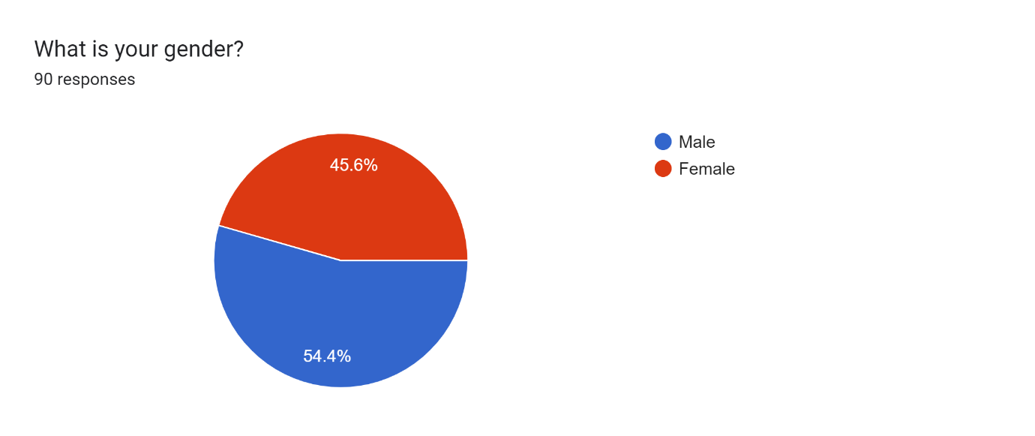

**More than half of the respondents were Males & around 46% were Females.**

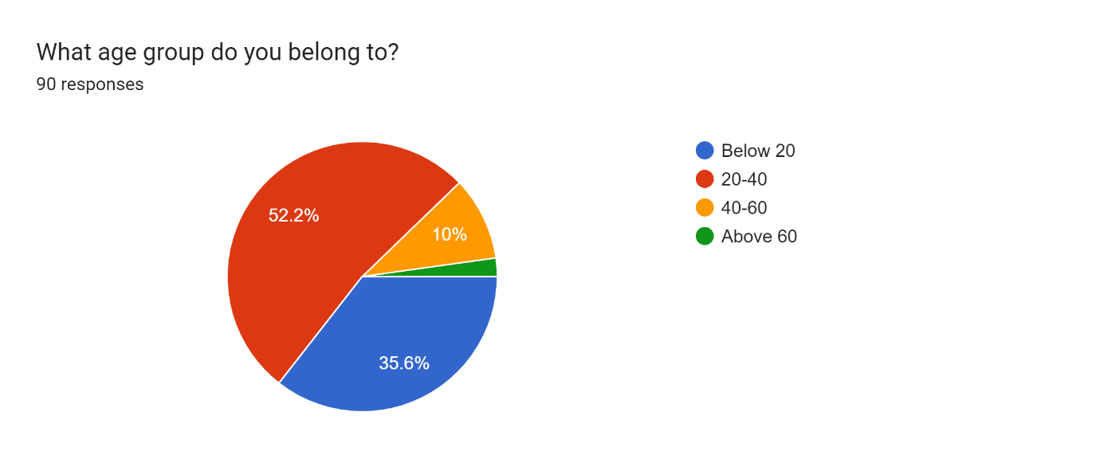

**More than half of the respondents were from the age group of 20-40 & 10% of the respondents were from the age group of 40-60 & Around only 2% were from Above 60 age group.**

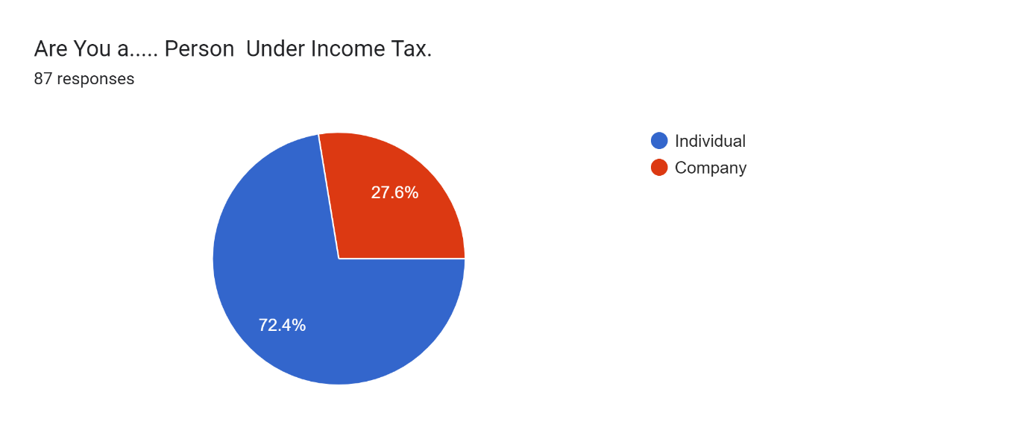

**Around ¾ th of the respondents were individuals &**

**27% are Company Registered as per Companies Act, 2013.**

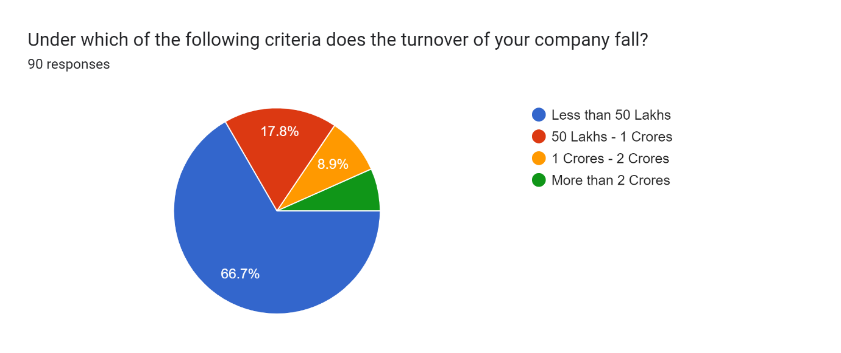

**Nearly 2/3 rd of the respondents who chosen Company were having less than 50 lakhs turnover, Around 8% of the respondents were having more than 2 crore turnover.**

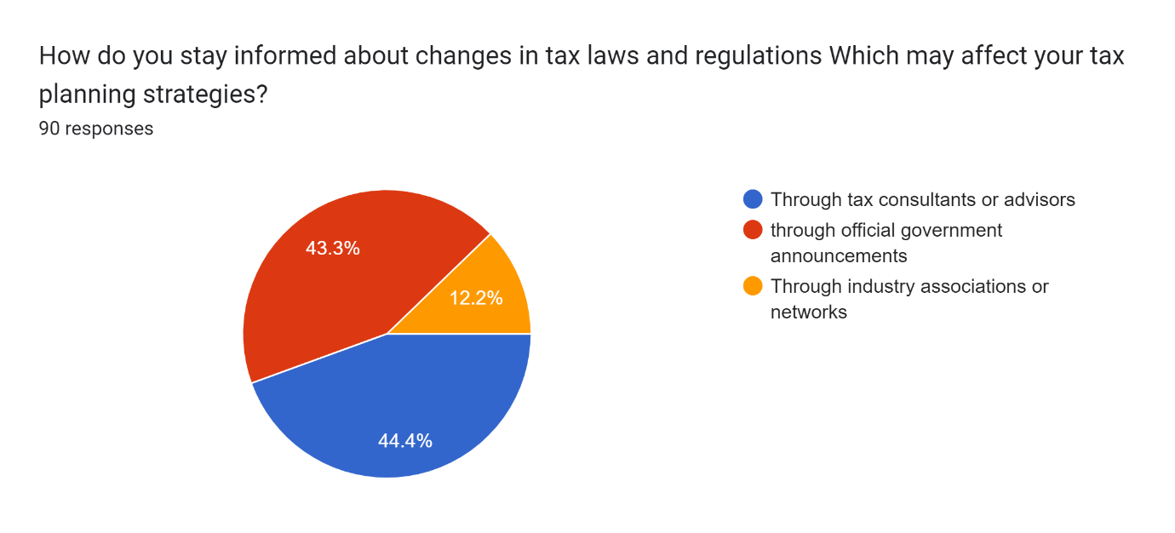

**Most of the respondents were aware about changes in tax laws and regulations which may affect tax planning strategies through Tax Consultancies followed by official government announcements.**

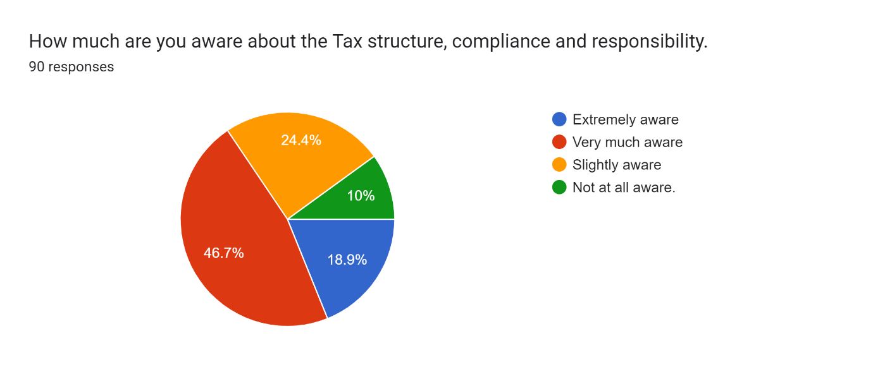

**Around 10% of the respondents are not at all aware about Tax structure , Compliance & Half of the respondents Were very much aware about it.**

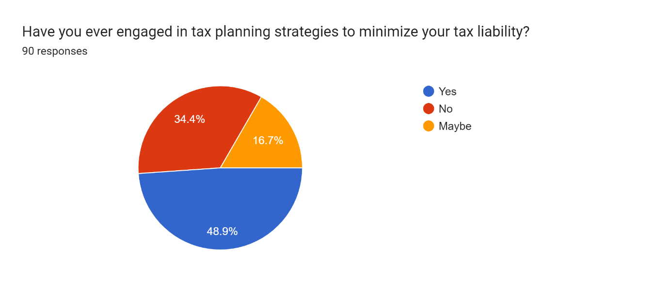

Half of the respondents were engaged in Tax planning Strategies & 1/3 rd. of the respondents have not engaged in Tax planning Strategies.

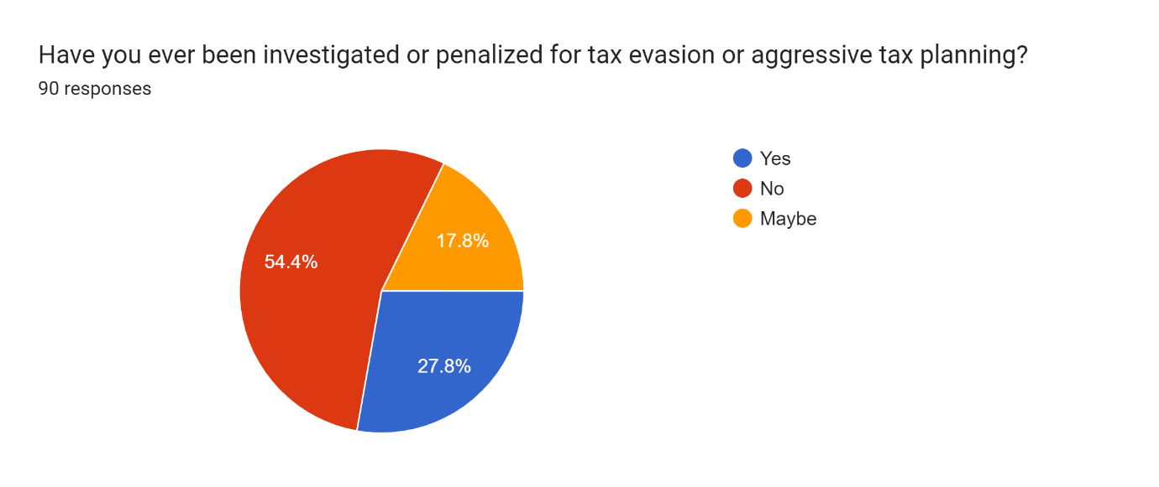

Half of the respondents were not been investigated or penalized for tax evasion or aggressive tax planning & 28% of the respondents were investigated or penalized for tax evasion or aggressive tax planning.

Forms response chart. Question title: In your opinion, What makes a selected person to evade tax?
. Number of responses: 89 responses.

* 1/3rd of the respondents chosen for inadequate maintenance accounts on the question what makes a person to evade Tax.
* 1/4th of the respondents voted for to retain income in Pocket.
* 23% of the respondents voted for inadequate maintenance accounts on the question what makes a person to evade evade Tax due to Ill- knowledge

**Choose any of the options as per your Experience.**

1. **Strongly Agree (SA) b) Somewhat Agree c) Neutral (N)**

**d) Somewhat Disagree e) Strongly Disagree (SD)**

10. It is wrong if a taxpayer does not report all of his or her income in order to pay less income tax.

11. If in doubt about whether or not to report a certain source of income, you would not report it.

12. Do you agree tax evaders being audited in more detail in the next years would deter people from evading tax if the IRB detects tax evasion?

13) Do you agree tax evaders should be prosecuted in court would deter people from evading tax if the IRB detects tax evasion?

14) The present tax system benefits the rich and is unfair to the ordinary working man or woman.

15) Reforms could be made to the tax system to discourage tax avoidance and evasion while still allowing for legitimate tax planning.

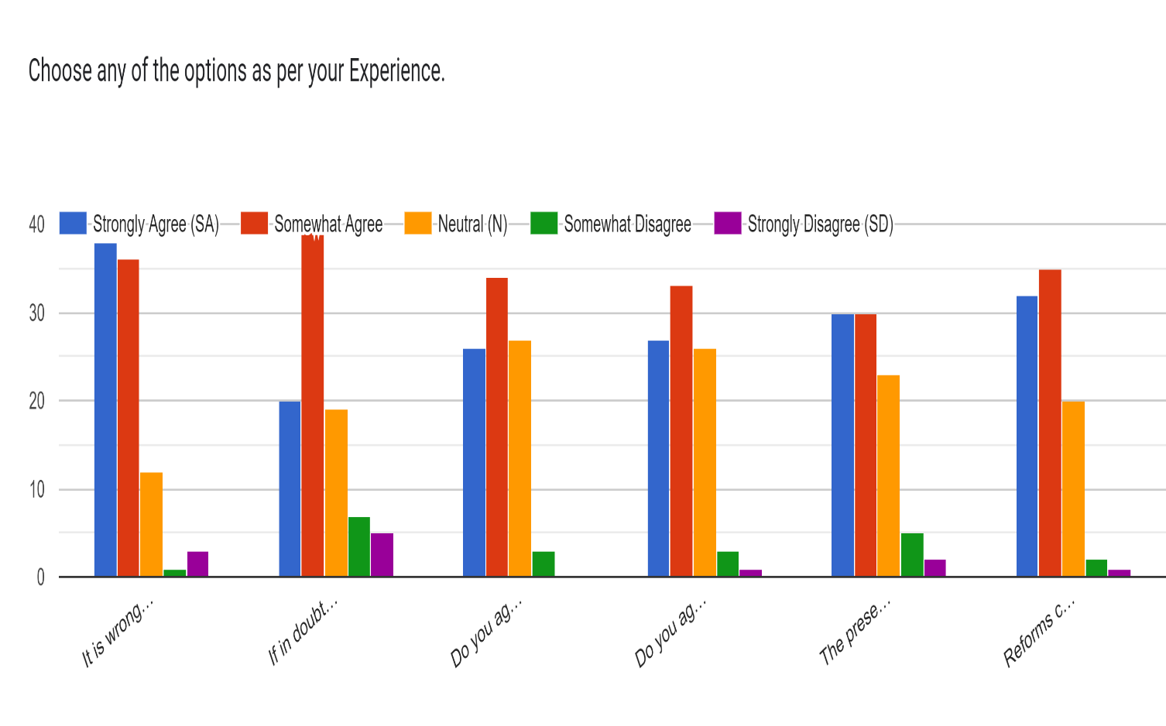

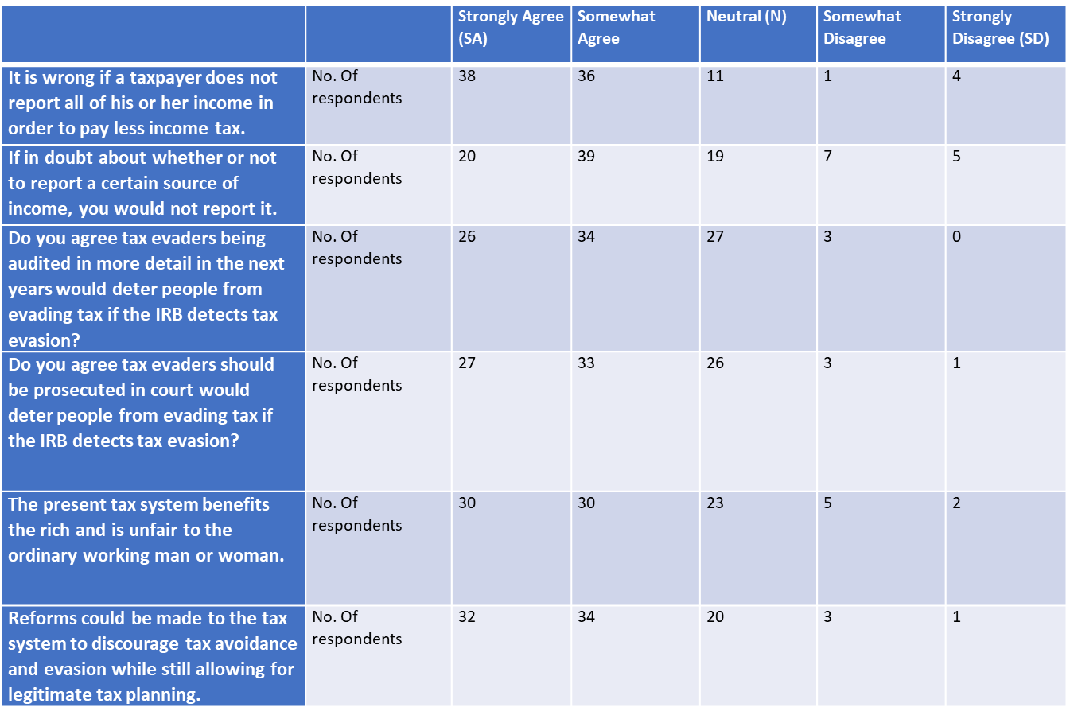

Forms response chart. Question title: Does you / your company have Strategies with any in place to monitor and evaluate the effectiveness of tax Planning & avoidance in driving economic growth?
. Number of responses: 90 responses.

Around 60% of the respondents voted for we have dedicated monitoring and evaluation mechanisms with professionals.

Forms response chart. Question title: How transparent do you find the process of getting benefitted by Tax Planning Strategies for You/Your company?
. Number of responses: 89 responses.10 respondents opted for unaware about the strategies.

An equal number of respondents opted for Neutral & very Transparent.

36% of the respondents were chosen Somewhat transparent on how transparent do you find the process of getting benefitted by Tax Planning Strategies for You/Your company

Forms response chart. Question title: what strategies do you employ for tax planning?
. Number of responses: 90 responses.

* 12 respondents chosen to employ Retirement Contributions.
* 21% of the respondents have opted to employ Charitable donations.
* 20% have chosen to Capital gain/losses management.
* Tax deductions comprises a large part for employing tax planning constituting 26.7 %.
* 19% of the respondents opted to chose more the one of the options available in the given choices.

**Rate the following Questions in Your opinion.(4-8)**

**Ratings : 1 2 3 4 5**

4) Role of professional advisors (such as accountants or tax attorneys) play in your tax planning process?

5) Ethical considerations you take into account when engaging in tax planning?

6) Challenges faced in reporting and documenting the utilization of tax incentives?

7) Utilization of tax planning & avoidance strategies provided by the government

8) Government Initiatives to combat & Penalizing the Tax Evaders.

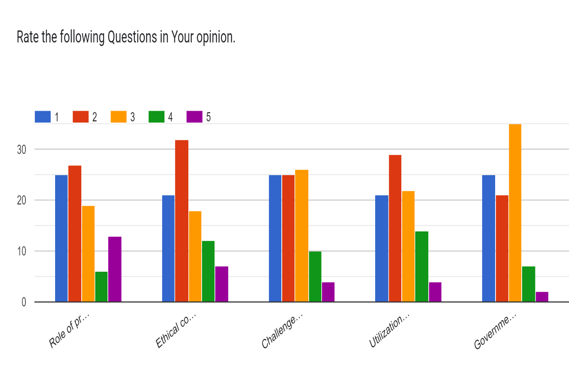

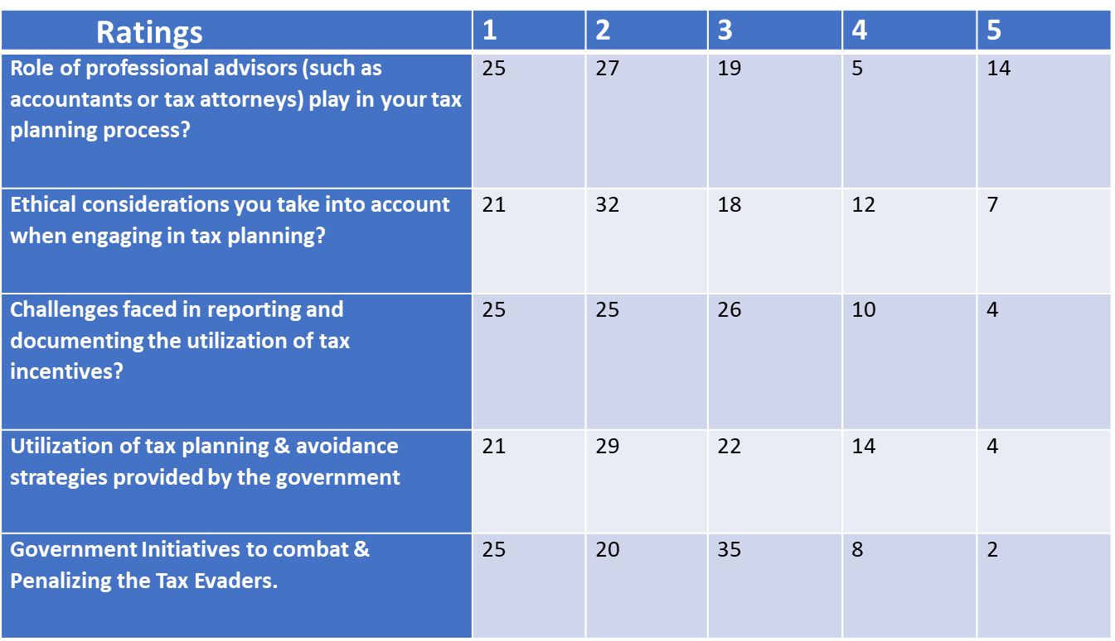

Forms response chart. Question title: Which of the following you would like to prefer the most
. Number of responses: 90 responses.

* More than Half of the respondents opted to prefer the Use Tax planning techniques & Pay Tax for development of Nation.
* 14 % opted not to pay Taxes .
* 22% chosen to pay Tax as per IT Act Provisions.

**CHAPTER - 6**

**Data Analysis**

**F- Test Series Analysis**

**1.GENDER ANALYSIS**

**Questions Opted**

1) What is your age?

* Below 20
* 20-40
* 40-60
* Above 60

2. What is your gender?

* Male
* Female

1. It is wrong if a taxpayer does not report all of his or her income in order to pay less income tax.
2. If in doubt about whether or not to report a certain source of income, you would not report it.
3. Do you agree tax evaders being audited in more detail in the next years would deter people from evading tax if the IRB detects tax evasion?
4. Do you agree tax evaders should be prosecuted in court would deter people from evading tax if the IRB detects tax evasion?
5. The present tax system benefits the rich and is unfair to the ordinary working man or woman.
6. Reforms could be made to the tax system to discourage tax avoidance and evasion while still allowing for legitimate tax planning.

|  |  |  |  |  |  |  |  |
| --- | --- | --- | --- | --- | --- | --- | --- |
| What is your gender? | A | B | C | D | E | F | Average |
| Male | 3 | 3 | 3 | 3 | 3 | 3 | 3 |
| Male | 4 | 4 | 4 | 2 | 3 | 5 | 3.666666667 |
| Male | 4 | 2 | 5 | 5 | 1 | 5 | 3.666666667 |
| Female | 5 | 2 | 4 | 5 | 2 | 5 | 3.833333333 |
| Male | 5 | 1 | 5 | 5 | 1 | 5 | 3.666666667 |
| Male | 4 | 4 | 3 | 3 | 2 | 4 | 3.333333333 |
| Female | 5 | 2 | 3 | 3 | 2 | 5 | 3.333333333 |
| Male | 4 | 1 | 3 | 3 | 3 | 3 | 2.833333333 |
| Male | 2 | 3 | 3 | 3 | 4 | 3 | 3 |
| Male | 3 | 3 | 3 | 2 | 2 | 4 | 2.833333333 |
| Male | 4 | 4 | 4 | 3 | 1 | 4 | 3.333333333 |
| Male | 5 | 5 | 4 | 4 | 4 | 4 | 4.333333333 |
| Male | 5 | 1 | 5 | 5 | 2 | 4 | 3.666666667 |
| Male | 5 | 1 | 5 | 5 | 1 | 5 | 3.666666667 |
| Male | 5 | 2 | 3 | 4 | 1 | 4 | 3.166666667 |
| Male | 5 | 2 | 4 | 3 | 3 | 4 | 3.5 |
| Male | 4 | 1 | 3 | 5 | 3 | 5 | 3.5 |
| Male | 4 | 3 | 5 | 5 | 3 | 5 | 4.166666667 |
| Male | 4 | 1 | 4 | 4 | 1 | 4 | 3 |
| Male | 4 | 2 | 4 | 4 | 2 | 4 | 3.333333333 |
| Male | 4 | 2 | 3 | 3 | 3 | 3 | 3 |
| Male | 5 | 4 | 4 | 4 | 1 | 5 | 3.833333333 |
| Female | 3 | 2 | 5 | 3 | 2 | 3 | 3 |
| Female | 4 | 2 | 4 | 3 | 3 | 4 | 3.333333333 |
| Male | 4 | 2 | 4 | 4 | 2 | 3 | 3.166666667 |
| Male | 4 | 1 | 5 | 4 | 2 | 4 | 3.333333333 |
| Male | 5 | 2 | 3 | 4 | 1 | 5 | 3.333333333 |
| Male | 5 | 2 | 3 | 4 | 1 | 4 | 3.166666667 |
| Male | 5 | 2 | 3 | 4 | 1 | 4 | 3.166666667 |
| Male | 4 | 2 | 4 | 4 | 2 | 4 | 3.333333333 |
| Male | 3 | 2 | 3 | 3 | 3 | 3 | 2.833333333 |
| Female | 5 | 2 | 4 | 5 | 3 | 5 | 4 |
| Male | 3 | 3 | 3 | 3 | 3 | 3 | 3 |
| Female | 5 | 3 | 4 | 4 | 3 | 5 | 4 |
| Male | 4 | 1 | 4 | 5 | 1 | 4 | 3.166666667 |
| Female | 4 | 3 | 4 | 3 | 2 | 2 | 3 |
| Female | 5 | 3 | 2 | 4 | 1 | 4 | 3.166666667 |
| Female | 5 | 2 | 5 | 5 | 1 | 5 | 3.833333333 |
| Male | 4 | 2 | 3 | 3 | 3 | 3 | 3 |
| Female | 5 | 1 | 5 | 5 | 1 | 5 | 3.666666667 |
| Male | 5 | 4 | 5 | 5 | 5 | 5 | 4.833333333 |
| Male | 5 | 2 | 4 | 4 | 1 | 5 | 3.5 |
| Male | 5 | 2 | 5 | 4 | 1 | 4 | 3.5 |
| Male | 5 | 2 | 4 | 5 | 2 | 4 | 3.666666667 |
| Male | 5 | 1 | 3 | 4 | 1 | 4 | 3 |
| Female | 4 | 3 | 5 | 4 | 2 | 3 | 3.5 |
| Male | 4 | 2 | 5 | 5 | 1 | 4 | 3.5 |
| Female | 1 | 3 | 2 | 3 | 4 | 1 | 2.333333333 |
| Female | 4 | 4 | 4 | 4 | 1 | 5 | 3.666666667 |
| Male | 1 | 2 | 4 | 3 | 1 | 4 | 2.5 |
| Male | 5 | 2 | 3 | 5 | 3 | 5 | 3.833333333 |
| Male | 4 | 5 | 5 | 4 | 1 | 5 | 4 |
| Male | 5 | 5 | 4 | 4 | 4 | 5 | 4.5 |
| Female | 3 | 5 | 2 | 2 | 3 | 3 | 3 |
| Male | 1 | 5 | 5 | 1 | 2 | 2 | 2.666666667 |
| Male | 5 | 1 | 5 | 5 | 1 | 5 | 3.666666667 |
| Female | 5 | 2 | 4 | 5 | 1 | 5 | 3.666666667 |
| Female | 4 | 1 | 4 | 3 | 3 | 3 | 3 |
| Female | 5 | 2 | 3 | 5 | 2 | 5 | 3.666666667 |
| Female | 5 | 1 | 5 | 5 | 1 | 5 | 3.666666667 |
| Female | 5 | 1 | 4 | 3 | 2 | 5 | 3.333333333 |
| Female | 4 | 2 | 4 | 5 | 3 | 5 | 3.833333333 |
| Female | 4 | 2 | 5 | 3 | 1 | 4 | 3.166666667 |
| Male | 4 | 2 | 4 | 4 | 2 | 4 | 3.333333333 |
| Male | 3 | 3 | 3 | 3 | 3 | 3 | 3 |
| Male | 4 | 4 | 5 | 5 | 5 | 4 | 4.5 |
| Female | 5 | 1 | 4 | 4 | 2 | 4 | 3.333333333 |
| Male | 5 | 1 | 5 | 5 | 1 | 5 | 3.666666667 |
| Female | 4 | 2 | 4 | 4 | 2 | 4 | 3.333333333 |
| Female | 5 | 1 | 4 | 5 | 2 | 5 | 3.666666667 |
| Female | 3 | 3 | 3 | 3 | 3 | 3 | 3 |
| Female | 4 | 2 | 4 | 4 | 2 | 4 | 3.333333333 |
| Male | 3 | 3 | 3 | 3 | 3 | 3 | 3 |
| Female | 3 | 3 | 3 | 3 | 3 | 3 | 3 |
| Female | 5 | 2 | 3 | 3 | 1 | 4 | 3 |
| Female | 4 | 1 | 4 | 5 | 2 | 3 | 3.166666667 |
| Female | 4 | 3 | 5 | 4 | 2 | 4 | 3.666666667 |
| Female | 3 | 2 | 5 | 4 | 2 | 3 | 3.166666667 |
| Female | 4 | 3 | 4 | 4 | 1 | 3 | 3.166666667 |
| Female | 4 | 3 | 4 | 5 | 2 | 4 | 3.666666667 |
| Female | 5 | 2 | 3 | 3 | 4 | 4 | 3.5 |
| Female | 4 | 2 | 3 | 4 | 3 | 4 | 3.333333333 |
| Female | 5 | 1 | 5 | 5 | 1 | 5 | 3.666666667 |
| Female | 4 | 2 | 4 | 4 | 2 | 4 | 3.333333333 |
| Female | 3 | 3 | 3 | 3 | 3 | 3 | 3 |
| Female | 5 | 1 | 5 | 5 | 1 | 5 | 3.666666667 |
| Female | 4 | 2 | 5 | 4 | 2 | 5 | 3.666666667 |
| Male | 5 | 2 | 3 | 4 | 2 | 4 | 3.333333333 |
| Female | 5 | 3 | 5 | 4 | 2 | 5 | 4 |
| Male | 4 | 2 | 4 | 4 | 2 | 4 | 3.333333333 |

|  |  |  |  |  |
| --- | --- | --- | --- | --- |
| Variable 1 | |  | Variable 2 | |
| Male | 3 |  | Female | 3.833333 |
| Male | 3.666667 |  | Female | 3.333333 |
| Male | 3.666667 |  | Female | 3 |
| Male | 3.666667 |  | Female | 3.333333 |
| Male | 3.333333 |  | Female | 4 |
| Male | 2.833333 |  | Female | 4 |
| Male | 3 |  | Female | 3 |
| Male | 2.833333 |  | Female | 3.166667 |
| Male | 3.333333 |  | Female | 3.833333 |
| Male | 4.333333 |  | Female | 3.666667 |
| Male | 3.666667 |  | Female | 3.5 |
| Male | 3.666667 |  | Female | 2.333333 |
| Male | 3.166667 |  | Female | 3.666667 |
| Male | 3.5 |  | Female | 3 |
| Male | 3.5 |  | Female | 3.666667 |
| Male | 4.166667 |  | Female | 3 |
| Male | 3 |  | Female | 3.666667 |
| Male | 3.333333 |  | Female | 3.666667 |
| Male | 3 |  | Female | 3.333333 |
| Male | 3.833333 |  | Female | 3.833333 |
| Male | 3.166667 |  | Female | 3.166667 |
| Male | 3.333333 |  | Female | 3.333333 |
| Male | 3.333333 |  | Female | 3.333333 |
| Male | 3.166667 |  | Female | 3.666667 |
| Male | 3.166667 |  | Female | 3 |
| Male | 3.333333 |  | Female | 3.333333 |
| Male | 2.833333 |  | Female | 3 |
| Male | 3 |  | Female | 3 |
| Male | 3.166667 |  | Female | 3.166667 |
| Male | 3 |  | Female | 3.666667 |
| Male | 4.833333 |  | Female | 3.166667 |
| Male | 3.5 |  | Female | 3.166667 |
| Male | 3.5 |  | Female | 3.666667 |
| Male | 3.666667 |  | Female | 3.5 |
| Male | 3 |  | Female | 3.333333 |
| Male | 3.5 |  | Female | 3.666667 |
| Male | 2.5 |  | Female | 3.333333 |
| Male | 3.833333 |  | Female | 3 |
| Male | 4 |  | Female | 3.666667 |
| Male | 4.5 |  | Female | 3.666667 |
| Male | 2.666667 |  | Female | 4 |
| Male | 3.666667 |  |  |  |
| Male | 3.333333 |  |  |  |
| Male | 3 |  |  |  |
| Male | 4.5 |  |  |  |
| Male | 3.666667 |  |  |  |
| Male | 3 |  |  |  |
| Male | 3.333333 |  |  |  |
| Male | 3.333333 |  |  |  |

|  |  |  |
| --- | --- | --- |
| F-Test Two-Sample for Variances |  |  |
|  |  |  |
|  | *Variable 1* | *Variable 2* |
| Mean | 3.414966 | 3.406504065 |
| Variance | 0.236253 | 0.129234417 |
| Observations | 49 | 41 |
| df | 48 | 40 |
| F | 1.828095 |  |
| P(F<=f) one-tail | 0.026185 |  |
| F Critical one-tail | 1.665575 |  |

**2) Age**

**Basis: Less than 40 Years & More than 40 Years**

|  |  |  |  |  |  |
| --- | --- | --- | --- | --- | --- |
| What age group do you belong to? | Average | Variable 1 | | Variable 2 | |
| 1 | 3 | 1 | 3 | 2 | 3.333333 |
| 1 | 3.666667 | 1 | 3.666667 | 2 | 3.666667 |
| 1 | 3.666667 | 1 | 3.666667 | 2 | 3 |
| 1 | 3.833333 | 1 | 3.833333 | 2 | 3 |
| 1 | 3.666667 | 1 | 3.666667 | 2 | 3 |
| 1 | 3.333333 | 1 | 3.333333 | 2 | 3 |
| 1 | 3.333333 | 1 | 3.333333 | 2 | 3.666667 |
| 1 | 2.833333 | 1 | 2.833333 | 2 | 3.5 |
| 1 | 3 | 1 | 3 | 2 | 3.333333 |
| 1 | 2.833333 | 1 | 2.833333 | 2 | 3 |
| 1 | 3.333333 | 1 | 3.333333 | 2 | 3.666667 |
| 1 | 4.333333 | 1 | 4.333333 |  |  |
| 1 | 3.666667 | 1 | 3.666667 |  |  |
| 1 | 3.666667 | 1 | 3.666667 |  |  |
| 1 | 3.166667 | 1 | 3.166667 |  |  |
| 1 | 3.5 | 1 | 3.5 |  |  |
| 1 | 3.5 | 1 | 3.5 |  |  |
| 1 | 4.166667 | 1 | 4.166667 |  |  |
| 1 | 3 | 1 | 3 |  |  |
| 1 | 3.333333 | 1 | 3.333333 |  |  |
| 1 | 3 | 1 | 3 |  |  |
| 1 | 3.833333 | 1 | 3.833333 |  |  |
| 1 | 3 | 1 | 3 |  |  |
| 2 | 3.333333 | 1 | 3.166667 |  |  |
| 1 | 3.166667 | 1 | 3.333333 |  |  |
| 1 | 3.333333 | 1 | 3.333333 |  |  |
| 1 | 3.333333 | 1 | 3.166667 |  |  |
| 1 | 3.166667 | 1 | 3.166667 |  |  |
| 1 | 3.166667 | 1 | 3.333333 |  |  |
| 1 | 3.333333 | 1 | 2.833333 |  |  |
| 1 | 2.833333 | 1 | 4 |  |  |
| 1 | 4 | 1 | 3 |  |  |
| 1 | 3 | 1 | 4 |  |  |
| 1 | 4 | 1 | 3.166667 |  |  |
| 1 | 3.166667 | 1 | 3 |  |  |
| 1 | 3 | 1 | 3.166667 |  |  |
| 1 | 3.166667 | 1 | 3.833333 |  |  |
| 1 | 3.833333 | 1 | 3 |  |  |
| 1 | 3 | 1 | 3.666667 |  |  |
| 1 | 3.666667 | 1 | 4.833333 |  |  |
| 1 | 4.833333 | 1 | 3.5 |  |  |
| 1 | 3.5 | 1 | 3.5 |  |  |
| 1 | 3.5 | 1 | 3.666667 |  |  |
| 1 | 3.666667 | 1 | 3 |  |  |
| 1 | 3 | 1 | 3.5 |  |  |
| 1 | 3.5 | 1 | 3.5 |  |  |
| 1 | 3.5 | 1 | 2.333333 |  |  |
| 1 | 2.333333 | 1 | 3.666667 |  |  |
| 1 | 3.666667 | 1 | 2.5 |  |  |
| 1 | 2.5 | 1 | 3.833333 |  |  |
| 1 | 3.833333 | 1 | 4 |  |  |
| 1 | 4 | 1 | 4.5 |  |  |
| 1 | 4.5 | 1 | 3 |  |  |
| 1 | 3 | 1 | 2.666667 |  |  |
| 1 | 2.666667 | 1 | 3.666667 |  |  |
| 1 | 3.666667 | 1 | 3.666667 |  |  |
| 2 | 3.666667 | 1 | 3.666667 |  |  |
| 2 | 3 | 1 | 3.333333 |  |  |
| 1 | 3.666667 | 1 | 3.833333 |  |  |
| 1 | 3.666667 | 1 | 3.166667 |  |  |
| 1 | 3.333333 | 1 | 3.333333 |  |  |
| 1 | 3.833333 | 1 | 3 |  |  |
| 1 | 3.166667 | 1 | 4.5 |  |  |
| 1 | 3.333333 | 1 | 3.333333 |  |  |
| 1 | 3 | 1 | 3.666667 |  |  |
| 1 | 4.5 | 1 | 3.333333 |  |  |
| 1 | 3.333333 | 1 | 3.666667 |  |  |
| 1 | 3.666667 | 1 | 3.333333 |  |  |
| 1 | 3.333333 | 1 | 3 |  |  |
| 1 | 3.666667 | 1 | 3.166667 |  |  |
| 2 | 3 | 1 | 3.166667 |  |  |
| 1 | 3.333333 | 1 | 3.166667 |  |  |
| 2 | 3 | 1 | 3.666667 |  |  |
| 2 | 3 | 1 | 3.666667 |  |  |
| 1 | 3 | 1 | 3.333333 |  |  |
| 1 | 3.166667 | 1 | 3.666667 |  |  |
| 2 | 3.666667 | 1 | 3.333333 |  |  |
| 1 | 3.166667 | 1 | 4 |  |  |
| 1 | 3.166667 | 1 | 3.333333 |  |  |
| 1 | 3.666667 |  |  |  |  |
| 2 | 3.5 |  |  |  |  |
| 2 | 3.333333 |  |  |  |  |
| 1 | 3.666667 |  |  |  |  |
| 1 | 3.333333 |  |  |  |  |
| 2 | 3 |  |  |  |  |
| 2 | 3.666667 |  |  |  |  |
| 1 | 3.666667 |  |  |  |  |
| 1 | 3.333333 |  |  |  |  |
| 1 | 4 |  |  |  |  |
| 1 | 3.333333 |  |  |  |  |

|  |  |  |
| --- | --- | --- |
| **F-Test Two-Sample for Variances** |  |  |
|  |  |  |
|  | *Variable 1* | *Variable 2* |
| Mean | 3.42827 | 3.287879 |
| Variance | 0.19778 | 0.089394 |
| Observations | 79 | 11 |
| df | 78 | 10 |
| F | 2.212458 |  |
| P(F<=f) one-tail | 0.084646 |  |
| F Critical one-tail | 2.602327 |  |

**3) Are You a..... Person Under Income Tax.**

* **Individual**
* **Company**

|  |  |  |  |  |  |
| --- | --- | --- | --- | --- | --- |
| Are You a..... Person Under Income Tax. | Average | Variable 1 | | Variable 2 | |
| Individual | 3 | Individual | 3 | Company | 3.666667 |
| Individual | 3.666667 | Individual | 3.666667 | Company | 3.833333 |
| Company | 3.666667 | Individual | 3.666667 | Company | 2.833333 |
| Company | 3.833333 | Individual | 3.333333 | Company | 3.333333 |
| Individual | 3.666667 | Individual | 3.333333 | Company | 3 |
| Individual | 3.333333 | Individual | 3 | Company | 3 |
| Individual | 3.333333 | Individual | 2.833333 | Company | 3.166667 |
| Company | 2.833333 | Individual | 3.333333 | Company | 3.166667 |
| Individual | 3 | Individual | 4.333333 | Company | 3.666667 |
| Individual | 2.833333 | Individual | 3.666667 | Company | 3.333333 |
| Individual | 3.333333 | Individual | 3.666667 | Company | 3.333333 |
| Individual | 4.333333 | Individual | 3.166667 | Company | 3 |
| Individual | 3.666667 | Individual | 3.5 | Company | 3.333333 |
| Individual | 3.666667 | Individual | 3.5 | Company | 3.166667 |
| Individual | 3.166667 | Individual | 4.166667 | Company | 3.666667 |
| Individual | 3.5 | Individual | 3 | Company | 3.166667 |
| Individual | 3.5 | Individual | 3.833333 | Company | 3.166667 |
| Individual | 4.166667 | Individual | 3.333333 | Company | 3.666667 |
| Individual | 3 | Individual | 3.333333 | Company | 3.5 |
| Company | 3.333333 | Individual | 3.333333 | Company | 3.333333 |
| Company | 3 | Individual | 3.166667 | Company | 3.333333 |
| Individual | 3.833333 | Individual | 3.333333 | Company | 3 |
| Company | 3 | Individual | 2.833333 | Company | 3.666667 |
| Individual | 3.333333 | Individual | 4 | Company | 3.333333 |
| Company | 3.166667 | Individual | 3 |  |  |
| Individual | 3.333333 | Individual | 4 |  |  |
| Individual | 3.333333 | Individual | 3.166667 |  |  |
| Company | 3.166667 | Individual | 3 |  |  |
| Individual | 3.166667 | Individual | 3.166667 |  |  |
| Individual | 3.333333 | Individual | 3.833333 |  |  |
| Individual | 2.833333 | Individual | 3 |  |  |
| Individual | 4 | Individual | 3.666667 |  |  |
| Individual | 3 | Individual | 4.833333 |  |  |
| Individual | 4 | Individual | 3.5 |  |  |
| Individual | 3.166667 | Individual | 3.5 |  |  |
| Individual | 3 | Individual | 3.666667 |  |  |
| Individual | 3.166667 | Individual | 3 |  |  |
| Individual | 3.833333 | Individual | 3.5 |  |  |
| Individual | 3 | Individual | 3.5 |  |  |
| Individual | 3.666667 | Individual | 2.333333 |  |  |
| Individual | 4.833333 | Individual | 3.666667 |  |  |
| Individual | 3.5 | Individual | 2.5 |  |  |
| Individual | 3.5 | Individual | 3.833333 |  |  |
| Individual | 3.666667 | Individual | 4 |  |  |
| Individual | 3 | Individual | 4.5 |  |  |
| Individual | 3.5 | Individual | 3 |  |  |
| Individual | 3.5 | Individual | 2.666667 |  |  |
| Individual | 2.333333 | Individual | 3.666667 |  |  |
| Individual | 3.666667 | Individual | 3 |  |  |
| Individual | 2.5 | Individual | 3.666667 |  |  |
| Individual | 3.833333 | Individual | 3.666667 |  |  |
| Individual | 4 | Individual | 3.833333 |  |  |
| Individual | 4.5 | Individual | 3.166667 |  |  |
| Individual | 3 | Individual | 3.333333 |  |  |
| Individual | 2.666667 | Individual | 3 |  |  |
| Individual | 3.666667 | Individual | 4.5 |  |  |
| Company | 3.666667 | Individual | 3.333333 |  |  |
| Individual | 3 | Individual | 3.666667 |  |  |
| Individual | 3.666667 | Individual | 3.666667 |  |  |
| Individual | 3.666667 | Individual | 3 |  |  |
| Company | 3.333333 | Individual | 3 |  |  |
| Individual | 3.833333 | Individual | 3 |  |  |
| Individual | 3.166667 | Individual | 3.666667 |  |  |
| Individual | 3.333333 | Individual | 3.666667 |  |  |
| Individual | 3 | Individual | 4 |  |  |
| Individual | 4.5 | Individual | 3.333333 |  |  |
| Individual | 3.333333 |  |  |  |  |
| Individual | 3.666667 |  |  |  |  |
| Company | 3.333333 |  |  |  |  |
| Individual | 3.666667 |  |  |  |  |
| Company | 3 |  |  |  |  |
| Company | 3.333333 |  |  |  |  |
| Individual | 3 |  |  |  |  |
| Individual | 3 |  |  |  |  |
| Individual | 3 |  |  |  |  |
| Company | 3.166667 |  |  |  |  |
| Company | 3.666667 |  |  |  |  |
| Company | 3.166667 |  |  |  |  |
| Company | 3.166667 |  |  |  |  |
| Company | 3.666667 |  |  |  |  |
| Company | 3.5 |  |  |  |  |
| Company | 3.333333 |  |  |  |  |
| Individual | 3.666667 |  |  |  |  |
| Company | 3.333333 |  |  |  |  |
| Company | 3 |  |  |  |  |
| Individual | 3.666667 |  |  |  |  |
| Company | 3.666667 |  |  |  |  |
| Company | 3.333333 |  |  |  |  |
| Individual | 4 |  |  |  |  |
| Individual | 3.333333 |  |  |  |  |

|  |  |  |
| --- | --- | --- |
| F-Test Two-Sample for Variances |  |  |
|  |  |  |
|  | *Variable 1* | *Variable 2* |
| Mean | 3.444444 | 3.319444 |
| Variance | 0.224217 | 0.072262 |
| Observations | 66 | 24 |
| df | 65 | 23 |
| F | 3.102807 |  |
| P(F<=f) one-tail | 0.001817 |  |
| F Critical one-tail | 1.85704 |  |

**4) Turnover**

**Basis: Less than 1 Crore & more than 1 Crore**

|  |  |  |  |  |  |  |
| --- | --- | --- | --- | --- | --- | --- |
| **Turnover** | Average |  | Variable 1 | | Variable 2 | |
| **Basis: Less than 1 Crore & more than 1 Crore** |  |  |  |  |  |  |
| 1 | 3 |  | 1 | 3 | 2 | 2.833333 |
| 1 | 3.666667 |  | 1 | 3.666667 | 2 | 3.833333 |
| 1 | 3.666667 |  | 1 | 3.666667 | 2 | 2.5 |
| 1 | 3.833333 |  | 1 | 3.833333 | 2 | 3 |
| 1 | 3.666667 |  | 1 | 3.666667 | 2 | 3 |
| 1 | 3.333333 |  | 1 | 3.333333 | 2 | 3 |
| 1 | 3.333333 |  | 1 | 3.333333 | 2 | 3.666667 |
| 1 | 2.833333 |  | 1 | 2.833333 | 2 | 3.166667 |
| 1 | 3 |  | 1 | 3 | 2 | 3.166667 |
| 2 | 2.833333 |  | 1 | 3.333333 | 2 | 3.666667 |
| 1 | 3.333333 |  | 1 | 4.333333 | 2 | 3 |
| 1 | 4.333333 |  | 1 | 3.666667 | 2 | 3.666667 |
| 1 | 3.666667 |  | 1 | 3.666667 | 2 | 3.666667 |
| 1 | 3.666667 |  | 1 | 3.166667 | 2 | 3.333333 |
| 1 | 3.166667 |  | 1 | 3.5 |  |  |
| 1 | 3.5 |  | 1 | 3.5 |  |  |
| 1 | 3.5 |  | 1 | 4.166667 |  |  |
| 1 | 4.166667 |  | 1 | 3 |  |  |
| 1 | 3 |  | 1 | 3.333333 |  |  |
| 1 | 3.333333 |  | 1 | 3 |  |  |
| 1 | 3 |  | 1 | 3 |  |  |
| 2 | 3.833333 |  | 1 | 3.333333 |  |  |
| 1 | 3 |  | 1 | 3.166667 |  |  |
| 1 | 3.333333 |  | 1 | 3.333333 |  |  |
| 1 | 3.166667 |  | 1 | 3.333333 |  |  |
| 1 | 3.333333 |  | 1 | 3.166667 |  |  |
| 1 | 3.333333 |  | 1 | 3.166667 |  |  |
| 1 | 3.166667 |  | 1 | 3.333333 |  |  |
| 1 | 3.166667 |  | 1 | 2.833333 |  |  |
| 1 | 3.333333 |  | 1 | 4 |  |  |
| 1 | 2.833333 |  | 1 | 3 |  |  |
| 1 | 4 |  | 1 | 4 |  |  |
| 1 | 3 |  | 1 | 3.166667 |  |  |
| 1 | 4 |  | 1 | 3 |  |  |
| 1 | 3.166667 |  | 1 | 3.166667 |  |  |
| 1 | 3 |  | 1 | 3.833333 |  |  |
| 1 | 3.166667 |  | 1 | 3 |  |  |
| 1 | 3.833333 |  | 1 | 3.666667 |  |  |
| 1 | 3 |  | 1 | 4.833333 |  |  |
| 1 | 3.666667 |  | 1 | 3.5 |  |  |
| 1 | 4.833333 |  | 1 | 3.5 |  |  |
| 1 | 3.5 |  | 1 | 3.666667 |  |  |
| 1 | 3.5 |  | 1 | 3 |  |  |
| 1 | 3.666667 |  | 1 | 3.5 |  |  |
| 1 | 3 |  | 1 | 3.5 |  |  |
| 1 | 3.5 |  | 1 | 2.333333 |  |  |
| 1 | 3.5 |  | 1 | 3.666667 |  |  |
| 1 | 2.333333 |  | 1 | 3.833333 |  |  |
| 1 | 3.666667 |  | 1 | 4 |  |  |
| 2 | 2.5 |  | 1 | 4.5 |  |  |
| 1 | 3.833333 |  | 1 | 3 |  |  |
| 1 | 4 |  | 1 | 2.666667 |  |  |
| 1 | 4.5 |  | 1 | 3.666667 |  |  |
| 1 | 3 |  | 1 | 3.666667 |  |  |
| 1 | 2.666667 |  | 1 | 3 |  |  |
| 1 | 3.666667 |  | 1 | 3.666667 |  |  |
| 1 | 3.666667 |  | 1 | 3.666667 |  |  |
| 1 | 3 |  | 1 | 3.333333 |  |  |
| 1 | 3.666667 |  | 1 | 3.833333 |  |  |
| 1 | 3.666667 |  | 1 | 3.166667 |  |  |
| 1 | 3.333333 |  | 1 | 3.333333 |  |  |
| 1 | 3.833333 |  | 1 | 3 |  |  |
| 1 | 3.166667 |  | 1 | 4.5 |  |  |
| 1 | 3.333333 |  | 1 | 3.333333 |  |  |
| 1 | 3 |  | 1 | 3.666667 |  |  |
| 1 | 4.5 |  | 1 | 3.333333 |  |  |
| 1 | 3.333333 |  | 1 | 3.666667 |  |  |
| 1 | 3.666667 |  | 1 | 3.333333 |  |  |
| 1 | 3.333333 |  | 1 | 3 |  |  |
| 1 | 3.666667 |  | 1 | 3.166667 |  |  |
| 2 | 3 |  | 1 | 3.5 |  |  |
| 1 | 3.333333 |  | 1 | 3.333333 |  |  |
| 2 | 3 |  | 1 | 3.666667 |  |  |
| 2 | 3 |  | 1 | 3.333333 |  |  |
| 1 | 3 |  | 1 | 4 |  |  |
| 1 | 3.166667 |  | 1 | 3.333333 |  |  |
| 2 | 3.666667 |  |  |  |  |  |
| 2 | 3.166667 |  |  |  |  |  |
| 2 | 3.166667 |  |  |  |  |  |
| 2 | 3.666667 |  |  |  |  |  |
| 1 | 3.5 |  |  |  |  |  |
| 1 | 3.333333 |  |  |  |  |  |
| 1 | 3.666667 |  |  |  |  |  |
| 1 | 3.333333 |  |  |  |  |  |
| 2 | 3 |  |  |  |  |  |
| 2 | 3.666667 |  |  |  |  |  |
| 2 | 3.666667 |  |  |  |  |  |
| 2 | 3.333333 |  |  |  |  |  |
| 1 | 4 |  |  |  |  |  |
| 1 | 3.333333 |  |  |  |  |  |

|  |  |  |
| --- | --- | --- |
| F-Test Two-Sample for Variances |  |  |
|  |  |  |
|  | *Variable 1* | *Variable 2* |
| Mean | 3.440789 | 3.25 |
| Variance | 0.187188 | 0.157051 |
| Observations | 76 | 14 |
| df | 75 | 13 |
| F | 1.191892 |  |
| P(F<=f) one-tail | 0.381646 |  |
| F Critical one-tail | 2.279125 |  |

|  |  |  |  |  |
| --- | --- | --- | --- | --- |
| Multivariate |  |  |  |  |
|  |  |  |  |  |
|  |  |  |  |  |
| Correlations |  |  |  |  |
|  |  |  |  |  |
|  | TC1 | TC3 | TC4 | TC6 |
| TC1 | 1 | 0.2132 | 0.5845 | 0.6966 |
| TC3 | 0.2132 | 1 | 0.442 | 0.3815 |
| TC4 | 0.5845 | 0.442 | 1 | 0.5981 |
| TC6 | 0.6966 | 0.3815 | 0.5981 | 1 |
|  |  |  |  |  |
|  |  |  |  |  |
| The correlations are estimated by Row-wise method. |  |  |  |  |
| Scatterplot Matrix |  |  |  |  |
|  |  |  |  |  |
| Cronbach's α |  |  |  |  |
|  |  |  |  |  |
|  | α |  |  |  |
| Entire set | 0.7926 | ++++++++ |  |  |
| Excluded Col | α |  |  |  |
| TC1 | 0.7313 | +++++++ |  |  |
| TC3 | 0.8337 | ++++++++ |  |  |
| TC4 | 0.6964 | +++++++ |  |  |
| TC6 | 0.6809 | +++++++ |  |  |

**F-TEST SERIES:**

* An F-test is any statistical test used to compare the variances of two samples or the ratio of variances between multiple samples.
* Under the null hypothesis, the F-test can be applied on the large sampled population. The T-test is used to compare the means of two different sets. It says whether the mean of one group is significantly different from the other group.
* 95% Significance level is used to accept the hypothesis.
* If Significance level (P(F<=f) one-tail) is < 5%, then Alternative hypothesis should be accepted.
* If Significance level (P(F<=f) one-tail) is >5%, then Null hypothesis should be accepted.
* Overall Significance of the data is < 5%, hence Alternative hypothesis should be accepted.

**CRON BACH ALPHA SERIES**

|  |  |  |  |  |  |  |  |  |  |  |  |
| --- | --- | --- | --- | --- | --- | --- | --- | --- | --- | --- | --- |
| TC1 | TC2 | TC3 | TC4 | TC5 | TC6 | TC7 | TP1 | TP2 | TP3 | TP4 | TP5 |
| 3 | 3 | 3 | 3 | 3 | 3 | 3 | 4 | 5 | 4 | 3 | 3 |
| 4 | 4 | 4 | 2 | 3 | 5 | 2 | 5 | 5 | 5 | 5 | 2 |
| 4 | 2 | 5 | 5 | 1 | 5 | 3 | 5 | 5 | 5 | 4 | 5 |
| 5 | 2 | 4 | 5 | 2 | 5 | 1 | 3 | 2 | 2 | 1 | 1 |
| 5 | 1 | 5 | 5 | 1 | 5 | 4 | 5 | 5 | 5 | 5 | 4 |
| 4 | 4 | 3 | 3 | 2 | 4 | 2 | 3 | 2 | 2 | 2 | 2 |
| 5 | 2 | 3 | 3 | 2 | 5 | 3 | 3 | 3 | 4 | 3 | 4 |
| 4 | 1 | 3 | 3 | 3 | 3 | 3 | 4 | 3 | 2 | 1 | 3 |
| 2 | 3 | 3 | 3 | 4 | 3 | 4 | 3 | 1 | 2 | 1 | 5 |
| 3 | 3 | 3 | 2 | 2 | 4 | 3 | 5 | 3 | 3 | 3 | 3 |
| 4 | 4 | 4 | 3 | 1 | 4 | 3 | 3 | 4 | 3 | 4 | 4 |
| 5 | 5 | 4 | 4 | 4 | 4 | 5 | 5 | 5 | 5 | 5 | 5 |
| 5 | 1 | 5 | 5 | 2 | 4 | 2 | 1 | 2 | 3 | 3 | 3 |
| 5 | 1 | 5 | 5 | 1 | 5 | 1 | 5 | 1 | 1 | 1 | 1 |
| 5 | 2 | 3 | 4 | 1 | 4 | 3 | 3 | 2 | 3 | 1 | 2 |
| 5 | 2 | 4 | 3 | 3 | 4 | 3 | 3 | 3 | 2 | 3 | 2 |
| 4 | 1 | 3 | 5 | 3 | 5 | 3 | 3 | 2 | 1 | 3 | 1 |
| 4 | 3 | 5 | 5 | 3 | 5 | 1 | 5 | 1 | 1 | 2 | 2 |
| 4 | 1 | 4 | 4 | 1 | 4 | 1 | 3 | 2 | 1 | 2 | 3 |
| 4 | 2 | 4 | 4 | 2 | 4 | 3 | 5 | 5 | 4 | 3 | 4 |
| 4 | 2 | 3 | 3 | 3 | 3 | 3 | 4 | 5 | 4 | 4 | 4 |
| 5 | 4 | 4 | 4 | 1 | 5 | 3 | 5 | 5 | 3 | 3 | 4 |
| 3 | 2 | 5 | 3 | 2 | 3 | 2 | 2 | 3 | 2 | 2 | 1 |
| 4 | 2 | 4 | 3 | 3 | 4 | 1 | 3 | 2 | 3 | 1 | 3 |
| 4 | 2 | 4 | 4 | 2 | 3 | 3 | 4 | 5 | 4 | 5 | 3 |
| 4 | 1 | 5 | 4 | 2 | 4 | 3 | 2 | 2 | 1 | 2 | 1 |
| 5 | 2 | 3 | 4 | 1 | 5 | 1 | 4 | 1 | 2 | 3 | 2 |
| 5 | 2 | 3 | 4 | 1 | 4 | 1 | 4 | 1 | 2 | 3 | 2 |
| 5 | 2 | 3 | 4 | 1 | 4 | 1 | 4 | 1 | 2 | 3 | 2 |
| 4 | 2 | 4 | 4 | 2 | 4 | 4 | 4 | 4 | 4 | 4 | 4 |
| 3 | 2 | 3 | 3 | 3 | 3 | 3 | 2 | 4 | 3 | 4 | 4 |
| 5 | 2 | 4 | 5 | 3 | 5 | 4 | 3 | 2 | 2 | 3 | 4 |
| 3 | 3 | 3 | 3 | 3 | 3 | 3 | 1 | 1 | 3 | 2 | 4 |
| 5 | 3 | 4 | 4 | 3 | 5 | 1 | 4 | 2 | 2 | 1 | 1 |
| 4 | 1 | 4 | 5 | 1 | 4 | 1 | 3 | 2 | 1 | 2 | 3 |
| 4 | 3 | 4 | 3 | 2 | 2 | 3 | 3 | 2 | 2 | 2 | 3 |
| 5 | 3 | 2 | 4 | 1 | 4 | 3 | 3 | 3 | 2 | 1 | 3 |
| 5 | 2 | 5 | 5 | 1 | 5 | 2 | 1 | 1 | 2 | 2 | 2 |
| 4 | 2 | 3 | 3 | 3 | 3 | 3 | 4 | 4 | 3 | 3 | 3 |
| 5 | 1 | 5 | 5 | 1 | 5 | 3 | 4 | 3 | 3 | 3 | 3 |
| 5 | 4 | 5 | 5 | 5 | 5 | 4 | 4 | 4 | 4 | 3 | 4 |
| 5 | 2 | 4 | 4 | 1 | 5 | 3 | 3 | 2 | 1 | 2 | 1 |
| 5 | 2 | 5 | 4 | 1 | 4 | 1 | 4 | 3 | 1 | 2 | 2 |
| 5 | 2 | 4 | 5 | 2 | 4 | 2 | 5 | 1 | 2 | 1 | 2 |
| 5 | 1 | 3 | 4 | 1 | 4 | 3 | 5 | 2 | 2 | 1 | 2 |
| 4 | 3 | 5 | 4 | 2 | 3 | 2 | 3 | 3 | 2 | 3 | 2 |
| 4 | 2 | 5 | 5 | 1 | 4 | 1 | 5 | 1 | 2 | 2 | 2 |
| 1 | 3 | 2 | 3 | 4 | 1 | 1 | 4 | 5 | 5 | 4 | 3 |
| 4 | 4 | 4 | 4 | 1 | 5 | 1 | 5 | 1 | 1 | 1 | 1 |
| 1 | 2 | 4 | 3 | 1 | 4 | 4 | 4 | 2 | 4 | 4 | 2 |
| 5 | 2 | 3 | 5 | 3 | 5 | 3 | 3 | 3 | 2 | 1 | 2 |
| 4 | 5 | 5 | 4 | 1 | 5 | 3 | 3 | 3 | 5 | 4 | 5 |
| 5 | 5 | 4 | 4 | 4 | 5 | 1 | 4 | 5 | 5 | 4 | 3 |
| 3 | 5 | 2 | 2 | 3 | 3 | 3 | 3 | 5 | 4 | 4 | 4 |
| 1 | 5 | 5 | 1 | 2 | 2 | 2 | 5 | 4 | 2 | 3 | 4 |
| 5 | 1 | 5 | 5 | 1 | 5 | 1 | 5 | 1 | 1 | 1 | 1 |
| 5 | 2 | 4 | 5 | 1 | 5 | 3 | 4 | 1 | 1 | 1 | 2 |
| 4 | 1 | 4 | 3 | 3 | 3 | 2 | 5 | 1 | 2 | 2 | 2 |
| 5 | 2 | 3 | 5 | 2 | 5 | 2 | 4 | 1 | 2 | 1 | 2 |
| 5 | 1 | 5 | 5 | 1 | 5 | 1 | 5 | 1 | 1 | 1 | 1 |
| 5 | 1 | 4 | 3 | 2 | 5 | 1 | 4 | 1 | 2 | 3 | 2 |
| 4 | 2 | 4 | 5 | 3 | 5 | 1 | 4 | 2 | 1 | 1 | 3 |
| 4 | 2 | 5 | 3 | 1 | 4 | 1 | 3 | 3 | 2 | 3 | 3 |
| 4 | 2 | 4 | 4 | 2 | 4 | 2 | 4 | 2 | 2 | 2 | 2 |
| 3 | 3 | 3 | 3 | 3 | 3 | 3 | 5 | 3 | 3 | 3 | 3 |
| 4 | 4 | 5 | 5 | 5 | 4 | 5 | 5 | 5 | 4 | 2 | 2 |
| 5 | 1 | 4 | 4 | 2 | 4 | 2 | 5 | 2 | 1 | 1 | 1 |
| 5 | 1 | 5 | 5 | 1 | 5 | 2 | 4 | 2 | 2 | 2 | 2 |
| 4 | 2 | 4 | 4 | 2 | 4 | 2 | 4 | 2 | 2 | 2 | 2 |
| 5 | 1 | 4 | 5 | 2 | 5 | 1 | 4 | 1 | 1 | 1 | 1 |
| 3 | 3 | 3 | 3 | 3 | 3 | 3 | 3 | 3 | 3 | 3 | 3 |
| 4 | 2 | 4 | 4 | 2 | 4 | 2 | 4 | 2 | 2 | 2 | 2 |
| 3 | 3 | 3 | 3 | 3 | 3 | 3 | 2 | 3 | 3 | 3 | 3 |
| 3 | 3 | 3 | 3 | 3 | 3 | 3 | 1 | 3 | 3 | 3 | 3 |
| 5 | 2 | 3 | 3 | 1 | 4 | 1 | 4 | 1 | 3 | 2 | 1 |
| 4 | 1 | 4 | 5 | 2 | 3 | 3 | 2 | 3 | 2 | 1 | 2 |
| 4 | 3 | 5 | 4 | 2 | 4 | 2 | 4 | 2 | 2 | 2 | 1 |
| 3 | 2 | 5 | 4 | 2 | 3 | 3 | 5 | 2 | 3 | 2 | 1 |
| 4 | 3 | 4 | 4 | 1 | 3 | 2 | 4 | 2 | 4 | 1 | 3 |
| 4 | 3 | 4 | 5 | 2 | 4 | 3 | 4 | 1 | 1 | 2 | 2 |
| 5 | 2 | 3 | 3 | 4 | 4 | 4 | 3 | 3 | 4 | 3 | 2 |
| 4 | 2 | 3 | 4 | 3 | 4 | 2 | 4 | 2 | 3 | 2 | 4 |
| 5 | 1 | 5 | 5 | 1 | 5 | 1 | 5 | 1 | 1 | 1 | 1 |
| 4 | 2 | 4 | 4 | 2 | 4 | 2 | 4 | 2 | 2 | 2 | 2 |
| 3 | 3 | 3 | 3 | 3 | 3 | 3 | 3 | 3 | 3 | 3 | 3 |
| 5 | 1 | 5 | 5 | 1 | 5 | 1 | 2 | 1 | 1 | 1 | 1 |
| 4 | 2 | 5 | 4 | 2 | 5 | 3 | 1 | 1 | 2 | 3 | 1 |
| 5 | 2 | 3 | 4 | 2 | 4 | 2 | 3 | 2 | 1 | 2 | 1 |
| 5 | 3 | 5 | 4 | 2 | 5 | 2 | 5 | 1 | 1 | 1 | 1 |
| 4 | 2 | 4 | 4 | 2 | 4 | 1 | 4 | 1 | 1 | 1 | 1 |

**Reliability Test TC**

|  |  |  |  |  |
| --- | --- | --- | --- | --- |
| Multivariate |  |  |  |  |
| Correlations |  |  |  |  |
|  |  |  |  |  |
|  | TC1 | TC3 | TC4 | TC6 |
| TC1 | 1 | 0.2132 | 0.5845 | 0.6966 |
| TC3 | 0.2132 | 1 | 0.442 | 0.3815 |
| TC4 | 0.5845 | 0.442 | 1 | 0.5981 |
| TC6 | 0.6966 | 0.3815 | 0.5981 | 1 |
|  |  |  |  |  |
|  |  |  |  |  |
| The correlations are estimated by Row-wise method. |  |  |  |  |
| Scatterplot Matrix |  |  |  |  |
|  |  |  |  |  |
| Cronbach's α |  |  |  |  |
|  |  |  |  |  |
|  | α |  |  |  |
| Entire set | 0.7926 | ++++++++ |  |  |
|  |  |  |  |  |
| Excluded Col | α |  |  |  |
| TC1 | 0.7313 | +++++++ |  |  |
| TC3 | 0.8337 | ++++++++ |  |  |
| TC4 | 0.6964 | +++++++ |  |  |
| TC6 | 0.6809 | +++++++ |  |  |

**Reliability Test TP**

|  |  |  |  |  |
| --- | --- | --- | --- | --- |
| Multivariate |  |  |  |  |
| Correlations |  |  |  |  |
|  |  |  |  |  |
|  | TP2 | TP3 | TP4 | TP5 |
| TP2 | 1 | 0.7488 | 0.6916 | 0.5928 |
| TP3 | 0.7488 | 1 | 0.7238 | 0.6404 |
| TP4 | 0.6916 | 0.7238 | 1 | 0.5533 |
| TP5 | 0.5928 | 0.6404 | 0.5533 | 1 |
|  |  |  |  |  |
|  |  |  |  |  |
| The correlations are estimated by Row-wise method. |  |  |  |  |
|  |  |  |  |  |
|  |  |  |  |  |
| Scatterplot Matrix |  |  |  |  |
|  |  |  |  |  |
| Cronbach's α |  |  |  |  |
|  |  |  |  |  |
|  | α |  |  |  |
| Entire set | 0.8845 | +++++++++ |  |  |
|  |  |  |  |  |
| Excluded Col | α |  |  |  |
| TP2 | 0.8421 | ++++++++ |  |  |
| TP3 | 0.824 | ++++++++ |  |  |
| TP4 | 0.8525 | +++++++++ |  |  |
| TP5 | 0.8834 | +++++++++ |  |  |

**TC 1:** How do you stay informed about changes in tax laws and regulations Which may affect your tax planning strategies?

TC 2: How much are you aware about the Tax structure, compliance and responsibility.

TC 3: Have you ever engaged in tax planning strategies to minimize your tax liability?

TC 4: Have you ever been investigated or penalized for tax evasion or aggressive tax planning?

TC 5: Have you ever engaged in tax planning strategies to minimize your tax liability?

TC 6: In your opinion, what makes a selected person to evade tax?

|  |  |  |  |  |  |
| --- | --- | --- | --- | --- | --- |
| TC1 | TC2 | TC3 | TC4 | TC5 | TC6 |
| 3 | 3 | 3 | 3 | 3 | 3 |
| 4 | 4 | 4 | 2 | 3 | 5 |
| 4 | 2 | 5 | 5 | 1 | 5 |
| 5 | 2 | 4 | 5 | 2 | 5 |
| 5 | 1 | 5 | 5 | 1 | 5 |
| 4 | 4 | 3 | 3 | 2 | 4 |
| 5 | 2 | 3 | 3 | 2 | 5 |
| 4 | 1 | 3 | 3 | 3 | 3 |
| 2 | 3 | 3 | 3 | 4 | 3 |
| 3 | 3 | 3 | 2 | 2 | 4 |
| 4 | 4 | 4 | 3 | 1 | 4 |
| 5 | 5 | 4 | 4 | 4 | 4 |
| 5 | 1 | 5 | 5 | 2 | 4 |
| 5 | 1 | 5 | 5 | 1 | 5 |
| 5 | 2 | 3 | 4 | 1 | 4 |
| 5 | 2 | 4 | 3 | 3 | 4 |
| 4 | 1 | 3 | 5 | 3 | 5 |
| 4 | 3 | 5 | 5 | 3 | 5 |
| 4 | 1 | 4 | 4 | 1 | 4 |
| 4 | 2 | 4 | 4 | 2 | 4 |
| 4 | 2 | 3 | 3 | 3 | 3 |
| 5 | 4 | 4 | 4 | 1 | 5 |
| 3 | 2 | 5 | 3 | 2 | 3 |
| 4 | 2 | 4 | 3 | 3 | 4 |
| 4 | 2 | 4 | 4 | 2 | 3 |
| 4 | 1 | 5 | 4 | 2 | 4 |
| 5 | 2 | 3 | 4 | 1 | 5 |
| 5 | 2 | 3 | 4 | 1 | 4 |
| 5 | 2 | 3 | 4 | 1 | 4 |
| 4 | 2 | 4 | 4 | 2 | 4 |
| 3 | 2 | 3 | 3 | 3 | 3 |
| 5 | 2 | 4 | 5 | 3 | 5 |
| 3 | 3 | 3 | 3 | 3 | 3 |
| 5 | 3 | 4 | 4 | 3 | 5 |
| 4 | 1 | 4 | 5 | 1 | 4 |
| 4 | 3 | 4 | 3 | 2 | 2 |
| 5 | 3 | 2 | 4 | 1 | 4 |
| 5 | 2 | 5 | 5 | 1 | 5 |
| 4 | 2 | 3 | 3 | 3 | 3 |
| 5 | 1 | 5 | 5 | 1 | 5 |
| 5 | 4 | 5 | 5 | 5 | 5 |
| 5 | 2 | 4 | 4 | 1 | 5 |
| 5 | 2 | 5 | 4 | 1 | 4 |
| 5 | 2 | 4 | 5 | 2 | 4 |
| 5 | 1 | 3 | 4 | 1 | 4 |
| 4 | 3 | 5 | 4 | 2 | 3 |
| 4 | 2 | 5 | 5 | 1 | 4 |
| 1 | 3 | 2 | 3 | 4 | 1 |
| 4 | 4 | 4 | 4 | 1 | 5 |
| 1 | 2 | 4 | 3 | 1 | 4 |
| 5 | 2 | 3 | 5 | 3 | 5 |
| 4 | 5 | 5 | 4 | 1 | 5 |
| 5 | 5 | 4 | 4 | 4 | 5 |
| 3 | 5 | 2 | 2 | 3 | 3 |
| 1 | 5 | 5 | 1 | 2 | 2 |
| 5 | 1 | 5 | 5 | 1 | 5 |
| 5 | 2 | 4 | 5 | 1 | 5 |
| 4 | 1 | 4 | 3 | 3 | 3 |
| 5 | 2 | 3 | 5 | 2 | 5 |
| 5 | 1 | 5 | 5 | 1 | 5 |
| 5 | 1 | 4 | 3 | 2 | 5 |
| 4 | 2 | 4 | 5 | 3 | 5 |
| 4 | 2 | 5 | 3 | 1 | 4 |
| 4 | 2 | 4 | 4 | 2 | 4 |
| 3 | 3 | 3 | 3 | 3 | 3 |
| 4 | 4 | 5 | 5 | 5 | 4 |
| 5 | 1 | 4 | 4 | 2 | 4 |
| 5 | 1 | 5 | 5 | 1 | 5 |
| 4 | 2 | 4 | 4 | 2 | 4 |
| 5 | 1 | 4 | 5 | 2 | 5 |
| 3 | 3 | 3 | 3 | 3 | 3 |
| 4 | 2 | 4 | 4 | 2 | 4 |
| 3 | 3 | 3 | 3 | 3 | 3 |
| 3 | 3 | 3 | 3 | 3 | 3 |
| 5 | 2 | 3 | 3 | 1 | 4 |
| 4 | 1 | 4 | 5 | 2 | 3 |
| 4 | 3 | 5 | 4 | 2 | 4 |
| 3 | 2 | 5 | 4 | 2 | 3 |
| 4 | 3 | 4 | 4 | 1 | 3 |
| 4 | 3 | 4 | 5 | 2 | 4 |
| 5 | 2 | 3 | 3 | 4 | 4 |
| 4 | 2 | 3 | 4 | 3 | 4 |
| 5 | 1 | 5 | 5 | 1 | 5 |
| 4 | 2 | 4 | 4 | 2 | 4 |
| 3 | 3 | 3 | 3 | 3 | 3 |
| 5 | 1 | 5 | 5 | 1 | 5 |
| 4 | 2 | 5 | 4 | 2 | 5 |
| 5 | 2 | 3 | 4 | 2 | 4 |
| 5 | 3 | 5 | 4 | 2 | 5 |
| 4 | 2 | 4 | 4 | 2 | 4 |

TC 7: Which of the following you would like to prefer the most

* Do not pay the taxes
* Use Tax planning techniques & Pay Tax for development of Nation
* Pay Tax as per IT ACT Provisions
* No idea as to Tax planning

Ratings: 1 2 3 4 5

TP 1: Role of professional advisors (such as accountants or tax attorneys) play in your tax planning process?

TP 2: Ethical considerations you take into account when engaging in tax planning?

TP 3: Challenges faced in reporting and documenting the utilization of tax incentives?

TP 4: Utilization of tax planning & avoidance strategies provided by the government

TP 5: Government Initiatives to combat & Penalizing the Tax Evaders.

|  |  |  |  |  |  |
| --- | --- | --- | --- | --- | --- |
| TP1 | TP2 | TP3 | TP4 | TP5 | TC7 |
| 4 | 5 | 4 | 3 | 3 | 3 |
| 5 | 5 | 5 | 5 | 2 | 2 |
| 5 | 5 | 5 | 4 | 5 | 3 |
| 3 | 2 | 2 | 1 | 1 | 1 |
| 5 | 5 | 5 | 5 | 4 | 4 |
| 3 | 2 | 2 | 2 | 2 | 2 |
| 3 | 3 | 4 | 3 | 4 | 3 |
| 4 | 3 | 2 | 1 | 3 | 3 |
| 3 | 1 | 2 | 1 | 5 | 4 |
| 5 | 3 | 3 | 3 | 3 | 3 |
| 3 | 4 | 3 | 4 | 4 | 3 |
| 5 | 5 | 5 | 5 | 5 | 5 |
| 1 | 2 | 3 | 3 | 3 | 2 |
| 5 | 1 | 1 | 1 | 1 | 1 |
| 3 | 2 | 3 | 1 | 2 | 3 |
| 3 | 3 | 2 | 3 | 2 | 3 |
| 3 | 2 | 1 | 3 | 1 | 3 |
| 5 | 1 | 1 | 2 | 2 | 1 |
| 3 | 2 | 1 | 2 | 3 | 1 |
| 5 | 5 | 4 | 3 | 4 | 3 |
| 4 | 5 | 4 | 4 | 4 | 3 |
| 5 | 5 | 3 | 3 | 4 | 3 |
| 2 | 3 | 2 | 2 | 1 | 2 |
| 3 | 2 | 3 | 1 | 3 | 1 |
| 4 | 5 | 4 | 5 | 3 | 3 |
| 2 | 2 | 1 | 2 | 1 | 3 |
| 4 | 1 | 2 | 3 | 2 | 1 |
| 4 | 1 | 2 | 3 | 2 | 1 |
| 4 | 1 | 2 | 3 | 2 | 1 |
| 4 | 4 | 4 | 4 | 4 | 4 |
| 2 | 4 | 3 | 4 | 4 | 3 |
| 3 | 2 | 2 | 3 | 4 | 4 |
| 1 | 1 | 3 | 2 | 4 | 3 |
| 4 | 2 | 2 | 1 | 1 | 1 |
| 3 | 2 | 1 | 2 | 3 | 1 |
| 3 | 2 | 2 | 2 | 3 | 3 |
| 3 | 3 | 2 | 1 | 3 | 3 |
| 1 | 1 | 2 | 2 | 2 | 2 |
| 4 | 4 | 3 | 3 | 3 | 3 |
| 4 | 3 | 3 | 3 | 3 | 3 |
| 4 | 4 | 4 | 3 | 4 | 4 |
| 3 | 2 | 1 | 2 | 1 | 3 |
| 4 | 3 | 1 | 2 | 2 | 1 |
| 5 | 1 | 2 | 1 | 2 | 2 |
| 5 | 2 | 2 | 1 | 2 | 3 |
| 3 | 3 | 2 | 3 | 2 | 2 |
| 5 | 1 | 2 | 2 | 2 | 1 |
| 4 | 5 | 5 | 4 | 3 | 1 |
| 5 | 1 | 1 | 1 | 1 | 1 |
| 4 | 2 | 4 | 4 | 2 | 4 |
| 3 | 3 | 2 | 1 | 2 | 3 |
| 3 | 3 | 5 | 4 | 5 | 3 |
| 4 | 5 | 5 | 4 | 3 | 1 |
| 3 | 5 | 4 | 4 | 4 | 3 |
| 5 | 4 | 2 | 3 | 4 | 2 |
| 5 | 1 | 1 | 1 | 1 | 1 |
| 4 | 1 | 1 | 1 | 2 | 3 |
| 5 | 1 | 2 | 2 | 2 | 2 |
| 4 | 1 | 2 | 1 | 2 | 2 |
| 5 | 1 | 1 | 1 | 1 | 1 |
| 4 | 1 | 2 | 3 | 2 | 1 |
| 4 | 2 | 1 | 1 | 3 | 1 |
| 3 | 3 | 2 | 3 | 3 | 1 |
| 4 | 2 | 2 | 2 | 2 | 2 |
| 5 | 3 | 3 | 3 | 3 | 3 |
| 5 | 5 | 4 | 2 | 2 | 5 |
| 5 | 2 | 1 | 1 | 1 | 2 |
| 4 | 2 | 2 | 2 | 2 | 2 |
| 4 | 2 | 2 | 2 | 2 | 2 |
| 4 | 1 | 1 | 1 | 1 | 1 |
| 3 | 3 | 3 | 3 | 3 | 3 |
| 4 | 2 | 2 | 2 | 2 | 2 |
| 2 | 3 | 3 | 3 | 3 | 3 |
| 1 | 3 | 3 | 3 | 3 | 3 |
| 4 | 1 | 3 | 2 | 1 | 1 |
| 2 | 3 | 2 | 1 | 2 | 3 |
| 4 | 2 | 2 | 2 | 1 | 2 |
| 5 | 2 | 3 | 2 | 1 | 3 |
| 4 | 2 | 4 | 1 | 3 | 2 |
| 4 | 1 | 1 | 2 | 2 | 3 |
| 3 | 3 | 4 | 3 | 2 | 4 |
| 4 | 2 | 3 | 2 | 4 | 2 |
| 5 | 1 | 1 | 1 | 1 | 1 |
| 4 | 2 | 2 | 2 | 2 | 2 |
| 3 | 3 | 3 | 3 | 3 | 3 |
| 2 | 1 | 1 | 1 | 1 | 1 |
| 1 | 1 | 2 | 3 | 1 | 3 |
| 3 | 2 | 1 | 2 | 1 | 2 |
| 5 | 1 | 1 | 1 | 1 | 2 |
| 4 | 1 | 1 | 1 | 1 | 1 |

Cronbach's alpha

* Cronbach's alpha is a way of assessing reliability by comparing the amount of shared variance, or covariance, among the items making up an instrument to the amount of overall variance. The idea is that if the instrument is reliable, there should be a great deal of covariance among the items relative to the variance.
* The general rule of thumb is that a Cronbach's alpha of . 70 and above is good, . 80 and above is better, and . 90 and above is best.
* Analysts frequently use 0.7 as a benchmark value for Cronbach's alpha. At this level and higher, the items are sufficiently consistent to indicate the measure is reliable.
* A low value for alpha may mean that there aren’t enough questions on the test. Adding more relevant items to the test can increase alpha. Poor interrelatedness between test questions can also cause low values, so can measuring more than one latent variable.
* Tax Compliance value of Cronbach's alpha is 0.79.
* Tax planning value of Cronbach's alpha is 0.78
* It Indicates that the responses are Reliable ( > 0.7---Responses are Reliable; < 0.7– Responses are not Reliable)

**CHAPTER – 7:** FINDINGS

Final Analysis Using SEM MODEL: 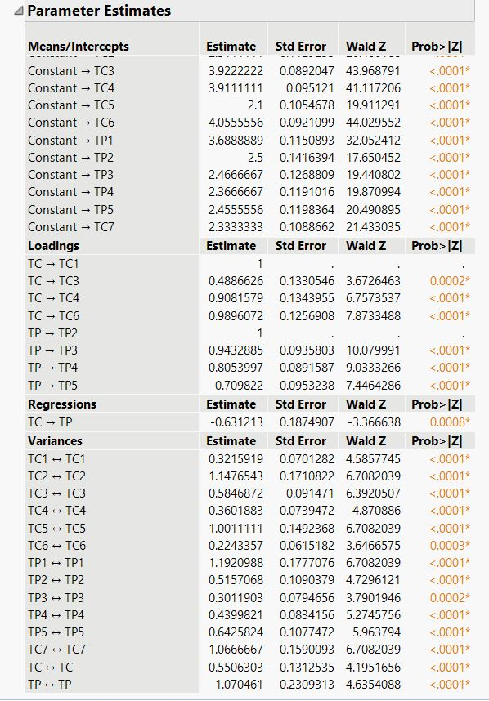

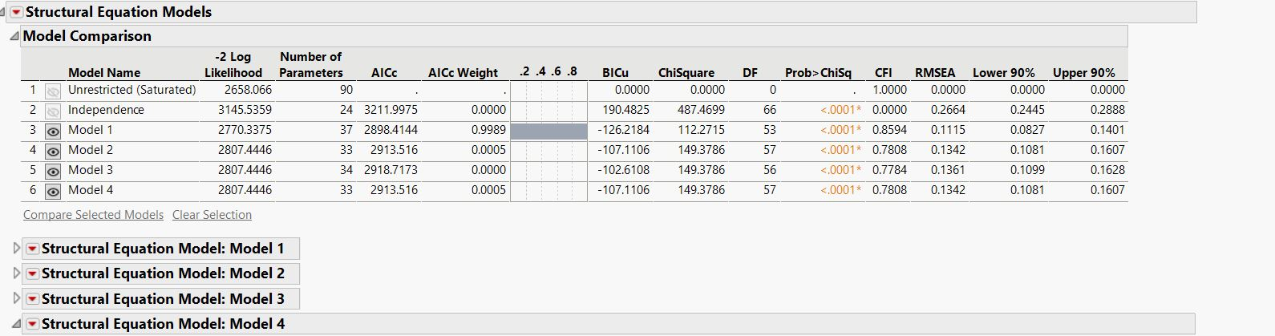

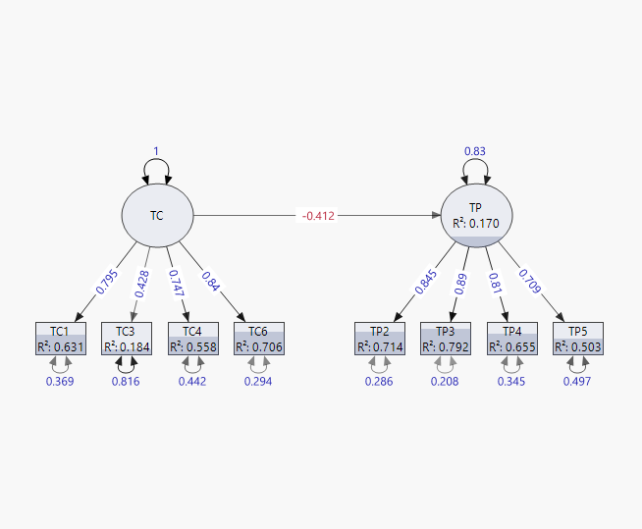

Structural equation modeling is a multivariate statistical analysis technique that is used to analyze structural relationships. This technique is the combination of factor analysis and multiple regression analysis, and it is used to analyze the structural relationship between measured variables and latent constructs.

R- Squared Values (Regression) is 0170 i.e., Impact of Tax Compliance on Tax Planning is 17%.

83% is Influencing by other factors.

FINAL VERIFICATION:

Since the model near to Lower Circuit, the SEM MODEL is approved.

**The broader impact of tax evasion on the economy and society, including loss of government revenue and erosion of public trust in Bangalore:**

Tax evasion has significant and far-reaching impacts on both the economy and society, including in cities like Bangalore. Here's how:

1. **Loss of Government Revenue**: Tax evasion deprives the government of much-needed revenue that could be used for public services and infrastructure development. In a rapidly growing city like Bangalore, where urbanization and infrastructure demands are high, the loss of tax revenue can severely hamper the government's ability to provide essential services such as

transportation, healthcare, education, and sanitation.

1. **Increased Tax Burden**: When individuals and businesses evade taxes, the burden of financing public services falls disproportionately on honest taxpayers. This can lead to higher tax rates or cuts in public spending, further exacerbating inequality and hindering economic growth.
2. **Distortion of Market Dynamics**: Tax evasion can distort market dynamics by giving unfair advantages to businesses that evade taxes. This creates an uneven playing field where compliant businesses struggle to compete with those operating outside the bounds of the law. In

Bangalore's vibrant business environment, this can stifle innovation and entrepreneurship.

1. **Erosion of Public Trust**: When tax evasion goes unchecked, it erodes public trust in the fairness and integrity of the tax system and government institutions. This can lead to a perception of inequality and injustice, fostering cynicism and disengagement among citizens. In Bangalore, where rapid urbanization and economic growth coexist with social and infrastructural

challenges, maintaining public trust is crucial for sustainable development.

1. **Undermining Social Programs**: Tax revenues are essential for funding social welfare programs aimed at alleviating poverty, providing healthcare, education, and housing assistance. When tax evasion reduces government revenues, these programs may suffer, leading to increased social inequality and hardship, particularly for marginalized communities in cities like Bangalore.
2. **Weakening of Rule of Law**: Tax evasion undermines the rule of law by fostering a culture of non- compliance and impunity. When individuals and businesses perceive that they can evade taxes without consequences, it undermines the authority of the legal system and weakens the overall fabric of society. This can have long-term consequences for governance and stability in cities like Bangalore.

**CHAPTER - 8**

**RECOMMENDATIONS**

Tax evasion and tax avoidance are major challenges faced by the Indian government. The prevalence of these practices has significant negative impacts on the Indian economy, including reduced tax revenue, increased income inequality, and reduced public trust in the government. The following aims to provide recommendations for addressing tax evasion and tax avoidance in India:

1. **Strengthen the tax administration**: The government should take measures to strengthen the tax administration to enhance its capacity to detect and prosecute tax evaders. This could involve investing in technology and human resources to improve tax compliance and reduce revenue leakages.

2. **Improve tax policy**: The government should review and reform tax policies to ensure that they are fair and transparent, and encourage tax compliance. This could involve reducing tax rates, simplifying tax laws, and broadening the tax base.

3. **Increase public awareness**: The government should engage in public education campaigns to increase public awareness of the importance of paying taxes and the negative effects of tax evasion and avoidance on the economy. This could involve using various media channels to inform and educate taxpayers on the benefits of paying taxes.

4. **Encourage voluntary compliance**: The government should adopt measures to encourage voluntary tax compliance by taxpayers. This could involve providing incentives such as tax rebates, tax credits, and other benefits to encourage taxpayers to comply with the laws.

5. **Strengthen international cooperation**: The government should strengthen international cooperation to combat tax evasion and avoidance. This could involve working with other countries to exchange information and best practices on tax administration and implementing international standards on tax transparency and exchange of information.

6. **Enhance penalty and enforcement mechanisms**: The government should impose severe penalties and strengthen enforcement mechanisms to deter tax evaders and avoiders. This could involve imposing heavy fines, criminal sanctions, and asset forfeiture to discourage them from these practices.

* Tax evasion consequences are not less than corruption consequences. Corruption and tax evasion are two sides of one coin, so civil society organizations should help the government to fight tax evasion, such as fighting corruption. It should be one more social activity like Anna Hazare ‘s to fight tax evasion, because tax evasion harms all of the people in the society in direct or indirect ways.
* Indian central government should raise tax awareness among the Indian society by using all possible means, like Hold conferences and Seminars to explain the harmful of tax evasion, and explain the importance of paying due tax to the community, in all India cities.
* Tax authorities in India should spread compliance with tax law in the society, should use all methods and means for that.
* Indian government should encourage people for inform about tax evasion cases to tax authorities and should introduce reward for any somebody informing about tax evasion operation.
* Tax evasion problem should teach in schools syllabus, as well as in the Universities syllabus to increase tax awareness among schools students and colleges‘ students in India.
* To curb tax evasion in India; it is recommended that should create a healthy relationship among the three stakeholders in the taxation system, Tax Authorities, Chartered Accountants and Taxpayers
* Income tax system in India should be made scientific and be based on economic planning according to the needs of the economy. It should encourage production, investment and saving.
* Tax authorities should expand the application of deduction of tax at sources, because it reduces the opportunities for tax evasion for example the revenue from indirect tax In Indian tax system more than the revenue from direct tax because in the indirect tax apply deduction of tax at sources.
* Tax authorities should develop planning to increase taxpayers ‘number in every year which will bring about more revenue for economic development.
* The tax authorities in India Should study the reasons for tax evasion, and try to remove these causes as much as possible and search for solutions to eliminate these causes in a scientific way.
* The phenomenon of corruption is widespread in tax administration in India, and it is a major cause for tax evasion, so Indian government must fight this phenomenon by all possible means. For example, the penalty should be imprisonment and fine for any person who commits corruption in tax administration or helps somebody in tax evasion case.

**CHAPTER - 9**

**CONCLUSION :**

1. Tax evasion undermines tax revenue, leading to reduced funding for public services and a strain on the government's ability to fulfil its obligations to taxpayers.
2. Individuals engage in tax fraud by altering their behaviour, such as changing work hours or professions, disrupting the optimal allocation of resources in the market and distorting economic efficiency.
3. Unequal opportunities resulting from tax evasion erode fairness in taxation, creating disparities in the tax burden among companies and fostering an environment of unfair competition.
4. Government resources are diverted towards auditing, measuring, and punishing tax evasion, resulting in additional costs and increasing the overall burden of tax compliance for both taxpayers and authorities.

According to their opinion, income tax evasion is prevalent in India. Tax evasion is primarily caused by high tax rates, corruption in public sector units, multiple tax rates, and inefficient tax authorities, according to experts. To improve Indian tax compliance, experts recommend implementing a proper tax regime, reducing tax rates, simplifying tax laws, closing loopholes, and processing information from annual returns.

Tax evasion and tax avoidance have significant negative impacts on the Indian economy. These practices lead to a loss of revenue for the government, hindering its ability to fund essential public services such as healthcare, education, and infrastructure development. This loss of revenue also exacerbates income inequality, as the burden of taxation falls more heavily on honest taxpayers. Moreover, tax evasion and avoidance undermine the integrity of the tax system, eroding public trust and confidence in the government. This can harm the overall business environment by discouraging domestic and foreign investment, as potential investors may view the tax system as unfair and unreliable.

To address these issues, the Indian government should take proactive steps to strengthen the tax administration system, including streamlining tax laws, improving enforcement capacity, and implementing stricter penalties for tax evaders. Additionally, promoting transparency and encouraging voluntary compliance through effective taxpayer education programs could also contribute to mitigating the negative effects of tax evasion and avoidance on the Indian economy. Ultimately, combating tax evasion and avoidance is not only essential for the sustained development of the Indian economy but also crucial for ensuring fairness, equal distribution of burden, and public trust in the tax system. By addressing these issues, the government can increase revenue collection, channel funds towards vital sectors, and foster a conducive environment for economic growth and investment.

* Tax rate ‘s one of the reasons of tax evasion, so the Indian government should reconsider the tax rate from time to time, according to economic conditions in the country.
* Tax audit should Improve and develop skills of tax audit team to become able to detect tax evasion when discharging tax audit because this is a main factor to help tax auditing to prohibit tax evasion in business and professions.
* Tax auditor must do his best and make every effort honest performance and high competence and professionalism and use all possible means to detect tax evasion.
* Indian government should enact penalty against Chartered Accountants and tax lawyers if they helping taxpayer for tax evasion.
* Professional skepticism requires an ongoing questioning of whether the information and audit evidence obtained suggests that a material misstatement due to fraud may exist.
* In order to improve the ability of the discover tax evasion by taxpayer, tax auditor should verify of the truth of deals from databases containing information provided by taxpayers to third parties, or relating to their transaction with third parties
* **Although the auditor cannot be expected to fully disregard past experience with the entity about the honesty and integrity of management and those charged with governance, the maintenance of an attitude of professional skepticism is important because there may have been changes in circumstances.**
* Tax laws should move towards synchronization of its policies and principles in alignment with the accounting standards, to ensure that the deviation and distortions are kept to minimum.
* **When performing analytical procedures to obtain an understanding of the entity and its environment, including its internal control, the auditor should consider unusual or unexpected relationships that may indicate risks of material misstatement due to tax evasion.**
* **The auditor should determine overall responses to address the assessed risks of material misstatement due to tax evasion at the financial statement level and should design and perform further audit procedures whose nature, timing and extent are responsive to the assessed risks at the assertion level**
* No law can be effective and satisfactorily implemented unless penalties and prosecutions are provided for. So, the researcher recommended that, the tax authorities should not neglect the application of the legal penalties on tax evaders.

**CHAPTER-10**

**Bibliography & References**

1. Hearings on Tax Reforms Act of 1969 before the House Committee

on Ways and Means, 91st Cong., 1st Sess., pt. 11 at 3978-85 (1969).

2. CITv Smt. Sindhubai Vasant Sahukar (1981)7 Taxman 188 (Bom.);

(1981) 24 CTR (Bom) 153; CIT v Bai Savita Gouri and others (1975)

100 ITR 680 (Bom).

3.https://www.investopedia.com/terms/t/taxevasion.asp

4. https://www.britannica.com/topic/taxation/History-of-taxation

5. <https://www.bankbazaar.com/tax/tax-evasion.html>

6. <https://cleartax.in/s/tax-evasion-and-penalties-in-india>

7. https://www.thehindubusinessline.com/opinion/col­umns/unorganised-growth/article29385181.ece

1. https://www.lawinsider.in/judgment/c-b-gautam-vs-union-of-india
2. https://indiankanoon.org/docfragment/98853113/?formInput=tax%20evasion

http://www.incometaxindia.gov.in

https://www.legalserviceindia.com/legal/article-3712- the-concept-of-tax-evasion-and-its-impact-on-na­tional economy.html

https://gsdrc.org/topic-guides/tax-reform/approaches/ taxing-the-informal-sector/

https://en.wikipedia.org/wiki/Taxation_in_India

1. https://www.thehindubusinessline.com/opinion/col­umns/unorganised-growth/article29385181.ecehttp://www.incometaxindia.gov.in
2. https://www.legalserviceindia.com/legal/article-3712- the-concept-of-tax-evasion-and-its-impact-on-na­tional economy.html
3. https://gsdrc.org/topic-guides/tax-reform/approaches/ taxing-the-informal-sector/
4. https://en.wikipedia.org/wiki/Taxation_in_India
5. https://www.thehindubusinessline.com/opinion/col­umns/unorganised-growth/article29385181.ece

**CHAPTER-11**

**ANNEXTURE**

Dear respondents,

I am THEETLA GANGAIH

From PES UNIVERSITY

I am doing my Internship in **ARU Advisers Pvt. Ltd.** & I’m conducting survey on ‘**Unveiling the Dynamics of Tax Compliance: A Comprehensive Analysis on Tax Avoidance, Planning, and Evasion Strategies and Practices in Bengaluru.*’***.

In this survey I have prepared a list of questionnaires relating to the same. I kindly request you to spare a few minutes from your precious time and fill this form. This information will be kept confidential and will be used only for academic purposes.

Regards,

Gangaiah Theetla

**1. What is your age?**

Below 20

20-40

40-60

Above 60

**2. What is your gender?**

Male

Female

1. **Are You a..... Person Under Income Tax.**

Individual

Company

**4. Under which of the following criteria does the turnover of your company fall?**

Less than 50 Lakhs

50 Lakhs - 1 Crores

1 Crores - 2 Crores

More than 2 Crores

**5. How do you stay informed about changes in tax laws and regulations Which may affect your tax planning strategies?**

Through tax consultants or advisors

through official government announcements

Through industry associations or networks

Others

1. **How much are you aware about the Tax structure, compliance and responsibility.**

Extremely aware Very much aware

Slightly aware Not at all aware.

1. **Have you ever engaged in tax planning strategies to minimize your tax liability?**

Yes, No May be

**8. Have you ever been investigated or penalized for tax evasion or aggressive tax planning?**

Yes No May be

**9. In your opinion, what makes a selected person to evade tax?**ILL-knowledge inadequate maintenance accounts

Afraid from jurisdiction to retain income in pocket

**Choose any of the options as per your Experience.**

1. **Strongly Agree (SA) b) Somewhat Agree c) Neutral (N)**

**d) Somewhat Disagree e) Strongly Disagree (SD)**

10. It is wrong if a taxpayer does not report all of his or her income in order to pay less income tax.

11. If in doubt about whether or not to report a certain source of income, you would not report it.

12. Do you agree tax evaders being audited in more detail in the next years would deter people from evading tax if the IRB detects tax evasion?

13) Do you agree tax evaders should be prosecuted in court would deter people from evading tax if the IRB detects tax evasion?

14) The present tax system benefits the rich and is unfair to the ordinary working man or woman.

15) Reforms could be made to the tax system to discourage tax avoidance and evasion while still allowing for legitimate tax planning.

**Research Methodology Questionnaire (Awareness Questions)**

**1) Does you / your company have Strategies with any in place to monitor and evaluate the effectiveness of tax Planning & avoidance in driving economic growth?**

Yes, we have dedicated monitoring and evaluation mechanisms with professionals

Yes, but they are not well-established

No, we do not have specific mechanisms in place

I'm unaware

2**) How transparent do you find the process of getting benefitted by Tax Planning Strategies for You/Your company?**

Very transparent Somewhat transparent Neutral Not very transparent Not transparent at all

**3) what strategies do you employ for tax planning?**

Retirement contributions

Charitable donations

Capital gains/losses management

Tax Deductions

More than one of the above strategies

**Rate the following Questions in Your opinion. (4-8)**

**Ratings: 1 2 3 4 5**

4) Role of professional advisors (such as accountants or tax attorneys) play in your tax planning process?

5) Ethical considerations you take into account when engaging in tax planning?

6) Challenges faced in reporting and documenting the utilization of tax incentives?

7) Utilization of tax planning & avoidance strategies provided by the government

8) Government Initiatives to combat & Penalizing the Tax Evaders.

**9) Which of the following you would like to prefer the most?**

Do not pay the taxes

Use Tax planning techniques & Pay Tax for development of Nation

Pay Tax as per IT ACT Provisions

No idea as to Tax planning