Artificial Intelligence in

Healthcare

**Student**: Himanshu Sharma(05714004423), Anushka Saxena(03550404423) and Aditya Manocha(04850404423)

**Guide:** Dr. Sanjiv Saxena

# Jagan Institute of Management Studies Rohini, New Delhi

***ABSTRACT***

*In recent years, artificial intelligence (AI) has grown rapidly in terms of hardware implementation, software algorithms, and applications across a wide range of industries. Artificial intelligence (AI) has become a game-changing technology in the healthcare sector, revolutionizing several facets of the sector. Diagnostics, treatment planning, drug discovery, electronic health record (EHR) analysis, and patient monitoring are just a few of the many applications of AI in healthcare. AI systems can analyze enormous volumes of healthcare data, including genomic sequences, clinical notes, and medical images, using machine learning algorithms and deep neural networks to derive relevant insights and make predictions. Artificial intelligence (AI) aims to mimic human cognitive functions. It is bringing a paradigm shift to healthcare, powered by increasing availability of healthcare data and rapid progress of analytics techniques [2]. AI in healthcare has an extensive number of advantages. It can increase the accuracy of diagnoses, hasten the discovery of diseases, and enable individualized treatment regimens. AI-driven algorithms can help clinicians make wise choices by presenting evidence-based suggestions and highlighting potential dangers. Additionally, AI technologies can boost organizational efficiency, improve resource allocation, and simplify administrative processes, resulting in cost savings and improved outcomes for patients.*

# Introduction

Artificial Intelligence is revolutionizing the healthcare industry by using latest technology to diagnose, treat, and manage diseases. It can analyze large amount of data and make prediction. Artificial Intelligence is transforming the healthcare environment and bringing in a new era of innovation and potential, from diagnostic help to personalized medication and administrative efficiency.

The application of AI in healthcare is not without obstacles, nevertheless. Essential factors include ensuring data privacy, security, and regulatory compliance. To avoid prejudice and maintain confidence among professionals and patients, AI models must be accessible, comprehensible, and robust. Consideration must also be given to the moral consequences of AI, including the appropriate use of patient data and the possibility of employment displacement.

Looking ahead, artificial intelligence in healthcare has a bright future. The capabilities of AI can be further improved through improvements in AI algorithms, greater accessibility to high-quality healthcare data, and higher processing capacity. Predictive analytics, early illness detection, and AI-driven precision medicine will spread, enabling proactive and individualized therapy. Aside from that, AI-powered telemedicine and remote monitoring technologies will increase access to healthcare, particularly in impoverished areas.

AI is now able to be applied in several healthcare domains because of the rapid development of healthcare data as well as improvements in machine learning techniques and processing power. Electronic health records, complex medical images, sequences of genomes, and other sources of healthcare data may all be processed and analyzed by AI systems to find patterns, spot trends, and produce insightful data that can be used to make decisions.

Additionally, AI enables precise medicine by examining a person's particular genetic make- up, lifestyle choices, and medical background to create individualized treatment recommendations. AI algorithms can detect biomarkers, forecast treatment outcomes, and help choose the most beneficial treatments based on the needs of a specific patient by combining this abundance of data.

AI streamlines administrative tasks, increasing efficiency and improving healthcare operations in addition to its clinical applications. Healthcare practitioners can spend more time focusing on providing direct patient care by using AI-powered

solutions to automate tasks like appointment scheduling, medical coding, and invoicing. AI- powered virtual assistants and chatbots provide continuous access to healthcare information, supporting patients with their questions and dispensing basic medical guidance.

Despite the immense potential of AI in healthcare, there are still issues that must be resolved. To preserve patient information, worries about data privacy and security must be minimized. Building confidence and acceptance among healthcare providers and patients requires that AI algorithms be transparent, equitable, and understandable. It is necessary to have intelligent debates and put in place legal frameworks to address ethical issues like responsible data usage, algorithm biases, and potential employment displacement.

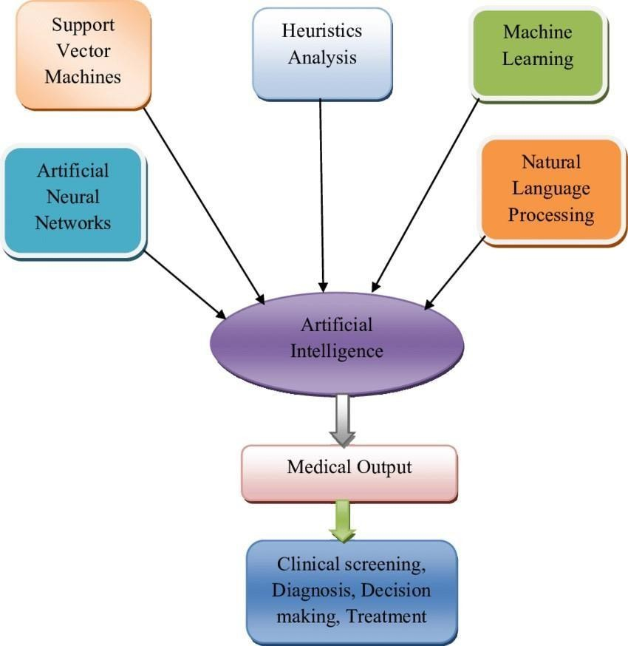

Process chart of artificial intelligence in the medical field

AI can also play a significant role in drug discovery and development. By analysing vast amounts of biomedical data and scientific literature, AI algorithms can identify potential drug targets, optimize drug design, and accelerate the process of clinical trials. This has the potential to bring new treatments to patients faster and more efficiently. While AI has already made substantial contributions to healthcare, its potential for the future is even more promising. Advancements in AI algorithms, coupled with the increasing availability of healthcare data, can further improve the accuracy and efficiency of diagnostic processes, enable personalized medicine, and enhance treatment recommendations.

# Literature Review

There have been related works several studies and research papers published on the use of AI in healthcare, addressing both the benefits and the potential challenges. Some of the related works in this area include: “Artificial intelligence in healthcare: past, present and future” by Hsueh et al., (2018). This paper provides an overview of the history and current state of AI in healthcare and discusses the future potential of the technology. “Challenges and opportunities in the use of artificial intelligence for medical imaging” by Oermann, et al., (2019). This paper discusses the potential for AI to transform medical imaging and highlights the

challenges that need to be addressed, including regulatory and ethical concerns. “Potential of machine learning in clinical medicine and decision- making” by Abd-Alrazaq et al., (2019). This paper explores the potential of machine learning in clinical decision-making and discusses the ethical and regulatory challenges that need to be addressed. “Ethical and social implications of artificial intelligence in health care” by Capan et al., (2019). This paper examines the ethical and social implications of AI in healthcare, including issues related to accountability, transparency, and bias. “Robotic-assisted surgery: a current perspective” by Srinivasa et al., (2018). This paper provides an overview of the current state of robotic- assisted surgery and discusses the potential benefits and challenges of the technology, including regulatory and ethical concerns. These studies and many others demonstrate the significant potential of AI in healthcare while also highlighting the importance of addressing ethical and regulatory concerns to ensure the safe and effective use of the technology.

# Current Applications of AI in Healthcare

Machine learning is a branch of AI that allows computers to learn from data without being explicitly programmed. Machine learning has a wide range of applications in healthcare, including image analysis, diagnosis, and treatment planning. For example, machine learning algorithms can be used to analyse medical images, such as MRI scans, to identify patterns and predict outcomes. Machine learning can also be used to develop predictive models for disease progression and treatment response. Machine learning has indeed revolutionized various aspects of healthcare, including image analysis, diagnosis, and treatment planning. With the ability to learn patterns and make predictions from large amounts of data, machine learning algorithms have shown great potential in improving healthcare outcomes.

In the field of medical imaging, machine learning algorithms have been developed to analyse images from various modalities, such as MRI scans, X-rays, and CT scans. These algorithms can detect and classify abnormalities, tumours, and other conditions with high accuracy. By training on large datasets of annotated images, machine learning models can learn to identify subtle patterns that may not be apparent to human observers. This can aid radiologists and other healthcare professionals in making more accurate and timely diagnoses, leading to improved patient care. Furthermore, machine learning algorithms can be used to develop predictive models for disease progression and treatment response. By analysing patient data, including clinical records, genetic information, and biomarkers, machine learning models can identify patterns and risk factors associated with specific diseases. This information can help healthcare providers predict disease progression, identify patients at higher risk of complications, and tailor treatment plans accordingly.

For example, in oncology, machine learning algorithms can analyse patient data to predict the likelihood of cancer recurrence and recommend appropriate treatment options.

Machine learning can also contribute to treatment planning and decision-making. By analysing large datasets of patient records, treatment outcomes, and medical guidelines, machine learning models can generate treatment recommendations based on individual patient characteristics. This can assist healthcare providers in choosing the most effective treatment options and optimizing patient care.

Moreover, machine learning algorithms have the potential to identify new patterns and relationships in biomedical data that may lead to novel discoveries and advancements in medical research. By analysing large-scale genomics, proteomics, and other -omics data, machine learning can help identify genetic markers, biomarkers, and potential drug targets. This can accelerate the process of drug discovery and development, leading to the development of more targeted and personalized treatments.

# Natural Language Processing (NLP)

NPL is another branch of AI that enables computers to understand and interpret human language. NLP has a wide range of applications in healthcare, including clinical documentation, patient engagement, and medical research. For example, NLP can be used to extract information from clinical notes and electronic health records (EHRs) to improve clinical decision-making and patient care. NLP can also be used to develop chatbots and virtual assistants that can help patients manage their health.

Natural language processing (NLP) is another branch of artificial intelligence (AI) that focuses on the interaction between computers and human language. NLP enables computers to understand, interpret, and generate human language, which has significant applications in healthcare. One of the primary applications of NLP in healthcare is clinical documentation.

Healthcare professionals generate a vast amount of textual data, including electronic health records (EHRs), clinical notes, and research papers. NLP algorithms can analyse and extract relevant information from these documents, making them more accessible and useful. NLP can automatically identify key clinical information, such as diagnoses, treatments, and lab results, from unstructured text, facilitating decision-making and improving information retrieval.

**Natural Language Processing**

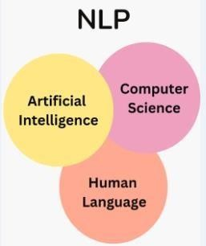

NLP can also support clinical decision-making and provide evidence-based recommendations. By analysing medical literature, treatment guidelines, and patient data, NLP algorithms can extract relevant information and generate insights to assist healthcare providers in making informed decisions. For example, NLP can analyse patient symptoms and medical history to suggest potential diagnoses or recommend appropriate treatment options based on current medical knowledge. Also, NLP can contribute to the improvement of patient outcomes through adverse event detection and monitoring. By analysing patient records, NLP algorithms can identify potential adverse events, such as medication errors or adverse drug reactions, by detecting patterns and anomalies in the data. This enables healthcare providers to intervene in a timely manner, reducing the risks and improving patient safety.

Patient engagement and communication can also benefit from NLP applications. Chatbots and virtual assistants powered by NLP can interact with patients, answering their questions, providing educational materials, and assisting with appointment scheduling. NLP algorithms enable these virtual assistants to understand and respond to natural language queries, making the interaction more user-friendly and efficient. Also, NLP can support clinical research and knowledge discovery. By analysing large volumes of scientific literature and research articles, NLP algorithms can extract relevant information, identify trends, and assist researchers in exploring new hypotheses and discoveries. This can accelerate the research process and enhance medical knowledge.

Though, there are challenges in implementing NLP in healthcare. Natural language is complex, ambiguous, and context-dependent, making it challenging for computers to understand and interpret accurately. Variations in language, medical terminology, and the need to handle sensitive patient data add further complexity to NLP applications in healthcare. Developing robust NLP algorithms that can handle these challenges and ensure high accuracy is an ongoing area of research.

# Phases of NPL

Natural Language Processing (NLP) can be broadly categorized into several phases or tasks that collectively enable computers to understand and process human language. These phases often overlap and can vary depending on the specific application or context. The main phases of NLP include:

**Phases of NLP**

**Text Preprocessing***:* This phase involves cleaning and preparing the text data for further analysis. It typically includes tasks such as tokenization (splitting text into words or smaller units), stemming or lemmatization (reducing words to their base form), removing stop words (commonly used words with little semantic value), and handling special characters or punctuation marks.

**Part-of-Speech Tagging***:* In this phase, each word in a sentence is assigned a grammatical label, such as noun, verb, adjective, etc. This information is crucial for understanding the syntactic structure and meaning of a sentence.

**Named Entity Recognition (NER)***:* NER involves identifying and classifying named entities in text, such as names of people, organizations, locations, dates, and other specific entities. This task is essential for extracting relevant information from text and enabling further analysis or understanding.

**Sentiment Analysis***:* This phase focuses on determining the sentiment or emotional tone expressed in text. It involves classifying text as positive, negative, or neutral, and may also include detecting emotions such as happiness, sadness, anger, etc. Sentiment analysis is widely used in applications like social media monitoring, customer feedback analysis, and market research.

**Syntax and Grammar Parsing***:* This phase involves analysing the syntactic structure of sentences and understanding the relationships between words. It includes tasks such as parsing, constituency analysis, dependency parsing, and syntactic tree construction. These techniques help in understanding the grammatical structure and meaning of sentences.

**Language Modelling***:* Language modelling involves building statistical or machine learning models that capture the patterns and relationships between words in a given language. These models can be used to generate coherent and contextually appropriate text, predict the next word in a sequence, or estimate the likelihood of a sentence.

**Machine Translation***:* Machine translation focuses on automatically translating text from one language to another. It involves tasks such as language identification, sentence alignment, word alignment, and generating a translated version of the source text. Machine translation systems often utilize a combination of statistical methods and neural network-based approaches.

**Question Answering***:* This phase deals with understanding questions posed in natural language and providing relevant answers. It involves tasks such as question classification, information retrieval, passage ranking, and answer generation. Question answering systems aim to provide accurate and contextually appropriate responses to user queries.

# Robotics is Another Area of AI that has the Potential to Transform Healthcare

Robots can be used for a wide range of tasks in healthcare, including surgery, rehabilitation, and patient care. For example, surgical robots can be used to perform minimally invasive procedures, which can reduce recovery time and improve outcomes. Robots can also be used for telemedicine, allowing healthcare providers to remotely monitor patients and provide care in real-time. Robotics, as a field of artificial intelligence (AI), holds great promise for transforming healthcare. Robotics combines AI algorithms with mechanical devices to create intelligent machines that can perform physical tasks and interact with the environment. In healthcare, robotic systems have the potential to revolutionize various aspects of patient care, medical procedures, and healthcare operations.

One of the key applications of robotics in healthcare is in surgical procedures. Robotic surgical systems, such as the da Vinci Surgical System, enable surgeons to perform minimally invasive surgeries with enhanced precision and control. These systems consist of robotic arms with specialized instruments controlled by the surgeon, offering increased dexterity, 3D visualization, and reduced invasiveness. Robotic surgery can lead to shorter hospital stays, faster recovery times, and improved surgical outcomes for patients. In accumulation to surgical applications, robots can also assist healthcare providers in tasks such as patient care and rehabilitation. Robots can be used to perform repetitive tasks, such as lifting and transferring patients, reducing the physical strain on healthcare professionals and minimizing the risk of injuries. Robotic exoskeletons can aid in rehabilitation by providing support and assistance to patients recovering from injuries or impairments, helping them regain mobility and strength.

Robots equipped with sensors and AI algorithms can also be employed for remote monitoring and telemedicine. These robots can navigate hospital corridors and patient rooms, capturing vital signs, relaying information to healthcare providers, and allowing for remote consultations. This enables healthcare professionals to monitor patients in real-time and provide timely interventions, especially in remote or underserved areas. Besides, robotics can enhance the efficiency of healthcare operations and logistics. Autonomous robots can be deployed for tasks such as medication delivery, inventory management, and sterilization of hospital environments. This automation reduces the workload on staff, improves accuracy, and allows healthcare professionals to focus more on patient care. While robotics in healthcare offers numerous advantages, there are challenges to be addressed. Ensuring the safety and reliability of robotic systems is crucial, particularly in critical procedures.

# Methodology

By enhancing diagnosis, therapy, research, and patient care in overall, artificial intelligence (AI) has the potential to completely transform the healthcare industry.

**Defining the problem**: Determine a specific healthcare issue or task that AI can resolve. This can involve making a diagnosis of an illness, predicting patient outcomes, or analyzing medical images.

**Collection of data**: Collecting relevant data for testing and training done by AI.

The data containing genetic records, clinical record, electronic health records etc. This all data helps in prediction and diagnosis the dieses.

**Data preprocessing**: In this removal of noise data and settling error to data take place. In other words, we can say normalization of data take place.

**Algorithm selection**: Choose and make appropriate algorithm for the data available. This could include machine learning (ML).

**Model development**: Using the prepared data, create and train the AI model. To do this, separate the data into sets for training, validating, and testing. Utilize the validation set to improve the model after it has been trained using the training set. To optimize performance, iteratively refine the model's architecture and hyperparameters.

**Evaluation and validation**: Using the data set for testing or cross-validation to assess the trained model's performance. The performance of the model can be assessed using metrics such as accuracy, precision, recall, F1-score, or area under the curve (AUC).

**Integration and deployment**: Bring the AI model into the workflow or healthcare system. This may involve integrating it with decision support tools, medical imaging platforms, or electronic health record systems. Make sure the AI system complies with legal standards while integrating seamlessly with the current infrastructure and workflows.

**Monitoring and maintenance**: Regular maintenance and monitoring of AI should be there. Should take care of AI that it will not lead to any error.

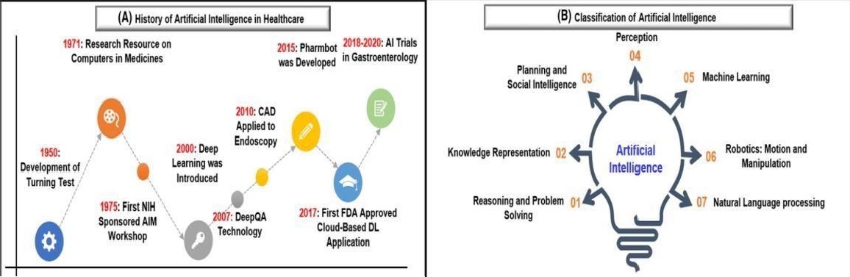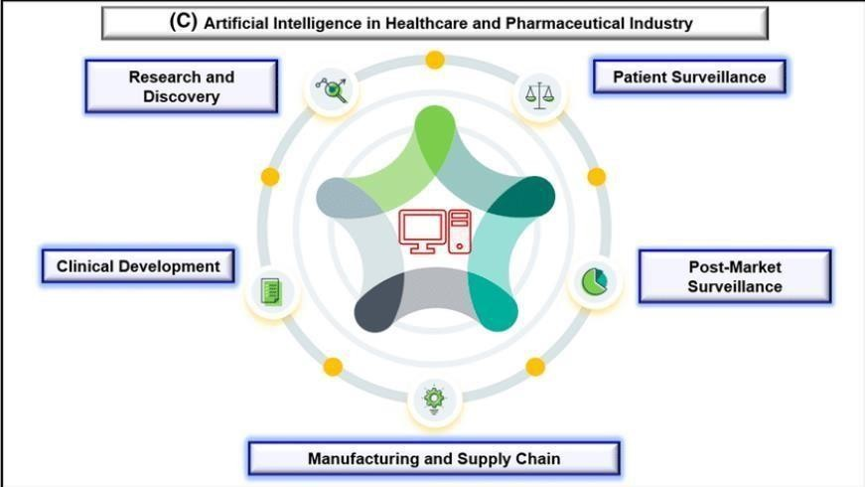

# IDENTIFIED GAPS

Though the integration of robotics in healthcare brings numerous benefits, there are several identified gaps or challenges that need to be addressed for its successful implementation:

**Cost:** Robotics systems can be expensive to acquire, maintain, and upgrade. The high cost of robotic technology can pose financial challenges for healthcare institutions, limiting their accessibility and adoption.

**Safety and Reliability:** Ensuring the safety and reliability of robotic systems is crucial, particularly in critical healthcare procedures. Robotic systems must undergo thorough testing, validation, and regulatory compliance to minimize the risk of errors, malfunctions, or adverse events.

**Training and Expertise:** Healthcare professionals need specialized training to operate and manage robotic systems effectively. The learning curve associated with robotics technology can be steep, requiring ongoing training and education to ensure proficiency and competence. **Integration and Interoperability:** Integrating robotics systems with existing healthcare infrastructure and information systems can be complex. Seamless integration, interoperability, and compatibility with electronic health records (EHRs) and other healthcare technologies are essential for efficient workflow and data exchange.

**Ethical and Legal Considerations:** Ethical dilemmas can arise in the use of robotics in healthcare, such as issues related to patient consent, privacy, and the potential for reduced human interaction and empathy. Ensuring ethical guidelines and legal frameworks are in place is critical to address these concerns and maintain patient trust.

**Acceptance and Resistance:** The acceptance and adoption of robotics in healthcare may face resistance from healthcare professionals who may fear job displacement or perceive robotics as a threat to the human touch in patient care. Overcoming these concerns and fostering a collaborative mindset is crucial for successful implementation.

**Regulatory and Reimbursement Challenges:** Regulatory bodies may need to adapt and establish guidelines specific to robotics in healthcare. Additionally, reimbursement models may need to be modified to accommodate the use of robotics, ensuring fair compensation for services provided and encouraging widespread adoption.

**Limited Data and Evidence:** Despite the potential of robotics in healthcare, there may be a lack of robust clinical evidence and long-term outcome data to support its efficacy and cost- effectiveness. More research and studies are needed to build a strong evidence base for the benefits and impact of robotics in different healthcare applications.

**Data quality and privacy:** AI relies on high-quality data to generate accurate results, but healthcare data can be incomplete, inconsistent, or biased. Additionally, there are concerns about protecting patient privacy when sharing medical data for AI analysis.

**Regulatory and ethical concerns:** There are concerns about the transparency and accountability of AI algorithms, as well as the potential for bias and discrimination. Regulatory bodies need to develop standards and guidelines for the use of AI in healthcare to ensure that it is used ethically and safely.

**Adoption and integration:** AI solutions need to be integrated into existing healthcare systems and workflows, which can be challenging and time-consuming. Healthcare providers need to be trained to use AI tools effectively, and there may be resistance to change from some stakeholders.

**Liability and accountability:** If an AI system makes a mistake that results in harm to a patient, it can be difficult to determine who is responsible. Liability and accountability need to be clearly defined to ensure that patients are protected.

# OPPORTUNITIES

The integration of robotics in healthcare presents several opportunities for advancements and improvements in patient care, medical procedures, and healthcare operations. Some of the key opportunities include:

**Enhanced Precision and Accuracy**: Robotic systems can offer enhanced precision and accuracy in surgical procedures, leading to better surgical outcomes and reduced risks. The high precision and dexterity of robotic arms can enable surgeons to perform intricate tasks with improved control and accuracy, minimizing the potential for human error.

**Minimally Invasive Surgeries**: Robotic surgical systems enable minimally invasive procedures, resulting in smaller incisions, reduced scarring, and faster recovery times for patients. The use of robotics can lead to shorter hospital stays, decreased post- operative pain, and a quicker return to daily activities.

**Remote and Telemedicine Capabilities:** Robots equipped with sensors, cameras, and communication technology can facilitate remote monitoring and telemedicine. Healthcare professionals can remotely access patient information, provide consultations, and monitor vital signs in real-time, allowing for more efficient and accessible healthcare delivery, particularly in remote or underserved areas.

**Repetitive and Physically Demanding Tasks**: Robots can assist healthcare professionals in performing repetitive and physically demanding tasks, reducing the strain on healthcare staff and minimizing the risk of injuries. This can free up healthcare professionals' time to focus on more complex and critical aspects of patient care.

**Rehabilitation and Assistive Devices**: Robotic exoskeletons and assistive devices can aid in rehabilitation and support patients with mobility impairments. These devices can provide targeted therapy, assist with movements, and enable individuals to regain or enhance their physical capabilities, improving their quality of life.

**Optimized Healthcare Operations:** Robotics can optimize healthcare operations by automating tasks such as medication delivery, inventory management, and sterilization processes. This automation can improve efficiency, accuracy, and reduce the workload on healthcare staff, enabling them to focus on patient care and complex decision-making.

**Training and Simulation**: Robotic systems offer opportunities for training and simulation in healthcare. Surgeons and other healthcare professionals can practice and refine their skills using virtual reality (VR) and augmented reality (AR) simulations, providing a safe and controlled environment for learning and enhancing expertise.

**Data-driven Insights:** The integration of robotics in healthcare generates vast amounts of data that can be analysed to gain insights, improve outcomes, and advance medical research. Analysing data from robotic procedures and patient monitoring can help identify patterns, trends, and correlations, leading to personalized treatment plans, early detection of complications, and advancements in medical knowledge.

**Improved diagnostics and treatment:** AI have the potential to analyse large amounts of data and generate insights that can help healthcare providers make more accurate diagnoses and develop more effective treatments.

**Personalized medicine:** By analysing patient data, AI can identify patterns and make predictions about individual patients' health risks and treatment needs. This can enable healthcare providers to deliver more personalized care.

**Efficiency and cost savings:** AI can automate repetitive tasks, reduce errors, and optimize resource allocation, which can improve efficiency and reduce costs.

# FUTURE POSSIBILITIES OF AI IN HEALTHCARE

The future possibilities of AI in healthcare are vast and exciting. One of the most promising areas of AI in healthcare is personalized medicine. Personalized medicine involves tailoring medical treatment to an individual's genetic makeup, lifestyle, and environment. AI can be used to analyse vast amounts of data to develop personalized treatment plans that are tailored to each patient's unique needs. Another promising area of AI in healthcare is disease prediction and prevention. AI can be used to analyse data from multiple sources, such as genetic testing, medical records, and environmental data, to identify individuals who are at high risk of developing certain diseases. This information can be used to develop preventive strategies that can reduce the incidence of disease. Finally, AI has the potential to revolutionize drug discovery. AI can be used to analyse vast amounts of data to identify new drug targets and develop more effective treatments. AI can also be used to optimize clinical trials, reducing the time and cost of bringing new drugs to market. There are concerns about the potential for AI to perpetuate bias and discrimination in healthcare. For example, if AI algorithms are trained on biased data, they may make biased decisions that negatively impact certain populations. Regulatory concerns also arise with the use of AI in healthcare. The development and use of AI algorithms must be subject to regulatory oversight to ensure their safety and effectiveness.

The future possibilities of AI in healthcare are vast and hold the potential to revolutionize the way healthcare is delivered. Advancements in AI techniques and technologies are expected to bring several benefits and advancements in healthcare. Some of the future possibilities of AI in healthcare include:

**Precision Medicine:** AI can play a crucial role in advancing precision medicine, which aims to tailor medical treatments and interventions to individual patients. AI algorithms can analyse large-scale genomic data, patient health records, and other relevant information to identify patterns, predict disease risks, and develop personalized treatment plans. This can lead to more targeted and effective therapies, minimizing adverse effects and optimizing patient outcomes.

**Drug Discovery and Development:** AI can accelerate the drug discovery and development process by analysing vast amounts of biomedical data, including genomic information, protein structures, and scientific literature. AI algorithms can identify potential drug candidates, predict their efficacy, and optimize their properties. This can reduce the time and cost associated with bringing new drugs to market and enhance the success rate of drug discovery efforts.

**Intelligent Imaging and Diagnostics:** AI-powered image analysis techniques can significantly enhance medical imaging and diagnostics. Machine learning algorithms can analyse medical images, such as X-rays, CT scans, and MRIs, to detect abnormalities, assist in early disease diagnosis, and provide quantitative assessments. AI can help radiologists and other healthcare professionals make more accurate and timely diagnoses, leading to improved patient outcomes.

**Virtual Assistants and Chatbots:** AI-driven virtual assistants and chatbots have the potential to enhance patient engagement and provide 24/7 support. These intelligent systems can interact with patients, answer their questions, provide guidance, and offer personalized health recommendations. Virtual assistants can assist with appointment scheduling, medication reminders, and post-care instructions, improving patient experience and adherence to treatment plans.

**Predictive Analytics and Early Warning Systems:** AI algorithms can analyse patient data in real-time to identify patterns, predict disease progression, and provide early warnings for adverse events. By continuously monitoring patient vital signs, electronic health records, and other relevant data, AI systems can alert healthcare providers to potential complications, allowing for timely interventions and preventive measures.

**Robotics and Automation:** Robotics combined with AI can further advance surgical procedures, patient care, and healthcare operations. Intelligent robotic systems can assist surgeons in performing complex surgeries with enhanced precision and control. Robots can also automate routine tasks, such as medication dispensing, sample processing, and logistics, freeing up healthcare professionals' time and improving overall efficiency.

**Natural Language Processing and Clinical Decision Support**: Natural language processing (NLP) techniques can be further advanced to improve clinical documentation, extract

relevant information from medical literature, and provide real-time clinical decision support. AI-powered systems can analyse vast amounts of medical literature, treatment guidelines, and patient data to support healthcare professionals in making evidence-based decisions and recommendations.

**Remote Monitoring and Telehealth:** AI-enabled remote monitoring systems can continuously collect patient data and transmit it to healthcare providers. AI algorithms can analyse the data to detect deviations from normal ranges and alert healthcare professionals in real-time. This enables remote monitoring of patients with chronic conditions, post-surgical care, and elderly populations, allowing for early intervention and reducing the need for hospital visits.

Bias and discrimination are also major ethical concerns with the use of AI in healthcare. AI algorithms may perpetuate bias if they are trained on biased data or if the algorithm itself has biases built-in. To address this concern, it is important to ensure that the data used to train AI algorithms is diverse and representative of the population. Additionally, algorithms should be designed with fairness and equity in mind and should be regularly audited to ensure that they are not perpetuating bias. In terms of regulatory concerns, there needs to be a clear regulatory framework for the development and use of AI algorithms in healthcare. This includes regulations around data privacy and security, as well as regulations around the safety and effectiveness of AI algorithms. Additionally, there needs to be clear guidelines around the use of AI algorithms in clinical decision-making and patient care. To realize these future possibilities, ongoing research and development are required to refine AI techniques, improve data quality and interoperability, address privacy and security concerns, and ensure ethical considerations are met. Collaboration between AI experts, healthcare professionals, regulatory bodies, and policymakers is essential to harness the full potential of AI in healthcare while addressing the challenges and ensuring patient safety and trust.

# Robust Regulatory Framework:

A robust regulatory framework for AI in healthcare should encompass both the techniques and algorithms used in AI systems. Here are some key aspects that can be included in such a framework:

* **Validation and Certification**: Establishing standards and procedures for the validation and certification of AI algorithms and systems in healthcare. This can involve rigorous testing, verification, and evaluation processes to ensure the safety, reliability, and effectiveness of AI technologies.
* **Transparency and Explain ability**: Requiring AI systems to provide explanations and justifications for their decisions and recommendations. Transparency in algorithmic decision-making is important to understand how AI arrives at its conclusions, enabling healthcare professionals to trust and verify the outputs.
* **Data Quality and Governance**: Setting guidelines for data collection, quality, and governance to ensure that AI algorithms are trained on diverse, representative, and reliable datasets. This includes addressing biases, ensuring data privacy and security, and obtaining appropriate consent for data usage.
* **Ethical Considerations**: Incorporating ethical principles into the regulatory framework, such as fairness, accountability, and respect for patient autonomy. This can involve guidelines for addressing biases, preventing discrimination, and safeguarding patient privacy and confidentiality.
* **Algorithm Monitoring and Auditing**: Requiring regular monitoring and auditing of AI algorithms to detect and mitigate biases, errors, or unintended consequences. This can involve periodic assessments of AI system performance, validation of ongoing data quality, and reviews of algorithmic decision-making processes.
* **Adverse Event Reporting**: Establishing mechanisms for reporting and investigating adverse events or incidents related to the use of AI in healthcare. This can help identify potential risks, improve system performance, and ensure accountability for any harm caused by AI technologies.
* **Continual Learning and Improvement**: Encouraging a culture of continual learning and improvement in AI systems. This involves updating algorithms based on new evidence, feedback, and advancements in medical knowledge, and ensuring that healthcare professionals are kept up to date with the latest developments.
* **Regulatory Oversight and Collaboration:** Establishing regulatory bodies or agencies responsible for overseeing AI in healthcare and collaborating with experts, healthcare professionals, researchers, and industry stakeholders. This collaborative approach can facilitate the development of effective regulations and ensure their adaptation to the evolving landscape of AI technologies. By incorporating these aspects into a robust regulatory framework, it is possible to address the unique challenges posed by AI in healthcare and promote the safe and responsible use of AI techniques and algorithms. This framework can provide guidance, establish standards, and create accountability, ultimately fostering trust in AI systems and maximizing their potential benefits while minimizing potential risks.

# CONCLUSION

The use of AI in healthcare has the potential to revolutionize patient care by improving outcomes, reducing costs, and enhancing efficiency. However, ethical and regulatory concerns must be addressed to ensure the safe and effective use of AI in healthcare. By developing a robust regulatory framework and addressing ethical concerns, we can harness the power of AI to improve patient care and advance medical research while ensuring that the technology is used in a responsible and equitable manner.

# REFERENCES

1. *Artificial Intelligence in Healthcare: Review and Prediction Case Studies. Guoguang Rong, Arnaldo Mendez, Elie Bou Assi, Bo Zhao, Mohamad Sawan*
2. *Artificial intelligence in healthcare: past, present and future. Fei Jiang, Yong Jiang, Hui Zhi, Yi Dong, Hao Li, Sufeng Ma, Yilong Wang, Qiang Dong,*

*Haipeng Shen, Yongjun Wang*

1. [*https://www.researchgate.net/figure/a-History-of-artificial-*](https://www.researchgate.net/figure/a-History-of-artificial-intelligence-in-healthcare-the-first-breakthrough-of-artificial_fig1_350830745)[*intelligenceinhealthcare-the-first-breakthrough-of-artificial_fig1_350830745*](https://www.researchgate.net/figure/a-History-of-artificial-intelligence-in-healthcare-the-first-breakthrough-of-artificial_fig1_350830745)
2. *https://*[*www.researchgate.net/figure/Process-chart-of-artificial-*](http://www.researchgate.net/figure/Process-chart-of-artificial-) *intelligenceinthe-medical-field_fig1_337191234*