**A Hybrid Precoding System Based on Kalman Algorithm for Multi-User Millimeter Wave Massive MIMO Systems**

**CH.Vinay 1 , Kuncham Anusha A 2 , Koleti Akshitha 3 , Boddu Anusha4 ,**

**Sampathikonda Ganesh 5 .**

**1 ASSOCIATE PROFESSOR IN DEPARTMENT OF ECE IN JYOTHISHMATHI INSTITUTE OF TECHNOLOGY &SCIENCE IN JITS RD, RAMAKRISHNA COLONY, VACHUNUR, TELANGANA, 505481.**

**2,3,4,5. FINAL YEAR STUDENTS IN DEPARTMENT OF ECE IN JYOTHISHMATHI**

**INSTITUTE OF TECHNOLOGY & SCIENCE IN JITS RD, RAMAKRISHNA COLONY, VACHUNUR, TELANGANA, 505481.**

**ABSTRACT**

Millimetre wave (mm Wave) communication requires huge recieving wire clusters to increment the capability of cellular systems of the fifth era with great beam-forming picks up and a considerable lessening in way misfortunes for both transmitting and accepting terminals. Completely computerized procedures are infeasible with huge recieving wire clusters due to equipment imperatives at such frequencies, whereas absolutely analog arrangements endure extreme execution impediments. Crossover analog/digital beamforming is a promising arrangement, particularly, when amplified to a multi-user situation. This paper passes on two fundamental commitments: 1) a Kalman-based definition for half breed analog/digital precoding in multi-user environment is proposed; 2) an iterative arrangement is planned for the cross breed precoding plot with reasonable complexity. A Kalman-based crossover analog/digital precoding is utilized with a downlink rate of 4.64 Gbps/cell and an uplink rate of 1.84 Gbps/cell in multi-user environments

**INTRODUCTION**

Millimeter wave (mm Wave) communication is a key empowering innovation for understanding the range crunch in future5G frameworks [1]–[7]. Due to restricted accessible range in the sub-6 GHz band, ordinary cellular and WiFi based arrangements cannot be scaled up to meet the ever-growing information requests of organize densiﬁcation, and rising applications related with information centers and versatile gadgets. Whereas imaginative arrangements such as utilizing authorized range on an astute premise have been proposed [8], such approaches are still subjected to visit disturbance and are restricted by the channel transmission capacity accessible in the authorized groups, such as the TV groups. Millimeter wave (mm Wave) band communication in the as of late opened up touching piece of unlicensed range in the 57-71GHz extend is an opportunity for accomplishing gigabit-per-second information rates [9]. Undoubtedly, existing benchmarks like the IEEE 802.11ad working in these groups permit up to 2GHz wide channels for short-distance communications. mm Wave challenges: Due to the tall way misfortune that happens in the mm Wave groups, directional beamforming misusing expansive radio wire clusters at both base station (BS) and versatile stations (MSs) is required [10]–[13]. This empowers tall qual-ity and long-distance communication joins, and increments the flag control concentrated at the recipient conclusion. The tall recurrence of operation too bolsters gigantic multi-antenna designs from a plan perspective, whereas decreasing the measurements of each recieving wire and permitting numerous of them to be stuffed in a little range. Whereas the equipment back from expansive radio wire clusters for beamforming capacities is accessible nowadays, the tall recurrence of operation, anticipated testing rates and channel transfer speeds make it difﬁcult to send conventional completely advanced beamforming arrangements [10]

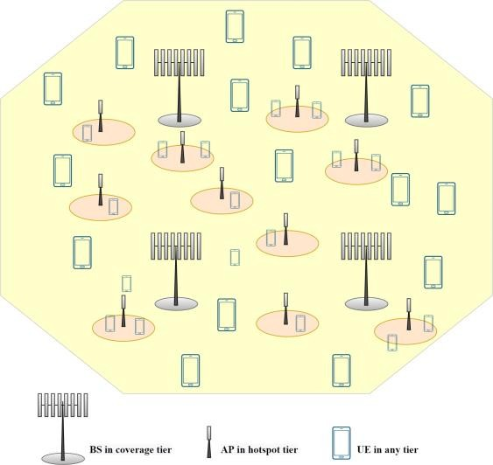

### Fig : Heterogeneous Network

**PROPOSED SYSTEM**

We propose an iterative Kalman-based multi-user half breed arrangement that minimizes the blunder be-tween the preface transmitted by the BS and the assessed gotten information at the MS. We scientifically deﬁne the blunder detailing as a work of as it were the precoding, combining and channel frameworks. In this way the calculation does not require any express information estimation. At that point, a two step method is carried out: ﬁrst, the RF analog precoding/combining step is performed as in single-user frameworks based on vitality greatest rule; at that point an iterative Kalman-based approach is connected to appraise the advanced baseband precoder at the BS in arrange to diminish inter-user obstructions. Contributions. The primary commitments of this work are:1) we plan a Kalman-based half breed precoding/combining plot for the disclosure stage in multi-user mm Wave gigantic MIMO frameworks, where the precoding base-band network is considered as the state lattice in the Kalman formulation;2) we deﬁne the blunder between transmitted and assessed information as a work as it were of the precoding, combining and channel networks, so that information estimation is not needed;3) we appear comparative recreation comes about both in terms of ghastly efﬁciency and BER execution, which conﬁrm that the proposed approach performs superior than other existing cross breed arrangements. The paper is organized as takes after: Sec. II portrays the sys-tem demonstrate, Sec. III points of interest the proposed Kalman detailing. Sec. IV presents the proposed Kalman cross breed analog/digital precoding calculation, and Sec. V gives 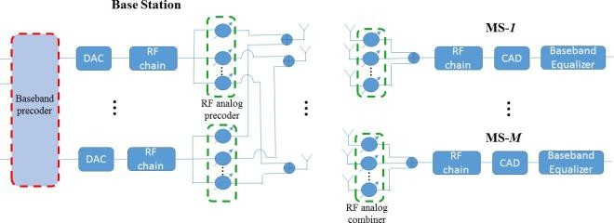the recreations comes about. At long last, a few concluding comments are given in Sec.

### Fig : mmWave multi-user system with hybrid analog/digitalprecoding and analog combining.

**WORKING**

determine ﬁrst the RF beamforming/combining matrices for each BS-MS link independently, similarly to [12], and then continue with the baseband precoding to reduce the multi-user interference. In the ﬁrst step, the BS and each MS-m calculate the RF beamforming and combining vectors, fRFmand wm, by maximizing the signal power for the MS-m(line 3-6in Algorithm 1). Existing single-user RF beamforming solution scan be used on this purpose, such as [46], [47], in order to de-sign the RF beamforming/combining vectors without explicit channel estimation and maintain a low training overhead. Once the combining vectors w mare determined for all MSs, as well as the analog precoder FRF at the BS, the digital baseband precoder FBB is computed as follows. C. ITERATIVE KALMAN BASEBAND PRECODING At this step, the BS utilizes the effective channels hHm.=wHmHmFRF ∀m. Each effective channel vector hHmhas dimension M×1, which is much lower than the original channel matrix Hm with size NMS ×NBS [12]. Each MS-muses a codebook H to quantize its effective channel response, and sends the index of the quantized channel vector to the BS(line 8-10 in Algorithm 1).

As the last step, the BS designs its Kalman-based digital precoder FBB based on the quantized channels (line 11-18 in Algorithm 1). The sparse mm Wave channels and the narrow beam forming ensure that the effective MIMO channel is well-conditioned [48]. This allows the Kalman-based digitalbeamforming approach to achieve near-optimal performance, as shown in Sec. V. In particular, we consider FRF with wm calculated in Sec. IV-B. Thus, the Kalman algorithm can be incorporated in the following measurements update equations to compute FBB .

We calculate the conditional mean FBB (n|n)and the variance R(n|n) = E[FBB (n)F∗BB (n)] of the state matrix FBB (n), the Kalman gains K(n), at time instant n, accord-ing to (15), (16), and (17) respectively: FBB (n|n) = FBB (n|n−1)+K(n)I−HDFB B (n|n−1)kI−HDFBB (n|n−1)k2F(15)K(n) = R(n|n−1)HHD [HDR(n|n−1) HHD +Qn] −1(16)R(n|n)=[I−K(n)HD]R(n|n−1) (17)where HDis set equal to the equivalent channel matrix estimate ˆHe, and Q nis the covariance matrix of the noise n(n). We set Qn= (1/SN R)∗I, where SNR is the signal to noise ratio.

Although the proposed solution requires some iterations compared to the ZF [12] and MMSE [29] closed form equations, it gives better performance in adjusting the precoding matrix in a hybrid architecture. Moreover, as will be detailed in Sec. V, the number of needed iterations is limited to only few trials. Finally, we note that all the matrices involved in the Kalman formulation, i. e., HD,K,Q n, and R, have small size M×Mwhere Mis the number of users, and are independent from the large number of antennas NBS and NMS of the massive MIMO system. The pseudo-code of the proposed Kalman-based hybrid precoding is summarized in the following Algorithm 1.V. PERFORMANCE EVALUATION In this section, we evaluate the performance of the proposed Kalman hybrid analog/digital precoding algorithm.

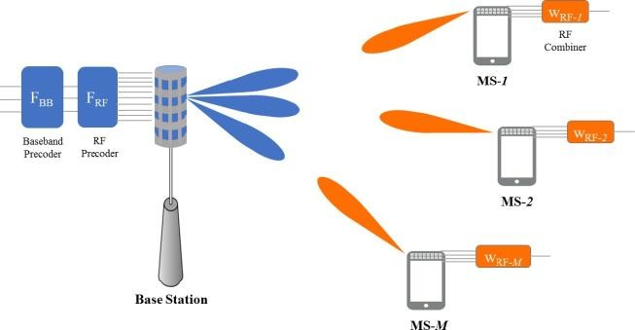

### Fig : mmWave multi-user system model: BS hybrid analog/digital precoding and MS analog combining.

**CONCLUSION and result**

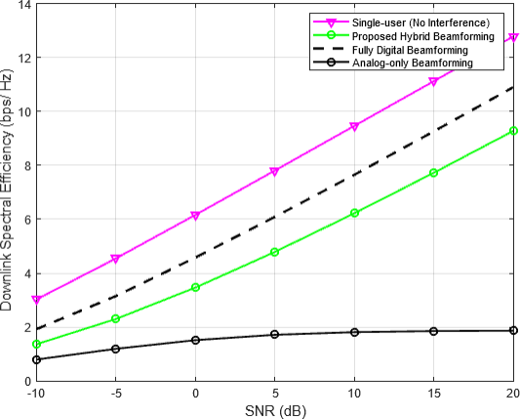We proposed a multi-user beamforming solution form Wave massive MIMO systems, based on a Kalman formulation and a hybrid precoding designed by minimizing VOLUME 4, 2016 9Themethod uses a specially designed formulation of the error, and following this, a two step procedure is carried out toﬁrst calculate the RF precoding/combining matrix, and then design the digital baseband precoder at the BS. Simulation results show that the proposed algorithm out-performs existing solutions, in terms of both spectral efﬁciency and BER, due to its ability to better adjust the precoding matrix in hybrid architectures. In future work we will incorporate a channel estimation scheme inn the Kalman hybrid precoding algorithm, and extend the proposed solution to mobile scenarios. Moreover, we will focus on extending the proposed solution to joint precoders/combiners iterative optimization [52] when user devices employ multiple streams.

Fig : Downlink Spectral Efficiency varying SNR in multipath (L=10) range of [-20, 20] dB

**REFERENCE**

1. Akyildiz, I. F., J. M. Jornet, and C. Han (2014) Terahertz band: Following wilderness for remote communications. Physical communication, 12, 16–32.
2. Alkhateeb, A., G. Leus, and R. W. Heath (2015) Restricted nourish- back half breed precoding for multi- client millimeter wave frameworks. IEEE exchanges on remote communications, 14(11), 6481–6494
3. Arun, S. L. and M. P. Selvan (2017) Energetic request reaction in shrewd buildings utilizing an brilliantly private stack administration framework. IET Era, Transmission Conveyance, 11(17), 4348– 4357.
4. Bianco, S., P. Napoletano, A. Raimondi, M. Feo, G. Petraglia, and P. Vinetti (2020) Aesa versatile beamforming utilizing profound learning. In 2020 IEEE Radar Conference (RadarConf20). 2020.
5. Busari, S. A., K. M. S. Huq, S. Mumtaz, and J. Rodriguez (2019a) Terahertz gigantic mimo for beyond-5g remote communication. In ICC 2019-2019 IEEE Universal Conference on Communications (ICC). IEEE, 2019a.
6. Busari, S. A., M. A. Khan, K. M. S. Huq, S. Mumtaz, and J. Rodriguez (2019b) Millimetre-wave gigantic mimo for cellular vehicle-to-infrastructure communication. IET Shrewdly Transport Frameworks, 13(6), 983–990.
7. Busari, S. A., S. Mumtaz, S. Al-Rubaye, and J. Rodriguez (2018) 5g millimeter-wave portable broadband: Execution and challenges. IEEE Communications Magazine, 56(6), 137–143.
8. Cai, M., K. Gao, D. Nie, B. Hochwald, J. N. Laneman, H. Huang, and K. Liu (2016) Impact of wideband bar squint on codebook plan in phased-array remote frameworks. In 2016 IEEE Worldwide Com- munications Conference (GLOBECOM). IEEE, 2016.
9. Cisco. (2016) Visual organizing list: Worldwide portable information activity figure overhaul, 2015 – 2020. Tech. rep.
10. Cooper, M. (2010) The myth of range shortage. URL https://ecfsapi.fcc.gov/file/7020396128.pdf. Tech. rep. DYNA llc.