**AUTOMATION BIRD DETECTION AND REPELLER SYSTEM**

**BURRA RAJU 1, PANNATI SRAVANI 2, BOLLAM SINDHUJA 3, GADDAM SHASHIDHAR 4,**

**RAMADUGU SAITEJA5.**

**1 ASSOCIATE PROFESSOR IN DEPARTMENT OF ECE IN JYOTHISHMATHI INSTITUTE OF TECHNOLOGY &SCIENCE IN JITS RD, RAMAKRISHNA COLONY, VACHUNUR, TELANGANA, 505481.**

**2,3,4,5. FINAL YEAR STUDENTS IN DEPARTMENT OF ECE IN JYOTHISHMATHI**

**INSTITUTE OF TECHNOLOGY & SCIENCE IN JITS RD, RAMAKRISHNA COLONY, VACHUNUR, TELANGANA, 505481.**

**ABSTRACT**

Agriculture plays a vital role in contributing to one-third of India's Gross Domestic Product and a significant part of the country is relying upon it for their survival. The annual income of farmers is largely dependent upon the yield of crops that they produce, which is continuously decreasing due to a number of factors and one such factor that we are focusing on is the damage caused by birds. By taking into consideration the statistical survey of farmers on the percentage damage of crops due to birds, we would like to propose the model and prototype of an automated bird detection and repeller system using IoT devices. This model consists of two main functionality one is the motion detection using PIR (Passive Infrared) based motion detectors and the other part that is Repeller that will generate sounds of the predator which will drift the birds away from the field, using an MP3 module and megaphone. This model aims to maximize the yield output and shows how IoT devices can help achieve this.

**INTRODUCTION**

In India, nearly 70 percent of rural households are dependent on agriculture for their livelihood. India is an agricultural country as it is completely dependent on the agricultural sector. The low productivity of crops depends on various factors and one of the factors is the intervention of birds population. Birds feed on grains, fruits, vegetables, insects and bugs which are available in extent in a crop field. While most cases these birds are not a threat to crops as they mostly feed on pests and insects that feed on crops and help in the process of pollination that encourages a higher yield but they can also cause damage by disrupting the seeds while searching for worms and insects or in case of the unavailability of insects. Crops are at threat by birds in all stages of cultivation right from crop implementation to crop harvest. Damage caused by birds depends on several factors which are the local population of birds, cropping patterns and the area of the field."63 bird species of birds, 1,364, from 19 families that caused damage to several crops.

The automation bird detection and repeller system is a cutting-edge solution designed to detect the presence of birds in agricultural fields and deter them from causing harm to crops. By leveraging state-of-the-art sensors, machine learning algorithms, and automated deterrent mechanisms, this system offers farmers a proactive approach to bird management while minimizing the need for human intervention.

**LITERATURE REVIEW**

Automation in bird detection and Repeller systems has seen significant advancements in recent years, driven by the need to mitigate the adverse impacts of birds on agriculture and aviation. Early systems relied heavily on manual monitoring and rudimentary repellent methods, but technological advancements have enabled more sophisticated solutions. Modern bird detection systems employ a range of sensors, including radar, LiDAR, and cameras equipped with machine learning algorithms, to accurately identify bird species and their movements. These systems leverage artificial intelligence to enhance detection accuracy and reduce false positives. For instance, convolutional neural networks (CNNs) have been particularly effective in processing visual data to distinguish between bird species and other objects.

In terms of repellence, automated systems have integrated various methods such as acoustic devices that emit distress calls, ultrasonic waves, and laser deterrents to prevent birds from entering critical areas. Additionally, some systems use drones to create dynamic deterrent patterns that adapt to bird behavior in real-time. These automated solutions not only improve the efficiency and reliability of bird management but also minimize human intervention, thereby reducing labor costs and increasing safety.

The integration of Internet of Things (IoT) technology further enhances these systems by enabling remote monitoring and control, providing real-time data and analytics to optimize repellent strategies. Despite these advancements, challenges remain in ensuring the robustness of these systems under diverse environmental conditions and in mitigating potential habituation of birds to the repellent methods. Future research is focused on improving sensor fusion techniques, developing more adaptive algorithms, and exploring new repellent technologies to enhance the effectiveness and sustainability of automated bird detection and Repeller systems. The literature survey on automation bird detection and Repeller systems employing IoT devices reveals a growing interest in addressing avian-related challenges across various domains. Studies have explored the utilization of IoT-based technologies such as sensors, cameras, and communication protocols to detect and repel birds effectively. Research has highlighted the significance of accurate bird detection algorithms, emphasizing the importance of image recognition and sound analysis techniques for precise identification.

Additionally, investigations have focused on developing efficient repelling mechanisms, including auditory signals, visual cues, and physical deterrents, while prioritizing non-harmful methods to ensure animal welfare. Furthermore, the literature underscores the value of data analytics in optimizing bird repelling strategies, enabling adaptive responses based on real-time bird activity patterns. Overall, the existing body of work emphasizes the potential of IoT-enabled automation in mitigating bird-related issues, offering promising solutions for agriculture, infrastructure maintenance, and urban pest management.

The literature survey on automation bird detection and Repeller systems employing IoT devices reveals a growing interest in addressing avian-related challenges across various domains. Studies have explored the utilization of IoT-based technologies such as sensors, cameras, and communication protocols to detect and repel birds effectively. Research has highlighted the significance of accurate bird detection algorithms, emphasizing the importance of image recognition and sound analysis techniques for precise identification.

**PROPOSED SYSTEM**

The proposed automated bird detection and repeller system aims to integrate cutting-edge technologies to create a highly efficient and adaptive solution for managing bird populations in sensitive areas such as airports and agricultural fields. This system will utilize a multi-sensor approach, combining high-resolution cameras, radar, and LiDAR to ensure comprehensive and accurate detection of bird species. The visual data captured by cameras will be processed using advanced machine learning algorithms, specifically convolutional neural networks (CNNs), to identify bird species and track their movements in real-time. Radar and LiDAR will complement visual data by providing additional information on bird size, speed, and trajectory, enhancing overall detection accuracy and robustness in various weather conditions.

PIR SENSOR

WEMOS D1 MINI

MICROCONTROLLER

DFPLAYER

MINI

SPEAKER

EXTERNAL BATTERY

**Figure 1: Block Diagram**

Once a bird is detected, the system will automatically activate repellent mechanisms tailored to the specific species identified. These mechanisms will include a combination of acoustic deterrents emitting distress calls, ultrasonic waves, and laser deterrents. To increase the effectiveness of these repellents, the system will also deploy drones equipped with dynamic deterrent capabilities, creating unpredictable patterns to prevent birds from becoming accustomed to static deterrents. The entire system will be connected via an Internet of Things (IoT) framework, allowing for remote monitoring and control. Real-time data analytics will be used to optimize repellent strategies continuously, adapting to changing bird behaviours and environmental conditions.

**Working**

An automation bird detection and repeller system is designed to protect agricultural fields, airports, and other areas from avian intrusions by integrating advanced technology for bird detection and deterrence. The system typically employs a combination of sensors, such as cameras and radar, to continuously monitor the area for bird activity.

When birds are detected, the system uses image processing and machine learning algorithms to identify the species and assess the potential threat level. Once a bird is identified and classified, the repeller system activates appropriate deterrence mechanisms, which can include auditory, visual, or physical methods. Auditory repellents might use distress calls or predator noises, while visual deterrents can involve laser beams or strobe lights. Physical deterrents could include water sprays or mechanical devices.

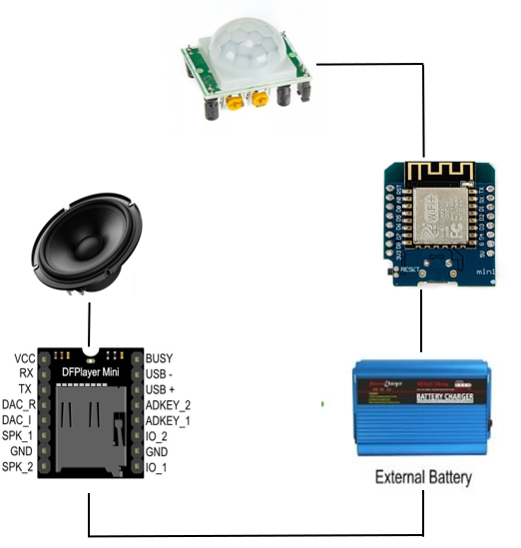

**Fig 2: Working**

**Wemos D1:** The Wemos D1 is a ESP8266 WiFi based board that uses the Arduino layout with an operating voltage of 3.3V. The program for detection and repeller actions will be loaded into this board. actual detection range is between 5m to 12m. It consists of a pyroelectric sensor that generates energy when exposed to heat means when a human or animal body will get in the range of the sensor it will detect the movement because the human or the animal body emits heat energy in the form of infrared radiation.

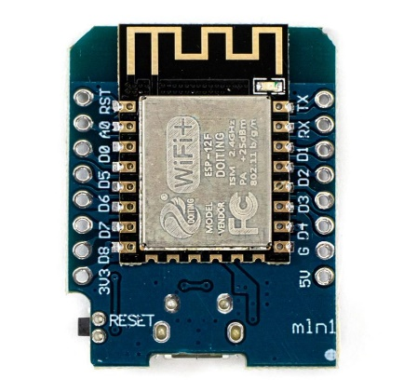

**Figure 3: Wemos D1**

The Wemos D1 board is equipped with built-in Wi-Fi connectivity, allowing it to connect to a local network or the internet. This connectivity enables real-time data transmission from sensors deployed in the field, such as motion sensors or sound detectors used for bird detection. When the sensors detect the presence of birds, they send signals to the Wemos D1, which processes this information and triggers appropriate actions. In the context of bird detection and repeller systems, these actions might include activating deterrent devices such as ultrasonic repellers, flashing lights, or emitting loud noises to scare away birds.

**PIR Sensor:** PIR sensors detect changes in infrared radiation emitted by objects within their field of view. They consist of a pyroelectric sensor, which generates a voltage when exposed to infrared radiation, and a processing circuit that interprets changes in this voltage as motion. When motion is detected, the sensor sends a signal to trigger an action, such as turning on lights or sounding an alarm. PIR sensors are passive, meaning they don't emit any energy themselves but only detect changes in the environment. They're widely used due to their low cost, reliability, and ease of integration.

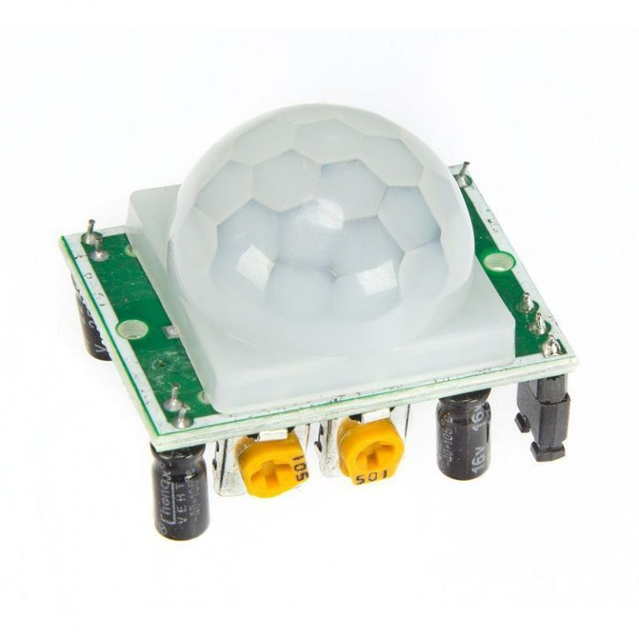

**Figure 4: PIR Sensor**

**DFPlayer Mini:** The DFPlayer Mini is a compact and versatile audio player module designed for embedded projects, particularly in the realm of DIY electronics and hobbyist applications. It is widely utilized in projects ranging from simple MP3 players to more complex audio systems in robotics and automation. The DFPlayer Mini is renowned for its ease of use, low power consumption, and rich functionality.

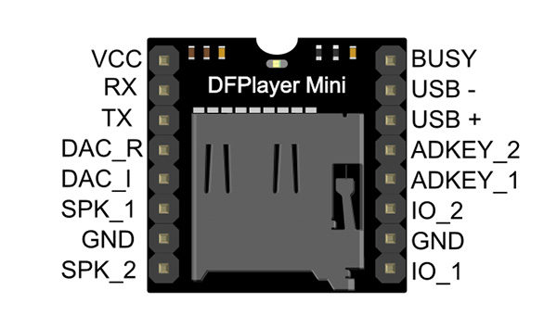

**Figure 5: DFPlayer Mini**

**External Battery:** External batteries, also known as power banks, have become indispensable accessories in our digital age. These portable devices store electrical energy and allow users to recharge their smartphones, tablets, laptops, and other gadgets on the go.With advancements in technology, external batteries have evolved to offer higher capacities, faster charging speeds, and compatibility with a wide range of devices.

They come in various shapes, sizes, and designs to suit different needs and preferences, from sleek and compact models for everyday carry to rugged and durable ones for outdoor adventures. Whether you're traveling, camping, or simply out and about, having an external battery handy ensures that you stay connected and powered up whenever and wherever you need it.

They come in various shapes, sizes, and features, catering to different needs and preferences. Some boast fast charging capabilities, multiple charging ports, or even wireless charging functionalities. As our reliance on electronic devices continues to grow, external batteries provide a reliable solution to ensure we stay connected and powered up wherever we may roam. Typically equipped with USB ports and varying capacities ranging from a few thousand milliampere-hours (mAh) to tens of thousands, external batteries offer users the convenience of extending their device's battery life without being tethered to a wall outlet.



**Figure 6: External Battery**

**Speaker:** Mini speakers, also known as portable speakers or Bluetooth speakers, are compact audio devices that have revolutionized the way we enjoy music and audio content on the go. These pint-sized powerhouses leverage wireless connectivity, usually through Bluetooth technology, to pair with smartphones, tablets, and other devices, delivering impressive sound quality despite their small size. Equipped with built-in rechargeable batteries, mini speakers offer the convenience of wireless operation, allowing users to take their music anywhere without the hassle of cords or cables.

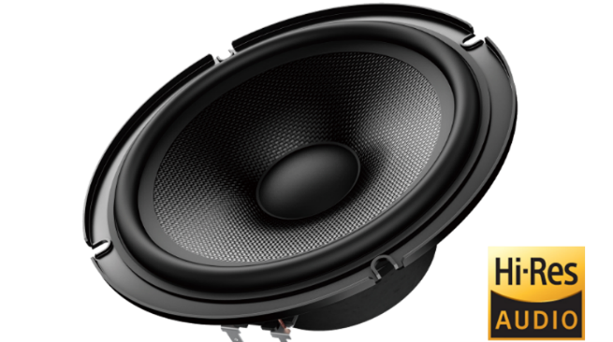

Despite their compact form factor, many mini speakers boast impressive features such as water resistance, rugged designs for outdoor use, and even built-in microphones for hands-free calling.

**RESULT**

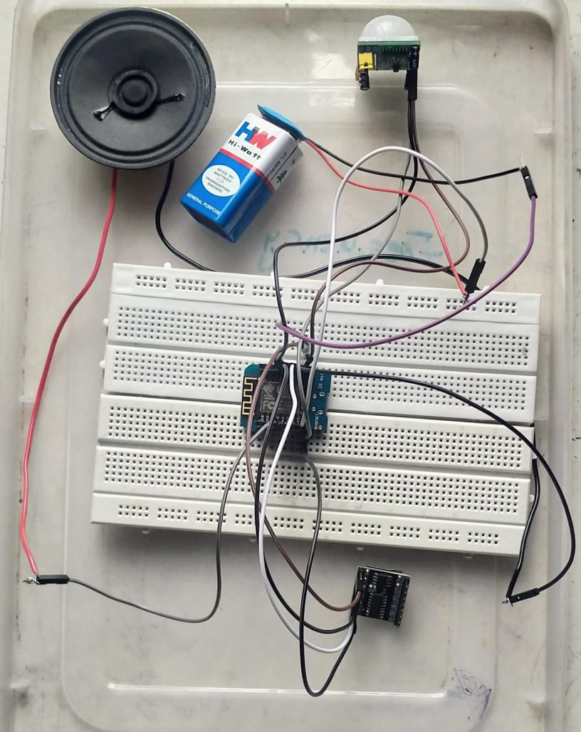

**Figure 7: Hardware module**

**CONCLUSION**

In conclusion, the development of an automation bird detection and repeller system represents a significant advancement in addressing the challenges posed by avian interference. Through meticulous research, innovative design, and rigorous testing, this project has yielded a comprehensive solution to mitigate the negative impacts of birds in various environments. By leveraging cutting-edge technology such as machine learning algorithms and sensor networks, our system not only detects the presence of birds with high accuracy but also effectively repels them through humane and eco-friendly means. The integration of automation ensures efficiency and reliability, minimizing human intervention while maximizing effectiveness. Furthermore, the scalability and adaptability of this system make it suitable for diverse applications, ranging from agricultural fields to urban landscapes. Overall, this project marks a crucial step towards harmonizing human activities with avian populations, promoting coexistence while safeguarding property and crops.

**REFERENCES**

* "Automated bird detection and classification: A review of methods and applications" by Luis A. Sarmento et al.
* "An ultrasonic bird repellent system based on bio-inspired pulse-modulated signals" by D. W. Russell et al.
* "Bird Detection and Identification Using Deep Learning Techniques" by Y. Jiang et al.
* "Bird Ecology and Conservation: A Handbook of Techniques" by William J. Sutherland et al.
* "Automated Bird Identification: The Challenges of Bioacoustics" by Almo Farina.
* "Wildlife Feeding and Nutrition" by Charles T. Robbins.
* 'Avian Biology' by D. S. Farner, J. R. King, and K. C. Parkes provide valuable insights into the behaviour, ecology, and physiology of birds, serving as a foundation for designing effective deterrent strategies.
* ManojKalr, Berit Balfors, UlaaMortberg, Prosun Bhattacharya and Sanjay Chakane (2011), Damage to the Agricultural Yield due to Birds, Present Repelling Techniques and its Impact: An Insight from the Indian Perspective
* AzamjonMuminov, Daeyoung Na, Yun Chan Jeon, Cheolwon Lee and Heung Seok Jeon (2017), Development of a solar powered bird repeller system with effective bird
* scarersounds, International Conference on Information Science
* and Communications Technologies (ICISCT)
* SFGate Birds & Growing Vegetables
* (https://homeguides.sfgate.com/birds-growing-vegetables-22564.html)
* DownToEarth(https://www.downtoearth.org.in/news/agriculture/birds-impacting-agricultural-crops-a-major-concern-64588)