**AI POWERED AUTO BILLING SYSTEM USING RASPBERRY PI**

**D. MAHESH KUMAR 1 , BODDULA POOJA 2 , DASARI SOWMITH 3 , POLAM RAKESH 4 ,**

**DUGYALA DEEPTHI 5 .**

**1 ASSOCIATE PROFESSOR IN DEPARTMENT OF ECE IN JYOTHISHMATHI INSTITUTE OF TECHNOLOGY &SCIENCE IN JITS RD, RAMAKRISHNA COLONY, KARIMNAGAR, TELANGANA, 505481.**

**2,3,4,5. FINAL YEAR STUDENTS IN DEPARTMENT OF ECE IN JYOTHISHMATHI**

**INSTITUTE OF TECHNOLOGY & SCIENCE IN JITS RD, RAMAKRISHNA COLONY, KARIMNAGAR, TELANGANA, 505481.**

**ABSTRACT:** AutoBill is an AI-powered independent checkout framework for retail stores, that combines the control of computer vision and machine learning to give an astounding shopping involvement. AutoBill gives a quicker checkout shopping involvement to minimize human intuitive in the store to keep customers and workers more secure amid the widespread. AutoBill employments computer vision and machine learning to outwardly distinguish and right away recognize the things put and the weight sensor degree the weights of the things put on the counter-top. Once the things are distinguished, things are naturally included to the cart and the charge is produced immediately. QR code for installment is created and clients can pay the charge by filtering the QR code. This venture is built with Raspberry Pi. Through integration with progressed AI calculations, the framework intellectuals distinguishes items, calculates sums, and produces solicitations consequently. Leveraging Raspberry Pi's compact plan, this arrangement gives a cost-effective and productive elective for businesses, guaranteeing exactness and decreasing human blunder in billing transactions.

**INTRODUCTION**

An AI-powered auto charging framework utilizing Raspberry Pi is a savvy framework that combines the control of counterfeit insights and the flexibility of Raspberry Pi to robotize the charging prepare. It employments AI calculations to create and oversee bills, making it speedier and more exact. With this framework, you can spare time and diminish human blunder in your charging assignments. It's a extraordinary way to disentangle your charging process. The AI calculations can analyze and prepare significant information, such as client data, item points of interest, and estimating, to create precise bills. It can too handle complex calculations, rebates, and charges, guaranteeing that the charging prepare is effective and error-free. By mechanizing the charging handle, this framework can spare you time and exertion. It disposes of the require for manual information section and calculations, decreasing the chances of human blunder. Furthermore, it can create bills rapidly, permitting you to give opportune solicitations to your customers. Additionally, the AI-powered auto charging framework can be customized to fit your particular trade needs. You can coordinated it with other frameworks, such as stock administration or client relationship administration (CRM) computer program, to streamline your by and large operations. Overall, this framework offers a helpful and effective way to handle charging assignments, making your life simpler and moving forward the precision of your charging process.

**LITERATURE REVIEW**

The AI-powered auto billing system using Raspberry Pi would involve researching existing studies, papers, and articles related to similar projects or technologies. It's a way to gather information and insights from previous work in the field.

1. AI in billing systems: Look for studies that discuss the integration of artificial intelligence techniques in automating billing processes. This could include machine learning algorithms, natural language processing, or pattern recognition applied to billing data.

2. Raspberry Pi applications: Explore how Raspberry Pi has been used in various projects, including billing systems. Look for case studies, articles, or research papers that highlight the advantages and challenges of using Raspberry Pi for automation purposes.

3. Billing system optimization: Investigate studies that focus on optimizing billing processes, such as improving accuracy, reducing errors, or enhancing efficiency. These studies might provide insights into best practices and potential areas for improvement in your project.

4. Integration with other systems: Research how billing systems can be integrated with other business systems like inventory management, CRM, or financial software. This can help you understand the benefits and challenges of integrating different systems for a seamless workflow.

**PROPOSED SYSTEM**

Based on the limitations of existing billing systems, I have a proposed system that could address those issues. The proposed system would be a cloud-based automated billing platform. It would offer several key features to overcome the limitations: 1. Automation: The system would automate the entire billing process, from generating invoices to calculating taxes and tracking payments. This would greatly reduce manual errors and save time for businesses. 2. Scalability: The cloud-based nature of the system would allow for easy scalability. As your business grows, the system can handle a larger volume of transactions and adapt to your evolving billing needs. 3. Integration capabilities: The proposed system would have seamless integration with other business systems like inventory management or CRM software. This would ensure a smooth flow of data between different systems, eliminating any compatibility issues. 4. Real-time insights: The system would provide real-time insights into billing data. You would have access to up-to-date information on outstanding payments, revenue trends, and customer payment history, helping you make informed decisions. 5. Enhanced security: The proposed system would prioritize the security of sensitive customer information. It would implement robust data encryption and comply with data privacy regulations to protect your customers' data. Overall, the proposed system aims to streamline the billing process, improve accuracy, and provide valuable insights for your business. It's important to consider your specific business requirements and evaluate different options to find the best fit.

**Working**

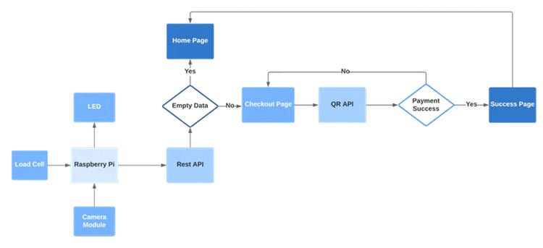

**Figure 1: Working**

An AI-powered auto billing system using a Raspberry Pi, REEs52 5-megapixel camera, and HX711 breakout board typically works by: Image Recognition: The Raspberry Pi captures images of items using the 5-megapixel camera. Object Detection: AI algorithms analyze these images to detect and recognize items placed on the billing counter. Weight Sensing: The HX711 breakout board measures the weight of each item placed on the counter using the weight sensor. Data Processing: The Raspberry Pi processes the image data along with weight measurements to identify items and their corresponding prices. Billing Calculation: Based on the identified items and their weights, the system calculates the total bill amount. User Interface: A user interface on a display or through a web interface allows customers to view their items and the total bill. Payment Processing: Optionally, the system may integrate with payment gateways for transaction processing. Data Storage and Analysis: Data about transactions, inventory, and sales may be stored for analysis and inventory management.

**Raspbian OS**

Raspberry Pi OS (once known as Raspbian) is a Unix-like working framework based on the Debian GNU/Linux conveyance for the Raspberry Pi family of compact single-board computers. To begin with created autonomously in 2012, it has been created as the essential working framework for these sheets since 2013, dispersed by the Raspberry pi foundation. Raspberry Pi OS is exceedingly optimized for the Raspberry Pi with ARM CPUs. It runs on each Raspberry Pi but the Pico microcontroller. Raspberry Pi OS employments a adjusted LXDE desktop environment with the Openbox stacking window supervisor, along with a special theme.Raspberry Pi OS was to begin with created by Mike Thompson and Dwindle Green as Raspbian, an free and informal harbour of Debian to the Raspberry Pi. Features: User interface: Raspberry Pi OS has a desktop environment, PIXEL (brief for Pi Made strides X windows Environment, Lightweight), based on LXDE, which looks comparable to numerous common desktops, such as macOS and Microsoft Windows. The desktop has a foundation picture. A menu bar is situated at the beat and contains an application menu and alternate routes to a web browser (Chromium), record chief, and terminal. The other conclusion of the menu bar appears a Bluetooth menu, Wi-Fi menu, volume control, and clock. The desktop can too be changed from its default appearance, such as repositioning the menu bar. Package management: Packages can be introduced through Well-suited, the Suggested Program app, and by utilizing the Add/Remove Program apparatus, a GUI wrapper for APT. Raspberry Pi OS is an fabulous alternative for common desktop utilize. The 64-bit adaptation when mated to an 8GB Pi board or indeed 4GB Pi ought to exhibit the credit card-sized creator board's potential for multi-tasking and common computing capabilities. Since it's Linux-based, Raspberry Pi OS can effectively be customized for person utilize cases. You can introduce media server program such as Plex, Emby, or Subsonic for a Raspberry Pi NAS. Or stack up the likes of Kodi and VLC for a domestic theater PC (HTPC). It's incredible for office efficiency counting picture or sound altering and programming.

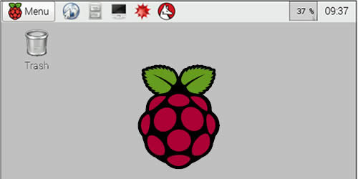

**Fig 2 –** Raspbian OS

**Object Detection Using Edge Impulse**

Edge Impulse Edge Motivation engineers can get information from different sources, counting their possess sensor equipment, open datasets, and information produced through reenactments or engineered information generation.Edge Motivation is introducing in the future of implanted machine learning by enabling designers to make and optimize arrangements with real-world information. We are making the prepare of building, sending, and scaling inserted ML applications less demanding and speedier than ever, opening enormous esteem over each industry, with millions of designers making billions of gadgets smarter. Edge Drive innovation enables designers to bring more AI items to advertise quicker, and makes a difference endeavor groups quickly create industry-specific arrangements in weeks instep of years.Edge Motivation gives capable automations and low-code capabilities to make it less demanding to construct profitable datasets and create progressed AI for edge gadgets. Utilized by producers of health-wearable gadgets like Oura, Know Labs, and NOWATCH, mechanical organizations like NASA, as well as best silicon merchants and over 100,000 engineers on over 250,000 ML ventures, Edge Drive has gotten to be the trusted stage for endeavors and engineers alike.

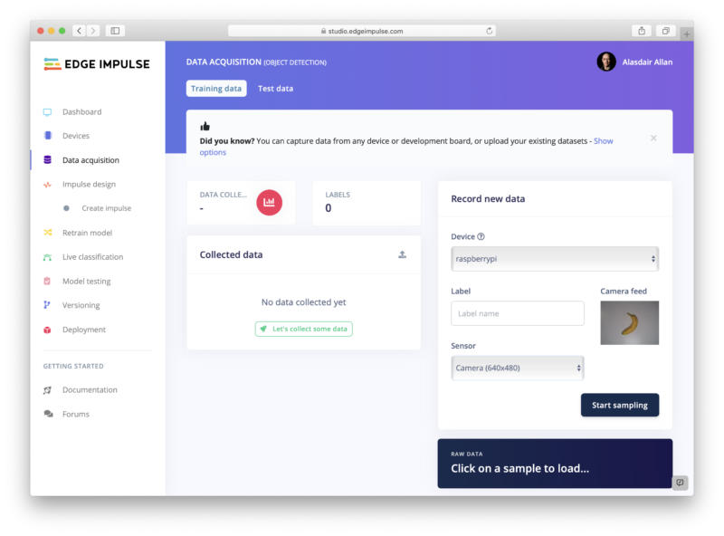

**Fig 3 –** Edge Impulse

**REES52 Camera Module**

Camera Module Here I am utilizing the REES52 5 Megapixel 160° degrees Wide Point Fish-Eye Camera for the protest location. Due to its tall seeing point, it can cover more range than the typical camera module. The primary highlight of this camera module is Omnivision 5647 sensors in a fixed-focus module. The module connects to Raspberry Pi, by way of a 15 Stick Lace Cable, to the devoted 15-pin MIPI Camera Serial Interface (CSI). The CSI transport is able of greatly tall information rates, and it only carries pixel information to the BCM2835 processor. The sensor itself has a local determination of 5 megapixels and has a settled center focal point onboard. The camera underpins 1080 p @ 30 fps, 720 p @ 60 fps, and 640 x480 p 60/90 video recording too it is bolstered in the most recent form of Raspbian, the Raspberry Pi's favored working system. For interfacing the camera module to the Raspberry pi, we have utilized an 18'' flex cable. There is impressive separate between the Raspberry Pi and the camera module.

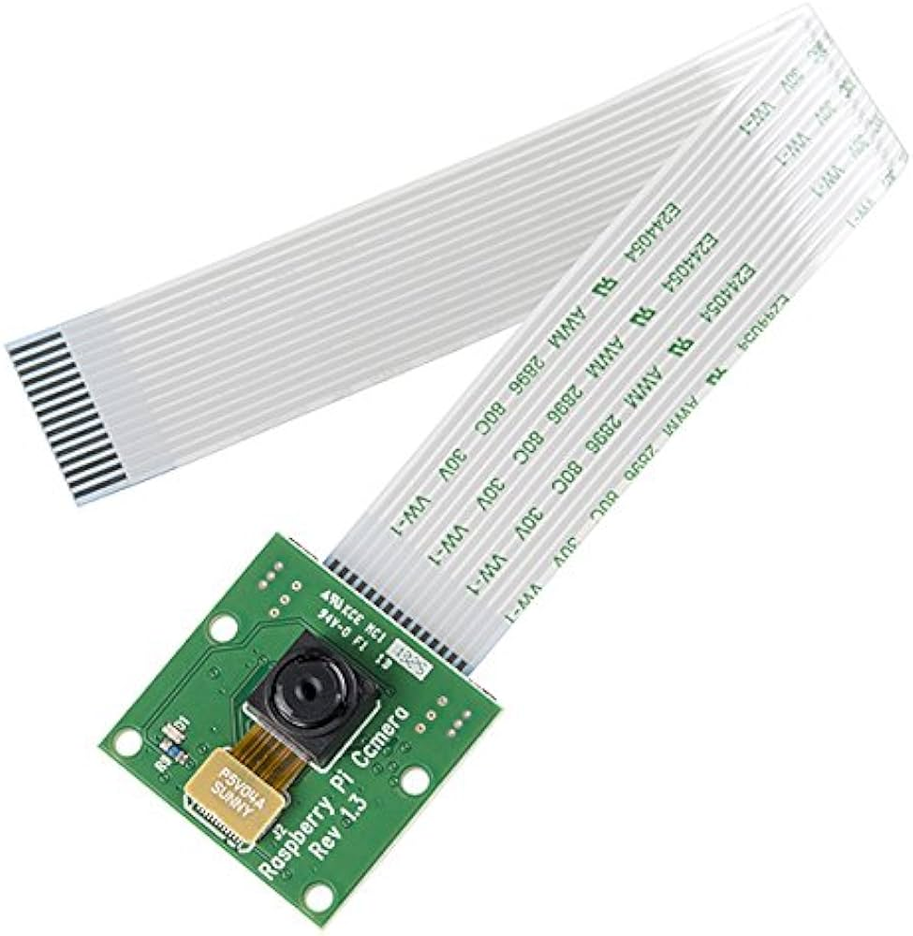

**Fig 4 -** REES52 5 Mega Pixel Camera Module

**RASPBERRY PI 3B**

The Raspberry Pi 3B is a single-board computer that can be used for a variety of projects, including running software applications like a billing system. Here are the hardware specifications of the Raspberry Pi 3B: 1. Processor: It is equipped with a 1.2GHz quad-core ARM Cortex-A53 CPU, which provides decent processing power for running software applications. 2. Memory: The Raspberry Pi 3B has 1GB of RAM, which should be sufficient for most billing system applications. 3. Storage: It doesn't come with built-in storage, but you can use a microSD card to store the operating system and your billing system software. 4. Connectivity: It has built-in Wi-Fi and Bluetooth capabilities, allowing you to connect to the internet and other devices wirelessly. 5. Ports: The Raspberry Pi 3B includes several ports, such as USB ports for connecting peripherals like keyboards and mice, an HDMI port for connecting to a display, and an Ethernet port for wired internet connectivity. The Raspberry Pi 3B is a versatile and affordable option for running a billing system, especially if you're looking for a compact and energy-efficient solution. Just make sure to choose compatible software that can run on the Raspberry Pi operating system.

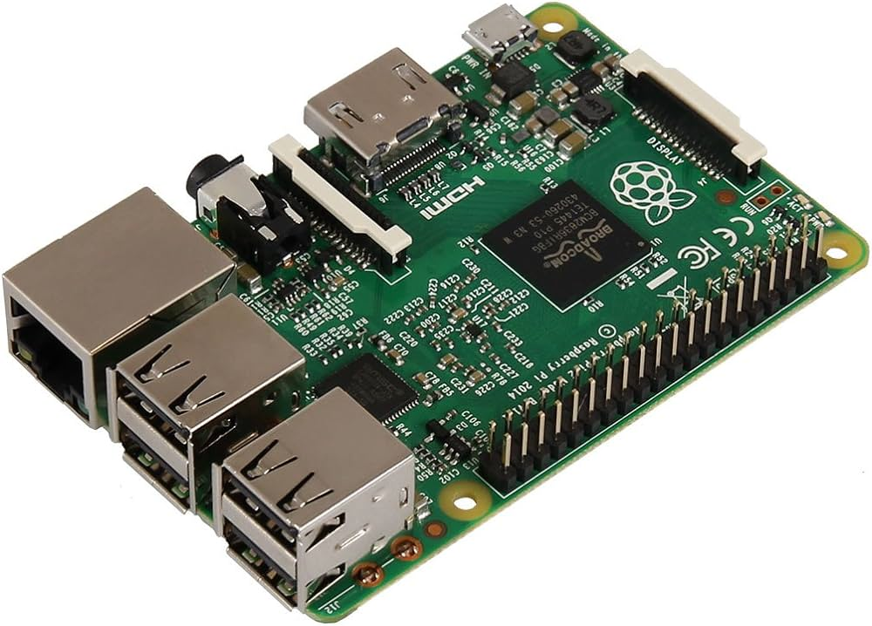

**Fig 5 –** Raspberry Pi 3B

**WEIGHT SENSOR (Stack CELL)**

Here we utilize the Stack cell to degree the weight of the objects. The stack cell is a sensor or a transducer that changes over a stack or drive acting on it into an electronic flag. This electronic flag can be a voltage alter, current alter, or recurrence alter depending on the sort of stack cell and circuitry utilized. There are numerous distinctive sorts of stack cells. Here we are utilizing a resistive stack cell. Resistive stack cells work on the rule of piezo-resistivity. When a load/force/stress is connected to the sensor, it changes its resistance. This alter in resistance leads to a alter in yield voltage when an input voltage is connected. The resistive stack cell is made by utilizing an flexible part (with a exceptionally profoundly repeatable avoidance design) to which a number of strain gages are connected. Here we are utilizing a stack cell which is having four strain gages that are reinforced to the upper and lower surfaces of the stack cell. When the stack is connected to the body of a resistive stack cell, as appeared over, the versatile part, diverts as appeared and makes a strain at those areas due to the push connected. As a result, two of the strain gages are in compression, though the other two are in pressure. Amid a estimation, the weight acts on the stack cell’s metal spring component and causes flexible distortion. This strain (positive or negative) is changed over into an electrical flag by a strain gage (SG) introduced on the spring component. The least complex sort of stack cell is a twisting bar with a strain gage. We utilize the Wheatstone bridge circuit to change over this alter in strain/resistance into a voltage that is corresponding to the load. The four strain gages are arranged in a Wheatstone Bridge setup with four partitioned resistors associated as appeared in what is called a Wheatstone Bridge Organize. An excitation voltage – more often than not 5V is connected to one set of corners and the voltage contrast is measured between the other two corners. At harmony with no connected stack, the voltage yield is zero or exceptionally near to zero when the four resistors are closely coordinated in esteem. That is why it is alluded to as a adjusted bridge circuit. When the metallic part to which the strain gages are connected, is pushed by the application of a constrain, the coming about strain – leads to a alter in resistance in one (or more) of the resistors. This alter in resistance comes about in a alter in yield voltage. This little alter in yield voltage (as a rule almost 20 mv of the add up to alter in reaction to full stack) can be measured and digitized after cautious intensification of the little milli-volt level signals to a higher sufficiency 0-5V signal.

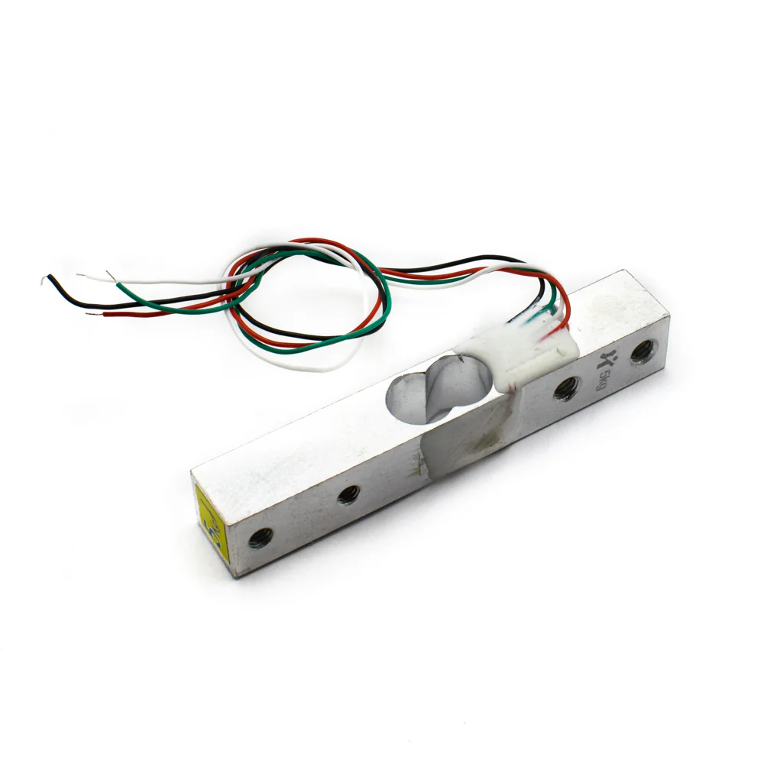

**Fig 6 –** Weight Sensor (Load Cell)

**HX711 BREAKOUT BOARD**

The HX711 module is a Stack Cell Speaker breakout board that permits you to effectively studied stack cells to degree weight. This module employments 24 high-precision A/D converter chips HX711. It is uncommonly planned for the tall accuracy electronic scale plan, with two analog input channels, the inner integration of 128 times the programmable pick up speaker. The input circuit can be arranged to give a bridge sort weight bridge (such as weight, weighing sensor mode), is of tall accuracy, moo taken a toll is an perfect testing front-end module. HX711 is an IC that permits you to effectively coordinated stack cells into your venture. No require for any enhancers or double control supply fair utilize this board and you can effectively interface it to any micro-controller to degree weight. The HX711 employments a two-wire interface (Clock and Information) for communication. Compared with other chips, HX711 has included focal points such as tall integration, quick reaction, resistance, and other highlights making strides the add up to execution and unwavering quality. At last, it's one of the best choices for electronic devotees. The chip brings down the taken a toll of the electronic scale, at the same time, making strides execution and unwavering quality. Its details are Differential input voltage: ±40mV (Full-scale differential input voltage is ± 40mV) Data precision: 24 bit (24 bit A / D converter chip.) Refresh recurrence: 10/80 Hz Operating Voltage: 2.7V to 5VDC Operating current: <10 Ma Size: 24x16mm.

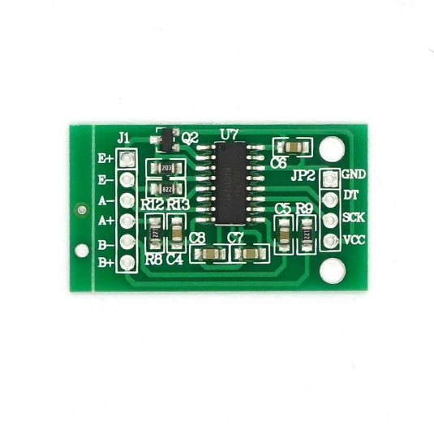

**Fig 7 –** HX711 Breakout Board

**WS2812B RGB Driven Strip**

The WS2812B 5V Addressable RGB Waterproof Driven Strip is amazingly adaptable, simple to utilize and each Driven of the strip can be controlled independently by utilizing a microcontroller. Each Driven has been prepared with an coordinates driver that permits you to control the color and brightness of each Driven freely. To light up the commodities in the framework we have utilized this RGB driven Strip. The combined LED/driver IC on these strips is the greatly compact WS2812B (basically an made strides WS2811 Driven driver coordinates specifically into a 5050 RGB Driven), which empowers higher Driven densities. WS2812B employments a specialized one-wire control interface and requires strict timing

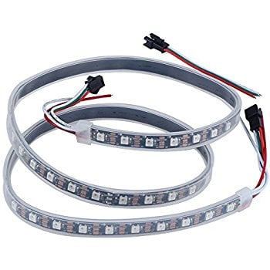

**Fig 8 -**  WS2812B RGB Driven Strip

**Auto Bill Circuit Diagram**

### Raspberry pi based Auto Billing Circuit Diagram

### Fig 9 – Circuit Diagram

**RESULT**

The result of an AI-powered auto billing system using a Raspberry Pi, REEs52 5-megapixel camera, and HX711 breakout board includes: Efficiency: Faster checkout process compared to manual billing, reducing waiting times for customers. Accuracy: More accurate billing due to automated item recognition and weight sensing, minimizing errors in pricing and quantity. Convenience: Simplified checkout experience for customers, as they can see the scanned items and total bill amount displayed on a screen. Data Insights: Collection of data on sales, popular items, and customer preferences, enabling businesses to make informed decisions about pricing, promotions, and stock management. Cost Savings: Reduction in labor costs associated with manual billing processes, leading to potential cost savings for businesses.

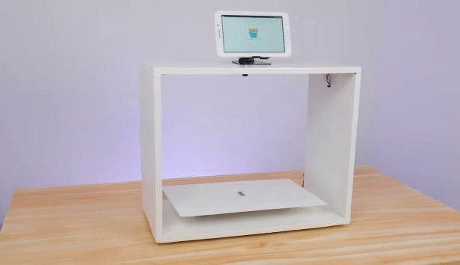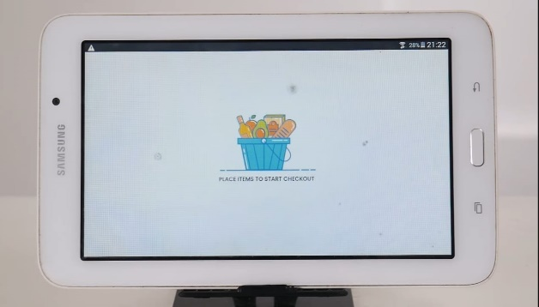

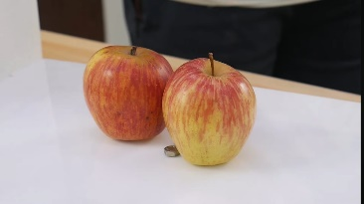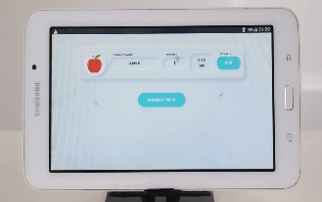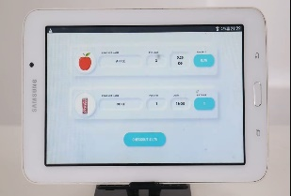

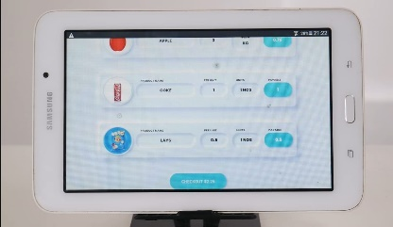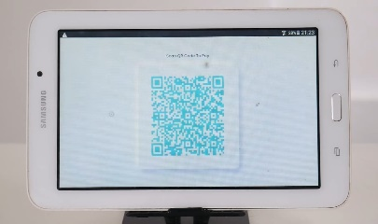

**Fig 10 –** Output of AI Powered Auto Billing System using Raspberry PI 3B

**CONCLUSION**

In conclusion, the AI-powered auto billing system utilizing a Raspberry Pi, REEs52 5-megapixel camera, and HX711 breakout board offers a comprehensive solution for automated checkout processes in retail environments.By combining image recognition with weight sensing technology, the system delivers efficient and accurate billing, enhancing the overall customer experience. With features such as real-time inventory tracking, data analytics, and simplified payment processing, businesses can streamline operations, reduce errors, and gain valuable insights for decision-making. The final system provided a seamless checkout interface with the camera capturing product images, the machine learning model recognizing them, and the load cell measuring the weight.Ultimately, this innovative solution represents a significant advancement in retail automation, providing convenience, accuracy, and cost-effectiveness for both businesses and customers alike.

**REFERENCES**

[1] Youssef, Sherin M., and Rana M. Salem. "Mechanized standardized tag acknowledgment for savvy distinguishing proof and assessment robotization" in Master Frameworks with Applications, vol.33, pp. 968-977, 2007.

[2] Manisha Agrawal , Nathi Slam Chauhan “3D Question Acknowledgment for Computerized charging in a General store utilizing Crossover PCA-SIFT Crack Algorithm” Vol. 6, Issue 7, July 2017 IJAREEIE.

[3] Priyanka S. Sahare , Anup Gade , Jayant Rohankar, ” A Audit on Mechanized Charging for Keen Shopping Framework Utilizing IOT” Vol. 6, No. 1, Walk, 2019, IIETA.

[4] Thakur Prerana, Shikha Ranjan, Prachi Kaushik, “Smart Shopping Cart For Programmed Charging In Supermarket”, Volume 5, Issue 2, IJEDR.

[5] B Sudha , Rupesh kumar , Mahanthesh K H, “Automated Shopping Trolley for Super Showcase Charging System” , Volume 3, Issue 5, May 2018 IJSDR.

[6] Manisha Agrawal, Nathi Smash Chauhan “3D Question Acknowledgment for Robotized charging in a General store utilizing Cross breed PCA-SIFT Crack Algorithm” Vol. 6, Issue 7, July 2017 IJAREEIE.

[7] Prof. Rajkumar Patil, Mr. Alim Bahadur, Mr. AbhinandanKandekar, Mr. Shubham Koli, Mr. Shridhar Bosge. “Automatic Charging Framework by utilizing Counterfeit Intelligence.”

[8]. Module Zubin Thomas, Nikil Kumar and D. Jyothi Preshiya, IEEE. “Automatic Charging Framework utilizing Li-Fi”.

[9]. A Vennila, S Balambigai, G Deepa, M Ilakkia, P Harshikaa Devi.” Picture acknowledgment based charging framework for natural product shop utilizing raspberry PI” February 2021. IOP Conference Arrangement Materials Science and Designing 1055.

[10]. J Haritha, K Prakash , B Navina, S Saveetha .” A Novel Strategy of Charging Framework Utilizing Profound Learning” Walk 2021. IOP Conference Arrangement Materials Science and Building 1084.