ENHANCING STOCK MARKET PREDICTION USING DEEP LEARNING

Sumith Yadav. N

*B. Tech*

*School of Engineering* Computer Science-(AI&ML) Malla Reddy University, India

SuryaKiran. K

*B. Tech*

*School of Engineering* Computer Science-(AI&ML) Malla Reddy University, India

Swathi Reddy. R

*B. Tech*

*School of Engineering* Computer Science-(AI&ML) Malla Reddy University, India

Swejana. G

*B. Tech*

*School of Engineering* Computer Science-(AI&ML) Malla Reddy University, India

Swetha. G

B. Tech School of Engineering

Computer Science-(AI&ML) Malla Reddy University,India

Guide: A. Kalyani Assistant Professor School of Engineering

Computer Science-(AI&ML) Malla Reddy University,India

1. ***Abstract:*** *Stock price prediction is one among the complex deep learning problems. It depends on a large number of factors which contribute to changes in the supply and demand. Stock prices are represented as time series data and neural networks are trained to learn the patterns from trends. Along with the numerical analysis of the stock trend, this research also considers the textual analysis of it by analyzing the public sentiment from online news sources and blogs. Utilizing both this information, a merged hybrid model is built which can predict the stock trend more accurately. Our project explains the prediction of a stock using Deep Learning, which itself employs different models to make prediction easier and authentic. The paper focuses on the use of Recurrent Neural Networks (RNN) called Long Short Term Memory (LSTM) to predict stock values. This will help us provide more accurate results when compared to existing stock price prediction algorithms. The eminent analysis of the stock will be an asset for the stock market investors and will provide real life solutions to the problems and also yield significant profit.*

# INTRODUCTION

Enhancing stock market prediction using deep learning involves leveraging the power of neural networks to analyze complex patterns in stock price data. Deep learning models, such as recurrent neural networks (RNNs) or long short-term memory networks (LSTMs) or convolutional neural network (CNNs), can learn from historical stock prices, trading volumes, and other relevant factors to make predictions about future stock

movements. These models are capable of capturing non-linear relationships and dependencies in the data, which traditional statistical methods may struggle with. By training on large datasets of historical market data, deep learning models can potentially uncover subtle trends and patterns that human analysts might miss. This approach aims to provide more accurate and timely predictions, aiding investors in making informed decisions in the ever-changing and volatile world of the stock market. Being different from previous studies, we introduce DLNNs with significant advantages for image recognition to achieve accurate prediction of stock price trend. We also contribute to the empirical extension of technical analysis with stock fundamentals such as price-to-earnings ratio.

# LITERATURE REVIEW

1. **Research on Stock Price Prediction Method Based on Convolutional Neural Network,** IEEE 2019- Sayavong Lounnapha et al. This paper intends for a prediction model for stock price which is centered at the convolutional neural networks, that has capability of learning on its own. The result shows that the model on grounds of Convolutional Neural Networks can effectually recognize the altering trend in stock market price and envisage it which provides significant allusion for stock price forecast. The accuracy of the prediction is found to be elevated, and it could also be promoted in the field of finance.
2. **Enhancing Profit by Predicting Stock Prices using Deep Neural Networks**, IEEE 2019-Soheila Abrishami, et al., The prediction of economic time series is quite a herculean task, which has fascinated the attentiveness of many scholars and is extremely vital for investors. This paper focuses on presenting a deep learning system. Further, this estimation is used by a profit maximization approach to offer assistance on the right time for buying and selling a particular stock. The results indicate that the suggested framework outclasses the state of the art time series forecasting methodologies with respect to analytical accuracy and effectiveness.
3. **An LSTM-Method for Bit-coin Price Prediction,A Case Study Yahoo Finance Stock Market,** IEEE 2019- Ferdiansyah et al., Bit-coin is a type of Cryptocurrency and currently is one of a kind of investment on the stock market. There’s a need for automation tools to predict bit-coin on the stock market because of its fluctuations. This research study studies how to create mode 4 prediction bit-coin stock market prediction using LSTM. Before confirming the results the paper tries to measure the results using RMSE (the Root Mean Square Error).The RMSE will at all times be larger or equal to the MAE. The RMSE metric assesses how well a model can calculate a continuous value. The method that is applied on this research to predict Bit-coin on the stock market Yahoo finance can forecast the result above $12600 USD for the next couple of days after prediction.
4. **Share Price Prediction using Machine Learning Technique,** IEEE 2019-Jeevan B et al., Lately stock market has been the talk of the town with more and more people from academics and business showing interest in it. This paper mostly deals with the approach towards predicting stock prices using RNN (Recurrent Neural Network) and LSTM (Long Short Term Memory) on National Stock Exchange using numerous elements such as the presentday market price as well as anonymous events. A recommendation system along with models constructed on RNN and LSTM methods are used in selecting the company is also mentioned in this paper.

Challenges in this field include the need for large, high- quality datasets, as well as the interpretability of deep learning models. Researchers are actively working on techniques to mitigate these challenges, such as transfer learning, which leverages pre-trained models on similar financial tasks. Ethical considerations, such as bias in training data and transparency in model decision-making, are also important topics of discussion in the literature. Overall, the literature indicates a growing interest in utilizing deep learning for stock market prediction due to its ability to handle complex data and improve prediction accuracy. Continued advancements in deep learning architectures, coupled with innovative approaches to data preprocessing and model interpretation, hold

promise for further enhancing stock market forecasting capabilities.

# METHODOLOGY

## Existing System:

**Traditional Statistical Methods:** Utilizes approaches such as linear regression, autoregressive integrated moving average (ARIMA), and support vector machines (SVM) for stock price prediction.

**Machine Learning Algorithms:** Relies on machine learning techniques, including decision trees, random forests, and k-nearest neighbors (KNN), to analyze historical data and make predictions.

**Interpretability:** Prioritizes models that are interpretable, allowing stakeholders to understand the reasoning behind predictions, although this may compromise predictive accuracy.

**Limited Model Sophistication:** Often employs linear or shallow learning models, which may not fully capture the complex nonlinear relationships and temporal dependencies in stock price data.

## Limitations:

**Accurate Detection:**The project aims for high accuracy in facial detection through advanced CNN architectures, transfer learning, and ensemble techniques, ensuring effectiveness across diverse environments.

**Robustness:** Enhanced robustness via data augmentation, preprocessing, and attention mechanisms enables the system to handle variations in facial appearance, pose, lighting, and occlusions.

**Efficiency:** Optimizing for hardware platforms facilitates real-time performance and scalability, suitable for deployment in resource-constrained environments.

**Data Constraints:** Performance heavily depends on data availability and quality, potentially impacting generalization in varied scenarios.

**Computational Resources:** Despite optimizations, computational demands for training and inference remain a challenge, particularly with complex architectures and large datasets.

## Proposed System:

**Recurrent Neural Networks (RNNs):** RNNs are a class of neural networks designed to process sequential data by maintaining a hidden state that captures information about the sequence seen so far. Each step in the sequence involves updating the hidden state based on the current input and the previous hidden state.

RNNs are capable of capturing temporal dependencies in data, making them suitable for tasks like time series prediction, language modeling, and speech recognition.

**Long Short-Term Memory (LSTM):** LSTM is a type of RNN architecture designed to address the vanishing gradient problem, which affects the training of standard RNNs over long sequences. LSTM introduces a more complex memory cell structure with gating mechanisms to regulate the flow of information through the network.

The key components of an LSTM cell include a cell state that carries information over time, an input gate to control the flow of new information into the cell state, a forget gate to remove irrelevant information, and an output gate to control the flow of information to the next time step.

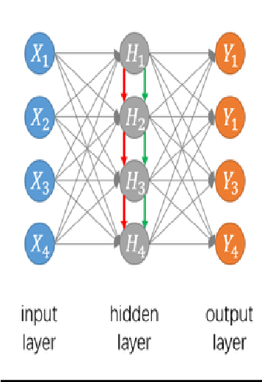

# ARCHITECTURE Data Splitting Phase:

In the data splitting phase, the available dataset is divided into three subsets: training data, validation data, and testing data. the validation data is used to tune hyperparameters and prevent overfitting, and the testing data is kept separate for final evaluation.

# Data Training Phase:

In the data training phase, the deep learning model is trained using the training dataset. This involves feeding the historical stock market data into the model, which learns to recognize patterns and relationships within the data.

# Testing and Evaluation Phase:

After training, the model's performance is assessed using the testing dataset. The model makes predictions on unseen data points, and its predictions are compared against the actual values. This phase ensures the model's reliability and effectiveness in real-world scenarios.

# Final Model:

The final model is the trained deep learning model that has gone through the data splitting, training, and testing phases. It has been fine-tuned and evaluated to achieve the desired level of accuracy and performance.

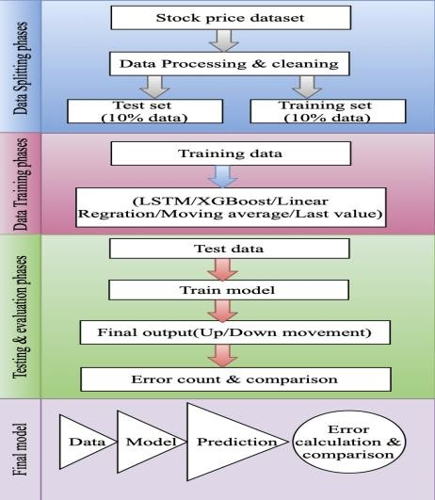

# Fig 1: Model Selection

## Prototype:

Stock market prediction is a challenging and complex task due to the inherent noise and unpredictability of financial markets. Traditional statistical models and algorithms often struggle to capture the non-linear and dynamic nature of market movements. Deep learning, a subset of machine learning, has emerged as a promising approach for stock market prediction due to its ability to automatically learn hierarchical representations of data, potentially capturing intricate patterns and dependencies in financial time series.

## Objective:

The objective of this project is to enhance stock market predictions using deep learning, aiming for improved accuracy, robustness, and real-time prediction capabilities. We aim to develop a model that can make more accurate predictions about future stock market movements compared to traditional statistical methods. Additionally, we seek to create a model that is more resilient to changes in market conditions, economic indicators, and other external factors. By developing a real-time prediction model, we can enable timely adjustments to investment strategies, optimizing returns and minimizing risks.

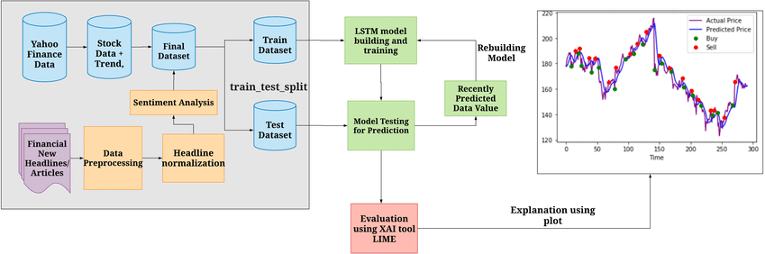

# Fig 2: Working of Project

1. **EXPERIMENTAL RESULTS**

Once the CSV file selected the training will be done and the following results will be displayed.

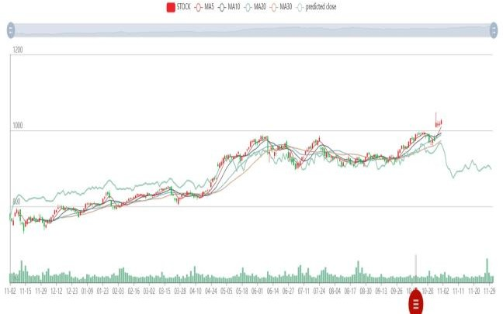

# Fig 3 : Stocks Prices and Value

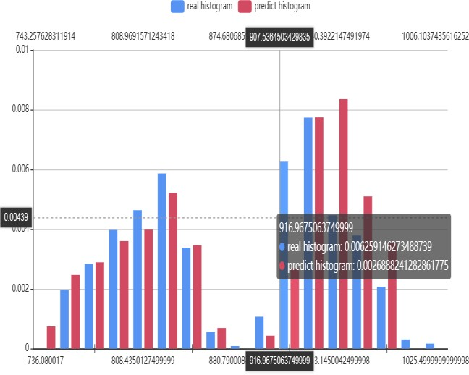

**Fig 4: Prediction Graph**

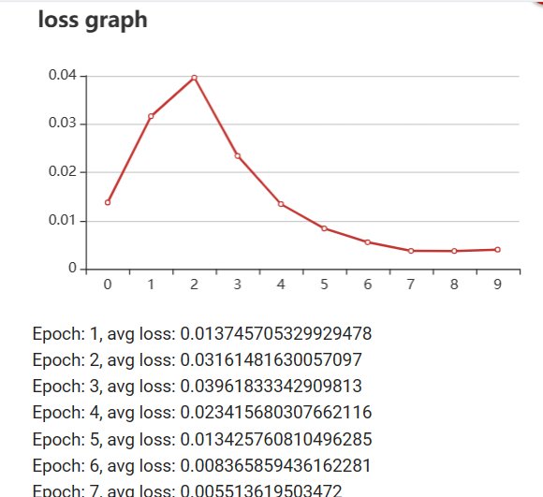

# Fig 5: Loss Graph

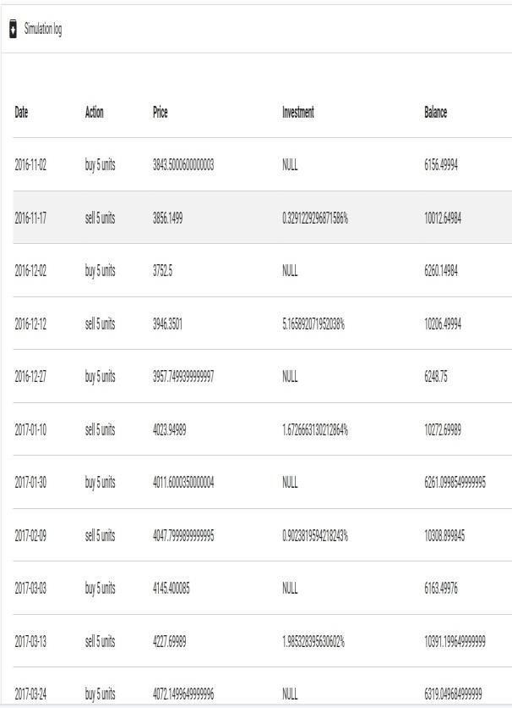

**Fig 6: Portfolio**

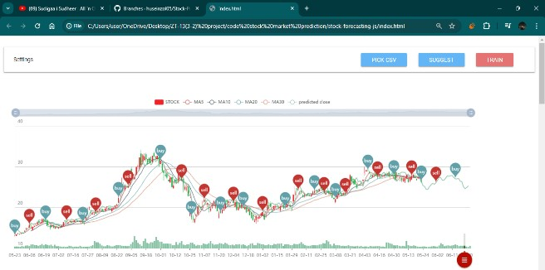

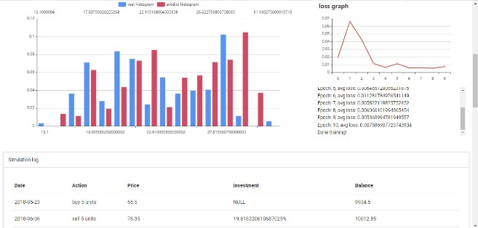

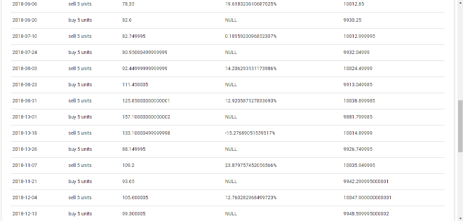

The overall website looks like this with all the information regarding a particular CSV file and we will get to know whether the stocks must me purchased or to sell. The prediction graph helps us to know the real histogram and predicted histogram. With followed loss graph gives the accuracy and simulation log shows the data regarding price, investment and balance.

# CONCLUSION

In conclusion, the project aims to enhance stock market predictions using deep learning, focusing on improving accuracy, robustness, and real-time prediction capabilities. The objectives include developing a more accurate model for volatile market conditions, improving resilience to market dynamics and external factors, enabling timely investment strategy adjustments, optimizing returns, and minimizing risks. Emphasis is placed on interpretability and providing transparent documentation and reporting for informed decision making.

Overall, the project seeks to provide a reliable tool for stock market prediction, supporting investment decisions in a complex financial landscape. With ample opportunities for innovation and advancement that can benefit both individual investors and the broader financial industry.

# FUTURE WORK

**Enhanced Model Architectures:** Exploring more complex neural network architectures or hybrid models that combine RNNs/LSTMs with other deep learning techniques, such as attention mechanisms or convolutional neural networks (CNNs), to capture more intricate patterns in stock market data.

**Feature Engineering:** Investigating novel features or alternative representations of financial data, including sentiment analysis of news articles, social media data, or incorporating macroeconomic indicators, to improve the predictive power of models.

**Uncertainty Estimation:** Incorporating techniques for uncertainty estimation in deep learning models, such as Bayesian neural networks or Monte Carlo dropout, to quantify prediction uncertainty and assess risk in investment decisions more accurately.

**Online Learning and Adaptation:** Designing algorithms for online learning and model adaptation that can continuously update predictions in real-time as new data becomes available, enabling adaptive trading strategies that respond dynamically to changing market conditions.

# REFERENCES

* + 1. S. Selvin, R. Vinayakumar, E. A. Gopalakrishnan, V. K. Menon and K. P. Soman. (2017) “Stock price prediction using LSTM, RNN and CNN-sliding window model.” *International Conference on Advances in Computing, Communications and Informatics*: 1643-1647.
    2. Rather A.M., Agarwal A., Sastry V.N.Recurrent neural network and a hybrid model for prediction of stock returns
    3. Zhang G., Patuwo B.E., Hu M.Y. Forecasting with artificial neural networks: The state of the art
    4. Heaton J. B., Polson N. G., and Witte J. H. (2017). ”Deep learning for finance: deep portfolios.”Applied Stochastic Models in Business and Industry 33 (1): 3-12.
    5. Jabin S. (2014). ”Stock market prediction using feed-forward artificial neural network”. growth 99 (9).
    6. Hamzaebi C., Akay D. and Kutay F. (2009). ”Comparison of direct and iterative artificial neural network forecast approachesin multi-periodic time series forecasting.” Expert Systems with Applications 36 (2): 3839-3844.
    7. Rout A. K., Dash P. K., Dash R., and Bisoi R. (2015).

”Forecasting financial time series using a low complexity recurrent neural network and evolutionary learning approach.”Journal of King Saud University-Computer and Information Sciences 29(4):536-552.

* + 1. Moghaddam A. H., Moghaddam M. H., and Esfandyari M. (2016). ”Stock market index prediction using artificial neural network.” Journal of Economics, Finance and Administrative Science 21 (41): 89-93.
    2. Zhang G. P. (2003). ”Time series forecasting using a hybrid ARIMA and neural network model.”Neurocomputing 50:159-175.
    3. Menon V. K., Vasireddy N. C., Jami S. A., Pedamallu V. T. N., Sureshkumar V., and Soman

K. P. (2016, June). ”Bulk Price ForecastingUsing Spark over NSE Data Set.”In International Conference on Data Mining and Big Data :137- 146.

* + 1. Budhani N., Jha C. K., and Budhani S. K. (2014). ”Prediction of stock market using artificial neural network.”In Soft Computing Techniques for Engineering and Technology (ICSCTET) : 1-8.
    2. Yetis Y., Kaplan H., and Jamshidi M. (2014). ”Stock market prediction by using artificial neural network.” In World Automation Congress (WAC)

:718-722.

* + 1. Roman J., and Jameel A. (1996). ”Backpropagation and recurrent neural networks in financial analysis of multiple stock market returns.” In Twenty-Ninth Hawaii International Conference on system sciences 2: 454-460.
    2. Sibi P., Jones S. A. and Siddarth P. (2013). ”Analysis of different activation functions using back propagation neural networks.” Journal of Theoretical and Applied Information Technology 47 (3): 1264-1268.