## **Systemic Lupus Erythematosus (SLE)**

## **Abstract**

Systemic lupus erythematosus, generally known as SLE, is an autoimmune disease that can damage the skin, joints, kidneys, central nervous system, and several other organs. Members of specific racial groups and pregnant women are frequently more susceptible to the sickness. Although uncommon, hereditary, single-gene complement deficiencies are strongly connected to SLE, most people acquire the disease in a polygenic manner. Genetic interactions with environmental factors, such as UV radiation exposure, Epstein-Barr virus infection, and hormonal factors, which may lead to the onset of the disease, may result in immune dysregulation at the level of cytokines, T cells, B cells, and macrophages. The diagnosis of SLE is primarily clinical and is still challenging because of its unpredictability. The majority of SLE diagnoses are clinical because of its unpredictability. Clinical trials have benefited from classification criteria, but even so, only one medicine (belimumab) has been licenced for treatment in SLE in the previous 60 years. The 10-year mortality rate has decreased, and newer treatments like mycophenolate mofetil and glucocorticoid-sparing regimens have somewhat mitigated the harmful side effects of previous drugs like cyclophosphamide and glucocorticoids. However, the negative effects of renal and neuropsychiatric involvement as well as the late diagnosis have impeded further progress. The increased risk of early cardiovascular disease in SLE patients and the danger of infection made worse by immunosuppressive medication add to this burden. Treatment-resistant illness and signs like weariness continue to be problems. The development of stem cell and genetic procedures may one day lead to a cure, while newer therapies may provide the prospect of better results.

**KEYWORDS –** Systemic Lupus Erythematosus(SLE), autoimmune diseases, gender differentiated diseases

## **Introduction**

A chronic autoimmune illness that can affect every organ and tissue, systemic lupus erythematosus (SLE) affects people all over the world. An autoimmune process that is self-sustaining is the result of a complicated interaction between defective apoptotic clearance, elevation of the innate and adaptive immune system, complement activation, immune complexes, and tissue inflammation. The clinical manifestations we refer to as SLE may be caused by a variety of pathogenic processes. Despite the fact that SLE may affect a wide range of organs and tissues, the pattern of clinical symptoms and autoimmune phenomena varies significantly among patients and even over the course of an individual patient’s lifetime. Because of this, making a diagnosis is frequently challenging or time-consuming and requires a high level of clinical skill to integrate clinical and immunological findings. Here, we evaluate the classification criteria as well as existing and proposed treatments from a mechanistic and empirical perspective[1]. However, primary care is also beginning to play a bigger part in the regular management of SLE patients. As a result, lupus is no longer seen as an uncommon disease, and in the local population, a sizeable proportion of individuals are probably undiagnosed or have lengthy diagnostic delays[2].For the purpose of raising awareness of the condition, May 10 is observed as World Lupus Day.

## **Epidemiology**

Worldwide, lupus is a condition that strikes women of reproductive age particularly hard. SLE is the gender-differentiated autoimmune diseases[3], with the majority of cases occurring in women between the ages of 15 and 44[4] and with a 9:1 female preponderance. Despite being present in all races, it is more common in non-Caucasians. SLE is uncommon in Africa, while having a higher prevalence among people of African heritage in Europe and the United States[5,6]. In the US, African-Americans are more likely to experience it, and they also frequently experience worse results. In contrast to Caucasian-American women, African-American women have a roughly thrice higher mortality rate[7].

The main emphasis of immunological involvement in SLE is the patient’s lack of “self-tolerance.” Patients with SLE have impaired phagocytosis, which causes antigen- antibody complexes and apoptotic cells to be removed improperly. The development of autoantibodies, which then combine with antigens to create immune complexes, is the defining feature of SLE and causes tissue damage and inflammation.

Patients with pulmonary symptoms complain of coughing, shortness of breath, and uncomfortable breathing. There have also been reports of pleural effusion and pulmonary hypertension[8].

SLE also has an impact on the central nervous system (CNS), gastrointestinal, renal, and haematological systems. Cardiovascular consequences frequently include coronary artery disease, myocarditis, endocarditis, and pericarditis[9,10]. It has been hypothesised that, in addition to the conventional risk factors seen in the general population, some medications used to treat SLE (such as immunosuppressants and corticosteroids) are risk factors for coronary artery disease in SLE patients[11].

Causes and risk factors

Although lupus is an autoimmune disorder, its specific cause is unknown.

The immune system defends the body from diseases like bacteria, yet it can occasionally confuse healthy tissue for infections. Inflammation, swelling, discomfort, and tissue damage may result from this.

Although they believe it is caused by a variety of circumstances, researchers do not yet fully understand what causes lupus.

Cell death, a normal process that takes place as the body renews its cells, is one theory that has been put forth. The bodies of lupus sufferers may not adequately eliminate dead cells because of hereditary reasons.

The lingering dead cells may trigger the development of autoantibodies like antinuclear antibodies (ANAs), which then assault the body and cause lupus symptoms.

ANAs are frequently found in patients with autoimmune diseases like lupus. They mostly work as contracting the nuclei of the cell in body. Genes are located in the nucleus.

## **Pathogenesis overview**

## An interaction of a person's genetic predisposition, environmental triggers, immunological, and hormonal components is necessary for SLE to manifest clinically. Immune tolerance to self-antigens is lost in such a permissive milieu, in addition to proinflammatory stimuli including type 1 interferons and other cytokines [12].

## Lupus is connected to numerous environmental causes. ultraviolet radiation (the most well-known) [13-15], medications/supplements (echinacea, trimethoprim/sulfamethoxazole), smoking[16], infections[17,18] (especially the Epstein-Barr virus [19]), silica[20], mercury [21], and others [18,22,23]. Additionally, a 50% increased risk of getting lupus has been connected to psychological stress[24,25].

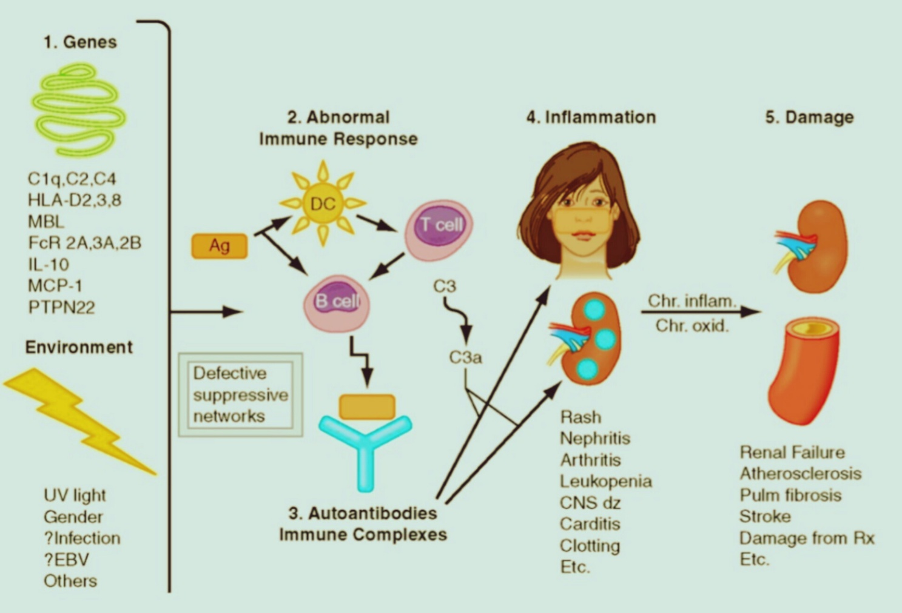

**● Environmental Risk Factors**

Roughly 90% of SLE patients are female, and the incidence of the disease is three to four times higher among African Americans than it is among Caucasians, according to population-based studies’ aggregate data[26,27].

There is compelling epidemiological evidence connecting environmental factors, such as current cigarette smoking, vitamin D status infections such Epstein-Barr virus, and nutritional factors. The risk factors associated with the environment are listed in the section that follows.

**• Genetic Risk Factors**

The genetic causes of SLE have been the subject of intense research during the past few years. The importance of genetic variation in SLE was initially demonstrated in the 1970s.Nearly four decades later, more than 25 genes are now understood to have a role in the pathways that predispose people to lupus with the aid of increasingly potent genetic techniques[28].

There are about 3073 genetic variations at 91 risk loci were suggested by a recent paper[29] focussing on the Genome-wide association studies of Systemic Lupus Erythematosus (SLE).Alleles in the major histocompatibility complex region (several genes), IRF5, ITGAM, STAT4, BLK, BANK1, PDCD1, TNFSF4, TNFAIP3, SPP1, some of the Fcg receptors, and deficits in a number of complement elements, including C1q, C4 and C2, are among the well-established risk factors.

## **Signs and Symptoms**

Lupus can affect almost any organ in your body. The symptoms of lupus also differ from person to person [30,31,32]. For example, one woman with lupus may have swollen knees and fever. Another woman may be tired all the time or have kidney trouble. Someone else may have rashes. Over time, new symptoms may develop, or some symptoms may happen less often.

 The 11 criteria are:

•Discoid rash: The skin becomes red, raised regions.

•Photosensitivity: When exposed to sunshine, a skin rash develops.

•Oral or nasal ulcers: A person may get ulcers in their mouth or nose.

• Molar rash: This type of rash spreads across the nose and cheeks in the shape of a butterfly.

• Nonerosive arthritis: This kind of arthritis produces pain and swelling but does not break down the bones around the joints.

• Kidney disease: If a person has a kidney condition, such as lupus nephritis, tests reveal high quantities of protein or cellular casts in the urine.

• Neurologic disorder: A person may experience seizures, psychosis, or problems with thinking and reasoning.

• Hematologic (blood) disorder: Blood may show a low red blood cell count (anemia), a low white blood cell count (leukopenia), or a low platelet count (thrombocytopenia).

• Immunologic disorder: Tests show thatare crfere are anti-doublfdrvdfe-stranded D NA antibodies, anti-Smith antibodies, or antiphospholipid antibodies (APLs).

• Positive ANA: A test detects high levels of ANA [33].

Additionally, lupus symptoms typically come on and off, so they're not constant. The illness lupus is characterised by flare-ups and remissions, when your symptoms get better and you feel better.

Additional signs and symptoms of lupus include:

• Pain in the joints and muscles

• Temperature

• Itching

• Pain in the chest

• Sensitivity to light or the sun

• Issues with the kidneys

• Sores on the mouth

• Extended or excessive tiredness

## **Diagnosis**

SLE is diagnosed using clinical indications and symptoms, laboratory tests, and diagnostic procedures specific to each patient. An important tool in the evaluation of patients when SLE is suspected is the 1997 Update of the 1982 American College of Rheumatology (ACR) Revised Criteria for Classification of Systemic Lupus Erythematosus.[58]The diagnosis of SffdLE can be achieved with 95% specificity and 85% sensitivity if a patient exhibits four or more of the 11 criteria (either concurrently or at various times)[34]. However, a 2003 study that compared modified weighted criteria with ACR criteria found that the weighted criteria had a greater sensitivity (sensitivity, 90.3% vs. 86.5%; specificity, 60.4% vs. 71.9%)[35].

Numerous sets of classification criteria have been created over time for epidemiological and research objectives due to the considerable variability of clinical presentations.

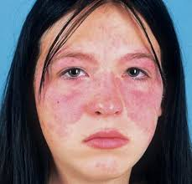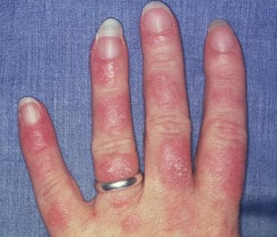A clinician can tell what is going on in the body or how the body is reacting to treatment by looking at biomarkers, which are antibodies, proteins, genetics, and other elements. Even there is no symptoms, they can aid in determining whether a person has an illness.

**Following are the test for SLE**

• Blood tests : Blood tests can show whether certain biomarkers are present, and biomarkers can give information about which autoimmune disease, if any, a person has.

• Antinuclear antibody: Around 95% of people with lupus will have a positive result in the ANA test, although some people test positive for ANA without having lupus.

• Anti-phospholipid antibodies (APLs): These are present in around 50%Trusted Source of people with lupus, but they can also occur in people without lupus.

• Anti-dsDNA antibody test: Around 47%Trusted Source of people with lupus test positive for these antibodies, according to a study involving 1,977 people.

• Anti-Smith antibody: People with lupus may have Trusted Source antibodies to Sm, a type of protein.

• Anti-U1RNP antibody: Around 25–30%Trusted Source of people with lupus have anti-U1RNP antibodies, and fewer than 1% of people without lupus have them. However, it may be present with other autoimmune conditions.

• Anti-Ro/SSA and anti-La/SSB antibodies: These antibodies have been linked Trusted Source to various immune conditions, including SLE.

• Antihistone antibodies: Antibodies to histones are proteins that play a role in the structure of DNA. People with DIL or SLE may have Trusted Source them

• Serum (blood) complement test: This test measures the levels of proteins that the body consumes when inflammation takes place. Low levels suggest inflammation is present, and the condition may be active.

• Nonspecific tests: Various other tests look for markers of inflammation, including C-reactive protein and erythrocyte sedimentation rate.

Further tests may include:

• Urine tests, which can help identify effects on the kidneys.

• Tissue biopsies Trusted Source, usually of the skin or kidneys, to check for damage or inflammation.

• Imaging tests to reveal any organ damage

## **TREATMENT**

Lupus treatment is the best way to manage your symptoms, feel better, and keep the disease from getting worse. Your symptoms and their severity will determine how you are treated for lupus[36].

You can benefit from treatment:

- Reduce your symptoms

-Reduce the level of inflammation

-Minimise and avoid flare-ups

-Avoid harm to your organs and further health issues

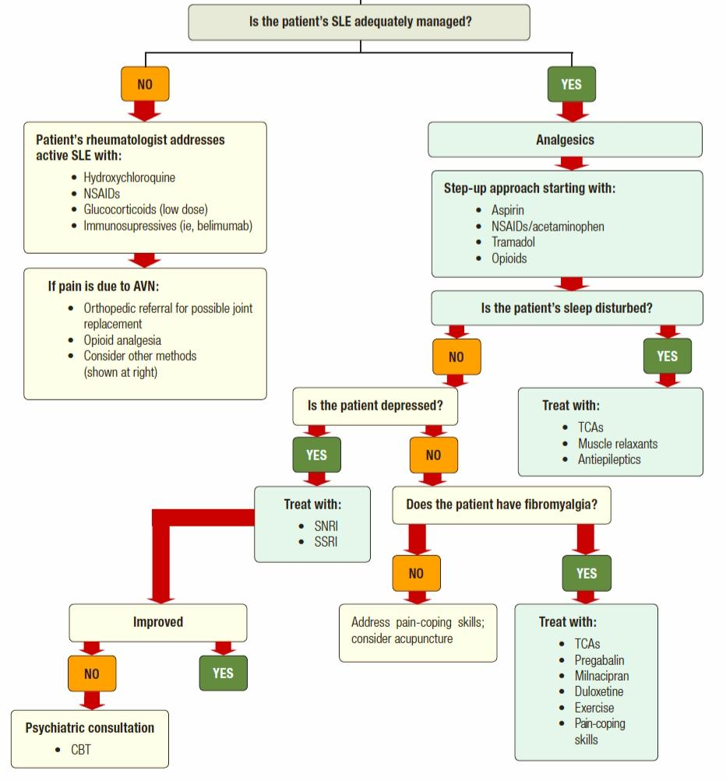

**Medications for Lupus**

• Anti-inflammatory drugs

If you have lupus, you may have joint pain and swelling, especially in your fingers, wrists, or knees. Sometimes, you may have a fever. Nonsteroidal anti-inflammatory drugs (NSAIDs) can usually help with these problems. You can buy them without a prescription.

* Over-the-counter anti-inflammatory drugs include:

Acetaminophen, Aspirin, Ibuprofen, Naproxen

* Side effects of anti-inflammatory drugs

Sometimes, anti-inflammatories can irritate your stomach, so take them with food or milk. NSAIDs, especially at higher doses, raise your chances of a heart attack or stroke.

•Antimalarial drugs

Some medications that treat malaria, such as hydroxychloroquine and chloroquine, can also treat lupus. They might help with skin rashes, mouth sores, and joint pain. They may also lower the risk of getting blood clots, which is a concern in some people with lupus.

* Side effects of antimalarial drugs

Side effects, like stomach upset, tend to be rare and mild.

• Corticosteroids

Because of the overactive immune system caused by lupus, healthy tissue is mistakenly attacked. This immunological response is weakened by corticosteroids. If lupus creates issues with your heart, lungs, kidneys, brain, or blood vessels, your doctor may advise taking them.

When taken orally or intravenously, corticosteroids quickly reduce swelling, warmth, and pain in joints brought on by inflammation. Additionally, they can stop long-term organ damage.

* Side effects of corticosteroids

Corticosteroids can have serious side effects like:

▪︎ Higher chance of infections Fragile bones or bone damage, especially in your hips Muscle weakness, Diabetes, Cataracts

▪︎ You may also have weight gain, bloating, and mood changes. Your doctor will probably give you the lowest dose they can and taper it off if your symptoms go away for a time.

• Immunosuppressive drugs

These medications, like corticosteroids, suppress your immune system, reduce symptoms, and aid in preventing long-term organ damage. In the event that corticosteroids have not relieved your symptoms, your doctor may prescribe them.

* Common immunosuppressive drugs for lupus include:

Azathioprine, cyclophosphamide, Methotrexate, Voclosporin

* Side effects of immunosuppressive drugs

Immunosuppressives can also have severe side effects like they can make it hard for your body to fight infections and raise your chances of cancer

• Other medications

Your doctor may also prescribe one or more of these types of drugs:

-Anticoagulants

-Belimumab (Benlysta)

-Rituxan (Rituximab)

-Anifrolumab-fnia (Saphnelo)

-Repository corticotropin injection.

•Alternative Treatments for Lupus

Alternative medicine is any treatment that you use instead of traditional medicine. Some people with lupus try to ease symptoms with:

Acupuncture, Biofeedback, Massage, Meditation, Chiropractic treatments, Herbs and other supplements

### **Pregnancy and Contraception for Women With Lupus**

If their lupus is under control, the majority of women who have it can give birth to healthy babies. Consult your doctor if you begin to consider getting pregnant to ensure that you are as healthy as possible before giving birth. In particular, if you have low platelets, antiphospholipid antibodies, anti-SSA/Ro antibodies, high blood pressure, lung, heart, or renal issues, close monitoring during pregnancy is imperative.

Finding an obstetrician with experience treating lupus-suffering women and managing high-risk pregnancies is crucial. Certain lupus drugs are contraindicated during pregnancy. To be sure that all of your lupus drugs are safe to use during pregnancy, it is crucial to discuss them with your doctors before becoming pregnant.

The incidence of severe flares among lupus patients is not increased by birth control pills, according to research, however estrogen-containing birth control pills are not advised for those who have antiphospholipid antibodies. Before beginning oral contraceptives, discuss your antibody test results with your doctor[37].

**Lifestyle Changes**

Maintaining a healthy lifestyle can prevent flare-ups and enhance your health. It can also reduce the risk of problems associated with lupus, such as kidney disease, heart attacks, and strokes.

Consider implementing the following suggestions:

Consume a diet that is well-balanced.

-To save your heart and blood vessels, stop smoking or refrain from starting.

-Avoid weariness, a typical lupus symptom, by getting lots of rest.

-Get regular exercise to improve heart health, happiness, and sleep.

-When heading outside, wear sunscreen at all times.

-Acquire flu and pneumonia vaccinations to ward against illnesses.

**How to Reduce Risk of Flares**

**Environmental Exposure**

Reduce environmental triggers, you may consider[38]

• Protecting your skin: Limit your exposure to the sun and UV light. Seek shaded areas when outdoors, wear sun-protective clothing (such as long-sleeved shirts, sunglasses, and wide-brimmed hats), and wear sunscreen that blocks UV-A and UV-B with a sun protection factor (SPF) greater than 55.

• Quitting smoking: Smoking can trigger lupus flares, If you smoke cigarettes, try to quit smoking or speak to your provider about ways to reduce your tobacco intake.

• Limiting exposure to toxins: Look for household products that do not contain silica dust.

**Nutrition and Dietary Choices**

Previous research suggests that certain dietary and nutrition factors may contribute to the onset of lupus. According to some experts, consuming meals like fatty fish, olive oil, and cooked veggies can help relieve the symptoms of long-term illnesses like lupus. Coffee has been demonstrated to lessen lupus disease activity and even cytokine levels, which are immune system proteins vital for cell signalling[39,40].

**Stress Management and Self Care**

Several chronic illnesses, including lupus, can have flare-ups in response to emotional stress. A chronic illness can increase your risk of experiencing anxiety and sadness, which can exacerbate symptoms and lead to more flare-ups.

The following methods are recommended by the Lupus Foundation of America to assist you in taking better care of yourself[41].

• Make time for your favourite activities and give relaxation a high priority. Take breaks throughout the day to avoid physical tiredness, do deep

breathing exercises, write down your worries and nervous thoughts in a notebook, practise yoga, or meditate.

• Establish healthy habits: Building a routine can help you lower stress. Try to make a schedule for your day, plan your meals with a loved one, find an exercise or activity that you can do for 30 minutes per day, and aim to get quality sleep each night.

• Find support: Living with a chronic condition can be stressful and can sometimes be difficult to talk about. But, it’s important to keep a close group of loved ones updated about your condition and communicate how they can support you.

## **CONCLUSION**

Multiple organs are affected by the systemic autoimmune illness known as SLE. These patients will inevitably receive care from specialists across multiple fields, which could lead to fragmented care. GPs must provide evidence-based, patient-centered treatment while also acknowledging their limitations as a result of their training. Collaboration between experts from many disciplines and levels of care (primary, secondary, and tertiary) is crucial to overcoming uncertainty and challenges in the clinical management of SLE patients. This process might be facilitated by the development of solid evidence, instruments to promote informed patient decisions, and interdisciplinary shared-care pathways. In this context, general practitioners (GPs) have a crucial role in identifying both milder and more severe SLE manifestations, guiding patients, and reducing the disease burden at the local level.

● **References**

 [1] Fava, Andrea, and Michelle Petri. “Systemic Lupus Erythematosus: Diagnosis and Clinical Management.” Systemic Lupus Erythematosus : Diagnosis and Clinical Management   16 Nov 2018,ncbi.nlm.nih.gov

[2] Johnson AE, Gordon C, Hobbs FD, Bacon PA. Undiagnosed systemic lupus erythematosus in the community. Lancet(1996) 345:367-9. Doi: 10.1016%S0140-6736(96)90539-5

     Pubmed Abstract | CrossRef Full Text | Google Scholar

[3]McCarty DJ, Manzi S, Medsger TA Jr, Ramsey-Goldman R, LaPorte RE, Kwoh CK: Incidence of systemic lupus erythematosus. Race and gender differences. Arthritis Rheum. 1995, 38:1260-70. 10.1002/art.1780380914

 [4]Weckerle CE, Niewold TB: The unexplained female predominance of systemic lupus erythematosus: clues from genetic and cytokine studies. Clin Rev Allergy Immunol. 2011, 40:42-9. 10.1007/s12016-009-8192-4

[5] Symmons DPM, Occasional Series: Lupus Around the World Frequency of lupus in people of African origin, Lupus. 4 (1995) 176–178. Doi: 10.1177/096120339500400303. [PubMed] [CrossRef] [Google Scholar]

[6] Pons-Estel GJ, Alarcón GS, Scofield L, Reinlib L, Cooper GS, Understanding the Epidemiology and Progression of Systemic Lupus Erythematosus, Semin. Arthritis Rheum 39 (2010) 257–268. Doi: 10.1016/j.semarthrit.2008.10.007. [PMC free article] [PubMed] [CrossRef] [Google Scholar]

[7] Krishnan E, Hubert HB, Ethnicity and mortality from systemic lupus erythematosus in the US, Ann. Rheum. Dis 65 (2006) 1500–1505. Doi: 10.1136/ard.2005.040907. [PMC free article] [PubMed] [CrossRef] [Google Scholar]

[8] Powers DB. Systemic lupus erythematosus and discoid lupus erythematosus. Oral Maxillofacial Surg Clin North Am. 2008;20:651–662. [PubMed] [Google Scholar]

[9] Sitia S, Atzeni F, Sarzi-Puttini P, et al. Cardiovascular involvement in systemic autoimmune diseases. Autoimmune Rev. 2009;8:281–286. [PubMed] [Google Scholar]

[10] Hall FC, Dalbeth N. Disease modification and cardiovascular risk reduction: Two sides of the same coin? Rheumatol (Oxford) 2005;44:1473–1482. [PubMed] [Google Scholar]

[11]Fava, Andrea, and Michelle Petri. “Systemic Lupus Erythematosus : Diagnosis and Clinical Management.” Systemic Lupus Erythematosus : Diagnosis and Clinical Management, 16 Nov. 2018, ncbi.nlm.nih.gov.

[12] Tsokos GC, Lo MS, Reis PC, Sullivan KE, New insights into the immunopathogenesis of systemic lupus erythematosus, Nat. Rev. Rheumatol 12 (2016) 716–730. Doi: 10.1038/nrrheum.2016.186. [PubMed] [CrossRef] [Google Scholar]

[13] Burger RA, Torres AR, Warren RP, Caldwell VD, Hughes BG, Echinacea-induced cytokine production by human macrophages, Int. J. Immunopharmacol 19 (1997) 371–379. Doi: 10.1016/S0192-0561(97)00061-1. [PubMed] [CrossRef] [Google Scholar]

[14] Spelman K, Burns JJ, Nichols D, Winters N, Ottersberg S, Tenborg M, Modulation of cytokine expression by traditional medicines: A review of herbal immunomodulators, Altern. Med. Rev 11 (2006) 128–150. Doi: 10.1016/j.cyto.2017.10.019. [PubMed] [CrossRef] [Google Scholar]

[15] Petri M, Allbritton J, Antibiotic allergy in systemic lupus erythematosus: a case-control study., J. Rheumatol 19 (1992) 265–9. <http://www.ncbi.nlm.nih.gov/pubmed/1629825>. [PubMed] [Google Scholar]

[16] Costenbader KH, Kim DJ, Peerzada J, Lockman S, Nobles-Knight D, Petri M, Karlson EW, Cigarette Smoking and the Risk of Systemic Lupus Erythematosus: A Meta-Analysis, Arthritis Rheum. 50 (2004) 849–857. Doi: 10.1002/art.20049. [PubMed] [CrossRef] [Google Scholar]

[17] Blomberg J, Nived O, Pipkorn R, Bengtsson A, Erlinge D, Sturfelt G, Increased antiretroviral antibody reactivity in sera from a defined population of patients with systemic lupus erythematosus: Correlation with autoantibodies and clinical manifestations., Arthritis Rheum. 37 (1994) 57–66. <http://www.ncbi.nlm.nih.gov/pubmed/7510483>. [PubMed] [Google Scholar]

[18] Cooper GS, Parks CG, Occupational and environmental exposures as risk factors for systemic lupus erythematosus., Curr. Rheumatol. Rep 6 (2004) 367–74. <http://www.ncbi.nlm.nih.gov/pubmed/15355749>. [PubMed] [Google Scholar]

[19] James JA, Neas BR, Moser KL, Hall T, Bruner GR, Sestak AL, Harley JB, Systemic lupus erythematosus in adults is associated with previous Epstein-Barr virus exposure., Arthritis Rheum. 44 (2001) 1122–6. Doi: 10.1002/1529-0131(200105)44:5<1122::AID-ANR193>3.0.CO;2-D. [PubMed] [CrossRef] [Google Scholar]

[20] Parks CG, Cooper GS, Nylander-French LA, Sanderson WT, Dement JM, Cohen PL, Dooley MA, Treadwell EL, St EW.Clair, G.S. Gilkeson, J.A. Hoppin, D.A. Savitz, Occupational exposure to crystalline silica and risk of systemic lupus erythematosus: A population-based, case-control study in the south-eastern United States, Arthritis Rheum. 46 (2002) 1840–1850. Doi: 10.1002/art.10368. [PubMed] [CrossRef] [Google Scholar]

[21] Crowe W, Allsopp PJ, Watson GE, Magee PJ, Strain JJ, Armstrong DJ, Ball E, McSorley EM, Mercury as an environmental stimulus in the development of autoimmunity – A systematic review, Autoimmune. Rev 16 (2017) 72–80. Doi: 10.1016/j.autrev.2016.09.020. [PubMed] [CrossRef] [Google Scholar]

[22] Zarmbinski MA, Messner RP, Mandel JS, Anti-dsDNA antibodies in laboratory workers handling blood from patients with systemic lupus erythematosus., J. Rheumatol 19 (1992) 1380–4. <http://www.ncbi.nlm.nih.gov/pubmed/1433005>. [PubMed] [Google Scholar]

[23] Chiou S-H, Lan J-L, Lin S-L, Chen D-Y, Tsai N-Y, Kuan C-Y, Lin T-Y, Lin F-J, Lee W-M, Chang T-J, Pet dogs owned by lupus patients are at a higher risk of developing lupus, Lupus. 13 (2004) 442–449. Doi: 10.1191/0961203303lu1039oa. [PubMed] [CrossRef] [Google Scholar]

[24] Song H, Fang F, Tomasson G, Arnberg FK, Mataix-Cols D, Fernández de la Cruz L, Almqvist C, Fall K, Valdimarsdóttir UA , Association of Stress-Related Disorders With Subsequent Autoimmune Disease., Jama. 319 (2018) 2388–2400. Doi: 10.1001/jama.2018.7028. [PMC free article] [PubMed] [CrossRef] [Google Scholar]

[25] Roberts AL, Malspeis S, Kubzansky LD, Feldman CH, Chang S-C, Koenen KC, Costenbader KH, Association of Trauma and Posttraumatic Stress Disorder With Incident Systemic Lupus Erythematosus in a Longitudinal Cohort of Women., Arthritis Rheumatol. (Hoboken, N.J.) 69 (2017) 2162–2169. Doi: 10.1002/art.40222. [PMC free article] [PubMed] [CrossRef] [Google Scholar]

[26] Al Sawah, S., Zhang, X., Zhu, B., Magder, L.S., Foster, S.A., Iikuni, N., et al. (2015) Effect of Corticosteroid Use by Dose on the Risk of Developing Organ Damage over Time in Systemic Lupus Erythematosus—The Hopkins Lupus Cohort. Lupus Science & Medicine, 2, Article ID: e000066.

[27] Pryor, W.A. and Stone, K. (1993) Oxidants in Cigarette Smoke. Radicals, Hydrogen Peroxide, Peroxynitrate, and Peroxynitrite. Annals of the New York Academy of Sciences, 686, 12-27.https://doi.org/10.1111/j.1749-6632.1993.tb39148.x

[28] Moser, K.L., Kelly, J.A., Lessard, C.J. and Harley, J.B. (2009) Recent Insights into the genetic Basis of Systemic Lupus Erythematosus. Genes and Immunity, 10, 373-379Lu, X., Chen, X., Forney, C., Donmez, O., Miller, D., Parameswaran, S., Hong, T., Huang, Y., Pujato, M., Cazares, T., Miraldi, E.R., Ray, J.P., de Boer, C.G.,

[29] Harley, J.B., Weirauch, M.T. and Kottyan, L.C. (2021) Global Discovery of Lupus Genetic Risk Variant Allelic Enhancer Activity. Nature Communications, 12, Article No. 1611.

<https://doi.org/10.1038/s41467-021-21854-5>

 [30] Longo, D.L., Kasper, D.L., Larry, J.J., Fauci, A.S. and Hauser, S.L. (2011) Harrison’s Principles of Internal Medicine. 18th Edition, McGraw-Hill Professional Pub, New York.

[31] Cojocaru, M., Cojocaru, I.M., Silosi, I. And Vrabie, C.D. (2011) Manifestations of Systemic Lupus Erythematosus. Maedica: A Journal of Clinical Medicine, 6, 330-336.

[32] Lee, Y.H., Woo, J.H., Choi, S.J., Ji, J.D. and Song, G.G. (2010) Induction and Maintenance Therapy for Lupus Nephritis: A Systematic Review and Meta Analysis. Lupus, 19, 703-710.https://doi.org/10.1177%2F0961203309357763

[33] Sarah N Al- Gahtani. SCIRP Open Access. Scirp.org. Accessed 2 Oct. 2023.

[34] Hochberg MC. Updating the American College of Rheumatology revised criteria for the classification of systemic lupus erythematosus (letter) Arthritis Rheum. 1997;40:1725. [PubMed] [Google Scholar]

[35] Sanchez ML, Alarcon GS, McGwin G, Jr, et al. Can the weighted criteria improve our ability to capture a larger number of lupus patients into observational and interventional studies? A comparison with the American College of Rheumatology criteria. Lupus. 2003;12:468–470. [PubMed] [Google Scholar]

[36] Zelman, David. “Lupus Treatment.” *Webmd*, 13 Sept. 2023, Webmd.com.

[37] *National Institute of Arthritis and Musculoskeletal and Skin Diseases (NIAMS)*. niams.nih.gov. Accessed 11 Oct. 2023.

[38] American Academy of Dermatology Association. [Lupus and your skin: Self-care dermatologists recommend](https://www.aad.org/public/diseases/a-z/lupus-self-care).

[39] Barbhaiya M, Costenbader KH. Environmental exposures and the development of systemic lupus erythematosus. Curr Opin Rheumatol. 2016;28(5):497-505. Doi:10.1097/BOR.0000000000000318

[40] Orifice V, Cascarilla F, Barbati C, Perricone C, Alessandri C, Conti F. The impact of caffeine intake on patients with systemic lupus erythematosus: Protect yourself, drink more coffee!. Mediterr J Rheumatol. 2020;31(4):374-375. Doi:10.31138/mjr.31.4.374

[41] Lupus Foundation of America. [Managing stress when you have lupus](https://www.lupus.org/resources/managing-stress-when-you-have-lupus).