**FUNDS FLOW STATEMENT**

1. Author: **A.ANITHA**, Asst. Prof., Dept. of MBA, SANTHIRAM ENGINEERING COLLEGE, NANDYAL

2. Author: **S.KARISHMA**, Student of MBA, SANTHIRAM ENGINEERING COLLEGE, NANDYAL

**ABSTRACT**:

The funds flow statement which reveals the methods by which the business has been finances and how it has used its funds between the opening and closing balance sheet date. Thus, a funds flow statement is a report on movement of funds explaining where from working capital originates and where into the same goes during an accounting period.

Fund flow statements can be used to identify a variety of problems in the way a company operates. For example, companies that are using short-term money to finance long-term investments may run into liquidity problems in the future. Meanwhile, a company that is using long-term money to finance short-term investments may not be efficiently utilizing its capital.

**REVIEW OF LITERATURE**:

Funds Flow Statement is a widely used tool in the hand of financial executives for analysing the financial performance of a concern concept. In a Narrow sense, it means cash only and a funds flow statement prepared on this basis is called as cash flow statement. Such a statement enumerates net effects of the various business transactions on cash takes into account receipts and disbursement net cash.

The basic financial statements i.e. the Balance Sheet and profit and Loss account or income statement of business reveal the net effect of the various transactions on operation and financial position of the company, the balance sheet gives a summary of assets and liabilities of an undertaking at a particular point of time. It reveals the financial position of the company. The profit and loss reflects the result of the business operation for a period of time. It contains a summary of expenses incurred and the revenue released in an accounting period. Every company prepares its Balance Sheet at the end of its accounting Year. It reveals the financial position of the company at a certain point of time.

**Importance of funds flow Statements**:

1. Funds flow statement determines the financial consequence of business operations as it shows how the funds were obtained and used in the past.
2. The management can formulate its financial policies – dividend, reserves etc. on the basis of the statement.
3. It serves a control device, when comparing with budgeted figures. The financial manager can take remedial steps, if there is any deviation.
4. It points out the sound and weak financial position of the enterprise.
5. It points out the causes for changes on working capital.
6. It enables the bankers, creditors or financial institutions on assessing their degree of risks involved in granting credit to the business.

**Steps involved in the preparation of funds flow statement**:

1. Ascertain the funds from operations.
2. Preparation of statement of changes.
3. Computation of any missing figures as to profit or loss on Sale of fixed assets purchases or sale of fixed assets and
4. The amount of depreciation on fixed assets etc.

**NEED FOR THE STUDY**:

This study is important for understanding the management of funds flow statement in Ultra Tech Cements it gives information on the basis of analysis about percentage of investment in each current asset cause for changes in working capital from different sources amount of working capital required. The firm‘s trade creditors are interest in the firm ability to meet their claim over a short period of time. So they required the evaluation of the firm‘s liquidity position. The suppliers of the long-term debt on the other hand of concerned with the long-term resolutions and survival. They analyses the firm profitability over time.

**OBJECTIVES OF THE STUDY:**

• To study the efficiency with which the firm is utilising its various assets in generating sales.

• To study the extent to which the firm has used its long-term solvency by borrowing funds.

• To know whether the current assets and current liabilities are properly managed.

• To review the structure, original growth and performance of ultra tech cement during the study period.

**RESEARCH METHODOLOGY**

This study is made through two sources

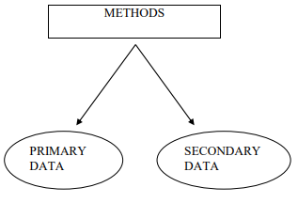

Primary Data: The primary data comprises information collected during discussions with Heads of Departments and from the meeting with officials and staff.

Secondary Data: The secondary data has been collected from information through Annual reports, Public report, Bulletins and other printed Materials supplied by the Company.

**DATA ANALYSIS AND INTERPRETATION**:

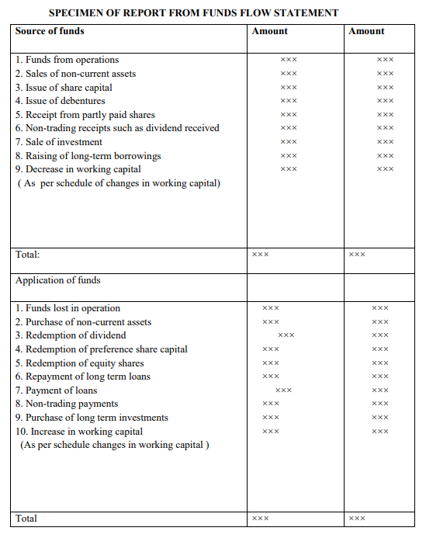

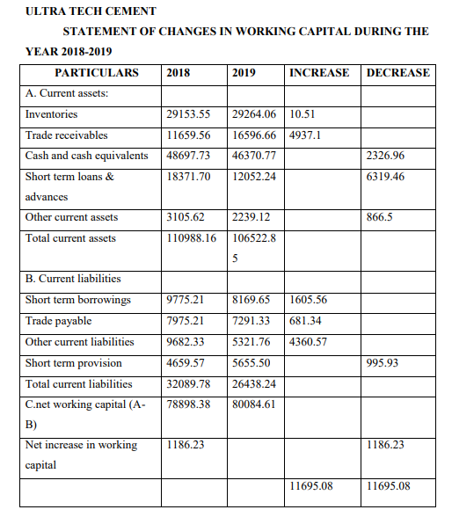

**INTERPRETATION**: As per above working capital in current assets inventories, trade receivables are increased in 2018. As well as cash and cash equivalents, short term loans & advances other current are decreased in2019. In other side in current liabilities short term borrowings, trade payable, other current liabilities are increased in 2019. As well as short term provisions are decreased in 2019. The overall ―Net working capital‖ increased to 1186.23/- in the years 2019.

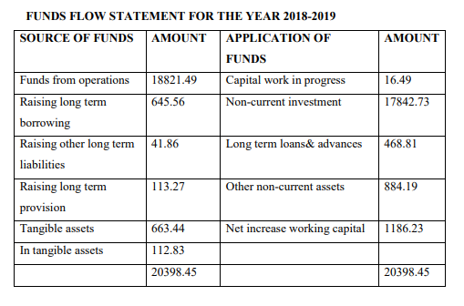

**FINDINGS**

• It helps identify liquidity blockage and assists in planning an effective dividend policy. This statement also serves as a financial guide for a company. It brings out the financial issues that a concerned company could face in the near future.

• In the balance sheet of 2019 Non-current liabilities have increased from 8408.63 to 9131.78

• In the financial year of 2018 Current liabilities has decreased from 32089.78 to 26438.24. Total liabilities have increased from 252108.88to 2660799.52.

• The total assets have increased from 281462.17 to 266079.52 in the year 2020. So the liquidity position is good at company.

**SUGGESTIONS**

• It provides an analytical view of the differences between current assets and current liabilities. Hence, it also explains how these changes take place in the context of the funds of a concerned company. In some cases, even if the company runs on profit, scenarios of cash shortage may arise.

• Effective inventory management is needed in the company; the firm should increase investment in current assets to create sufficient securities for the current liabilities.

• According to above balance sheet of the company, in the year 2022 reserves and surplus has increased from 244887.22 to 253465.25, so return on assets are good.

• Non-current liabilities have decreased from 9322.09 to 7605.49 in the year 2020 may follow profitability position based on the balance sheet.

**CONCLUSION**

Based on data collection, the subsequent analysis and results thereof, it is concluded that Ultra tech cement sales are continuously shows up and downs during the study period and Net profits showing growth and Returns on capital employed showing growth during the study period. The company ability to manage the assets for generation of sales has improving during the study period.

**BIBLIOGRAPHY:**

**Books:**

1. M.Y. Khan & P. K. Jain , Financial Management, Fourth edition, published by TATA McGraw HILL New Delhi: 2001.
2. Prof. Satish Inamdar, Financial Management published by Symbiosis center for distance learning, Pune,2019
3. M. Pandey, Financial Management Second edition published by TATA McGraw HILL publishing company. New Delhi: 2017.
4. Sashi K Sharma, Gupta, Financial Management, 10th Edition, Cengage Publication, Hyderabad, 2019.
5. Nirmal, Gupta, Financial Management, 12th Edition, Cengage Publication, Hyderabad, 2017.

Journals & Magazines:

* Financial Budget.
* Times of India.
* Financial cornices.

Internet sites:

* [www.ultratech.com](http://www.ultratech.com)
* [www.yahoofinance.com](http://www.yahoofinance.com)
* [www.google.com](http://www.google.com)