**INTRUDER DETECTION SYSTEM**

**Sejal Lokhande1, Apurva Khare2, Srushti Marathe3, Mayuri Andhale4,Prof.Puspendu Biswas5**

1,2,3,4Computer Engineering Student, S.M.E.S. Sanghavi College Of Engineering, Nashik, Maharashtra, India

5H.O.D, Computer Engineering Department, S.M.E.S. Sanghavi College Of Engineering, Nashik, Maharashtra, India

**ABSTRACT**

The face is one of the easiest ways to distinguish the individual identity of each other. Face recognition is a personal identification system that uses personal characteristics of a person to identify the person's identity. Human face recognition procedure basically consists of two phases, namely face detection, where this process takes place very rapidly in humans, except under conditions where the object is located at a short distance away, the next is the introduction, which recognize a face as individuals. Stage is then replicated and developed as a model for facial image recognition (face recognition) is one of the much-studied biometrics technology and developed by experts. There are two kinds of methods that are currently popular in developed face recognition pattern namely, Eigenface method and Fisher face method. Facial image recognition Eigenface method is based on the reduction of face dimensional space using Principal Component Analysis (PCA) for facial features. The main purpose of the use of PCA on face recognition using Eigen faces was formed (face space) by finding the eigenvector corresponding to the largest eigenvalue of the face image. The area of this project face detection system with face recognition is Image processing. The software requirements for this project is MATLAB software.

**Keywords:** Digital Image Processing, Face Detection, Face Recognition, Motion Detection

1. **INTRODUCTION**

In sensitive area where generally no one is allowed So first we will detect the motion after the motion detection it automatically revoke the functions for face detection. The identification of human can be done through the face of human. So first we detect face of human after that, does that face has mask or it is naked face. If it is naked face check in our database that does that human is present in database or someone else. Real time security face recognition is part of the field of biometrics. Biometrics is the ability for a computer to recognize a human through a unique physical trait. Face recognition provides the capability for the computer to recognize a human by facial characteristics

1. **METHODOLOGY**

Motion Detection: One commonly used algorithm for motion detection is the Background Subtraction method, which compares each video frame with a background model to identify moving objects. Other methods like Optical Flow or Frame Difference can also be utilized.

Face Detection: The project can employ popular face detection algorithms such as Haar cascades or the more advanced methods like Convolutional Neural Networks (CNNs) or Histogram of Oriented Gradients (HOG) to detect human faces within the video frames.

Face Recognition: For face recognition, the project can utilize algorithms like Eigenfaces, Fisher faces, or Local Binary Patterns (LBP) to extract facial features and compare them with the database of known individuals. Deep learning-based approaches such as Siamese Networks or Face Net can also be employed for more accurate and robust face recognition.

Alarm Triggering: When a covered face is detected or an unrecognized face is identified, an alarm can be triggered using appropriate audio or visual indicators. This can be achieved through simple logic-based rules or machine earning techniques for decision-making.

1. **MODELING AND ANALYSIS**

Fluid and Material which are used is presented in this section. Table and Fluid should be in prescribed format.

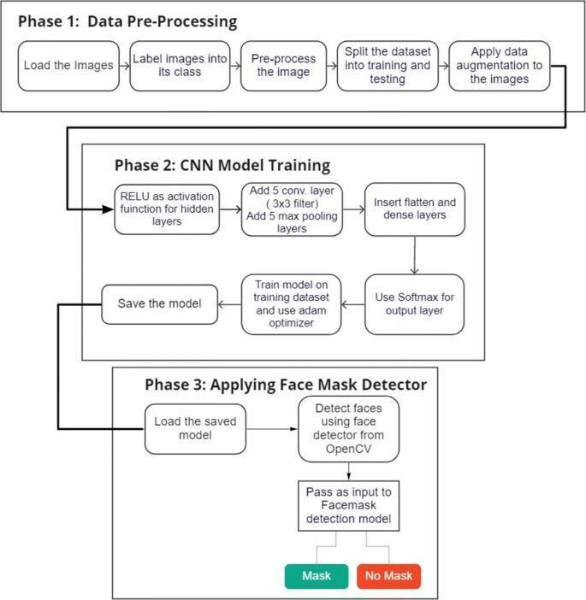

**Figure 1:** Architecture Diagram

1. **Output**



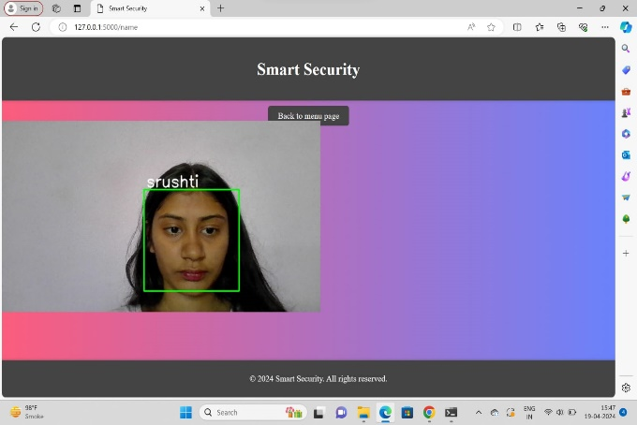

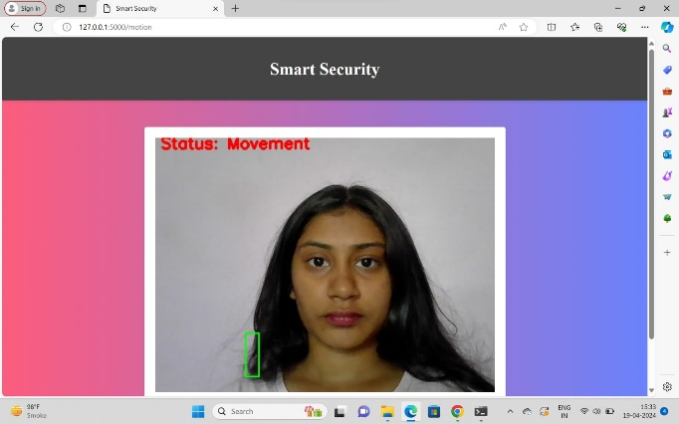

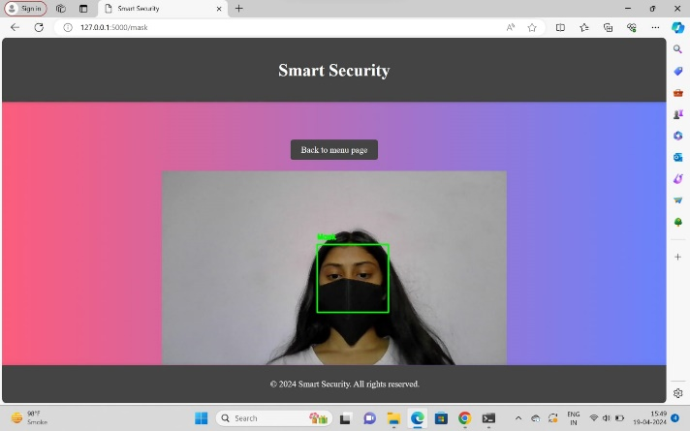

1. **CONCLUSION**

We can use this application to recognize a person. Face detection improves surveillance efforts and helps track down criminals and terrorists. Personal security is also enhanced since there is nothing for hackers to steal or change such as passwords easy to integrate. Smart surveillance system significantly contributes to situation awareness. Such systems transform video surveillance from data acquisition tool to information and intelligence acquisition systems. Real-time video analysis provides smart surveillance systems with the ability to react in real time. Our system senses the intrusion and sends notifications to authorized persons so that action can be taken in response to the intrusion. This web app can be live hosted on a server, a user interface can be made more user-friendly and more professional-looking, can add more useful features for making it commercially viable.

1. **REFERENCES**
2. -Time Face Mask Detection using OpenCV and DeepLearning, Department of ECE, KoneruLakshmaiah Education Foundation, Andhra Pradesh, India.
3. An Intelligent Motion Detection Using OpenCV. International Journal of Scientific Research in Science, Engineering and Technology Print ISSN: 2395-1990
4. Y. You, S. Gong, C. Liu, "Adaptive moving object detection algorithm based on back ground subtraction and motion estimation", Int. J. Advancements in Computing Technology, vol. 5, no. 6, pp. 357-363, 2013 Conference, WWW2019,2019.
5. 9M. Murshed, A. Ramirez, O. Chae, “Statistical Background Modeling: An Edge Segment Based Moving Object Detection Approach”, Proc. of IEEE International Conf. on Advanced Video and Signal Based Surveillance, pp. 300-305, 2010
6. Geethapriya. S, N. Duraimurugan, S.P. Chokkalingam, “Real-Time Object Detection with Yolo”, International Journal of Engineering and Advanced Technology (IJEAT) ISSN: 2249
   * 8958, Volume-8, Issue-3S, February 2019.
7. Marengoni and Stringhini. High Level Computer Vision using OpenCV. 2011. Universidade Presbiteriana Mackenzie.
8. Design a face recognition system, The 15th International Conference on Machine Design and Production June 19 – 22, 2012, Pamukkale, Denizli, Turkey.