**PERFORMANCE STUDIES OF HIGH STRENGTH FIBROUS CONCRETE PAVEMENT INCORPORATING WOLLASTONITE AND BASSAGE ASH**

***Vishnu MV1, Pardeep2***

*1Student, 2Assistant Professor*

*Sat Priya Group of Institutions, Rohtak*

***\*Corresponding Author***

***E-mail Id:- vishnumv1989@gmail.com***

***ABSTRACT***

Looking into the present era of road scenario in the developing countries like India, construction of rigid pavement is encouraging confidence of engineers due to its excellent riding surface and pleasing appearance. The life of cement concrete road pavements is much more than bituminous roads but unfortunately, due to its high initial cost it is not possible to construct all the roads with cement concrete, because cement is the major constituent which is used as a building material as well. Also concrete is weak in tension. So there is a need to look for the materials that can be used as partial replacement of cement and other ingredients of conventional concrete with improved mechanical properties of the concrete. These materials should fall under the category of low cost materials so that economy is maintained. The fusion of limestone with silica in the presence of hot magmas leads to the formation of wollastonite micro fiber, chemically known as calcium meta-silicate. Due to the presence of high amount of silica, wollastonite has the potential to be used as an admixture in concrete. Bagasse, an inexhaustibly delivered rural waste, is the build-up of sugarcane that is acquired after extraction of juice. The addition of bagasse ash to concrete improves compressive strength of concrete but contributes less to improve other properties like tensile strength, ductility. resistance to cracking etc. The present investigation has been aimed to determine the influence of wollastonite-bagasse ash combination on the strength of concrete to make economical and improved concrete pavement. In this study, wollastonite was used to replace cement by 5, 7.5, 10, 12.5, 15 and 17.5 percent while bagasse ash was used to replace 10 percent of sand of the control concrete. The hardened state properties that is compressive strength, split tensile strength and flexural strength of concrete were determined at 28 days. It was observed that the use of 12.5% wollastonite and 10% bagasse ash in concrete gives maximum flexural strength. It further shows that the combination of wollastonite and bagasse ash has a synergic effect on the enhancement of flexural strength. Thickness of rigid pavement has been calculated based on experimental value of flexural strength for control mix of M-40 grade without admixtures and the mix of concrete with admixtures and a reduction in thickness up-to 14% and cost wise with 13.6% was observed with respect to conventional concrete pavement.

***Keywords:-*** *wollastonite micro fibre, bassage, compressive strength, concrete pavement, mechanical properties*

**INTRODUCTION**

In a developing country like India, road network forms the arteries of the nation. Roads play a very important part in building up nation's infrastructure. The country's total road length is 4.24 million km at present. The present national highway system includes a total road length of 93,051 km, most of the national highways are constructed with flexible pavement due to its low cost initial investment. Construction and maintenance of roads, and the vehicles that move over them, consume large amounts of energy. This energy consumption results in atmospheric emissions, reduction of a non-renewable resource, and other environmental impacts. Any reduction of the lifetime energy use associated with roads, even if only by a small percentage, will have significantly positive implications for sustainable development.

Concrete pavements are used for sustainable development. Due to high initial cost of concrete pavement it is not generally adopted in India.

Although construction agencies, engineers are well aware of the fact that life cycle cost of concrete pavement is less than flexible pavement, but the initial cost of these pavements is high and are therefore not commonly adopted. On the other hand, studies have proved that trucks consumed less fuel on concrete pavements than on asphalt pavements, with a profound impact on highway life-cycle costs (Zaniewski, J.P., 1989).

Concrete is a widely used building material which can be used for the construction of bridge, piles, pavement and many more due to its high strength, durability, mouldability, and versatility. However, its low tensile strength is one of the major concern that really need to be addressed before using it in any structure especially in pavement. It has been found that with the advancement in the vehicular configuration and the introduction of heavy load vehicles pavements are likely to experience high flexural tensile stress under the influence of these heavy loads. Therefore, it becomes essential to increase the tensile strength of concrete and many attempts have already been made. One of the successful and the most commonly used method is providing steel reinforcement, but it is not economical. Fiber reinforcement can also be one of the solution to improve the tensile strength of concrete and it is also economical in comparison to the steel reinforcement. The main reasons for adding fibers to concrete matrix is to avoid the post-cracking i.e. to improve energy absorption capacity and apparent ductility, and to provide crack control and also helps to maintain structural integrity. As a matter of fact, the use of fibrous concrete comes up contributing to many benefits in pavement construction by reducing their thickness and surface layers on bridge and viaducts, less materials consumption and consequent minor environment impact by using less natural resources, decreasing the construction and repairing schedules, and increasing durability and service life, with lesser maintenance works and costs. An attempt has been made to improve the strength of concrete and from economic point of view also it would be beneficial if cost of concrete pavement is reduced.

TYPE OF PAVEMENTS

A highway pavement is a structure which consists of superimposed layers of processed materials above the natural soil sub-grade, whose main function is to distribute the applied vehicle loads to the sub-grade. The pavement structure should be able to provide a surface of acceptable riding quality, adequate skid resistance, favorable light reflecting characteristics. and low noise pollution. The ultimate aim is to ensure that the transmitted stresses due to wheel load are sufficiently reduced, so that they will not exceed bearing capacity of subgrade. Two type of pavements are generally recognized to this purpose, namely flexible pavements and rigid pavements. In flexible pavements, wheel loads are transferred by grain-to-grain contact of the aggregate through the granular structure. The flexible pavement, having negligible flexural strength, acts like a flexible sheet. On the contrary, in rigid pavements, wheel loads are transferred to sub-grade soil by flexural strength of the pavement and the pavement acts like a rigid sheet.

APPLICATION OF RIGID PAVEMENTS

Rigid pavements are so named because the pavement structure deflects very little under loading due to the high modulus of elasticity of their surface course. Rigid pavements have sufficient flexural strength to transmit the wheel load stresses to a wider area below. Compared to flexible pavement, rigid pavements are placed either directly on the subgrade or on single layer of granular or stabilized material.

A typical rigid pavement structure consists of the surface course and the underlying base and sub-base courses (if used). The surface course which is made of PQC, is the stiffest and provides the majority of strength. The underlying layers are less stiff, but still make important contribution to

pavement strength. Depending on conditions, engineers may design the pavement slab with plain, reinforced or pre-stressed concrete. Figure 1.1 and 1.2 show how the resulting beam action enables rigid pavement to distribute loads over large areas of the subgrade.

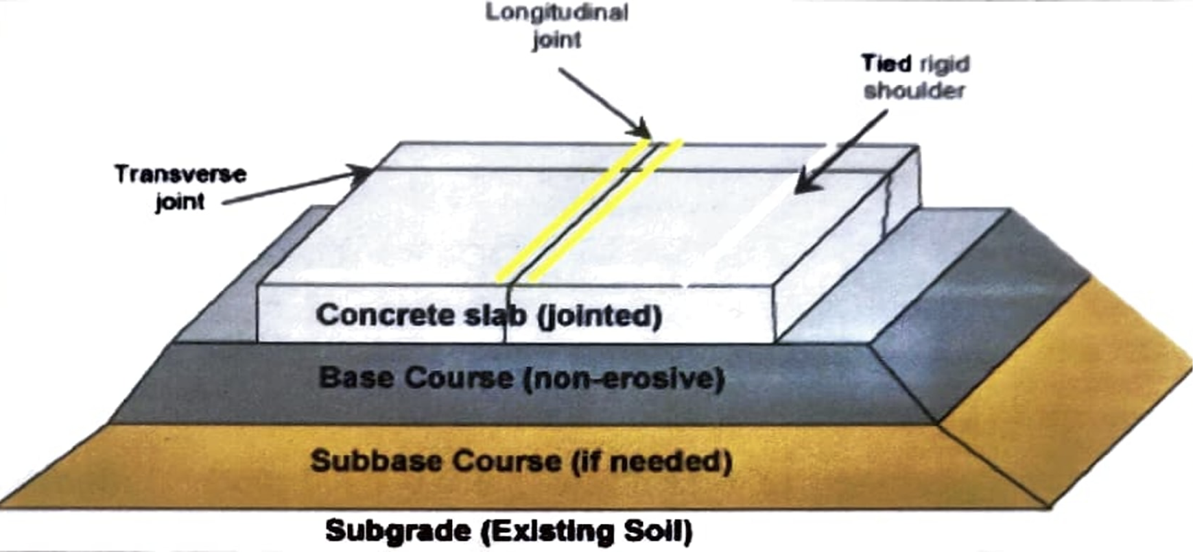

Fig. 1.1 Rigid Pavement Structure



Fig. 1.2 Beam Action of Rigid Pavement

Use of rigid pavement is expected to increase substantially over time but the production of concrete is not an environment friendly process because of its primary raw material i.e. cement. On one hand, cement offers excellent performance as binder in concrete, whereas on the other hand its manufacturing is an energy intensive process. Apart from consuming large amounts of energy, the production of cement also accounts for a significant portion of CO2 emissions and other greenhouse gases. Thus, finding waste materials that can act as substitute for raw materials of concrete, has become a necessity with time.

WOLLASTONITE MICRO FIBERS

Wollastonite is a micro fiber which is derived from natural mineral sources.

Wollastonite is named after the English chemist and mineralogist W. H. Wollaston (1766-1828). It is formed when impure lime stones aremetamorphosed (subjected to heat and presser) or silica bearing fluids are introduced into calcareous sediments during metamorphic processes. The simple metamorphic reaction between silica and calcium carbonate to form wollastonite as shown below occurs at about 600°C. The temperature required increases with depth (pressure).

SiO2 + CaOCO2 + CaOSiO2 → CO2

It is basically calcium meta silicate, available in 400 to 10 micron size and has aspect ratios of 3:1 to 20:1. Its particles usually have diameters in the same range of the cement particles, i.e. the fiber length is about 0.4 0.6 mm and occurs as prismatic crystals that break into massive to plate like fragments. Physically it occurs as bladed crystal masses, single crystal show an acicular particle shape and usually it exhibits a white colour, but sometimes cream. gray or very pale green. And its streak is of white colour. Its hardness on Mohs' scale is between 4.5-5 and specific gravity between 2.87 and 3.09. The melting point of wollastonite is about 1540°C.

As per the literature, different chemical composition of wollastonite was reported by Kalla P., et al. from various countries and it is being shown in

the Table 1.1.

The application of wallastonite as describes by Crooks, 1999, include its use in friction products (brakes and cluthes), ceramics, paints, metallurgy and plastics. Some of the properties that make it so useful are its high brightness and whiteness, low moisture and oil absorption, low volatile content. At present it is being used in numerous field for example adhessives, joint compounds, refractions, rubber, wallboard applications, floor tiles, friction products, insulating board and panels, paint, plastics and roofing products. It shows good resistant to chemical attack and stable at high temperatures. Wollastonite itself possess no cementitious properties, but when it reacts with calcium hydroxide in the presence of water it form compounds possessing cementitious properties. This property of Wollastonite helps in classifying it as a pozzolanic material. Some of the properties that make wollastonite so useful are its high brightness and whiteness, low moisture and oil absorption, and low volatile content. According to USGS, the larger reserves of wollastonite are in China, India, Australia. Finland, United States, Mexico, Spain and South Africa. Wolkem India Ltd., is the leading producers of wollastonite in the world, it was established in the year 1972.

Table 1.1 Chemical Composition (%) of Wollastonite from several countries

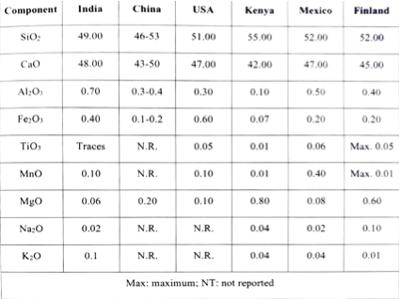

NEED FOR THE PRESENT STUDY

Flexible pavement, inherently built with weaker and less stiff material, does not spread loads like concrete. Therefore flexible pavements usually require more layers and greater thickness for optimally transmitting load to the subgrade. Combined strength of the layers is the major factor considered in the design of flexible pavements. A bitumen road with a rapidly deteriorating surface needs increasing amounts of maintenance if it is to continue serving its intended purpose. A bitumen road may require the patching of potholes, repair of eroded edges, and the sealing and repairing of cracked areas. Moreover, the cost of strengthening and reconstructing paved roads is considerably greater than the annual cost of routine, recurrent and periodic maintenance. Bituminous pavement do not serve the purpose, although the initial cost of these pavement is very less as compared with cement concrete pavements but when compared with maintenance and life cycle aspects cement concrete pavements are more economical. But due to high initial investment it is not possible to construct the total length of the road, because cement is the major constituent, which is used as a binding material in concrete ingredients, also it is costliest item among the concrete ingredients. So if adding a suitable admixtures without affecting the minimum strength requirement criteria reduces a certain percentage of cement content, it may be economical in the construction of rigid pavement. It may be even comparable with the cost of flexible pavements. So it's necessary to develop awareness towards this aspect between construction agencies and engineers. Thus, it is important to study the properties of concrete mixes along with combination of wollastonite and bagasse ash.

DISSERTATION TOPIC AND ITS IMPORTANCE

The research work is entitled as “Performance Studies of High Strength Fibrous Concrete Pavement Incorporating Wollastonite and Bagasse Ash”. The dissertation topic was selected to investigate the effect of Wollastonite and Bagasse ash on concrete for pavements that may lead to positive economic and environmental change in construction of roads.

Environmental Benefits

• Energy saving: Production of cement consumes a large amount of energy, the production of cement also accounts for a significant portion of CO; emissions and other greenhouse gases. Thus, wollastonite and bagasse ash can act as cleaner partial substitute for cement.

• Pollution control: By reducing the production of cement, pollution is also indirectly controlled. CPWD recognizes cement industry as one of the 17 most polluting industry.

Economic Benefits

• The cost of cement is increasing day by day. Partial replacement of cement with wollastonite will result in substantial reduction in cost of concrete.

• Reutilization of waste materials also helps in reducing the cost incurred in disposal of waste materials.

OBJECTIVES OF THE STUDY

The research work entitled as "Performance Studies of High Strength Fibrous Concrete Pavement Incorporating Wollastonite and Bagasse Ash" was initiated to investigate the influence of wollastonite-bagasse ash combination on the properties of concrete over a range of cement replacement. The main objectives of the present study are as follows:

• To study the Physical, chemical and structural properties of wollastonite,

bagasse ash, cement and aggregate used in the present study.

• To study the variation in compressive, flexural and split tensile strength with varying wollastonite content into concrete mixes.

• To find the optimum content of wollastonite and bagasse ash that can be used as replacement of concrete ingredients.



• To design the rigid pavement thickness using varying strength of concrete using combination of wollastonite and bagasse ash.



• To recommend reduced cost of construction by attaining the minimum strength requirement.



• To compare cost of concrete pavement without any additives and concrete pavement with wollastonite and bagasse ash combination.



• To study the benefits, if any, by adopting wollastonite and bagasse ash in concrete for rigid pavement.



SCOPE OF THE RESEARCH

The study has been undertaken to investigate the feasibility and effect of natural mineral fiber "Wollastonite" and industrial waste "Bagasse ash" on properties of concrete for rigid pavements. The study in this research work can be used to design a concrete mix for a concrete pavement in which cement and sand is replaced by wollastonite microfiber and bagasse ash respectively. The replacement of sand is constant as 10% by bagasse ash. Furthermore, the replacement of cement has been varied from 5%-17.5% in interval of 2.5%. The design of concrete mix has been done in accordance to IRC:44-2008" and it has been taken care of that the properties of design mix meets the requirements of the standard specification mentioned in IRC:15-2011". A concrete pavement has been designed in accordance to IRC:58-2015 for a given axle load spectrum.

**LITERATURE REVIEW**

The long-term performance of concrete infrastructures are associated with its mechanical strength and durability. The selection of proper ingredients and mix proportions are important to produce durable and economical concrete. In this chapter an introduction about the Wollastonite micro fiber (WMF) along with its application potential in cement concrete for the production of economical durable concrete has been described. In this chapter literature related to wollastonite and bagasse ash and their effect on properties of concrete was studied and important facts of related investigation are summarized.

HISTORICAL REVIEW OF WOLLASTONITE BLENDED CONCRETE

Preliminary investigation on use of wollastonite in cement concrete were reported in nineties (1992-1999), most of these studies were on cement composites. A review of literature pertaining to influence of wollastonite on strength, permeability and durability properties of concrete mixes have been reported in this sections.

Low and Beaudoin, (1993)18 studied the flexural strength characteristics of cement- wollastonite and cement-silica fume-wollastonite system reinforced with WMF between 2% to 15% by volume of cement. Results of flexural strength test as shown in Figure 2.1, shows a small increase in flexural strength as the hydration period increase from seven days to twenty eight days. A liner increase in flexural strength was observed when amount of wollastonite was increased from 2% to 11.5%. A maximum flexural strength in the composite system was observed when the mixture contained about 11.5% by volume of the WMF. However increase in the WMF in the cement matrix up to 15% by volume resulted in a slight reduction in the flexural strength of the composite system.

Low and Beaudoin, (1994) , further investigated the stability of Portland cement based binders reinforced with wollastonite, for hydration period up to one year. The composite systems were examined on a similar line to that of his earlier studies. Based on the experimental results obtained it was concluded that these fibres were relatively stable in cement composite systems and apparently unaffected by exposure to prolonged hydration in calcium hydroxide solution.

Fig. 2.1 Variation of Flexural Strength

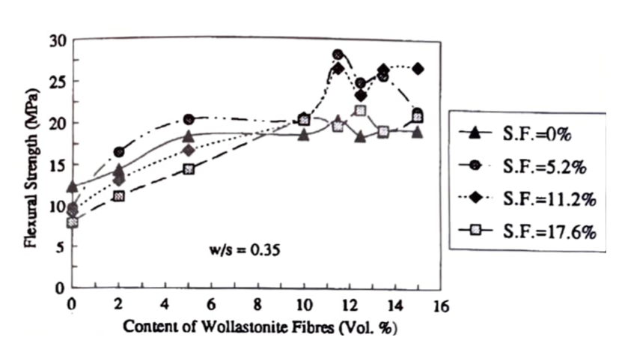

Deutschmann and sicker et al, (1997) ^ 26 investigated the ductility properties of high performance concrete by the change in the microstructure of cement matrix and the interfacial zone by mineral admixture such as wollastonite, polypropylene fibre, fly ash etc. The improved shape of stress- strain curve of concrete with above mentioned mineral admixtures in the region of maximum stress indicates modification in concrete microstructure.

CRRI. (2004)21 reported the application of wollastonite in concrete mixes as a partial replacement of cement, sand or both. Different wollastonite grades designated as A-60, H-3and H-3k with different aspect ratios were used. From the results of study it was evident that incorporation of wollastonite in concrete increases flexural strength. Mixes in which wollastonite was used as a partial substitute of sand (10% by weight) keeping the cement content same, the gain in flexural strength was between 9 to 10.5%. When 20% cement was replaced by fly ash and the total cementitious material was replaced by 10% wollastonite the gain in flexural strength was up to 12.7%. Strength properties of grade H-3k wollastonite were observed better as compared to other grades.

HISTORICAL REVIEW OF BAGASSE ASH BLENDED CONCRETE

Cordeiro et al. (2008)37 analyzed the physical-chemical impacts of a fine SCBA with broken quartz as a mineral expansion in mortars. They have chosen pound quartz since it is an inactive filler material of comparative packing density and molecule size to the SCBA. Both materials had a diluting effect on the mortars, reducing strengths when compared with control. mix. The strength of the mortars at 7 days showed no difference between the SCBA and the crushed quartz however, at 28 days, the SCBA showed an increment in strength, achieving 80% of the control mix, though the broken quartz mortar achieved 60% strength, hence the enhancement in strength with a low amorphous silica SCBA is from a combination of both filler and pozzolanic properties.

Chusilp et al. (2009)38 investigated the compressive strength, water permeability and thermal evaluation of concrete admixed with ground BA. Reduction in the maximum temperature rise by 13, 23, and 33% was observed by cement replacement by BA at 10, 20, and 30%. The maximum compressive strength 47.4 MPa was achieved, when 20% BA by weight of binder is used. By increasing BA replacement level, reduction in the permeability of concrete was observed.

Akram et al. (2009)4 investigated low cost self-compacting concrete by the

using BA as a viscosity modifying agent. By cost analysis results it was concluded that it is feasible to develop low cost self-compacting concrete by incorporating bagasse ash. Sales and Lima (2010)5 compared SCBA to an idle quartz sand, as a result of the high quartz substance and low pozzolanic movement. They researched SCBA as a fractional sand substitution in mortar and cement.

The SCBA was initially processed to fine sand, with a fineness modulus of 1.23-1.46 while the characteristic sand had a fineness modulus of 2.11. Mortars made with a fixed water to binder (W/B) ratio of 0.55 (by weight) and sand supplemented by SCBA in incremental amounts from 10 percent up to 100 percent by mass, had up to 25 percent increased compressive strength when SCBA supplemented sand aside from on account of the 100% SCBA mortar in which case the compressive strength was lower than controls. The workability of the mortars remained genuinely stable, again except for the 100% SCBA mortar in which case the workability reduced.

The optimum levels for SCBA replacing sand in mortars were 30% and 50% by mass. Concretes with sand replaced at 50% with SCBA, by mass, had 28-day strength 17.20% higher than controls and also improved elastic modulus. The workability of concretes as measured by the slump test, were marginally different from controls and all within the range of 60.00 mm to 80.00 mm. In conclusion, SCBA as partial sand replacement with cement- slag modified Portland cement produced concretes with a specified strength up to 30 MPa.

**CONCLUSION**

An extensive experimental study has been conducted to investigate the performance of high strength fibrous concrete pavement incorporating wollastonite and bagasse ash. In this study, fresh and hardened properties of concrete were analyzed after using wollastonite and bagasse ash as supplementary cementitious material by casting cubes, beams and cylinders. Also the thickness of concrete pavement was designed for varying strength of concrete and cost estimation was done in terms of material saving. This section comprises of the analysis of results and depiction of the conclusions.

The conclusions which can be obtained from the extensive study carried out to assess fresh and hardened properties of concrete incorporating wollastonite and bagasse ash based on the experimental analysis are as follow:

* The addition of wollastonite micro fibre with bagasse ash in concrete reduces the slump of concrete. The reduction in slump increases with increases in replacement level of cement by wollastonite.
* The strength properties of concrete such as compressive strength, flexural strength and splitting tensile strength has shown an upward trend up to 15% addition of wollastonite in combination with 10% bagasse ash. More than 15% addition of wollastonite micro fiber results in lowering the strength values. Thus the cement content in the construction of rigid pavement may be reduced to fifteen percent by weight of cement, by attaining minimum compressive strength criteria.

**REFERENCES**



1. Zaniewski, J.P ., "Effect of Pavement Surface T ype on Fuel Consumption", Portland Cement Association, Skokie, Illinois, 1998.

2. Kalla, P., Rana, A., Chad, Y.B., Misra, A. and Csetenyi, L., "Durability studies on concrete containing wollastonite". Journal of Cleaner Production, 2015, Vol.87, pp.726-734.

3. Crooks. A.F.. "Wollastonite in South Australia", Department. Primary

Industries and Resource, Adelaide, South Australia, Report book 99/00016, 1999.



4. Akram, T.. Memon, S.A., and Obaid, H., "Production of low cost self- compacting concrete using bagasse ash". Construction and Building Materials, 2009, Vol.23, pp.703-712.

5. Sales, A. and Lima, S.A.. "Use of Brazilian sugarcane bagasse ash in concrete as sand replacement. Waste Management, Use of Brazilian sugarcane bagasse ash in concrete as sand replacement, 2010, Vol.30, pp.1114-1122.

6. Rukzon, S., and Chindaprasirt, P., "Utilization of bagasse ash in high-

strength concrete". Materials & Design, 2012, Vol. 34, pp.45-50.

7. Montakarntiwong, K., Chusilp, N., Tangchirapat, W. and Jaturapitakkul, C... "Strength and heat evolution of concretes containing bagasse ash from thermal power plants in sugar industry". Materials & Design, 2013, Vol.49, pp.414-420.