**APPLICATION OF ZYCOSOIL IN BITUMINOUS MIX**

***Saurav Kumar1*, Pardeep2***

*1Student, 2Assistant Professor*

*Sat Priya Group of Institutions, Rohtak*

***\*Corresponding Author***

***E-mail Id:- sauravsingh962@gmail.com***

***ABSTRACT***

Rapid increase of urban population in India with rapid rise in industrialization needs high demand of vehicles. Road sectors are very important for the growth of economy, employments and empowerment of a country. India's road network with nearly 55 lakh Km road length is second largest road network in the world. About 98% roads are flexible in nature and rest 2% are rigid pavements. Approximately 40% roads are unpaved of total road lengths. The natural bitumen shows failure and serious problems during rainy seasons. Because of increasing traffic load in term of number of axles and high tyre pressure due to heavy vehicles the traffic related pavement distresses are found in the pavement. Stripping occurred because of moisture damage is considered as one of important pavement distress in bituminous pavement since 1990s. Moisture damage causes the stripping of pavement layer aggregate which is to be considered as a serious problem these days. Moisture damage is progressive loss of functionality of the materials because of that there is the loss of adhesion between bitumen binder and the aggregates, Zycosoil as an anti-stripping agent is used to provide the better adhesion bond between bitumen binder and the aggregates in the presence of water. The treatment and strengthening of bitumen is required to keep the pavement surface serviceable. Zycosoil, a Nano material recently used as an additive to strengthen the pavement surface and to improve the properties like penetration, ductility and moisture damage of pavement.

***Keywords:-*** *Zycosoil, bituminous pavement, stripping, bitumen binder, ductility*

**INTRODUCTION**

The rapid increase of urban population of India with the rapid rise in industrialization coupled with the high increase of road vehicles engaging in rapidly expanding cities to fit the developmental needs of the economy demands good quality of roads to meet the increasing pressure of road traffic. It becomes the responsibility of scientists, researchers, contractors to improve the riding quality while maintaining the economy for the country like ours. Bituminous Mixes are most commonly used in the world for the pavement construction. India has a road network of over 54 lakh kilometers as on March 2015, the second largest road network in the world. However, qualitatively India's roads are a mix of modern highways and narrow, unpaved roads, and are being improved. As on March 2015, 61% of Indian roads were paved. About 97 to 98% of the paved roads in India have flexible pavements, within which are included surfacing of various types and thickness. The complicated micro-structure of asphalt concrete is related to the gradation of aggregate, the properties of the aggregate and binder interface, the void size distribution, and the interconnectivity of voids. For important applications where traffic is extremely heavy, stiffer mixes are required. Keeping these facts in minds it was felt that efforts can be made to use some chemical additive in VG- 30 grade bitumen and study the various parameters of bitumen and bituminous mixes. Generally, 92 to 96% aggregate are used in bituminous concrete. Aggregate is also used for base and sub-base courses for both rigid and flexible pavements. Thus. aggregate plays an important role in the roads construction. The country like India, where massive construction is going on, and a huge quantity of aggregate is required every day either in building or in road construction, there are limited sources of stone and if the present condition continues, in near future, there will be shortage of aggregate for important constructional works. Hence the road developers need an additive which is used to improve the various properties of binder and bituminous mix so as to helpful in the construction of long life. The road industry is therefore looking forward for a materials and construction technology, which are environment friendly, energy efficient and cost effective for the construction and maintenance of roads. Zycosoil have been used as a construction material all over the world. Zycosoil is a very good anti striping additive and capable to increase the adhesion between asphalt binder and aggregates in presence of water. Asphalt concrete prepared with Zycosoil shows higher strength and stiffness of the mix. The addition of Zycosoil in bituminous mix increased the stability.

Research Topic and its Importance

The topic entitled "Application of Zycosoil in Bituminous Mixes" aims at determining and analyzing various parameters influenced by the addition of Zycosoil as an additive in the bituminous mix and also determines its effect on the properties of bitumen. Also stripping of aggregate is a major problem associated with the aggregates of pavement. Many times, it is experienced that stripping of aggregate takes place on the road even when laboratory test indicates no stripping. This is because of the field condition is different from laboratory condition.

As nowadays the increasing numbers of heavily traffic load vehicles need high strength sustaining pavement with very good flexibility and smoothness to facilitate appropriate vehicle movement. It is very important to control the problem of stripping as it is initiated with de-bonding and gradually leads to complete collapse of pavement. Such an acute problem may cause innumerous damage to the road. Bad condition of the road due to stripping creates various transportation problems like delay, congestion, increment in travel time and travel cost, maneuvering difficulties, socio- economic losses. Loss of lives in case of fatal accidents due to bad road condition must be taken into account because approximately 1.5% of road accident occurs due to the poor condition of the road.

The present study investigates the problem of different pavement distress caused due to moisture damage and to find out the various parameters which are enhanced by using Zycosoil.

Objectives of the Study

The objectives of the study "Application of Zycosoil in Bituminous Mixes" include the collection of different materials. A series of test as per IRC and IS code guideline to access the suitability of material for road construction.

The purpose of this study is to access the suitability of an additive named Zycosoil for bituminous concrete road construction. The main objectives of the study are followings:

• To study the various properties of selected material like gradation, water absorption, specific gravity, impact value, Los Angeles abrasion value.

• To study the various properties of bitumen like penetration value, softening point, ductility of VG-30 grade bitumen with and without Zycosoil and evaluate the effect of Zycosoil over bitumen.

• To find out the stripping value of aggregate by performing the stripping value test.

• To study the engineering properties such as Marshall Stability, flow value, density, air void, void filled with bitumen.

• To find out the Optimum Bitumen Content of the bituminous mix.

• To study the engineering properties such as Marshall Stability, flow value, density, air void, void filled with bitumen of bituminous mix modified with zycosoil additive at Optimum Bitumen Content.

Scope of the Study

The study has been conducted on VG-30 grade bitumen for different test with and without the chemical additive zycosoil and material used in the construction of bituminous concrete pavement construction. The aggregate material used for study is 10mm and 6mm size. For filler material stone dust is used and for binder material VG-30 grade bitumen is used. In this study, the additive used is zycosoil which is used to modify the various properties of bitumen and bituminous mix such as penetration value, ductility, softening point, Marshall Stability value, flow value etc. So various test is carried out on the selected materials. Marshall Test is performed on bituminous mix prepared for the bituminous concrete of grading-2 to evaluate different parameters.

**LITERATURE REVIEW**

A pavement is designed to support the wheel loads imposed on it from the moving traffic. Additional stresses are imposed by changes in the environment. Pavement should be strong enough to resist the stresses imposed on it. Pavement should be sufficient thick so that the stresses on different layers of the pavement due to wheel loads are within permissible limit. Based on structural behavior, pavements are generally classified into two categories, flexible pavements and rigid pavements. Flexible pavements have negligible flexural rigidity as compared to rigid pavement. Load is transfer by grain to grain transfer mechanism in flexible pavement. A typical flexible pavement consists of surface course, base course and sub-base course. Rigid pavements do possess high flexural rigidity. In rigid pavement load is transfer to the sub grade through slab action. A typical rigid pavement consists of base course and a cement concrete slab.

Damage of bituminous pavement due to moisture susceptibility is a problem that is experienced by most of the pavements. The dominant failure mode is separation of bitumen coating from the aggregate. This phenomenon is called as stripping. Stripping is mainly caused due to presence of moisture on the pavement and the deficient property of aggregate. The most serious consequence of stripping is loss of strength and integrity of the pavement.

Component of Flexible Pavements

In order to take maximum advantage, material layers are usually arranged in order of descending load bearing capacity with the highest load bearing capacity material on the top and the lowest load bearing capacity material on the bottom. The top surface is generally most expansive and the bottom surface is least expansive.

Surface Course

This layer is in contact with the traffic. It provides characteristics such as friction, smoothness, noise control. In addition, it prevents entrance of surface water into underlying base, sub base, and sub grade. This top structural layer of material is sometimes subdivided into two layers: the wearing course (top) and binder course (bottom).

Base Course

It is the layer immediately beneath the surface course. It provides additional load distribution and contributes to drainage and frost resistance. Base courses are usually WBM and WMM.

Sub-base Course

It is the layer between the base course and sub grade. Its prime function includes

• Minimize the intrusion of fines from sub grade into pavement structure

• Improve drainage

• Minimize frost action damage

Need for surface course

The bituminous surface, or wearing course, is made up of a mixture of various selected aggregates bound together with asphalt cement or other bituminous binders. This layer serves the following functions-

• To provide resistance against wear and tear due to traffic movements

• To provide smooth and dense riding surface to resist the pressure exerted by vehicle and to resist surface water infiltration

Literature Reviews

Some of the literature reviews are presented below-

Arabani et al., (2011) shows that granite is more susceptible to water as compared to lime stone because of higher free energy of adhesion in between granite aggregate and water as compared to lime stone and water. The WMA additive named sasobit and asphamin increases the moisture susceptibility by decreasing the adhesion between acidic aggregates. While on using Zycosoil as an anti-stripping agent it increases the surface free energy between aggregate and asphalt modified with WMA additive in the presence of water resulting to decrease the stripping. By using zycosoil as anti-stripping agents the dynamic modulus for wet/dry condition is increased shows better resistance to moisture damage in mixture with higher dynamic modulus value. Also, Zycosoil helps to decrease the surface area wetted by water by converting the hydrophilic silanol groups into molecular level hydrophobic siloxane (Si-O-Si) group.

Ameri et al., (2013) said that the anti-stripping additives named Zycosoil and hydrated lime slurry have more effect on the mix made with siliceous aggregate than mix made with lime stone. In the other result, the higher value of fracture energy of Zycosoil mixture in comparison to hydrated lime slurry mixture shows that the Zycosoil mix is more dominant to resist the moisture damage than hydrated lime slurry mix and it improves the adhesion bond between aggregates and bitumen binder. So, addition of Zycosoil improves the resistance to moisture damage of HMA mixture.

Khodaii et al., (2013) shows that Zycosoil decreases the difference between free energy for adhesion of asphalt-aggregate in the dry and wet condition which is considered as the amount of energy released for stripping resulting the mixture to become more resistive to moisture. Also, it decreases the rate of moisture damage by decreasing the difference between SFE of aggregate-asphalt and aggregate-water. Aggregate surface area exposed to water is also decreased after treating with Zycosoil. As the dynamic modulus ratio is increased for Zycosoil treated aggregate shows the decrease in moisture susceptibility of mixes.

Sarkar et al., (2014) stated that there is the shortage of stone aggregates in some parts of the country so there is a need to find out an optional material which can be used as aggregate in place of regularly used material so to fulfill this requirement the weak materials like over burnt bricks are used as a coarse aggregate in bituminous concrete pavement construction when it is treated with Zycosoil. As the over burnt bricks aggregates are water susceptible leads to the stripping of aggregates so anti-stripping additive Zycosoil is used to take care of this problem. The stripping percentage is decreased for both stone and over burnt brick aggregates after treating it with Zycosoil.

The optimum bitumen content is high in case of over burnt brick as compared to conventional mix because of higher porosity and roughness of over burnt brick. Stability value is increased by 30% in case of over burnt brick aggregates when it is treated by Zycosoil.

Behbahani et al., (2015) concluded that the mechanical property of glasphalt such as stiffness modulus which is increased and its permanent deformation is reduced due to improvement of bitumen stiffness by using Zycosoil in the mix. The mixture modified with Zycosoil has higher tensile strength resulting in the mixture to be capable to withstand larger tensile stress. Also, the increase in specific area of modified bitumen provides better adhesion between asphalt, glass cullet and aggregate and also the improvement in moisture susceptibility is observed. In this study, the 4.5% (by weight of bitumen) zycosoil improves the moisture susceptibility. So, the use of Zycosoil can enhances the cohesive strength in between glass cullet and aggregates.

Mirzababaei Peyman (2016) shows that the siliceous aggregate has greater affinity to water than asphalt shows more affinity of it towards the moisture damage. The type of aggregate and gradation both affects the functional properties of mix but type of aggregate has greater effect and it is suggested that do not use the siliceous aggregate without anti stripper because mix of only siliceous material does not satisfy the criteria ensuring the good performance against stripping.

**MATERIAL USED**

In this study, the various materials used to perform the experimental investigation to conclude their suitability are described with their requirements for bituminous concrete pavement construction.

Material Used

The material used in the test program includes-  
• Natural aggregates as a coarse and fine aggregate

• Stone dust as filler material

• Bitumen binder of VG-30 grade

• Zycosoil as an additive and

• Water

MATERIAL USED

General

In this study, the various materials used to perform the experimental investigation to conclude their suitability are described with their requirements for bituminous concrete pavement construction.

Material Used

The material used in the test program includes-

• Natural aggregates as a coarse and fine aggregate

• Stone dust as filler material

• Bitumen binder of VG-30 grade

• Zycosoil as an additive and

• Water

Aggregates

The aggregate used in the present study are of 10 mm and 6 mm size. Aggregates procured are from Yamuna Nagar quarries. The aggregates should have sufficient strength, toughness, hardness, specific gravity and desired shape. The limiting values of different test result for properties of coarse aggregate used for the preparation of bituminous concrete is specified by MoRTH. The aggregate should have superior mechanical and engineering properties to fulfill the requirement of long life pavement and to sustain the heavy traffic loads. As per MoRTH (2013) specification, the maximum Impact value, Los-Angeles abrasion value and water absorption value of aggregates for bituminous concrete should not exceed 30%, 40% and 2% respectively. Range of specific gravity should be 2.5 to 3.

Characteristics of Aggregate

Aggregate is an important constituent of bituminous concrete (BC) construction and for satisfactory performance, its requirements for cleanliness, free from impurities and particle size will depend on the purpose for which it is used. Aggregate form the major part of the pavement structure and it is the prime material used in pavement construction. The aggregate in the pavement are also subjected to impact due to moving wheel loads. Severe impact like hammering is quite common when heavily loaded vehicle moves on roads. The resistance to impact or toughness is hence another desirable property of aggregate.

The size of aggregate is identified by the size of sieve opening through which the same may pass. All the aggregate that happen to fall in a particular size range may not have the same strength and durability when compared with cubical, angular or rounded particles of the same stone. Too flaky and elongated aggregate should be avoided as far as possible as they can be crushed easily under load. Aggregate having angular shape is preferred in road construction works due to their better interlocking strength.

The desirable property of the aggregate may be summarized as follows:  
  
• Resistance to impact or toughness.

• Resistance to abrasion.

• Resistance to crushing.

• Good shape to avoid flaky and elongated particles of coarse aggregate.

• Good adhesion with bitumen materials in presence of water.

The required properties of aggregates depend upon the type of pavement construction, traffic and climatic conditions. All the above-mentioned properties need not necessarily be possessed for a particular construction.

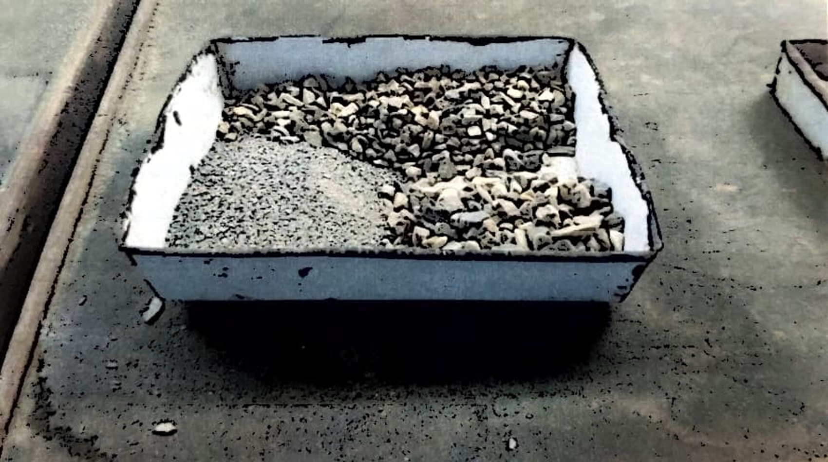

Fig. Aggregates and Filler used for testing

Fine aggregate

Here in this study stone dust is used as a fine aggregate which is obtained from local Kurukshetra market.

Bitumen Binder

Now days VG-30 viscous grade bitumen is used as binder in place of 60/70 penetration grade bitumen to take care of heavy traffic load of bituminous concrete pavement. It has excellent bonding and adhesion properties with aggregates. It resists moisture to a greater extent. In this study, the VG-30 grade bitumen is used for the analysis of bituminous concrete construction.

Water

Tap water, potable free from salt is used in test program.

Zycosoil as modifier

The chemical additive used as modifier in this study is Zycosoil. It is a Nano material (size 50-100 nm) water soluble organo-silicon fragment. As it has the property to function amine and hydrated lime to give Mother Nature's strongest bond which can't be uproot by water. It eliminates the de-bonding of bituminous mix and enhances the durability of bituminous pavement.

Table : Physical and Chemical properties of Zycosoil

|  |  |
| --- | --- |
| Typical Properties | Values |
| Physical State | Liquid |
| Colour | Pale yellow (colourless) |
| Flash point | 80°C |
| Density | 1.01-1.05 gm/ml |
| Viscosity (at 25 °C) | 0.2-0.8 Pa-s |
| Water solubility | Miscible with water |
| Explosive property | NA |
| Oxidizing property | NA |

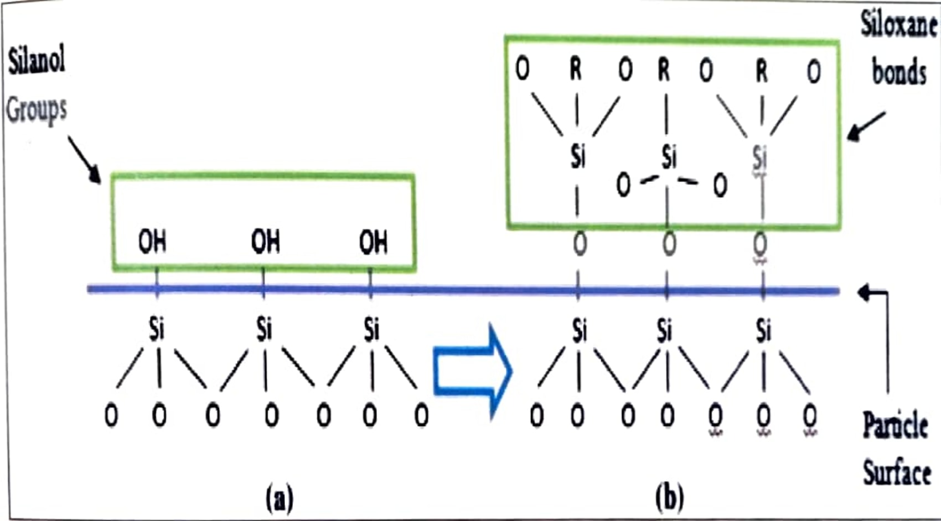

Fig.:(a) and (b) Soil and Aggregate structure before and after adding Zycosoil

From the above two figures mentioned the silanol group makes surface very hydrophilic (water loving) and after adding Zycosoil, it create molecular level hydrophobic zone (water repellent) by forming newly siloxane (Si-O-Si) bond.

There are some of the following benefits of Zycosoil are mentioned-

• It enhances the moisture and rut resistance

• It also improves the Marshall Stability and tensile strength ratio of mix, maintaining the flow value

• It provides higher compaction level

• It is non-corrosive unlike amines and lime

• It can be used in both modified and unmodified binder

• It makes the alkyl siloxane bond with the aggregate which have UV and heat resistive power.

**CONCLUSION**

The present study on the topic "Application of Zycosoil in Bituminous Mixes" has been carried out with a perspective to determine the effect of Zycosoil over bitumen and bituminous mixture for the bituminous concrete (grading-2) construction. Test has been carried out on aggregates and bitumen (VG-30). The chemical additive Zycosoil is used to determine its effect on bitumen and bituminous mix. Test results shows that the performance of bituminous mix is enhanced with the addition of Zycosoil as an additive. The chemically modified bituminous mix shows better performance than the conventional mix. The main conclusion drawn on the basis of test results are given below-

• Addition of 0.03% to 0.05% zycosoil increases the softening point of VG- 30 grade bitumen from 50°C to 52°C. It shows the decrease in the tendency to soften in hot weather which results in the increase in rutting resistance, load taking capacity, stability and durability of pavement.

• The penetration value of the VG-30 grade bitumen decreases from 68 to 57 units with the addition of 0.05% zycosoil.

**REFERENCES**

1. R. Khaloo and N. Kim, "Mechanical Properties of Normal to High- Strength Steel Fiber-Reinforced Concrete," Concrete and Aggregates, vol. 2, no. 18, pp. 92-97, 1996.
2. J. Thomas and A. Ramaswmy, "Mechanical Properties of Steel Fiber Reinforced Concrete," ASCE Journal of Materials in Civil Engineering, vol. 5, no. 19, pp. 385-392, 2007.
3. Aitcin, P.C. “The Art and Science of Durable High-performance Concrete.” ACI Conferences, pp. 69-88, 2003.
4. Baalbaki, W., Benmokrane, B., Chaallal, 0., Aitcin, P.C., “Influence of Coarse Aggregate on Elastic Properties of high performance concrete,” ACI Materials Journal, Vol. 88, No. 5, pp. 499-503,1999.
5. Lessard, M. Dallaire, E. Blouin, D., Aitcin, P.C, “High Performance Concrete Speeds Reconstruction of McDonald’s,” Concrete International, Vol. 16, No. 9, pp. 47-50,1994.
6. Mehta, P.K., and P.C. Aitcin. “Principles Underlying the Production of High- Performance Concrete.” Cement, Concrete and Aggregates Journal 12(2), pp. 70- 78, 1990.
7. Nilsen, A.U., Aitcin, P.C. “Properties of High-Strength Concrete Containing Light-, Normal–and Heavyweight Aggregate,” Cement, Concrete and Aggregates, Vol. 14, No.1, pp. 8-12,1992.
8. ACI 544, "Design Considerations for Steel Fiber Reinforced Concrete," ACU Journal Proceedings, vol. 1, no. 2003, pp. 1-23, 2003.