**ABSTRACT:**

Concrete is mixed, delivered, laid, compacted, and finished in the modern day. Even with meticulous attention to detail and a rigorous work schedule, occasional faults like honeycombing and voids in concrete can occur and intended results may not be reached. Thus, the new method known as SCC, or self-compaction concrete, takes the place of the conventional concerte. There is a notable improvement in the strength and workability qualities of SCC. Segregation resistance in self-compacting concrete is assessed by workability tests, including slump flow, V funnel, and L-Box tests.  
In the current work, 1%, 1.5%, and 2% of the cement weight is added to the concrete as nano-silica as a partial replacement.   
Adding nano-silica to cement concrete can significantly boost its compressive strength. The performance of concrete is improved when modest amounts of nano-Silica are used to partially replace cement, according to the results of the experiment. Small additions of nano-silica can increase compressive strength.

Keywords: Self Compacting Concrete, Flowability, Passing Ability, Nano Silica, Super Plasticizer.

INTRODUCTION:

An innovative concrete that may be placed and compacted without the need for vibration is called self-compacting concrete (SCC). Even in the midst of crowded reinforcement, it can flow under its own weight, fully filling formwork and attaining full compaction. The dense, uniform hardened concrete shares the same durability and engineering qualities as conventional vibrated concrete. By removing vibrating machinery, workers are exposed to less noise and vibration when working on and around construction and precast sites where concrete is being put. Despite all of its benefits—such as labor savings and expedited construction—SCC is still not extensively used in India.

The present work deals with addition of nano-silica to concrete as partial replacement to cement in dosages of 1%, 1.5%, and 2% by weight of cement. Based on early research, M25 grade concrete has been chosen for this work. The mix design was prepared using IS: 10262-2009 guidelines for concrete mix design proportioning. In the present work, 24 numbers of cube moulds and 12 numbers of cylinder moulds were casted with addition of nano-silica with different proportions, which are tested for compressive strength and split tensile strength. Addition of nano-silica to normal cement concrete show increase in compressive strength and decrease in splitting tensile strength.

**LITERATURE REVIEW:**

**M.C. Nataraja, Anvit Gadkar and Giridhar Jogin (2018)** developed a straightforward process to create self-compacting concrete by slightly altering IS 10262:2009 in accordance with the strength requirement. examined 25 mix proportions while taking into account the EFNARC's mandated limitations in order to determine the correlation between SCC's water cementitious ratio and compressive strength. Using a poly corboxilic ether-based high water reduction agent, compressive strength ranges of 20 MPa to 60 MPa were taken into consideration for this approach. It was found that the strength values between 25 and 60 MPa could be 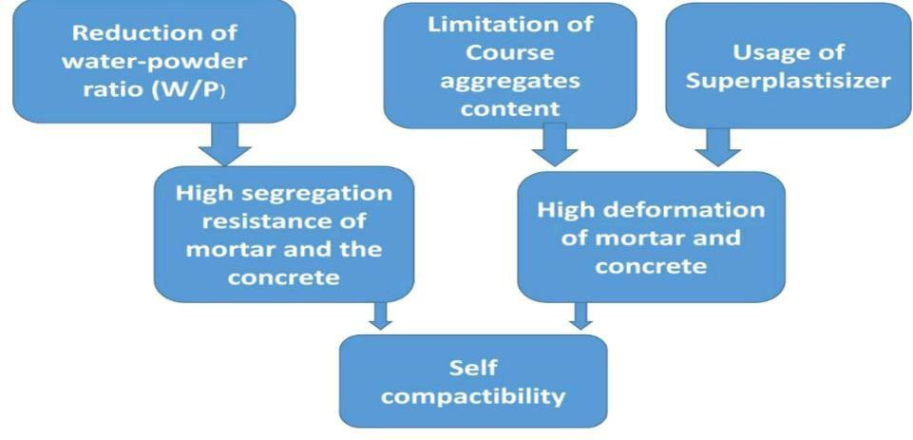obtained with w/c between 0.47 and 0.37. The approach produced fresh properties and strength findings that were in good accord.

**Athiyamaan. V & G. Mohan Ganesh (2018)** Trail mixes were created using the Design of Experiments method (DOE) and studies on SCC mix design were conducted using the Nan-Su method. The fundamental composite design of trail mixes was cultivated using the following variables: w/c, fine and coarse aggregate, cement, and superplasticizer. After 33 trail runs were examined, the M16 numbered combination produced the best outcomes. Additionally, it was shown that raising the fine aggregate will result in the highest packing factor, while decreasing the coarse aggregate from 750 kg/m3 to 710 kg/m3 increased the rheological characteristics but showed signals against the strength.

**M. Sri Rama Chand, P. Swamy Naga Ratna, K. L. Radhika, P. Rathish Kumar and C. Yedukondalu (2017)** looked into ways to get the specifications for self-compacting concrete by optimizing the proportions on the particle packing model. On concrete of grades M20, M40, and M60, three models were examined: the Modified Toufar method, the J.D. Dewar method, and the Compressible Packing Method (CPM). It was found that the percentage passing value of CPM corresponds with top limits of IS grading when particle packing methods MTM, JDDM, and CPM were used with IS 383 grading. With its coarser material, MTM and JDDM are unsuitable for SCC, but CPM-based optimization works well for creating SCC blends.

METHODOLOGY:

**Fig.1** Methodology to achieve self compactibility in concrete

RESULT AND DISCUSSIONS:

1. BASIC TEST ON MATERIALS:

* The fineness of cement is found to be 6%, Which is less than 10%
* Initial setting time of given cement sample is found to be 40 min & Final setting time as 10 hrs
* The percentage of water for normal consistency for the given sample of cement is 36%
* The specific gravity of the given cement sample is 3.92
* The given cement is found to be SOUND obtained by soundness test.
* Max passing value is found at the chemical dosage of 300ml by marsh cone test as 7sec
* Fine aggregate is allowed to pass through the 4.75mm sieve and retain on 150 microns sieve.
* Bulking of fine aggregate is 25.6%.
* Slump value for the given SCC sample is found to be 22cm for W/C ratio of 0.4, 17cm for W/C ratio of 0.5 & 15cm for W/C ratio of 0.6.
* J-ring value for the given SCC sample is found to be 7mm for W/C ratio of 0.4, 6mm for W/C ratio of 0.5 & 4mm for W/C ratio of 0.6.
* The time of the flow in V-funnel for SCC is found to be 8sec
* The time of flow of SCC in L-box is 1.7min.
* The passing value of SCC in U-box test is found to be 26cm.
* The flow table value of SCC is found to be max at 300ml chemical dosage as 102%

2. COMPRESSIVE STRENGTH TEST:

The compressive strengths of the casted specimens were determined by the compressive test machine and are tabulated as follows:

𝐶𝑜𝑚𝑝𝑟𝑒𝑠𝑠𝑖𝑣𝑒 𝑠𝑡𝑟𝑒𝑛𝑔𝑡**ℎ = (**𝑀𝑎𝑥𝑖𝑚𝑢𝑚𝑙𝑜𝑎𝑑**) /** (𝐶𝑟𝑜𝑠𝑠−𝑠𝑒𝑐𝑡𝑖𝑜𝑛𝑎𝑙 𝑎𝑟𝑒𝑎)

Plots of the data are shown, and it is easy to see how the characteristic compressive strengths have increased. It was shown that the compressive strength increased at a higher percentage rate after 7 days as opposed to 28 days. Therefore, it can be concluded from the results of the experimental inquiry that nano-silica also enhances early strength.

**Table 1 Compressive Strength Values**

|  |  |  |  |
| --- | --- | --- | --- |
| **S.No** | **Mix Designation** | **Characteristic Compressive Strength(N/mm2)** | |
| **7 Days** | **28 Days** |
| 1 | Nominal Concrete | 17.52 | 20.8 |
| 2 | SCC | 19.81 | 22.32 |
| 3 | SCC 2% NS | 21.30 | 23.12 |
| 4 | SCC 2.5% NS | 22.20 | 24.90 |
| 5 | SCC 3% NS | 21.40 | 24.50 |

30

24.924.5

25

21. 22.2 1.4

3 2

22.32

20.8

23.12

19.81

20 17.52

15

10

5

0

7 Days

28 Days

Nominal Concrete SCC(without NS) SCC with 2% NS SCC with 2.5% NS SCC with 3% NS

**Fig 2 Compressive Strength of Nominal Concrete, SCC without NS, SCC with 2% NS, SCC with 2.5% NS and SCC with 3% NS**

Nano silica reacts with calcium hydroxide (Ca(OH)2) to develop more of the strength carrying structure of cement: calcium silica hydrate (C-S-H). Hence there is an increase in the compressive strength in specimens in which cement is replaced by Nano-silica.

**Table 2** Percentage increase in Compressive Strength

|  |  |  |  |
| --- | --- | --- | --- |
| **S.No** | **Dosage of Nano –Silica (% by weight)** | **Percentage increase in**  **Characteristic Compressive Strength** | |
| **7 Days** | **28 Days** |
| 1 | 2% | 0.25 | 1.28 |
| 2 | 2.5% | 2.26 | 1.38 |
| 3 | 3% | 1.25 | 2.9 |

3. SPLIT TENSILE STRENGTH TEST:

It is the standard test, to determine the tensile strength of concrete in an indirect way. This test could be performed in accordance with IS: 5816-1970.

It can be observed that as the percentage of Nano-silica is increased, split tensile strength of concrete is also decreased. The split tensile strength of M20 grade controlled concrete is 3.306N/mm2.

**Table 3** Tensile strength of concrete

|  |  |  |
| --- | --- | --- |
| **S.No** | **Mix Designation** | **Tensile Strength**  **(N/mm2)** |
| 1 | SCC | 3.30 |
| 2 | SCC with NS 2% | 3.45 |
| 3 | SCC with NS 2.5% | 3.12 |
| 4 | SCC with NS 3% | 2.96 |

Tensile Strength

3.5

3.45

3.4

3.3

3.2

3.1

3.12

3

2.9

~~2.96~~

2.8

SCC SCC with 2% NS SCC with 2.5% NS SCC with 3% NS

**Fig 3 Tensile Strength of SCC and SCC with NS dosages**

**5. CONCLUSION:**

Based on the aforementioned experimental investigation, 2.5% substitution of Nano Silica is the ideal amount for M20 concrete. Adding Nano-silica to cement concrete can significantly boost its compressive strength. According to the experimental findings, using modest amounts of nano-silica to partially substitute cement improves concrete's performance. Small additions of nano-silica can increase compressive strength. The availability of more binder in the presence of nano-silica may be the cause of the increase in certain strength parameters of concrete containing nano-silica. The content of amorphous silicon dioxide in nano silica is high. During the hydration process, the Portland cement in concrete produces calcium hydroxide.

More binder material is created when the calcium hydroxide and nano silica combine. The presence of extra binder increases the paste-aggregate bond, which enhances the strength characteristics of concrete made with a nano-silica mixture.

The overall analysis indicates that the strength parameters of the mix are influenced by the micro structural behavior of the concrete. The behavior of the concrete's microstructure was altered by the addition of nanomaterials, which also affected the concrete mixes' compressive strength. The compressive strength test results showed that substituting concrete materials increases the strength of the resulting mixes somewhat.

* In comparison to normal, compressive strength rose by 0.25 and 1.28 percentage points for 7 and 28 days, respectively, when given a 2% NS dosage.
* With NS dosage of 2.5%, the percentage improvement in compressive strength over regular concrete is 2.26 for 7 days and 1.38 for 28 days.
* Comparing that to concrete with a 3% NS dosage, a similar percentage increase of 1.25 for 7 days and 2.9 for 28 days has been noted.
* Together with Nano-silica, the concrete's workability has declined.

**6. REFERENCE:**

1. EFNRC, specification and guidelines for self-compacting concrete, February 2002.
2. Jagadesh vengala and R.V Ranganath (August 2004), Mixture Proportioning Procedures For Self Compacting Concrete, Indian Concrete Journal.
3. P. Kumar Metha (June 1997) Concrete Microstructure, Properties and Materials, page no 381 to 393.
4. S. Nagataki (1995), Self-Compacting Property Of Highly Flowable Concrete, American Concrete Institute, sp 154 , page no. 301 to 304.
5. M. S. SHETTY Concrete Technology, by S. CHAND Publisher. EFNARC (www.efnarc.org)
6. SUBRAMNIAN. S. CHATTOPADHYAY. D. "Experiments for mix- proportioning of self-compacting concrete", The Indian Concrete Journal, Jan 2002.
7. C.Sivasanthosh, K.Porulselvi “Glass Fibre Insulated with self-Compacting Concrete” International Journal of Scientific Research in Science Engineering and Technology,2023 pg no: 16-26.