**A CHALLENGES FACED BY IMPORT AND EXPORT PROCESS OF AIR VASANTHAM CARGO**

*RAMU P*Dr.D. ANITHA KUMAR*

**\* RAMU P, MBA Shipping and logistics management, Vels Institute of Science and**

**Technology and Advanced Studies (VISTAS), Pallavaram, Chennai, Ramupalani1481@gmail.com**

**\*Corresponding Author: Dr.D. ANITHA KUMAR. Associate Professor, School Management studies, Vels Institute of Science and Technology and Advanced Studies (VISTAS), Pallavaram, Chennai,**

**I. ABSTRACT**

The import and export of air cargo face numerous challenges, including regulatory complexities, logistical constraints, security vulnerabilities, and coordination issues. Compliance with customs regulations, security protocols, and trade agreements is crucial for smooth operations. Airport congestion, limited infrastructure, and capacity constraints impede the flow of air cargo, increasing transit times and operational costs. The dynamic nature of global supply chains also presents coordination and communication challenges. Security threats, such as terrorism, theft, and smuggling, require robust measures and surveillance systems. Proactive measures include enhanced collaboration, infrastructure investment, and innovative technologies.

**II.INTRODUCTION**

Air cargo is a vital part of global trade, enabling the swift movement of goods across borders. However, it faces numerous challenges, including regulatory complexities and logistical bottlenecks. Proper documentation is crucial for customs clearance and compliance with import/export regulations. Customs authorities conduct thorough examinations of documentation and goods, ensuring compliance to avoid delays or penalties. Tariff classification and customs brokerage services help navigate clearance procedures. Compliance with regulations, including customs laws and security measures, is essential to avoid penalties and shipment delays. Security screening processes, like X-ray screening and physical inspection, prevent the transportation of prohibited or dangerous goods. Once clearance is obtained, airlines and freight forwarders manage transportation logistics to ensure safe delivery. Understanding and addressing these challenges is crucial for optimizing air cargo operations and ensuring seamless global trade.

**III.INDUSTRY PROFILE**

India's air cargo industry is a crucial part of the country's logistics sector, facilitating the movement of goods domestically and internationally to support economic growth. It comprises airlines, airports, freight forwarders, customs brokers, and logistics companies, forming a robust ecosystem for efficient transportation. Indian airlines like Air India Cargo, Spice Xpress, and Blue Dart Aviation offer cargo services, while airports like Delhi, Mumbai, and Chennai are vital hubs for air freight traffic. Freight forwarders and logistics companies provide end-to-end solutions, while customs brokers facilitate clearance. Despite challenges like infrastructure constraints and regulatory bottlenecks, ongoing investments, technological advancements, and policy reforms are expected to drive growth and innovation in the air cargo industry.

**IV.COMPANY PROFILE**

Vasantham Cargo Service Pvt. Ltd. was founded in 1997, to provide cargo, clearance, logistics, and travel services to customers with a personal touch.

To ensure that the customers’ delivery and quality focus are maintained at all costs, we develop dedicated and customised rethemes. The goal as a customer-focused cargo company is to meet customer expectations by offering high-performance solutions through cost-control, continuous technological up-gradation, and continuous development. In addition, we are committed to providing comprehensive global transportation solutions and custom value-added services. The services are provided door-to-door throughout the world. The cargo is always the top priority, regardless of whether you are a new or existing customer. The solutions are tailored to the business’s specific requirements, and we offer comprehensive and efficient services at very competitive prices.

**V. OBJECTIVE OF THE STUDY**

**PRIMARY OBJECTIVES**

A Challenge Faced by Import and Export process of air cargo at VASANTHAM CARGO SERVICES.

**SECONDARY OBJECTIVES:**

* To assess the role of customs house agent in the export and import process.
* To know the challenges faced during the time of customs house agent
* To identify the various problems faced by CHA while handling the goods
* To provide suggestion to overcome the challenges in CHA

#### 

**VI.NEED OF THE STUDY**

Logistics is a vital aspect of business operations, involving the planning, implementation, and control of goods, services, and information flow from origin to consumption. It optimizes supply chain processes, reduces costs, and enhances customer satisfaction. Efficient logistics offers a competitive advantage by enabling faster, cheaper, and higher-quality delivery. It also manages risks, promotes environmental sustainability, and integrates with technology to enhance supply chain efficiency, visibility, and decision-making. Globalization complicates logistics, necessitating effective global supply chain management.

**VII. SCOPE OF THE STUDY**

Air cargo studies analyse the transportation of goods by air, analysing operational dynamics, infrastructure, regulations, market trends, and technological advancements. They evaluate air cargo's role in global trade, supply chain management, and economic growth. Emerging trends like e-commerce, sustainable practices, and geopolitical factors are also explored. Supply chain management (SCM) involves understanding the end-to-end process of procuring raw materials, transforming them into finished products, and delivering them to customers. Transportation management determines efficient routes and carriers, inventory management optimizes levels, warehouse layouts, storage systems, and distribution networks, and risk management integrates sustainability and green logistics. Performance measurement and continuous improvement are crucial for enhancing efficiency and competitiveness.

**VIII.STATEMENT OF THE PROBLEM:**

Customs house agents (CHAs) are vital in facilitating import and export clearance procedures, but face challenges like changing regulatory environments, dealing with multiple nations with their own customs regulations, and ensuring accurate documentation. Inaccurate or incomplete documentation can lead to delays, inspections, or product seizure.

**IX.REVIEW OF LITERATURE**

The air cargo industry in India is vital for domestic and international trade, but it faces challenges such as long dwell times, ineffective customs clearance processes, and operational inefficiencies. These issues lead to increased costs, delays, and reduced productivity. To improve efficiency, research suggests strategies like implementing electronic technology like RFID, optimizing operations at ports and airports, and reengineering business processes. Understanding and addressing challenges faced by freight forwarding businesses is also crucial. Efficient warehouse design is also essential to meet high service standards and customer expectations. Addressing these challenges is crucial for India's air cargo industry's competitiveness and sustainability in the face of global trade demands.

**X.RESEARCH METHODOLOGY**

Research methodology is crucial in improving operational efficiency and effectiveness in supply chain transportation, inbound and outbound logistics, and return materials authorization (RMA). It involves methodical planning and execution of studies to investigate and enhance the movement of goods and materials along the supply chain. Various methodologies, such as case studies, questionnaires, interviews, and data analysis, can be employed to pinpoint issues, propose solutions, and streamline logistics procedures. A robust research methodology should include clear research questions, a comprehensive literature review, appropriate research design, robust data collection and analysis, and actionable recommendations. For air cargo import and export challenges, a comprehensive approach involving qualitative and quantitative methods is essential. Qualitative methods capture stakeholder perspectives, while quantitative methods quantify the prevalence and impact of these challenges across different regions and industries.

**XI.DATA ANALYSIS AND INTERPRETATION**

**Table NO1: Do you agree that understanding air freight documentation is crucial for successful shipping?**

|  |  |  |
| --- | --- | --- |
| **PARTICULARS** | **FREQUENCY** | **PERCENTAGES** |
| STRONGLY AGREE | 11 | 40.7% |
| AGREE | 14 | 51.9% |
| NEUTRAL | 0 | 0 |
| DISAGREE | 1 | 3.7% |
| STRONGLY DISAGREE | 1 | 3.7% |
| **TOTAL** | **27** | **100%** |

**CHART NO1: Do you agree that understanding air freight documentation is crucial for successful shipping?**

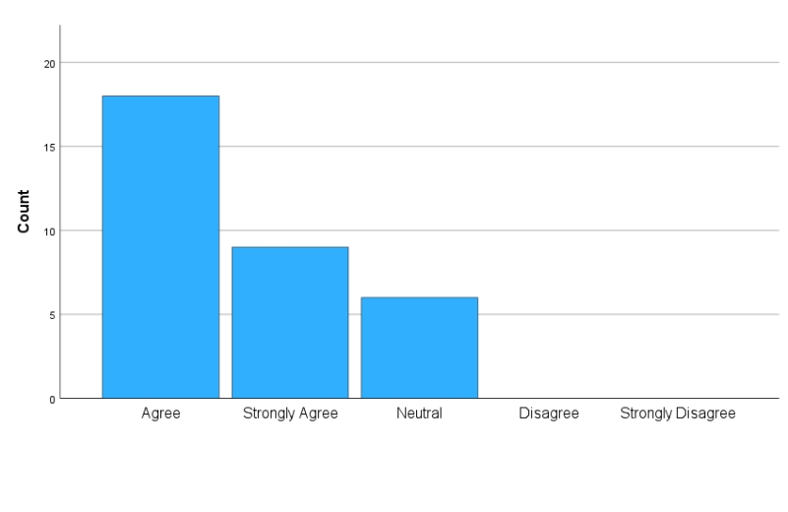

**INFERENCE:**

From the table and chart inferred that 51.9% of the respondents are Agree and 3.7 % of the respondents are from this Disagree air freight documentation is crucial for successful shipping.

**Table NO 2: Do you believe that learning about air freight documentation helps prevent shipping delays?**

|  |  |  |
| --- | --- | --- |
| **PARTICULARS** | **FREQUENCY** | **PERCENTAGES** |
| STRONGLY AGREE | 9 | 33.3% |
| AGREE | 14 | 51.9% |
| NEUTRAL | 4 | 14.8% |
| DISAGREE | 0 | 0 |
| STRONGLY DISAGREE | 0 | 0 |
| **TOTAL** | **27** | **100%** |

**CHART NO 2: Do you believe that learning about air freight documentation helps prevent shipping delays?**

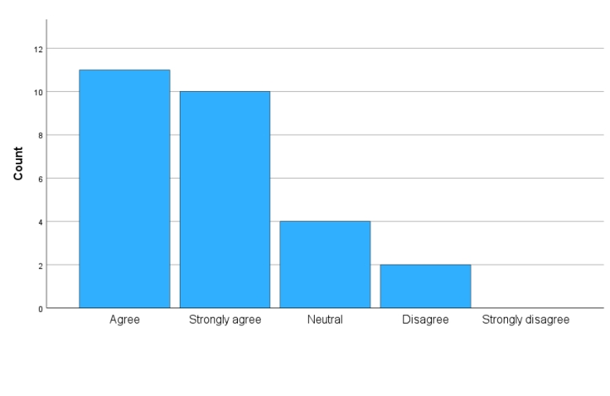

**INFERENCE:**

From the table and chart inferred that 51.9% of the respondents are Agree and 14.8% of the respondents are from this Disagree air freight documentation helps prevent shipping delays.

**Table NO 3: Do you agree that familiarity with air freight documentation reduces the risk of errors?**

|  |  |  |
| --- | --- | --- |
| **PARTICULARS** | **FREQUENCY** | **PERCENTAGES** |
| STRONGLY AGREE | 10 | 37% |
| AGREE | 11 | 40.7% |
| NEUTRAL | 4 | 14.8% |
| DISAGREE | 2 | 7.4% |
| STRONGLY DISAGREE | 0 | 0 |
| **TOTAL** | 27 | 100% |

**CHART NO 3: Do you agree that familiarity with air freight documentation reduces the risk of errors?**

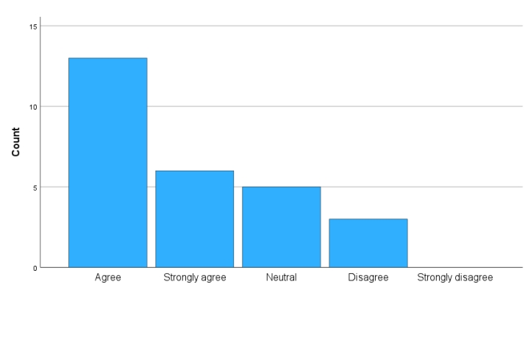

**INFERENCE:**

From the table and chart inferred that 40.7% of the respondents are Agree and 7.4% of the respondents are from this Disagree air freight documentation reduces the risk of errors.

**XII.FINDINGS OF THE STUDY**

* The majority of respondents 51.9%. AGREE. Do you agree that understanding air freight documentation is crucial for successful shipping?
* The majority of respondents 51.9%. STONGLY AGREE. Do you believe that learning about air freight documentation helps prevent shipping delays?
* The majority of respondents 40.7%. AGREE. Do you agree that familiarity with air freight documentation reduces the risk of errors?

**WEIGHTED AVERAGE METHOD:**

The weighted average for the statement is "yes", and most members agree for adequate notice for any changes in terms and conditions. This results in many members agreeing for the new terms and conditions. The majority of members are in favor of these changes, indicating a strong support for the new terms and conditions.

**CHI-SQUARE:**

There is no significant association between the customs duties and taxes are often unpredictable communication with customs officials can be challenging due to language barrier.

There is no significant association between creating a feedback mechanism for clients to rate and review CHA can help in improving service quality and enhancing communication channels between CHA and importers and exports can help in understanding requirements betters.

**CORRELATION:**

The willingness to adapt product offerings and marketing, as well as being aware of competitive advantages and challenges faced by customs clearance during import and export clearance, is crucial.

**XIII.SUGGESTIONS**

The study highlights customer dissatisfaction with current freight rates and suggests proactive measures to attract more business. Progressive's Freight Private Limited can streamline its documentation process by transitioning to a fully computerized system. The company should address existing transportation issues and provide product security to enhance its reputation. Implementing round-the-clock customer care services can boost satisfaction and retention. Utilizing top-tier social media and digital marketing tools can facilitate market expansion and better meet customer demands.

**XIV.CONCLUSION**

Air cargo import and export face challenges like complex customs regulations, fluctuating fuel prices, and outdated technology. These factors can cause delays, increased costs, and infrastructure constraints. Geopolitical tensions and regulatory changes can disrupt supply chains. However, leveraging technological advancements, forming strong partnerships with logistics providers, and staying updated on regulations can help mitigate risks and streamline the process. Proactively addressing these challenges can enhance global competitiveness and ensure smoother operations in the dynamic international trade landscape.