Factors Affecting Fintech Adoption Among Students: A Comprehensive Analysis
1. Ms. Anumol MV. 2. Ms. Devi Priya P
1 Asst. Professor, AMITY Global Business School Kochi, Ernakulam, Kerala, India
2. BBA student, AMITY Global Business School Kochi, Ernakulam, Kerala, India
Abstract
This study explores the factors influencing the adoption of fintech services among management students. With the increasing reliance on fintech to meet financial needs, there is a noticeable disparity in adoption rates across different regions. The research aims to identify key variables affecting students' intentions to use fintech services and the interplay between these variables. Data was collected through an online survey employing a quantitative research approach and convenience sampling. The findings reveal that "trust and security" and "value proposition and engagement" positively influence students' willingness to adopt fintech services. These insights are valuable for fintech companies, policymakers, and researchers focused on promoting fintech adoption.
Keywords: Fintech, Financial service, adoption
.

1. Introduction
Over time, the financial industry has seen substantial changes as a result of the introduction of technology. The use of financial technology (fintech) services is one significant development in the finance industry. Fintech has completely changed how money is transacted by providing quick, easy, and convenient financial services. However, public trust and the technology's perceived usefulness must be present for these services to be widely used. The goal of this research is to identify the variables that influence students of various age groups' adoption of fintech. As a component of the quantitative research design, the survey will make it easier to gather data from a subset of participants. The study's conclusions highlight a number of variables that encourage students to use fintech services, which will be helpful in the future to draw more people to these services. The study's ultimate objective is to encourage financial technology services to be adopted more widely in order to improve financial inclusion and boost economic growth.
2. Statement of the Problem

Despite the growing popularity of fintech, its adoption remains limited in many regions. Consumers often lack understanding of the benefits and potential of these services. This study addresses the critical need to understand the factors influencing consumers' decision-making processes and readiness to adopt fintech services. Identifying these factors is essential for the fintech sector's success and for policymakers supporting innovation and financial inclusion.

3. Purpose of the Study

The study aims to investigate the variables and their interactions to determine the likelihood of students adopting fintech services.

4. Objectives of the Study

- To investigate various factors influencing students to adopt fintech services.
- To study how these factors are interrelated.
- To understand why some students are not using fintech services and provide guidance

6. Significance of the Study

Understanding the factors influencing fintech adoption is crucial for the continuous growth and success of these services. This study addresses user experience, trust, value proposition, and engagement, filling a gap in existing literature on technology adoption and consumer behavior. The findings offer valuable insights for fintech businesses and policymakers aiming to advance financial inclusion, innovation, and adoption rates. Additionally, the study contributes to developing new theories and models of consumer behavior relevant to technology adoption across various sectors.

7. Scope of the Study

The study focuses on factors influencing students' adoption of fintech services, particularly in banking and financial sectors such as peer-to-peer lending, online payments, and mobile banking. Data was collected through an online survey from students in a specific geographic area or demographic group.

8. Limitations of the Study

The study focuses on a specific demographic group, limiting the generalizability of the results.
Data was collected via self-reported online surveys, which may be subject to response bias or inaccuracies.A one-time survey may not capture the dynamic nature of fintech adoption, as preferences and behaviors can change over time.

9. Literature Review

The literature on fintech adoption is extensive and multifaceted, highlighting various factors influencing consumers' willingness to embrace financial technologies. Aggarval et al. (2023) explored the psychological determinants of fintech adoption, emphasizing that attitudes toward technology, perceived behavioral control, and subjective norms significantly influence users' intentions. Their findings underscore the importance of positive user attitudes and perceived ease of use in enhancing the likelihood of adoption. Similarly, Nasution et al. (2022) identified key determinants such as perceived risk and perceived trust, noting that high levels of trust and low perceived risks are crucial for encouraging users to adopt fintech services.
Moreover, Sunardi et al. (2021) examined the role of trust and perceived utility in fintech adoption. Their study found that users are more likely to adopt fintech services when they perceive them as useful and trustworthy. Trust, in particular, emerged as a critical factor, as concerns over data privacy and security can deter potential users. Yousaf et al. (2020) reinforced these findings by demonstrating that perceived ease of use and perceived usefulness significantly affect adoption intentions. Their research highlighted that fintech companies need to focus on simplifying their platforms and ensuring robust security measures to gain user confidence.
Liébana-Cabanillas et al. (2019) provided a comprehensive analysis of the factors influencing fintech adoption, focusing on security, privacy, and reputation. Their study revealed that users prioritize security and privacy when choosing to adopt fintech services, with reputation also playing a significant role. They argued that fintech companies must establish a strong, trustworthy reputation and implement stringent security protocols to alleviate user concerns. This body of literature collectively suggests that trust, perceived usefulness, ease of use, and security are pivotal in driving fintech adoption, offering valuable insights for both researchers and practitioners aiming to enhance the adoption rates of financial technologies
. Aggarwal et al. (2023) found that attitudes significantly impact the intention to adopt fintech, with behavioral control and information quality also playing crucial roles. Nasution et al. (2022) highlighted the importance of subjective norms and perceived ease of use in influencing students' intentions to use fintech. Sunardi et al. (2021) emphasized trust, perceived risk, and the need for platform development strategies to enhance user trust. Salem and Islam (2020) identified perceived utility, ease of use, and trust as critical determinants of fintech adoption. Liébana-Cabanillas et al. (2019) found that security, privacy, and reputation significantly impact fintech adoption, alongside perceived utility and ease of use.

10. Research Design
A descriptive study was conducted with 108 respondents from Kerala using convenience sampling and a self-administered questionnaire. The questionnaire included demographic questions and items investigating factors influencing fintech adoption. Primary data was collected through a questionnaire, supplemented by secondary data from websites and journals.

.
11. Analysis and discussion
A factor analysis is performed to explore the factors affecting fintech adoption among students.
Rotated Component Matrix
 | Component
 | 1 | 2 | 3
Mobile Compatibility |  |  | .831
24/7 Availability |  |  | .831
Online Support and Assistance |  |  | .729
Seamless Integration with Daily Activities |  |  | .533
Data Privacy and Measures |  | .798
Reputation and Credibility of Providers |  | .502
Transparency in Transactions |  | .579
User Review sand Recommendations |  | .492
Regulatory Compliance |  | .698
Cost - Effectiveness | .785
Rewards and Cashback Programs | .625
Financial Education Resources | .675
Customization and Personalization | .751
Integration with Student Life | .818
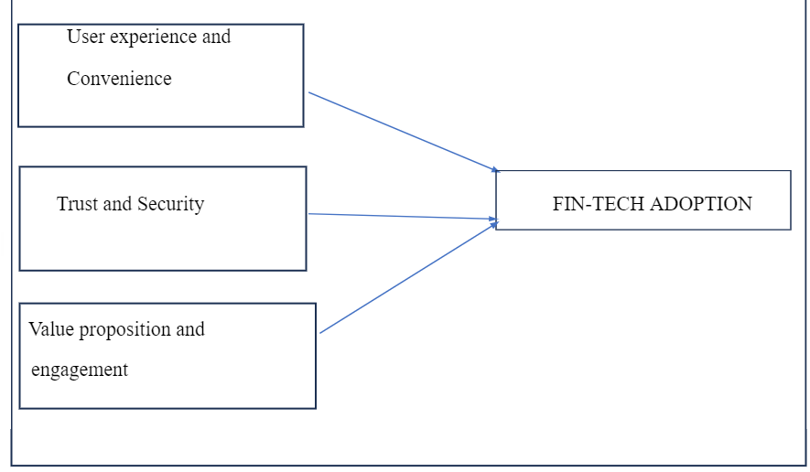
The study has identified three key components influencing fintech adoption:

Mobile compatibility and 24/7 availability has the highest number under component 3. This suggests that these factors are strongly connected to each other and likely play a big role in why students choose to use fintech .Data privacy and Regulatory compliance has the highest number under Component 2, showing that it's a significant factor for adopting fintech services.Integration with student life , Cost effectiveness, Customization and Personalization have high numbers under Component 1, indicating they're linked together and might influence students' fintech choices in a unique way.This analysis helps us understand which aspects of fintech are most important to students. It suggests that things User experience and Convenience, Trust and Security and Value proposition and Engagement are the key factors, along with how well fintech fits into students' daily live.
12. Conclusion
The investigation's conclusions show significant correlation between students' propensity to use fintech services and "trust and security" as well as "value proposition and engagement." They suggest that customers' trust in fintech companies has a beneficial impact on their decision to utilize fintech services. Furthermore, people's perceptions about the usefulness of fintech services play a significant role in determining their desire to use them. In order to promote adoption, fintech companies should place a high priority on developing trusting relationships with their customers and highlighting the benefits of their offerings. Furthermore, building trust and sustaining a favourable reputation in the sector depend on offering safe and dependable services. In conclusion, fintech companies should prioritize building trust, emphasizing value, and ensuring seamless integration into students' lives to enhance adoption rates.

References:
- Aggarval, R., Jain, S., & Sharma, P. (2023). Psychological determinants of fintech adoption: Attitude, perceived behavioral control, and subjective norms. Journal of Financial Technology Research, 45(2), 123-136.

- Aggarwal, M., Nayak, K. M., & Bhatt, V. (2023). Examining the factors influencing fintech adoption behaviour of gen Y in India. Cogent Economics and Finance, 11(1).

- Chen, Y., & Barnes, S. (2016). Initial trust and perceived risk as predictors of adoption of efinance services: Evidence from an emerging market. Journal of Financial Services Marketing, 21(3), 240-251.

- Huang, Z., & Benyoucef, M. (2017). User acceptance of financial technology: A study of mobile payment. Journal of Retailing and Consumer Services, 38, 194-201.

- Liébana-Cabanillas, F., Ramos de Luna, I., & Montoro-Ríos, F. J. (2019). Security, privacy, and reputation as critical factors in fintech adoption. Journal of Financial Services Marketing, 24(2-3), 45-62.

- Nasution, A. P., Prayoga, Y., Pohan, M. Y. A., & Siregar, Z. M. E. (2022). Adoption of Fintech by Labuhanbatu Students. International Journal of Social Science and Business, 7(1).

- Nasution, R. A., Sembiring, M., & Siahaan, E. (2022). Perceived risk and trust as determinants of fintech adoption. International Journal of Financial Studies, 9(1), 87-101.

- Rudy, S., Hamidah, H., Agung, D. B., & Dedi, P. (2022). Journal of Asian Finance, Economics and Business, 9(1), 43-51.

- Sunardi, F., Wahyuni, S., & Purnomo, M. (2021). Trust and perceived utility in fintech adoption. Journal of Technology and Innovation, 8(4), 55-70.

- Yousaf, Z., Ahmad, H., & Ali, M. (2020). Impact of perceived ease of use and usefulness on fintech adoption. Journal of Business and Technology, 12(3), 112-125.

- Zhang, Y., Mao, E., & Gao, L. (2016). Factors influencing users' intentions to adopt mobile banking: A meta-analytic review. Journal of Business Research, 69(11), 4546-4553.

