ARTIFICIAL INTELLIGENCE SMART COSMETIC SUGGESTION BASED ON SKIN CODITION

**Md. Naurez Alam, M Sanskar, Jay Kumar Yadav, Marapakula Madhu**

Head of Dept. of CSE , Sambhram Institute of Technology, Bengaluru Urban, Karnataka, India, Final Year Students, Dept. Of CSE, Sambhram Institute of Technology, Bengaluru Urban, Karnataka, India

# ABSTRACT

**These days, beauty and cosmetology are exceptionally basic to a person's look. People get to a collection of things through online shopping and ecommerce websites. It is very challenging to choose the right cosmetic for human skin. Given that each person contains a specific type of skin, choosing right cosmetics that suit the person may be annoying. The composition depends on skin type, which can be combination, dry, oily, or normal. Due to the significant crash that makeup have on a person's looks, the client must to choose the finest cosmetics for themselves based on person components. Identification of product that does not include any harms or allergies for the clients is very important. Thus the point of this application is to highlight the current applications of AI and machine learning in beautification and cosmetology by thorough examination of skin condition and prescribe personalized cosmetics based on the type of skin and buy secure things for the skin utilizing the Convolutional Neural Network (CNN). The objective is to achieve tall precision and recognize the skin type precisely.**

1. **Keywords**— Cosmetic, Skin type, Machine learning, Convolutional Neural Network.

# INTRODUCTION

**In recent years, the beauty and cosmetic items has experienced quick expansion that has resulted in increased client numbers as well as what is publicized. As a result of improvement in both clients and cosmetic items, choosing the foremost fabulous remedial cosmetic is troublesome. It is fundamental to choose the fitting remedial cosmetic for each individual based on person skin type, since correct cosmetic have a basic vital role in one's appearance. The skin type of a person is affected by qualities, in addition there would be any other exterior components like climate, genetics and can modify skin condition.**

**Based on the different skin characteristics, skin has been isolated based on their type broadly as normal, oily, dry, combination. It is of most remarkable significance for a person to know their skin type a few time as of late selecting a skin care plan. It is fundamental to know which kind of item would be reasonable for an individual, and hence, one need to be careful of their skin type. As plenty of skin care things being available these days in the publicize, people tend to go for the predominant things instead of going for a thing which is best suited to their skin type. In expansion the side impacts of utilizing a cosmetic which isn't suited to one skin can lead to serious skin issues.**

# METHODOLOGY

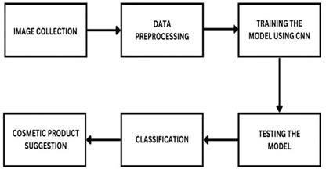

**Figure 1:** Methodology of Cosmetic Suggestion

* 1. Cosmetic Suggestion is a method of suggesting suitable products for the applicants’ skin condition by analyzing their skin condition.
  2. We propose a method of digital analysis of skin condition of the applicant with the help of Convolutional Neural Network algorithm.
  3. By analyzing their skin type, personalized cosmetic product is recommended to the applicants.
  4. Finally, the cosmetics combination is displayed in the output layer.

# MODELING AND ANALYSIS

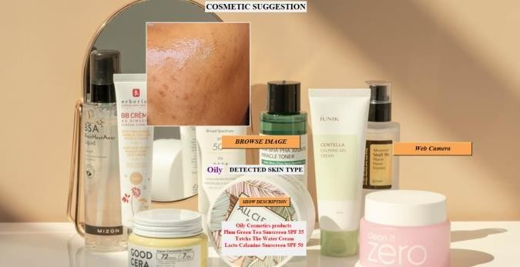

**Figure 2:** User Interface

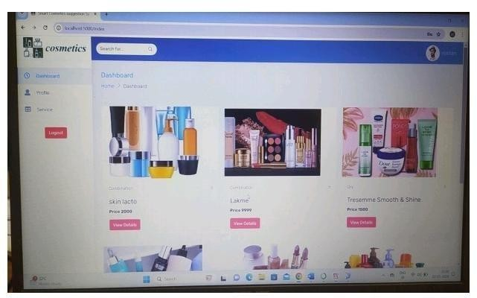

**Figure 3:** Products for Skin

**Enhanced Skin Analysis**: Improve the accuracy and depth of skin analysis by incorporating advanced computer vision algorithms. This could involve detecting and analyzing various aspects such as skin texture, hydration levels, pigmentation, and signs of aging.

**Personalized Recommendations**: Tailor cosmetic recommendations based on individual skin conditions identified through analysis. For example, if the system detects dry skin, it could suggest hydrating moisturizers or serums, while for oily skin, it might recommend oil-free products.

**Accessibility**: Make the system accessible to a wide range of users by ensuring compatibility with different devices and interfaces. Consider factors such as language support and user-friendly design.

**Education and Information**: Provide users with educational resources on skincare basics, common skin conditions, and ingredient knowledge.

**Ethical Considerations:** Pay attention to ethical considerations such as user privacy and data security. Ensure that user data is anonymized and protected, and obtain consent before collecting any personal information.

**User Feedback Loop**: Implement a feedback mechanism where users can provide input on the effectiveness of recommended products. This data can be used to refine the recommendation algorithms and improve future suggestions.

**Real -time Updates** : Keep the system up-to-date with the latest skincare trends, product releases, and scientific research. This ensures that recommendations are based on the most current information available.

# RESULTS AND DISCUSSION

The AI-based Smart Cosmetics Suggestion System leverages advanced technology to provide personalized recommendations tailored to individual skin conditions. By analyzing and understanding various aspects of the user's skin, such as texture, tone, and specific concerns like dryness or acne, the system generates precise suggestions for cosmetics products. This intelligent system takes into account a comprehensive range of factors, ensuring that the recommended products align with the user's unique needs. This innovative approach enhances the user experience by offering targeted solutions that cater to their skin's specific requirements, ultimately contributing to a more effective and satisfying cosmetic routine. The system's capability to adapt and respond to changes in the user's skin condition over time ensures ongoing relevance and optimal results.

# CONCLUSION

In conclusion, the development of an AI-based smart cosmetics suggestion system tailored to individual skin conditions marks a significant stride in the beauty industry. This innovative system harnesses the power of artificial intelligence to analyze and understand various skin conditions, providing personalized recommendations for cosmetic products. By integrating advanced algorithms, this technology ensures a precise and customized approach, taking into account factors such as skin type, tone, and specific concerns. This not only enhances the user experience by offering tailored solutions but also contributes to the overall effectiveness of skincare routines. The advent of such smart systems reflects a harmonious synergy between technology and beauty, revolutionizing how individual approach and engage with cosmetics to achieve optimal skincare results. As the beauty industry continues to embrace technological advancements, the AI-based smart cosmetics suggestion system stands out as a beacon of personalized and efficient skincare solutions, catering to the diverse needs of consumers.

# REFERENCES

1. Tingting Li, Ruihe Qian et al, “BeautyGAN: Instance-level Facial Makeup Transfer with Deep Generative Adversarial Network”, Multimedia (MM, 2018), ACM, 2018.
2. Songsri Tangsripairoj, Kwanchanok Khongson et al, “SkinProf: An Android Application for Smart

Cosmetic and Skincare Users”, International Joint Conference on Computer Science and Software Engineering, JCCSE, 2018.

1. Florian Strub, Romaric Gaudel et al, “Hybrid Recommender System based on Autoencoders”, DLRS ’16, September 15 2016, Boston, MA, USA, ACM, 2016.
2. Valeriy Gavrishchaka, Zhenyi Yang, Rebecca Miao, and Olga Senyukova. “Advantages of Hybrid

Deep Learning Frameworks in Applications with Limited Data”, International Journal of Machine Learning and Computing IJMLC, 2018.

1. Gediminas Adomavicius and Alexander Tuzhilin.“Toward the next generation of recommender systems: A survey of the state- of-the-art and possible extensions”. IEEE transactions on knowledge and data engineering 17, 6 (2005), 734–749.
2. Basiliyos Tilahun Betru, Charles Awono Onana, and Bernabe Batchakui. 2017. “Deep Learning Methods on Recommender System: A Survey of State-of-the-art”. International Journal of Computer Applications 162, 10 (Mar 2017).