**Analysis on Structural Behaviour of R.C Building by Using Software**

Ms. Shruti Randive**1**, Prof. Girish Sawai2 , Prof Mayur Bodane3

**1**M-Tech Scholar, Civil Engineering Department, V. M. Institute of Engineering and Technology, Nagpur

**2,3,** Assistant Professor, Civil Engineering Department, V. M. Institute of Engineering and Technology, Nagpur

***Abstract****:*

***During seismic action, building will deform in in-elastic zone, so its required evaluation which consider post-elastic behavior of structure. Performance based seismic design is a modern technique to earthquake resistance which can predict performance of structure using rigorous non-linear static analysis. Easy and most used method to evaluate performance of structure is non-linear static analysis widely known as pushover analysis. As name implies, it’s a process of pushing structure horizontally, with a prescribed loading pattern incrementally, i.e. "pushing structure & plotting total applied shear force & associated lateral displacement at each increment, until structure reaches a limit state or collapse condition". This project aims to analysis the structural behavior of multi-storey building by comparing the result of static and pushover analysis using Building Information Modeling (BIM) implementation. BIM is a complex process of new intelligent approach and process of maintaining all relevant information to a building over all phase of the building life cycle. It is used to improvement of process, predict outcomes and create computational representation of all building with less environmental impact.***

1. Introduction

The role of non-linear equivalent static (pushover) analyses is being more and more recognized as a practical tool for the evaluation of the seismic response of structures. During earthquakes, many concrete structures have been severely damaged or collapsed, has indicated need for seismic adequacy of existing building. One can't avoid future earthquakes, but safe building construction practices can surely reduce extent of damage and loss.

Performance based seismic engineering is the modern approach to earthquake resistance design. The objective of performance-based analysis is to produce structures with predictable seismic performance. The overall capacity of a structure depends on the strength and deformation capacity of the individual components of the structure. In order to determine capacities beyond the elastic limits, some form of nonlinear analysis, such as the pushover procedure, is required. Pushover analysis can be performed as force-controlled or displacement-controlled. In force-controlled pushover procedure, full load combination is applied as specified, i.e. force-controlled procedure should be used when the load is known (such as gravity loading). Pushover analysis has been the preferred method for seismic performance evaluation of structures by the major rehabilitation guidelines and codes because it is conceptually and computationally simple. Pushover analysis allows tracing the sequence of yielding and failure on member and structural level as well as the progress of overall capacity curve of the structure.

The area of interest where non-linear analysis is applied are as follows:

1. To analyse and design seismic retrofit solutions for existing buildings.
2. To assess the performance of buildings for specific owner requirement.
3. To analysis and design for new buildings.

Building Information Modelling (BIM) is a set of interacting policies, processes and technologies generating a “methodology to manage the essential building design and project data in digital format throughout the building's life-cycle”. As a key part in the project life cycle, contractors play an important role in making sure the project will be delivered on time and within the budget. BIM uses of Scheduling and Cost Estimating in BIM respectively and provides a case study to show how BIM can work for Architect. Engineer and contractor. Building Information Modelling (BIM) is an emerging technology throughout the world in the Architecture, Engineering, and Construction (AEC) industries. BIM technology provides users with accurate and consistent building/project data and information, accommodating the functions needed to model the building and provides a virtual view of it.

Autodesk Revit is a building information modelling software for architects, structural engineers, MEP engineers, designers and contractors. It allows user to design a building and structure and its components in 3D, annotate the model with 2D drafting elements, and access building information from the building model's database. Revit was intended to allow architects and other building professionals to design and document a building by creating a parametric three dimensional model that included both the geometry and non - geometric design and construction information, what later becomes known as Building Information Modelling or BIM.

1. **Literature Review**

The various literature review have been referred from journal, preceding books understand the present status of project undertaken, from this literature data is summarized for work. These are explained in following ways:

Komal Joshi, Asst. Prof. Urvesh Barot, Asst. Prof. Keyur Shah

- In recent years, an extensive examination going on performance of structure during a seismic event. During seismic action, building will deform in in-elastic zone, so its required evaluation which consider post-elastic behavior of structure. Performance based seismic design is a modern technique to earthquake resistance which can predict performance of structure using rigorous non-linear static analysis. Easy and most used method to evaluate performance of structure is non-linear static analysis widely known as pushover analysis. As name implies, it’s a process of pushing structure horizontally, with a prescribed loading pattern incrementally, i.e., "pushing" structure & plotting total applied shear force & associated lateral displacement at each increment, until structure reaches a limit state or collapse condition. It provides better understanding of seismic performance of building & also give identification of progression of damage and subsequently failure of building's structural element .By pushover analysis, One can get behavior of building in non-linear zone, which is not covered in conventional elastic design.

Dakshes J. Pambhar - Performance Based Seismic Engineering is the modern approach to earthquake resistant design. It is limit-states design extended to cover complex range of issues faced by earthquake engineers. Two typical new R.C.C. buildings were taken for analysis: G+4 and G+10 to cover the broader spectrum of low rise & high rise building construction. Different modeling issues were incorporated through nine model for G+4 building and G+10 building were; bare frame (without infill), having infill as membrane, replacing infill as a equivalent strut in previous model. All three conditions for 2×2, 3×3, 4×4 bays. Comparative study made for bare frame (without infill), having infill as membrane, replacing infill as a equivalent strut.

S.C.Pednekar1,H.S.Chore2,S.B.Patil3 - Seismic Assessment Using Pushover Analysis- Earthquakes have created serious damages to structures. The structure which are already built are vulnerable to future earthquake. This serious damage to structures can cause deaths, injuries with economic loss. There is an urgent need for seismic assessment of structure. Performance based seismic engineering is a simple and modern approach to earthquake resistance design to achieve desirable and predictable performance of structures. The concept of performance based seismic engineering is becoming future direction for seismic design codes. The present study gives an overview of past work done in this recently growing concept of performance based seismic assessment using non-liner static pushover analysis.

Shrikant Bhuskade - The case study shows that BIM does enhance the traditional scheduling and cost estimating methods with a more reliable and automated technology. Based on the reviews on BIM and the case study, the work finds out that there are three areas of potential development in the future: i) higher levels of detail (LOD) in BIM model will be available as BIM technology develops, ii) linking time and cost parameters concurrently to BIM components in the building model to deliver a scheduled financial analysis, and iii) allocation of resources on 4D BIM model to analyses and plan the resource usage based on the most updated design, and even simulate the resource allocation.

Guido Magenes - A method for the nonlinear static analysis of masonry buildings is presented, suitable for seismic assessment procedures based on pushover analyses. The method is based on an equivalent frame idealization of the structure, and on simplified constitutive laws for the structural elements. Applications on up to five storey structures are discussed, pointing out some issues regarding modeling hypotheses and calculated response. A possible use of the method in seismic assessment is presented. The procedure makes use of displacement response spectra and of the substitute structure approach which has been proposed by other authors for reinforced concrete structures. A simple example of the assessment procedure on a two-storey masonry structure is presented. Open questions and future developments are pointed out.

1. **Proposed Methodology**

Research is currently underway. Analysis will be done by using 2 & 3 Dimensional tools & technics model for different span arrangements. Pushover Analysis will applied and different loads such as Dead Load, Live Load, Wind load, Earthquake Load will be applied on STAAD or ETABS model at appropriate location as per codes used for Loading. Based on all calculations, Designs and results. We will creates a model (In Revit-Autodesk) and showing the actual visuals of site practices. That model can shows Clash Detection for each component of the building, Quantity takeoff, Construction schedules, Construction sequencing and Detailing of the model (Overall Project).

The area of interest where Pushover analysis with Building Information Modeling is applied are as follows:

* + Compliance to designs and building codes in BIM environment minimizes seismic effect damages.
  + Retrofitting of Earthquake Affected Infrastructure.
  + Fiber & Steel Columns and Base Isolation

Methods for Sustaining Seismic Vibration. Alternative technics for lateral system such as Eccentric base frame. BIM replace with higher performing system such as Buckling resistant base frame, which can more predictable & resilient performance during seismic event.

**Modeling**

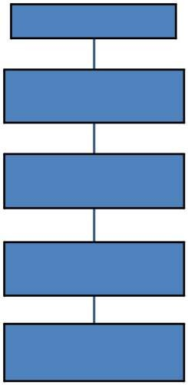

BIM & codes

Performance Based Design

Alternative Technology

Simulation Result For Seismic Events

Design Coordination And BIM Application

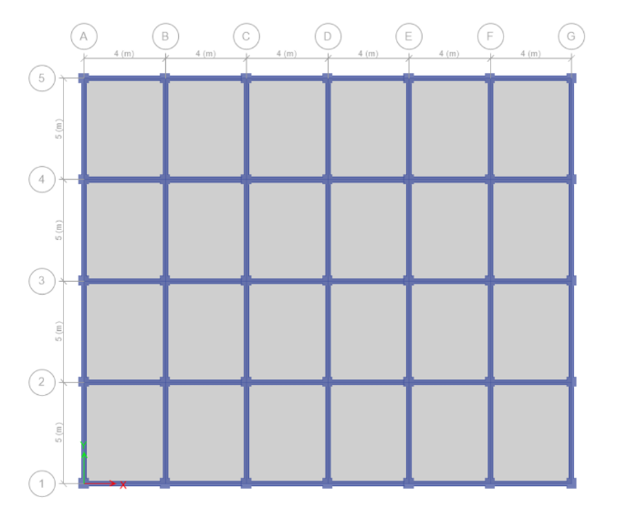Problem statement:- The building is analysed for G+10 multi storey R\C framed structure. Complete analysis is carried out for dead load, live load, wind load & seismic load using ETAB 2015. Response Spectrum Method of seismic analysis is used. All combinations are considered as per IS 1893:2002.

Fig. Floor Plan of G+10 RC framed structure

Above figure shows, floor Floor Plan of G+10 (multi story) RC framed structure.

The main aim and objectives of the model is to study as below:

* To study effect Static analysis
* To study effect Pushover analysis
* 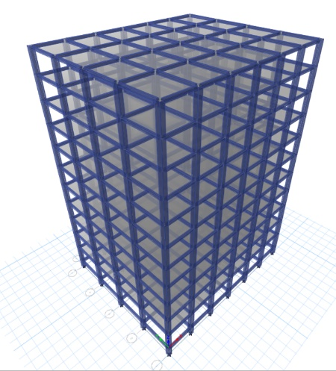To provide Building Information modeling (BIM) solution as per the comparison results of static and pushover analysis.

Fig. 3D view of G+10 RC framed structure

**Non Linear Analysis (Pushover Analysis)**

A pushover analysis can consist of more than one pushover load case. Each pushover load case can have a different distribution of load on the structure. For example, a typical pushover analysis might consist of three pushover load cases. The first would apply gravity load to the structure, the second would apply one distribution of lateral load over the height of the structure, and the third would apply another distribution of lateral load over the height of the structure. There are four different methods of describing the distribution of load on the structure for a pushover load case:

1. A uniform acceleration can be automatically applied. In that case, the lateral force automatically applied at each node is proportional to the mass tributary to that node.
2. A lateral force that is proportional to the product of a specified mode shape times its circular frequency squared (w2) times the mass tributary to a node can be automatically applied at each node. The user may specify the mode shape to be used in that instance.
3. An arbitrary static load pattern may be defined.
4. 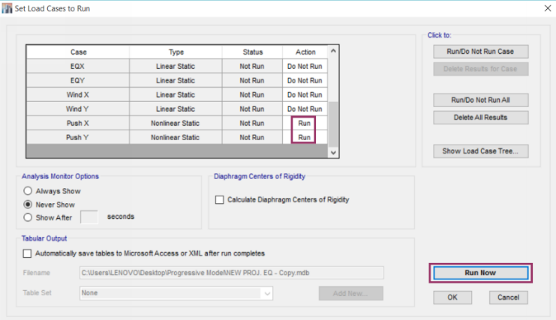Any of the methods described in 1, 2 and 3 can be combined.

**Fig : Run analysis for push X, push Y, Dead and live load cases**

**Results**

**Pushover Analysis**

**Table 5.1 Base Force Vs. Displacement pushover curve for RC frame structure with X and Y direction**

|  |  |  |  |  |  |  |  |  |  |  |  |  |
| --- | --- | --- | --- | --- | --- | --- | --- | --- | --- | --- | --- | --- |
| **Step** | **Monitored Displ.**  **mm** | **Base Force KN** | **A-B** | **B-C** | **C-D** | **D-E** | **>E** | **A-IO** | **IO-LS** | **LS-CP** | **>CP** | **Total** |
| 0 | 0 | 0 | 4464 | 0 | 0 | 0 | 0 | 4464 | 0 | 0 | 0 | 4464 |
| 1 | -39.62 | 1671.431 | 4436 | 28 | 0 | 0 | 0 | 4464 | 0 | 0 | 0 | 4464 |
| 2 | -93.263 | 3638.46 | 3696 | 768 | 0 | 0 | 0 | 4464 | 0 | 0 | 0 | 4464 |
| 3 | -172.437 | 5310.314 | 3286 | 1178 | 0 | 0 | 0 | 4300 | 120 | 0 | 44 | 4464 |
| 4 | -193.118 | 5544.974 | 3240 | 1224 | 0 | 0 | 0 | 4240 | 140 | 0 | 84 | 4464 |

Above Table shows base shear Vs. monitored displacement for RC structure. This value shows overall response of the structure against incremental loading. This load is increased monotonically until the failure occurs in the structure. As the loading is increased, a curve between the base shear and roof displacement is plotted. The curve is initially increasing linear but later begins to change from linearity as the components go through inelastic actions.

Comparison of Story Responses on Static and Pushover Analysis:

Table : Story Responses of Static Analysis.

Table 5.5 : Story Responses of Static Analysis

|  |  |  |  |  |
| --- | --- | --- | --- | --- |
| Story | Elevation | Location | X-Dir | Y-Dir |
| M | mm | mm |
| ROOF | 33 | Top | 2.30E-07 | 0.026 |
| 10 | 30 | Top | 4.10E-07 | 0.026 |
| 9 | 27 | Top | 3.49E-07 | 0.025 |
| 8 | 24 | Top | 3.37E-04 | 0.023 |
| 7 | 21 | Top | 3.14E-07 | 0.022 |
| 6 | 18 | Top | 2.87E-04 | 0.02 |
| 5 | 15 | Top | 2.57E-04 | 0.017 |
| 4 | 12 | Top | 2.22E-07 | 0.015 |
| 3 | 9 | Top | 1.95E-07 | 0.012 |
| 2 | 6 | Top | 4.60E-08 | 0.009 |
| 1 | 3 | Top | 7.79E-07 | 0.006 |
| P | 0 | Top | 8.80E-07 | 0.002 |
| Base | -1.5 | Top | 0 | 0 |

Fig : Story Responses of Static Analysis.

Above table and graph representing story Responses of Static Analysis based on maximum story displacement.

**Conclusion**

A brief review of several literatures presented shows that non- linear static analysis (pushover analysis) proves to be efficient method for studying the performance based analysis and for behaviour of structure in in-elastic zones. This method also gives the data about the sequence of damage of different elements of building with performance evaluation of structural system. It involves determination of performance levels and the estimation of the structural strength and deformation demands. Based on the analysis, Building Information Model are produced, the quantity take offs can be generated to provide cost estimations and overall scheduling on a construction project. In other words BIM provides time and cost savings and yields better quality construction products.

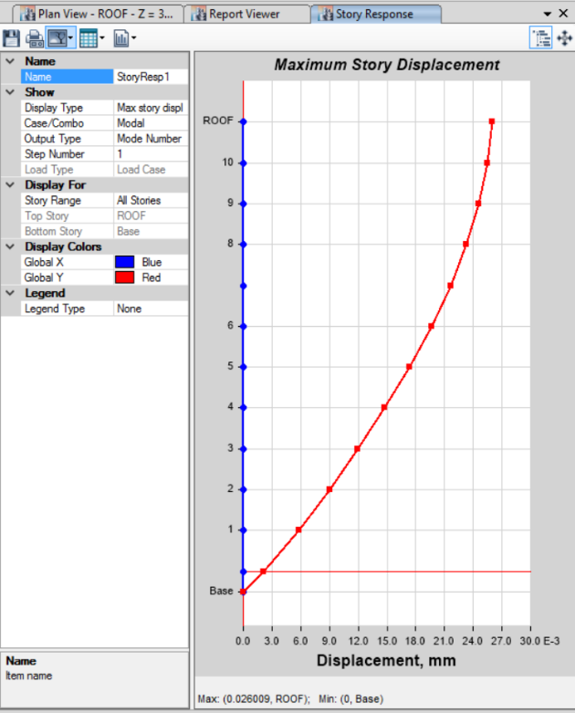As the construction industry continues to adopt BIM, the cost-savings benefit is undeniable. However, for designers, namely structural designers, to fully release the benefits of BIM, collaboration between modeling and analysis software must be enhanced. Additionally, new sets of tools for the evaluation of complex buildings under both static and dynamic loading will need to be developed to protect from the next seismic event. The ability to analyze discrete members, entire buildings, and individual connections within a single analysis package will increase the productivity of engineers. Finally, as the industry progresses into the next decade, having the ability to perform all of this analysis from within a single BIM model will become the new norm and will enable true performance-based earthquake engineering.

**Future Scope**

1. The study can be further extended to analysis of irregular RC building.
2. Analysis can be done by using software SAP 2000, STAAD- pro etc.
3. Analysis can be carried out using Time history method.
4. Comparison of Time history method and response spectrum method can be done.
5. Analysis can be doing with different soil conditions.
6. Analysis can be done with different ground slope.
7. Building Information Modeling can provide bill of Quantities for each structural elements
8. BIM by integration with sustainable analysis tools for business management such as feasibility studies, cost management, and life-cycle costing analysis.
9. **References**
10. *Komal Joshi, Asst. Prof. Urvesh Barot, Asst. Prof. Keyur Shah “Non-Linear Static Analysis (Pushover Analysis)”*
11. *Dakshes J. Pambhar “Performance Based Pushover Analysis of R.C.C Frames” - E-ISSN2249-8974*
12. *Shrikant Bhuskade “Building Information Modeling (BIM)”- E-ISSN: 2395-0056*
13. *S.C.Pednekar1, H.S.Chore2, S.B.Patil3 “Seismic Assessment Using Pushover Analysis”*
14. *Guido Magenes “A Method For Pushover Analysis In Seismic Assessment Of Masonry Buildings”*
15. *Mehmet F. Hergunsel “Benefits of building information modelling for construction manager and BIM based scheduling”*
16. *Komal Joshi, Asst. Prof. Urvesh Barot, Asst. Prof. Keyur Shah “Non-Linear Static Analysis (Pushover Analysis)” International Journal of Advanced Research in Engineering, Science & Management, ISSN:2394-1766.*
17. *Dakshes J. Pambhar “Performance Based Pushover Analysis of R.C.C Frames” International Journal of Advanced Engineering Research and Studies, E-ISSN2249-8974.*
18. *Shrikant Bhuskade “Building Information Modeling (BIM)” International Research Journal of Engineering and Technology (IRJET), E-ISSN: 2395-0056*
19. *S.C.Pednekar1, H.S.Chore2, S.B.Patil3 “Seismic Assessment Using Pushover Analysis” International Journal of Pure And Applied Research in engineering And Technology, ISSN: 2319-507X.*
20. *Guido Magenes “A Method For Pushover Analysis In Seismic Assessment Of Masonry Buildings”**Department of Structural Mechanics, University of Pavia.*
21. *Jenish M Mistry1, Chintan Khatri2, Anuj.K.Chandiwala3 “A Review on Performance Based Design of Multi Story Building” International Journal of Advance Engineering and Research Development, E-ISSN (O): 2348-4470*
22. *Jenish M Mistry1, Chintan Khatri2, Anuj.K.Chandiwala3 “A Review on Performance Based Design of Multi Story Building” International Journal of Advance Engineering and Research Development, E-ISSN (O): 2348-4470*
23. Polupalli Victor Paul1, K Sampath Kumar2” Non- Linear Static Pushover Analysis For Multi-Stored Building B Using ETABS” International Journal of Advanced Technology in Engineering And Science. ISSN: 2348-7550.
24. Neethu K. N.1, Saji K. P.2” Pushover Analysis of RC Building” International Journal of Science and Research (IJSR), ISSN (Online): 2319-7064.
25. Dona Mary Daniel, Shemin T. John” Pushover Analysis of RC Building” International Journal of Scientific & Engineering Research, Volume 7, Issue 10, ISSN 2229-5518.
26. Jaya Prakash Kadali1, M.K.M.V.Ratnam2” Static Analysis of Multistoreyed RC Buildings By Using Pushover Methodology” International Journal for Innovative Research in Science & Technology| Volume 1 | Issue 8 | January 2015 ISSN (online): 2349-6010.

1. Sunil Dhananja Rahod1, Swati Sham Bhokare2” Comparative Pushover Analysis of RCC, Steel And Composite High Rise Building Frame (G+11) By Using ETABS”, Journal Of Information, Knowledge And Research In Civil Engineering ISSN: 0975 – 6744.
2. E. Hassaballa1, M. A. Ismaeil2, A. N. Alzead3, Fathelrahman M. Adam4” Pushover Analysis of Existing 4 Storey RC Flat Slab Building” International Journal of Sciences: Basic and Applied Research (IJSBAR), ISSN 2307-4531.
3. Yousuf Dinar1, Md. Imam Hossain2, Rajib Kumar Biswas2, Md. Masud Rana3” Descriptive Study of Pushover Analysis in RCC Structures of Rigid Joint” IOSR Journal of Mechanical and Civil Engineering (IOSR-JMCE) e-ISSN: 2278-1684, p-ISSN: 2320-334X, Volume 11, Issue 1 Ver. II (Jan. 2014), PP 60-68.
4. Armagan Korkmaz1, Mustafa Duzgun2” Evalution Of Different Pushover Analysis for R\C Frame Structures” Joint International Conference on Computing and Decision Making in Civil and Building Engineering.