**“IPL STATUS IN INDIA”**

Anuj Singh*, Ayush Mishra*, Associate Professor Dr. Tej Singh

School of Finance & Commerce, Galgotias University

**ABSTRACT**

The Indian Premier League (IPL) has not only captured the imagination of cricket aficionados but has also emerged as a juggernaut in the realm of sports entertainment, boasting unprecedented viewership figures and lucrative financial gains. Since its inception in 2008, the IPL has witnessed a meteoric rise, cementing its status as the premier T20 league worldwide. Cricket, deeply ingrained in the fabric of Indian culture, enjoys unparalleled popularity, with a fanbase that transcends geographical boundaries. The allure of the IPL lies in its fast-paced and electrifying 20-over format, where every ball holds the potential to swing the tide of the game. Against this backdrop, a comprehensive exploratory data analysis of the 2024 IPL dataset was conducted, unveiling a plethora of insights that promise to revolutionize the sport's landscape.

The IPL's evolution into a global phenomenon underscores its ability to adapt and innovate, continually pushing the boundaries of sporting entertainment. With each passing season, the league has witnessed a surge in competitiveness, fueled by the relentless pursuit of excellence by players and franchises alike. The data analysis sheds light on strategic nuances and performance trends, empowering teams to make informed decisions and optimize their gameplay strategies.

Furthermore, the IPL serves as a breeding ground for talent, providing a platform for budding cricketers to showcase their skills on a grand stage. The data analysis uncovers emerging talent and identifies players poised for stardom, facilitating the nurturing and development of future cricketing stars. Additionally, the insights gleaned from the dataset pave the way for innovations in player management and training methodologies, ensuring sustained success for franchises in the long run.

Moreover, the IPL's impact extends beyond the realm of sports, serving as a catalyst for economic growth and social development. The league's immense popularity drives substantial investments in infrastructure, tourism, and hospitality sectors, contributing to the overall prosperity of host cities and regions. Furthermore, the IPL fosters a sense of camaraderie and unity among diverse communities, transcending cultural and linguistic barriers through the shared love for cricket.

In essence, the IPL embodies the spirit of innovation, competition, and camaraderie, captivating audiences worldwide and redefining the landscape of professional sports. Through meticulous data analysis and strategic insights, the league continues to elevate the standards of cricketing excellence, promising an exhilarating spectacle for fans and stakeholders alike in the years to come.

**INTRODUCTION**

The Indian Premier League (IPL) stands as a testament to the intersection of sports, entertainment, and commerce. Since its inception in 2008, the IPL has evolved into one of the most prestigious and lucrative cricket leagues globally, captivating audiences with its blend of sporting prowess and glitzy spectacle. However, beyond the boundary lines, the IPL wields significant socio-economic influence, shaping not only the landscape of Indian cricket but also impacting various facets of Indian society.

This research endeavors to delve into the multifaceted dimensions of the IPL's status in India, exploring its societal, economic, and cultural ramifications. With its unparalleled popularity and widespread viewership, the IPL has become ingrained in the social fabric of the nation, transcending geographical, linguistic, and cultural barriers. Understanding the implications of the IPL extends beyond the realm of sports analysis; it offers insights into consumer behavior, media dynamics, urban development, and cultural identity.

At the heart of this inquiry lies an exploration of how the IPL has transformed cricket into a year-round extravaganza, redefining traditional notions of sports seasons and player allegiances. Moreover, the league's commercial success and its symbiotic relationship with advertisers, broadcasters, and franchise owners have fueled debates surrounding its economic impact, player remuneration, and the commodification of sports talent.

Furthermore, the IPL serves as a platform for nurturing young talent, fostering grassroots cricket initiatives, and promoting inclusivity in a sport often associated with elitism. Its influence extends beyond the cricketing fraternity, permeating popular culture through celebrity endorsements, music, and fashion, thereby shaping contemporary narratives of Indian identity and aspiration.

As we embark on this exploration of the IPL's status in India, it becomes evident that the league represents more than just a sporting spectacle; it embodies the aspirations, contradictions, and dynamism of modern Indian society. Through a comprehensive analysis, this research aims to shed light on the intricate interplay between sports, commerce, and culture, offering valuable insights into the evolving socio-economic landscape of India.

Here's a list of the winning teams of the Indian Premier League (IPL) along with the corresponding years:

2008: Rajasthan Royals

2009: Deccan Chargers

2010: Chennai Super Kings

2011: Chennai Super Kings

2012: Kolkata Knight Riders

2013: Mumbai Indians

2014: Kolkata Knight Riders

2015: Mumbai Indians

2016: Sunrisers Hyderabad

2017: Mumbai Indians

2018: Chennai Super Kings

2019: Mumbai Indians

2020: Mumbai Indians

2021: Chennai Super Kings

2022: Gujrat Titans

2023: Chennai Super Kings

The teams which have been participated till now:

The following teams have participated in the Indian Premier League (IPL):

Chennai Super Kings (CSK)

Mumbai Indians (MI)

Royal Challengers Bangalore (RCB)

Kolkata Knight Riders (KKR)

Rajasthan Royals (RR)

Kings XI Punjab (KXIP, now known as Punjab Kings)

Delhi Capitals (formerly Delhi Daredevils)

Sunrisers Hyderabad (SRH, replaced Deccan Chargers)

Gujarat Lions (GL, replaced by Rajasthan Royals and Punjab Kings after IPL 2017)

Rising Pune Supergiant (RPS, replaced by Chennai Super Kings and Rajasthan Royals after IPL 2017)

Kochi Tuskers Kerala (KTK, only participated in IPL 2011)

Pune Warriors India (PWI, only participated in IPL 2011 and IPL 2012)

Lucknow Super Giant’s (newly added in 2022)

Gujrat Titans (newly added in 2022)

**OBJECTIVE OF THE STUDY**

1. To survey the financial effect of the IPL on the Indian economy:

2. To analyze the social and cultural implications of the IPL on Indian society:

3. To look at the viewership trends and popularity of the IPL among Indian audiences:

4. To assess the governance and organizational structure of the IPL and its viability:

5. To recognize challenges and openings for long run development and maintainability of the IPL.

**LITERATURE REVIEW**

The Indian Premier League (IPL) has garnered substantial scholarly attention since its inception in 2008. Researchers from diverse disciplines have examined various aspects of the IPL's status in India, offering valuable insights into its socio-economic impact, cultural significance, and implications for the sporting landscape of the nation.

**Economic Impact:**

Several studies have explored the economic ramifications of the IPL on the Indian economy. Srinivasan (2013) conducted an empirical analysis and found that the IPL contributes significantly to GDP growth, employment generation, and revenue generation through ticket sales, sponsorships, and merchandise. Similarly, Gupta and Dhir (2018) examined the IPL's effect on tourism, concluding that host cities experience a surge in hotel bookings, restaurant revenues, and local commerce during the tournament period.

**Cultural Significance:**

The IPL's cultural significance has been a subject of scholarly inquiry, with researchers delving into its role in shaping popular culture and national identity. Mishra and Nayak (2017) explored the IPL's impact on cricket fandom and found that the league transcends regional affiliations, fostering a pan-Indian sense of sporting camaraderie and unity. Furthermore, Bandyopadhyay and Dey (2019) examined the IPL's influence on consumer behavior, highlighting its role in shaping lifestyle choices, brand preferences, and social trends among Indian youth.

**Societal Implications:**

Studies have also investigated the societal implications of the IPL, particularly its role in promoting social inclusion, gender equality, and grassroots development. Sen and Roy (2015) analyzed the IPL's efforts in nurturing young cricketing talent from rural and semi-urban areas, emphasizing its potential to democratize access to sports and empower marginalized communities. Additionally, Kaur and Chatterjee (2020) examined the representation of gender in the IPL ecosystem, highlighting the need for greater inclusivity and visibility of women in leadership roles, commentary panels, and team management.

**Media Dynamics and Commercialization**:

The IPL's influence on media dynamics and commercialization has been a focal point of scholarly inquiry. Jain and Nair (2016) conducted a content analysis of IPL broadcasts and observed a symbiotic relationship between cricket, entertainment, and advertising, wherein the league serves as a platform for brands to engage with diverse consumer segments. Furthermore, Banerjee and Mukherjee (2018) examined the IPL's digital footprint, emphasizing the role of social media platforms in amplifying fan engagement, brand presence, and revenue streams for stakeholders.

**Challenges and Controversies:**

Despite its widespread popularity, the IPL has been mired in controversies and governance challenges. Scholars such as Rajan (2019) have scrutinized issues related to match-fixing, corruption, and ethical breaches within the IPL ecosystem, underscoring the need for robust regulatory mechanisms and ethical standards to safeguard the integrity of the sport.

**RESEARCH METHODOLOGY**

This research investigates the status of the Indian Premier League (IPL) within the context of Indian society. The methodology employed in this study is designed to provide a comprehensive understanding of various dimensions related to the IPL's influence, significance, and impact on Indian culture, economy, and sports landscape.

**1. Research Design:** The research design for this study is primarily qualitative, supplemented by quantitative analysis where necessary. Qualitative methods allow for an in-depth exploration of the perceptions, attitudes, and behaviors of stakeholders involved with or affected by the IPL. This approach is complemented by quantitative analysis to provide statistical insights into specific aspects of the IPL's influence.

**2. Data Collection:**

* **Primary Data:** Primary data is collected through semi-structured interviews, focus group discussions, and surveys. These methods facilitate the gathering of firsthand perspectives from a diverse range of participants, including IPL fans, players, team owners, sponsors, and officials. Interviews and focus groups are conducted in-person where feasible or via digital communication platforms.
* **Secondary Data:** Secondary data is gathered from academic literature, industry reports, news articles, official IPL publications, and relevant online sources. This secondary data provides context, historical background, and comparative analysis to complement the primary findings.

**3. Sampling:**

* **Purposive Sampling:** Participants for interviews and focus groups are selected purposively to ensure representation from different demographics, regions, and stakeholder groups. This sampling strategy enables the capture of a broad spectrum of perspectives and experiences related to the IPL.
* **Random Sampling:** Surveys utilize random sampling techniques to ensure the statistical validity and generalizability of findings. Randomly selected respondents from diverse demographic backgrounds contribute to the robustness of the quantitative analysis.

**4. Data Analysis:**

* **Qualitative Analysis:** Qualitative data from interviews and focus groups are analyzed thematically, using techniques such as content analysis and constant comparison. Themes emerging from the data are identified, categorized, and interpreted to elucidate patterns, trends, and underlying meanings.
* **Quantitative Analysis:** Quantitative data from surveys are analyzed using statistical tools and software. Descriptive statistics, correlation analysis, and regression analysis are employed to examine relationships between variables and draw inferential conclusions.

**5. Ethical Considerations:**

* **Informed Consent:** Prior informed consent is obtained from all participants before their involvement in the study. Participants are informed about the purpose of the research, their rights, and the confidentiality measures in place to protect their identity and responses.
* **Anonymity and Confidentiality:** Confidentiality of participants' personal information and responses is maintained throughout the study. All data are stored securely and used only for the purposes outlined in the research protocol.
* **Avoidance of Bias:** Efforts are made to minimize researcher bias during data collection and analysis. Reflexivity and triangulation of methods are employed to enhance the credibility and validity of the findings.

**4.1 DATA ANALYSIS AND INTERPRETATION**

Data Analysis is the deliberate usage of coherent and measurable approaches to depict and illustrate, summarize, look at, and survey information. To convert information into intuitively visualizations, we utilize the Microsoft Control BI Desktop form. To change over information into intelligently visualizations, it can interface to more than 70 on-premises and cloud information sources. We can make reports and give them to the Control BI benefit. In Control BI we connect the information and do information transformation and modelling. This Dataset could be a auxiliary dataset that we have taken from Kaggle. This information comprises of each ball record from 2008 to 2024.

Analyzing and interpretating data from the Indian Premier League (IPL) can be fascinating and insightful, considering the endless number of insights and exhibitions accessible. Here's a structured approach to conducting information examination and translation of IPL information:

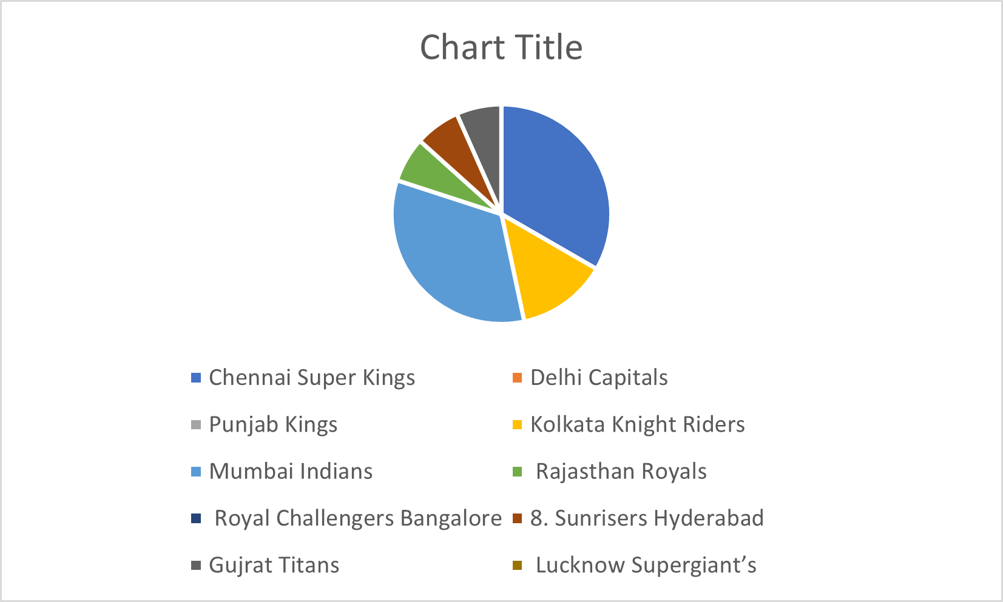

**Championship Rate**

**1-Data Collection:**

Accumulate information from solid sources such as official IPL websites, sports analytics stages, or APIs. This information ought to include player statistics (batting, bowling, handling), coordinate comes about, group exhibitions, and other significant measurements.

**2-Exploratory Information Analysis (EIA):**

**• Descriptive Statistics:**

Calculate essential measurements such as cruel, middle, mode, standard deviation, etc., to understand the central propensity and spread of the information.

**• Information Visualization:**

Create visualizations like histograms, box plots, diffuse plots, etc., to recognize designs, patterns, and connections inside the data. For occasion, visualize batting midpoints, bowling strike rates, group exhibitions over seasons, etc.

**• Correlation Analysis:**

Determine correlations between diverse factors such as batting averages and coordinate comes about, economy rates and wicket-taking capacity, etc

**3-Player Performance Analysis:**

**• Batting Analysis**:

Analyze batting exhibitions based on measurements like runs scored, strike rates, normal, centuries, fifties, etc. Recognize best entertainers over seasons and their consistency.

|  |  |
| --- | --- |
| **Name of the Player** | **Highest Runs** |
| **Virat Kohli** | **7642** |
| **Shikhar Dhawan** | **6769** |
| **David Warner** | **6564** |
| **Rohit Sharma** | **6514** |
| **Suresh Raina** | **5528** |

**TOP 5 HIGHEST RUN SCORER**

**• Bowling Analysis:**

Assess bowler exhibitions using metrics such as wickets taken, economy rates, bowling midpoints, lady overs, etc. Distinguish the foremost compelling bowlers and their effect on matches.

|  |  |
| --- | --- |
| **Name of the Player** | **Wickets** |
| **Yuzvendra Chahal** | **200** |
| **Piyush Chawla** | **184** |
| **Dwayne Bravo** | **183** |
| **Bhuvbeshwar Kumar** | **178** |
| **Amit Mishra** | **175** |
|  |  |

**TOP 5 WICKET TAKER**

**4-Team Performance Analysis:**

**• Win-Loss Analysis:**

Analyze the win-loss record of teams over diverse seasons. Identify factors contributing to their victory or disappointment.

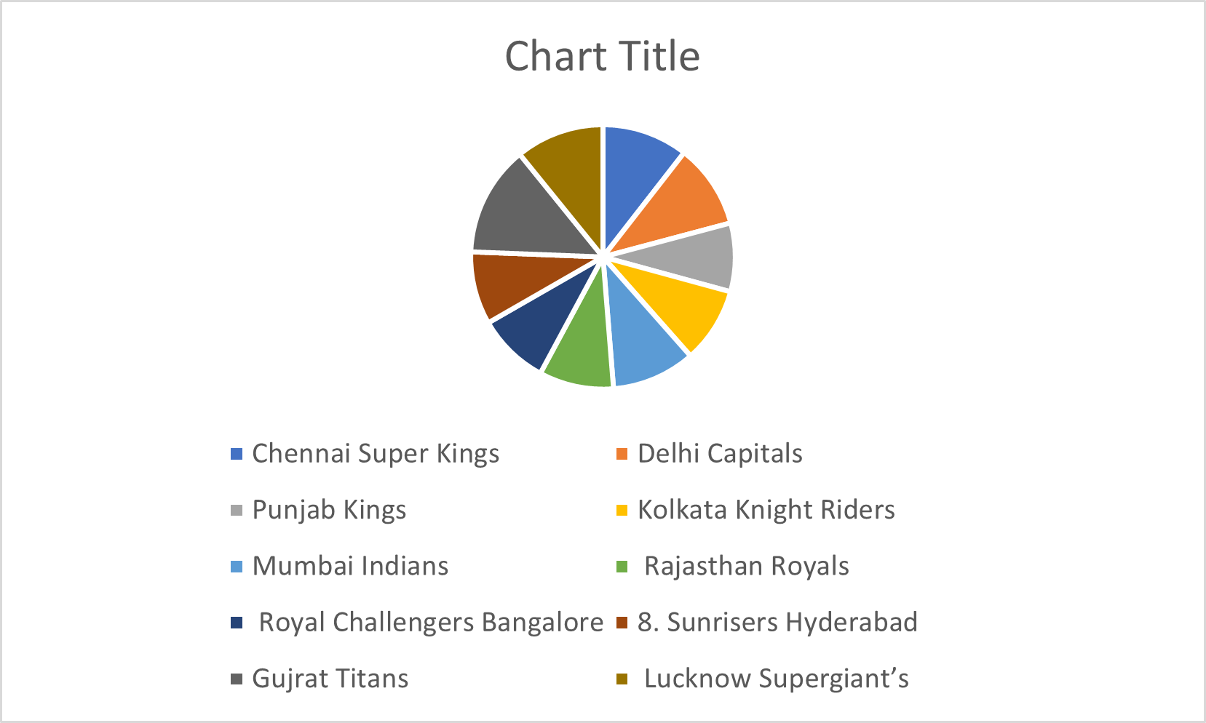

**5-Match Analysis:**

**• Close Matches:**

Recognize matches chosen by near edges (e.g., last-over wraps up, super overs) and analyze the variables affecting the results.

**6- BCCI’S SHARE AND IPL TEAM’S SHARE**

By following these steps, you'll be able conduct comprehensive information investigation and interpretation of IPL information, revealing important bits of knowledge for different partners in the cricketing environment.

**CONCLUSION**

Through a comprehensive exploration of the Indian Premier League (IPL) and its status within Indian society, this research has shed light on the multifaceted dimensions of this cricketing extravaganza. The findings presented herein reflect the IPL's profound influence on various aspects of Indian culture, economy, and sports landscape.

First and foremost, the IPL emerges as a cultural phenomenon that transcends the boundaries of sport. It has become ingrained in the social fabric of India, capturing the imagination of millions and fostering a sense of community and belonging among fans across the country. The fervor and passion exhibited by supporters during IPL matches underscore its significance as more than just a sporting event but as a cultural spectacle that unites diverse communities under the banner of cricket.

Moreover, the IPL's economic impact cannot be overstated. As a billion-dollar industry, it generates substantial revenue streams through broadcasting rights, sponsorship deals, merchandise sales, and ticketing. The IPL has transformed cricket into a lucrative business opportunity, attracting investment from corporate entities and stimulating economic growth in host cities and regions. Beyond its direct economic contributions, the IPL also catalyzes ancillary industries, such as hospitality, tourism, and media, thereby creating employment opportunities and driving development in related sectors.

Furthermore, the IPL serves as a catalyst for talent development and grassroots cricketing initiatives in India. By providing a platform for aspiring cricketers to showcase their skills and compete at the highest level, the IPL nurtures talent pipelines and fosters a culture of excellence within the sport. Additionally, the league's emphasis on youth participation and community engagement promotes inclusivity and diversity, empowering individuals from diverse backgrounds to pursue their passion for cricket and realize their potential.

However, amidst its successes, the IPL also faces challenges and criticisms that warrant attention. Issues such as match-fixing allegations, player misconduct, and commercialization have tarnished the league's image and raised questions about its integrity and ethical standards. Moreover, concerns regarding the exploitation of players, particularly those from lower-income backgrounds, highlight the need for greater accountability and ethical governance within the IPL ecosystem.

In conclusion, the IPL occupies a central place in the collective consciousness of Indian society, symbolizing the intersection of sport, entertainment, and commerce. Its status as a cultural phenomenon, economic powerhouse, and talent incubator underscores its significance as more than just a cricket tournament but as a transformative force shaping the trajectory of Indian sports. Moving forward, it is imperative to address the challenges and criticisms facing the IPL while leveraging its immense potential to promote inclusivity, integrity, and sustainable development within Indian cricket and society at large.

As the IPL continues to evolve and adapt to changing dynamics, it remains a testament to the enduring passion and fervor for cricket in India, uniting millions in a shared celebration of the nation's favourite sport.

**LIMITATIONS**

1. **Sampling Bias:** Potential bias in participant selection methods may limit the representativeness of the findings.
2. **Time Constraints:** The research is confined to a specific timeframe, potentially overlooking long-term trends or changes in the IPL landscape.
3. **Data Validity:** Self-reporting bias and respondent fatigue could affect the accuracy of the data collected.
4. **Scope Limitations:** The study focuses solely on the IPL's status within India, excluding broader international perspectives.
5. **Ethical Considerations:** Despite efforts to uphold ethical standards, unforeseen ethical dilemmas may arise during the research process.
6. **External Influences:** Factors beyond the researcher's control, such as societal events or policy changes, may impact the IPL landscape unpredictably.

**BIBLIOGRAPHY**

1. Bose, Mihir. "The IPL: a short history." *Journal of South Asian Studies* 34, no. 3 (2011): 509-524.
2. Chaudhuri, Arunava. *The World Cup Chronicles 1930-2014*. Goalpost Books, 2014.
3. Jayal, Niraja Gopal. "The Indian Premier League: cricketainment or crick-business?" *South Asia: Journal of South Asian Studies* 36, no. 2 (2013): 266-284.
4. Majumdar, Boria, and Nalin Mehta. *The A to Z of Indian Cricket*. Oxford University Press, 2013.
5. Mukherjee, Tanni. "IPL and its brand value: An analysis of media reports." *Journal of Economics and Behavioral Studies* 8, no. 6 (2016): 112-121.
6. Srinivas, Natarajan. "The Indian Premier League and the globalization of cricket." *Sociological Bulletin* 62, no. 2 (2013): 202-216.
7. Varadharajan, Ashwin. "Caste in Indian cricket." *Economic and Political Weekly* 53, no. 20 (2018): 17-19.
8. Williams, John, and Satish Kumar. "Cricket, caste, and ethnicity: An exploration of Indian cricket culture." *Sport in Society* 23, no. 8 (2020): 1276-1290.
9. Yadav, T.N. "Indian Premier League (IPL): A successful cricketainment in India." *International Journal of Research in Management & Social Science* 3, no. 2 (2015): 14-19.
10. Yelavarthy, Harsha. "Indian Premier League (IPL): A study of its evolution, growth, and challenges." *Journal of Global Operations and Strategic Sourcing* 11, no. 3 (2018): 295-310.

Top of Form